The Impact of the COVID-19 Pandemic on Perceived Publication Pressure Among Academic Researchers in Canada
Celeste Suart¹, Kaitlyn Neuman¹, and Ray Truant^{1,*}
1 Department of Biochemistry and Biomedical Sciences, McMaster University, Hamilton, Ontario, Canada
* Corresponding Author, Email: truantr@mcmaster.ca

Supporting Material
Supporting Appendix 1. Online Survey Protocol.
Supporting Table 1. Trainee respondent goal career field following completion of studies.
Supporting Table 2. Location of respondents’ affiliated research institution.
Supporting Table 3. Respondent ethnicity.
Supporting Table 4. Publication Pressure Questionnaire Subscale Scores stratified by trainee goal career field after studies.
Supporting Table 5. Publication Pressure Questionnaire Subscale Scores stratified by location.
Supporting Table 6. Publication Pressure Questionnaire Subscale Scores stratified by ethnicity.
Supporting Figure 1. Publication pressure questionnaire subscale scores by academic position.
Supporting Figure 2. No significant differences in perceived publication pressure experienced by respondents with different research funding agencies.
Supporting Table 1. Trainee respondent goal career field following completion of studies. N= 777.
Career Field | N (%)
Academia | 400 (51%)
Non-academic field (Research publication history is valued) | 312 (40%)
Non-academic field (Research publication history is not considered) | 65 (8%)
Total | 777 (100%)
Supporting Table 2. Location of respondents’ affiliated research institution. N=1020
Career Field | N (%)
Alberta | 77 (8%)
British Columbia | 168 (16%)
Manitoba | 69 (7%)
New Brunswick | 42 (4%)
Newfoundland and Labrador | 40 (4%)
Northwest Territories | 30 (3%)
Nova Scotia | 47 (5%)
Nunavut | 19 (2%)
Ontario | 434 (43%)
Prince Edward Island | 11 (1%)
Quebec | 57 (6%)
Saskatchewan | 14 (1%)
Yukon | 5 (0.5%)
Prefer not to Answer | 7 (1%)
Total | 1020 (100%)

Supporting Table 3. Respondent ethnicity. Respondents could select multiple responses. N=1020. These categories were adapted from the Statistics Canada Visible Minority and Population Group Reference Guide, Census of Population (2016) [66]. Examples of respondent descriptions who chose to self-identify include: Biracial or mixed race, Canadian, Jewish, and West Indian.
Race | N (%)
Arab | 29 (3%)
Black | 59 (6%)
Chinese | 57 (6%)
Filipino/a | 11 (1%)
Indigenous | 25 (2%)
Japanese | 6 (1%)
Korean | 10 (1%)
Latin American | 29 (3%)
South Asian | 49 (5%)
South East Asian | 9 (1%)
West Asian | 17 (2%)
White | 737 (72%)
Prefer to Self-Identify | 20 (2%)
Prefer not to Answer | 28 (23%)
Total | 1020 (100%)

Supporting Table 4. Publication Pressure Questionnaire Subscale Scores stratified by trainee goal career field after studies. Values represent mean score with standard deviation in brackets.
Career Field | N | Stress |  | Attitude |  | Resources
 |  | Pre-COVID | Post-COVID | Pre-COVID | Post-COVID | Pre-COVID | Post-COVID
Academia | 400 | 3.28 (0.76) | 3.51 (0.84) | 3.36 (0.68) | 3.44 (0.76) | 2.65 (0.63) | 2.79 (0.68)
Non-academic field (Research publication history is valued) | 312 | 3.05 (0.60) | 3.20 (0.67) | 3.21 (0.61) | 3.24 (0.65) | 2.78 (0.65) | 2.82 (0.54)
Non-academic field (Research publication history is not considered) | 65 | 3.24 (0.66) | 3.37 (0.62) | 3.33 (0.72) | 3.39 (0.70) | 2.95 (0.58) | 3.09 (0.51)
Total Population | 1020 | 3.20 (0.72) | 3.38 (0.82) | 3.31 (0.66) | 3.37 (0.72) | 2.65 (0.62) | 2.78 (0.63)

Supporting Table 5. Publication Pressure Questionnaire Subscale Scores stratified by location. Values represent mean score with standard deviation in brackets.
Location | N | Stress |  | Attitude |  | Resources
 |  | Pre-COVID | Post-COVID | Pre-COVID | Post-COVID | Pre-COVID | Post-COVID
Alberta | 77 | 3.05 (0.68) | 3.16 (0.83) | 3.12 (0.62) | 3.15 (0.73) | 2.77 (0.57) | 2.85 (0.67)
British Columbia | 168 | 3.08 (0.58) | 3.29 (0.68) | 3.22 (0.63) | 3.31 (0.69) | 2.71 (0.58) | 2.80 (0.57)
Manitoba | 69 | 3.07 (0.55) | 3.15 (0.58) | 3.19 (0.51) | 3.14 (0.60) | 2.86 (0.46) | 2.96 (0.49)
New Brunswick | 42 | 2.92 (0.54) | 3.10 (0.52) | 3.19 (0.55) | 3.15 (0.41) | 2.86 (0.48) | 2.88 (0.40)
Newfoundland and Labrador | 40 | 3.13 (0.64) | 3.19 (0.65) | 3.17 (0.71) | 3.20 (0.67) | 2.71 (0.54) | 2.80 (0.57)
Northwest Territories | 30 | 3.08 (0.39) | 2.91 (0.51) | 3.09 (0.37) | 3.08 (0.35) | 2.88 (0.39) | 2.95 (0.35)
Nova Scotia | 47 | 3.06 (0.69) | 3.08 (0.82) | 3.15 (0.61) | 3.17 (0.65) | 2.78 (0.58) | 2.81 (0.51)
Nunavut | 19 | 2.91 (0.30) | 2.89 (0.19) | 3.06 (0.41) | 2.96 (0.49) | 3.02 (0.35) | 3.07 (0.33)
Ontario | 434 | 3.35 (0.81) | 3.60 (0.88) | 3.46 (0.70) | 3.55 (0.74) | 2.51 (0.66) | 2.70 (0.70)
Prince Edward Island | 11 | 2.76 (0.42) | 3.03 (0.35) | 2.89 (0.55) | 3.07 (0.59) | 3.12 (0.45) | 3.00 (0.37)
Quebec | 57 | 3.27 (0.73) | 3.53 (0.91) | 3.42 (0.70) | 3.48 (0.88) | 2.53 (0.60) | 2.68 (0.73)
Saskatchewan | 14 | 3.42 (0.89) | 3.54 (0.82) | 3.37 (0.86) | 3.50 (0.87) | 2.40 (0.78) | 2.50 (0.56)
Yukon | 5 | 2.80 (0.14) | 2.70 (0.46) | 3.13 (0.32) | 3.03 (0.36) | 3.20 (0.32) | 3.00 (0.26)
Prefer not to Answer | 7 | 3.69 (1.22) | 3.95 (1.26) | 3.04 (0.92) | 2.98 (1.11) | 2.61 (0.65) | 2.88 (0.74)
Total Population | 1020 | 3.20 (0.72) | 3.38 (0.82) | 3.31 (0.66) | 3.37 (0.72) | 2.65 (0.62) | 2.78 (0.63)

Respondents from Ontario had significantly higher pre-COVID Stress scores (M=3.35) than British Columbia (M=3.08, p=0.0025, one-way ANOVA) and New Brunswick (M=2.92, p=0.014, one-way ANOVA). Post-COVID Ontario respondents had significantly higher Stress scores (M=3.60) than Alberta (M=3.16, p=0.0004, one-way ANOVA), British Columbia (M=3.29, p=0.0016, one-way ANOVA), Manitoba (M=3.15, p=0.0011, one-way ANOVA), New Brunswick (M=3.10, p=0.0067, one-way ANOVA), Northwest Territories (M=2.91, p=0.0003, one-way ANOVA), Nova Scotia (M=3.08, p=0.0013, one-way ANOVA), and Nunavut (M=2.89, p=0.01, one-way ANOVA).
Respondents from Ontario had significantly higher pre-COVID Attitude scores (M=3.46) than Alberta (M=3.12, p=0.003, one-way ANOVA) and British Columbia (M=3.22, p=0.0054, one-way ANOVA). Following the COVID-19 pandemic, Ontario respondents had significantly higher Attitude scores (M=3.55) than Alberta (M=3.15, p=0.0004, one-way ANOVA), British Columbia (M=3.31, p=0.017, one-way ANOVA), Manitoba (M=3.14, p=0.0007, one-way ANOVA), New Brunswick (M=3.15, p=0.038, one-way ANOVA), Northwest Territories (M=3.08, p=0.033, one-way ANOVA), Nova Scotia (M=3.17, p=0.033, one-way ANOVA), and Nunavut (M=2.96, p=0.029, one-way ANOVA).
Respondents from Ontario had significantly lower pre-COVID Resources scores (M=3.46) than Alberta (M=2.77, p=0.04, one-way ANOVA), British Columbia (M=2.71, p=0.019, one-way ANOVA), Manitoba (M=2.86, p=0.00066, one-way ANOVA), New Brunswick (M=2.86, p=0.026, one-way ANOVA), and Nunavut (M=3.02, p=0.026, one-way ANOVA). There were no significant differences in post-COVID Resources scores between respondent locations.

Supporting Table 6. Publication Pressure Questionnaire Subscale Scores stratified by ethnicity. Values represent mean score with standard deviation in brackets.
Location | N | Stress |  | Attitude |  | Resources
 |  | Pre-COVID | Post-COVID | Pre-COVID | Post-COVID | Pre-COVID | Post-COVID
Arab | 29 | 2.89 (0.71) | 3.23 (0.79) | 3.29 (0.78) | 3.47 (0.67) | 2.57 (0.64) | 2.74 (0.59)
Black | 59 | 2.93 (0.44) | 3.15 (0.66) | 3.21 (0.65) | 3.26 (0.74) | 2.76 (0.61) | 2.75 (0.54)
Chinese | 57 | 3.07 (0.63) | 3.28 (0.66) | 3.26 (0.69) | 3.34 (0.70) | 2.63 (0.64) | 2.80 (0.58)
Filipino/a | 11 | 3.11 (0.62) | 3.18 (0.74) | 2.80 (0.44) | 3.06 (0.64) | 2.89 (0.55) | 3.05 (0.35)
Indigenous | 25 | 3.05 (0.55) | 3.08 (0.61) | 3.18 (0.61) | 3.15 (0.75) | 2.68 (0.58) | 2.77 (0.65)
Japanese | 6 | 3.03 (0.37) | 3.11 (0.99) | 3.25 (0.55) | 3.25 (0.58) | 3.11 (0.31) | 3.14 (0.46)
Korean | 10 | 3.12 (0.77) | 3.17 (0.89) | 3.23 (0.56) | 3.33 (0.65) | 2.67 (0.45) | 2.63 (0.44)
Latin American | 29 | 3.32 (0.82) | 3.59 (0.85) | 3.53 (0.74) | 3.49 (0.82) | 2.60 (0.70) | 2.72 (0.70)
South Asian | 49 | 3.36 (0.67) | 3.55 (0.87) | 3.35 (0.69) | 3.59 (0.72) | 2.57 (0.54) | 2.78 (0.70)
South East Asian | 9 | 3.02 (0.47) | 3.19 (0.72) | 3.22 (0.67) | 3.17 (0.54) | 2.69 (0.61) | 2.69 (0.63)
West Asian | 17 | 3.09 (0.64) | 3.29 (0.71) | 3.36 (0.40) | 3.39 (0.52) | 2.76 (0.49) | 2.89 (0.37)
White | 737 | 3.21 (0.72) | 3.38 (0.81) | 3.32 (0.65) | 3.36 (0.71) | 2.64 (0.61) | 2.77 (0.64)
Prefer to Self-Identify | 20 | 3.29 (1.13) | 3.53 (1.21) | 3.55 (0.68) | 3.72 (0.63) | 2.63 (0.83) | 2.59 (0.79)
Prefer not to Answer | 28 | 3.73 (0.78) | 3.96 (0.91) | 3.51 (0.72) | 3.53 (0.80) | 2.62 (0.69) | 2.88 (0.62)
Total Population | 1020 | 3.20 (0.72) | 3.38 (0.82) | 3.31 (0.66) | 3.37 (0.72) | 2.65 (0.62) | 2.78 (0.63)

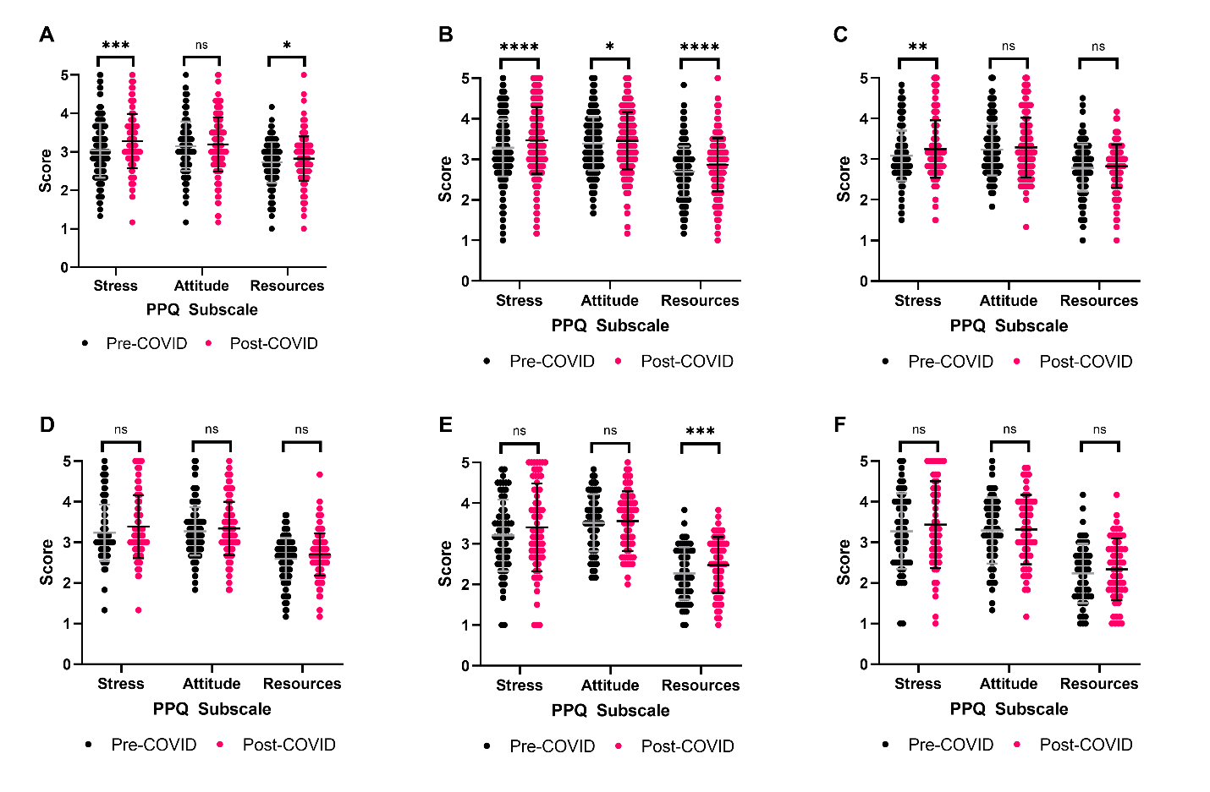
Supporting Figure 1. Publication pressure questionnaire subscale scores by academic position. Paired Student’s t-test with Bonferroni correction. * P≤0.05, ** P≤0.01, *** P≤0.001, **** P≤0.0001. (A) Graduate Student: Master’s Degree Scores. N= 166. (B) Graduate Student: Doctoral Degree Scores. N=410. (C) Postdoctoral Fellow Scores. N=201. (D) Principal Investigator: Early Career Scores N=121. (E) Principal Investigator: Mid-Career Scores N=66. (F) Principal Investigator: Senior Scores N=66.

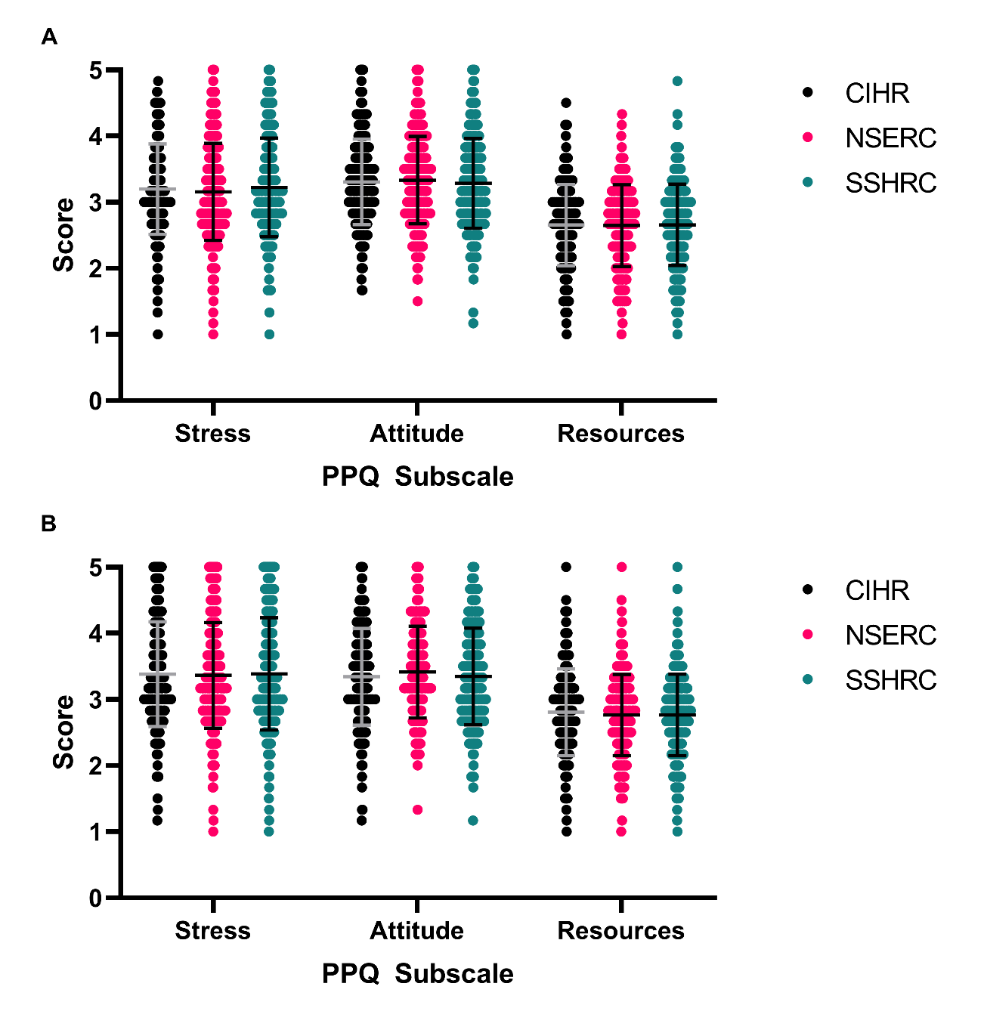
Supporting Figure 2. No significant differences in perceived publication pressure experienced by respondents with different research funding agencies. One-way ANOVA, N=306-393. P>0.64 for all comparisons. CIHR: Canadian Institutes of Health Research, NSERC: Natural Sciences and Engineering Research Council, SSHRC: Social Sciences and Humanities Research Council. (A) Scores Pre-COVID. (B) Scores Post-COVID.

