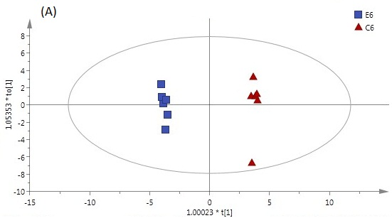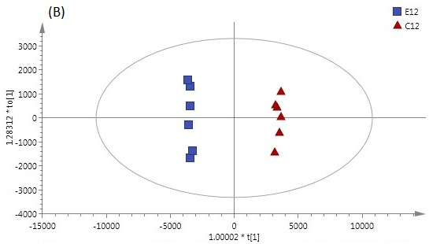
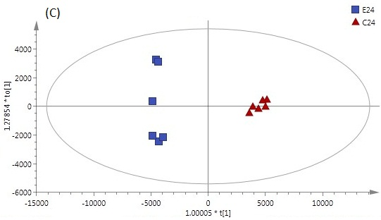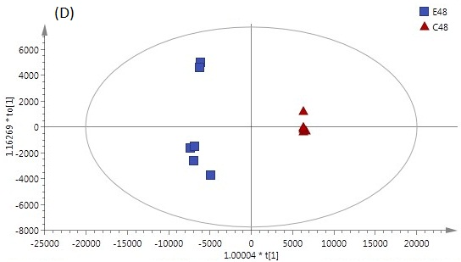
Figure S1. OPLS-DA score plot of erastin-treated MGC-803 cells and the controls: (A) 6h, (B) 12h, (C) 24h, (D) 48h.

