Supplementary material

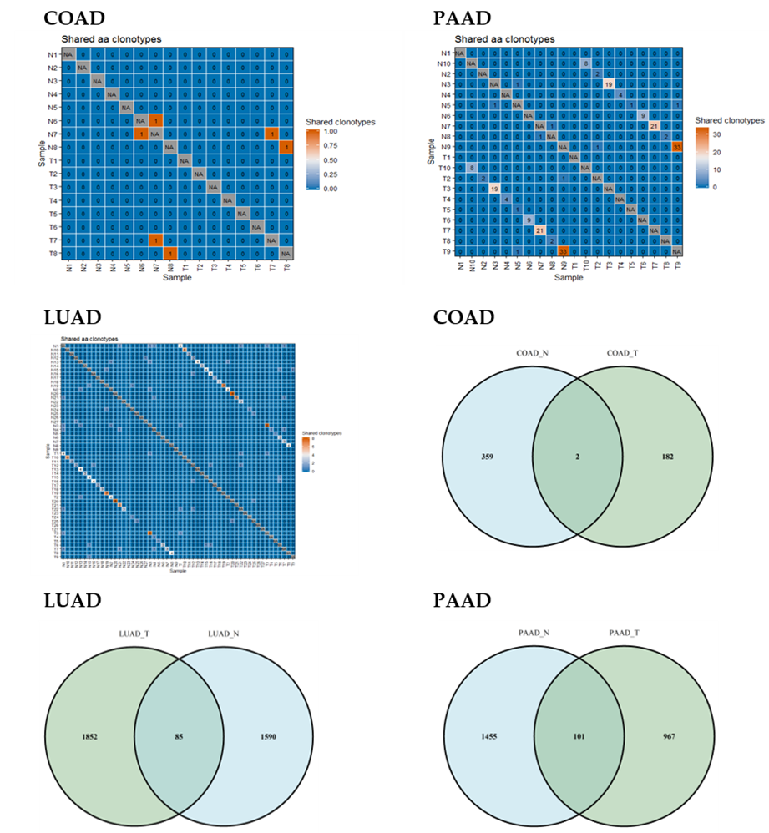
Figure S1 number of shared TRB sequences of COAD, LUAD, PAAD

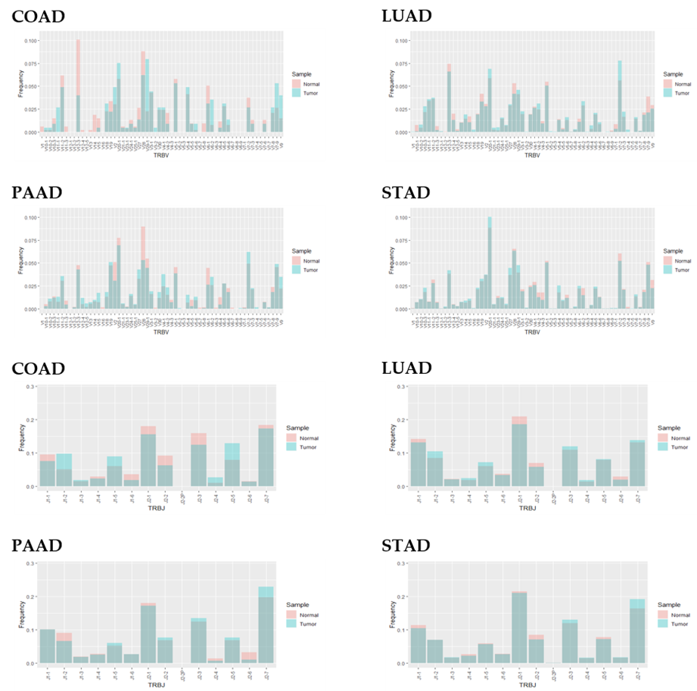
Figure S2 The usage of TRBV and TRBJ
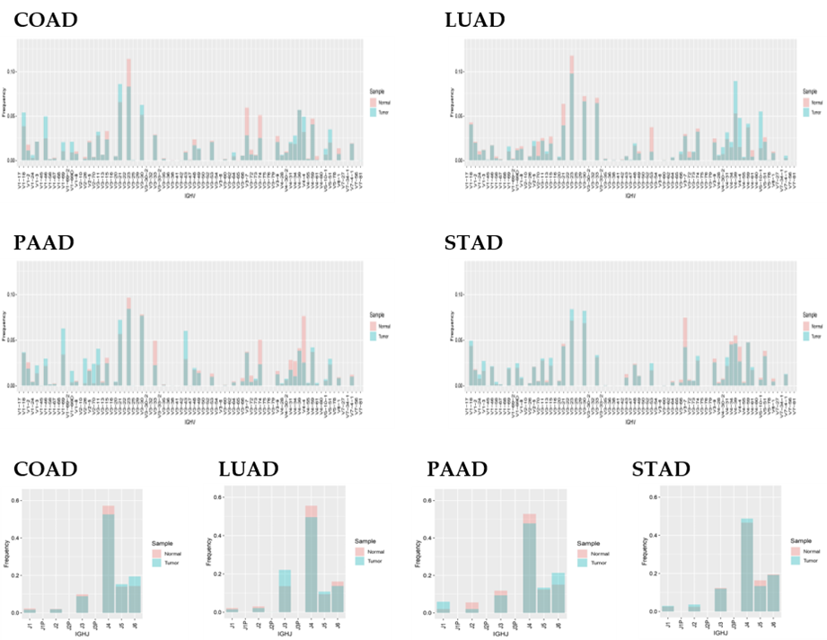
Figure S3 The usage of IGHV and IGHJ

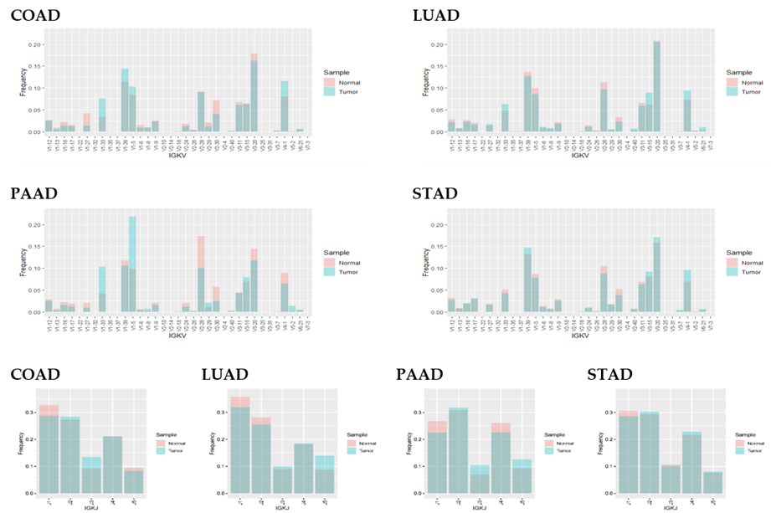
Figure S4 The usage of IGKV and IGKJ

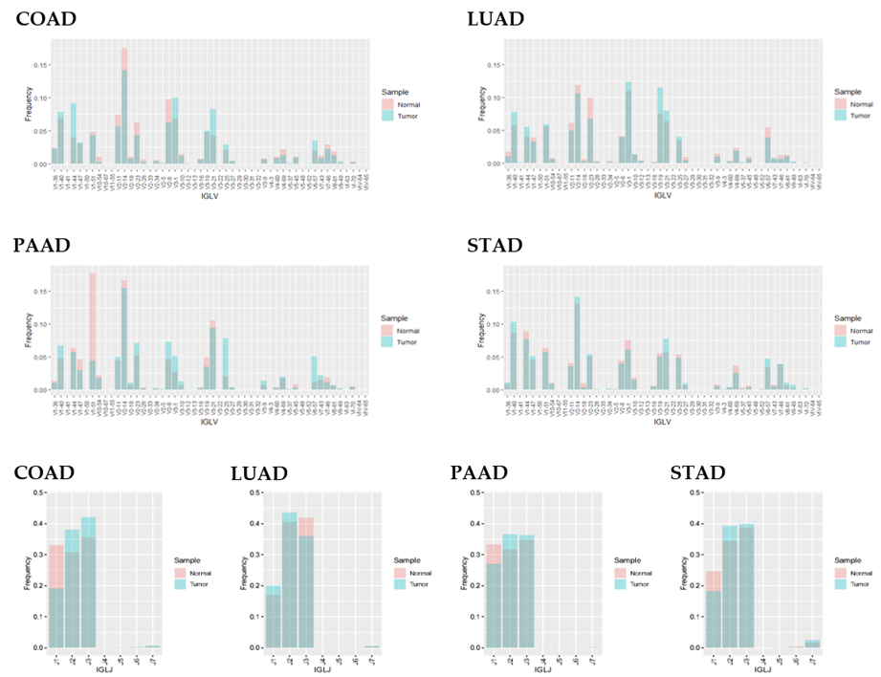
Figure S5 The usage of IGLV and IGLJ

