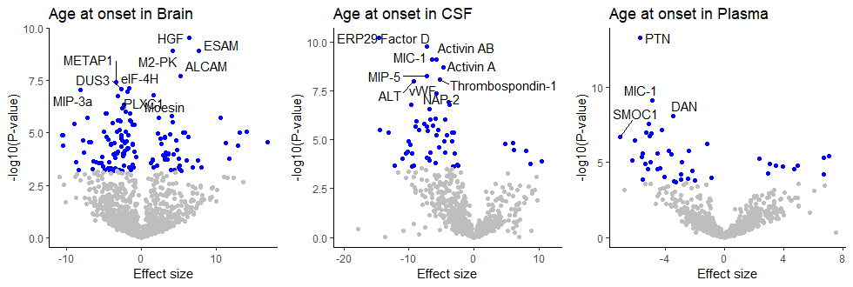

Supplementary Figure 1: We also performed survival analysis for age at onset while considering age, sex and surrogate variables as covariates. We created a survival object using R function Surv and performed a Cox proportional hazards regression model using coxph function. There were 139, 59 and 44 proteins significant at Bonferroni-corrected threshold (shown in blue) in brain, CSF, and plasma, respectively.

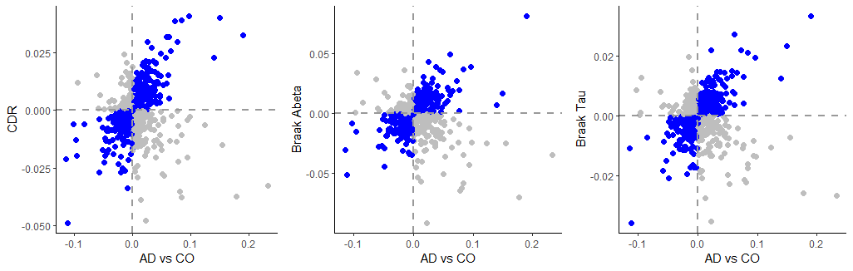
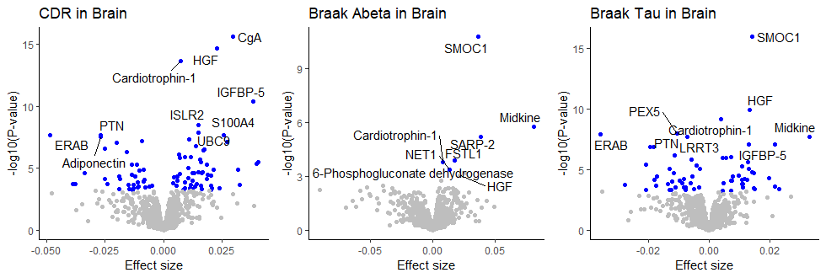
b
a

Supplementary Figure 2: We performed differential abundance analyses of CDR and Braak scores in the brain data.
a. The 3 panels show the corresponding volcano plots. All 12 proteins associated with AD status are significant across these traits.
b. Their effect on protein abundance (y-axis) is correlated with the effect of AD status on protein abundance (x-axis), as shown in the 3 panels. Correlations are 0.21 (P = 1.75×10⁻¹²), 0.04 (P = 0.18), and 0.11 (P=1.46×10⁻⁴) for CDR, Braak Aβ, and Braak Tau measures

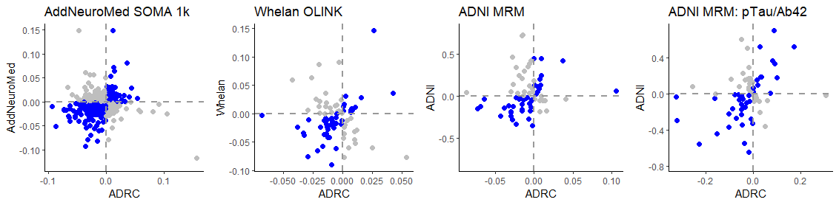
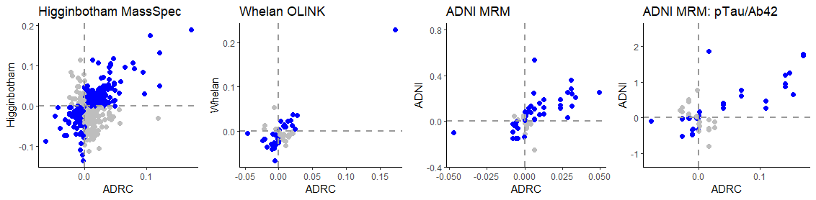
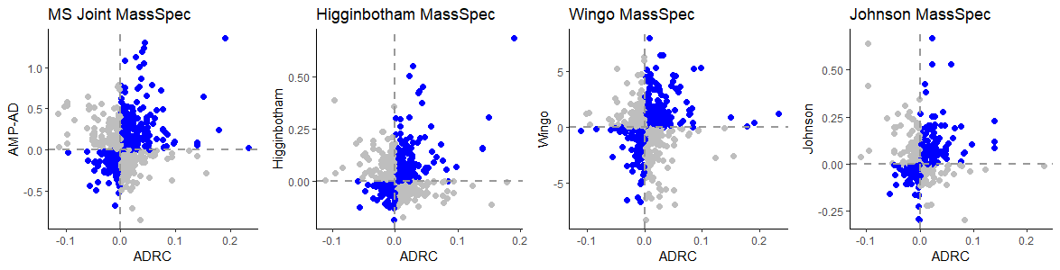
a
c
b

Supplementary Figure 3: To externally replicate our findings, we downloaded and analyzed publicly available proteomic data. We found that their effects of AD status on protein abundance (y-axis) are generally consistent with the effects we found in our Knight-ADRC discovery data (x-axis). The mass-spectrometry brain proteomics data consisting of 10078 proteins from 415 AD patients and 194 controls in the ACT, BANNER, BLSA, MSSM, ROSMAP and MAYO studies provided correlation of 0.10 (P = 3.6×10⁻³, panel a, left plot). In CSF tissue (panel b), the correlation is even higher (0.43 - 0.82, P < 3.4×10⁻⁷). In plasma tissue, modest correlation was observed in AddNeuroMed (cor = 0.07) and ADNI MRM (cor = 0.18). In addition, we found a strong correlation between the effects of p-Tau/Aβ42 ratio in ADNI and effects of AD status in our discovery data (cor = 0.69 in CSF and 0.36 in plasma, P < 2.15×10⁻³),

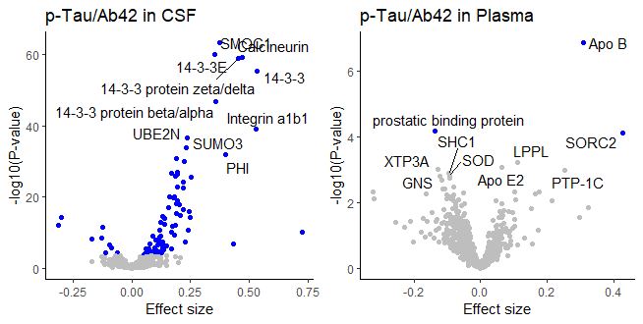
a

b
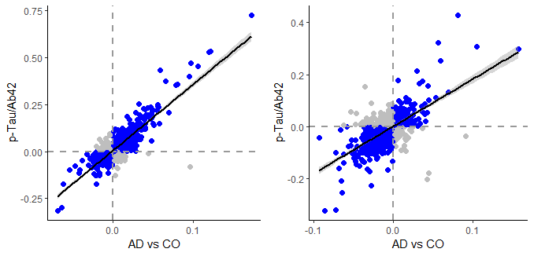

Supplementary Figure 4: We performed differential abundance analyses of the well-accepted p-Tau/Aβ42 ratio measured and available in our CSF (n=689) and plasma data (n=393).
a. The 2 panels show the corresponding volcano plots. Out of 117 proteins associated with AD status in CSF, 74 are also significant for p-Tau/Aβ42 ratio at the Bonferroni-corrected threshold.
b. The effect of the p-Tau/Aβ42 ratio on protein abundance levels (y-axis) is strongly correlated with the effect of clinically defined AD status (x-axis). The correlation is 0.86 in CSF and 0.63 in plasma (both with P < 1.0×10⁻¹⁶).

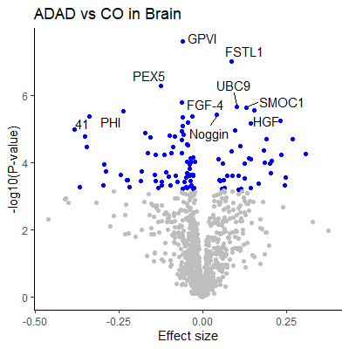
Supplementary Figure 5: We performed analyses and identified 109 proteins with differential abundance in individuals carrrying autosomal dominant AD (ADAD) mutations in brain tissue compared to cognitively normal individuals with no significant brain pathology, at Bonferroni corrected threshold.
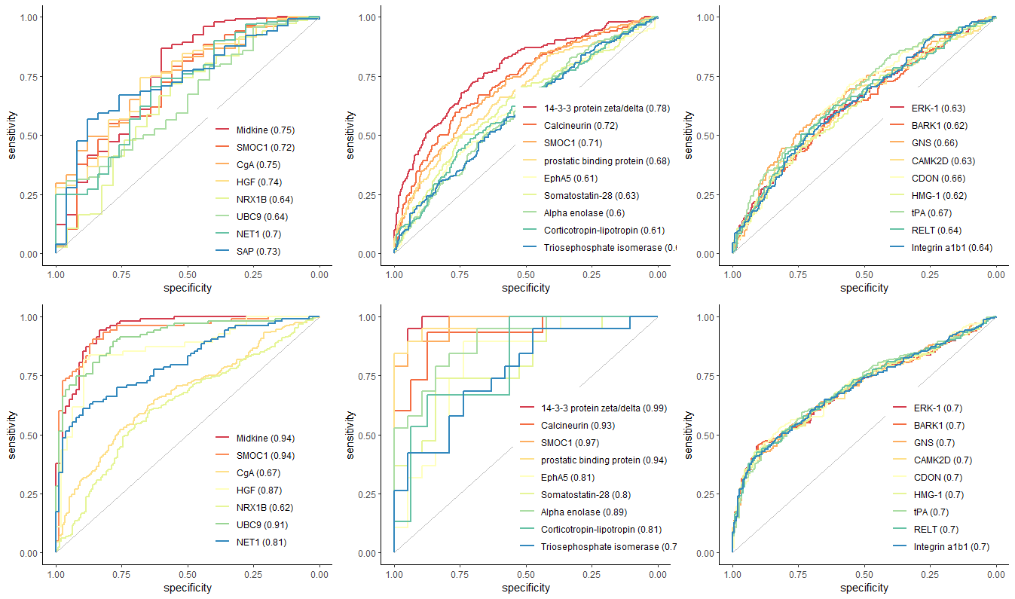
Brain
CSF
Plasma

Supplementary Figure 6: We created prediction model for sporadic AD status with each of proteins that were identified and externally replicated. Top panels show ROC for the discovery dataset and the bottom panels for replication datasets.

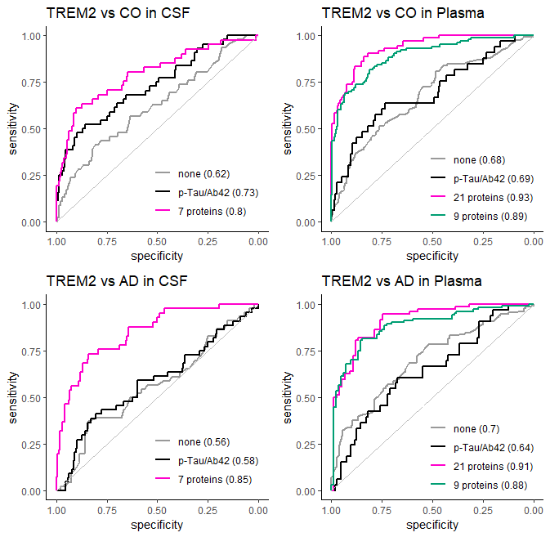

Supplementary Figure 7: We created prediction model for TREM2 carrier status while considering age, sex, and APOE status as covariates. Our identified and internally validated proteins (7 in CSF and 21 in plasma) provide higher accuracy than the p-Tau/Aβ42 ratio. In plasma data, we performed step-wise regression analysis and found 9 proteins (Bone proteoglycan II, STAT3, uPA, ERK-1, VCAM-1, PAPP-A, BSSP4, XTP3A, and S100A4) that provided almost comparable accuracy as the 21 proteins.

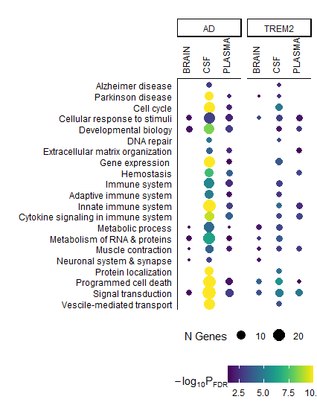
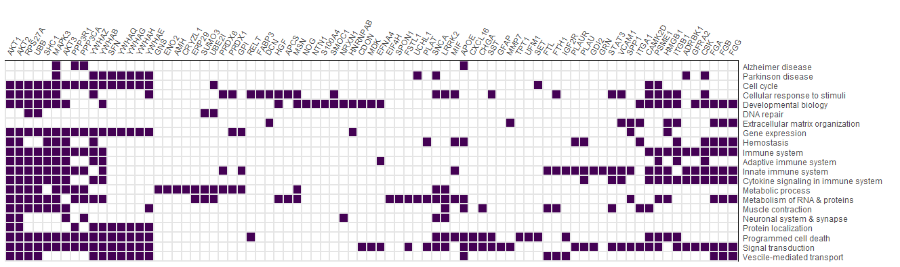

Supplementary Figure 8: Our identified proteins and the encoding 79 genes are enriched in several pathways known to be part of AD. A subset of 28 genes is shown in Figure 4.
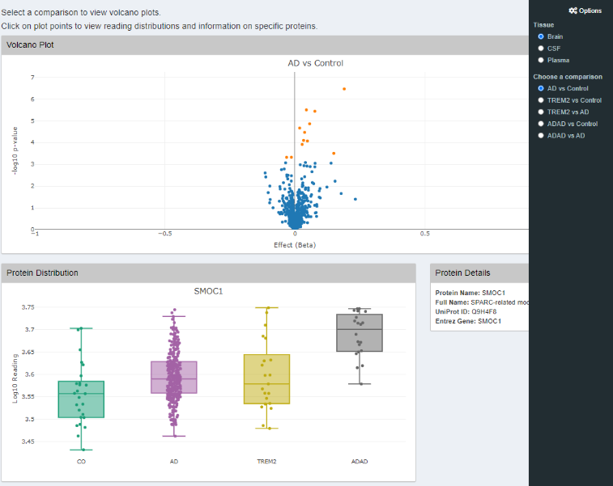
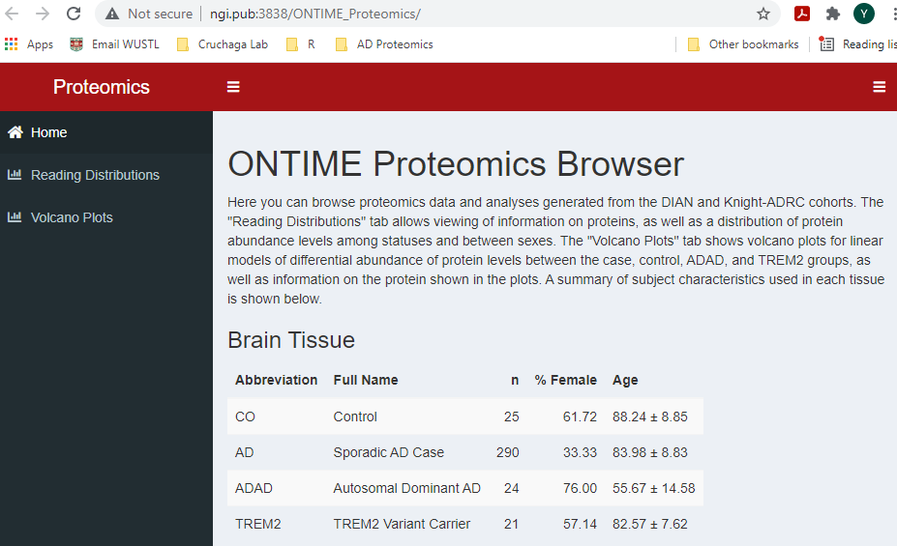
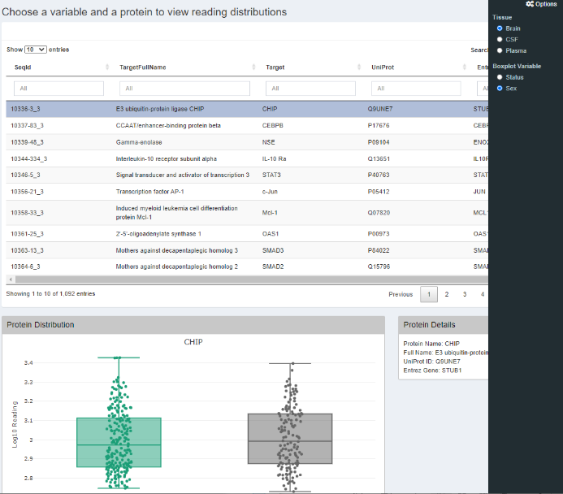

Supplementary Figure 9: We created a web portal (http://ngi.pub:3838/ONTIME_Proteomics/) to facilitate both exploration of our analysis and further investigation into individual proteins across disease status or sex. The browser provides three tabs. The first tab provides a brief description of data set and explanation. The second tab (Reading distribution) displays a table including proteomic abundance levels on each analyte that passed our QC process, along with its effect and p-value for each comparison presented here. The table allows the user to select a protein, which displays the distribution of the selected protein levels across disease status or sex. The third tab (Volcano plot) displays the volcano plots for each comparison

