Supplementary Table 1. Demographic and clinical data for the participants. NC-LC= no or low caries ; MC-HC = moderate-high caries
ID | smoking | sex | age | ageBegin | duration of smoking years | VPI % | Decayed | Missing | Filled | DMF | Groups
C4 | S-Cigarettes | Male | 23 | 15 | 8 | 0.1 | 1 | 1 | 4 | 6 | MC-HC
C12 | S-Cigarettes | Male | 35 | 26 | 9 | 0.29 | 2 | 3 | 0 | 5 | MC-HC
C25 | S-Cigarettes | Male | 37 | 15 | 22 | 0.41 | 6 | 1 | 0 | 7 | MC-HC
C30 | S-Cigarettes | female | 50 | 30 | 20 | 0.33 | 0 | 11 | 5 | 16 | MC-HC
C38 | S-Cigarettes | Male | 25 | 15 | 10 | 0.91 | 1 | 2 | 0 | 3 | NC-LC
C49 | S-Cigarettes | Male | 44 | 22 | 22 | 0.32 | 2 | 6 | 12 | 20 | MC-HC
C51 | S-Cigarettes | Male | 20 | 15 | 5 | 0.35 | 8 | 0 | 9 | 17 | MC-HC
C55 | S-Cigarettes | Male | 20 | 16 | 4 | 0.95 | 1 | 0 | 7 | 8 | MC-HC
C75 | S-Cigarettes | Male | 27 | 20 | 7 | 0.5 | 4 | 0 | 0 | 4 | NC-LC
C76 | S-Cigarettes | Male | 38 | 17 | 21 | 0.85 | 9 | 0 | 2 | 11 | MC-HC
M11 | S-Medwakh | Male | 24 | 17 | 7 | 0.11 | 4 | 0 | 0 | 4 | NC-LC
M17 | S-Medwakh | Male | 23 | 19 | 4 | 0.05 | 0 | 1 | 0 | 1 | NC-LC
M23 | S-Medwakh | Male | 24 | 22 | 2 | 0.47 | 0 | 0 | 8 | 8 | MC-HC
M29 | S-Medwakh | Male | 23 | 22 | 1 | 0.46 | 0 | 2 | 0 | 2 | NC-LC
M31 | S-Medwakh | Male | 28 | 26 | 2 | 0.74 | 3 | 0 | 0 | 3 | NC-LC
M52 | S-Medwakh | Male | 21 | 12 | 9 | 0.27 | 5 | 4 | 2 | 11 | MC-HC
M59 | S-Medwakh | Male | 18 | 10 | 8 | 0.22 | 0 | 1 | 4 | 5 | MC-HC
M64 | S-Medwakh | Male | 20 | 9 | 11 | 0.42 | 1 | 0 | 2 | 3 | NC-LC
M68 | S-Medwakh | Male | 27 | 14 | 13 | 0.8 | 6 | 2 | 2 | 10 | MC-HC
M77 | S-Medwakh | Male | 33 | 27 | 6 | 0.23 | 3 | 0 | 6 | 9 | MC-HC
SH14 | S-Shisha | Male | 24 | 19 | 5 | 0.22 | 1 | 0 | 11 | 12 | MC-HC
SH28 | S-Shisha | Male | 23 | 16 | 7 | 0.54 | 2 | 4 | 4 | 10 | MC-HC
SH42 | S-Shisha | Male | 54 | 52 | 2 | 0.57 | 2 | 1 | 2 | 5 | MC-HC
SH44 | S-Shisha | female | 27 | 22 | 5 | 0.4 | 0 | 4 | 1 | 5 | MC-HC
SH56 | S-Shisha | Male | 19 | 15 | 4 | 0.39 | 1 | 1 | 0 | 2 | NC-LC
SH60 | S-Shisha | Male | 20 | 18 | 2 | 0.14 | 8 | 0 | 0 | 8 | MC-HC
SH61 | S-Shisha | Male | 38 | 23 | 15 | 0.5 | 0 | 1 | 0 | 1 | NC-LC
SH62 | S-Shisha | Male | 44 | 24 | 20 | 0.19 | 0 | 3 | 1 | 4 | NC-LC
SH63 | S-Shisha | female | 20 | 18 | 2 | 0.13 | 0 | 0 | 11 | 11 | MC-HC
SH70 | S-Shisha | Male | 22 | 22 | 1 | 0.58 | 0 | 0 | 0 | 0 | NC-LC
X3 | Non-smoker | Male | 24 | 0 | 0 | 0.18 | 0 | 0 | 0 | 0 | NC-LC
X6 | Non-smoker | female | 47 | 0 | 0 | 0.11 | 4 | 4 | 7 | 15 | MC-HC
X15 | Non-smoker | Male | 62 | 0 | 0 | 0.3 | 0 | 0 | 2 | 2 | NC-LC
X16 | Non-smoker | female | 52 | 0 | 0 | 0.16 | 0 | 1 | 0 | 1 | NC-LC
X32 | Non-smoker | Male | 24 | 0 | 0 | 0.22 | 0 | 0 | 0 | 0 | NC-LC
X46 | Non-smoker | female | 34 | 0 | 0 | 0.76 | 0 | 0 | 8 | 8 | MC-HC
X84 | Non-smoker | Male | 23 | 0 | 0 | 0.75 | 0 | 1 | 0 | 1 | NC-LC
X87 | Non-smoker | Male | 29 | 0 | 0 | 0.37 | 3 | 6 | 0 | 9 | MC-HC
X89 | Non-smoker | Male | 44 | 0 | 0 | 0.14 | 0 | 1 | 2 | 3 | NC-LC
X92 | Non-smoker | Male | 46 | 0 | 0 | 0.02 | 3 | 0 | 1 | 4 | NC-LC

Supplementary Table 2. The relative abundance (%) of phyla detected in the supragingival plaque samples from non-smokers, smokers of cigarettes, medwakh and shisha.
Smoking group | Phyla
Relative abundance (%)
Mean ± Std. Deviation

Non-smokers | Firmicutes | 51.22 ± | 22.66
 | Proteobacteria | 26.24 ± | 22.11
 | Fusobacteria | 8.01 ± | 6.11
 | Bacteroidetes | 11.97 ± | 7.30
 | Candidatus Saccharibacteria | 1.24 ± | 1.18
 | Actinobacteria | 0.79 ± | 0.74
 | Spirochaetes | 0.40 ± | 0.60
 | Tenericutes | 0.06 ± | 0.07
Cigarettes smokers | Firmicutes | 65.56 ± | 16.17
 | Proteobacteria | 18.02 ± | 10.31
 | Fusobacteria | 7.14 ± | 4.72
 | Bacteroidetes | 7.31 ± | 3.60
 | Candidatus Saccharibacteria | 0.84 ± | 0.75
 | Actinobacteria | 0.57 ± | 0.22
 | Spirochaetes | 0.38 ± | 0.90
 | Tenericutes | 0.10 ± | 0.14
Medwakh smokers | Firmicutes | 65.30 ± | 14.90
 | Proteobacteria | 14.77 ± | 9.88
 | Fusobacteria | 8.95 ± | 2.70
 | Bacteroidetes | 9.25 ± | 6.27
 | Candidatus Saccharibacteria | 0.79 ± | 0.51
 | Actinobacteria | 0.71 ± | 0.39
 | Spirochaetes | 0.10 ± | 0.13
 | Tenericutes | 0.04 ± | 0.03
Shisha smokers | Firmicutes | 55.19 ± | 12.08
 | Proteobacteria | 24.55 ± | 5.82
 | Fusobacteria | 8.14 ± | 5.98
 | Bacteroidetes | 10.01 ± | 4.90
 | Candidatus Saccharibacteria | 0.78 ± | 0.82
 | Actinobacteria | 0.94 ± | 0.45
 | Spirochaetes | 0.19 ± | 0.22
 | Tenericutes | 0.05 ± | 0.04

Supplementary Figure 1. The relative abundance (%) of phyla detected in 40 supragingival plaque samples

A B
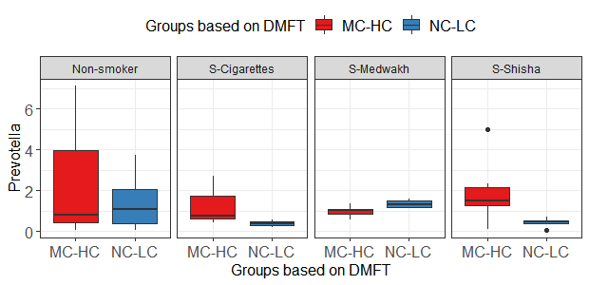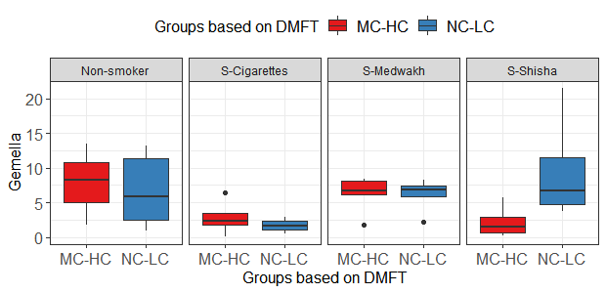
C D
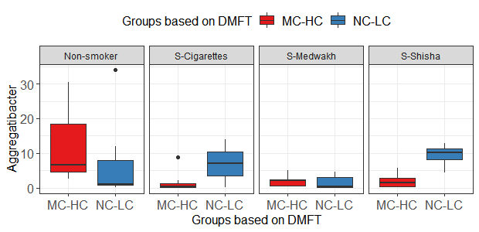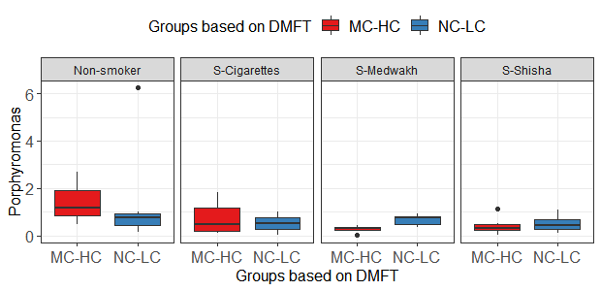
E F
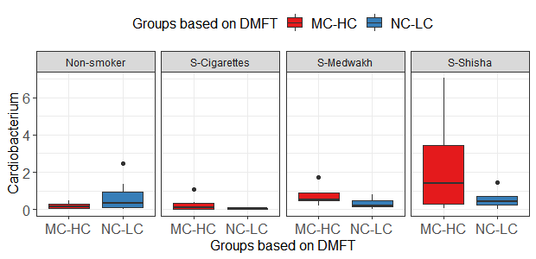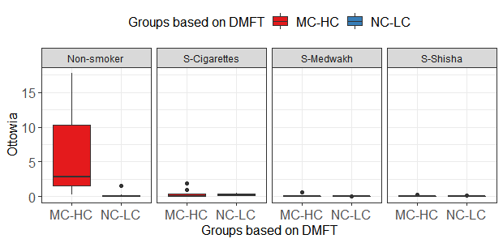

G E
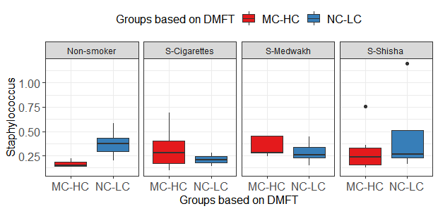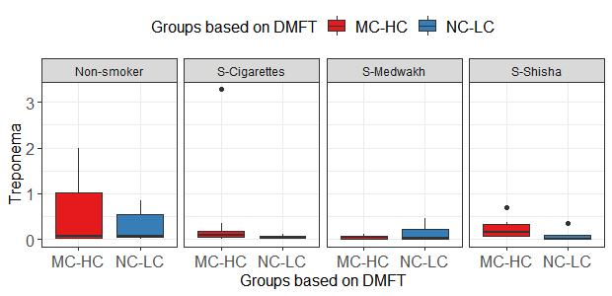
H I
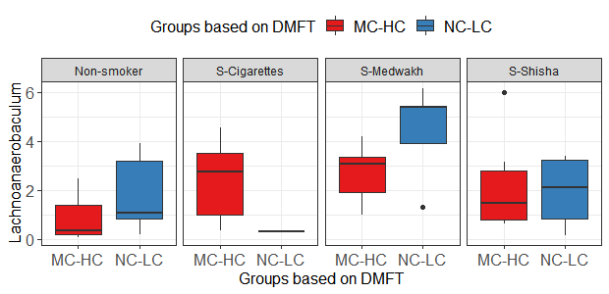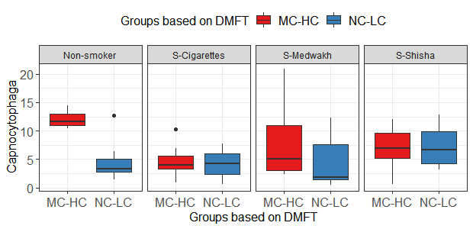
J K
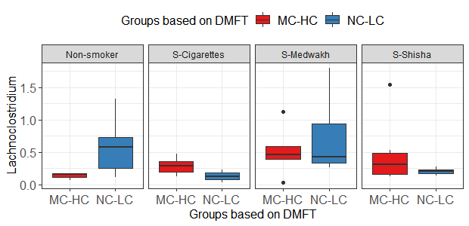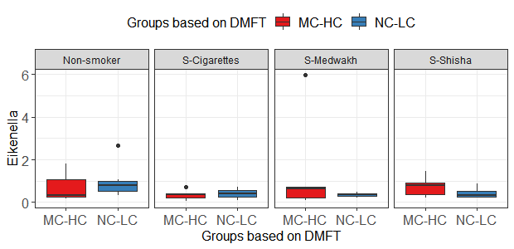
L M
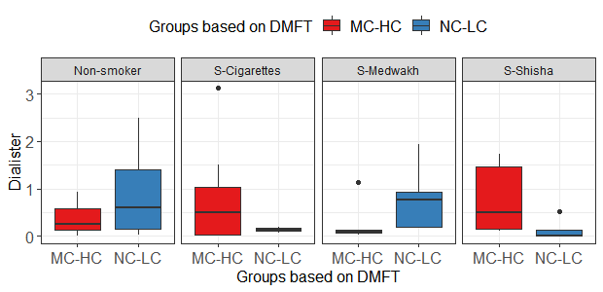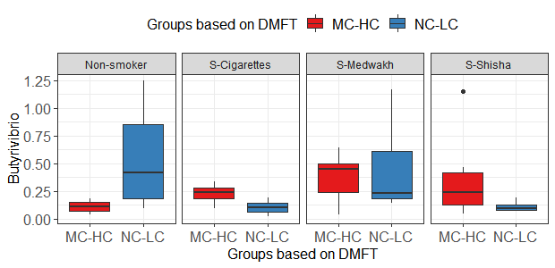
O P
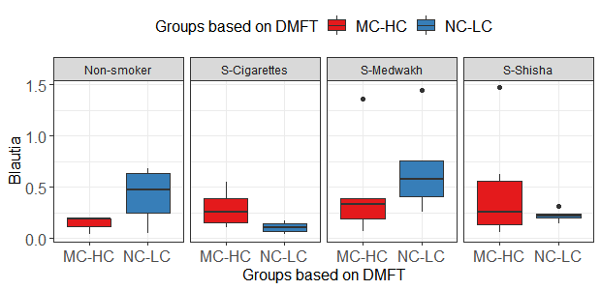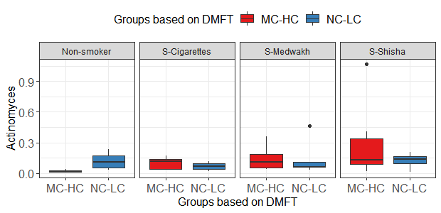

Supplementary Figure 2. Comparison of the relative abundance (%) of the major genera detected in the supragingival plaque samples; collected from subjects with no or low (NC-LC) caries and moderate-high (MC-HC) caries, in smokers of different types of tobacco and non-smokers. Box plots show Q1-median-Q3 with data range. Black dots are outlier values. Only the genera (n=16) that were significantly different between the study groups considering both smoking and caries are shown in the figure.

A
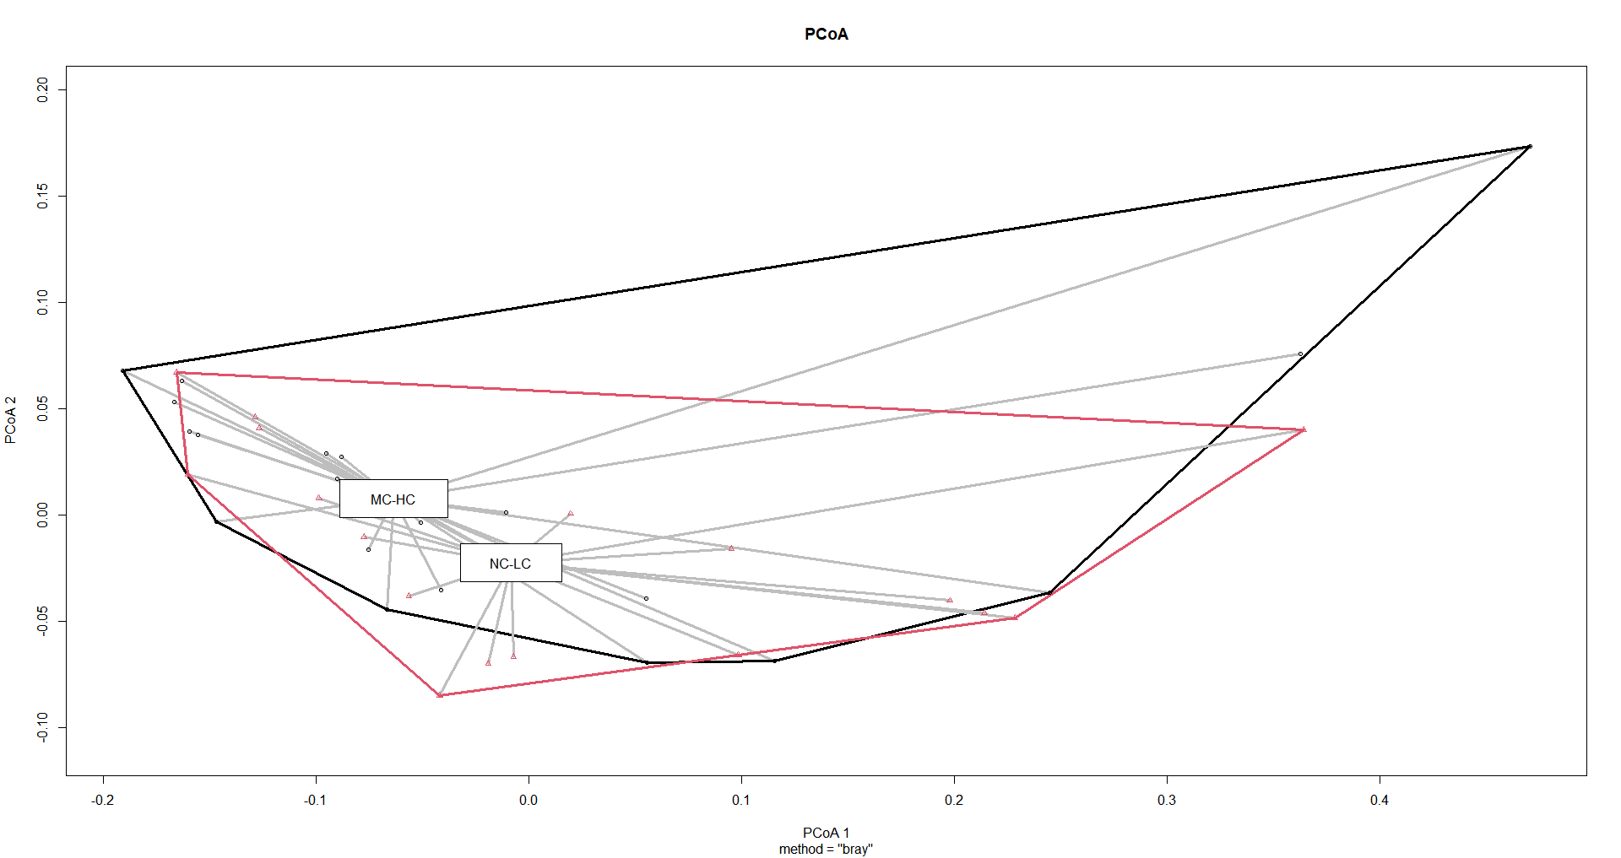

B
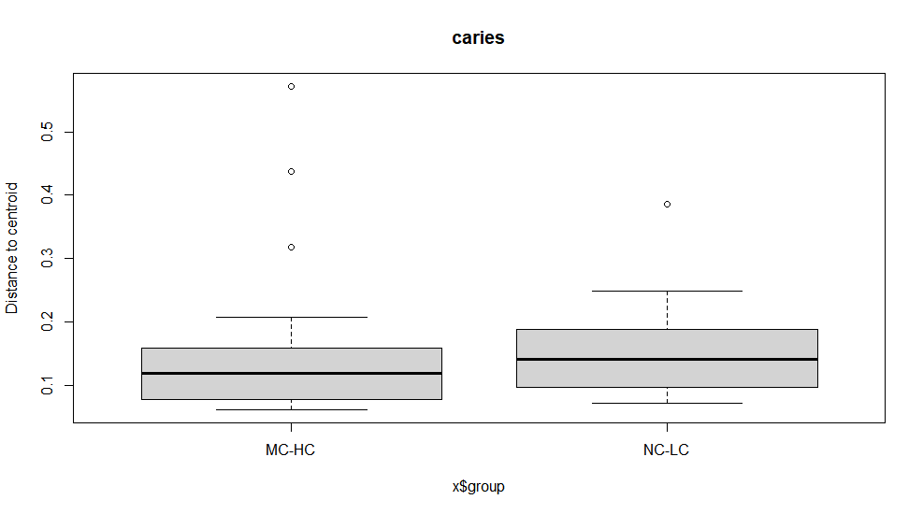

C
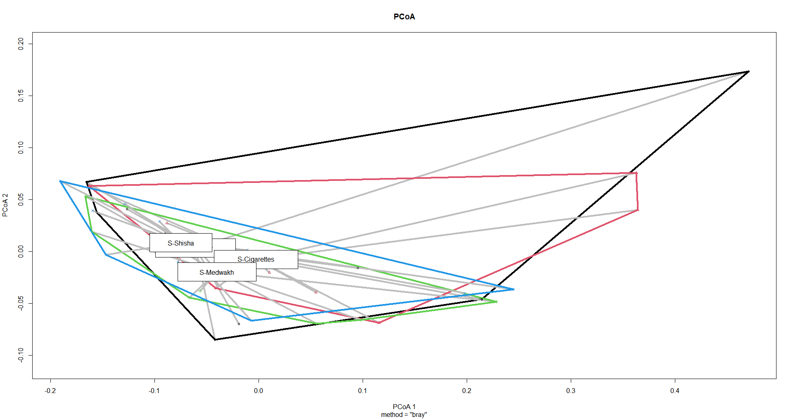

D
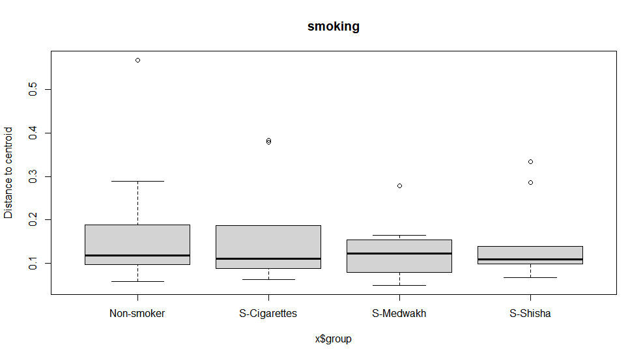
Supplementary Figure 3. Beta diversity measured using Bray Curtis index. The samples were clustered based on the index according to the dental caries (A-B) and tobacco smoking (C-D). No significant difference was found between the groups.

