Supplementary information for

Metagenomic insights into sulfate-reducing bacteria in a revegetated acidic mine wasteland

Jin-tian Li^{1,2,†}, Pu Jia^{1,†}, Xiao-juan Wang¹, Shi-wei Feng¹, Tao-tao Yang², Zhou Fang¹, Jun Liu², Bin Liao², Wen-sheng Shu¹, & Jie-Liang Liang^{1,}*

¹Institute of Ecological Science, Guangzhou Key Laboratory of Subtropical Biodiversity and Biomonitoring, Guangdong Provincial Key Laboratory of Biotechnology for Plant Development, School of Life Sciences, South China Normal University, Guangzhou 510631, PR China
²School of Life Sciences, Sun Yat-sen University, Guangzhou 510275, PR China

†These authors contributed equally to this work.

*Corresponding author:
School of Life Sciences, South China Normal University, Guangzhou 510631, PR China
E-mail: Jie-Liang Liang (liangjl@m.scnu.edu.cn)
Tel.: +86 20 85211850; Fax: +86 20 85211850

Supplementary Methods
Sequence alignment of DsrD and DsrT proteins
The DsrD and DsrT protein sequences identified in the genomic bins reported in this study were aligned along with the reference sequences respectively, using ClustalW with slow/accurate setting parameters (https://www.genome.jp/tools-bin/clustalw). The alignments were manual corrected and later visualized by ESPript 3.0 [1]. The conserved residues were highlighted.

Calculation of the average amino acid identity (AAI)
The AAI values between five genomes from Syntrophobacteraceae family were calculated by AAI calculator (http://enve-omics.ce.gatech.edu/aai/index) with default parameters. The reciprocal best hits (two-way AAI) between two genomic datasets of proteins were used for further comparisons.

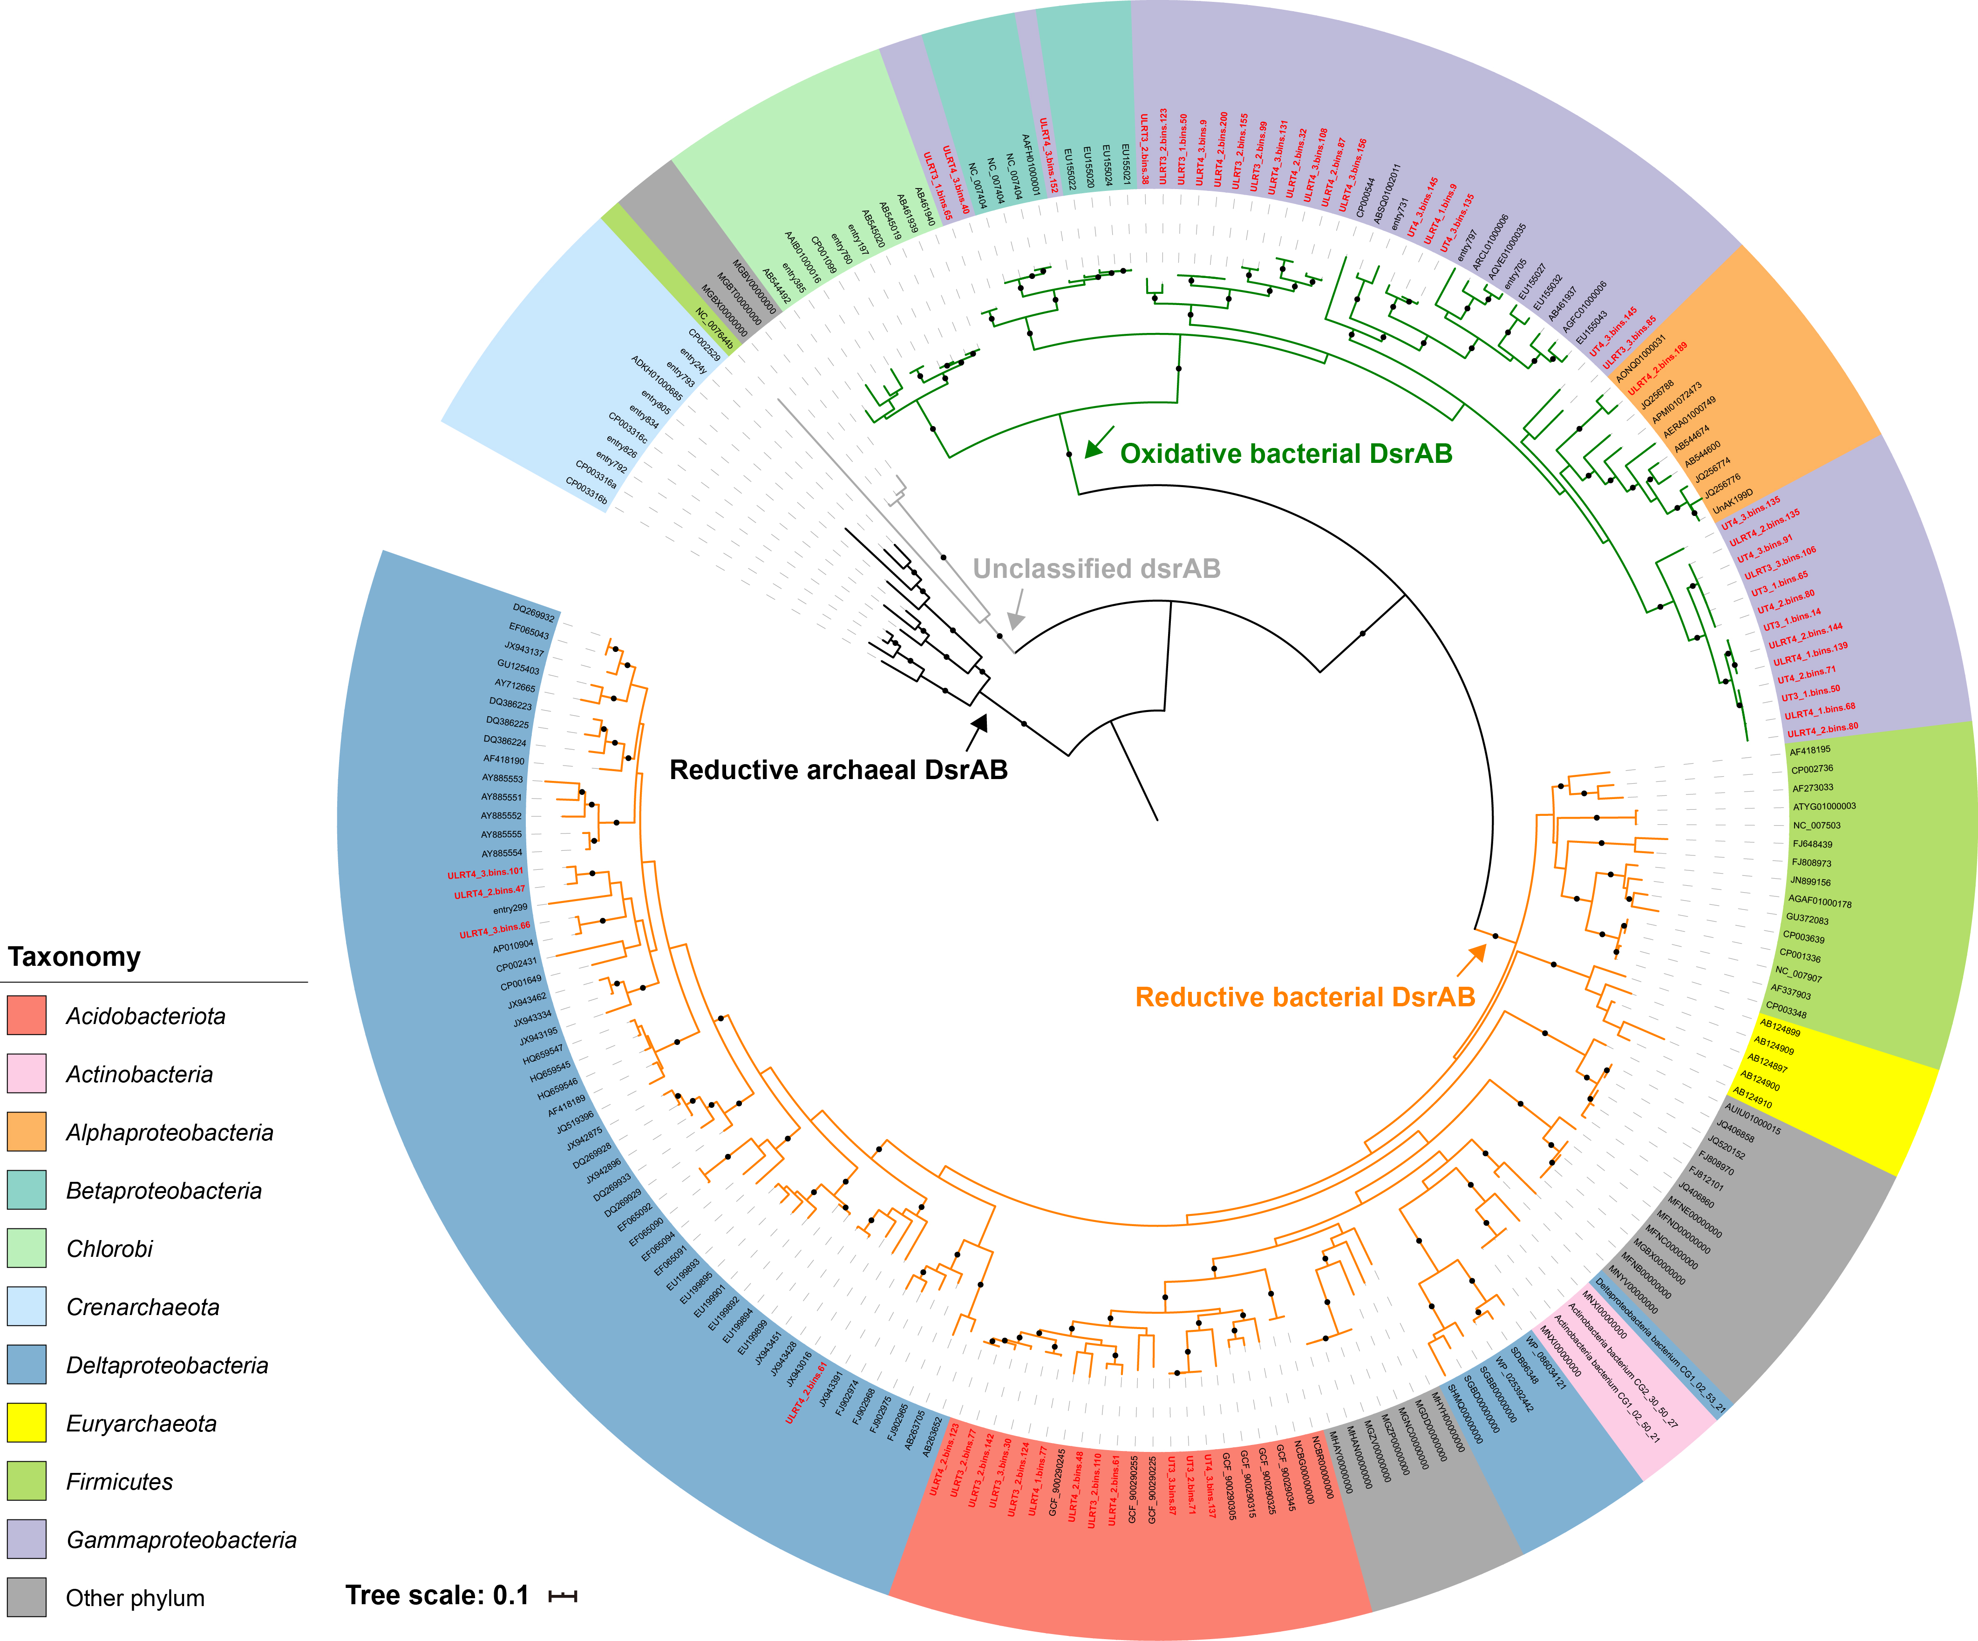

Figure S1. Phylogenic analysis of dissimilatory sulfite reductases DsrAB. Concatenated DsrAB protein sequences identified in this study are marked in bold red. Assignment of oxidative/reductive, bacterial/archaeal type DsrAB was according to previous studies [2, 3]. Bootstrap values were based on 100 replicates, and only bootstrap values higher than 70% are shown with black circles.

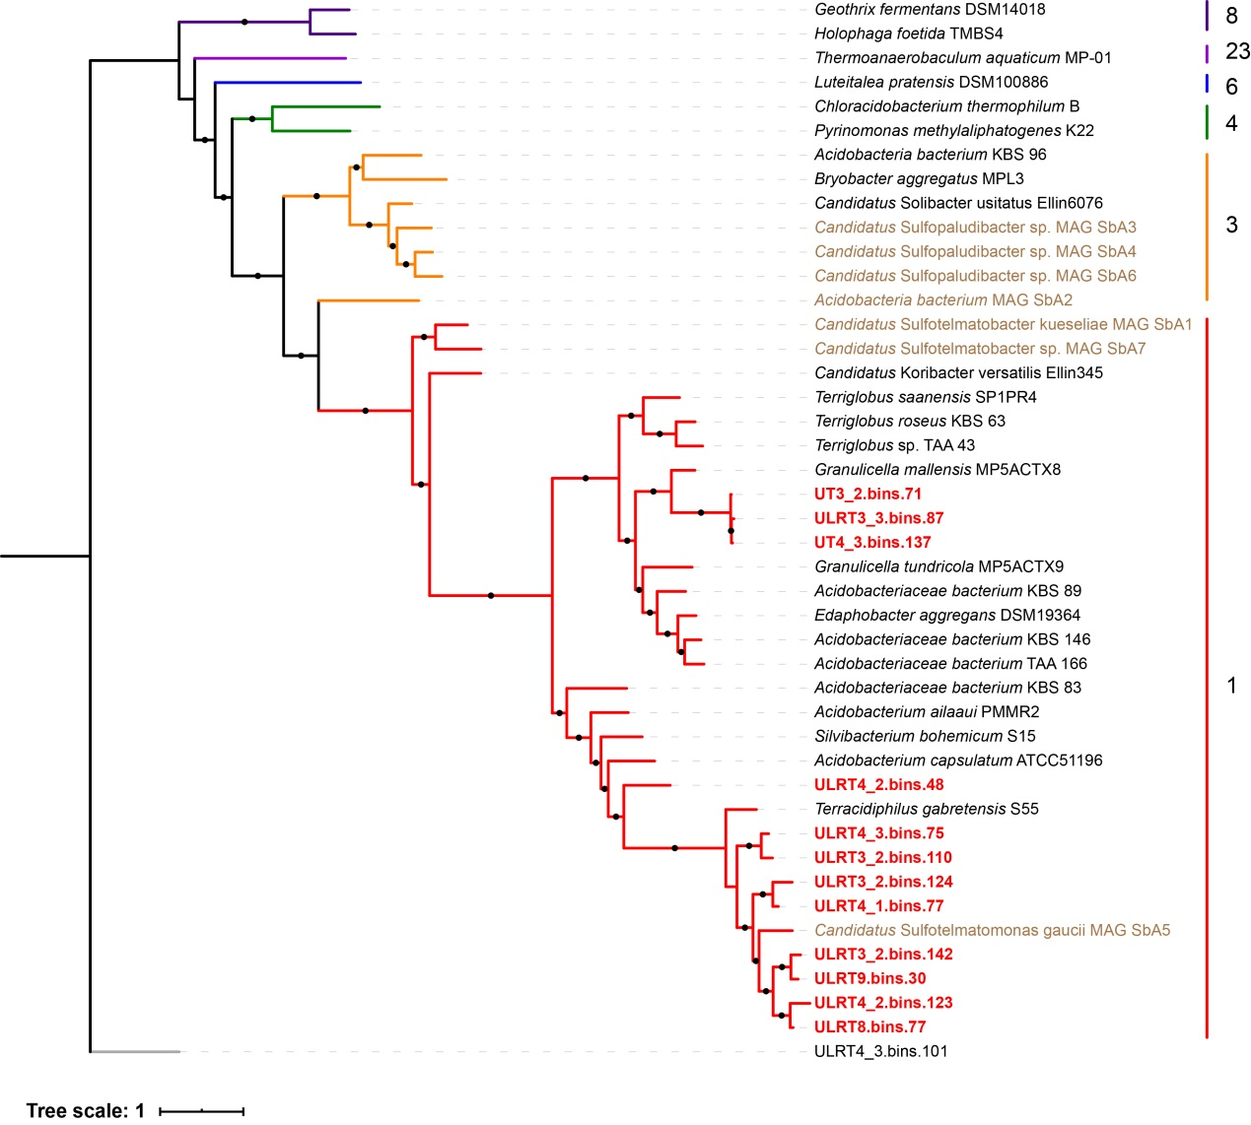

Figure S2. Phylogenic analysis of the genomes from Acidobacteria phylum. The maximum-likelihood phylogenetic tree was constructed based on a concatenated dataset of 400 universally conserved marker proteins using PhyloPhlAn. Subdivisions are indicated to the right of the tree. The 12 metagenome-assembled genomes (MAGs) harboring sequences of dsrAB genes reported in this study are marked in bold red. The 7 MAGs previously reported to have a dissimilatory sulfur metabolism potential are marked in brown. Bootstrap values were based on 100 replicates, and percentages higher than 70% are shown with black circles. The MAG (ULRT4_3.bins.101) from Deltaproteobacteria was used as an outgroup.

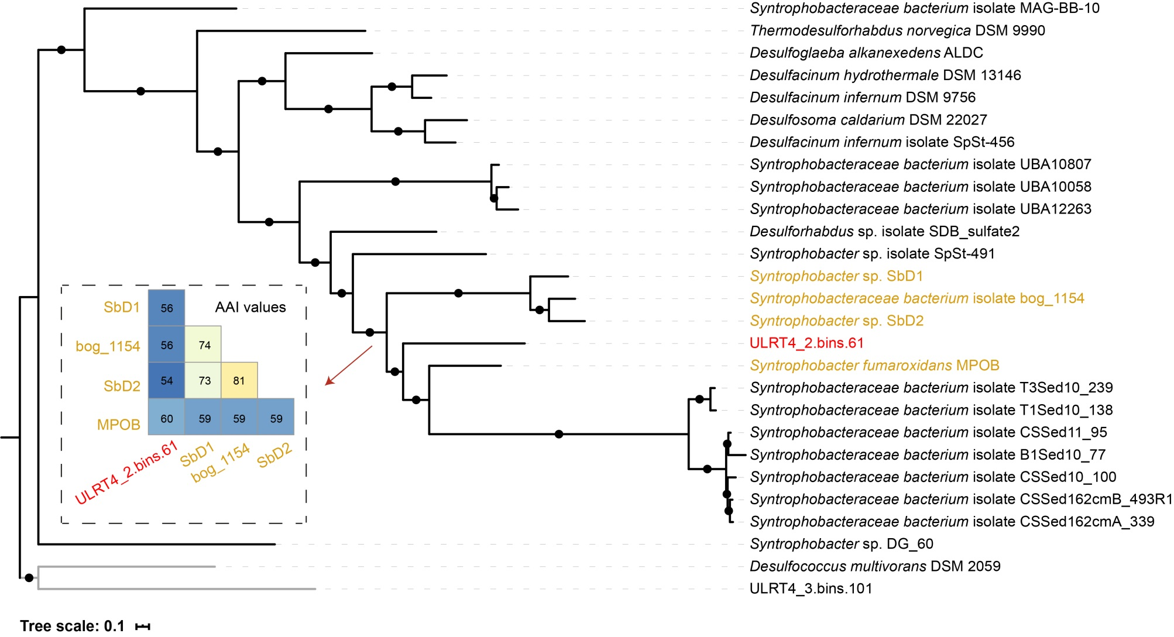
Figure S3. Phylogenic analysis of the genomes from Syntrophobacteraceae family. The maximum-likelihood phylogenetic tree was constructed using PhyloPhlAn. The dsrAB-containing MAG reported in this study is marked in bold red. The four reference genomes of the two closest genera to the MAG are marked in brown. The average amino acid identity (AAI) values between the 5 closest genomes are shown in the inset. Bootstrap values were based on 100 replicates, and percentages higher than 70% are shown with black circles. The genomes (ULRT4_3.bins.101 and Desulfococcus multivorans DSM 2059) from Deltaproteobacteria were used as the outgroup.

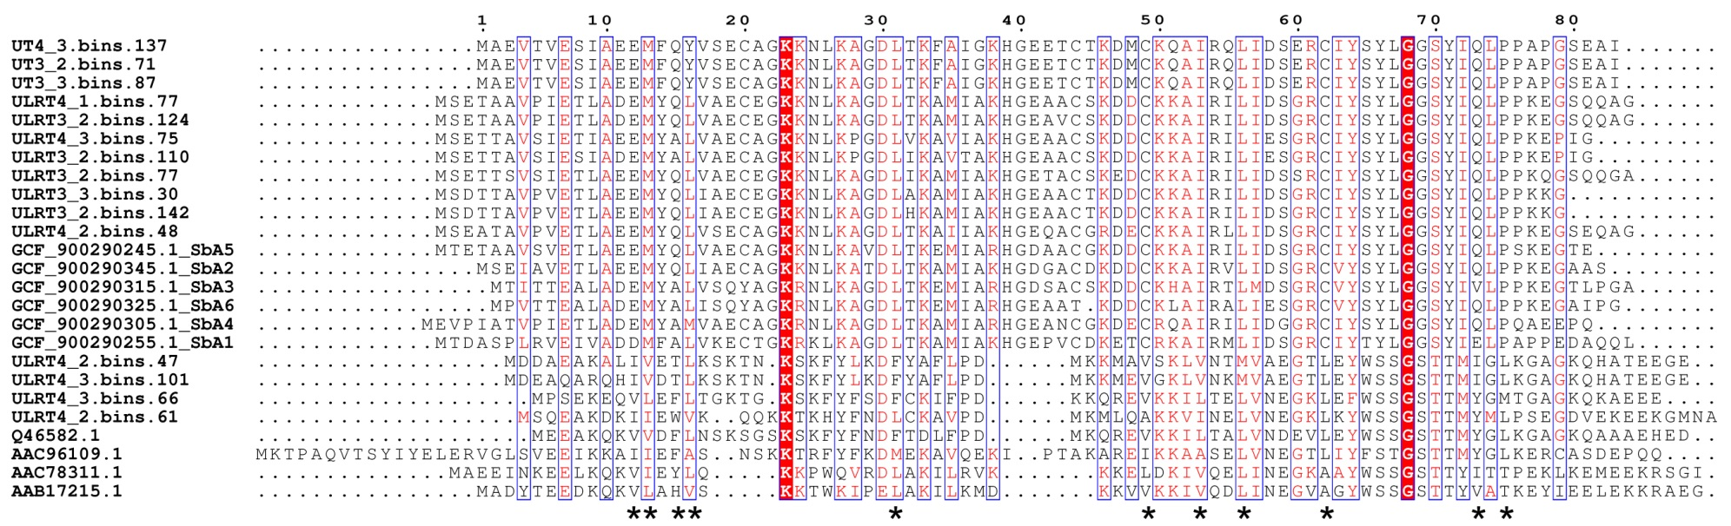
Figure S4. Sequence alignment of DsrD proteins identified in this study with reference sequences. Positions of conserved, hydrophobic residues in the DsrD family are marked with asterisks [4]. Highly conserved residues of the same type are highlighted in red background.

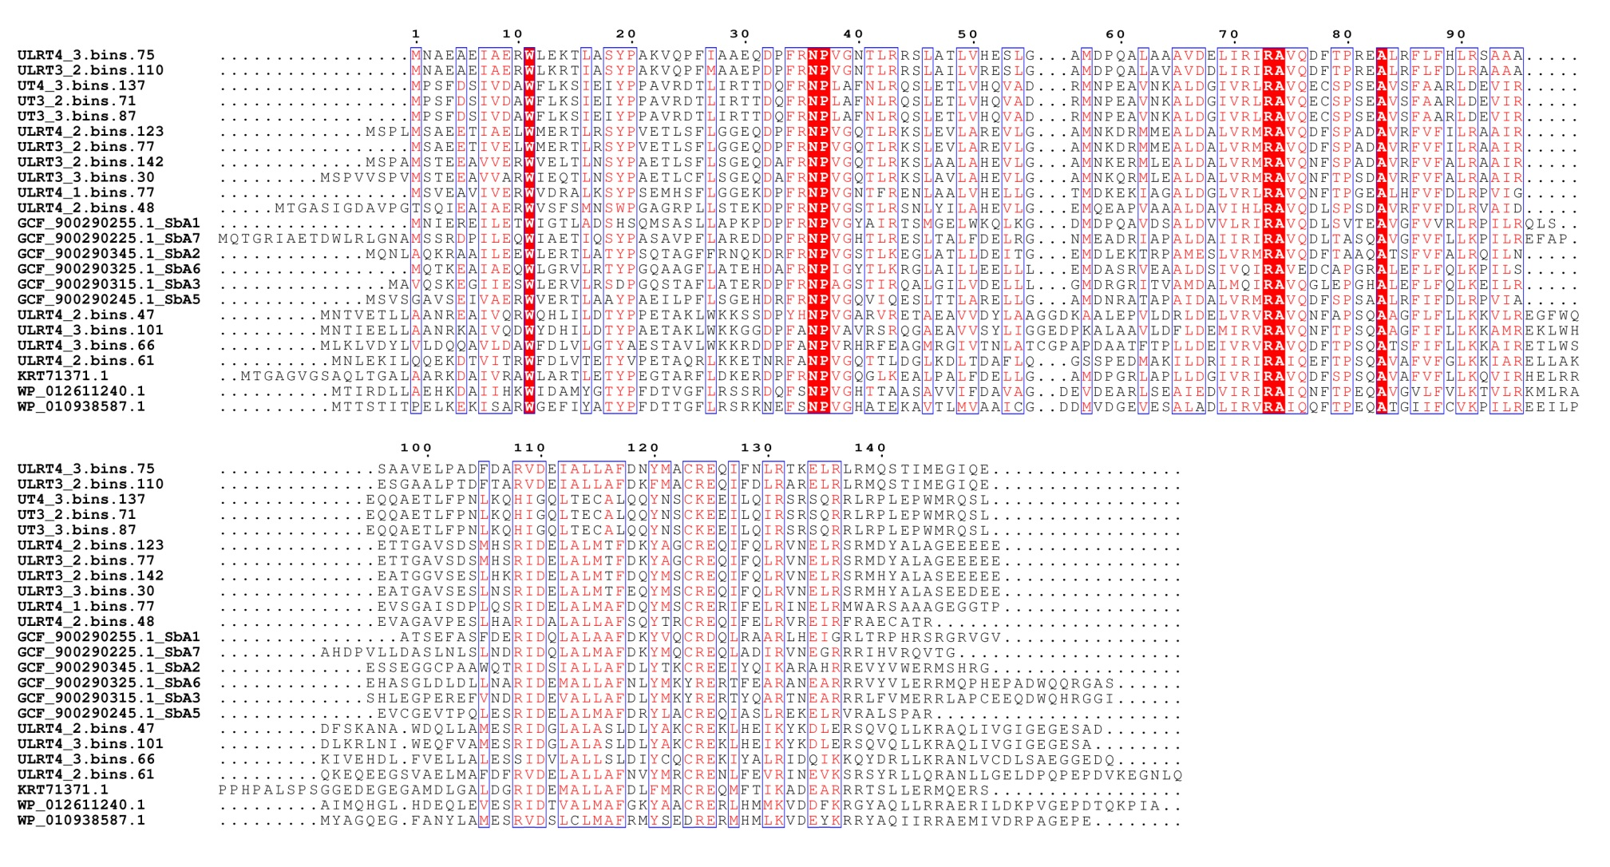
Figure S5. Sequence alignment of DsrT proteins identified in this study with reference sequences. Highly conserved residues of the same type are highlighted in red background.
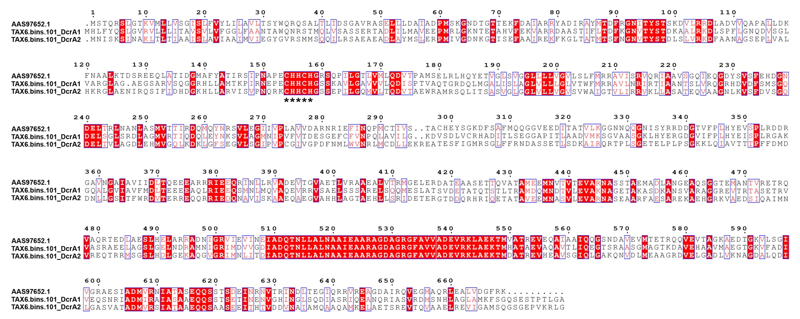
Figure S6. Sequence alignment of DcrA proteins identified in this study with reference sequence DcrA identified in Desulfovibrio vulgaris str. Hildenborough. Specific sequences, CHHCH, corresponding to a consensus c-type heme-binding site are marked with asterisks [5]. Highly conserved residues of the same type are highlighted in red background.

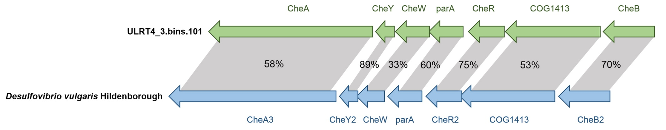
Figure S7. Operons encoding the cheA chemotaxis gene in ULRT4_3.bins.101 and D. vulgaris [6]. Arrows represented the coding regions. The percentages in grey shadings indicated sequence similarities.

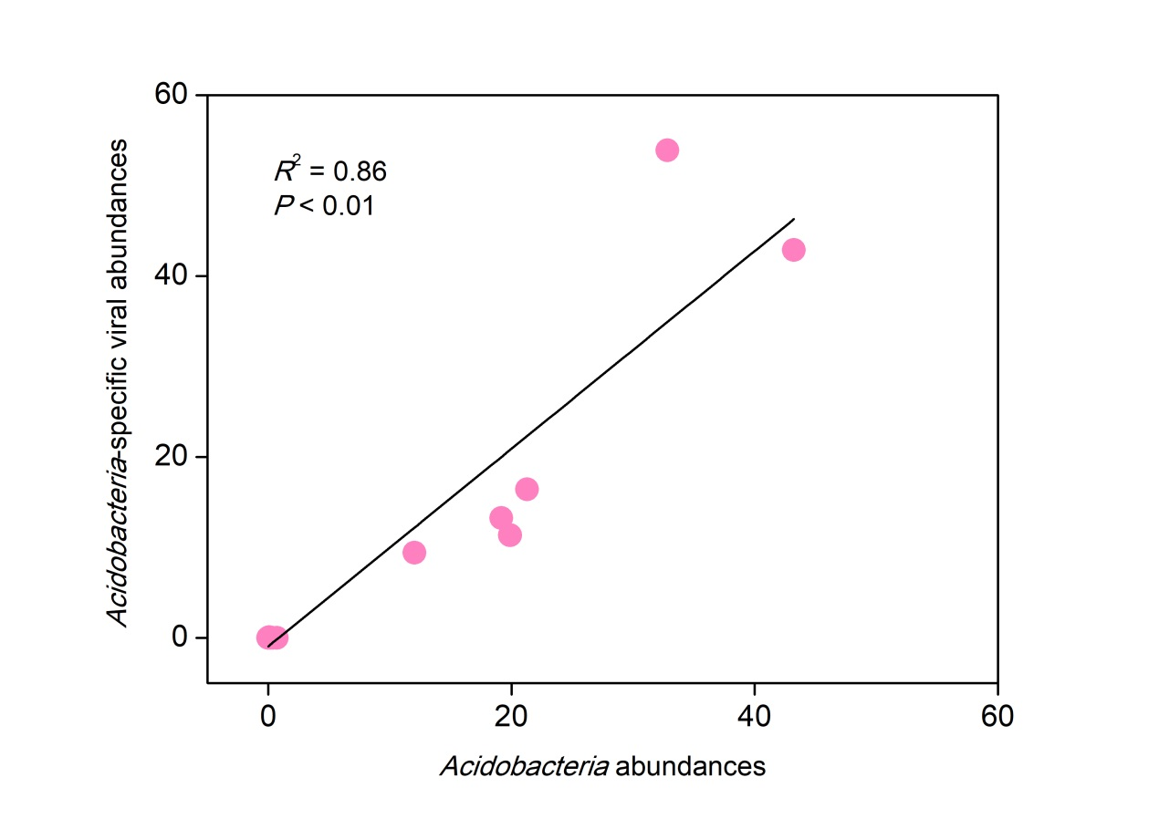
Figure S8. Virus/host abundance ratio for Acidobacteria with a dissimilatory sulphur metabolism. Acidobacteria abundance and the abundance of their viruses (both calculated as the mean coverage depth from reads mapping, normalized by the number of reads in each metagenomic dataset) are plotted for each sample. Pearson correlation analysis was used to correlate the host and viral abundances.

Supplementary References
1. Robert X, Gouet P. Deciphering key features in protein structures with the new ENDscript server. Nucleic Acids Res. 2014;42(W1):W320–4.
2. Müller AL, Kjeldsen KU, Rattei T, Pester M, Loy A. Phylogenetic and environmental diversity of DsrAB-type dissimilatory (bi)sulfite reductases. ISME J. 2015;9(5):1152–65.
3. Anantharaman K, Hausmann B, Jungbluth SP, Kantor RS, Lavy A, Warren LA, et al. Expanded diversity of microbial groups that shape the dissimilatory sulfur cycle. ISME J. 2018;12(7):1715–28.
4. Mizuno N, Voordouw G, Miki K, Sarai A, Higuchi Y. Crystal structure of dissimilatory sulfite reductase D (DsrD) protein–possible interaction with B- and Z-DNA by its winged-helix motif. Structure. 2003;11(9):1133–40.
5. Fu R, Wall JD, Voordouw G. DcrA, a c-Type Heme-containing methyl-accepting protein from Desulfovibrio vulgaris Hildenborough, senses the oxygen concentration or redox potential of the environment. J Bacteriol. 1994;176(2):344–50.
6. Ray J, Keller KL, Catena M, Juba TR, Zemla M, Rajeev L, et al. Exploring the role of CheA3 in Desulfovibrio vulgaris Hildenborough motility. Front Microbiol. 2014;5:77.

