Facile synthesis of crosslinked Cu:ZnS-lignocellulose nanocomposite: a potent antifungal and antisporulant system against the tea pathogen Exobasidium vexans
Chayanika Chaliha¹, Julie Baruah^{1, 2}, Eeshan Kalita^{1,3*}
¹Department of Molecular Biology and Biotechnology, Tezpur University, Tezpur, India, 784028
²Department of Chemical Sciences, Tezpur University, Tezpur, India. 784028
³Department of Molecular Biology and Biotechnology, Cotton University, Guwahati, India, 781001
*Corresponding author
Dr. Eeshan Kalita
eeshankalita@gmail.com

Table S1. Elemental composition of 2 h variant from XPS analysis
Element | Atomic %  Cu:ZnS-lignocellulose
C | 31.54
O | 51.24
S | 6.02
Cu | 7.19
Zn | 4

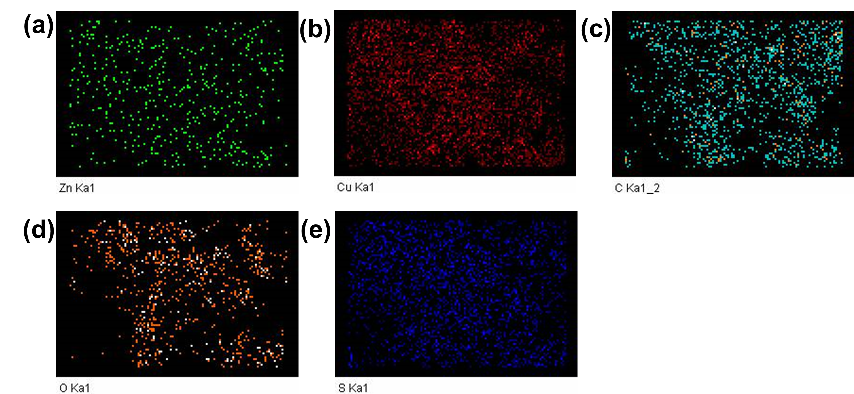
Fig. S1. Pseudo-colour elemental distribution maps of 2 h variant of Cu:ZnS-lignocellulose nanomatrix (a-e).

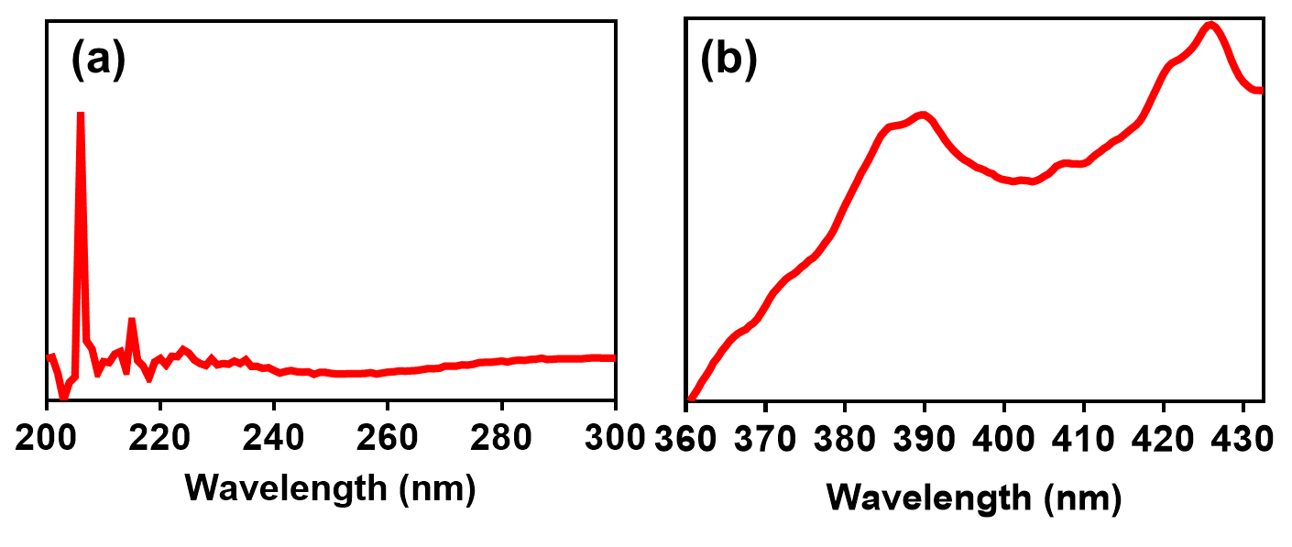
Fig. S2. UV–vis absorption spectra (a) and PL spectra (b) of 2 h variant of Cu:ZnS-lignocellulose nanomatrix

