Supplementary Information for

Sub-thermionic, ultra-high-gain organic transistors and circuits

Zhongzhong Luo^{1,10}, Boyu Peng^{2,10}, Junpeng Zeng^{1,10}, Zhihao Yu^{1,3,10}, Ying Zhao⁴, Jun Xie⁵, Longfang Lan⁵, Zhong Ma¹, Lijia Pan¹, Ke Cao⁶, Yang Lu⁶, Daowei He¹, Hongkai Ning¹, Wanqing Meng¹, Yang Yang¹, Xiaoqing Chen¹, Weisheng Li¹, Jiawei Wang⁴, Danfeng Pan¹, Xuecou Tu¹, Wenxing Huo⁷, Xian Huang⁷, Dongquan Shi⁸, Ling Li⁴, Ming Liu⁴, Yi Shi¹, Xue Feng⁹, Paddy. K. L. Chan^{2*}, Xinran Wang^{1*}
*Correspondence to: xrwang@nju.edu.cn, pklc@hku.hk

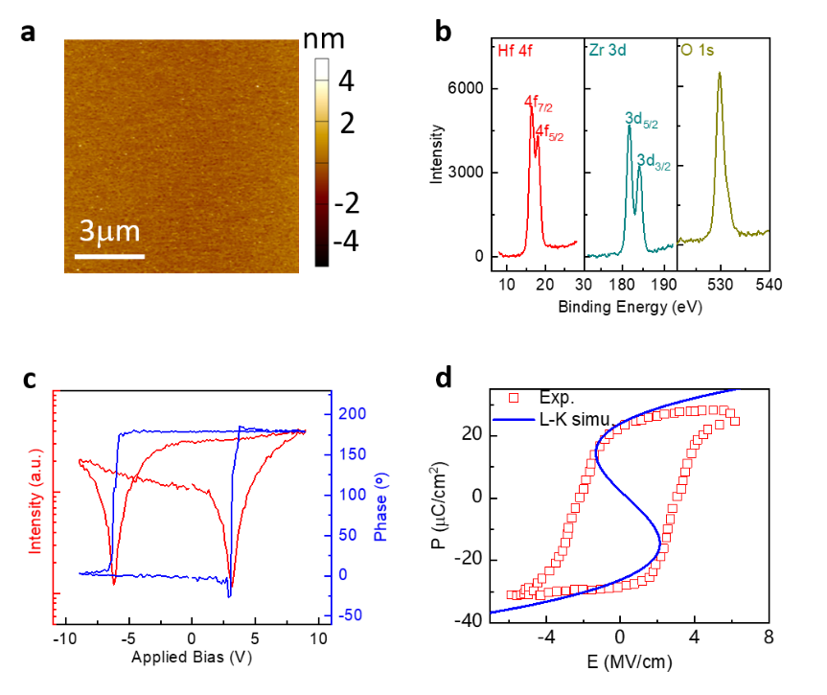

Supplementary Figure 1| Characterization of HZO dielectric. a, AFM image and b, XPS of the HZO film on Si substrate. The composition of Hf:Zr = 1:0.95. c, Single-point PFM characterization showing ferroelectric behavior of HZO. d, The experiment Polarization-electric field loop of Si/ 22 nm HZO/Au stack showing hysteretic behavior (red square). The blue line is the fitting curve using the L-K equation to extract the Landau coefficients.

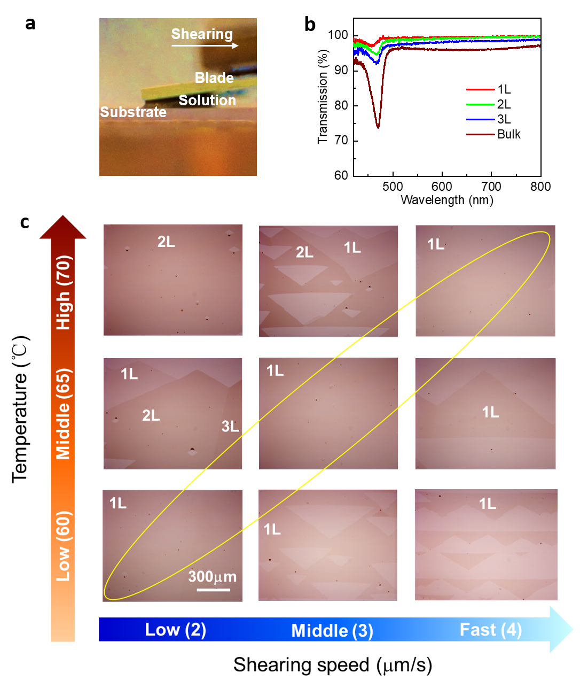

Supplementary Figure 2| Solution shearing of C₁₀-DNTT films. a, Photograph of the shearing process. b, Transmission spectra of C₁₀-DNTT films at different number of layers. c, The film morphology depends on the substrate temperature and shearing speed. By optimizing the growth condition, uniform and large area monolayer could be realized.

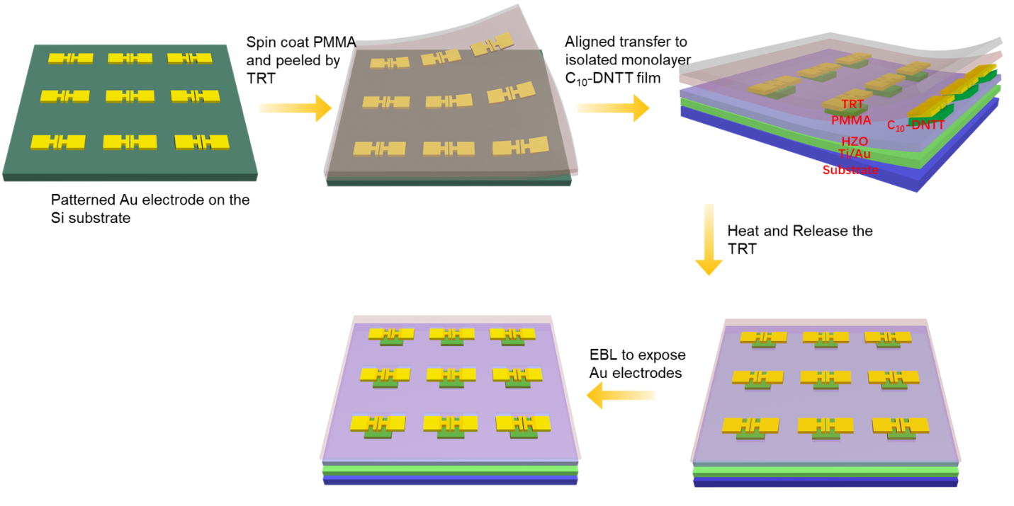

Supplementary Figure 3| Schematic illustration of vdW fabrication process for sub-thermionic OTFTs array.
- Fabricate the patterned Au electrode on the Si substrate using EBL and EBE;
- Spin coat PMMA and then peel the electrode and PMMA using thermal released tape (TRT);
- Aligned transfer to patterned monolayer C₁₀-DNTT film;
- Heat at 90 ℃ to release the TRT;
- Perform EBL to pattern the PMMA to expose Au electrodes;

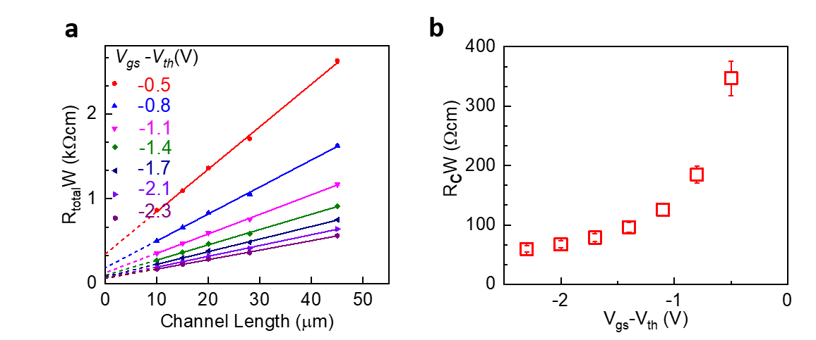

Supplementary Figure 4| Contact resistance measurement. a, Linear fits to the total width-normalized resistance (R_{total}W) at different gate overdrive voltages. b, Width-normalized contact resistance (R_{C}W) plotted as a function of the gate-overdrive voltage.

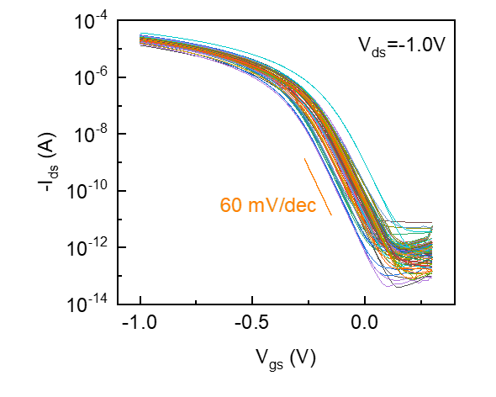

Supplementary Figure 5| Transfer characteristics of 50 sub-thermionic monolayer OTFTs.

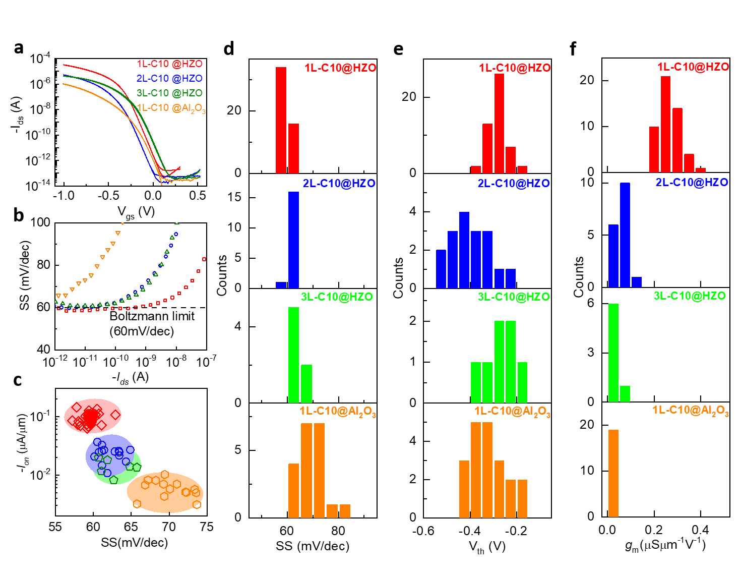

Supplementary Figure 6| Thickness and substrate dependence of the OTFTs. a, I_{ds}-V_{gs} characteristics of typical monolayer, bi-layer and tri-layer C₁₀-DNTT OTFTs on 22 nm HZO/2 nm Al₂O₃ as well as monolayer C₁₀-DNTT OTFT on 24 nm Al₂O₃ under V_{ds} = -1 V. b, SS versus I_{ds} characteristics of the devices in a. c, Statistical analysis of I_{on} vs SS for monolayer (red), bi-layer (blue) and tri-layer (green) C₁₀-DNTT OTFTs on 22 nm HZO/ 2nm Al₂O₃ as well as monolayer C₁₀-DNTT OTFTs on 24 nm Al₂O₃ (orange). I_{on} is defined as the current at |V_{ds}| = |V_{gs(on)}-V_{gs(off)}| = 1 V. Statistical distribution of SS (d), V_{th} (e) and normalized $g_{m}$ (f) for different thickness and substrates.

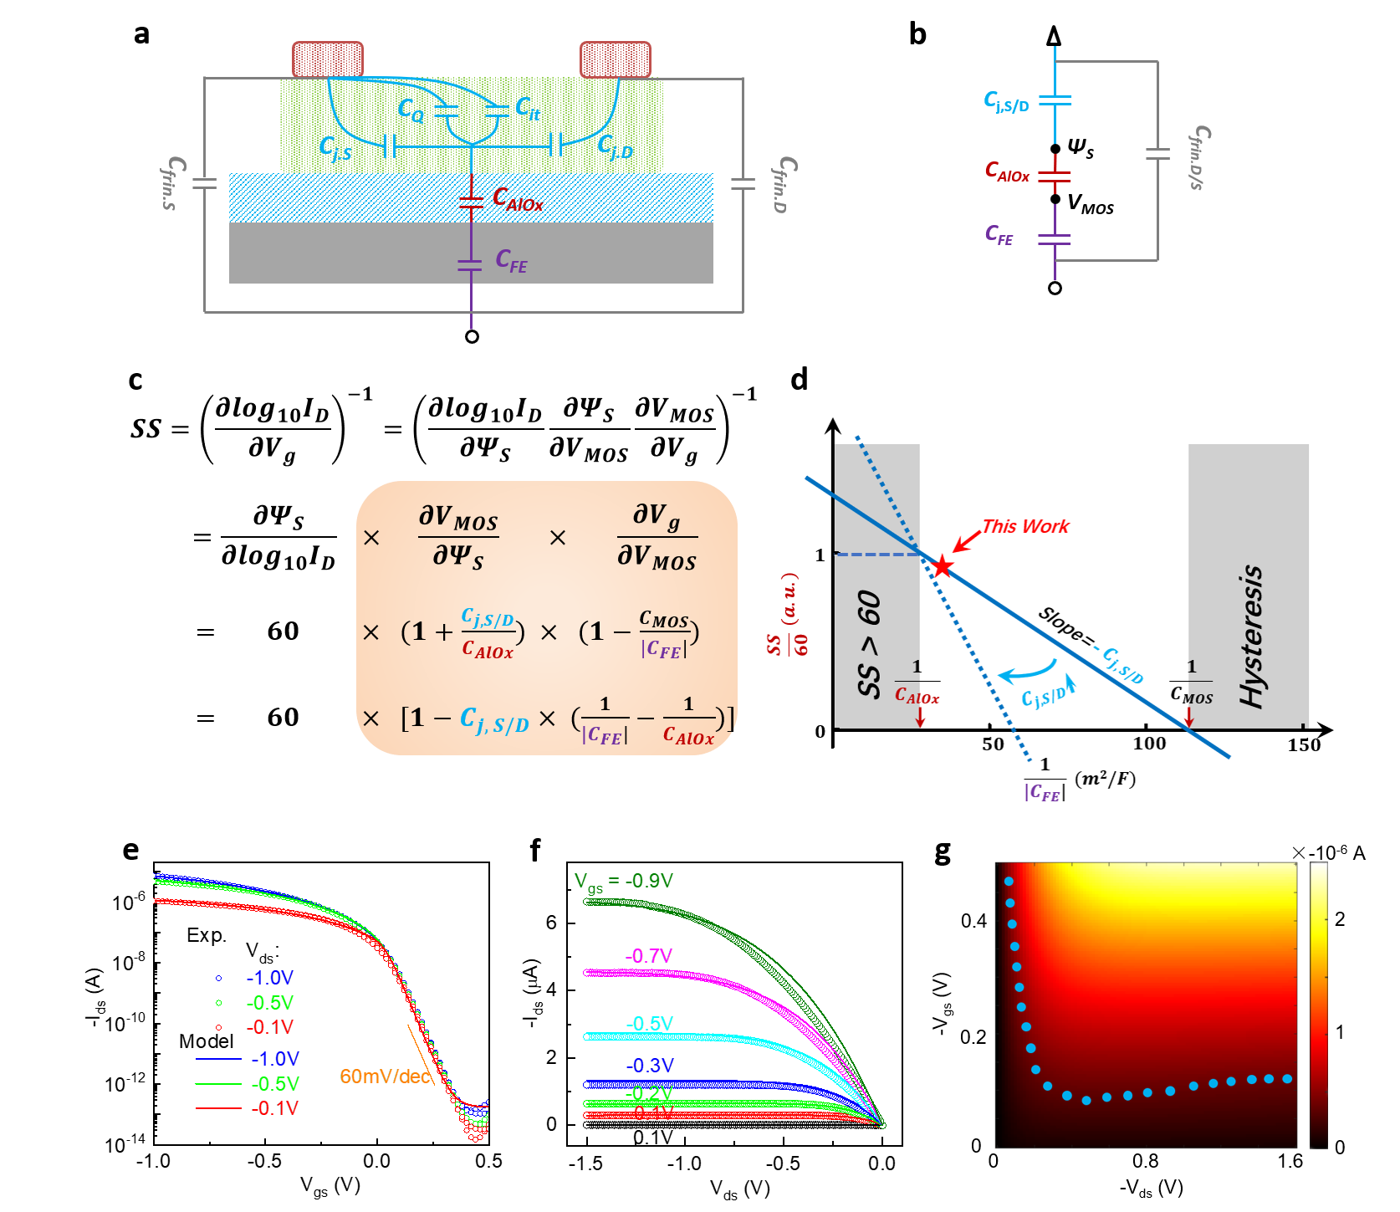

Supplementary Figure 7| Device model of sub-thermionic monolayer OTFT. a, Capacitors network and b, simplified small-signal model of sub-thermionic OTFTs. c, Formulating SS by decoupling the electrostatics and transport contributions. d, Graphical display of the dependence of SS on capacitance. The region of $\frac{1}{C_{AlOx}}<\frac{1}{|C_{FE}|}<\frac{1}{C_{MOS}}$ is the design space for capacitance matching, where SS < 60 mV/dec without hysteresis. In the left shade region ($\frac{1}{|C_{FE}|}<\frac{1}{C_{AlOx}}$), SS > 60 mv/dec. In the right shade region ($\frac{1}{|C_{FE}|}>\frac{1}{C_{MOS}}$), SS < 0, hysteresis appears. The dashed line illustrates the ultra-small window for capacitance matching, when the C_{j,S/D} increases. e,f, Experimental transfer and output characteristics (symbols) and the model fitting result (solid line). The model successfully reproduces the experimental data. g, Calculated output curves at different V_{gs} and the blue points are I_{ds} = -0.5 μA, showing negative to positive differential resistance crossover, which is responsible for the very large r₀.

The ferroelectric (FE) properties of HZO can be described as double-well energy landscape by the Landau Khalatnikov (L-K) equation. According to the L-K equation, in the interval between coercive fields, the value of differential capacitance C_{FE} is the negative, which is also metastable state regime. Through proper capacitance matching, we can stabilize the metastable negative capacitance (NC) range, and the NC effect can be used to realize sub-thermionic transport. The Landau coefficients can be extracted by fitting the experimental P-E curve of HZO ferroelectric capacitor to calculate the ferroelectric capacitance C_{FE}. Figure. S1D shows the best fitting results through L-K equation with $α=-7.7×{10}^{8} m/F$ and $β=2.8×{10}^{9} m^{5}/(F {coul}^{2})$, and the corresponding $c_{FE}≈\frac{1}{2αt_{FE}}=-2.8 μF/{cm}^{2}$.
We extend the model in Ref. 1 for quantitative analysis and modify a physical based NC-FET analytical model² for our 2D organic monolayer structure, incorporating the multi-domain L-K theory with the domain interaction term, polarization relaxation and semi-classical Boltzmann transport theory. To predict the characteristics of the sub-thermionic OTFT and understand more details of the mechanisms, we depict all relevant capacitors in our back-gate sub-thermionic OTFT in Supplementary Fig. 7a. C_{FE} and C_{AlOx} are the capacitance of HZO layer and Al₂O₃ layer, respectively. C_{Q}, C_{it}, and C_{j,S/D} represent quantum capacitance (negligible in subthreshold regime of OTFT), interface trap induced capacitance (negligible due to the small value), and capacitance of Schottky junction under source/drain electrodes, respectively. Therefore, $C_{j, S/D}=\frac{ε_{O}}{t_{j}}$ (where $ε_{O}$ is dielectric constant of organic layer, which is about 3³, and $t_{j}$ is thickness of Schottky junction⁴) is the dominant capacitance in the channel region. Due to the low doping concentration of the ultra-thin channel, $t_{j}$ is close to the monolayer molecular thickness of 4 nm, and the corresponding $C_{j, S/D}=6×{10}^{-7} F/{cm}^{2}$. In addition, C_{AlOx} is measured to be $3.6×{10}^{-6} F/{cm}^{2}.$ Supplementary Fig. 7b plots the simplified small-signal model of sub-thermionic OTFTs. It is worth noting that source/drain-to-gate fringing capacitance C_{frin} is connected in parallel outside the capacitor network that modifies channel charges, and does not contribute to capacitor matching. Based on the analytical model in Supplementary Fig. 7c, we can plot the relationship of SS versus 1/|C_{FE}| in Supplementary Fig. 7d. To satisfy non-hysteretic conditions, 1/|C_{FE}| need to be smaller than 1/C_{MOS} (1/C_{MOS} = 1/C_{j,S/D} +1/C_{AlOx}), while to maintain SS < 60mV/dec, 1/|C_{FE}| need to be greater than 1/C_{AlOx}. |C_{FE} | in the optimal NC-FET should fall between C_{AlOx} and C_{MOS.} Therefore, as shown in Supplementary Fig. 7d, reduced C_{j,S/D} will enlarge the |C_{FE}| design space significantly. Meanwhile, small C_{j,S/D} appears as smaller slope in Supplementary Fig. 7d, which will make it more difficult to reduce SS because extremely thick ferroelectric will be needed.
It is essential to extract the key parameters using capacitor network above in real device after setting up the whole physical model of sub-thermionic OTFT, to guarantee the reasonable values. The surface potential $φ_{s}$ is the clue of the whole model, obtained by solving the voltage balance condition equation in the vertical direction of sub-thermionic OTFT via the special method ². The voltage across the FE layer, $V_{FE}$, is obtained by L-K theory, as Eq. (1).
$V_{FE}=$ ($2αQ_{G}+4β{Q_{G}}^{3}-4π\frac{1}{t_{fe}}\int_{0}^{t_{fe}}{Q_{G}dy}+4πjQ_{G}-\frac{1}{2}K_{P}\frac{d^{2}Q_{G}}{dx^{2}}$)$t_{fe}$ (1)
The relationship for $V_{FE}$and $P$ in the Landau theory is a cubic function. $α$ and $β$ can be obtained via the two poles. The third and fourth items in the right part of Eq. (1) represents depolarization field⁵ and the last one is multi-domain interaction item⁶, both of which modulated severely the negative differential conductance (NDC) effect and well considered as the most possible reason of NC effect. $α$ and $β$ are the Landau coefficients relating to remnant polarization and coercive field. $t_{fe}$ is the thickness of FE layer, and $j, K_{P}$ are the depolarization and domain interaction coefficients. The gate charge $Q_{G}$, which is obtained by the Poisson Equation and modified as areal density for monolayer C₁₀-DNTT, is equivalent to Polarization $P$ when the effect of multi-domain, depolarization has already incorporated as the extra items.
Based on the continuity equation, I-V characteristics can be established. The Current at any position in the channel comprising of drift and diffusion components is given by Eq (2)-Eq (3), with mobility model considering the scattering mechanisms and temperature dependence⁷ in Eq (4).
$I_{drift}=\frac{μW}{L} γ \frac{2}{3}\left[φ_{ss}^{3/2}-φ_{sd}^{3/2}\right]+\frac{μW}{L}{\left[\frac{1}{2}\left(α+1/{C_{AlOx}}\right){Q_{g}}^{2}\left(φ_{s}\right)+\frac{3}{4}β{Q_{g}}^{4}(φ_{s})\right]}_{φ_{sd}}^{φ_{ss}}$ (2)
$I_{diffusion}=\frac{μW}{L}φ_{t}\left[Q_{i}\left(φ_{ss}\right)-Q_{i}\left(φ_{sd}\right)\right]$ (3)
$μ=μ_{0}{\left\{\left(1+U_{a}E_{eff}^{\frac{1}{3}}\right){\left(\frac{T}{300}\right)}^{\frac{3}{2}}+U_{b}{\left(\frac{T}{300}\right)}^{-\frac{1}{2}}E_{eff}^{2}\left(1+U_{k_{1}}V_{bs}\right)\right\}}^{-1}$ (4)
The parameter $γ$ including some intrinsic parameters like permittivity, unit charge, body factor. $W$, $L$ and $C_{AlOx}$ are the width, length of channel and capacitances of Al₂O₃ layer, respectively. $φ_{t}$ is the thermal voltage and $E_{eff}$ is the effective average transverse electric field in channel, $μ_{0}$ is the originate mobility, while $U_{a}$, $U_{b}$ and $U_{k_{1}}$are the Semi-fitting parameters representing the strengthen of scattering mechanism.
The current equation can be simplified in linear region, and the originate mobility $μ_{0}$ and other parameters like $U_{b}$ can be extracted from the experimental data. An accurate match between prediction results of the model and experimental data for transfer (in linear and log coordinates) and output characteristics are given in Supplementary Fig. 7e,f, via fine tuning the value of parameters in a reasonable tiny range. Supplementary Fig. 7g plots a mapping diagram of simulated I_{ds} versus V_{ds} and V_{gs}, where the blue points are I_{ds} = -0.5 μA, and the NDC can be clearly captured.

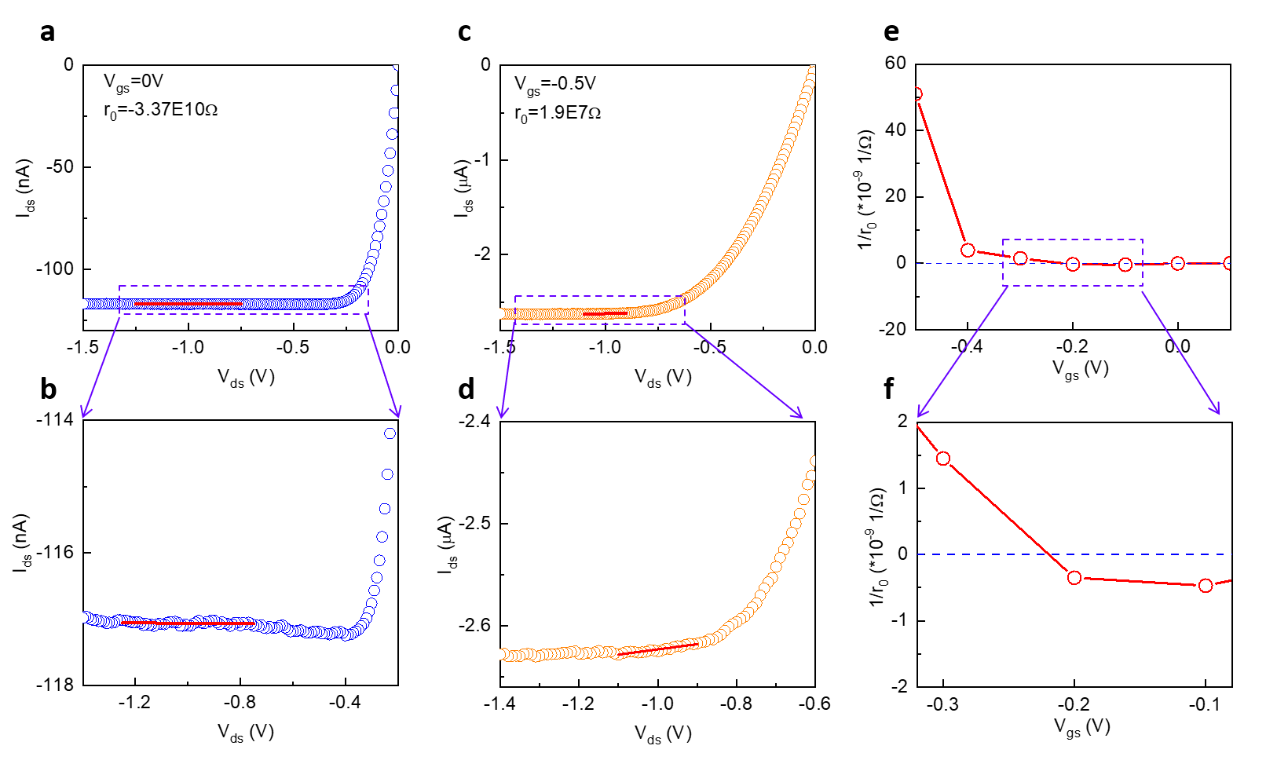

Supplementary Figure 8| Output resistance of the sub-thermionic OTFTs. a-d, Output characteristics at V_{gs} = 0 and -0.5 V of a sub-thermionic OTFT. When V_{gs} = 0 V, the negative differential resistance (NDR) phenomenon appears and the output resistance is negative; when V_{gs} = -0.5 V, the NDR disappears and the output resistance is positive. The red curve is the linear fitting to extract the output resistance. e, Output resistance as a function of V_{gs}. f, Zoom-in of the curve in e, showing a transition of output resistance from negative to positive.

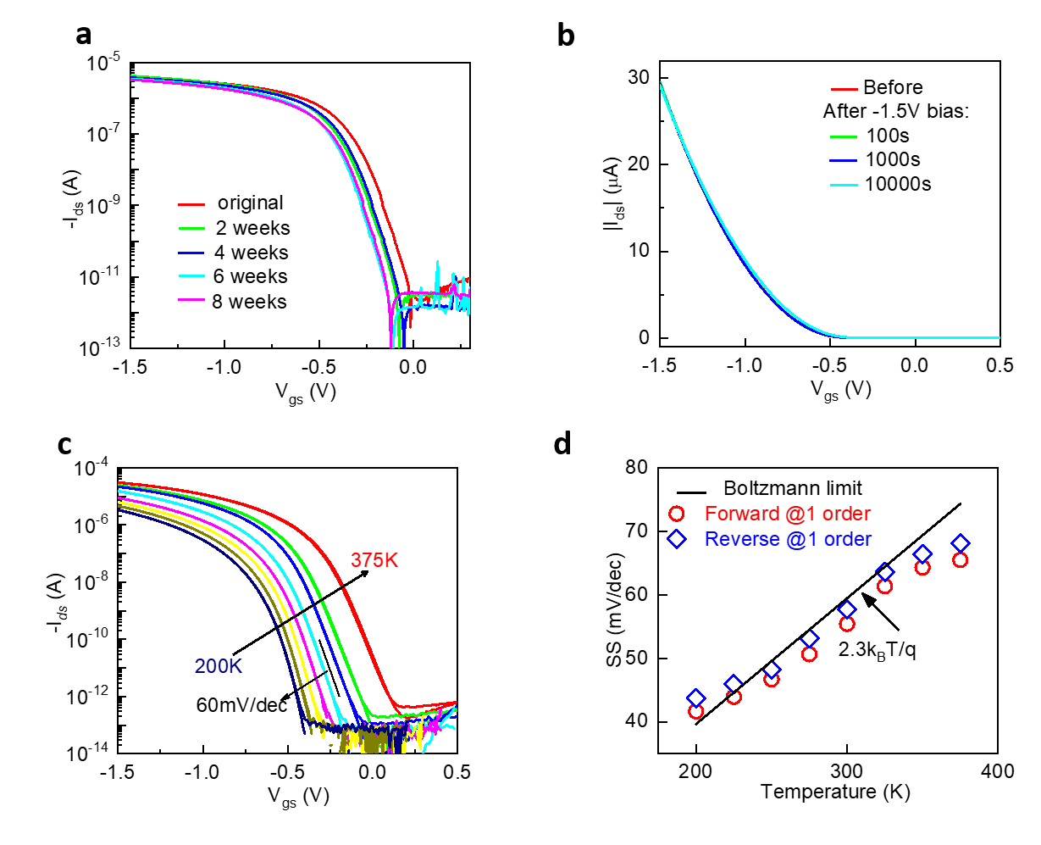

Supplementary Figure 9| Stability of the sub-thermionic OTFTs. a, I_{ds}-V_{gs} characteristics (V_{ds} = -0.1 V) for an OTFT after two-month storage at room-temperature. b, I_{ds}-V_{gs} characteristics measured at before and after -1.5 V bias stress test. c, Double-sweep I_{ds}-V_{gs} characteristics (V_{ds} = -1 V) at different temperatures of a sub-thermionic OTFT. d, Temperature dependence of SS (averaged over one decade of I_{ds}) from 200 to 375 K, showing that the SS was below the Boltzmann limit in a wide temperature range. Red, forward sweep; blue, reverse sweep.

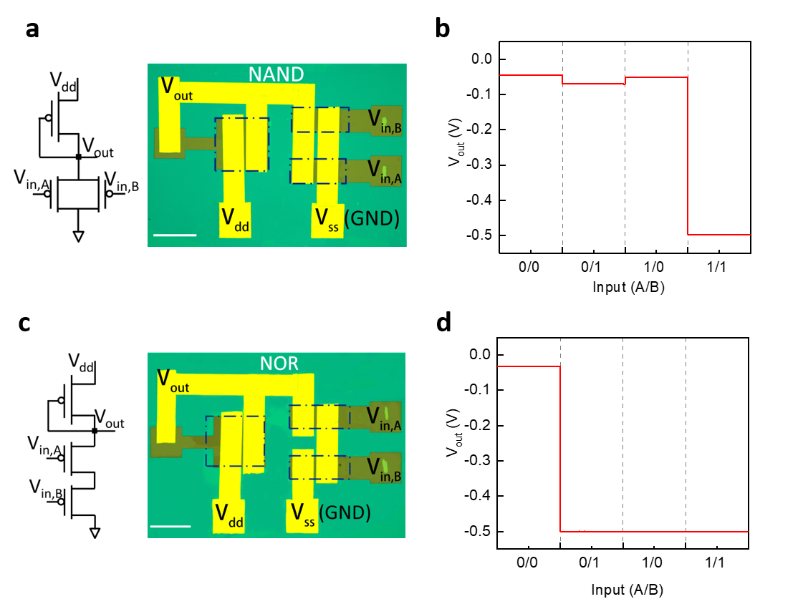

Supplementary Figure 10| Integrated logic gates based on sub-thermionic monolayer OTFT. a,c, Equivalent circuit diagram (left) and optical microscope image (right) of NAND (a) and NOR (c) gates. The dotted boxes indicate organic film areas for transistors. b,d, Output characteristics of NAND (b) and NOR (d) gates.

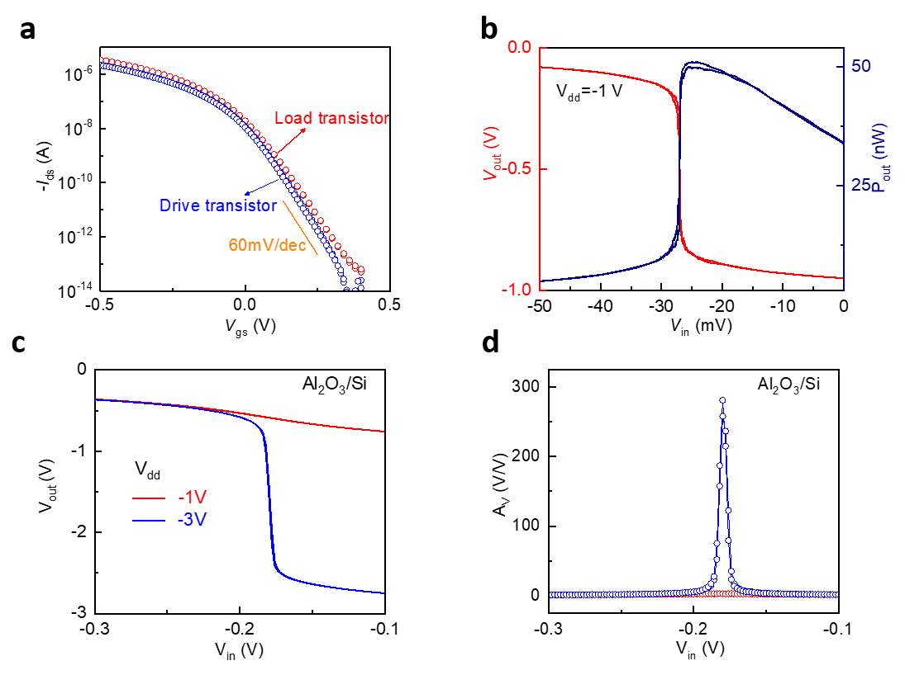

Supplementary Figure 11| Performance comparison of amplifiers on different dielectrics. a, Transfer characteristics of the load (W/L=180/5) and drive (W/L=90/5) transistors. b, Measured voltage transfer characteristic and power curve of an inverter on HZO substrate. c, Voltage transfer characteristic and d, voltage gain of an inverter on Al₂O₃ substrate. At V_{dd} = -1V, the device on normal Al₂O₃ dielectric barely shows any gain, which is dramatically different from sub-thermionic OTFTs.

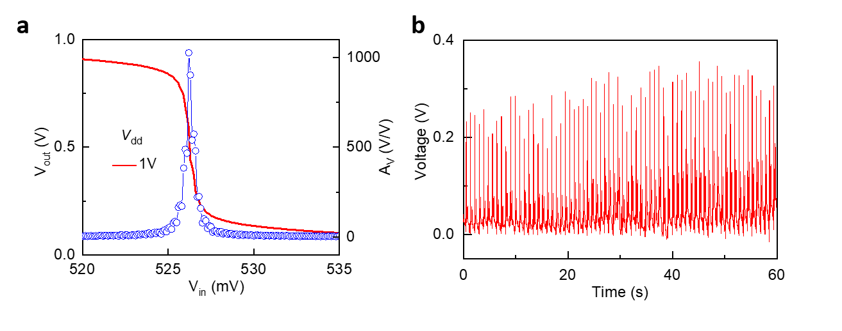

Supplementary Figure 12| Battery-power amplifier module to monitor ECG. a, Voltage transfer characteristic and voltage gain of an inverter powered by a coin battery showing a peak gain greater than 1000 at V_{dd} = 1 V. b, ECG monitoring using battery-powered amplifier module.

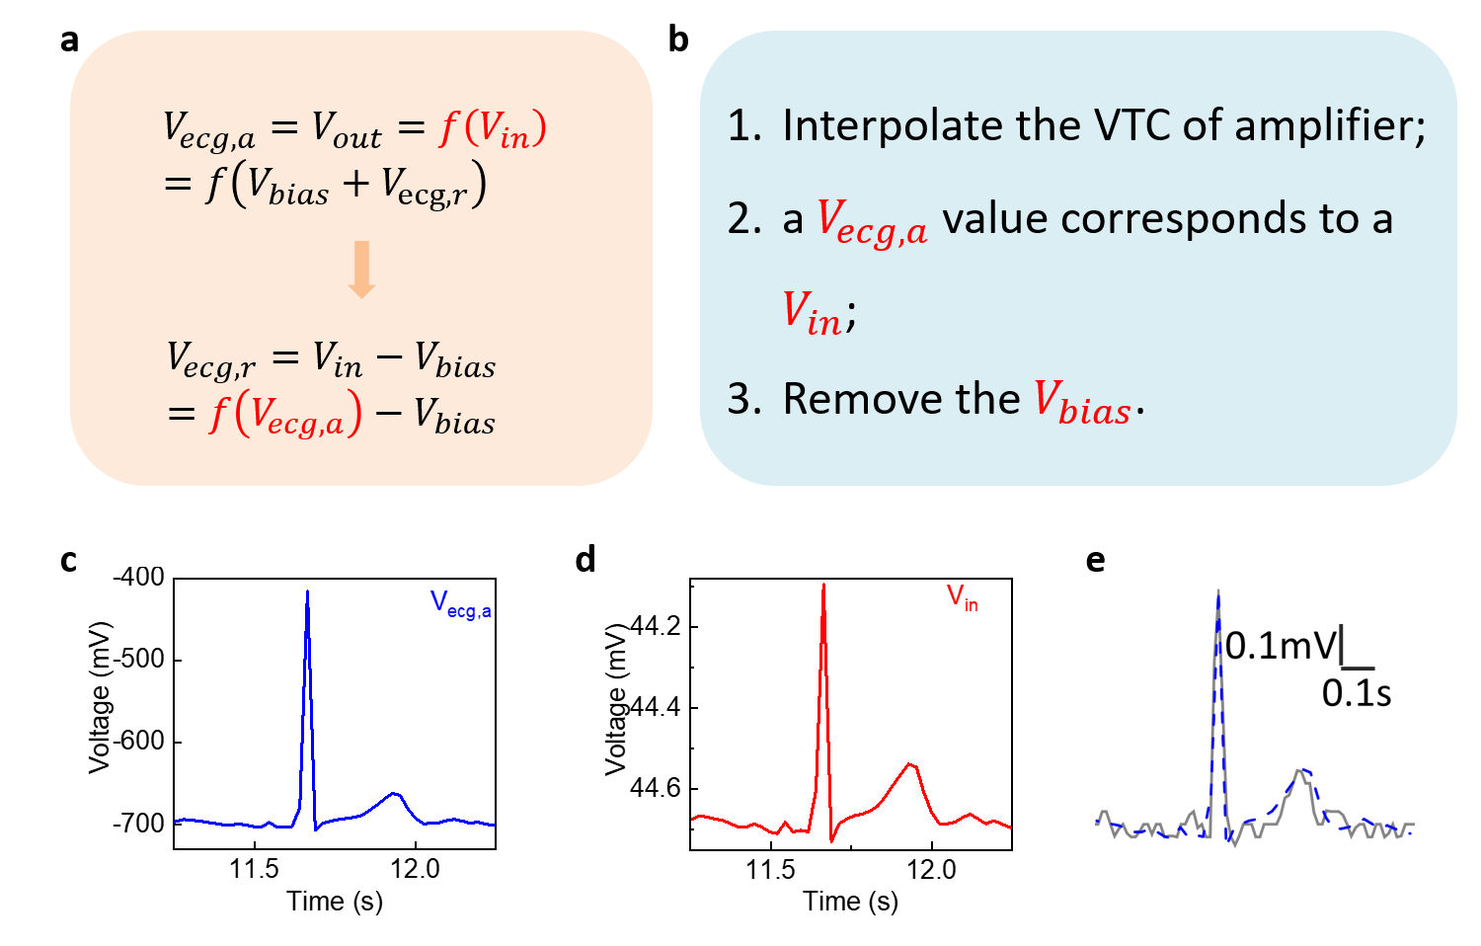

Supplementary Figure 13| ECG deconvolution. a, The principle of ECG signal deconvolution. b, The specific deconvolution steps. c,d, ECG signal before (c) and after (d) deconvolution. The gain is calculated to be 459. e, Comparison of the deconvoluted ECG signal (blue dashed line) and commercial equipment taken on the same human subject (grey line).

Supplementary Table 1| Contact resistance comparison for OTFTs.
Material | Device structure | Thickness (nm) | Contact technique | R_{c}W  (Ωcm) | Ref.
Rubrene | Bottom-contact | 1000 | Nickel contact | 100 | 8
Pentacene | Bottom-contact | NA | UV/ozone treatment | 80 | 9
C₈-BTBT | Bottom-contact | 40 | Doped | 100 | 10
C₈-BTBT | Top-contact | 40 | Doped | 200 | 10
C₈-BTBT | Top-contact | Monolayer | Graphene contact | 100 | 11
C₈-DNBDT-NW | Top-contact | Bilayer | F₄-TCNQ/Au | 46.9 | 12
DPH-DNTT | Bottom-contact | 20 | PFBT treatment | 29 | 13
DPH-DNTT | Top-contact | 20 | PFBT treatment | 56 | 13
C₁₀-DNTT | Top-contact | Monolayer | vdW contact | 59.4 | This work

Supplementary Table 2| Performance comparison of low-voltage OTFT technologies.
Dielectric | Material | Thickness (nm) | L/W (μm/μm) | V_{dd}  (V) | SS (mV/dec) | I_{on}/I_{off} | g_{m} (μS μm⁻¹V⁻¹) | Ref.
TiO₂+SAM | DNTT | 30 | 25/300 | -1 | 77 | 2.1×10⁷ | 2.4×10⁻² | 14
AlO_{X}+SAM | DPA | 27 | NA/6.8 | -3 | 66 | 1.1×10⁴ | 3.6×10⁻³ | 15
AlO_{X}+SAM | DPH-DNTT | 20 | 8/200 | -3 | 62 | 3.2×10⁷ | 5.6×10⁻² | 13
AlO_{X}+SAM | DPH-DNTT | 20 | 8/200 | -3 | 68 | 6.7×10⁶ | 5.9×10⁻² | 13
AlO_{X}+SAM | DPH-DNTT | NA | 0.6/100 | -3 | NA | 2×10⁷ | 3.7×10⁻¹ | 16
AlO_{X}+SAM | C₈-DNBDT-NW | Bilayer | 3/750 | -10 | NA | 4.9×10⁴ | 2.5×10⁻⁵ | 12
AlO_{X}+SAM | DNTT | 20 | 50/500 | -2 | NA | 4.1×10⁴ | 3.0×10⁻³ | 17
HfO₂+SAM | Pentacene | 50 | 20/1000 | -3 | 75 | 1.5×10⁵ | 1.8×10⁻³ | 18
AlO_{X}+PVP | TES-ADT | 50 | 100/1500 | -1 | 85 | 5.2×10⁴ | 2.0×10⁻³ | 19
PVC | C₈-BTBT | 20 | 40/1400 | -3 | 60.2 | 3.5×10⁵ | 4.2×10⁻⁵ | 20
Copolymer | Pentacene | 50 | 30/240 | -3 | 220 | 3.7×10⁴ | 5.8×10⁻⁴ | 21
PVDF | PTDPPTFT4 | NA | 50/1000 | -5 | 120 | 1.0×10³ | 4.1×10⁻⁴ | 22
PVP | PTDPPTFT4 | NA | 50/1000 | -5 | 110 | 5.4×10⁴ | 1.3×10⁻⁵ | 23
Polymer | C60 | 50 | 200/1000 | 2.5 | 173 | 7.9×10² | 6.1×10⁻⁵ | 24
Ba_{0.7}Sr_{0.3}TiO₃ | Pentacene | 40 | 100/2000 | -2.5 | 140 | 2.6×10³ | 1.3×10⁻³ | 25
HaLaO | Pentacene | 70 | 80/2000 | -2 | 78 | 1.2×10⁵ | 2.5×10⁻³ | 26
EDL | C₈-BTBT | NA | 100/21000 | -5 | NA | 1.6×10¹ | 1.1×10⁻⁶ | 27
EDL | P(T₀T₀TT₁₆) | NA | 2.5/1000 | -1 | 70 | 5.8×10³ | 1.5×10⁻² | 28
HZO | C₁₀-DNTT | Monolayer | 5/180 | -1 | 58.6 | 2.0×10⁸ | 4.1×10⁻¹ | This work

Supplementary Table 3| Voltage gain comparison of inverters based on different semiconductors.
Materials | V_{dd} (V) | Gain (V/V) | Ref.
IGZO | 2 | 220 | 29
ITO | 0.5/2.5 | 178/476 | 30
MoS₂ | 10 | 155 | 31
MoS₂ | 5 | 60 | 32
WSe₂ | 5.5 | 340 | 33
WSe₂ | 3 | 12 | 34
MoTe₂ | 1/2 | 18/29 | 35
BP | 2 | 13 | 36
MoS₂/MoTe₂ | 0.5/1 | 7.7/33.3 | 37
C₈-BTBT | 2 | 260 | 20
DNTT | 2 | 496 | 17
Pentacene | 1.5/2.5 | 574/478 | 38
DNTT | 3 | 11 | 39
P-Pentacene | 4 | 500 | 40
P-DPH-BTBT | 1 | 180 | 41
CNT | 3 | 290 | 42
CNT | 6 | 25 | 43
CNT | 5 | 16 | 44
CNT | 2 | 30 | 45
C₁₀-DNTT | -1/-2/-3 | 4069/6621/11220 | This work
C₁₀-DNTT | -1/-2/-3 | 4825/7690/9762 | This work

Supplementary Table 4| Performance comparison of amplifiers for detecting biosignals.
TFT Type | TFT Scale | Circuit topology | Biosignal | Clinical | V_{dd} (V) | Battery Power | Gain (V/V) | SNR (dB) | Ref.
OFET | 4 | 2-stage inverter | Rat’s ECG | - | 2 | - | ~100 | ~36 | 17
OFET | 4 | 2-stage inverter | Pulse | - | 30 | - | ~10 | - | 46
OFET | 7 | 1-stage differential amplifiers | ECG | - | 4 | - | ~16 | 34 | 47
IGZO TFT | 4 | 1-stage  differential amplifier | HR | - | 10 | - | ~13 | - | 48
Dual Gate IGZO TFT | 5 | 1-stage  differential amplifier | ECG | - | 10 | - | ~60 | - | 49
IGZO TFT | 10 | Differential Amplifier | ECG | - | 10 | - | ~32 | - | 50
CNT-FET | 4 | 1-stage inverter | ECG | - | 10 | - | >60 | - | 51
OFET | 2 | 1-stage inverter | Pulse | - | 1 | Yes | ~900 | 40.4 | This work
OFET | 2 | 1-stage inverter | ECG | Yes | 1 | Yes | ~324 | 42 | This work

Supplementary Movie 1| ECG monitoring by sub-thermionic amplifier and commercial equipment (Prince 180B by Heal Force).

References:
1. Cao W, Banerjee K. Is negative capacitance FET a steep-slope logic switch? Nature Communications 2020, 11(1): 196.

2. Zhao Y, Li L, Peng Y, Li Q, Yang G, Chuai X, et al. Surface potential-Based Compact Model for Negative Capacitance FETs Compatible for Logic Circuit: with Time Dependence and Multidomain Interaction. 2019 IEEE International Electron Devices Meeting (IEDM); 2019 7-11 Dec. 2019; 2019. p. 7.5.1-7.5.4.

3. Hayashi T, Take N, Tamura H, Sekitani T, Someya T. Alternating current admittance of DNTT-based metal-insulator-semiconductor capacitors. J Appl Phys 2014, 115(9): 093702.

4. Yang SJ, Park K-T, Im J, Hong S, Lee Y, Min B-W, et al. Ultrafast 27 GHz cutoff frequency in vertical WSe2 Schottky diodes with extremely low contact resistance. Nature Communications 2020, 11(1): 1574.

5. Zubko P, Wojdeł JC, Hadjimichael M, Fernandez-Pena S, Sené A, Luk’yanchuk I, et al. Negative capacitance in multidomain ferroelectric superlattices. Nature 2016, 534(7608): 524-528.

6. Saha AK, Sharma P, Dabo I, Datta S, Gupta SK. Ferroelectric transistor model based on self-consistent solution of 2D Poisson's, non-equilibrium Green's function and multi-domain Landau Khalatnikov equations. 2017 IEEE International Electron Devices Meeting (IEDM); 2017 2-6 Dec. 2017; 2017. p. 13.15.11-13.15.14.

7. Rabe KM, Dawber M, Lichtensteiger C, Ahn CH, Triscone J-M. Modern Physics of Ferroelectrics:Essential Background. Physics of Ferroelectrics: A Modern Perspective. Springer Berlin Heidelberg: Berlin, Heidelberg, 2007, pp 1-30.

8. Hulea IN, Russo S, Molinari A, Morpurgo AF. Reproducible low contact resistance in rubrene single-crystal field-effect transistors with nickel electrodes. Appl Phys Lett 2006, 88(11): 113512.

9. Stadlober B, Haas U, Gold H, Haase A, Jakopic G, Leising G, et al. Orders-of-Magnitude Reduction of the Contact Resistance in Short-Channel Hot Embossed Organic Thin Film Transistors by Oxidative Treatment of Au-Electrodes. Advanced Functional Materials 2007, 17(15): 2687-2692.

10. Darmawan P, Minari T, Xu Y, Li S-L, Song H, Chan M, et al. Optimal Structure for High-Performance and Low-Contact-Resistance Organic Field-Effect Transistors Using Contact-Doped Coplanar and Pseudo-Staggered Device Architectures. Advanced Functional Materials 2012, 22(21): 4577-4583.

11. He D, Qiao J, Zhang L, Wang J, Lan T, Qian J, et al. Ultrahigh mobility and efficient charge injection in monolayer organic thin-film transistors on boron nitride. Science Advances 2017, 3(9): e1701186.

12. Yamamura A, Watanabe S, Uno M, Mitani M, Mitsui C, Tsurumi J, et al. Wafer-scale, layer-controlled organic single crystals for high-speed circuit operation. Science Advances 2018, 4(2): eaao5758.

13. Borchert JW, Peng B, Letzkus F, Burghartz JN, Chan PKL, Zojer K, et al. Small contact resistance and high-frequency operation of flexible low-voltage inverted coplanar organic transistors. Nature Communications 2019, 10(1): 1119.

14. Jinno H, Yokota T, Matsuhisa N, Kaltenbrunner M, Tachibana Y, Someya T. Low operating voltage organic transistors and circuits with anodic titanium oxide and phosphonic acid self-assembled monolayer dielectrics. Organic Electronics 2017, 40: 58-64.

15. Yang F, Sun L, Han J, Li B, Yu X, Zhang X, et al. Low-Voltage Organic Single-Crystal Field-Effect Transistor with Steep Subthreshold Slope. ACS Applied Materials & Interfaces 2018, 10(31): 25871-25877.

16. Borchert JW, Zschieschang U, Letzkus F, Giorgio M, Weitz RT, Caironi M, et al. Flexible low-voltage high-frequency organic thin-film transistors. Science Advances 2020, 6(21): eaaz5156.

17. Sekitani T, Yokota T, Kuribara K, Kaltenbrunner M, Fukushima T, Inoue Y, et al. Ultraflexible organic amplifier with biocompatible gel electrodes. Nature Communications 2016, 7: 11425.

18. Acton O, Dubey M, Weidner T, O’Malley KM, Kim T-W, Ting GG, et al. Simultaneous Modification of Bottom-Contact Electrode and Dielectric Surfaces for Organic Thin-Film Transistors Through Single-Component Spin-Cast Monolayers. Advanced Functional Materials 2011, 21(8): 1476-1488.

19. Kim SH, Jang M, Yang H, Anthony JE, Park CE. Physicochemically Stable Polymer-Coupled Oxide Dielectrics for Multipurpose Organic Electronic Applications. Advanced Functional Materials 2011, 21(12): 2198-2207.

20. Jiang C, Choi HW, Cheng X, Ma H, Hasko D, Nathan A. Printed subthreshold organic transistors operating at high gain and ultralow power. Science 2019, 363(6428): 719.

21. Ji D, Li T, Zou Y, Chu M, Zhou K, Liu J, et al. Copolymer dielectrics with balanced chain-packing density and surface polarity for high-performance flexible organic electronics. Nature Communications 2018, 9(1): 2339.

22. Wang C, Lee W-Y, Kong D, Pfattner R, Schweicher G, Nakajima R, et al. Significance of the double-layer capacitor effect in polar rubbery dielectrics and exceptionally stable low-voltage high transconductance organic transistors. Scientific Reports 2015, 5(1): 17849.

23. Wang C, Lee W-Y, Nakajima R, Mei J, Kim DH, Bao Z. Thiol–ene Cross-Linked Polymer Gate Dielectrics for Low-Voltage Organic Thin-Film Transistors. Chemistry of Materials 2013, 25(23): 4806-4812.

24. Moon H, Seong H, Shin WC, Park W-T, Kim M, Lee S, et al. Synthesis of ultrathin polymer insulating layers by initiated chemical vapour deposition for low-power soft electronics. Nature Materials 2015, 14(6): 628-635.

25. Wang Z, Ren X, Leung CW, Shi S, Chan PKL. A UV-ozone treated amorphous barium–strontium titanate dielectric thin film for low driving voltage flexible organic transistors. Journal of Materials Chemistry C 2013, 1(24): 3825-3832.

26. Chang MF, Lee PT, McAlister SP, Chin A. Low Subthreshold Swing HfLaO/Pentacene Organic Thin-Film Transistors. IEEE Electron Device Letters 2008, 29(3): 215-217.

27. Dai S, Chu Y, Liu D, Cao F, Wu X, Zhou J, et al. Intrinsically ionic conductive cellulose nanopapers applied as all solid dielectrics for low voltage organic transistors. Nature Communications 2018, 9(1): 2737.

28. Herlogsson L, Crispin X, Tierney S, Berggren M. Polyelectrolyte-Gated Organic Complementary Circuits Operating at Low Power and Voltage. Advanced Materials 2011, 23(40): 4684-4689.

29. Lee S, Nathan A. Subthreshold Schottky-barrier thin-film transistors with ultralow power and high intrinsic gain. Science 2016, 354(6310): 302.

30. Li S, Tian M, Gao Q, Wang M, Li T, Hu Q, et al. Nanometre-thin indium tin oxide for advanced high-performance electronics. Nature Materials 2019, 18(10): 1091-1097.

31. Dai Z, Wang Z, He X, Zhang X-X, Alshareef HN. Large-Area Chemical Vapor Deposited MoS2 with Transparent Conducting Oxide Contacts toward Fully Transparent 2D Electronics. Advanced Functional Materials 2017, 27(41): 1703119.

32. Wachter S, Polyushkin DK, Bethge O, Mueller T. A microprocessor based on a two-dimensional semiconductor. Nature Communications 2017, 8: 14948.

33. Kong L, Zhang X, Tao Q, Zhang M, Dang W, Li Z, et al. Doping-free complementary WSe2 circuit via van der Waals metal integration. Nature Communications 2020, 11(1): 1866.

34. Tosun M, Chuang S, Fang H, Sachid AB, Hettick M, Lin Y, et al. High-Gain Inverters Based on WSe2 Complementary Field-Effect Transistors. ACS Nano 2014, 8(5): 4948-4953.

35. Lim JY, Pezeshki A, Oh S, Kim JS, Lee YT, Yu S, et al. Homogeneous 2D MoTe2 p–n Junctions and CMOS Inverters formed by Atomic-Layer-Deposition-Induced Doping. Advanced Materials 2017, 29(30): 1701798.

36. Chen L, Li S, Feng X, Wang L, Huang X, Tee BCK, et al. Gigahertz Integrated Circuits Based on Complementary Black Phosphorus Transistors. Advanced Electronic Materials 2018, 4(9): 1800274.

37. Pezeshki A, Hosseini Shokouh SH, Jeon PJ, Shackery I, Kim JS, Oh I-K, et al. Static and Dynamic Performance of Complementary Inverters Based on Nanosheet α-MoTe2 p-Channel and MoS2 n-Channel Transistors. ACS Nano 2016, 10(1): 1118-1125.

38. Liu J, Gao X, Xu J, Ruotolo A, Wang S. Flexible Low-Power Organic Complementary Inverter Based on Low- ${k}$ Polymer Dielectric. IEEE Electron Device Letters 2017, 38(10): 1461-1464.

39. Yokota T, Kajitani T, Shidachi R, Tokuhara T, Kaltenbrunner M, Shoji Y, et al. A few-layer molecular film on polymer substrates to enhance the performance of organic devices. Nature Nanotechnology 2018, 13(2): 139-144.

40. Petritz A, Wolfberger A, Fian A, Griesser T, Irimia-Vladu M, Stadlober B. Cellulose-Derivative-Based Gate Dielectric for High-Performance Organic Complementary Inverters. Advanced Materials 2015, 27(46): 7645-7656.

41. Zschieschang U, Bader VP, Klauk H. Below-one-volt organic thin-film transistors with large on/off current ratios. Organic Electronics 2017, 49: 179-186.

42. Lei T, Shao L-L, Zheng Y-Q, Pitner G, Fang G, Zhu C, et al. Low-voltage high-performance flexible digital and analog circuits based on ultrahigh-purity semiconducting carbon nanotubes. Nature Communications 2019, 10(1): 2161.

43. Tang J, Cao Q, Tulevski G, Jenkins KA, Nela L, Farmer DB, et al. Flexible CMOS integrated circuits based on carbon nanotubes with sub-10 ns stage delays. Nature Electronics 2018, 1(3): 191-196.

44. Sun D-m, Timmermans MY, Tian Y, Nasibulin AG, Kauppinen EI, Kishimoto S, et al. Flexible high-performance carbon nanotube integrated circuits. Nature Nanotechnology 2011, 6(3): 156-161.

45. Zhang H, Xiang L, Yang Y, Xiao M, Han J, Ding L, et al. High-Performance Carbon Nanotube Complementary Electronics and Integrated Sensor Systems on Ultrathin Plastic Foil. ACS Nano 2018, 12(3): 2773-2779.

46. Wang S, Xu J, Wang W, Wang G-JN, Rastak R, Molina-Lopez F, et al. Skin electronics from scalable fabrication of an intrinsically stretchable transistor array. Nature 2018, 555: 83.

47. Sugiyama M, Uemura T, Kondo M, Akiyama M, Namba N, Yoshimoto S, et al. An ultraflexible organic differential amplifier for recording electrocardiograms. Nature Electronics 2019, 2(8): 351-360.

48. Zulqarnain M, Stanzione S, Steen JPJVD, Gelinck GH, Myny K, Abdinia S, et al. A 52 µW Heart-Rate Measurement Interface Fabricated on a Flexible Foil with A-IGZO TFTs. ESSCIRC 2018 - IEEE 44th European Solid State Circuits Conference (ESSCIRC); 2018 3-6 Sept. 2018; 2018. p. 222-225.

49. Zulqarnain M, Stanzione S, Steen JPJvd, Gelinck GH, Myny K, Cantatore E. A Low Power Time Domain ECG Interface Based on Flexible a-IGZO TFTs. 2019 IEEE 8th International Workshop on Advances in Sensors and Interfaces (IWASI); 2019 13-14 June 2019; 2019. p. 205-209.

50. Garripoli C, Steen JPJvd, Torricelli F, Ghittorelli M, Gelinck GH, Roermund AHMV, et al. Analogue Frontend Amplifiers for Bio-Potential Measurements Manufactured With a-IGZO TFTs on Flexible Substrate. IEEE Journal on Emerging and Selected Topics in Circuits and Systems 2017, 7(1): 60-70.

51. Koo JH, Jeong S, Shim HJ, Son D, Kim J, Kim DC, et al. Wearable Electrocardiogram Monitor Using Carbon Nanotube Electronics and Color-Tunable Organic Light-Emitting Diodes. ACS Nano 2017, 11(10): 10032-10041.

