Enhanced functional properties of biodegradable Polyvinyl alcohol /carboxymethyl cellulose (PVA/CMC) composite films reinforced with L-alanine surface modified CuO nanorods
Yamanappagouda Amaregouda¹, Kantharaju Kamanna¹*, Tilak Gasti² and Vijay Kumbar³

¹School of Basic Sciences: Department of Chemistry, Rani Channamma University, Vidyasangama, P-B, NH-4, Belagavi -591156, Karnataka.
Tel: +91(0831)-2565203; Fax: +91-(0831)-2565240
*Corresponding author: E-mail: kk@rcub.ac.in
²Department of Chemistry, Karnatak University, Dharwad – 580003, India
³Maratha Mandal's Central Research Laboratory, Belgavi-590010
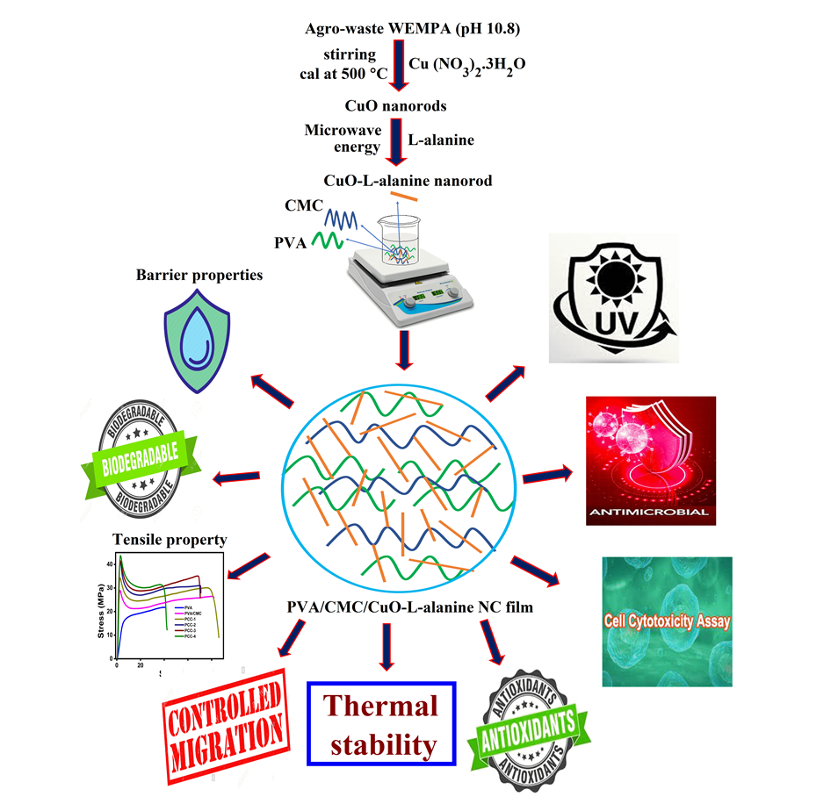
Graphical abstract

