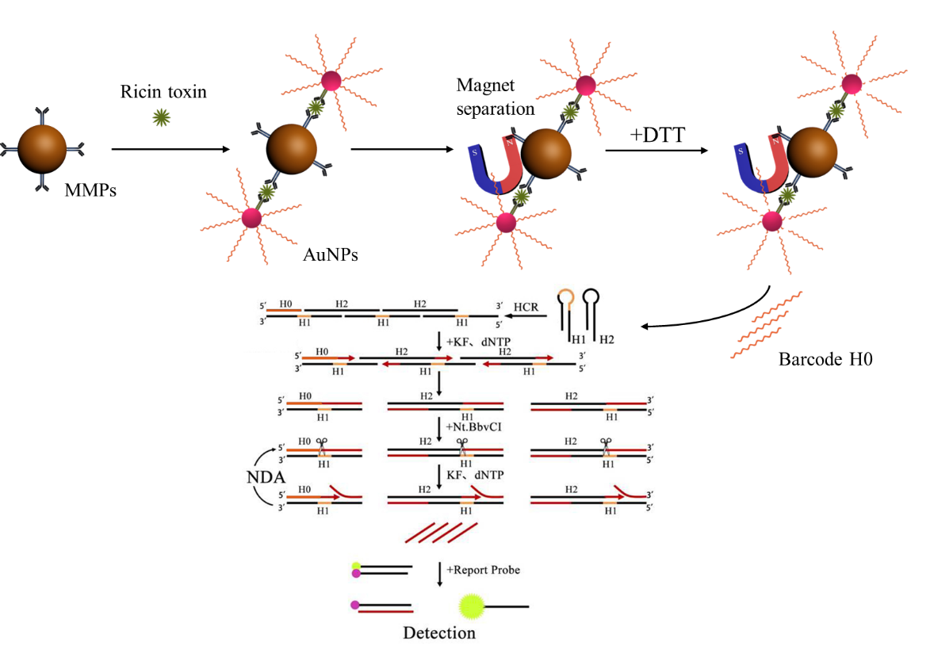
Hybridization assemble nicked displacement amplification (HANDA) was combined with DNA barcodes (DNA barcodes-HANDA) to achieve ultra-sensitive detection of ricin.

The graphic entry for the Table of Contents (TOC)

