Supporting information

Biochar enhanced the nitrogen removal performance of heterotrophic nitrification-aerobic denitrification strain pseudomonas fluorescent sp. Z03 for insufficient carbon source wastewater under low temperature

¹ Key Laboratory of Nasihu Lake Wetland Ecosystem & Environment Protection, Qufu Normal University, Qufu, Shandong, China

⁎ Corresponding author.
E-mail address: qsd_tmzh@qfnu.edu.cn (M. Tang).

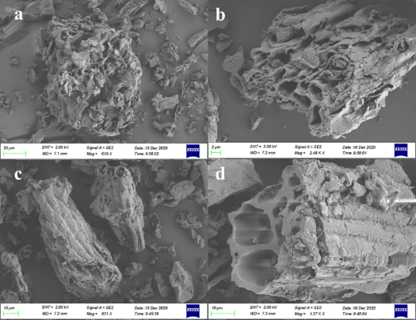
Fig. S1 SEM images of BC400 (a-b) and BC700 (c-d)

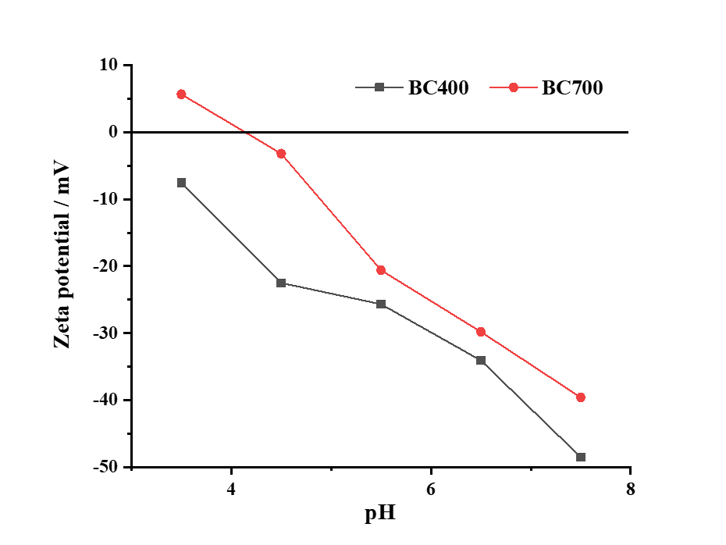
Fig. S2 Zeta potential diagram of BC400 and BC700

Fig. S3 The adsorption effect of biochar control group on ammonia nitrogen within 12h.

