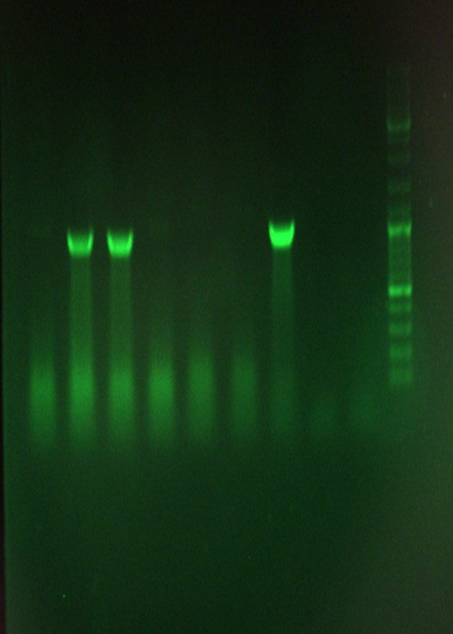

Fig; PCR product of the designed hva1 inserted in PUC57. The primers were amplified approximately 1200pb. The experiment was conducted to confirm the insertion of the structure to the PUC57 vector and cloning. From Right; the 1000bp DNA ladder, the control reaction without the template, the control group of non-inserted PUC57 plasmids, and the structure inserted in PUC57.

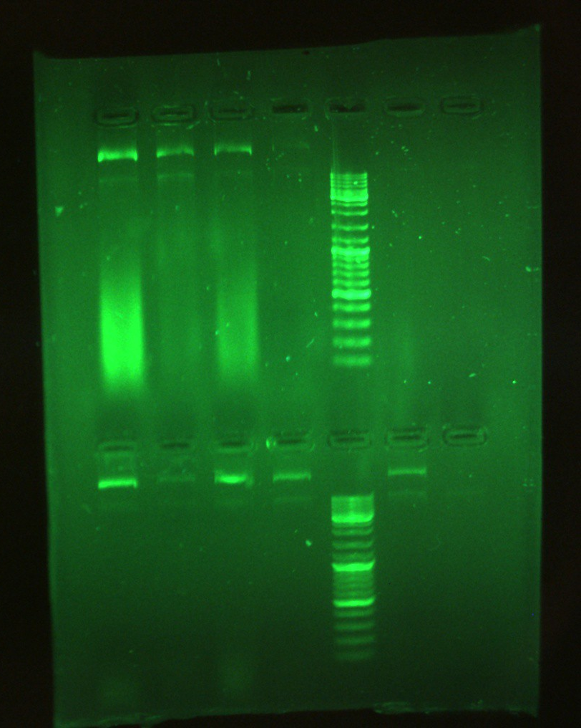
Fig; Extraction of cloned hva1-pBI121 vectors in E. coli. The hva1-pBI121 vector was cloned in E. coli after introducing it to the Agrobacterium tumefaciens C58. From right, 1000bp DNA ladder, the control (E. coli with no hva1-pBI121 vector) and the binary vector hva1-pBI121 was cloned by E. coli in three replicates.

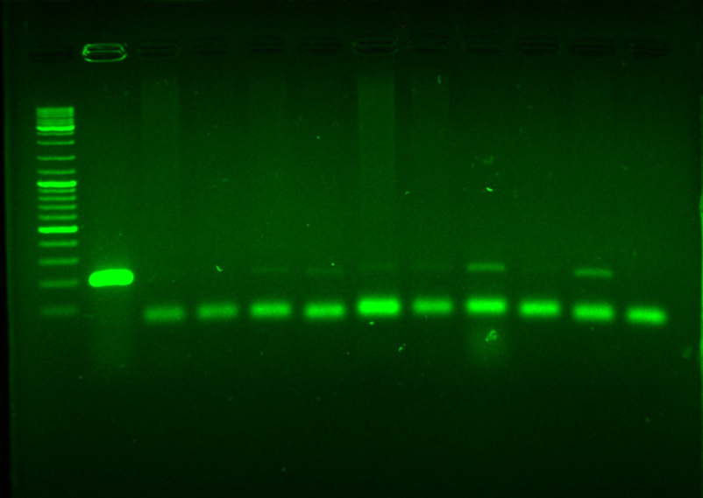

Fig; PCR analysis of DNA using the specific primers to detect the presence of the hva1 in the transgenic potatoes transformed by hva1-pBI121 showing the correct expected band sizes. From left, 1kbp DNA ladder marker, the hva1-pBI121 positive control, transgenic plants from 10 independent samples and finally non-transformed control potato.

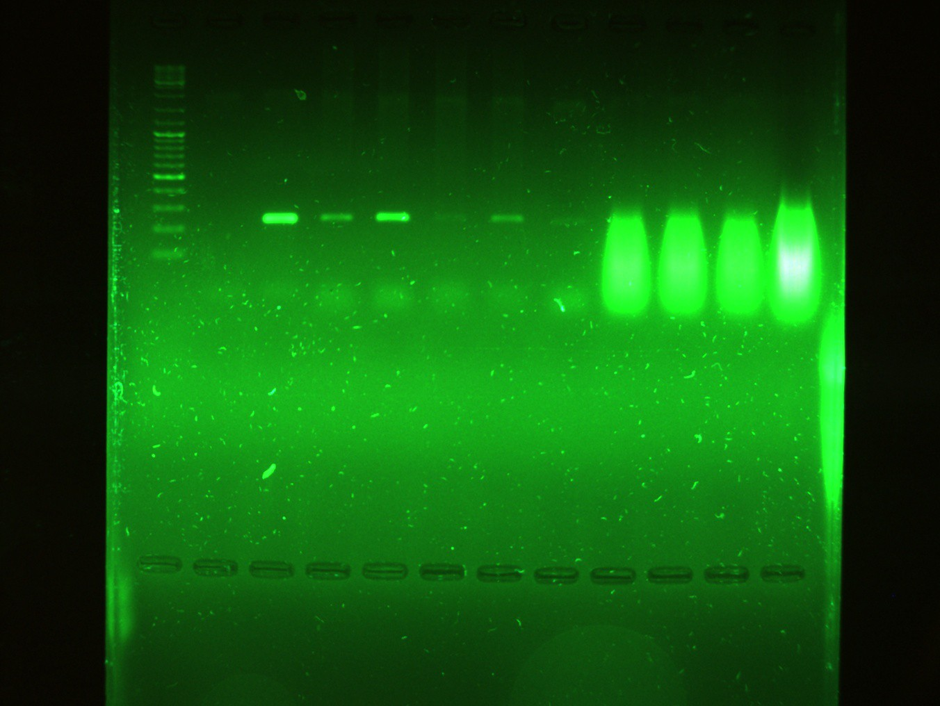

Fig; PCR analysis of DNA using the specific primers to detect the presence of EPSPS in the transgenic potatoes transformed by hva1-pBI121 showing the correct expected band sizes. From left, 1kbp DNA ladder marker, non-transformed control potato, the EPSPS positive control, transgenic plants from 5 independent samples.

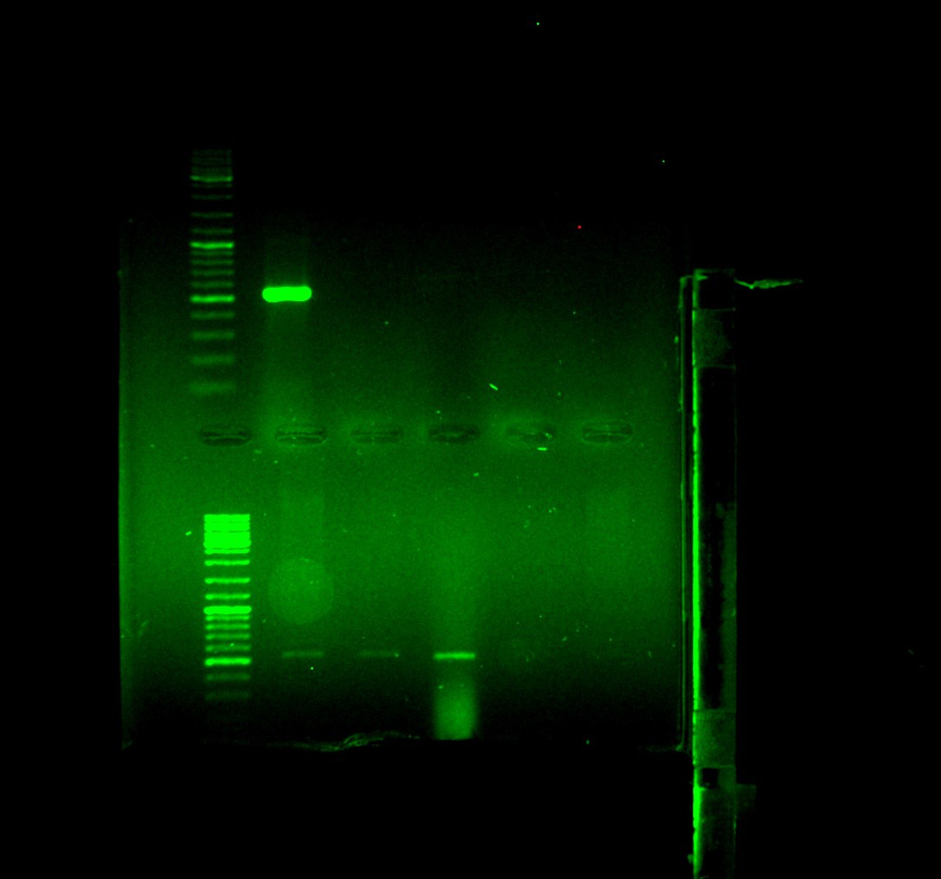

Fig; PCR analysis of the treated samples after one month using the specific primers to detect the presence of the virG to examine the contamination of the transformed samples with Agrobacterium. From left, 1kbp DNA ladder marker, the positive control, transgenic plants from two independent samples and the negative control replicates.

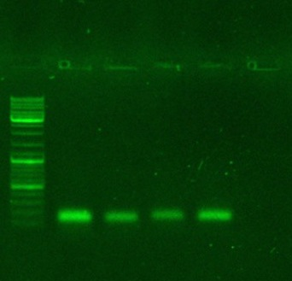

Fig; the PCR reaction product of the hva1 genes in PCR-positive potato lines with the gene specific primer. From left, 1 kb DNA size marker, PCR product from the full-length hva1 sequence as a positive control, the PCR products from the produced cDNA from extracted RNA of three independent transgenic samples, and PCR product from the non-transformed potato (a negative control).

