Table S1
Clinical characteristics of the sepsis-induced ARDS patients and healthy control

 | ARDS patients(n=40) | Healthy control(n=40) | P value
Baseline
Age, median (IQR), y | 56 (35-67) | 58 (30-65) | 0.067
Male, n (%) | 28（70%） | 26（65%） | 0.211
Sepsis etiology, No. (%)
Thorax | 26 (65)
Abdomen | 9 (22.5)
Urinary tract | 3 (7.5)
Central nervous system | 1 (2.5)
Central venous catheter | 1 (2.5)
Admission source, No. (%)
Emergency department | 28 (70)
Outside hospital transfer | 6 (15)
Inpatient ward transfer | 4 (10)
Operating room | 2 (5)
Respiratory, mean (SD)
Tidal volume, ml | 412.7 (86.4)
PaO2/FiO2 ratio at baseline | 178.5 (92.1)
PEEP, cmH2O | 8.5 (4.2)
Oxygenation index, mean (SD) | 10.8 (9.2)
Incidence of shock, No (%)
At baseline, vasopressor in use | 26
mSOFA scores, mean (SD) | 8.7 (3.0)
Outcome measures
Total hospital time, median (IQR) | 14（8.25-21）
ICU time, median (IQR) | 10（5.75-14.25）
28-Day mortality, No. (%) | 17 (42.5)
Data are presented as frequencies and percentages (%) for categorical data and medians and interquartile ranges [IQR] for continuous variables. P-values were calculated using Chi-Square tests for categorical data and one-way ANOVA on log-transformed continuous data. PEEP, positive end-expiratory pressure; mSOFA, modified Sequential Organ Failure Assessment; Oxygenation index = mean airway pressure × Fio₂/Pao₂; mSOFA score range, 0 to 20 (values >8 indicate severe illness); ICU=intensive care unit.

Table S2. Details of primers used for RT-PCR
Gene | forward | reverse
INOS | 5’-GGAGCCAGCTCTGCATTATC-3’ | 5’-TTTTTGTCTCCAAGGGACCAG-3’
Arg-1 | 5’-CAGAAGAATGGAAGAGTCAG-3’ | 5’-CAGATATGCAGGGAGTCAC-3’
FIZZ-1 | 5’-TCCCAGTGAATACTGATGAGA-3’ | 5’-CCACTCTGGATCTCCCAAGA-3’
circN4bp1 | 5’-TGCGGAAATTAGGGTCGGAA-3’ | 5’-CCGACCGGAACTTGAGTCTT-3’
miR-138-5p | 5’-GCTTAAGGCACGCGG-3’ | 5’-GTGCAGGGTCCGAGG-3’
METTL3 | 5’-CTATCTCCTGGCACTCGCAAGA-3’ | 5’-GCTTGAACCGTGCAACCACATC-3’
FTO | 5’-CCAGAACCTGAGGAGAGAATGG-3’ | 5’-CGATGTCTGTGAGGTCAAACGG-3’
YTHDF2 | 5’-TAGCCAGCTACAAGCACACCAC-3’ | 5’-CAACCGTTGCTGCAGTCTGTGT-3’
METTL14 | 5’-CTGAAAGTGCCGACAGCATTGG-3' | 5' -CTCTCCTTCATCCAGATACTTACG-3'
WTAP | 5’-GCCAACTGCTGGCGTGTCT-3' | 5’-ATGGCGAAGTGTCGAATGCT-3'
ALKBH5 | 5’-CCAGCTATGCTTCAGATCGCCT-3' | 5’-GGTTCTCTTCCTTGTCCATCTCC-3'
YTHDF1 | 5’-CAAGCACACAACCTCCATCTTCG-3' | 5’-GTAAGAAACTGGTTCGCCCTCAT-3'
GAPDH | 5’-GGATTGGTCGTATTGGG-3’ | 5’-GGAAGATGGTGATGGGATT-3’

Table S3. Details of primary antibodies used for immunoblotting analysis
Antibody | Catalogue number | Supplier | Dilution
EZH2 | #5246 | Cell Signaling Technology (Danvers, MA, USA) | 1:1000
iNOS | #:2982 | Cell Signaling Technology | 1:1000
Arginase-1 | #79404 | Cell Signaling Technology | 1:1000
p-STAT1 | #8217 | Cell Signaling Technology | 1:1000
PPAR-γ | #2435 | Cell Signaling Technology | 1:1000
GAPDH | sc-32233 | Santa Cruz Biotechnology (Santa Cruz, CA, USA) | 1:1000

Figure S1
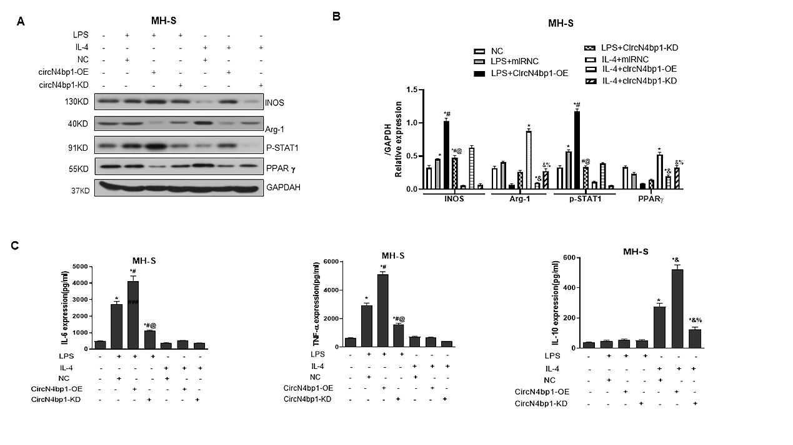
MH-S was transfected with Si-circN4bp1 (circN4bp1-KD), circN4bp1 lentivirus plasmids (circN4bp1-OE) or scrambled control and then exposed to either LPS (50 ng/ml) or IL-4 (10ng/ml) for an additional 24 h. (A) Representative western blot depicting MH-S cell lysates probed for iNOS, Arg-1, p-STAT1, PPAR-γ and GAPDH. (B) Expression levels of iNOS, Arg-1, p-STAT1 and PPAR-γ were quantified by densitometry and normalized using GAPDH. (C) The levels of IL-6, TNF-α and IL-10 were measured by ELISA in the supernatants of LPS and IL-4 stimulated MH-S cells. All data are expressed as mean ± SEM. (* p﹤0.05 vs. NC group, #p﹤0.05 vs. LPS stimulated group, @ p﹤0.05 vs. circN4bp1-OE+LPS group, & p﹤0.05vs. IL-4 stimulated group and % p﹤0.05 vs. circN4bp1-OE+IL-4 group determined by one-way ANOVA for multiple group comparisons).

Figure S2
RAW264.7 and MH-S were transfected with miR-138-5p mimic or inhibitor and then exposed to either LPS (50 ng/ml) or IL-4 (10ng/ml) for an additional 24 h. The levels of IL-6(A, D), TNF-α (B, E) were measured by ELISA in the supernatants of LPS stimulated raw264.7 or MH-S cells and IL-10 (C, F) levels were qualified by ELISA in IL-4 stimulated raw264.7 cells or MH-S cells. All data are expressed as mean ± SEM. (* p﹤0.05 vs. NC group, #p﹤0.05 vs. LPS stimulated group, @ p﹤0.05 vs. miR-138-5p mimic +LPS group, & p﹤0.05vs. IL-4 stimulated group and % p﹤0.05 vs. miR-138-5p mimic +IL-4 group determined by one-way ANOVA for multiple group comparisons).

Figure S3

MH-S cells was transfected with miR-138-5p mimic with/without circN4bp1 lentivirus plasmids (circN4bp1-OE) or scrambled control and then exposed to either LPS (50 ng/ml) or IL-4 (10ng/ml) for an additional 24 h. The levels of IL-6 (A), TNF-α (B) and IL-10 (C) were measured by ELISA in the supernatants of LPS and IL-4 stimulated raw264.7 cells. (D) Representative western blot depicting raw264.7 cell lysates probed for iNOS, Arg-1 and GAPDH. (E) Expression levels of iNOS and Arg-1 were quantified by densitometry and normalized using GAPDH. All data are expressed as mean ± SEM. (* p﹤0.05 vs. NC group, #p﹤0.05 vs. miRNC + LPS stimulated group, @ p﹤0.05 vs. circN4bp1-OE+LPS group, & p﹤0.05vs. miRNC +IL-4 stimulated group and % p﹤0.05 vs. circN4bp1-OE +IL-4 group determined by one-way ANOVA for multiple group comparisons).

