Photochemically Induced Cyclic Morphological Dynamics via Degradation of Autonomously Produced Self-Assembled Polymer Vesicles
Supplementary Information File
Chenyu Lin,† Sai Krishna Katla,† Juan Pérez-Mercader*†§
†Department of Earth and Planetary Sciences, Harvard University, Cambridge, Massachusetts 02138-1204, United States
§The Santa Fe Institute, Santa Fe, New Mexico 87501, United States

Table of Contents
Materials and Methods 3
Materials 3
Synthesis of m-RAFT chain transfer agent 3
Preparation of PET-RAFT Polymerization Induced Self-Assembly (PISA) Reaction 3
Instrumentation 4
¹H Nuclear Magnetic Resonance Measurement (¹H-NMR) 4
Gel Permeation Chromatography Measurement 4
Dynamic Light Scattering (DLS) 5
Fluorescence Microscopy and Confocal Microscopy 5
Temperature Controlled Fluorescence Microscopy 5
Photoinduced Chemical Degradation Measured by Ultraviolet Visible Spectroscopy (UV-VIS) 6
Transmission Electron Microscopy (TEM) 6
Supplementary Figures 7
Supplementary movie 1 13
Supplementary movie 2 13

Materials and Methods

Materials
4-Cyano-4-(phenylcarbonothioylthio)pentanoic acid (M_{w} = 279.38, Sigma-Aldrich), Hydroxypropyl methacrylate (144.17 g/mol, Alfa Aesar), 4-Hydroxybutyl Acrylate (HBA, 144.17 g/mol, >97%, TCI America) , Butyl Acrylate (BA, ≥99%, 128.17 g/mol, Sigma-Aldrich) , Styrene (St, 104.15 g/mol, 99%, ACROS ORGANICS), Rhodamine 6G (M_{w} = 479.01, Sigma), N,N-Dimethylpyridin-4-amine (DMAP, 122.17 g/mol, Aldrich) dicyclohexylcarbodiimide (DCC, 206.33 g/mol, Aldrich), Water (HPLC plus, Sigma-Aldrich), Anhydrous Dichloromethane (Sigma-Aldrich), Diethyl ether (Sigma-Aldrich) were used as received. Poly(ethylene glycol) methyl ether (M_{n} = 1900, Alfa Aesar) was dried in a desiccator overnight.

Synthesis of m-RAFT chain transfer agent
In a typical synthesis, 1.41 g (Mn = 1900, 0.74 mmole) poly(ethylene glycol) methyl ether, 0.017g (0.14 mmole) N,N’dimethylaminopyridine, 0.413 g (1.48 mmole) 4-cyano-4-(phenylcarbonoylthio)pentanoic acid and 10 mL of anhydrous dichloromethane were placed in an oven-dried 25 mL round bottom flask.. The mixture was stirred and cooled in an ice bath for 10 mins. A mixture of 0.305 g (1.48 mmole) dicyclohexylcarbodiimide in 5 mL of dichloromethane was then added dropwise into the flask. This mixture was then stirred for 24 h. Afterward, the resulting precipitate was filtered and the filtrate was transferred into a large quantity of diethyl ether. The pink-colored m-RAFT chain transfer agent that precipitated in the diethyl ether was later filtered and dried in a desiccator for two days before use. The dried product was stored at 4 ºC in a refrigerator.

Preparation of PET-RAFT Polymerization Induced Self-Assembly (PISA) Reaction
At first, 63.44 uL of hydroxypropyl methacrylate, 13.9 mg (6.95 μmol) of Poly(ethylene glycol) methyl ether 4-cyano-4-(phenylcarbonothioylthio) or m-RAFT, 3.26 uL of Ru(bpy)₃²⁺ (8.5 mM), and 2 mL water (HPLC Plus, Sigma-Aldrich) were added to a 1 dram glass vial. The mixture was then vortexed for 5 mins followed by nitrogen bubbling for 15 mins (5 mins over the headspace of the liquid and 10 mins within the liquid). The mixture was transferred to a 1.5 mL quartz cuvette (purged with nitrogen prior to transfer) which was then capped with a Teflon stopper. The cuvette was then irradiated for 16 h using 7 blue LED units (6.57 mW for each LED unit) and the temperature was maintained at 25 °C using circulation of water around the sample with a pump connected to water-bath. For the other PISA reactions using different monomers such as butyl acrylate, hydroxybutyl acrylate and polystyrene, equal number of moles of the monomer was used to replace hydroxypropyl methacrylate in the mixture followed by the same reaction process.

Instrumentation

¹H Nuclear Magnetic Resonance Measurement (¹H-NMR)
50 uL of PET-RAFT PISA solution was transferred from the reaction cuvette to an Eppendorf tube with 550 uL of methanol-d4 within it. The mixture was vortexed for 5 min and then transferred to an NMR tube. The ¹H-NMR spectra of the PISA sample was then measured at 25 °C on a 500 MHz Varian Unity/Inova spectrometer.

Gel Permeation Chromatography Measurement
After NMR measurement, the solution was transferred from the NMR tube into an Eppendorf tube and speed-dried. The solid compound remaining in the tube was then dissolved in Dimethylformamide with 0.05 mol/L LiBr addition. The mixture was filtered at first by a PTFE syringe filter (pore size is 220 nm) followed by detection using gel permeation chromatography (GPC, Agilent 1260 Infinity II) instrument equipped with a refractive index (RI) detector while eluting with DMF solvent at a flow rate of 1.0 mL/min at 50 °C. Similar procedure was followed for all the PISA samples prepared under different conditions.

Dynamic Light Scattering (DLS)
40 uL of PET-RAFT PISA solution was transferred to a disposable polystyrene cuvette and placed in a temperature-controlled chamber in a dynamic light scattering instrument, Malvern Zetasizer Nano ZS. The solution was incubated at 25 ºC for 5 min before the measurement of hydrodynamic diameters.

Fluorescence Microscopy and Confocal Microscopy
For oxygen-rich samples, an aliquot (72 uL) of PISA solution was transferred to an Eppendorf microcentrifuge tube and stained with 8 uL of Rhodamine 6G. The mixture was then bubbled with air for 10 min. Afterward, 50 uL of the mixture was transferred to glass microscope slide with a frame-seal slide chamber (15 mm x15 mm, 65 µL capacity, BIO-RAD). For oxygen poor microscopic specimens, the above steps were done under nitrogen purging. The samples were then moved to a fluorescence microscope (Zeiss Axio Observer Z1) and irradiated by blue light (λ = 470 nm, 6.65 mW). The fluorescence images were captured using green light (λ = 563 nm) with 50 ms exposure every 5 seconds. After the irradiation in the Zeiss microscope, the sample was used for confocal microscopy (LSM 880 Confocal Microscope) imaging for further morphological analysis.

Temperature Controlled Fluorescence Microscopy
A sample of PISA solution was incubated at desired temperature (25 ºC or 40 ºC) for 30 min in a temperature controlled incubator (Harvard Apparatus, TC-202A) ) before further fluorescence microscopy analysis.

Photoinduced Chemical Degradation Measured by Ultraviolet Visible Spectroscopy (UV-VIS)
The chemical solutions (i.e. 3.14 mM macro-RAFT, 40 uM rhodamine 6G, or 13.4 uM Ru(bpy)₃²⁺ in water (HPLC plus)) to be tested were individually prepared and bubbled with air. For a degradation test, 1 mL of chemical solution was transferred to a temperature-controlled quartz cuvette (temperature = 25ºC) capped with a Teflon stopper. The solution then was exposed to blue light irradiation with 22 blue LED units (6.57 mW for each unit). Every 1 hour, aliquots of the solution were measured using UV-VIS spectroscopy (Cole Parmer S2100UV+ Spectrophotometer).

Transmission Electron Microscopy (TEM)
For morphological characterization of the structures formed from PET-RAFT PISA, a small portion of the PISA solution that underwent 16 h of blue LED irradiation was stained with Phosphotungstic Acid and then dropped onto a 400 mesh Copper Grid with Ultrathin Carbon Film (PELCO from Ted Pella Inc.). After 1 min, the excessive solution was blotted with a filter paper from the grid. The grid was then placed in the dark for overnight drying followed by detection using Hitachi HT7800 electron microscope at voltage of 80 kV. For characterization of Phoenix dynamic morphology, the portion of the PISA solution that underwent 16 h of blue light irradiation under microscope was extracted using a capillary tube and transferred to the grid. Afterward, the grid was stained by Phosphotungstic acid, blotted with a filter paper and placed in dark overnight for drying before detection.

Supplementary Figures
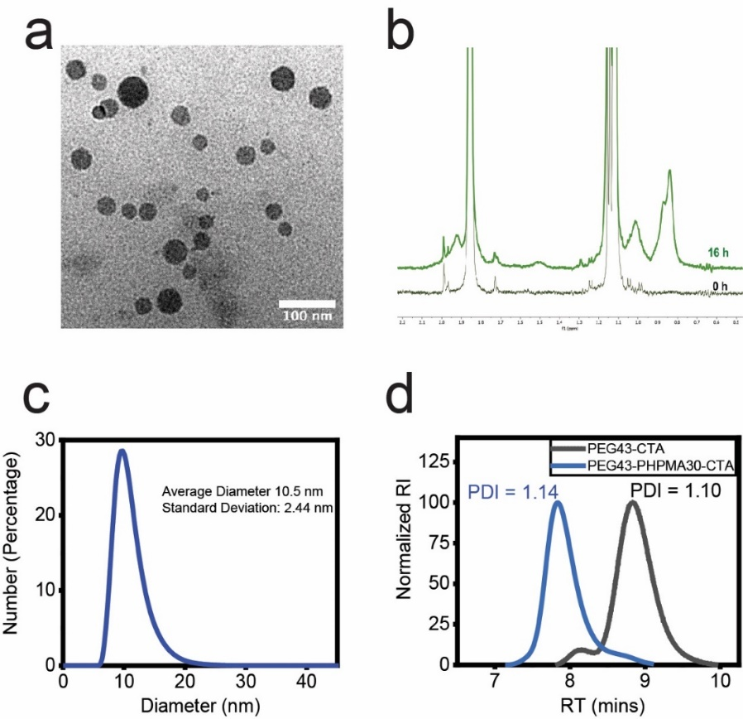
Fig. S 1 Characterization for PEG-b-PHPMA block copolymers and the resulting self-assembled nano-objects: a TEM image of micelles (scale bar: 100 nm), b a portion of ¹H-NMR spectrum for block copolymers (black line: before polymerization; green line: after polymerization; the signature peaks located between 0.75 and 1.2 ppm represent the methyl group protons on the PHPMA blocks, Degree of polymerization: 20) c DLS confirms the hydrodynamic diameter to be 10.5 nm with standard deviation of 2.44 nm, d GPC shows the PDI (1.10) of PEG blocks before polymerization (black curve) and the PDI (1.14) of PEG-b-PHPMA copolymers after polymerization (blue curve).
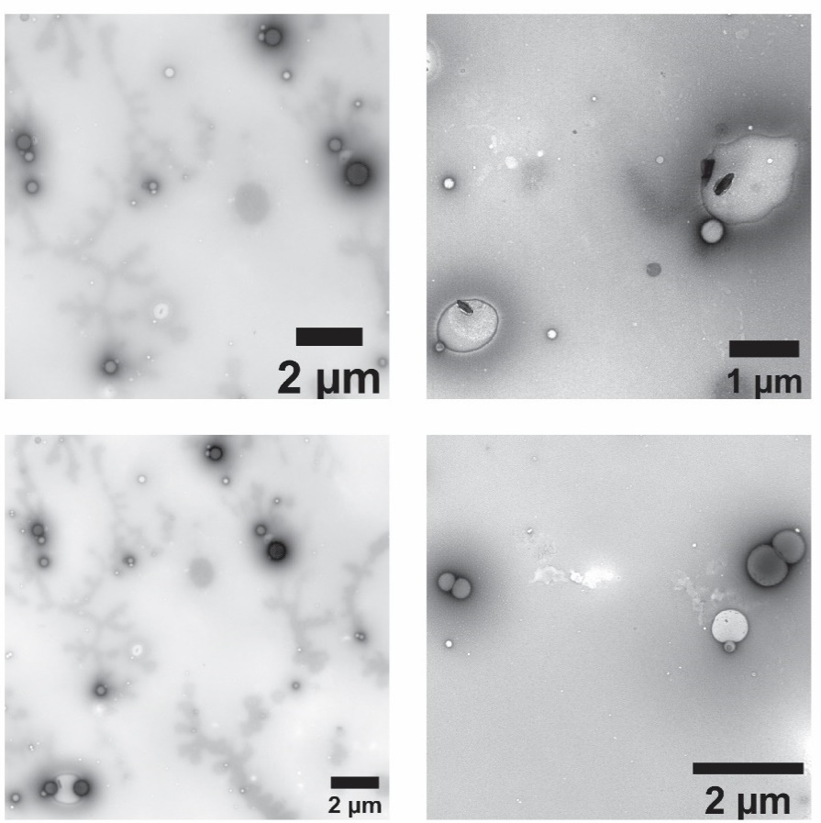
Fig. S 2 TEM images of the giant vesicles from oxygen-rich PISA specimens after irradiation from microscope.

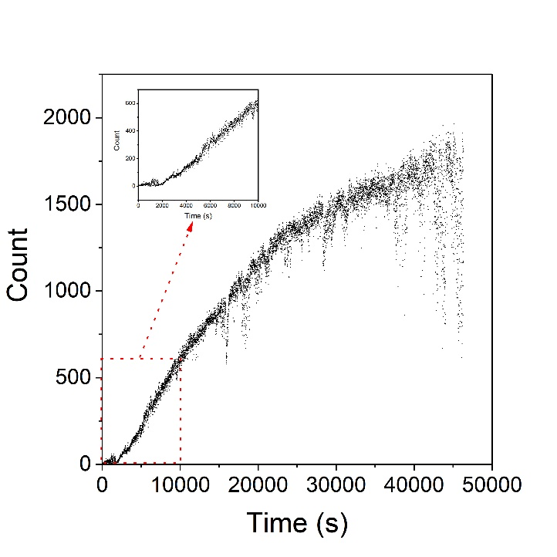
Fig. S 3 Growth curve of giant vesicle population in an oxygen rich specimen under blue light irradiation from microscope.

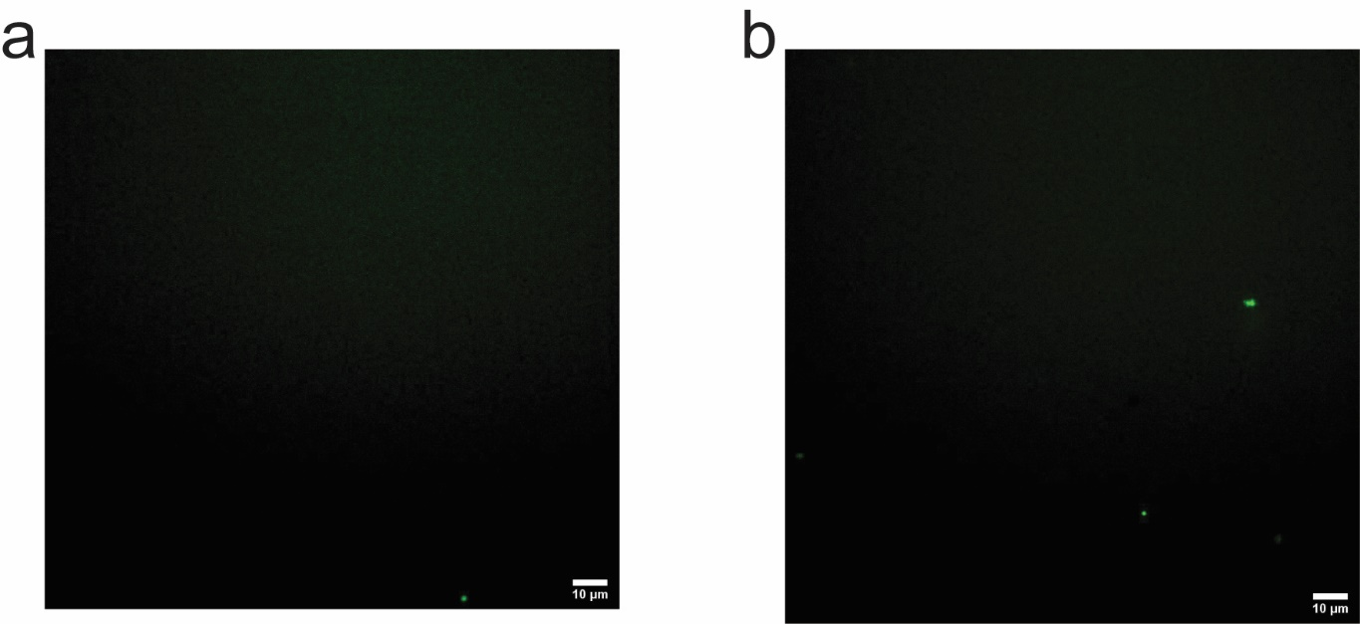
Fig. S 4 Fluorescence images for air-bubbling PISA specimens which were incubated at 40 ºC: a After 30min incubation, b After 16-h incubation. The PISA specimens were kept in dark during incubation period.

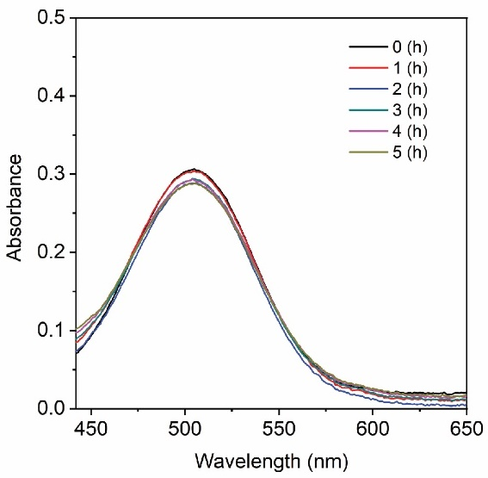
Fig. S 5 UV-VIS spectra of the photo-induced degradation product of m-RAFT aqueous solution prepared in an oxygen-poor environment.

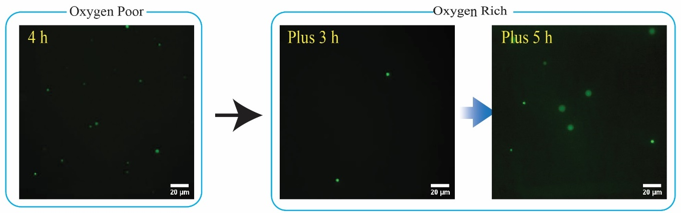
Fig. S 6 The effect of in-situ photo-induced degradation for oxygen-poor PET-PISA process in reactors. The first 4 h was PET-PISA process using styrene as the monomer in an oxygen poor environment. Afterward, the reactor was exposed to stronger power of blue light with introduction of air and rhodamine 6G. Unlike the use of HPMA, the polymer objects with PS as the hydrophobic cores tend to remain in droplet forms and very few objects show multi-compartmentalization during additional irradiation time.

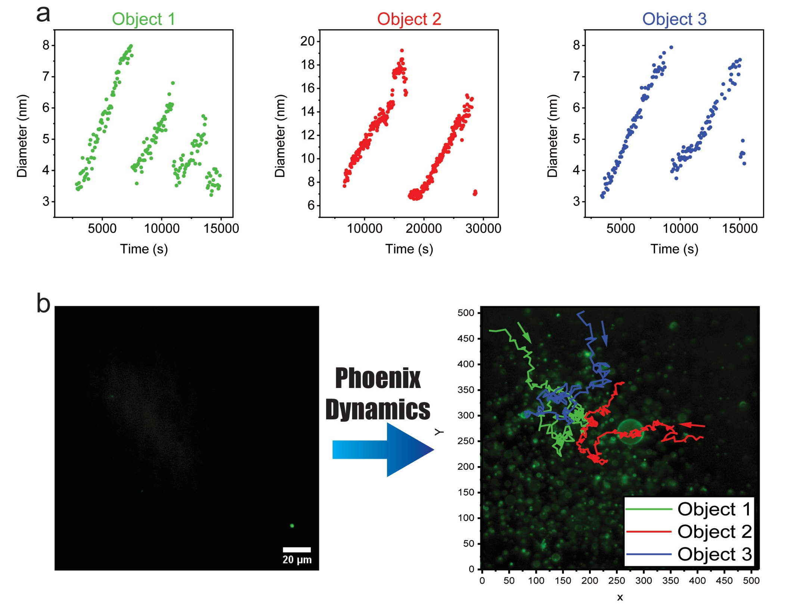
Fig. S 7 a Plots of the diameter variation with time for three objects from an oxygen-rich PISA specimen when exposed to irradiation under microscope. b Traces of the moving objects shown in a. Newborn objects tend to appear in the area where these objects undergoing Phoenix dynamics move.

Supplementary movie 1
A video clip for an oxygen-poor PISA specimen undergoing 16-h blue light irradiation from Zeiss microscope. Pseudo color: green.

Supplementary movie 2
A video clip for an oxygen-rich PISA specimen undergoing 16-h blue light irradiation from Zeiss microscope. Pseudo color: green.

