Additional Files
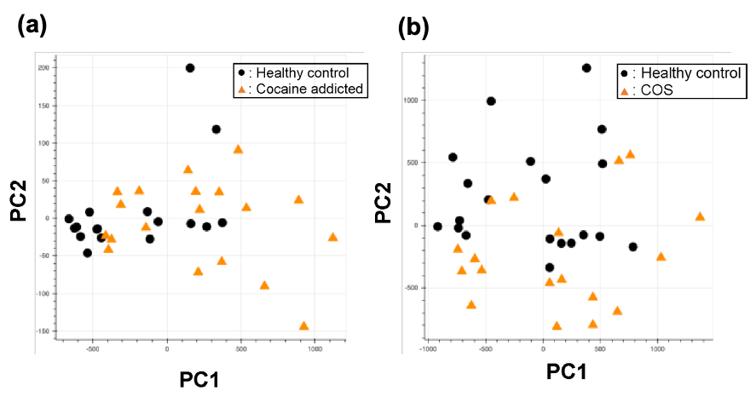
Additional file 1: Figure S1. PCA of the gene expression table without gene selection for the study of cocaine addiction (a) and childhood-onset schizophrenia (COS) (b).
Additional file 2: Figure S2. Example alignments near the region where the oligomers in Figure 5(c) are mapped. The positions of the oligomers are indicated by green dotted lines.

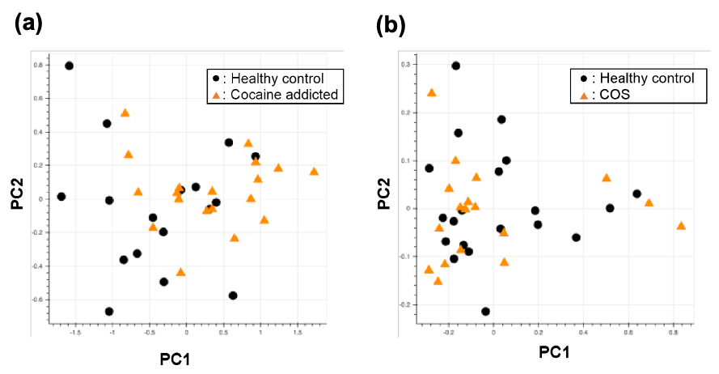
Additional file 3: Figure S3. PCA of the gene expression table with the genes in Figure 5(c) and in Figure 6(c).

Additional file 4: Figure S4. Example alignments near the region where the oligomers in Figure 6(c) are mapped. The position of the oligomers is indicated by the arrow.

