Supplementary informations
Recombinant TAT-Thymosin β-4 promotes angiogenesis by activating VEGFR2 Signaling pathway

Chul Min Kim^{1,§}, Yun-Mi Jeong^{2,§}, Jae-Hun Kim², Guolong Jin², Jung Seok Kim³, Dal Yong Park³, Songwan Jin², Jin-hyung Shim², Won-soo Yun², Seokhwan Yun^{2,*}
* Correspondence: yuntobi@kpu.ac.kr(S.Y) ; Tel.:+82-31-8041-1819
§ These authors contributed equally to this work.

Original Images of Western blotting

Figure 4a
t-VEGFR2
Primary antibody – Sigma, Cat# SAB4501645
Titer – 1:1000 in 3% TBST
Figure 4a
p-VEGFR2
Primary antibody – Merk, Cat# PS1013
Titer – 1:1000 in 3% TBST

Figure 4a
Ang1. Primary antibody
Millipore, Cat# AB3120
Titer – 1:1000 in 3% TBST

Ang2. Primary antibody
Millipore, Cat# AB3121
Titer – 1:1000 in 3% TBST
Figure 4a
Beta actin
Primary antibody – Sigma, Cat# A5441
Titer – 1:5000 in 3% TBST
Figure 5a
VEGFa
Primary antibody – Santacruz, Cat# sc7269
Titer – 1:1000 in 3% TBST

Figure 5a  Ponceau S staining  Standard for cell culture media protein because cell culture media contains no beta actin | 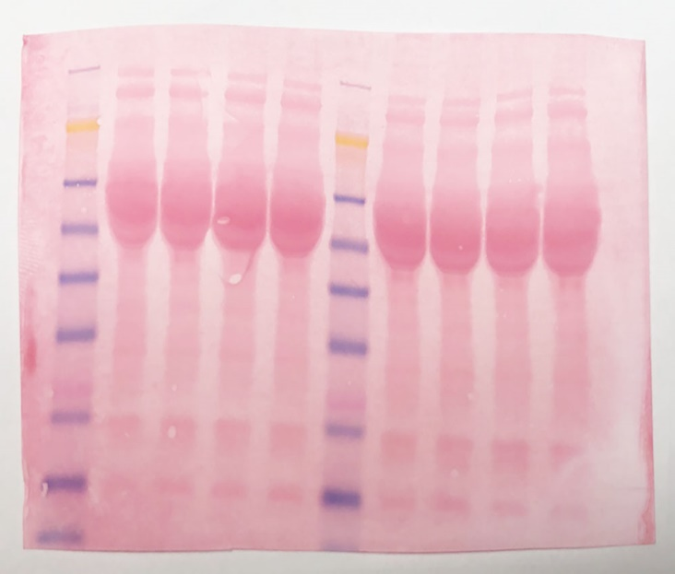
Figure 5b
VEGFa
Primary antibody – Santacruz, Cat# sc7269
Titer – 1:1000 in 3% TBST
Figure 5b
p-VEGFR2
Primary antibody – Merk, Cat# PS1013
Titer – 1:1000 in 3% TBST

Figure 5b
t-VEGFR2
Primary antibody – Sigma, Cat# SAB4501645
Titer – 1:1000 in 3% TBST
Figure 5b
p-AKT
Primary antibody – CST, Cat# 9272
Titer – 1:1000 in 3% TBST
Figure 5b
p-AKT
Primary antibody – CST, Cat# 9271
Titer – 1:1000 in 3% TBST

Figure 5b
p-ERK
Primary antibody – CST, Cat# 9102
Titer – 1:1000 in 3% TBST
Figure 5b
t-ERK
Primary antibody – CST, Cat# 9101
Titer – 1:1000 in 3% TBST
Figure 5b
CD31
Primary antibody – abcam, Cat# ab28364
Titer – 1:1000 in 3% TBST

Figure 5b
Beta actin
Primary antibody – Sigma, Cat# A5441
Titer – 1:5000 in 3% TBST
Figure 6a
Apoptosis Western blot Cocktail
(Cleaved PARP, beta actin, procaspase3, cleaved caspase3)
Primary antibody – abcam, Cat# ab136812
Titer – 1:1000 in 3% TBST

