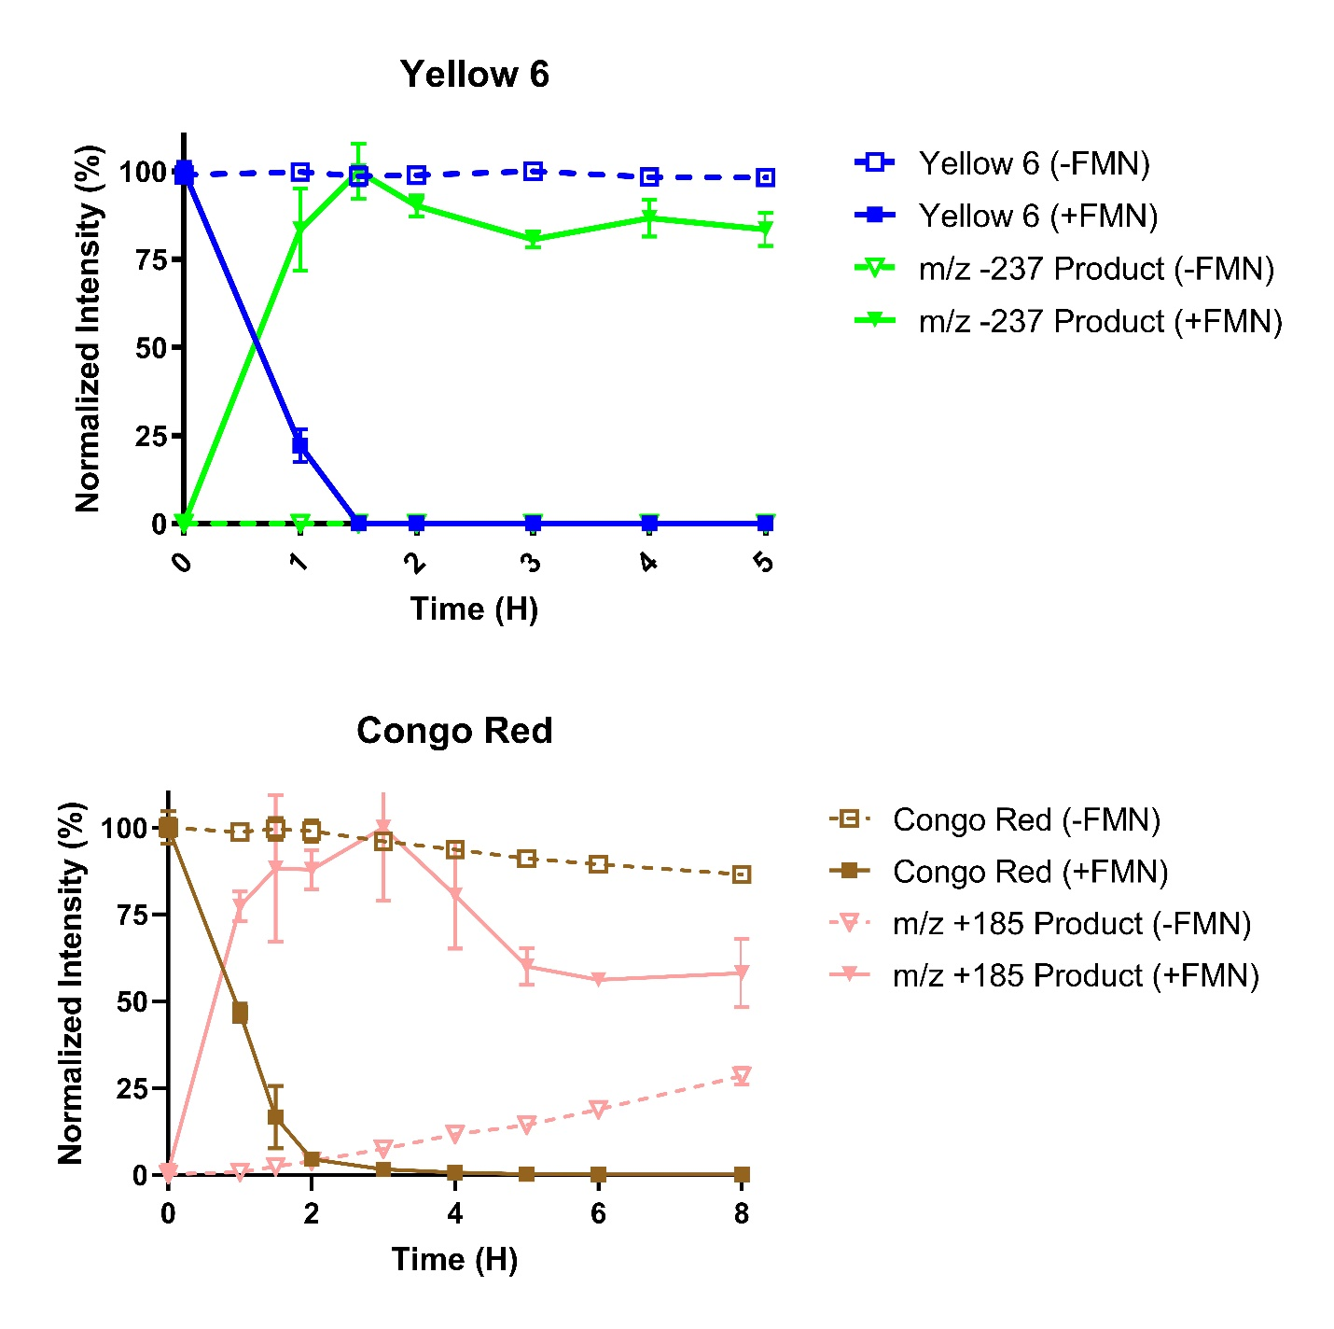

Supplementary Fig. 1. Azoreduction Rates of Flavin-Dependent Compounds. Normalized MS intensities of azo compounds and their proposed azoreduced metabolites. Dashed lines indicate conditions without FMN as an electron shuttle.

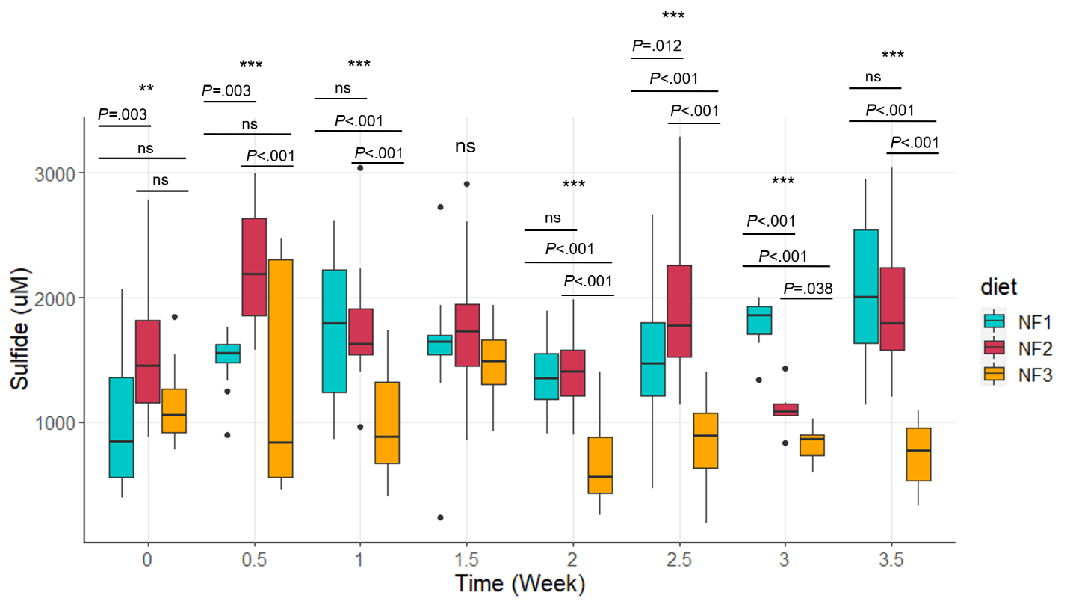

Supplementary Fig. 2. Dietary cysteine and fecal sulfide. Mice fed 8 g/kg cysteine (NF2, High Cys) could not be distinguished from mice fed 4 g/kg cysteine (NF1, Control Cys) after 1 week (Tukey HSD p<0.05). After 2 weeks, fecal sulfide is lower in 0 Cysteine diet (NF3) than either Control or High Cysteine diets.

