Supplementary Materials

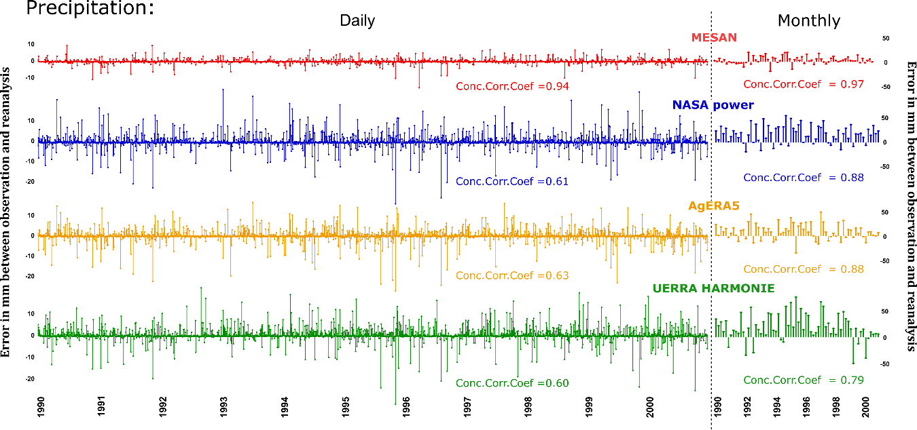
Fig. S1: Error between observed precipitation and reanalysis product values for each cropping season (April-September) 1990-2000 at Ultuna. Left: error based on daily data and right: error based on monthly data, with agreement given as concordance correlation coefficient (Conc.Corr.Coeff).

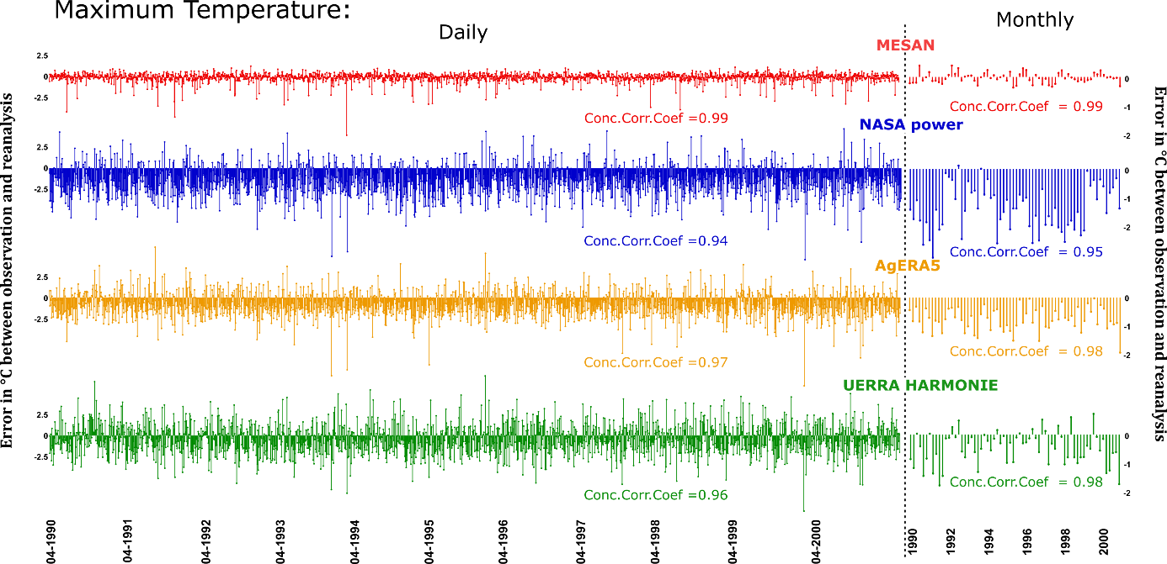
Fig. S2: Error between observed maximum temperature and reanalysis product values for each cropping season (April-September) 1990-2000 at Ultuna. Left: error based on daily data and right: error based on monthly data, with agreement given as concordance correlation coefficient (Conc.Corr.Coeff).

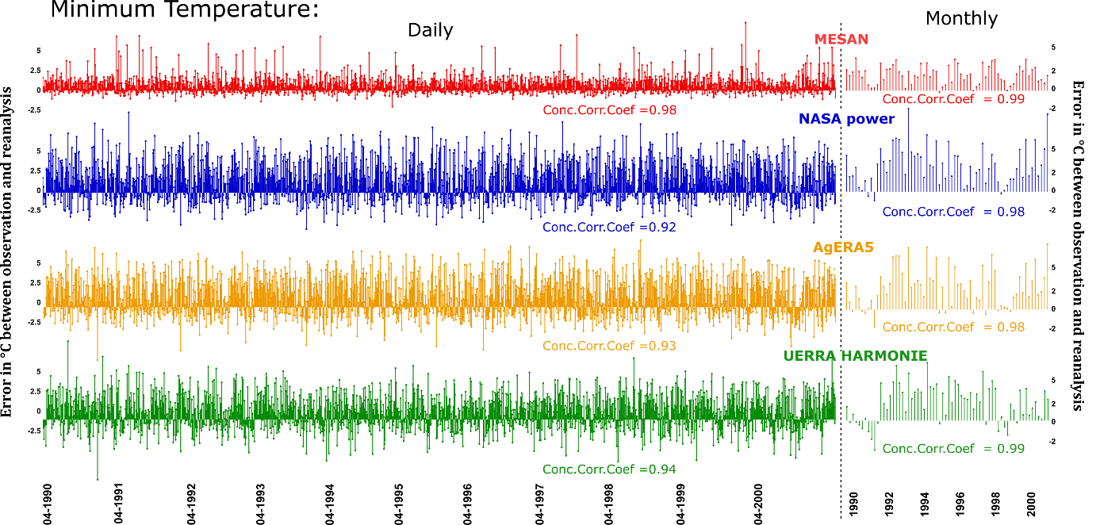
Fig. S3. Error between observed minimum temperature and reanalysis product values for each cropping season (April-September) 1990-2000 at Ultuna. Left: error based on daily data and right: error based on monthly data, with agreement given as concordance correlation coefficient (Conc.Corr.Coeff).

