DMSO + TGFβ SB-505124 + TGFβ
A B
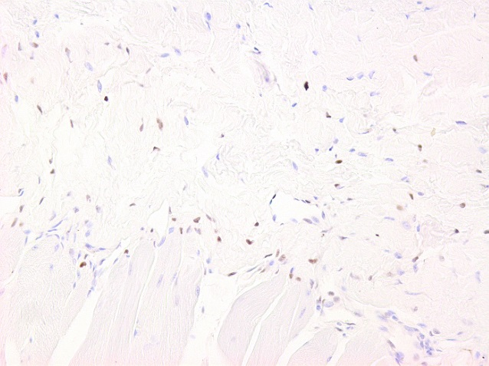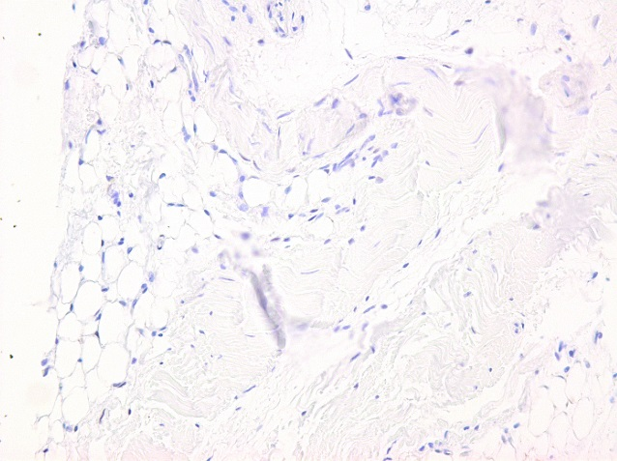
Supplementary figure S1. Intra-articular injection of SB-505124 + TGFβ results in less pSMAD2/3 confirming the efficacy of SB-505124. Synovium from naïve mice was collected to determine pSMAD2/3 3 hours after intra articular injection of SB-505124 with TGFβ . Injection with SB-505124 (B) resulted in less pSMAD2/3 compared to TGFβ injected mice (A) (n=3 mice).
DMSO + TGFβ SB-505124 + TGFβ
A B
Supplementary figure S2. Intra-articular injection of SB-505124 + TGFβ results in less pSMAD2/3 confirming the efficacy of SB-505124. Synovium from naïve mice was collected to determine pSMAD2/3 3 hours after intra articular injection of SB-505124 with TGFβ . Injection with SB-505124 (B) resulted in less pSMAD2/3 compared to TGFβ injected mice (positive cells highlighted with use of ImageJ) (A) (n=3 mice).

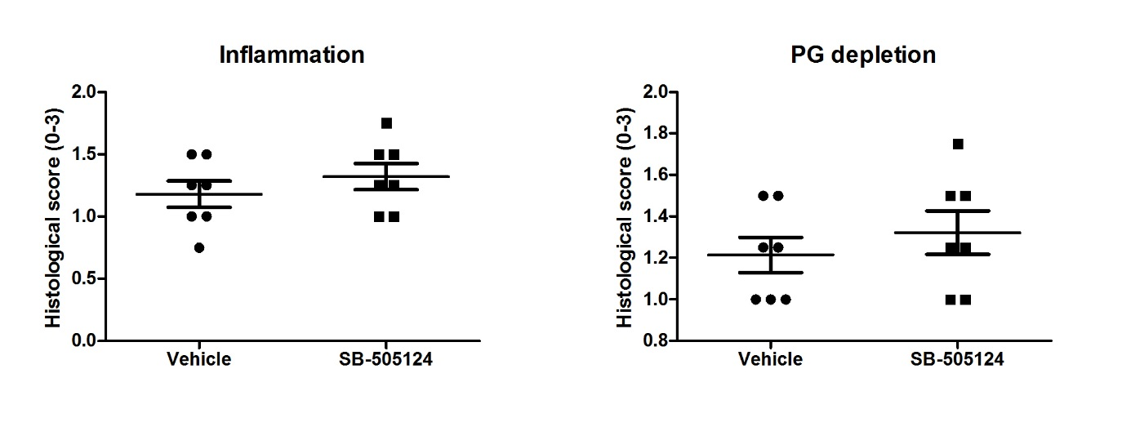
A B
Supplementary figure S3. Repeated intra-articular injections of SB-505124 do not decrease joint inflammation and cartilage PG depletion during streptococcal cell wall (SCW) arthritis. Mice were daily injected i.a. with vehicle or SB-505124 for 4 days. Total knee joints were isolated for histopathologic analysis (n=7 mice/group). Joint inflammation (H&E stain, original magnification 100x) (A) and PG depletion (Safranin O staining, original magnification 100x) (B) on day 4 were analyzed on histological slides. Values are mean ±SEM.

