Anti-tumor effect of CTLA-4 antibody is independent of checkpoint blockade

Supplementary Materials

Supplementary Table S1-S4
Supplementary Figure S1-S3

Supplementary Table 1. Data collection and refinement statistics for crystal structures
 | CTLA-4/ipilimumab-Fab | CTLA-4/D138-dAb
PDB code | 6RP8 | 6RPJ
Crystallization condition | 20% PEG 3000, 0.2M Ca(AC)₂, 0.1M Hepes pH 7.0 | 12% PEG 3350, 3% Tascimate pH5.0
Data collection
Space group | P1211 | C121
Cell dimensions
a, b, c (Å)  α, β, γ (°) | 56.91, 129.89, 76.91  90, 96.44, 90 | 309.98, 75.708, 83.047  90, 100.05, 90
Wavelength (Å) | 0.9792 | 0.97915
Resolution (Å) | 48.11-2.60 (2.72-2.60) | 50-3.25 (3.37-3.25)
Total NO. of observation | 121541 (15065) | 140556 (27487)
Total NO. unique | 34019 (4158） | 30159 (1926)
R_{merge} | 0.17 (0.87) | 0.15 (0.72)
I/σI | 6.4 (1.5) | 8.0 (3.0)
Completeness (%) | 99.3 (99.7) | 100 (99.9)
Multiplicity | 3.6 (3.6) | 4.7 (4.5)
Refinement
Resolution (Å) | 48.11-2.60(2.667-2.60) | 47.57-3.25 (3.329-3.25)
No. of reflections | 33990 （1911） | 27487 (1926)
No. of residues | 1073 | 973
No. of atoms | 8177 | 7424
R_{work}/R_{free} | 0.211/0.267 | 0.248/0.263
B-factors (Å²) | 45.0 | 98.0
Bond length RMSD (Å) | 0.010 | 0.006
Bond angle RMSD (°) | 1.227 | 0.937
Ramachandran plot
In Preferred Region (%) | 96.3 | 94.6
In Allowed Region (%) | 3.7 | 5.33
Outliers (%) | 0 | 0.10

Supplementary Table 2. Hydrogen bonds and salt bridges between CTLA-4 and D138-dAb（distance ≤ 3.7Å）
CTLA-4 contact residue | CTLA-4 residue location | D138-dAb contact  residue | D138-dAb residue  location
V46 | C’ strand | N29 | CDR1
T47 | C’ strand | N29 | CDR1
E48 | C’ strand | G102 | CDR3
E48 | C’ strand | A104 | CDR3
E48 | C’ strand | W105 | CDR3
D64 | C’’D loop | R108 | CDR3
D65 | C’’D loop | R47 | C’ strand
D65 | C’’D loop | C106 | CDR3
D65 | C’’D loop | R108 | CDR3
G83 | DE loop | T56 | CDR2
D88 | DE loop | G55 | CDR2

Supplementary Table 3. Binding affinities of CTLA-4 variants towards D138
CTLA-4 variants | Kd (M) | K_{on} (1/Ms) | K_{off} (1/s)
WT | 5.21E-08# | 1.29E+05 | 6.70E-03
T47A | 7.27E-07 | 2.69E+04 | 1.95E-02
E48A | —* | — | —
V49A | —* | — | —
L63A | 2.91E-08 | 2.74E+05 | 8.00E-03
D64A | 3.15E-05 | 4.17E+02 | 1.32E-02
D65A | —* | — | —
I67A | 1.36E-06 | 6.96E+04 | 9.48E-02
D88A | —* | — | —
Y92A | —* | — | —
#CTLA-4-His protein has a larger Kd value than that of CTLA-4-mFc (Fig. 1b) due to CTLA-4-mFc is bivalent.
*No significant binding could be detected when the concentrations of these CTLA-4 variants were increased to 6.6 μM.

Supplementary Table 4. Antibodies used for Flow Cytometry analysis
Reagent | Source | Cat number
Livedead-BV510 | BD Biosciences | Cat# 564406
Anti-mouse CD45-APC-Cy7 | Biolegend | Cat# 103114
Anti-mouse CD45.2-APC | Biolegend | Cat# 109828
Anti-mouse CD4-APC | eBioscience | Cat# 47-0042-82
Anti-mouse CD8-PerCy5.5 | Biolegend | Cat# 100712
Anti-mouse Foxp3-PE-Cy7 | eBioscience | Cat# 17-5773-82
Anti-mouse ICOS-PE | Biolegend | Cat# 107705
Anti-mouse OX40-FITC | Abcam | Cat# ab33998
Anti-mouse PD1-PE-Cy7 | eBioscience | Cat# 25-9985-80
Anti-human CTLA-4-PE-Cy7 | Biolegend | Cat# 349914
Anti-human CTLA-4 PE | Biolegend | Cat# 349905
Anti-mouse Ki67-PE | BD Biosciences | Cat# 556027

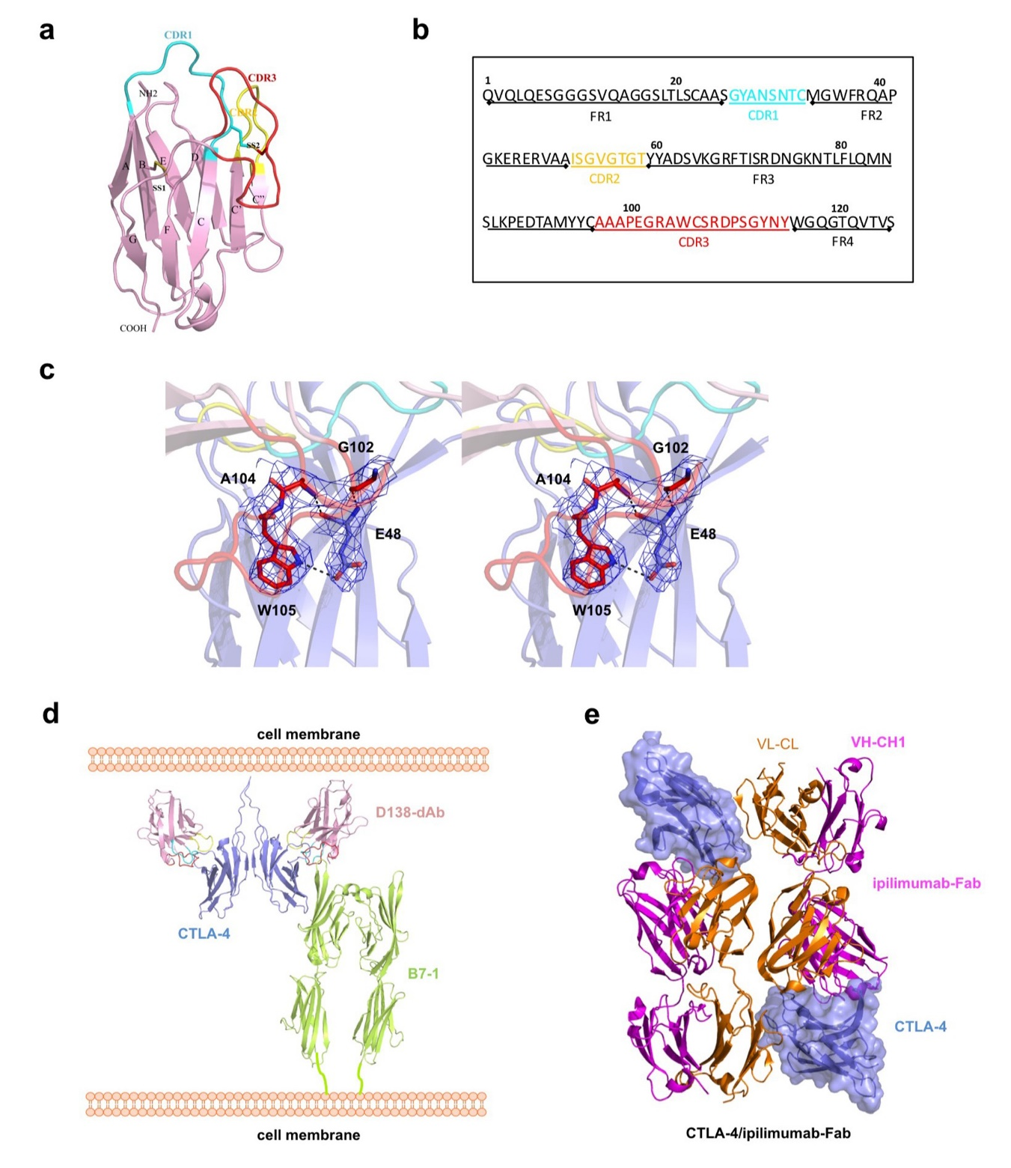
Supplementary Fig. 1. Structures of CTLA-4 antibodies. a. Structure of D138-dAb with CDR1 loop in cyan, CDR2 in yellow and CDR3 in red. b. The sequence of D138-dAb with each CDR region highlighted in corresponding color. c. The wall-eye stereo view of the interaction between Trp105 of D138 and Glu48 of CTLA-4 with electron density (blue mesh) contoured at 1σ. d. A model of a complex of CTLA-4 dimer with D138 and B7-1 dimer on the cell surface showing D138 binding would not affect the CTLA-4-B7 interaction. e. Two copies of CTLA-4 and ipilimumab-Fab complex in the asymmetry unit of the crystal structure.

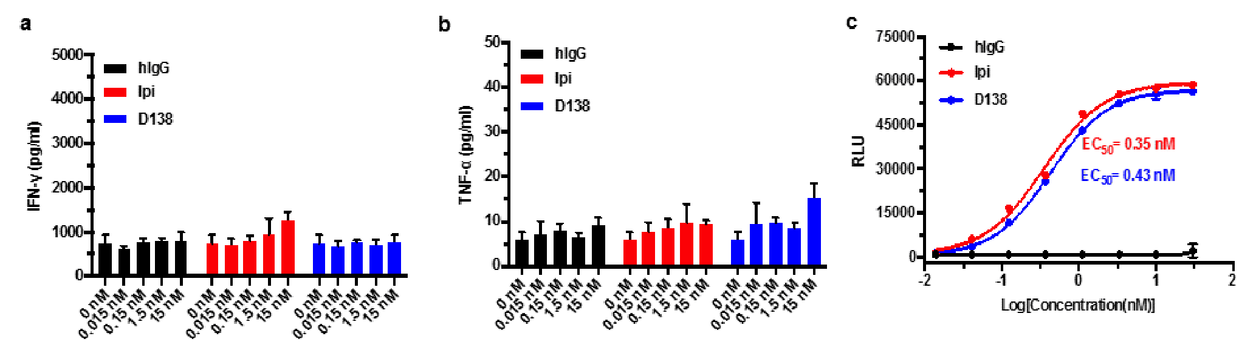
Supplementary Fig. 2. INF-γ (a), TNF-α (b) production and ADCC activities (c) by antibodies. a,b. Freshly prepared PBMCs were plated in serum free RPMI-1640, and incubated in 37°C, 5% CO₂ for 2 hours in 96-well plate (2×10⁵ cells). The cells were then treated with different concentrations of ipilimumab or D138 for one hour. Staphylococcus Enterotoxin B (SEB, 200 ng/ml) was subsequently added. The supernatant was collected after five days culture and the levels of INF-γ and TNF-α were evaluated by ELISA kit according to the manufacturer instructions. c. ADCC activities of antibodies were also determined using Fc Effector Reporter Bioassays. CTLA-4 transiently expressed on HEK293T cells were used as targeted cells. The effector cells were co-cultured with target 293-CTLA-4 cells at an effector-to-target ratio of 4:1, and along with different concentrations of anti-human CTLA-4 antibodies or control. After incubation of the 96-well plates at 37°C for 6h, 75 μl Bio-Glo™ luciferase assay reagent was added into each well and the luminescence intensity was measured (n=3).

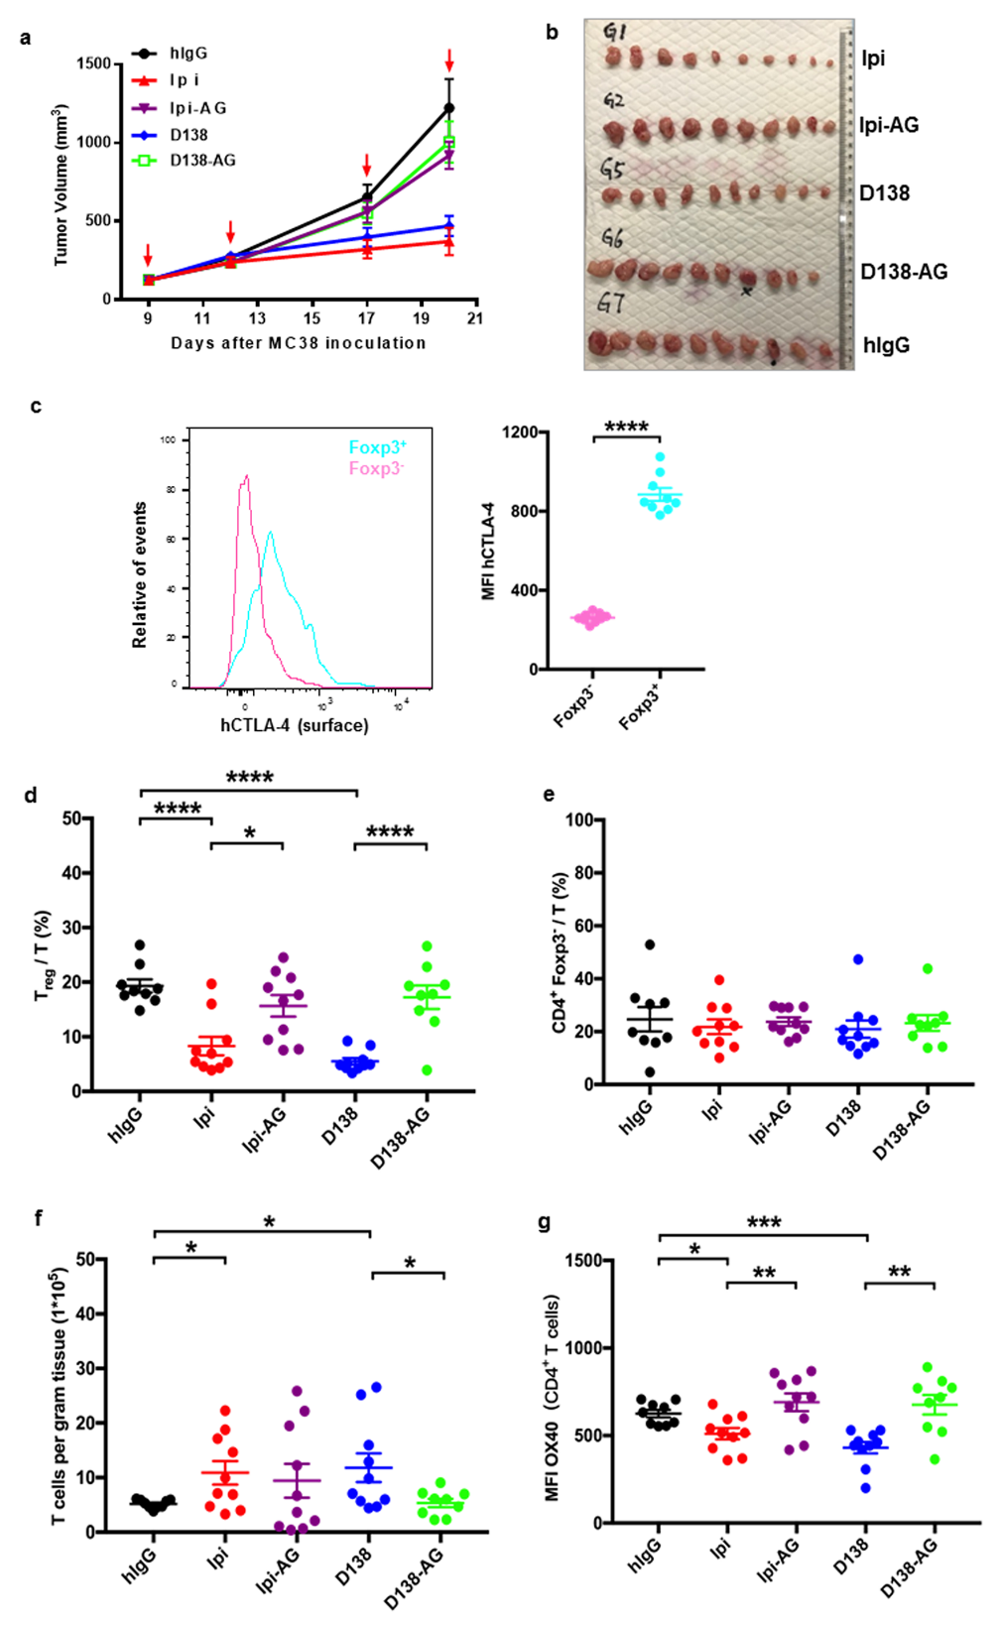
Supplementary Fig. 3. Intra-tumor T cell population analysis. a. Age-matched Ctla4^{h/h} C57BL/6J female mice were inoculated with MC38 (1×10⁶ cells). After tumor size reached about 80~160 mm³, mice were grouped (n=10 each group) and treated (arrowed) via intraperitoneal administration of antibodies. Tumor volume and body weight of tumor were recorded. Data represent mean±S.E.M. b. Mice were sacrificed on day 21 (one day after the fourth injection)with tumors extracted. c. The shaded histogram (left) or summary graph (right) showing surface CTLA-4 expression on CD4⁺Foxp3⁺ or CD4⁺Foxp3⁻ T cells in tumors from the control hIgG-treated group. d-g, Tumors were digested and cells were stained with various mAbs and analyzed with flow cytometry similarly as in Figure 4. d. The percentage of T_{reg} cells over total T cells. e. The percentage of CD4⁺Foxp3⁻ cells over total T cells. f. Numbers of T cells per gram of tumor tissue. g. MFI of OX40 on CD4⁺ T cells. Statistical significance was determined using unpaired Student’s t test. Notably, two mice died one day before the 4th treatment and their tumors (marked with black dot below in b) were extracted but were excluded for T cell population analysis.

