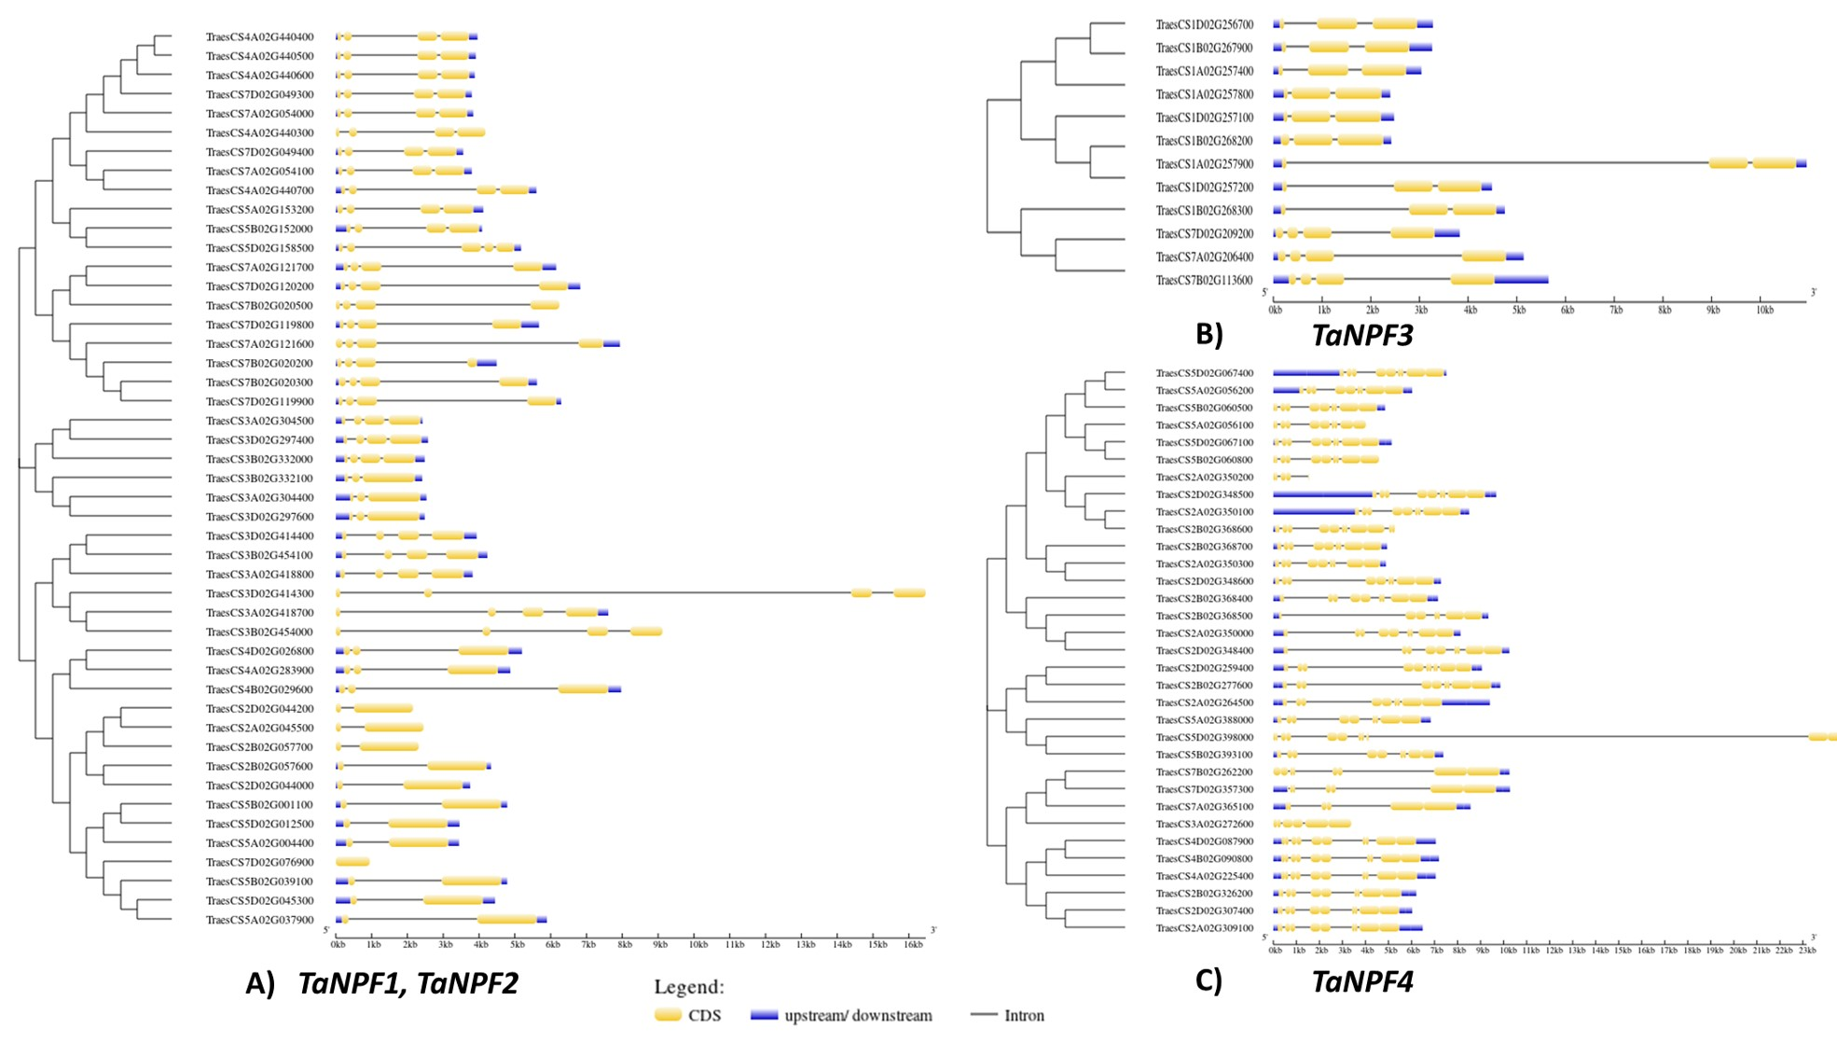

Supplementary Figure S1a Gene structures of nitrate transporter genes. A- TaNPF1, TaNPF2, B- TaNPF3 C- TaNPF4
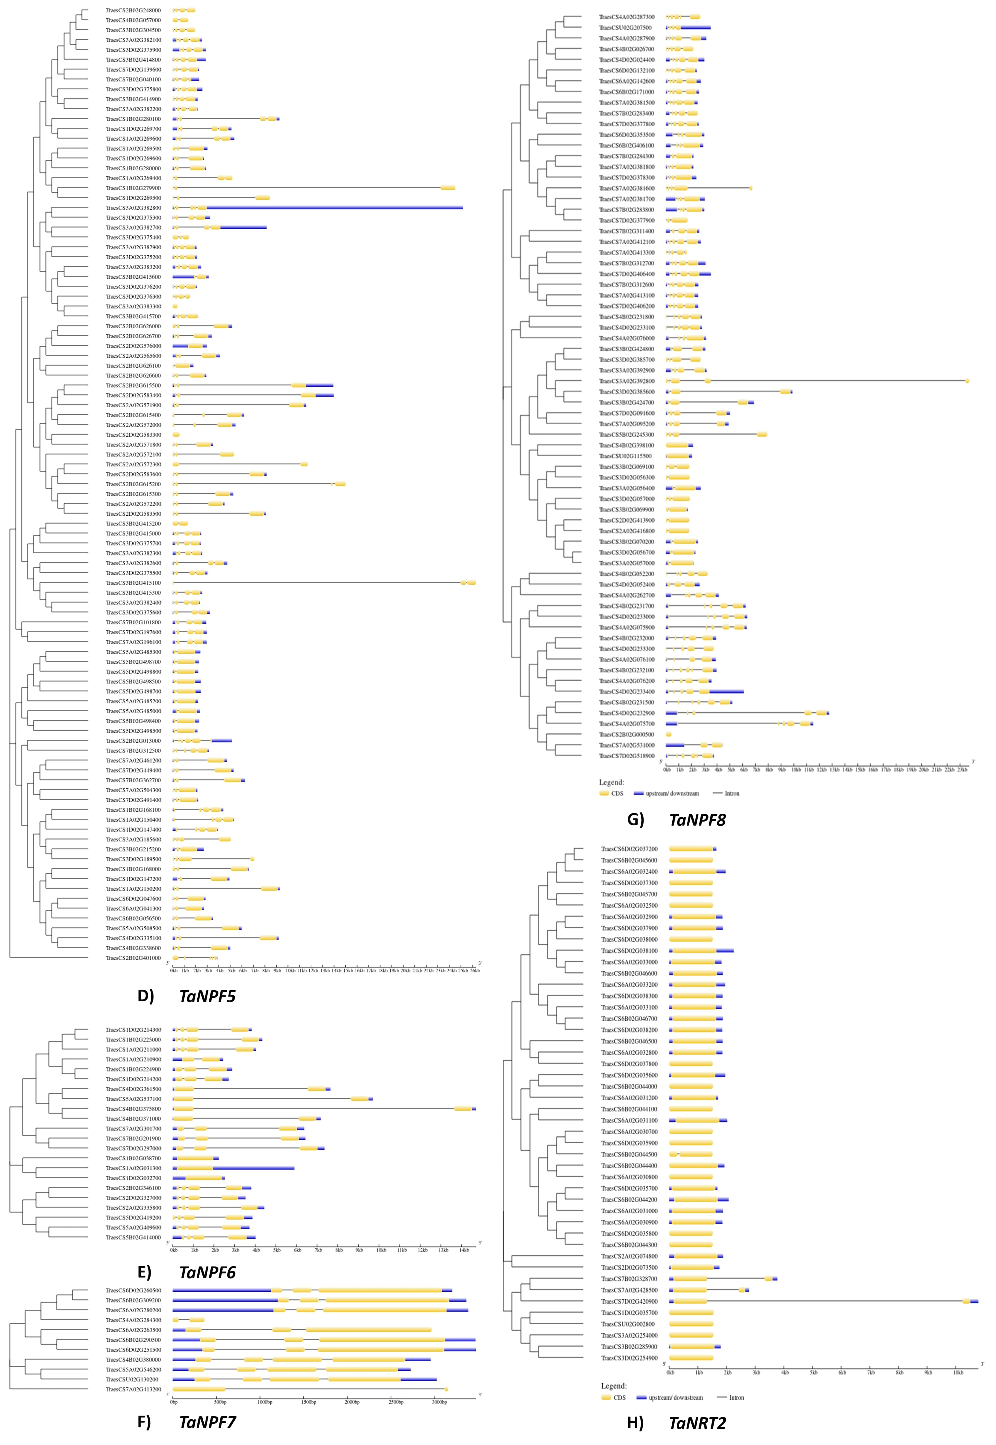

Supplementary Figure S1b Gene structures of nitrate transporter genes. D- TaNPF5, E- TaNPF6 F- TaNPF7, G- TaNPF8, H- TaNRT2.

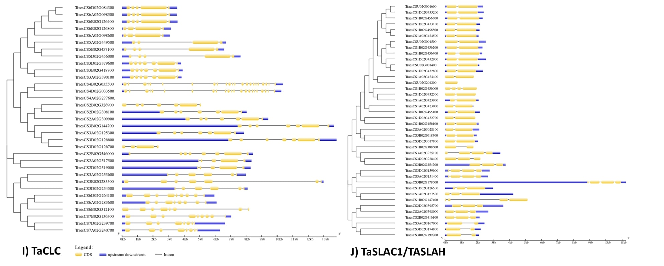

Supplementary Figure S1c Gene structures of nitrate transporter genes. I-TaCLC, K- TaSLAC/TaSLAH.
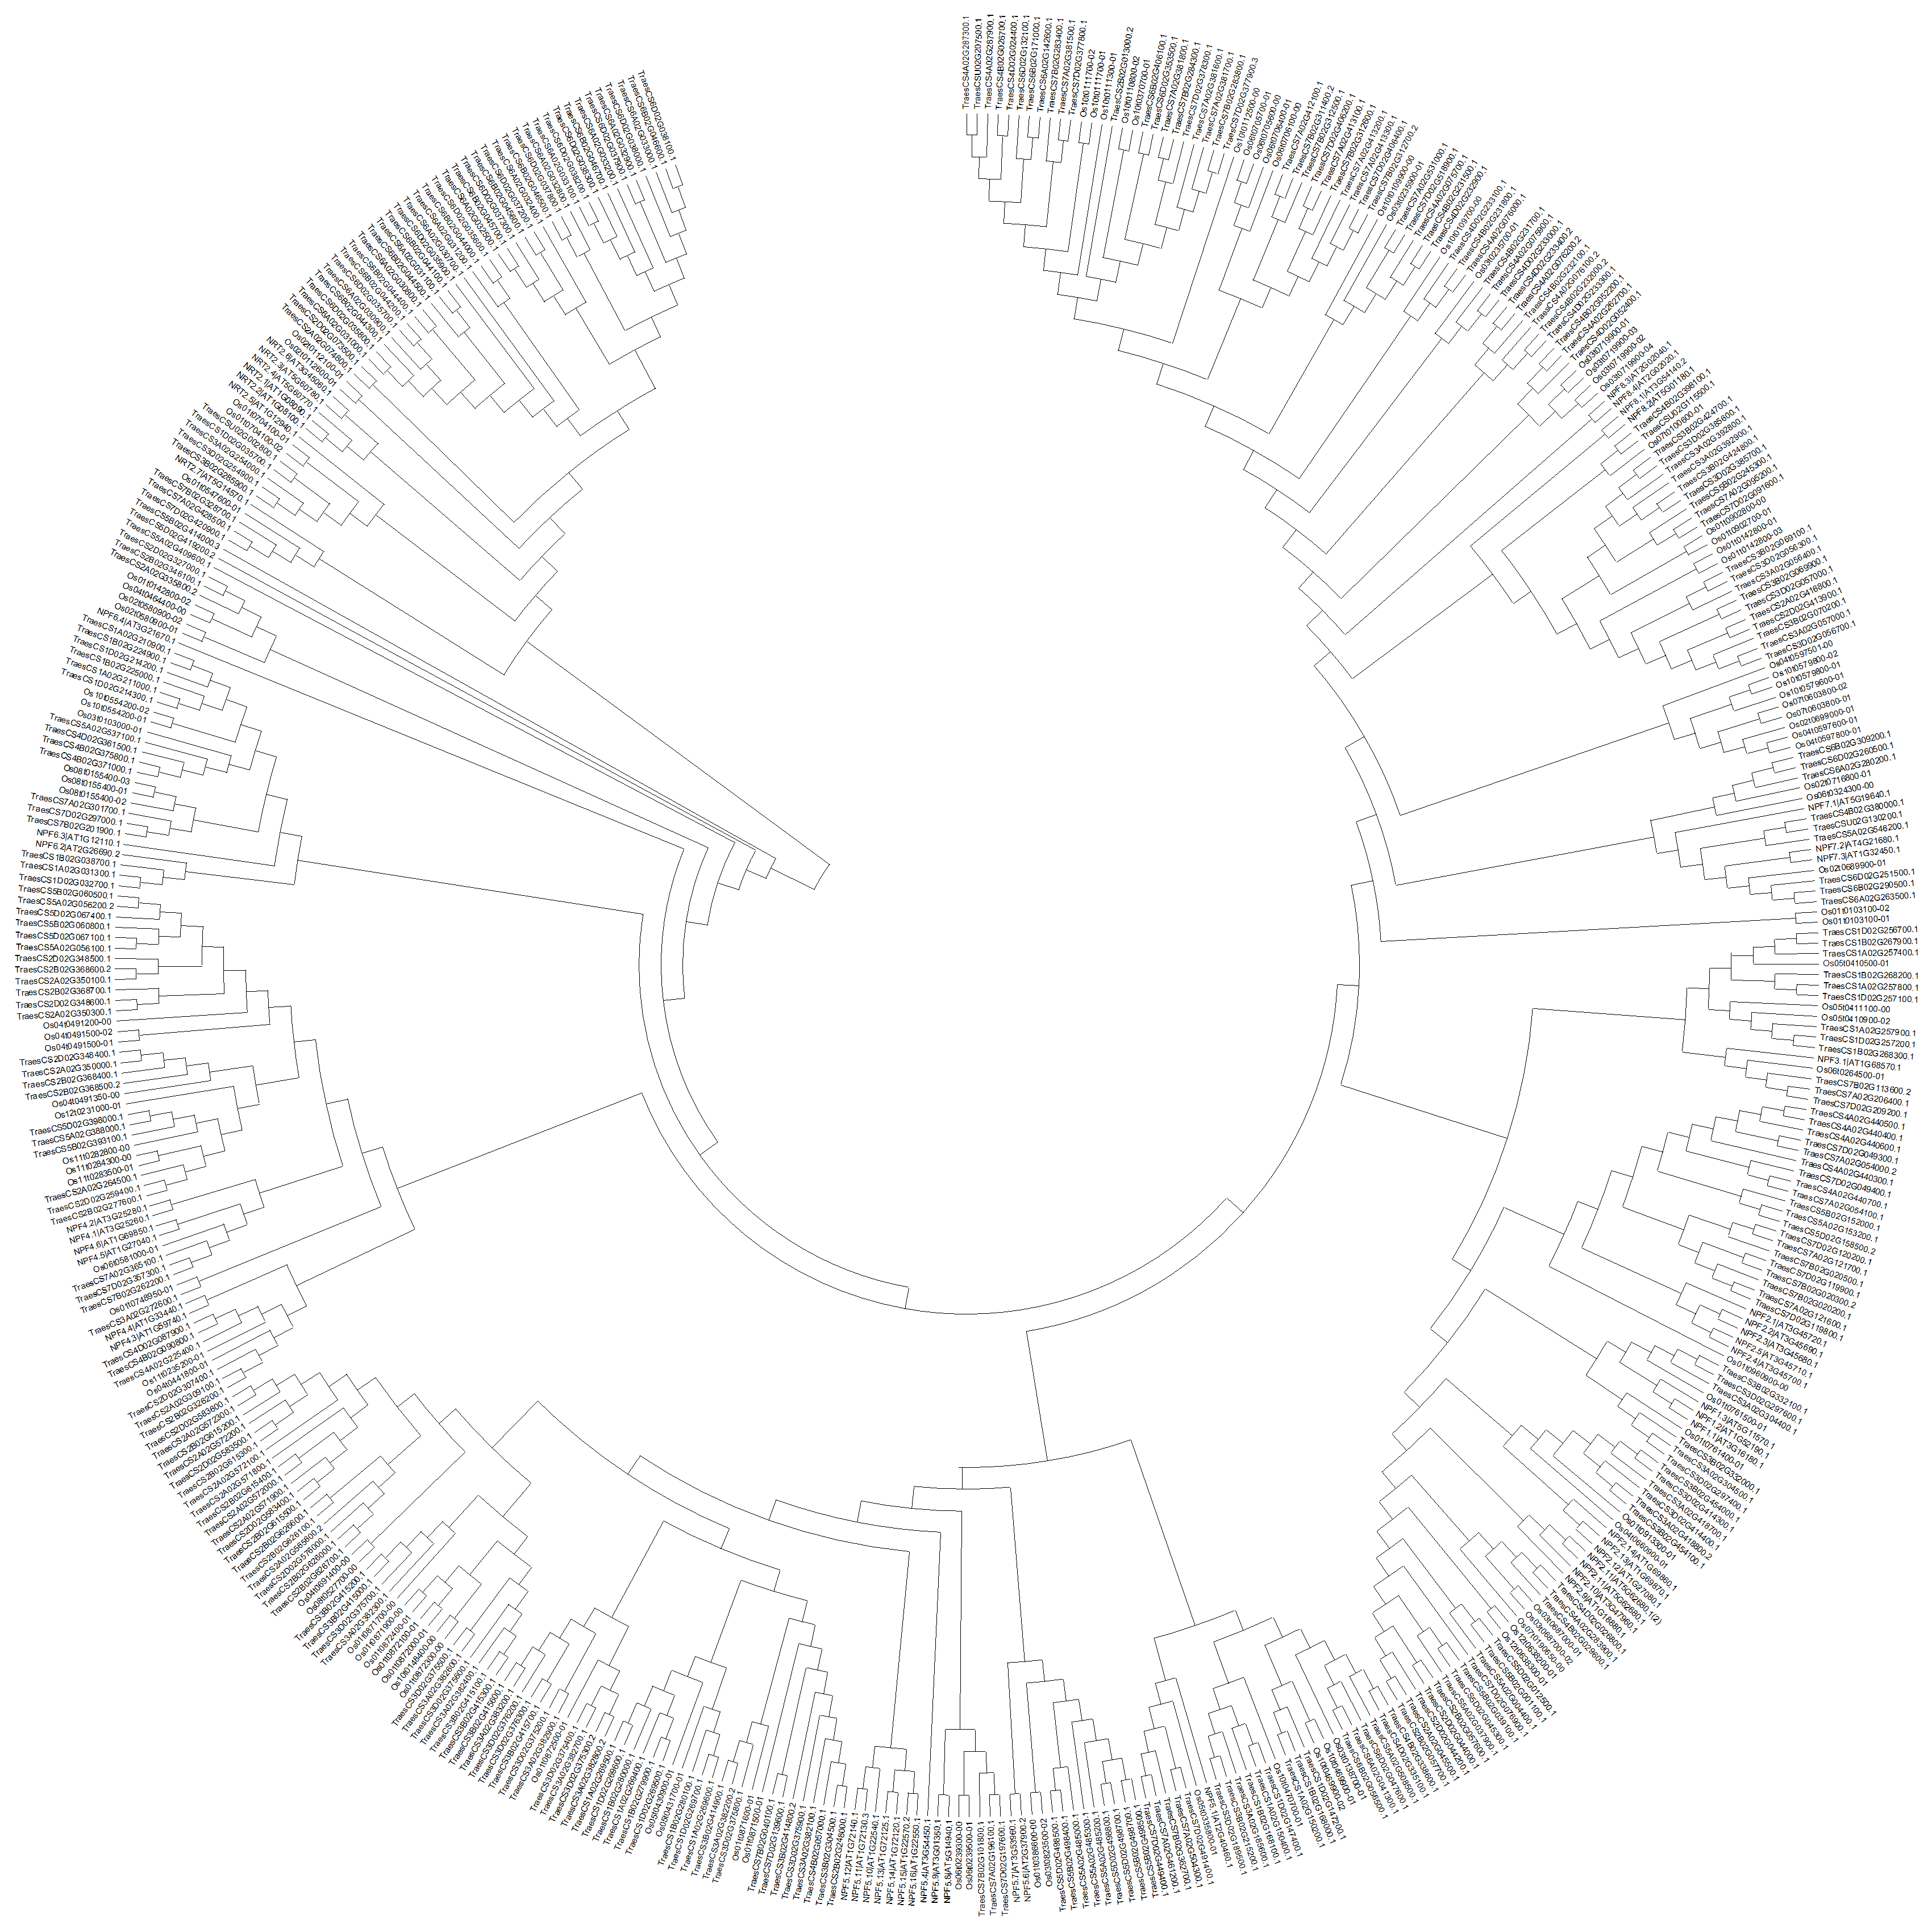

Supplementary Figure S2 Phylogenetic relationship of wheat NPF and NRT2 genes with Arabidopsis and rice nitrate transporter genes

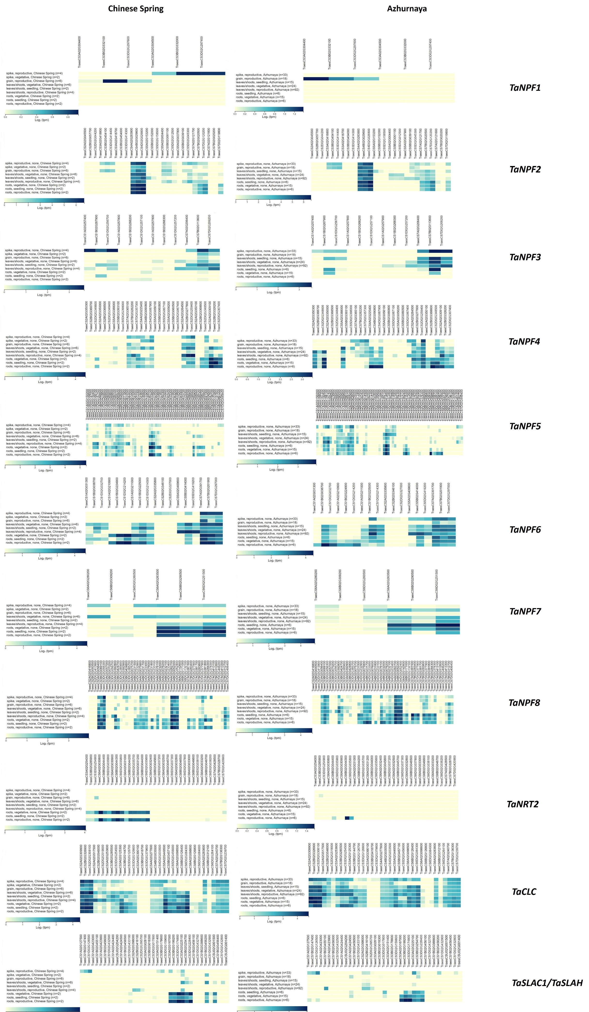
Figure S3 Expression patterns of all nitrate transporter genes in developmental stages of Chinese spring and Azhurnaya

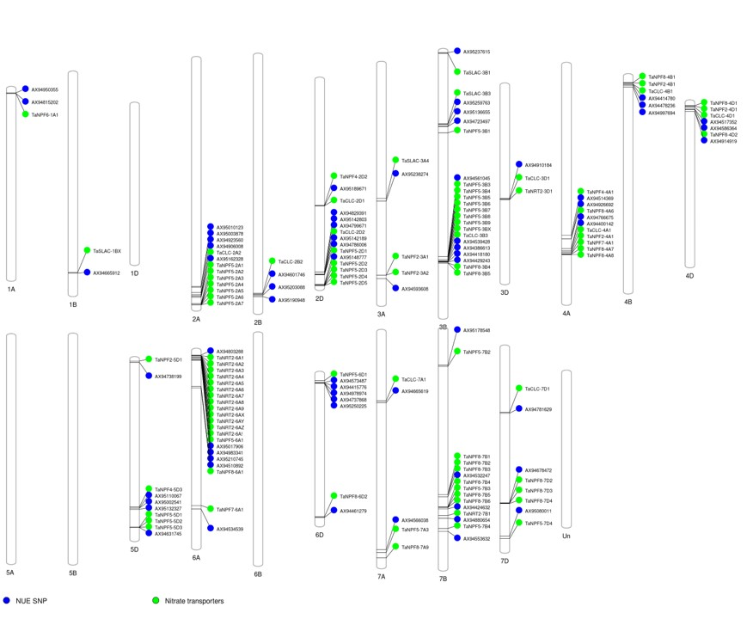
Figure S4 Proximity of nitrogen use efficiency (NUE) linked SNPs to nitrate transporters detected in this study

