Supplementary Information
Enhanced Photocatalytic CO₂ Reduction with Defective TiO₂ Nanotubes Modified with Single-Atom Binary Metal Components.

Honghui Panª, Xiaoguang Wangª, Zhiwei Xiongª, Minghui Sunª, Yanrong Zhang^{a*}

ªEnvironmental Science Research Institute, Huazhong University of Science and Technology, Wuhan 430074, P.R. China

^{b}Department of Chemistry, PSG College of Technology, Peelamedu, Coimbatore, 641004, India

*Corresponding author information:
Prof. Yanrong Zhang
E-mail: yanrong_zhang@hust.edu.cn
Phone: +86 27 87793001; Fax: +86 27 87793001
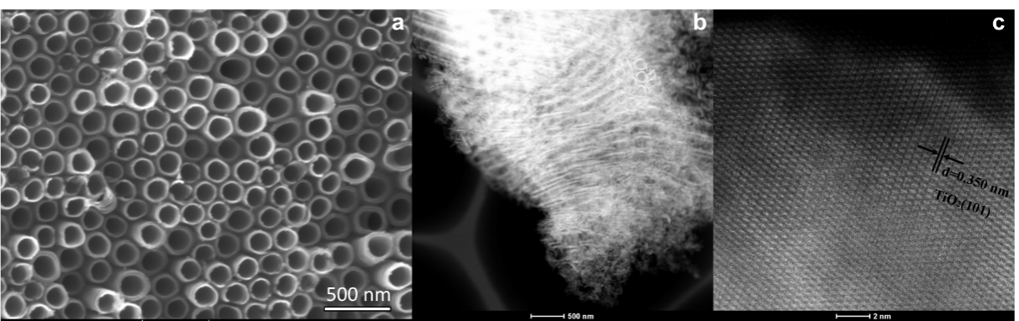

Supplementary Figure 1. (a) SEM image, (b) TEM image, and (c) high-resolution TEM images of the TNTs support.

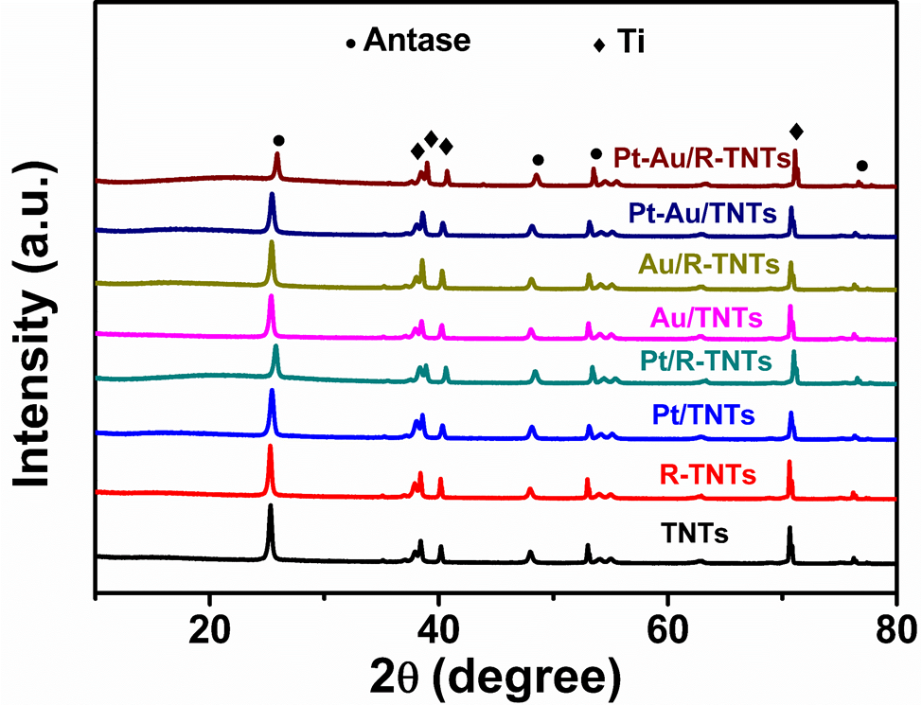
Supplementary Figure 2. XRD patterns of the fabricated catalysts.

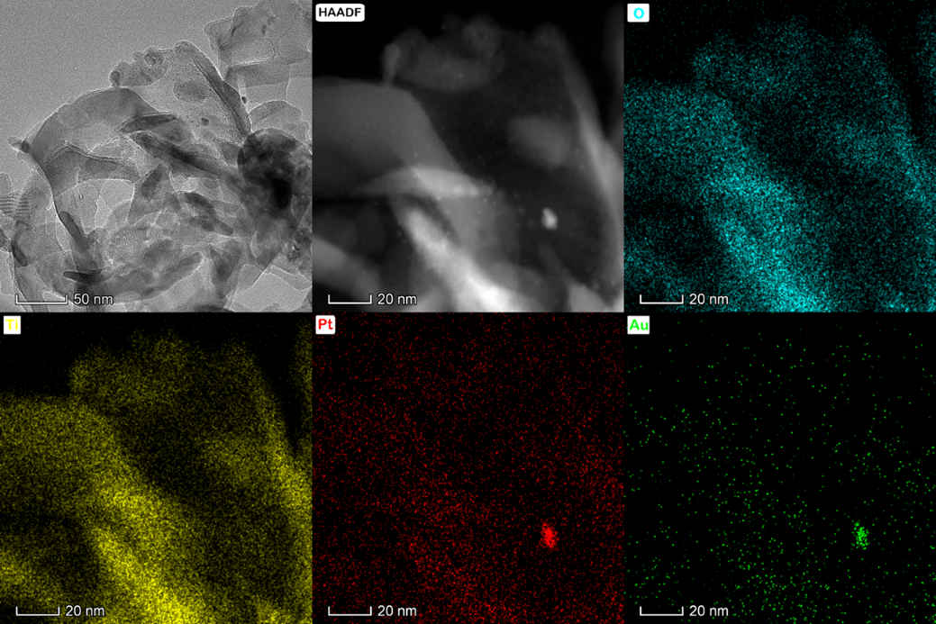

Supplementary Figure 3. Elemental mappings of Pt-Au/TNTs show the distribution of O (cyan), Ti (yellow) Pt (red), and Au (green).

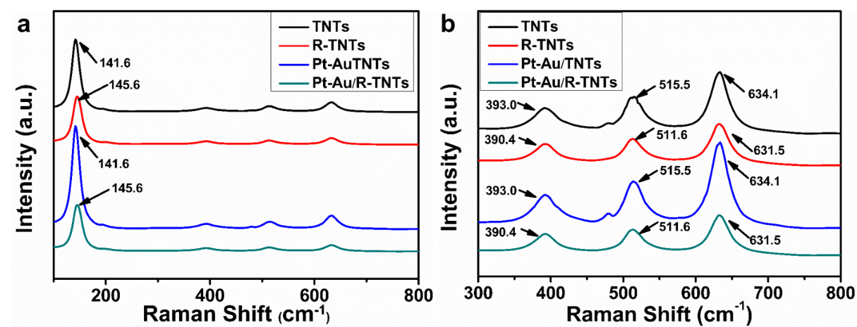
Supplementary Figure 4. (a) Raman spectra of catalysts, (b) the amplifying spectra between 300 and 800 nm.

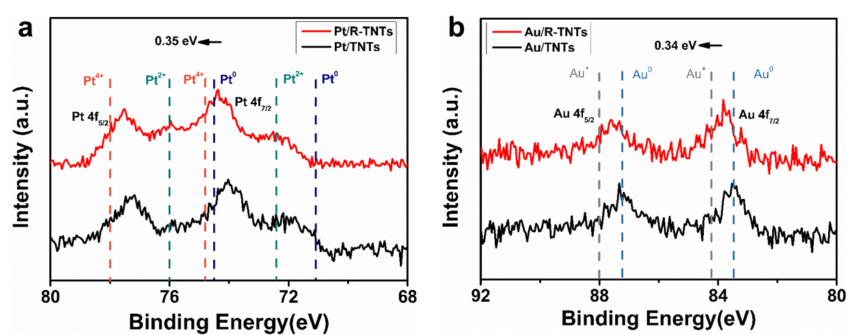
Supplementary Figure 5. High resolution XPS: (a) Pt 4f spectra of Pt/R-TNTs and Pt/TNTs; (b) Au 4f spectra of Au/R-TNTs and Au/TNTs.

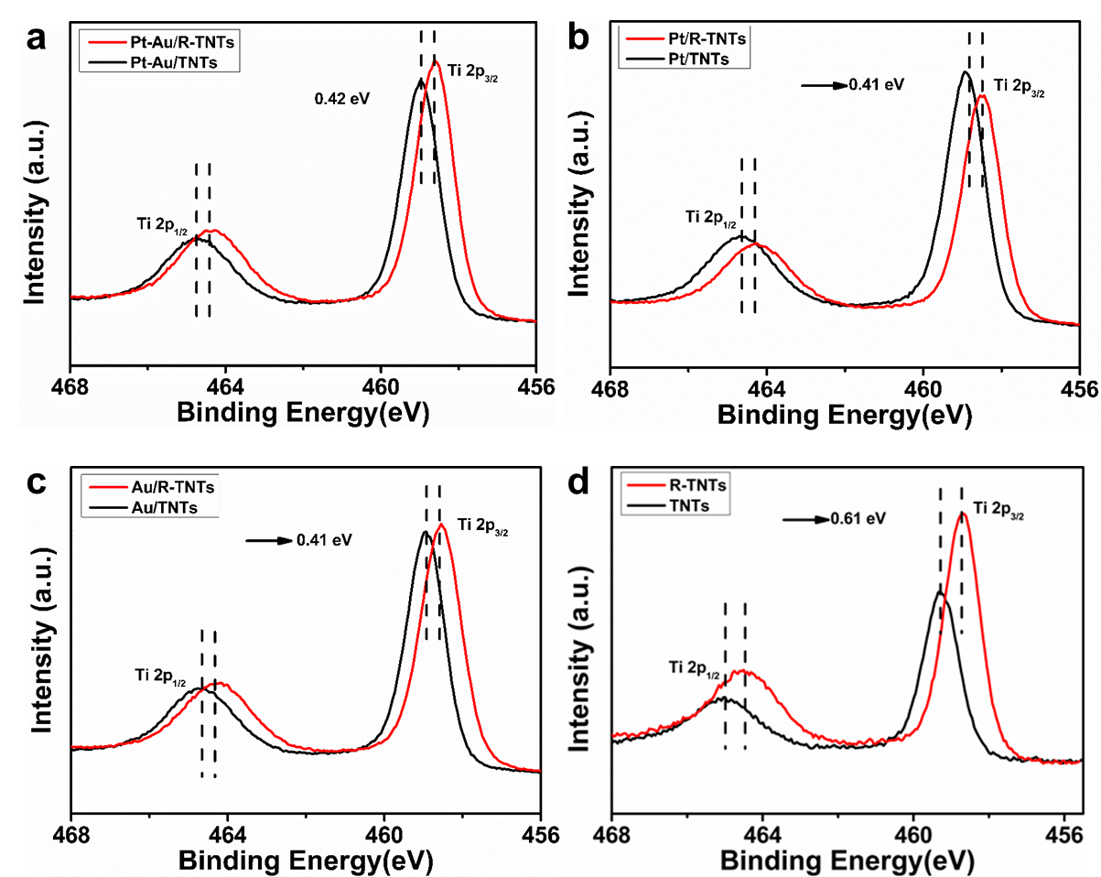
Supplementary Figure 6. High resolution XPS Ti 2p spectra of catalysts.

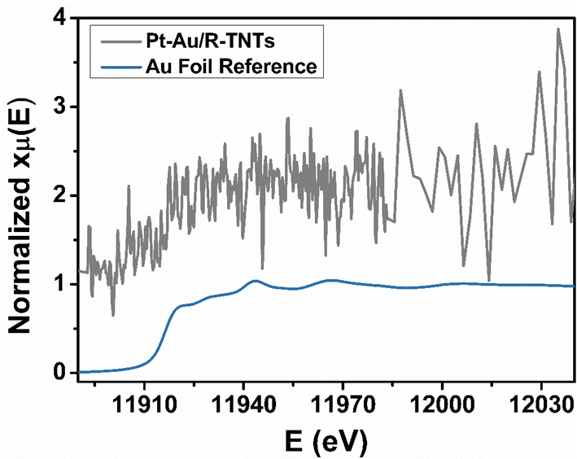
Supplementary Figure 7. XANES spectra of Au L₃-edge. No characteristic signals for Au was observed due to trace quantity of the Au and high disturbance of Pt.

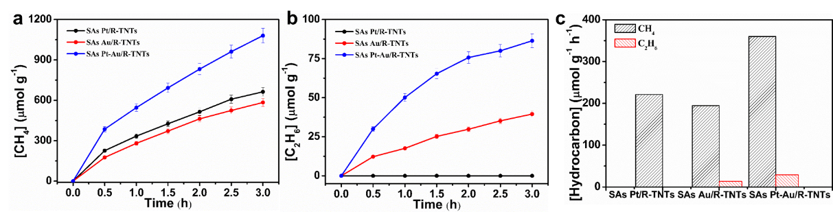
Supplementary Figure 8. Cumulative (a) CH₄ and (b) C₂H₆ evolution for SAs Pt-Au/R-TNTs, Pt/R-TNTs, and Au/R-TNTs catalysts. (c) The average yield of CH₄ and C₂H₆ for per hour.

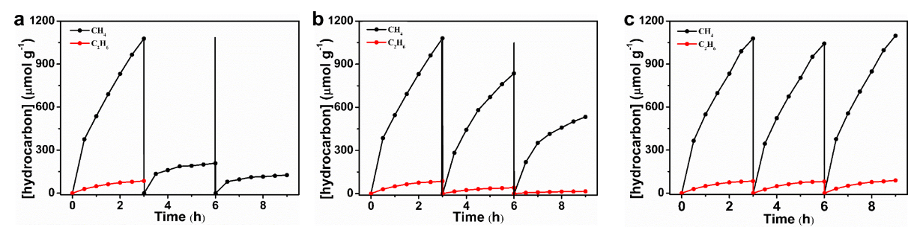
Supplementary Figure 9. Photocatalytic stability test of the SAs Pt-Au/R-TNTs catalysts under: (a) no treatment of the catalyst, (b) the surface of the catalyst refreshed with deionized water for repeated test, and (c) replaced water vapor with 10 vol % CH₃OH/H₂O as the proton source.

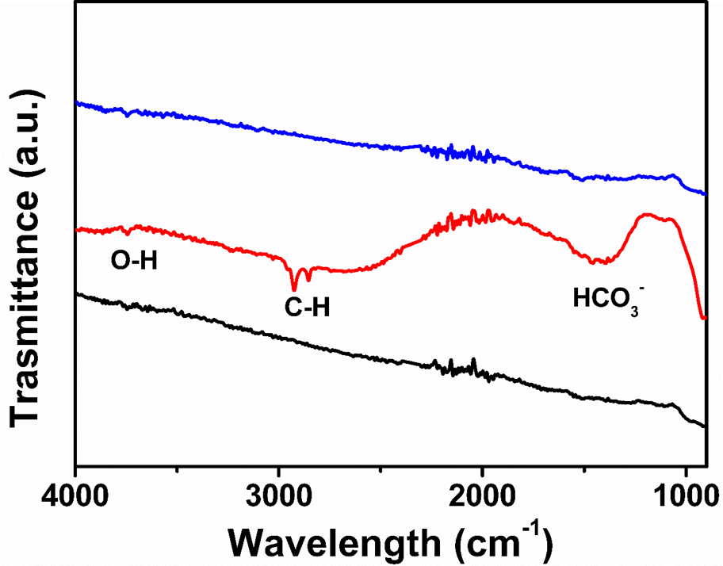
Supplementary Figure 10. FIRT spectrum of SAs Pt-Au/R-TNTs catalysts: before reaction (black), after photocatalysis for 3 h (red), after photocatalysis for 3 h and scouring off the surface with deionized water (blue).

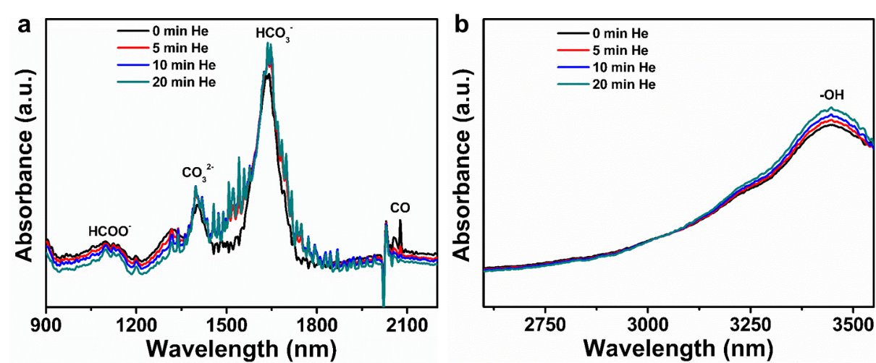
Supplementary Figure 11. In situ DRIFT spectra of SAs Pt-Au/R-TNTs in CO₂ atmosphere under dark condition.

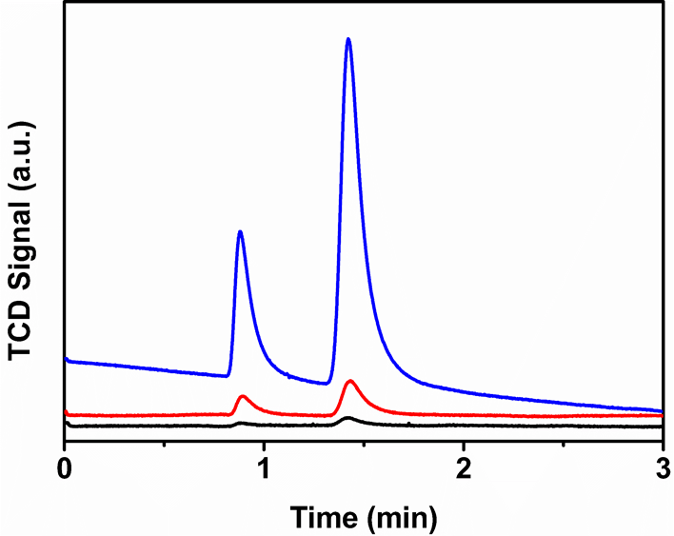
Supplementary Figure 12. TCD signals of measured gas: before reaction (black), after photocatalysis of SAs Pt-Au/R-TNTs catalysts for 3 h (red, the volume ratio of O₂/N₂ viz. 0.42), air atmosphere (blue, the volume ratio of O₂/N₂ viz. 0.27).

Supplementary Table 1. Summary of catalytic performance and metals mass percentage in the catalysts.

catalyst | CH₄ yield  (µmol g⁻¹ h⁻¹) | C₂H₆ yield  (µmol g⁻¹ h⁻¹) | Pt wt % | Au wt %
SAs Pt-Au/R-TNTs | 360.0 | 28.8 | 0.16 | 0.17
Pt-Au/TNTs | 75.5 | -- | 0.18 | 0.15
SAs Pt /R-TNTs | 221.5 | -- | 0.31 | --
SAs Au/R-TNTs | 194.7 | 13.2 | -- | 0.29
R-TNTs | 2.8 | -- | -- | --

