High Throughput Printing of Two-Dimensional Materials into Wafer-scale Three-dimensional Architectures

Xuan Wei¹, Chia-Ching Lin², Christine C. Wu³, Ang-Yu Lu⁴, Nadeem Qaiser¹, Yichen Cai¹, Jui-Han Fu¹, Yu-Hsiang Chiang¹, Lianhui Ding⁵, Ola. S. Ali⁵, Wei Xu⁵, Wenli Zhang⁶, Jing Kong⁴, Han-Yi Chen², and Vincent Tung¹

¹Physical Science and Engineering Division, King Abdullah University of Science and Technology, Thuwal, 23955-6900, Saudi Arabia
²Department of Materials Science and Engineering, National Tsing Hua University, Hsinchu, 300 Taiwan
³Molecular Foundry, Lawrence Berkeley National Lab, Berkeley, California 94720, USA
⁴Department of Electrical Engineering, Massachusetts Institute of Technology, Cambridge, Massachusetts 02139, USA
⁵Saudi Aramco, Chemicals R&D Lab at KAUST, Research and Development Center, Thuwal, 23955-6900, Saudi Arabia
⁶Guangdong Provincial Key Laboratory of Plant Resources Biorefinery, School of
Chemical Engineering and Light Industry, Guangdong University of Technology
(GDUT), 100 Waihuan Xi Road, Panyu District, Guangzhou 510006, China

*To whom correspondence should be addressed: vincent.tung@kaust.edu.sa

Preparation of chemically exfoliated MoS₂, and MXene
For chemically exfoliated MoS₂, Li-intercalation was accomplished by immersing 2 g of MoS₂ powder in 15 ml of 0.8 M n-butyl Li in hexane. The mixture was stirred vigorously in an Ar-filled glovebox for 96 h. The compound was filtered over Whatman filter paper (#41, ashless) and rinsed with 300 mL hexane. Next, the intercalated compound was transferred into 150 mL deionized water (DI-H₂O). Next, the intercalated compound was transferred to DI-H₂O and sonicated to yield exfoliated monolayers. After ultrasonication, the compound was repeatedly washed over Millipore (pore size 200nm) filter paper. The resulting monolayer MoS₂ sheets were resuspended to 250 µg/ml in a mixture of DI-H₂O and IPA (7:3, v/v).
Ti₃AlC₂ powder (∼50 μm) is chemically exfoliated by HCl + LiF etchant.³² 1 g of Ti₃AlC₂ powder (11 Technology Co., Ltd) was slowly added into a mixture of 0.666 g lithium fluoride (LiF, Sigma-Aldrich) in 10 mL of 9 M HCl (Sigma-Aldrich), followed by stirring at 35°C for 24 h. The acidic suspension was washed with ethanol and centrifuged several times until pH ≥6 is reached. The sediment was collected, followed by adding 50 mL of DI-H₂O. After sonication and subsequent centrifugation at 3,500 r.p.m., a stable colloidal suspension of delaminated Ti₃C₂T_{x} MXene was obtained and the concentration of the Ti₃C₂T_{x} MXene suspension was regulated to 0.5 mg/mL in a mixture of DI-H₂O and ethanol (1:1, v/v).
General description of the dewetting-driven destabilization strategy. Experiments were performed using a customized electrohydrodynamic (EHD) printing setup. All 3D architected MoS₂ electrodes were prepared via the dewetting-driven destabilization strategy at 180 °C and no post-treatment was performed. Prior to deposition, copper (Cu) substrates were cleaned through sonication in ethanol for 20 min. To prepare 3D architected MoS₂, a mixture of DI-H₂O and IPA (volume ratio of 7:3, v/v) was used as the solvent to impart controlled evaporation. Next, aqueous solutions of ce-MoS₂ (250 µg/mL) were fed to the spinneret (gauge 23 TW needle) by a programmable syringe pump. An external electric field of 0.75 kV/cm was generated with a high-power supply (ES 40P-20 W/DAM, Gamma high voltage research). Computerized multi-pass deposition was achieved through the integration of an x-y translational stage (LTS 300, Thorlabs) at a linear stage speed of 2.5 mm/sec. The flow rate was carefully maintained at 7 µL/min to achieve the high yield of 3D architected MoS₂. With matching surface chemistry and boundary conditions, thickness of the ce-MoS₂ containing thin films remained below the critical thickness and then spontaneously dewet to drive the pattern formation that regulates the 2D ce-MoS₂ sheets into hierarchically structured 3D architected MoS₂. The aerial mass loading of deposited 3D architected MoS₂ hinges on the deposition time. A high-speed camera was implemented to observe and adjust of the flow rate in a timely fashion, thus suppressing the unwanted formation of ce-MoS₂-containing droplets. Deposition yield is found to linearly scale with the flow rate, and duration of printing. A circular-shaped anode can be directly cut from the disc punching machine. Note that no binders, additives or conductive paste was used to prepare the 3D architected MoS₂ anode for Li-ion battery. Further details of the methods are available in the Supplementary Information.
Electrochemical characterization. Working electrodes were directly printed on a Cu current collector. The loading level of spatially homogeneously 3D architected MoS₂ was ∼1, 2.2 and 3.5 mg/cm², respectively, and the cases of MoS₂ crumples, MoS₂ wrinkles and MoS₂ bulk were ∼1 cm⁻², respectively. 3D architected MoS₂ electrodes were used as printed without additional processing steps. All other electrodes were dried at 200°C for 2 h, and then pressed until the density of the electrode became >1.0 g/cm³ with the electrode thickness of 100 µm for all electrodes, and finally vacuum-dried at 50°C overnight. CR2032 coin-type cells were assembled in an argon-filled glove box containing pure Li metal foil (1 mm) as the counter electrode. The electrolyte was 1.0M Lithium hexafluorophosphate (LiPF₆) in a mixture of ethylene carbonate (EC) and dimethyl carbonate (DMC) with a volume ratio of 1:1 (Sigma-Aldrich). Advantec GC50 microporous glass fiber was used as a separator with a thickness of 19 µm. Galvanostatic cycling was conducted on a computer-controlled Neware battery test system at different current densities in a potential range of 0.01−3.0 V. The Cyclic voltammetry (CV) tests were carried out to examine the electrode reaction under the scan rate of 1, 2, 5, 10 mV/s with a voltage range of 0.01−3.0 V. Electrochemical impedance spectra (EIS) were recorded in a frequency range from 10⁶ to 0.01 Hz, while the disturbance amplitude was 5 mV. CV and EIS were conducted with a Biologic VMP3 electrochemical workstation. All electrochemical measurements were under constant 25 °C.
3D architected MoS₂ ║LiFePO₄ (LFP) full cells were assembled with 3D architected MoS₂ anode and LiFePO₄ cathode in a CR2032 coin-type cell. The electrolyte is 1 M LiPF₆ in EC: DMC with a volume ratio of 1:1 (Sigma-Aldrich). The cathodes comprised 90 wt% LiFePO₄, 5 wt% polyvinylidene fluoride (PVDF), and 5 wt% super-P on Al current collectors. The architected MoS₂ anode capacity was tuned as 10 % higher than that of the LiFePO₄ cathode. The active material loading was 1 mg/cm² for the 3D architected MoS₂ anode and 10 mg/cm² for the LFP cathode. Each cell was aged for 24 h at room temperature before commencing the electrochemical tests. The specific capacity of the full cell is calculated based on the mass of the MoS₂ anode electrode. Galvanostatic cycling was conducted on a computer-controlled Neware battery test system at different current densities in a potential range of 0.6−3.6 V. The cyclic voltammetry (CV) tests were carried out by a Biologic VMP3 electrochemical workstation to examine the electrode reaction under the scan rate of 0.1 mV/s¹ with a voltage range of 1.0−4.2 V. All electrochemical measurements were under constant 25 °C.

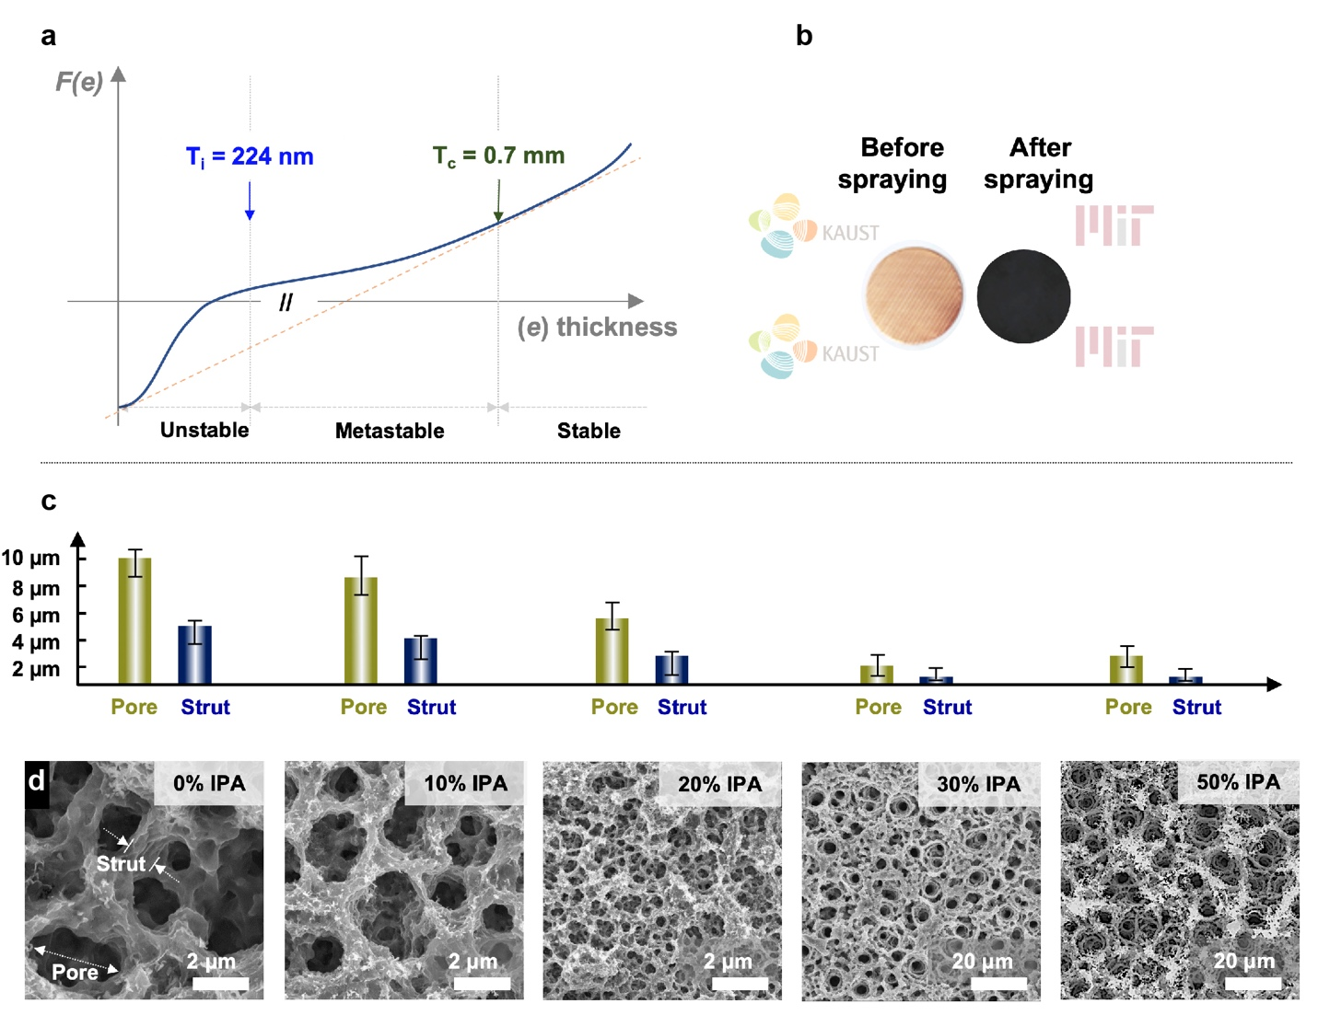
Supplementary Scheme 1 | a, Free energy F_{(e)} as a function of the thickness (e) of an electrohydrodynamically printed liquid thin film deposited on a Cu substrate. b, Photographs of a bare Cu substrate (left) and a fully covered Cu substrate (right). c, Bar chart summarizes the dimensions of both pores and struts of 3D architected MoS₂ prepared from various solvent combinations. d, Corresponding scanning electron microscopy (SEM) images of 3D architected MoS₂ printed from different solvent combinations.

Supplementary Discussion 1
On a fundamental level, the underlying mechanisms governing the way liquid films recede are somewhat akin to those involved in phase transitions. The liquid thin film can be metastable and dewet by nucleation and expansion of drying patching under the critical thickness (T_{c}). To determine the T_{c} that accounts for the transition, we adapt the puddle thickness, T_{c} = 2κ⁻¹sin (θ/2), where κ⁻¹ and θ are the capillary length and contact angle of H₂O.^{1,2} Implementing κ⁻¹ of 2.7 mm, and θ of 15º measured on Cu substrates, we thus extrapolate T_{c} ≈ 0.7 mm. Indeed, the density of drying patches surges if the initial thickness of ce-MoS₂ containing liquid thin film is greatly reduced below the T_{c}.³ This is probably due to the substantially increased nucleation sites as the dewetting proceeds. Once the foam-like puddle pattern is formed, ordering is induced among the disordered ce-MoS₂ stacks. Specifically, the electrostatic charges enable the ordered arrangement of monodisperse droplets into periodic arrays upon impacting the liquid surface, closely resembling the breath figures.^{4–6} The result is the appearance of spatially organized ripples that emit capillary waves directed downstream, creating ordered arrays of nucleation sites for drying patches.

Supplementary Discussion 2
To analyze the intrinsic conductivity and electrochemical polarization of MoS₂ bulk, wrinkled film, crumples and architected structure, kinetics investigation in electrochemical impedance spectroscopy (EIS) was employed. The Nyquist plots of the impedance spectrum contain two semicircles in the high-frequency region and a straight line in the low-frequency region. The intercept of the semicircle with the Re (Z) axis in the high-frequency region presents the Ohmic resistance (R_{s}) of the entire cell; the diameters of the first and second semicircle are associated with the resistance of Li-ion migration through the SEI films (R_{SEI}) and the charge transfer resistance (R_{ct}), respectively; the slope of the straight line is related to ion diffusion efficiency.
As shown in Fig. 5b, the semicircle diameters for 3D architected MoS₂ and crumples are significantly smaller than those of MoS₂ bulk and wrinkled films, indicating enhanced electric conductivity. Moreover, the straight-line slopes for 3D architected MoS₂ and crumples are steeper than the other two at a low frequency. The change in slope is an indication of higher surface capacitance and more efficient ion diffusion because of larger interlayer spacing and shorter ion transmission paths. More exposed surface area facilitates the charge transfer. Indeed, MoS₂ crumples shows smallest R_{ct}. However, the formation of secondary electrolyte interface (SEI) arises and thus degrades the electrochemical stability in crumpled MoS₂ anode. Here, the well-organized and hierarchically architected structure reconciles the dilemma between SEI formation and electrochemical degradation, resulting in electrochemical stability during charging and discharging.
Rate capability, static and dynamic cycling stability tests are designed to test the capacity retention of 3D architected MoS₂. In the rate capability test, the reversible specific capacity of MoS₂ are stabilized at 1575, 1550, 1515, 1431, 1268 and 1111 mA h/g upon increasing the discharge/charge current density of 0.2, 0.5, 1.0, 2.0, 5.0, and 10 A/g, respectively (Supplementary Fig. 9a). In the dynamic test (Supplementary Fig. 9b), the current density alternately changed between 1 A/g and 5 A/g for every ten cycles. The specific capacity of 3D architected MoS₂ maintains more than 1500 mA h/g at 1 A/g and around 1200 mA h/g at 5 A/g, while that of MoS₂ bulk and wrinkles are less than 100 mA h/g. Crumples deliver better reversible capacity than MoS₂ bulks and wrinkles, showing 1000 (800) mA h/g at 1(5) A/g. In the static cycling performance test (Supplementary Fig. 9c), the capacity is measured more than 200 cycles at the constant current density of 5 A/g. The capacity of 3D architected MoS₂ maintains 1200 mA h/g in 200 cycles, while the capacity of MoS₂ bulk, wrinkled films and crumples decreases quickly after 100 cycles.

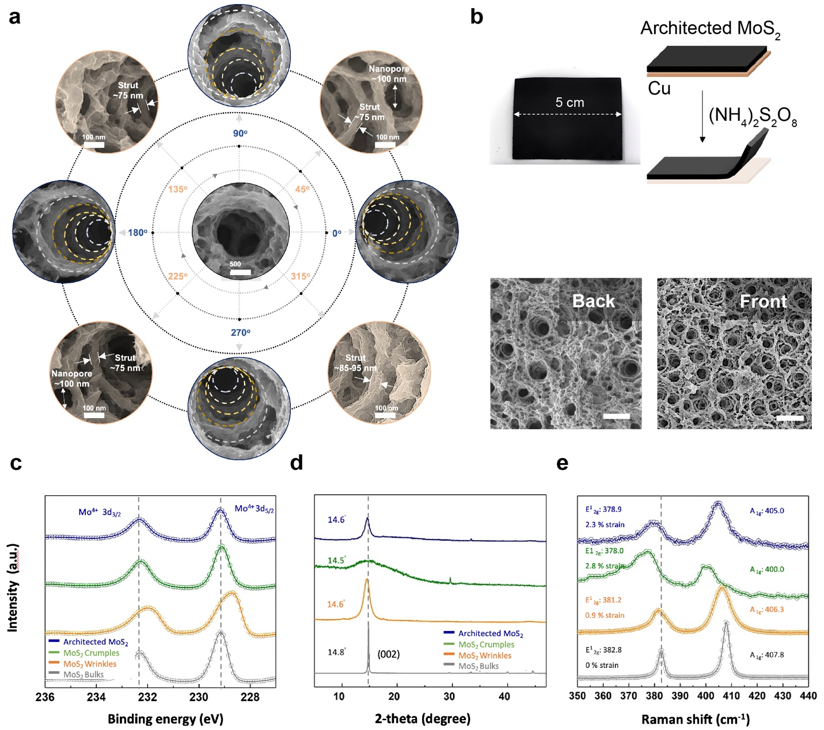
Supplementary Fig. 1 | a, Reconstruction of SEM images taken at different perspectives (peripherals, tilted view) in close proximity to the selected spot (center, top view) collectively attests to the formation of uniform, layered sponge-like nanostructures with interconnected struts and spatially distributed nanopores. Note that each layer is false colored with dotted lines for clarity. Meanwhile, HRSEM images (false colored in light orange) further reveal detailed nanoscale features that comprise thin, wrinkled struts with an average thickness of 75~95 nm and nanopores in oval shapes with a bimodal average distribution of diameters of 85 and 200 nm, respectively. b, Architected MoS₂ can be removed by dissolving Cu substrate in ammonium persulfate solution. c, High resolution XPS spectra of Mo 3d proves pure 2H phase in 3D architected MoS₂. d, XRD spectra indicates that 3D architected MoS₂ exhibits wider interlayer space and higher irregularity compared with bulk. e, Raman spectra show a significant shift in the E¹_{2g} peak in 3D architected MoS₂, indicative of the high strain load on the overall nanostructure. The vertical black dash lines indicate peak positions from MoS₂ standard.
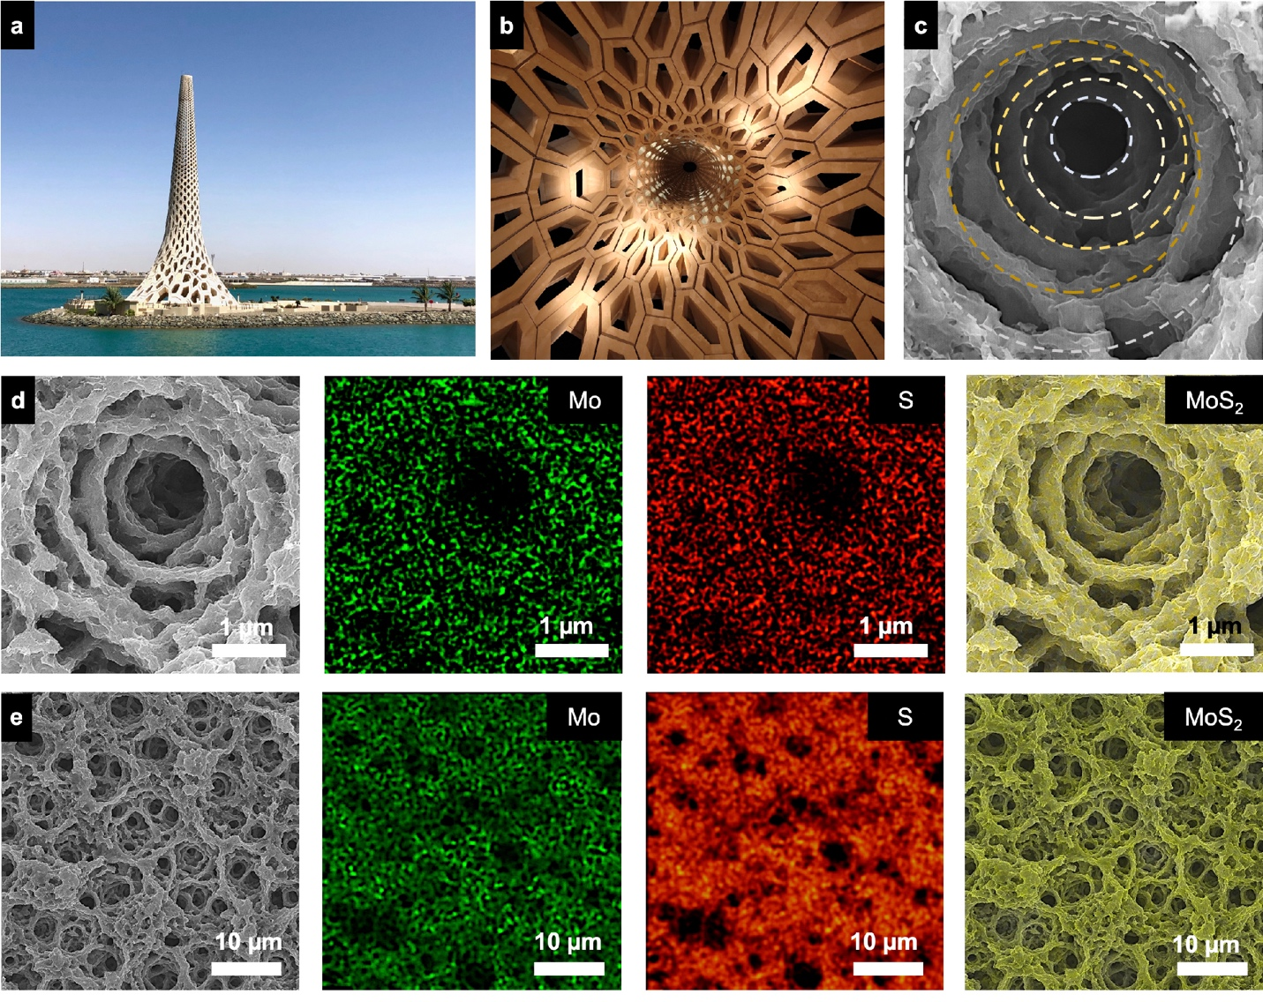
Supplementary Fig. 2 | a-c, The vertically tapered truss unit cell bears a close resemblance of the landmark beacon at KAUST that takes an organic foam inspired by coral forms. Eenergy-dispersive X-ray spectroscopy (EDX) mapping of relevant elements in (d) a single truss unit and (e) within percolated networks, including Mo in green and S in orange, confirms the chemical coherence across the entire architected MoS₂.
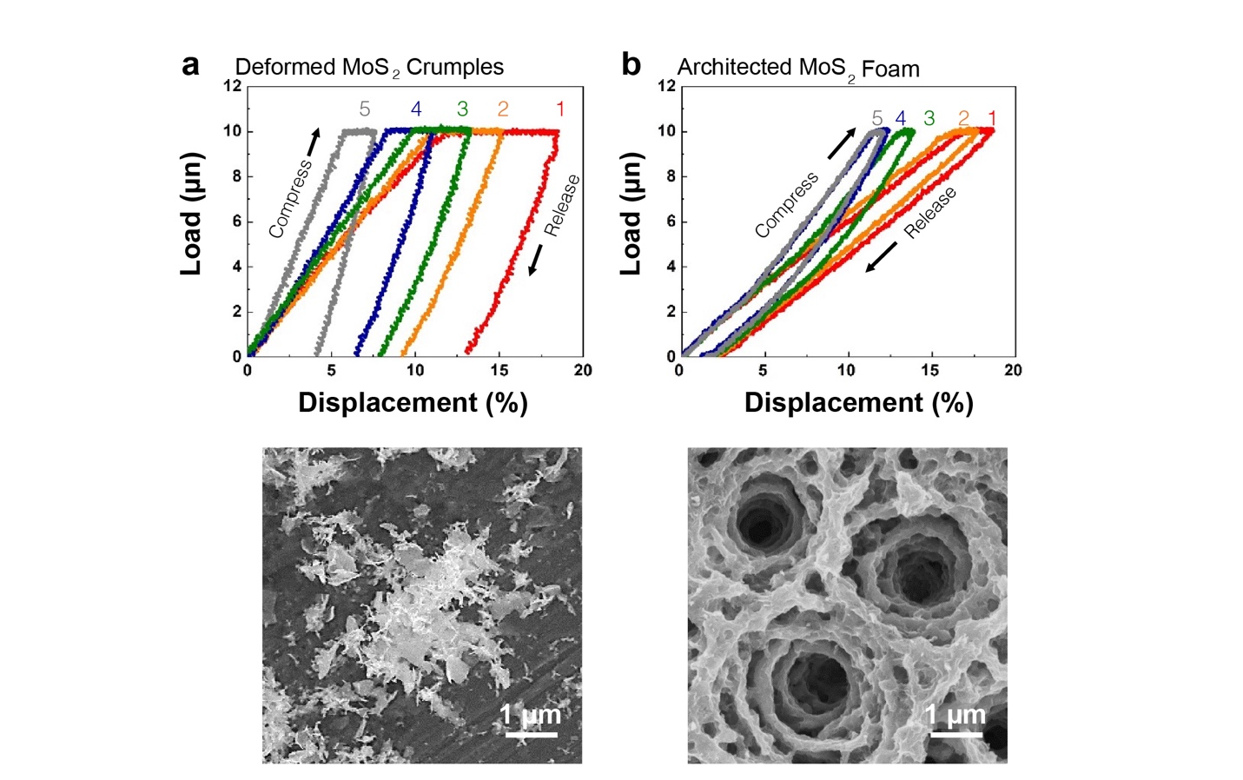
Supplementary Fig. 3 | Representative load/displacement curves of five cycles of compression and release on (a) deformed MoS₂ crumples and (b) architected MoS₂ in tandem with their corresponding SEM images, respectively.

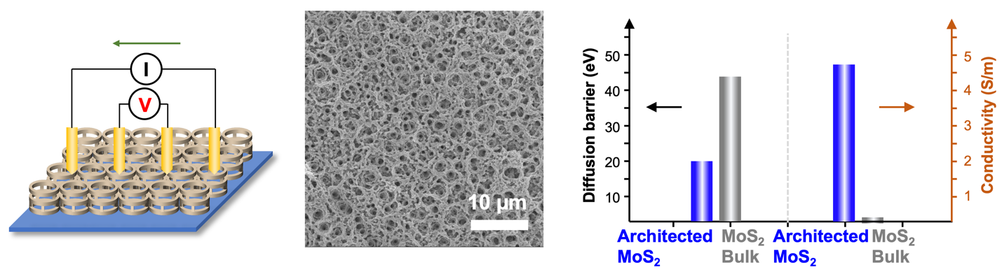
Supplementary Fig. 4 | a, Schematic illustration shows our design for 4-point probe. Corresponding SEM image reveals the hierarchically porous but spatially interconnected conductive pathways. b, Bar chart shows the dissimilar trends of diffusion barrier and conductivity before (color in gray, MoS₂ bulk) and after dewetting-driven destabilization of hierarchical structuring (color in blue, architected MoS₂).

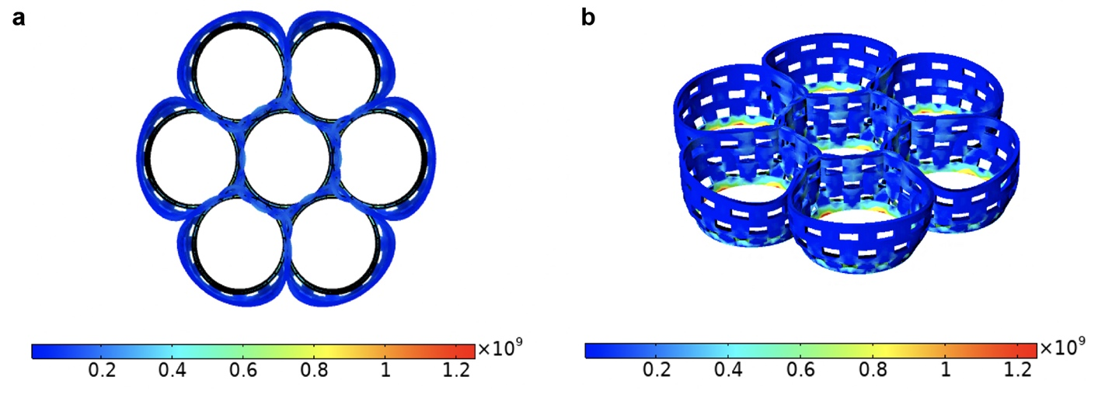
Supplementary Fig. 5 | Von Mises stress distribution is simulated at SOC of 100%. a, Top and (b) perspective views of the 3D architected MoS₂ clearly confirms that the structural integrity is largely preserved and shows no sign of electrochemomechanical fatigue and fracture.

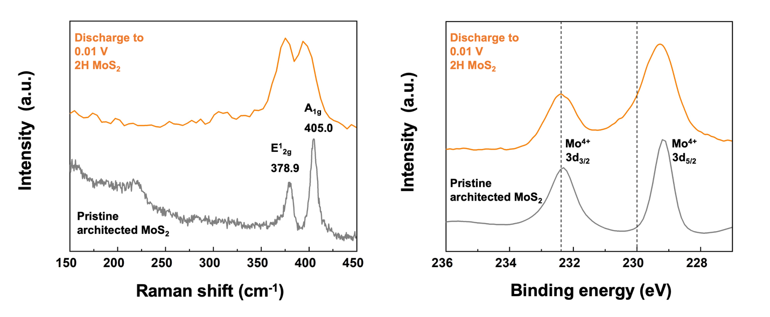
Supplementary Fig. 6 | Ex-situ (a) Raman and (b) X-ray photoelectron spectroscopy (XPS) spectra reveal the preservation of the 2H semiconducting phase, ruling out the transition to the metallic 1T phase.

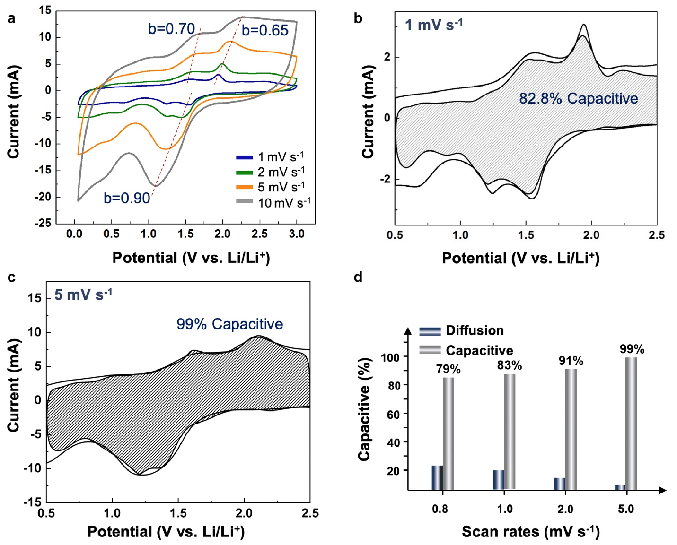
Supplementary Fig. 7 | a, Capacitive effects are characterized by analyzing the cyclic voltammetry data at various sweep rates based on i = av^{b}, where the measured current i follows a power law relationship with the sweep rate v. b, Capacitive and diffusion-controlled charge storage contributions for architected MoS₂ cycled in a Li-ion electrolyte at a scan rate of 1 mV/s as well as at a scan rate of 5 mV/s (c). d, Bar chart showcases the dominant capacitive contribution at the high scan rates (>5 mV/s).

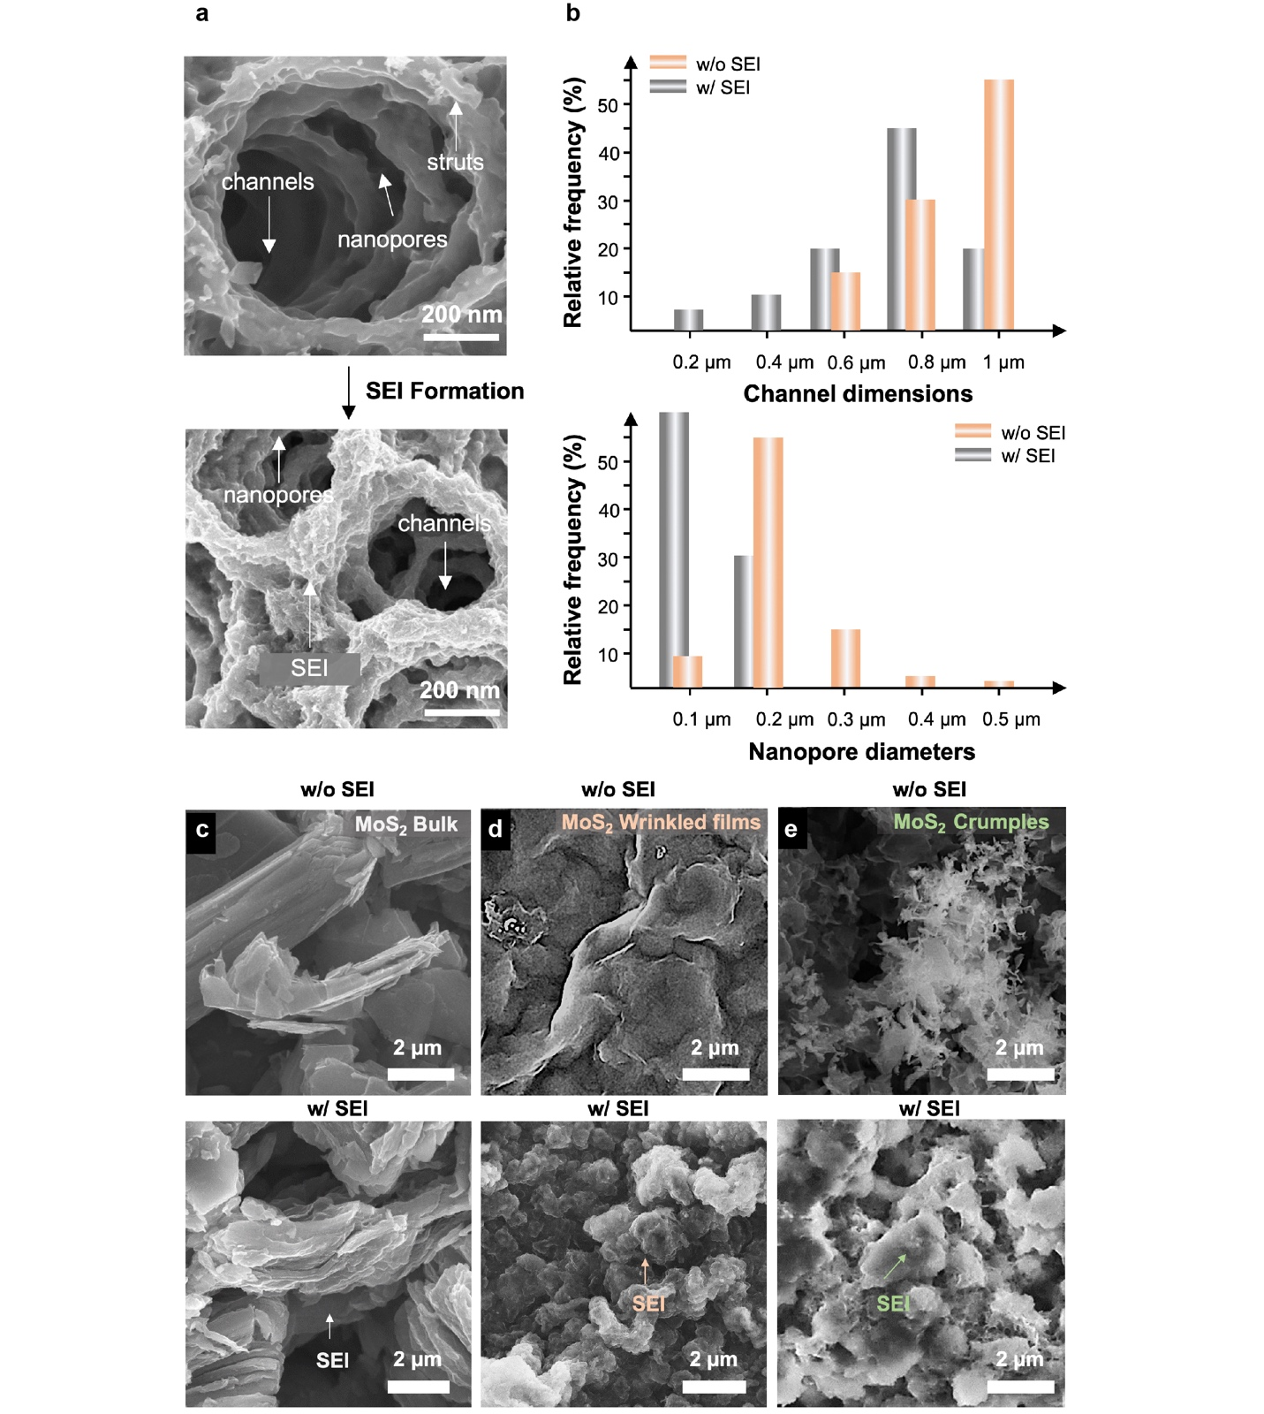
Supplementary Fig. 8 | a, Scanning electron microscopy (SEM) images of architected MoS₂ before (top) and after (bottom) the deposition of secondary electrolyte interphase (SEI) formation. b, Statistical analysis of channel dimensions and nanopore diameters of architected MoS₂. Meanwhile, (c) MoS₂ bulk, (d) wrinkles and (e) crumples display rampant growth of SEI and thus the congested ion transport channels.

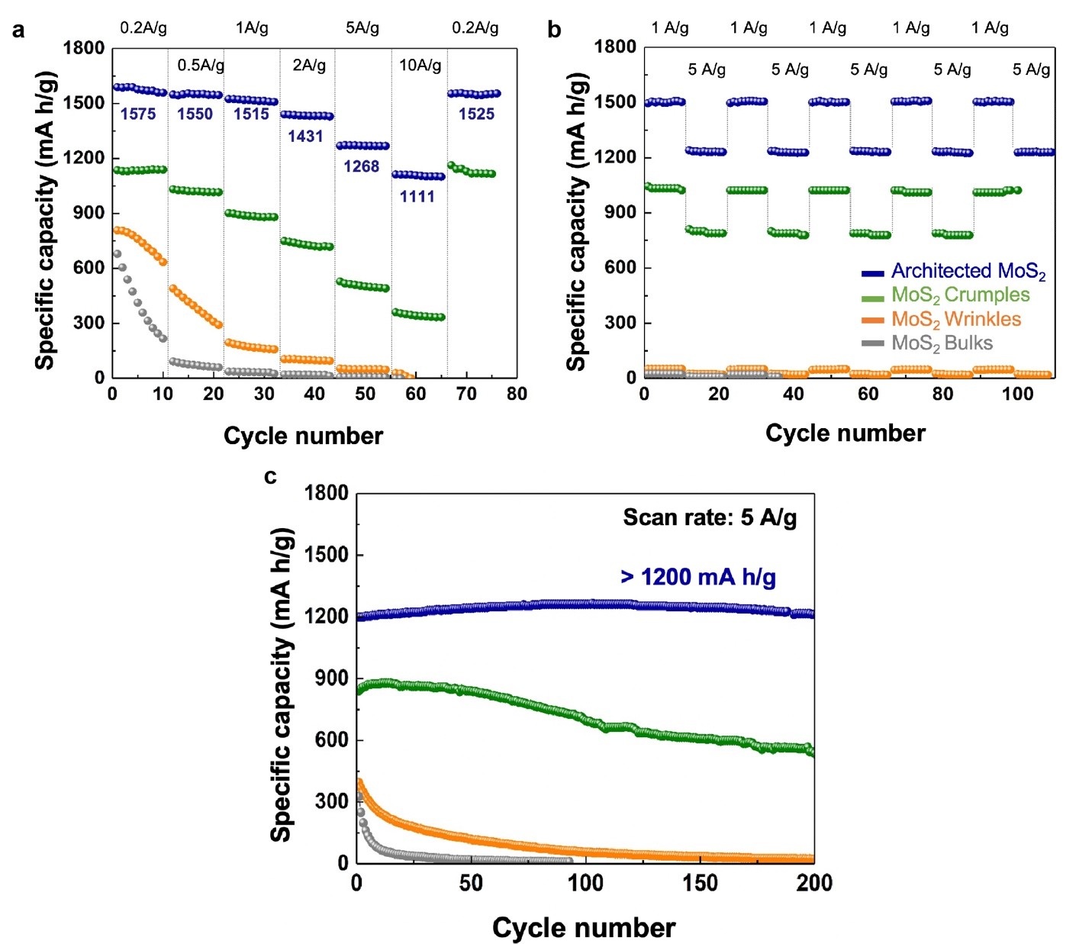
Supplementary Fig. 9 | Cycling performance of the MoS₂-based anodes in dissimilar forms, including architected MoS₂ in blue, crumples in green, wrinkles in orange and bulks in gray, with a mass loading of 1.25 mg/cm² at different rates.

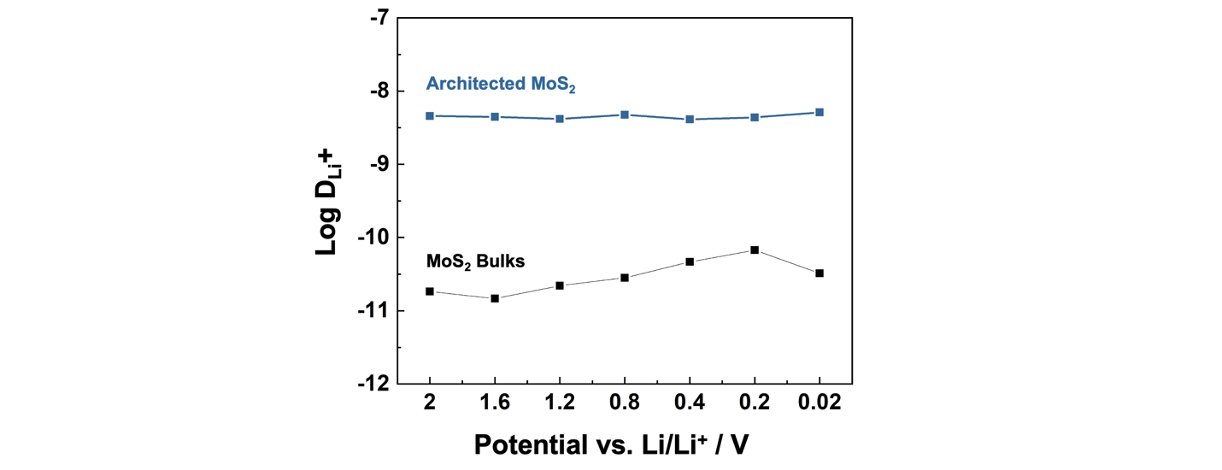
Supplementary Fig. 10 | Diffusion coefficient values (D_{Li}⁺) in terms of logarithms to the base 10 of 3D architected MoS₂ are juxtaposed with MoS₂ bulks when measured under various potentials versus Li/Li⁺.

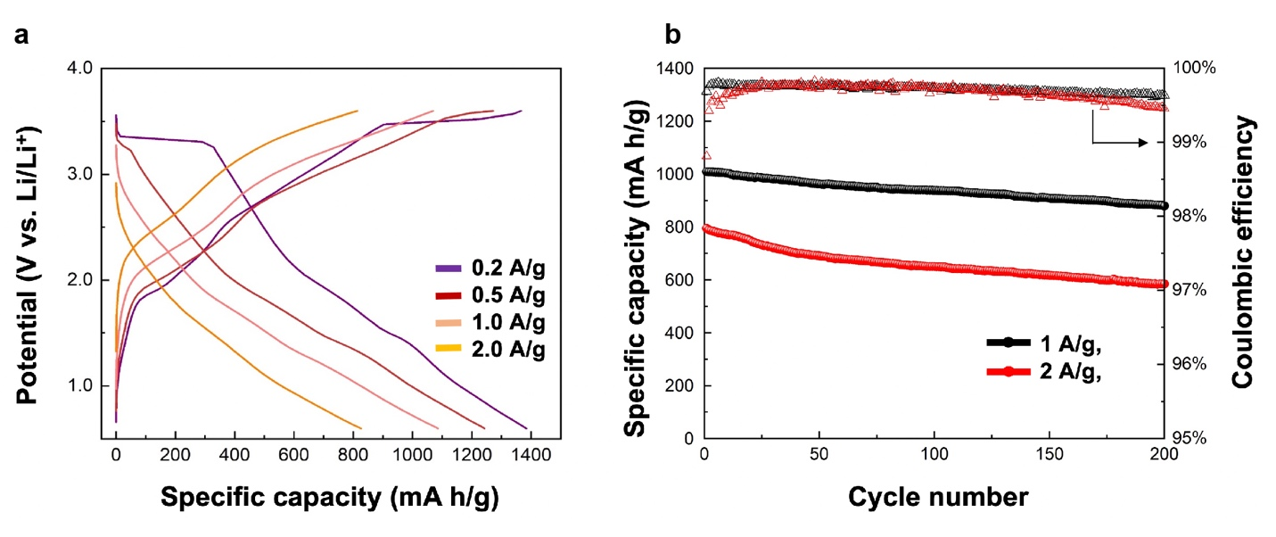
Supplementary Fig. 11 | Electrochemical performance of full cells containing architected MoS₂ anodes. (A) Voltage profiles of an architected MoS₂ || LiFePO₄ (LFP) full cell measured at different charge/discharge rates. (B) Specific capacity and Coulombic efficiency of architected MoS₂ ||LFP full cell measured at current density of 1 and 2 A/g, respectively .

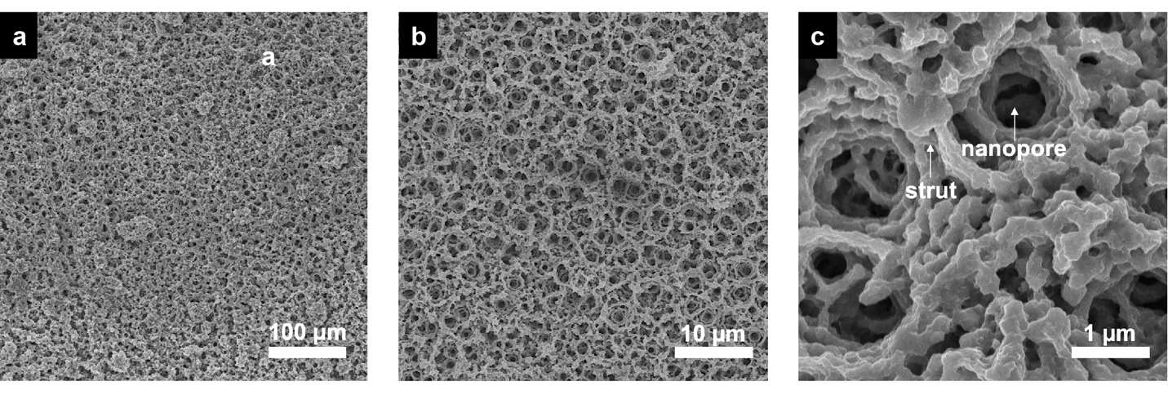
Supplementary Fig. 12 | Scanning electron microscope (SEM) images show the intricate features architected reduced-graphene oxide (rGO).

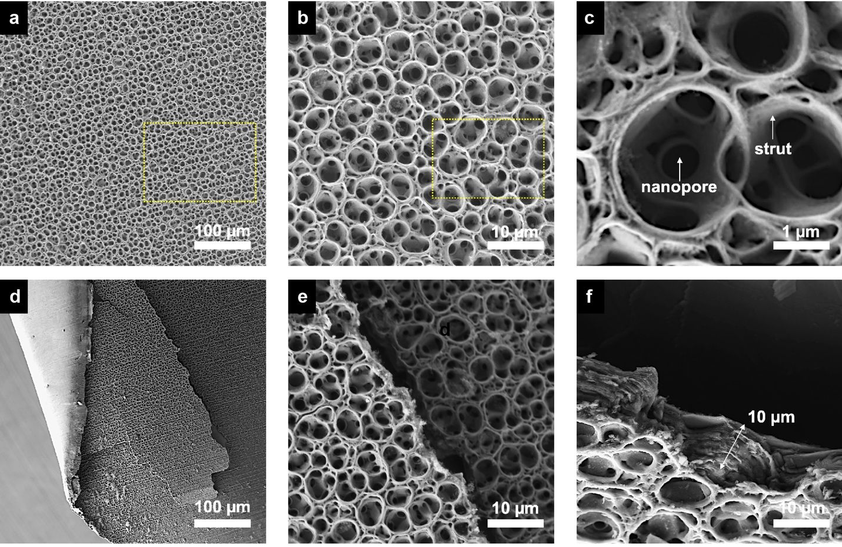
Supplementary Fig. 13 | A series of scanning electron microscope (SEM) images showcases the hierarchically structured morphology of architected MXene defined by the well-controlled dewetting regulated pattern formation.

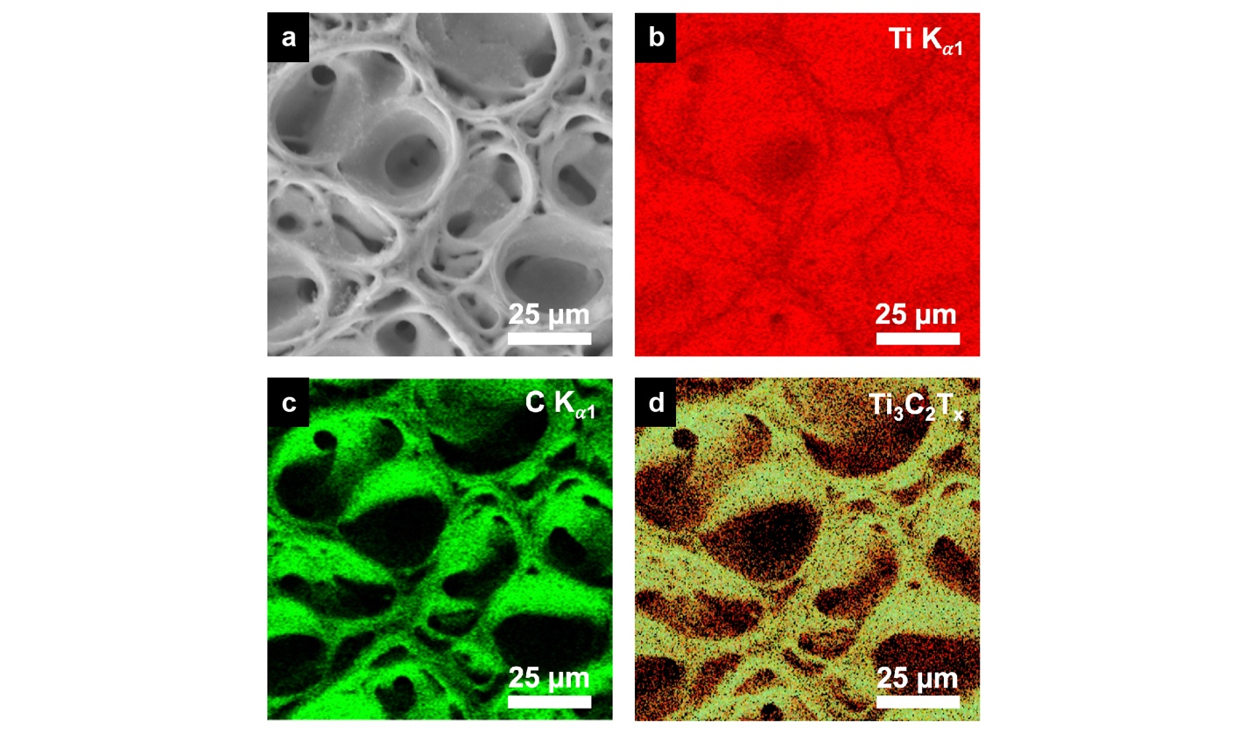
Supplementary Fig. 14 | Energy-dispersive X-ray spectroscopy (EDX) mapping of relevant elements in MXene, including Ti in red, C in green and the combination of both.

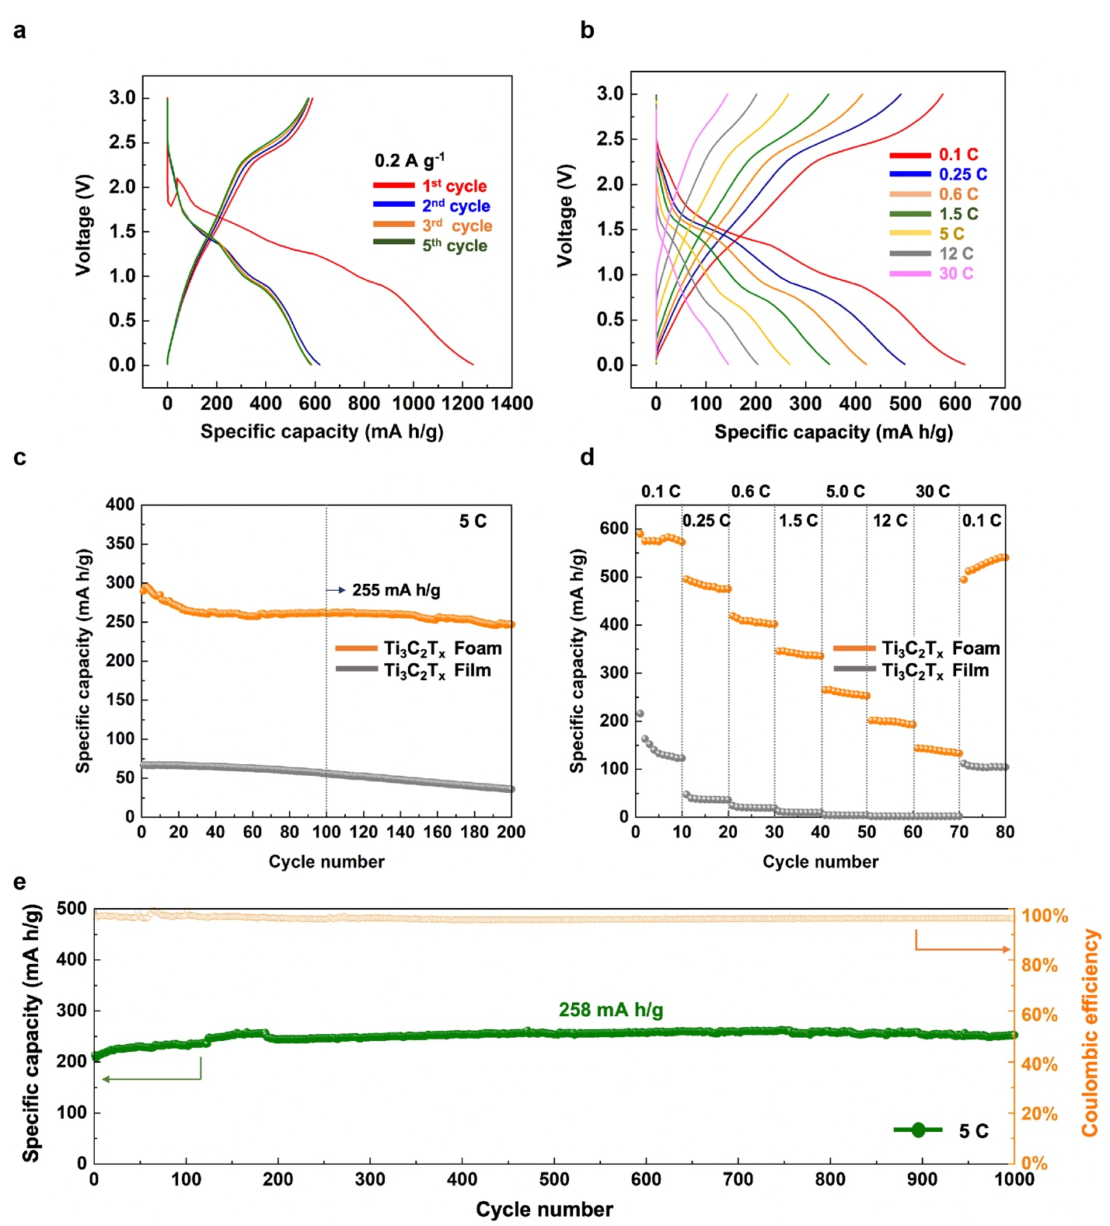Supplementary Fig. 15 | a, Galvanostatic discharge/charge profiles of different cycles and (b) measured at different current densities. c, Cycling performance of architected MXene measured at current densities of 5 C. d, Rate capability performance ranges from 0.1 C to 30 C. e, Long-term cycling performance at 5 C (2 A/g).

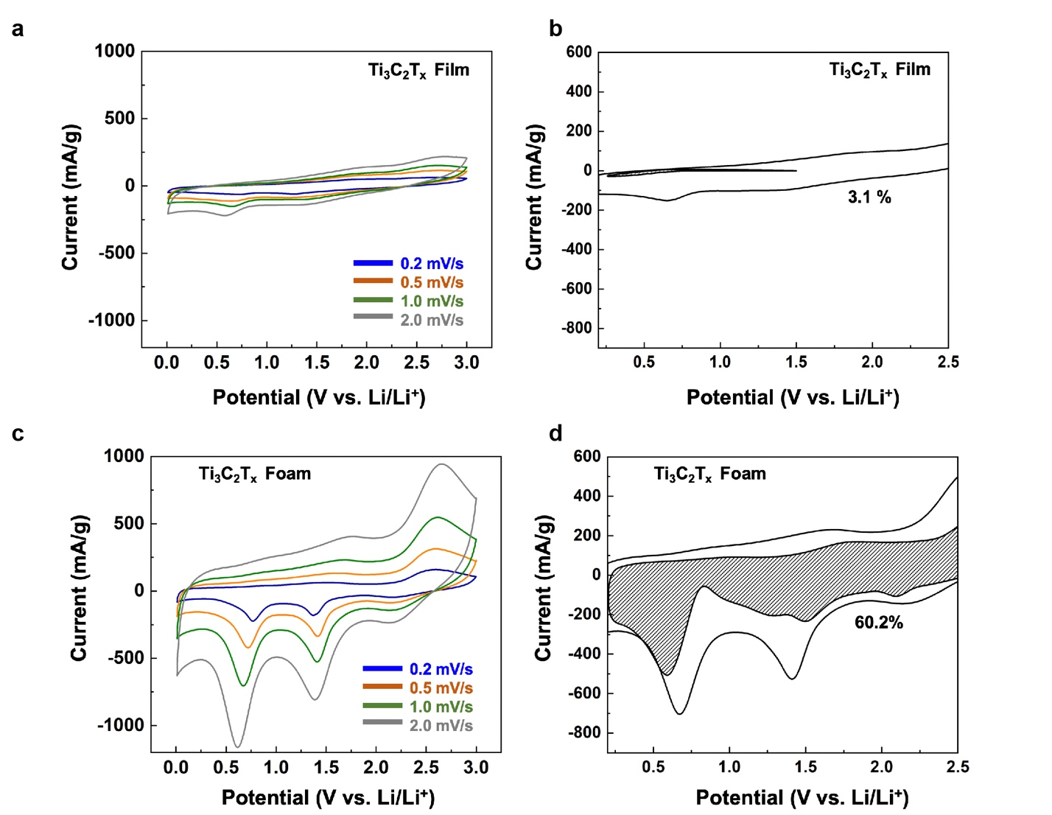
Supplementary Fig. 16 | (a-b) Capacitive and diffusion-controlled charge storage contributions for Ti₃C₂Tx thin films cycled in a Li-ion electrolyte at a scan rate of 1 mV/s as well as at a scan rate of 5 mV/s. (c). d, Architected Ti₃C₂T_{x} anode showcases the dominant capacitive contribution at the high scan rates (>5 mV/s).

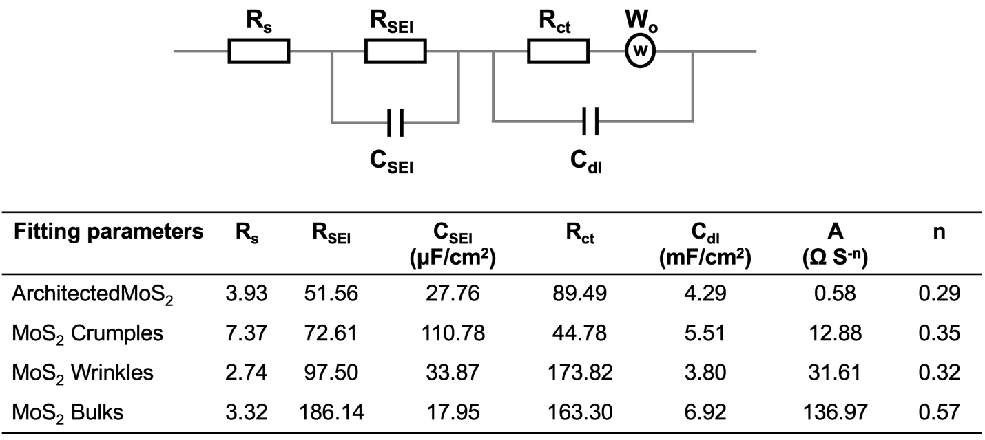
Table S1. R_{s}, R_{SEI}, and R_{CT} values of various MoS₂ based materials.

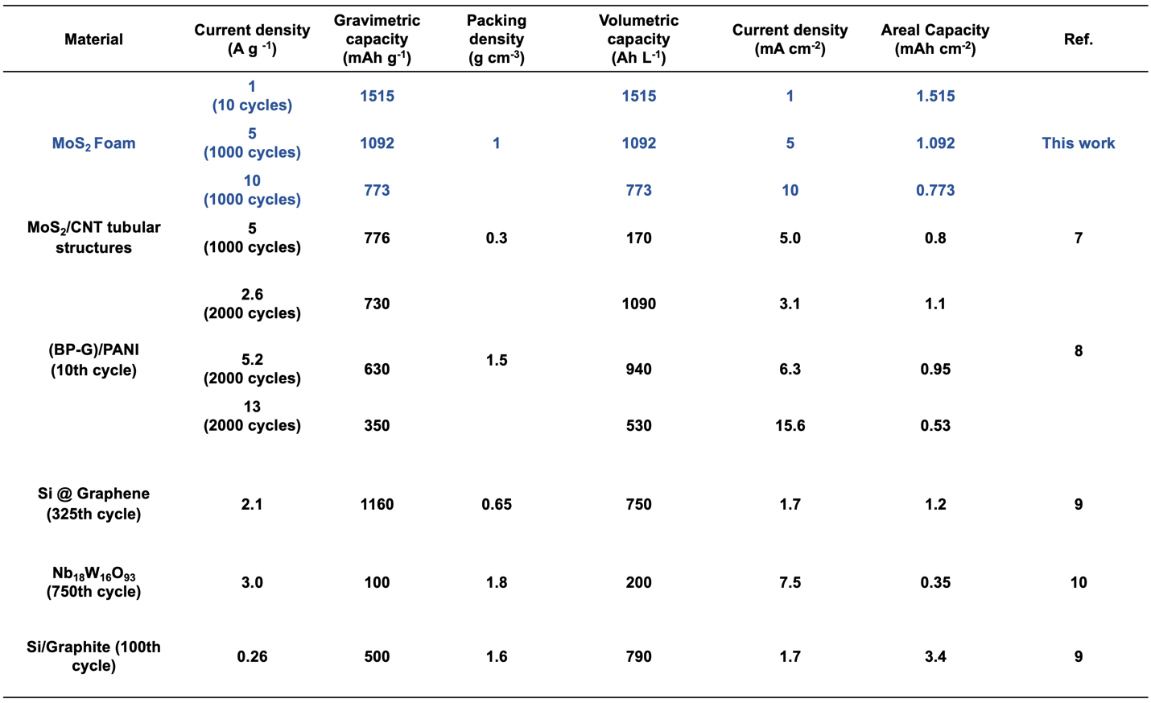
Table S2. Comparison of gravimetric and volumetric capacities between architected MoS₂ and other state-of-the-art anode materials after cycling at high current densities. Note that the gravimetric capacities are calculated on the basis of the total electrode material (e.g., MoS₂) which does not contain any additive or binder. The volumetric capacity is the result of the gravimetric capacity and packing density of the anodes.^{7–10}

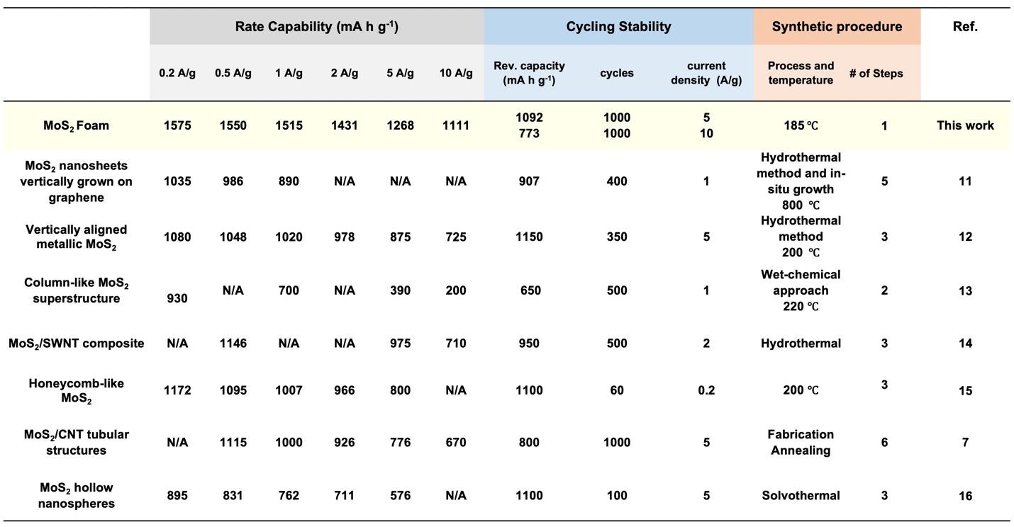
Table S3. Comparison of rate capability, cycling stability and scalability between architected MoS₂ and the other prevailing MoS₂ composite anodes.^{7,11–16}

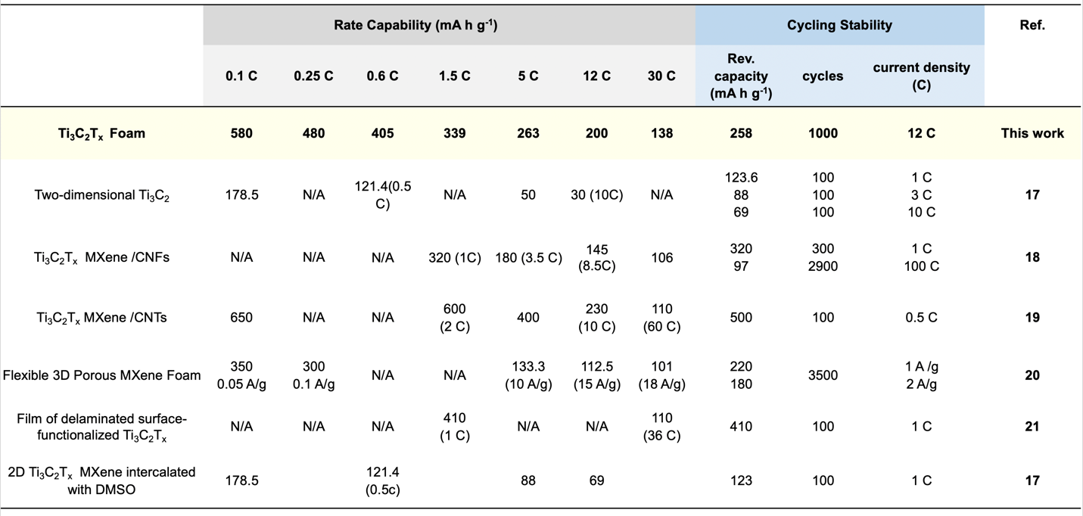Table S4. Comparison of architected Ti₃C₂T_{x} and other Ti₃C₂T_{x} composite electrodes for rechargeable Li-ion battery applications.^{17–21}

Reference:

1. Naffouti, M. et al. Complex dewetting scenarios of ultrathin silicon films for large-scale nanoarchitectures. Sci. Adv. 3, eaao1472 (2017).
2. Aussillous, P. & Quéré, D. Liquid marbles. Nature 411, 924–927 (2001).
3. Fu, J. et al. Additive manufacturing assisted van der Waals integration of 3D/3D hierarchically functional nanostructures. Commun. Mater. 1, 42 (2020).
4. Böker, A. et al. Hierarchical nanoparticle assemblies formed by decorating breath figures. Nat. Mater. 3, 302–6 (2004).
5. Srinivasarao, M., Collings, D., Philips, A. & Patel, S. Three-Dimensionally Ordered Array of Air Bubbles in a Polymer Film. Science (80). 292, 79–83 (2001).
6. Lee, S. H. et al. Three-dimensional self-assembly of graphene oxide platelets into mechanically flexible macroporous carbon films. Angew. Chemie - Int. Ed. 49, 10084–10088 (2010).
7. Ming Chen, Y., Yao Yu, X., Li, Z., Paik, U. & Wen Lou, X. Hierarchical MoS 2 tubular structures internally wired by carbon nanotubes as a highly stable anode material for lithium-ion batteries. Sci. Adv. 2, e1600021 (2016).
8. Jin, H. et al. Black phosphorus composites with engineered interfaces for high-rate high-capacity lithium storage Downloaded from. Science 370, (2020).
9. Ko, M. et al. Scalable synthesis of silicon-nanolayer-embedded graphite for high-energy lithium-ion batteries. Nat. Energy 1, 1 (2016).
10. Griffith, K. J., Wiaderek, K. M., Cibin, G., Marbella, L. E. & Grey, C. P. Niobium tungsten oxides for high-rate lithium-ion energy storage. Nature (2018). doi:10.1038/s41586-018-0347-0
11. Teng, Y. et al. MoS2 Nanosheets Vertically Grown on Graphene Sheets for Lithium-Ion Battery Anodes. ACS Nano 10, 8526–8535 (2016).
12. Jiao, Y. et al. Ion Transport Nanotube Assembled with Vertically Aligned Metallic MoS2 for High Rate Lithium-Ion Batteries. Adv. Energy Mater. 8, (2018).
13. Ding, J., Zhou, Y., Li, Y., Guo, S. & Huang, X. MoS2 Nanosheet Assembling Superstructure with a Three-Dimensional Ion Accessible Site: A New Class of Bifunctional Materials for Batteries and Electrocatalysis. Chem. Mater. 28, 2074–2080 (2016).
14. Liu, Y. et al. Electrical, Mechanical, and Capacity Percolation Leads to High-Performance MoS 2 / Nanotube Composite Lithium Ion Battery Electrodes. ACS Nano 10, 5680–5990 (2016).
15. Fei, L. et al. Three-dimensional macroporous graphene monoliths with entrapped MoS 2 nanoflakes from single-step synthesis for high-performance sodium-ion batteries. RSC Adv. 8, 2477–2484 (2018).
16. Zhang, X. et al. Petal-like MoS 2 Nanosheets Space-Confined in Hollow Mesoporous Carbon Spheres for Enhanced Lithium Storage Performance. ACS Nano 11, 8429–8436 (2017).
17. Sun, D., Wang, M., Li, Z., Fan, G. & Zhohu, A. Two-dimensional Ti3C2 as anode material for Li-ion batteries | Elsevier Enhanced Reader. Electrochemistry Communications 80–83 (2014).
18. Lin, Z. et al. Carbon nanofiber bridged two-dimensional titanium carbide as a superior anode for lithium-ion batteries †. J. Mater. Chem. A 3, 14096 (2015).
19. Ren, C. E. et al. Porous Two-Dimensional Transition Metal Carbide (MXene) Flakes for High-Performance Li-Ion Storage. ChemElectroChem 3, 689–693 (2016).
20. Zhao, Q. et al. Flexible 3D Porous MXene Foam for High-Performance Lithium-Ion Batteries. Small 15, (2019).
21. Mashtalir, O. et al. Intercalation and delamination of layered carbides and carbonitrides. Nat. Commun. 4, 1716 (2013).

