***Supporting Information***

**Highly Diastereoselective Cascade [5+1] Double Michael Reaction, a Route for the Synthesis of Spiro Thio-oxindoles**

Firouz Matloubi Moghaddama*, Vahid Saberia, Ashkan Karimia,b

a Laboratory of Organic Synthesis and Natural Products, Department of Chemistry,

Sharif University of Technology, 111559516 Tehran, Iran

b Department of Chemistry, McGill University, H3A-0B8 Montreal, Canada

Table of contents

1. Figures and tables S**Error! Bookmark not defined.**

2. NMR spectra S4

3. Crystallography data S24

5. Computational data S36

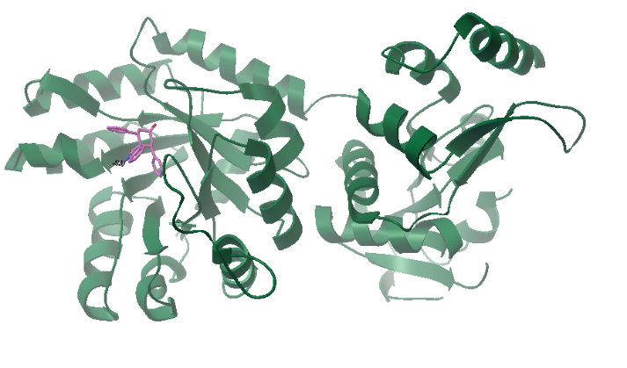 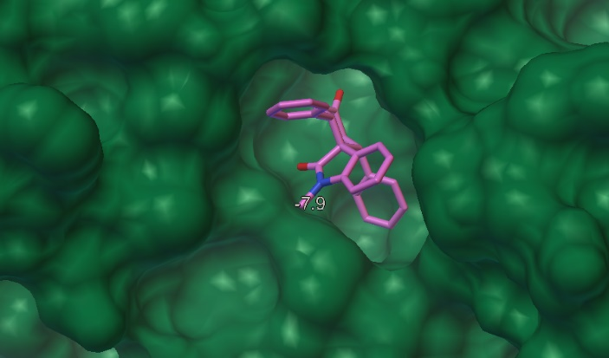

**Figure S1.** Interaction between *cis*-spiro oxindole **2** with OPRT domain of the LdUMPS (PDB ID: 2WNS). The figure is drawn using UCSF chimera 1.8.

**Table S1.** Electronic energy (Hartree) of *cis/trans* spiro oxindole and thiooxindole **1**-**4** calculated using B3LYP/6-31+G(d) in gas phase.

|  |  |  |  |
| --- | --- | --- | --- |
| **1**  -1203.218 Hartree | **2**  -1203.209 Hartree | **3**  -1524.616 Hartree | **4**  -1524.624 Hartree |

*F:\Users\asus\Documents\Custom Office Templates\CHEMISTRY\spiro\dibenzal.tifF:\Users\asus\Documents\Custom Office Templates\CHEMISTRY\spiro\pro.tif*

**B**

**A**

**Figure S2.** Mulliken charge distribution on (A) dibenzal ketone and (B) dibenzal iminium the product of reaction of L-proline with dibenzal ketone. Calculations were performed using B3LYP/6-31G(d) in gas phase.

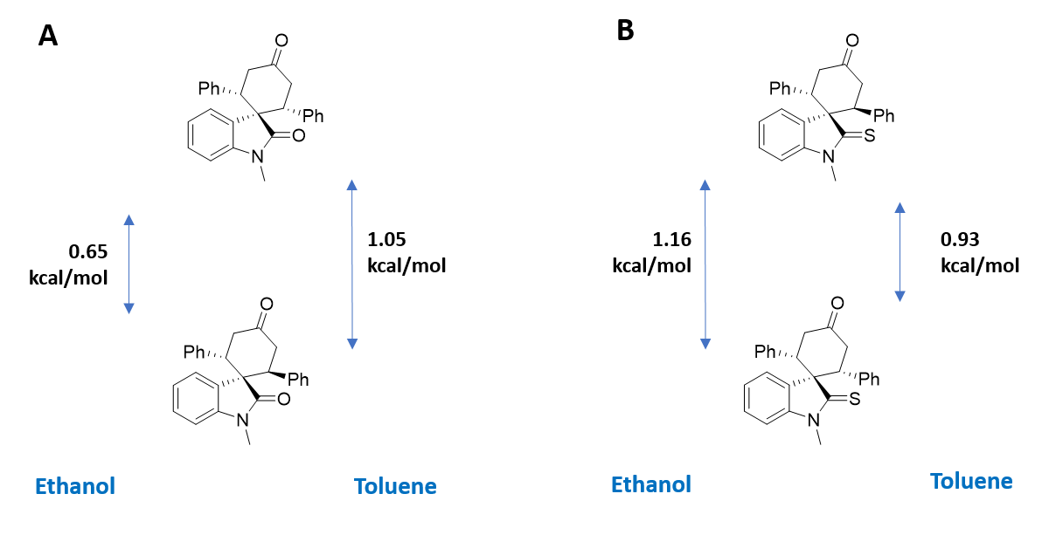

**Figure S3.** The energy diagram of *cis* and *trans* (A) oxindole (B) thiooxindole in ethanol and toluene.

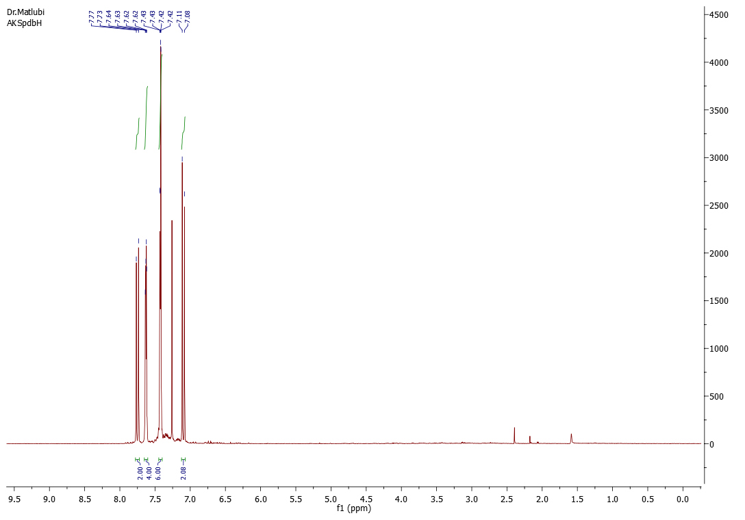

1H NMR spectrum (CDCl3, 500 MHz)

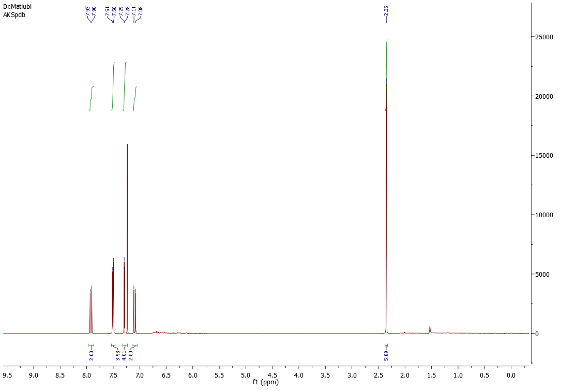

1H NMR spectrum (CDCl3, 500 MHz)

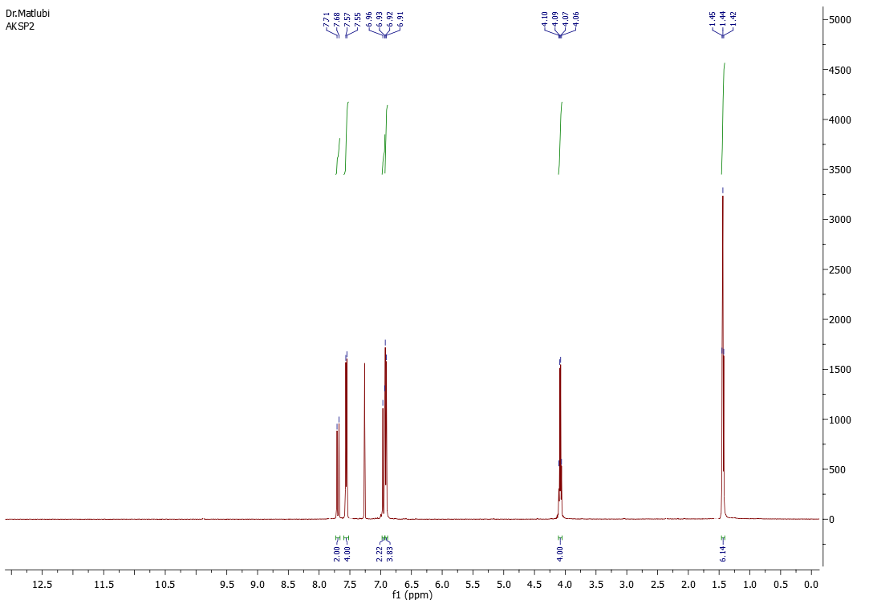

1H NMR spectrum (CDCl3, 500 MHz)

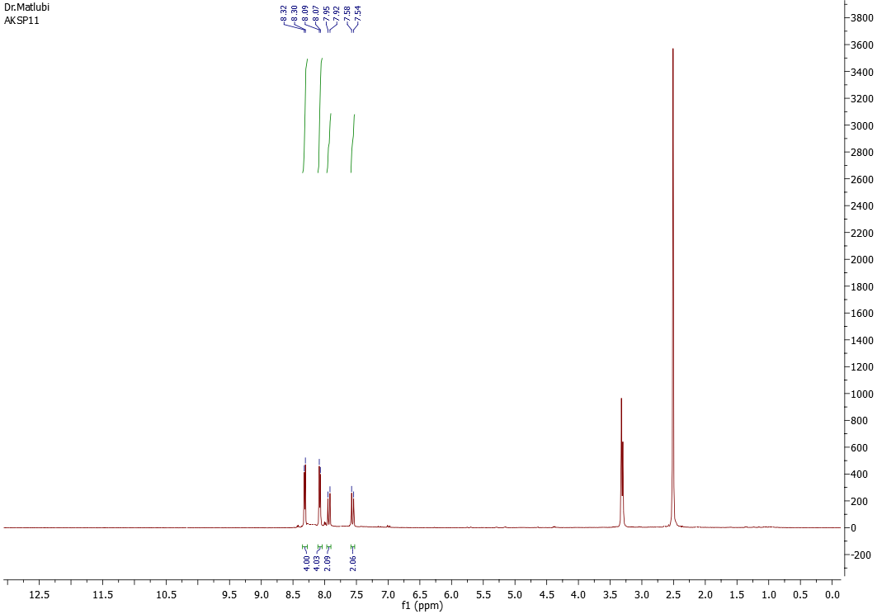

1H NMR spectrum (d6-DMSO, 500 MHz)

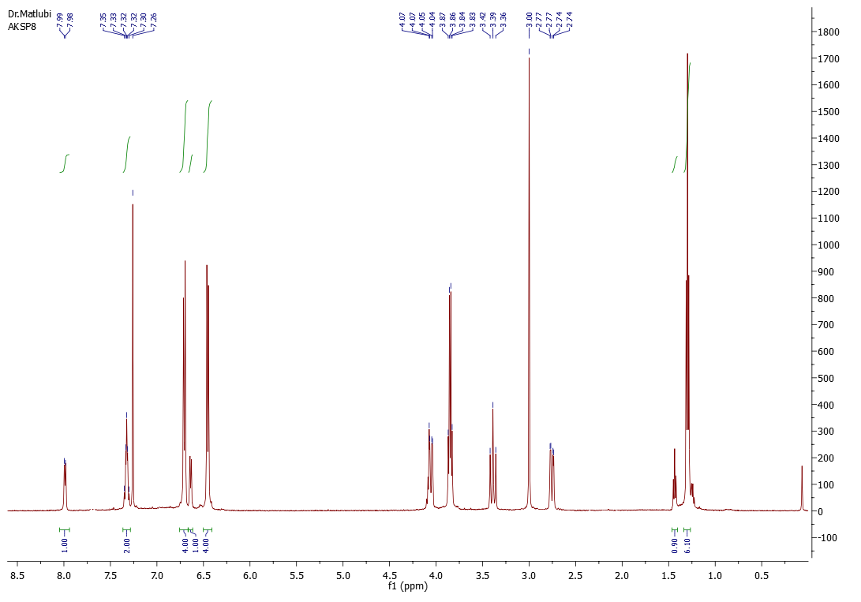

1H NMR spectrum (CDCl3, 500 MHz)

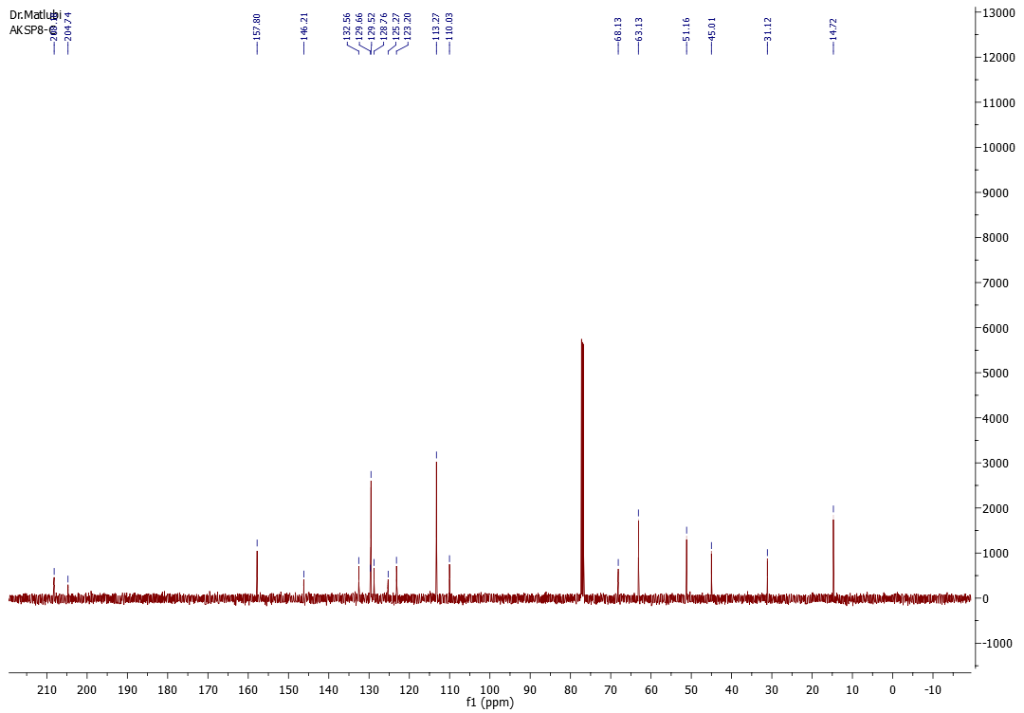

13C NMR spectrum (CDCl3, 125.8 MHz)

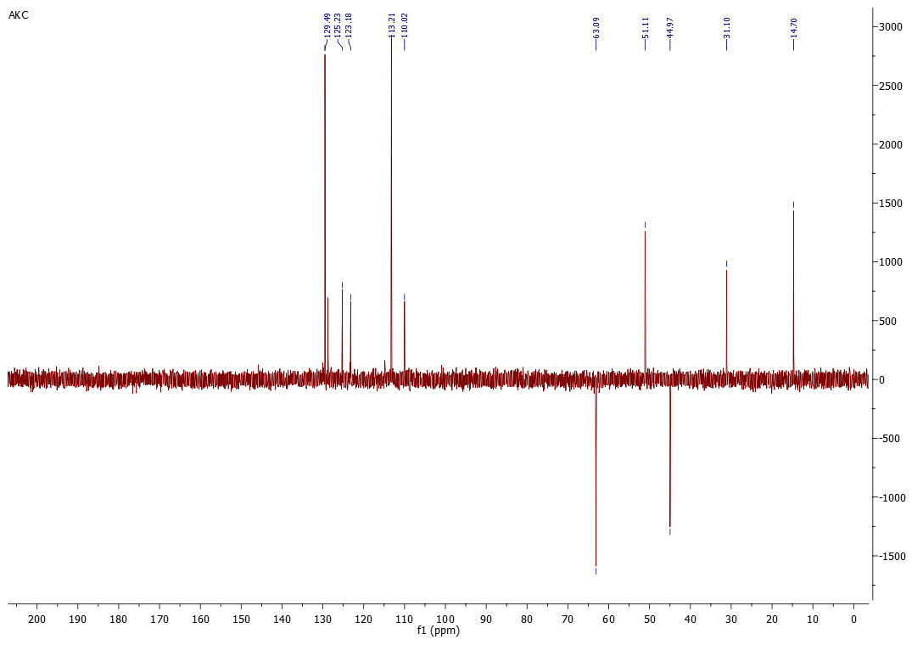

DEPT 135



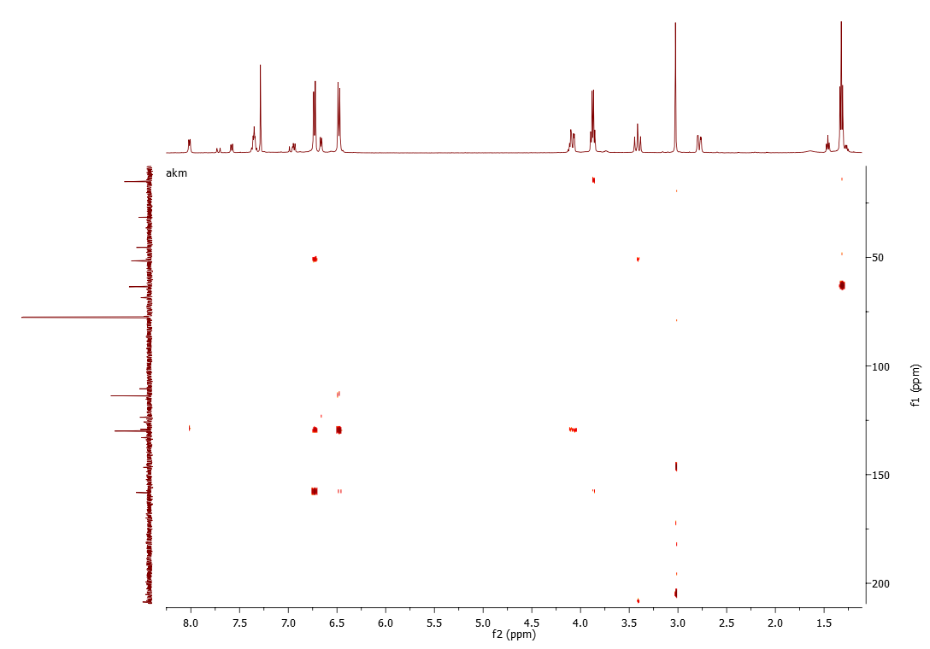

HMBC



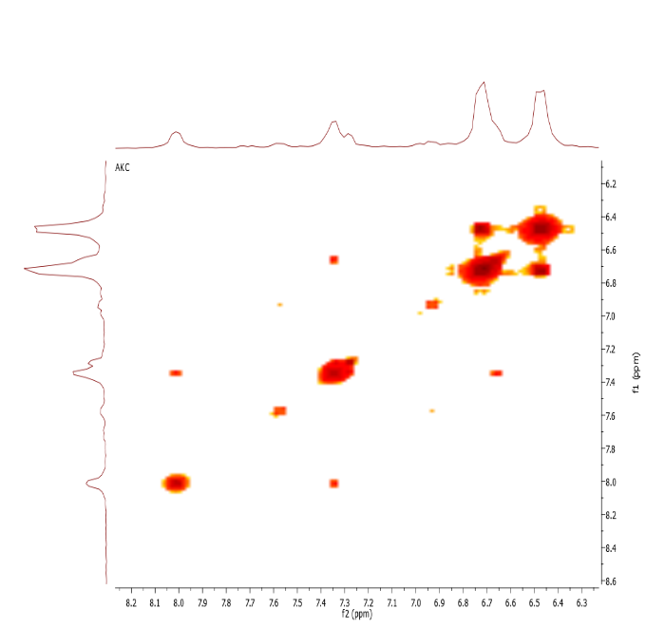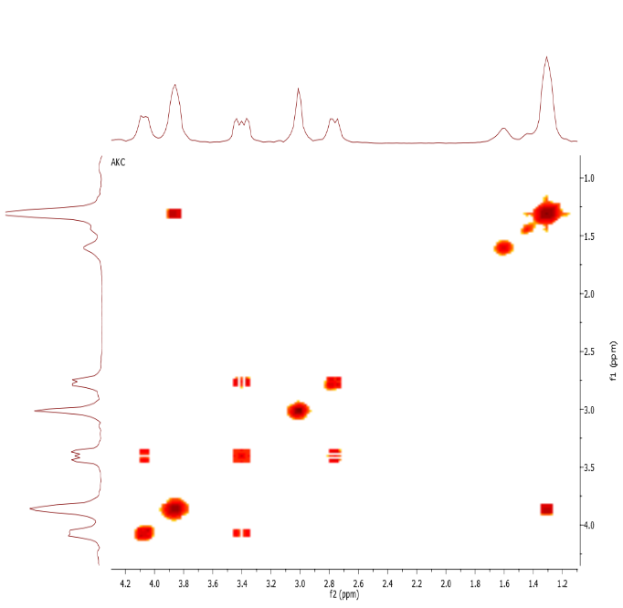

COSY

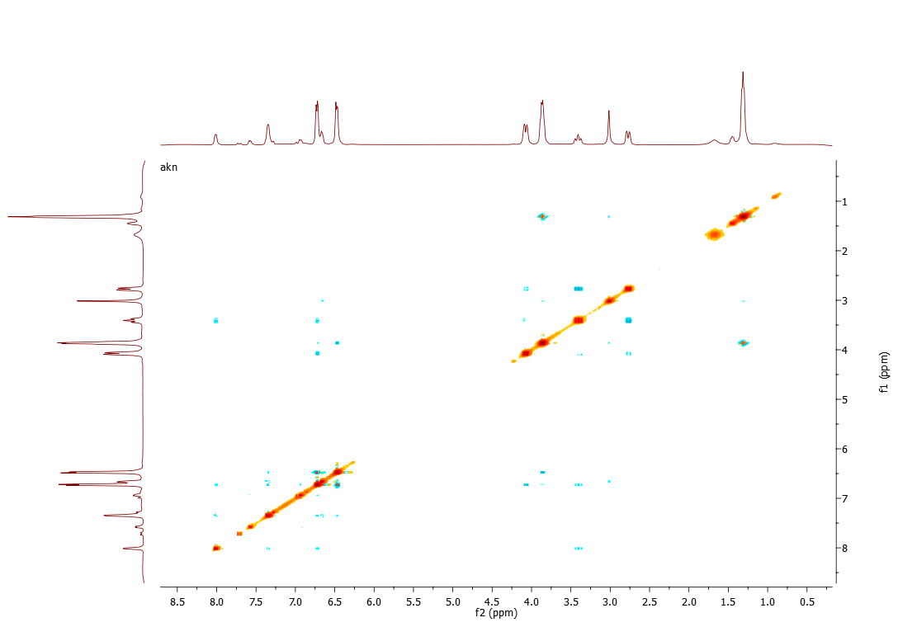

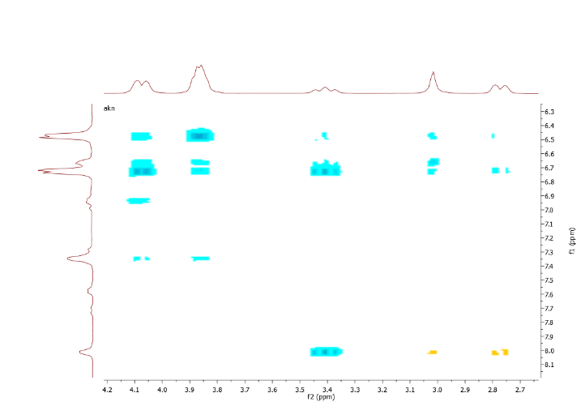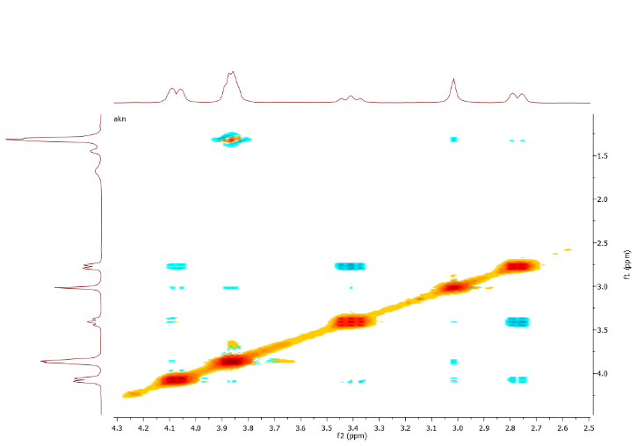

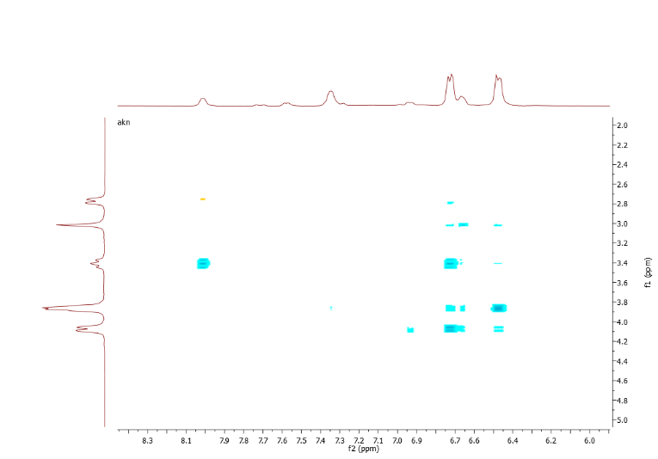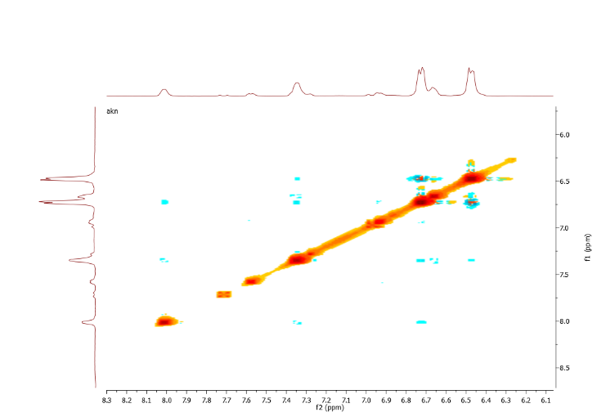

NOESY

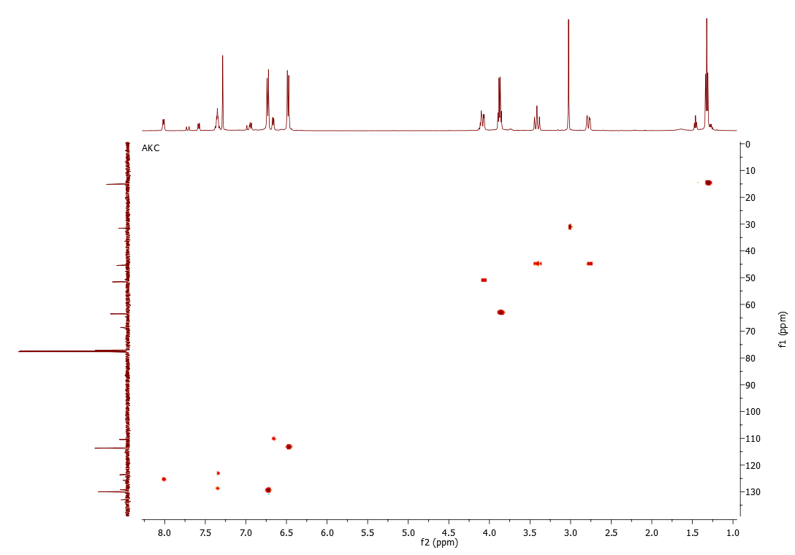

HSQC

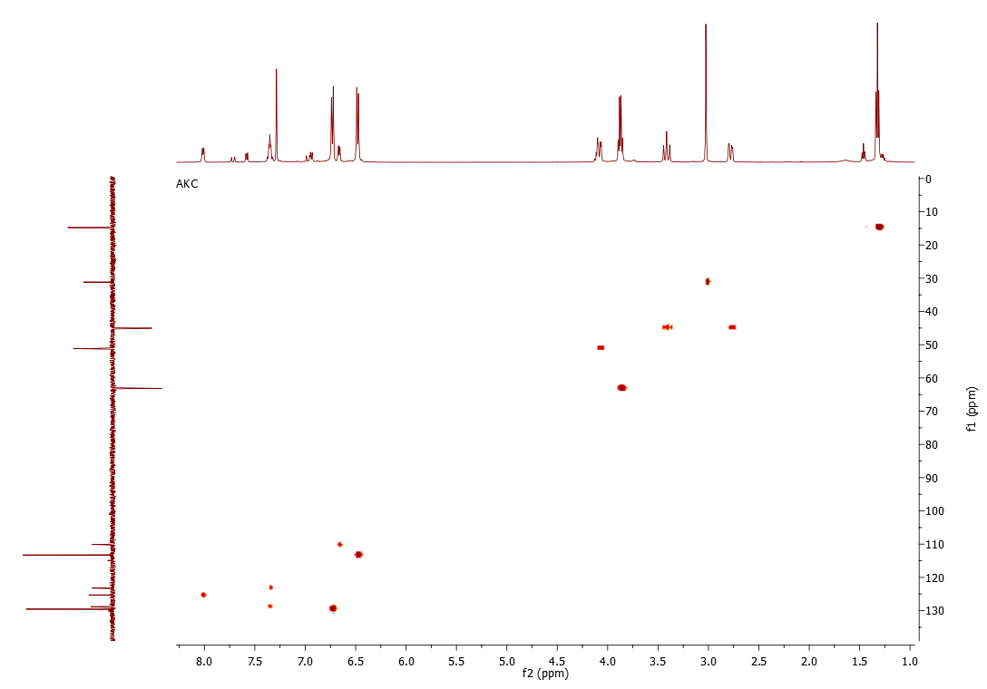

HSQC (on DEPT 135)

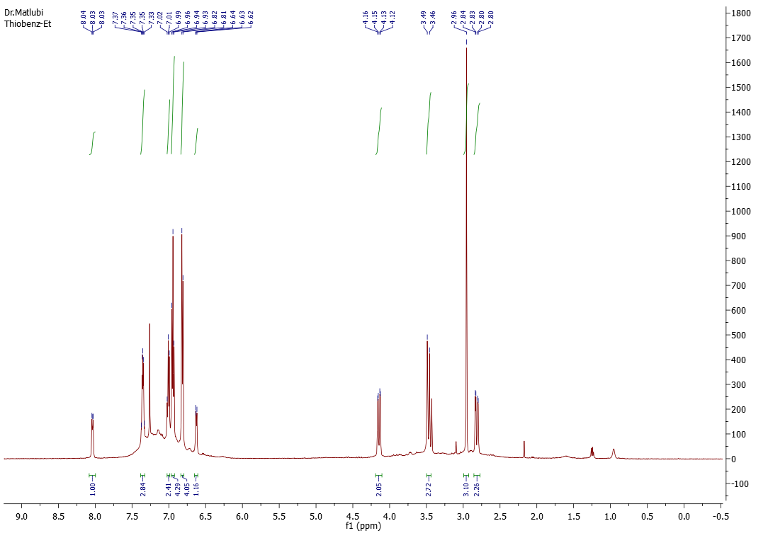

1H NMR spectrum (CDCl3, 500 MHz)

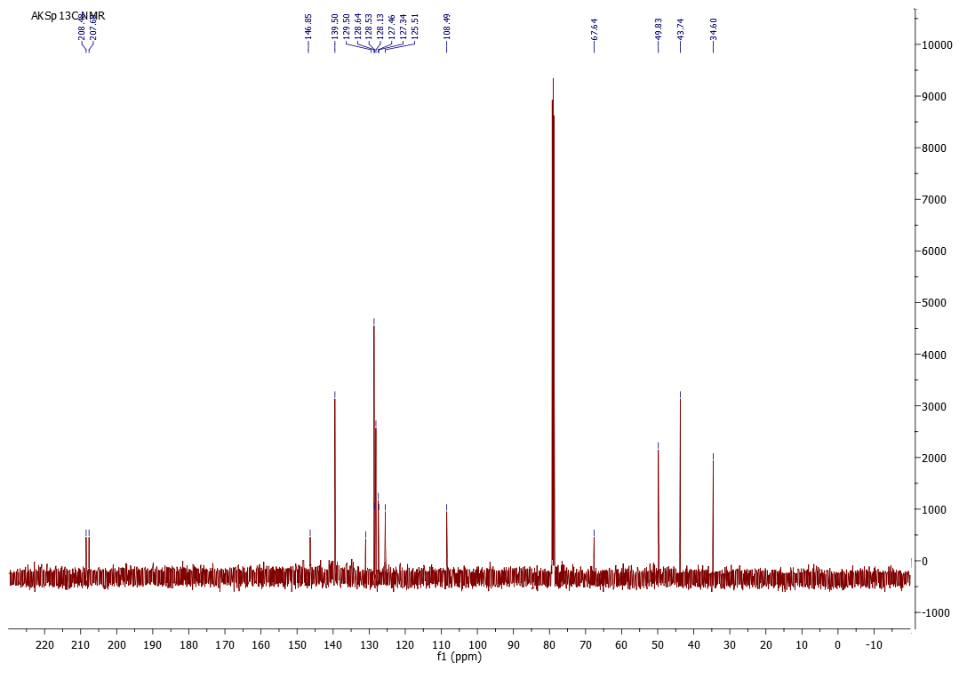

13C NMR spectrum (CDCl3, 125.8 MHz)

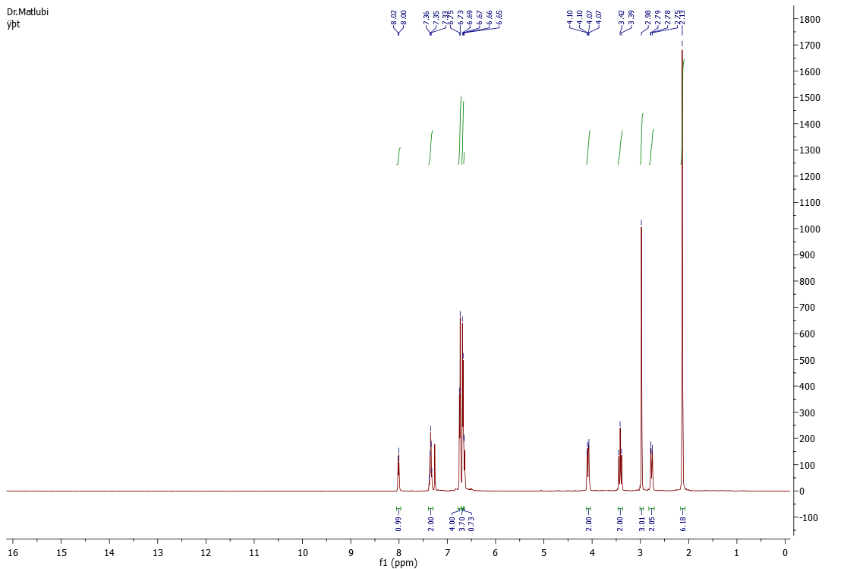

1H NMR spectrum (CDCl3, 500 MHz)

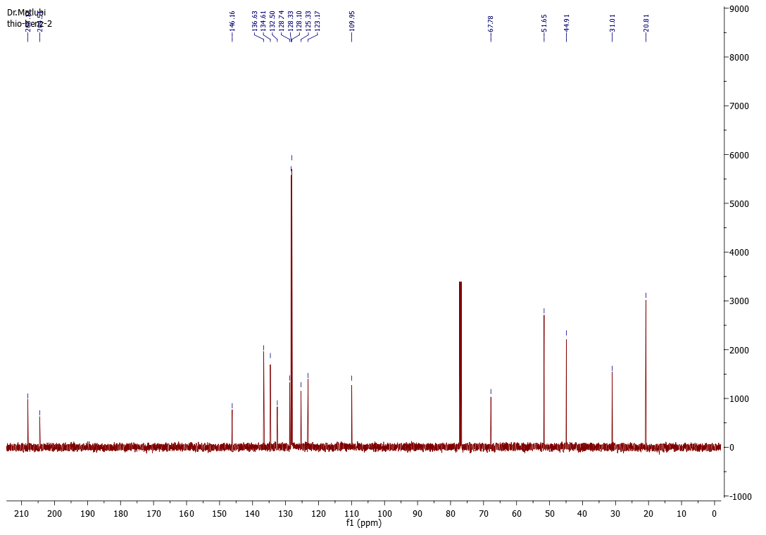

13C NMR spectrum (CDCl3, 125.8 MHz)

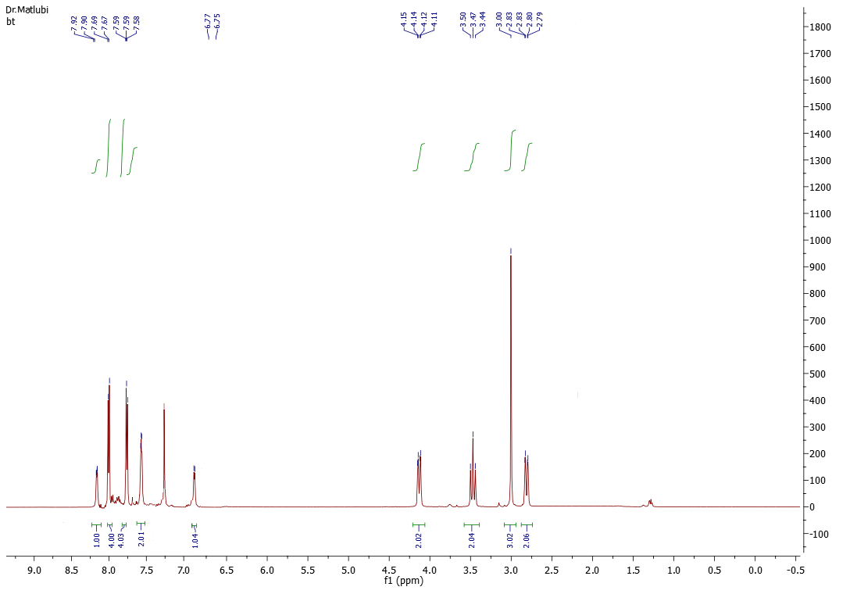

1H NMR spectrum (CDCl3, 500 MHz)

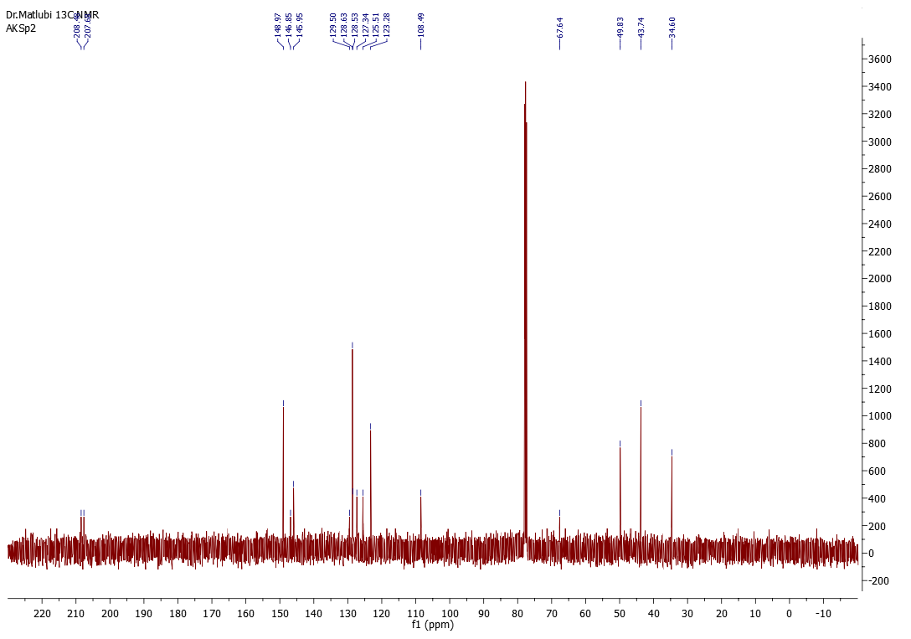

13C NMR spectrum (CDCl3, 125.8 MHz)

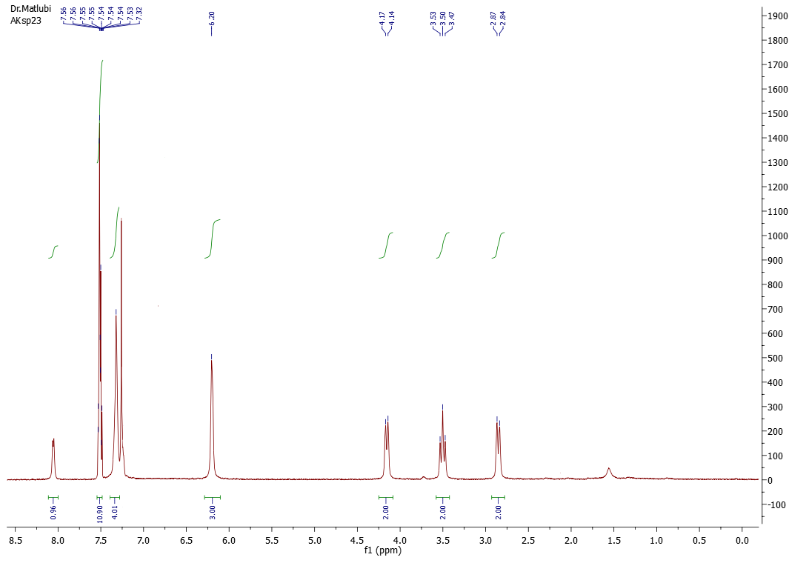

1H NMR spectrum (CDCl3, 500 MHz)

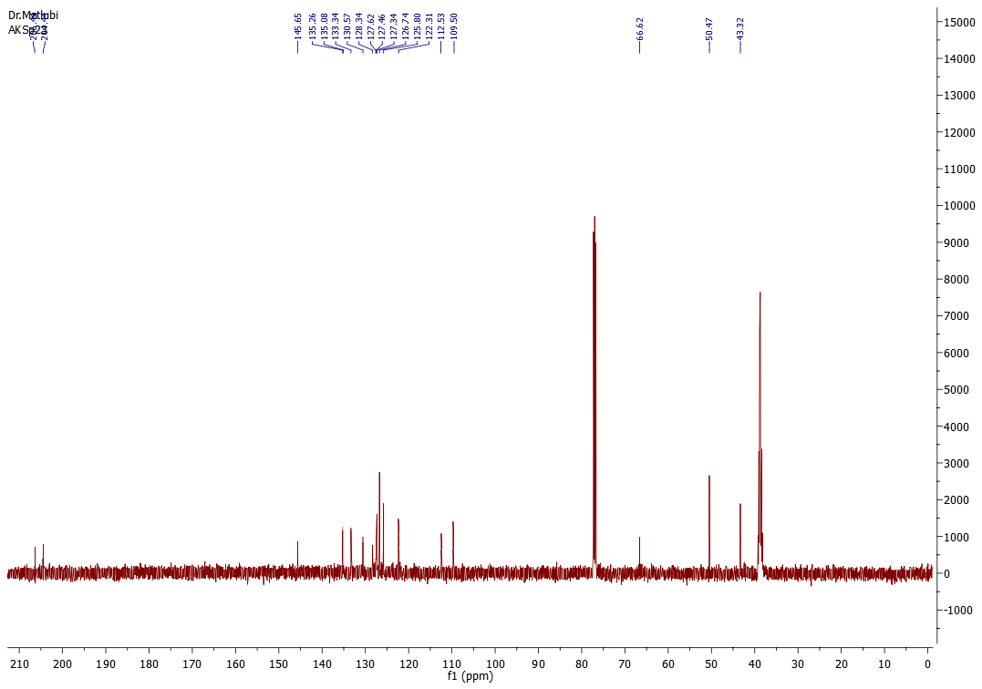

13C NMR spectrum (CDCl3 and d6-DMSO, 125.8 MHz)

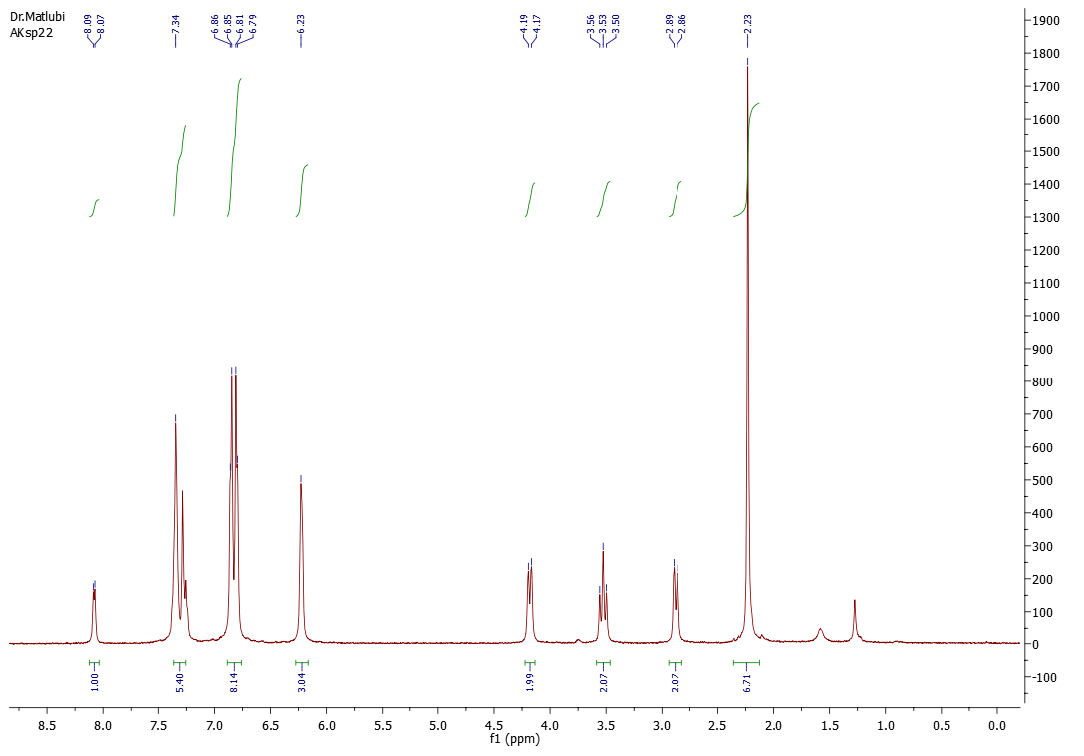

1H NMR spectrum (CDCl3, 500 MHz)

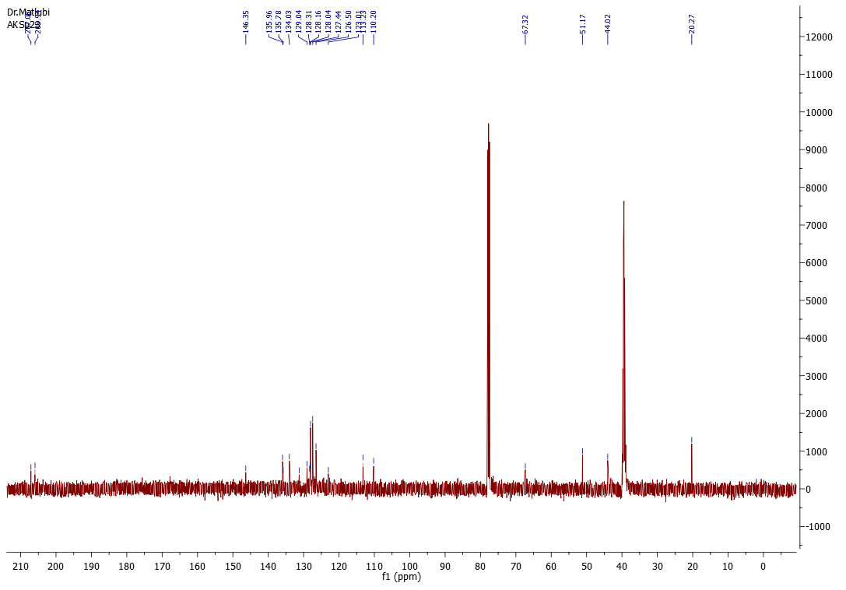

13C NMR spectrum (CDCl3 and d6-DMSO, 125.8 MHz)

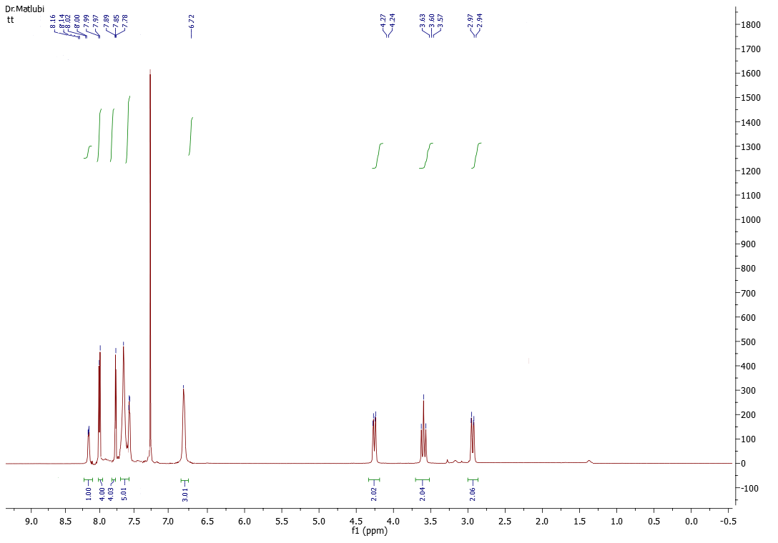

1H NMR spectrum (CDCl3, 500 MHz)

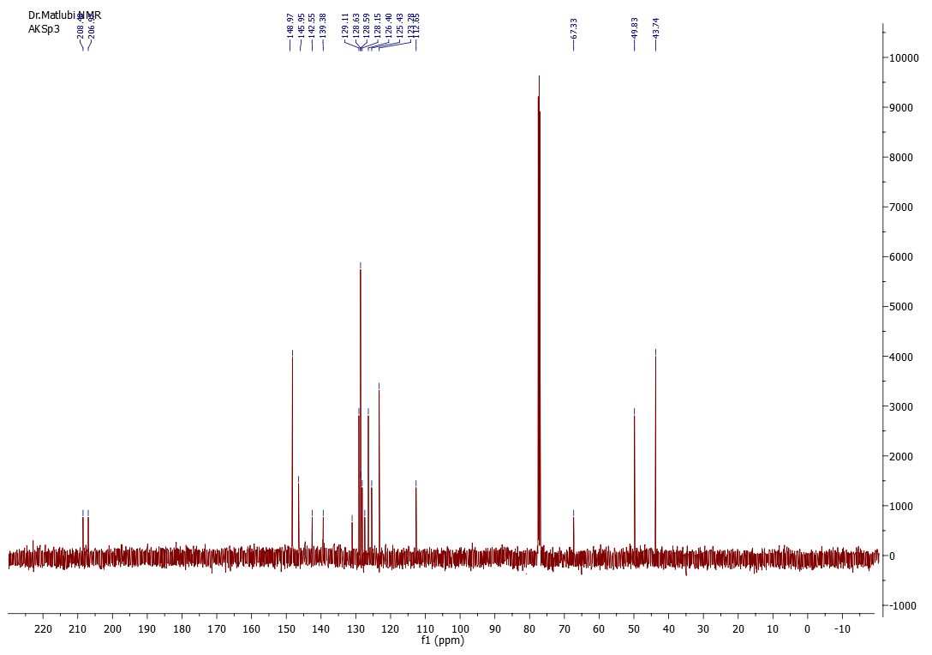

13C NMR spectrum (CDCl3, 125.8 MHz)

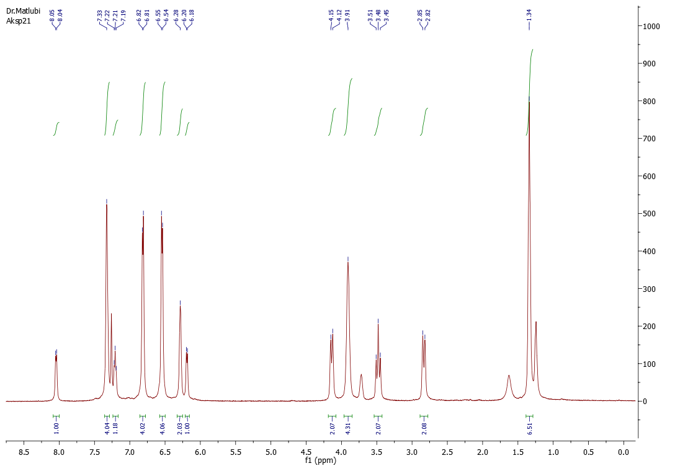

1H NMR spectrum (CDCl3, 500 MHz)

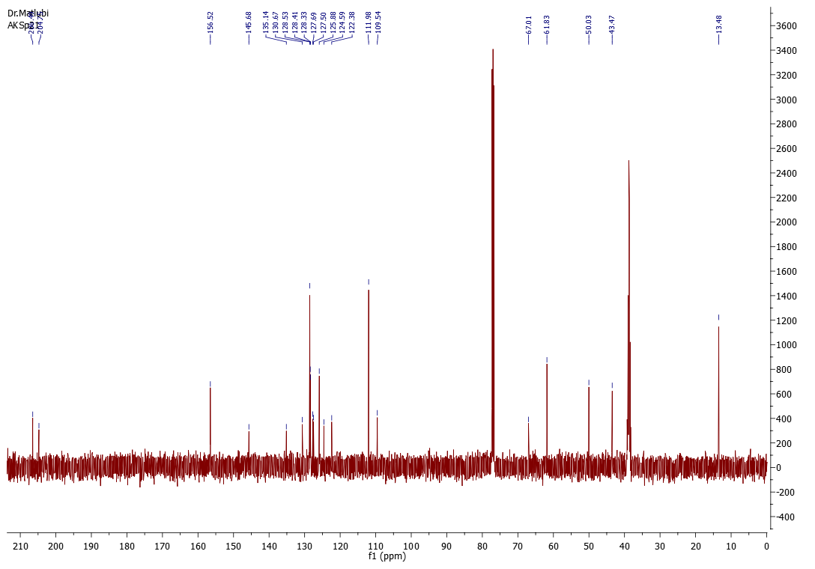

13C NMR spectrum (CDCl3, 125.8 MHz)

X-Ray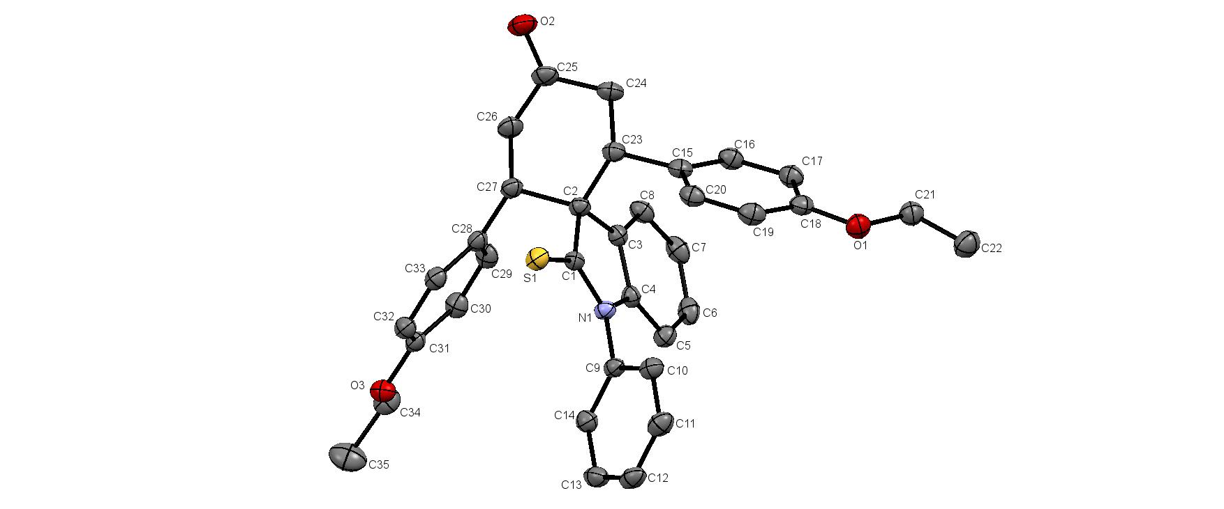

Crystal data:

Empirical Formula C35 H33 N O3 S

Formula Weight 547.68

Crystal Color, Habit pale yellow plate

Crystal Dimensions 0.240x0.160x0.080 mm

Crystal System monoclinic

Lattice Type P 21/c

a(Å) 16.7611(5)

b(Å) 10.7285(4)

c(Å) 16.8814(4)

(°) 90

(°) 113.469(1)

(°) 90

V(Å3) 2784.52(15)

Z 4

d(g-cm-3) 1.306

F(000) 1160

(cm-1) 0.154

Intensity measurements:

Diffractometer Bruker APEX II CCD

Monochromator graphite

Radiation MoKα (λ = 0.71069 Å)

Maximum theta 27.532 °

HKL ranges -21 21 ; -13 13 ; -21 21

No. of Reflexions measured Total: 19308 Unique: 6331

(Rint = 0.0360)

Absorption corrections multi-scan; 0.6822 min, 0.7456 max

Structure solution and refinement:

Structure Solution SHELXT-2014

Refinement SHELXL-2014/7

Refinement type Fsqd

Hydrogen atoms constr

Parameters refined 363

Reflections/parameter 14

wR2 0.1042

**R1 3.74 %**

**Completeness 98.9 %**

Weights a, b 0.0520; 0.6732

GoF 1.038

Difference peak / hole (e Å-3) 0.293(0.042) / -0.217(0.042)

**Data:**

Table 2. Atomic Coordinates (A x 10^4) and equivalent isotropic displacement parameters (A^2 x 10^3)

-----------------------------------------------------------------

atom x y z U(eq)

-----------------------------------------------------------------

S(1) 1741(1) 4434(1) 2205(1) 25(1)

O(1) 1119(1) 246(1) 5029(1) 30(1)

O(2) -102(1) 8054(1) 3359(1) 36(1)

O(3) 5237(1) 8411(1) 3617(1) 27(1)

N(1) 2955(1) 4123(1) 3805(1) 20(1)

C(1) 2218(1) 4679(1) 3254(1) 20(1)

C(2) 1906(1) 5585(1) 3778(1) 21(1)

C(3) 2589(1) 5415(1) 4686(1) 21(1)

C(4) 3198(1) 4552(1) 4664(1) 20(1)

C(5) 3911(1) 4189(1) 5388(1) 26(1)

C(6) 3987(1) 4695(1) 6176(1) 29(1)

C(7) 3381(1) 5534(1) 6220(1) 30(1)

C(8) 2681(1) 5907(1) 5478(1) 26(1)

C(9) 3402(1) 3150(1) 3567(1) 21(1)

C(10) 2997(1) 2003(1) 3316(1) 27(1)

C(11) 3428(1) 1062(1) 3083(1) 31(1)

C(12) 4252(1) 1267(1) 3107(1) 31(1)

C(13) 4655(1) 2410(1) 3370(1) 30(1)

C(14) 4228(1) 3362(1) 3601(1) 26(1)

C(15) 984(1) 3865(1) 4061(1) 23(1)

C(16) 1104(1) 3681(1) 4915(1) 27(1)

C(17) 1140(1) 2494(1) 5264(1) 27(1)

C(18) 1064(1) 1452(1) 4750(1) 25(1)

C(19) 922(1) 1613(1) 3886(1) 29(1)

C(20) 882(1) 2802(1) 3551(1) 26(1)

C(21) 1197(1) 39(1) 5897(1) 30(1)

C(22) 1295(1) -1343(1) 6061(1) 37(1)

C(23) 977(1) 5157(1) 3680(1) 23(1)

C(24) 531(1) 6139(1) 4027(1) 28(1)

C(25) 551(1) 7423(1) 3678(1) 29(1)

C(26) 1432(1) 7873(1) 3758(1) 30(1)

C(27) 1882(1) 6919(1) 3391(1) 23(1)

C(28) 2777(1) 7348(1) 3473(1) 23(1)

C(29) 3397(1) 7821(1) 4239(1) 27(1)

C(30) 4220(1) 8181(1) 4317(1) 27(1)

C(31) 4445(1) 8075(1) 3612(1) 23(1)

C(32) 3839(1) 7603(1) 2837(1) 25(1)

C(33) 3022(1) 7250(1) 2774(1) 24(1)

C(34) 5835(1) 9037(1) 4373(1) 31(1)

C(35) 6646(1) 9318(2) 4231(1) 48(1)

-----------------------------------------------------------------

U(eq) is defined as 1/3 the trace of the Uij tensor.

Table 3. Bond lengths (A) and angles (deg)

S(1)-C(1) 1.648(1) O(1)-C(18) 1.367(2)

O(1)-C(21) 1.437(2) O(2)-C(25) 1.214(2)

O(3)-C(31) 1.372(2) O(3)-C(34) 1.437(2)

N(1)-C(1) 1.353(2) N(1)-C(4) 1.418(2)

N(1)-C(9) 1.433(2) C(1)-C(2) 1.540(2)

C(2)-C(3) 1.515(2) C(2)-C(27) 1.567(2)

C(2)-C(23) 1.568(2) C(3)-C(8) 1.387(2)

C(3)-C(4) 1.390(2) C(4)-C(5) 1.382(2)

C(5)-C(6) 1.394(2) C(5)-H(5) 0.9500

C(6)-C(7) 1.382(2) C(6)-H(6) 0.9500

C(7)-C(8) 1.391(2) C(7)-H(7) 0.9500

C(8)-H(8) 0.9500 C(9)-C(14) 1.382(2)

C(9)-C(10) 1.388(2) C(10)-C(11) 1.386(2)

C(10)-H(10) 0.9500 C(11)-C(12) 1.382(2)

C(11)-H(11) 0.9500 C(12)-C(13) 1.385(2)

C(12)-H(12) 0.9500 C(13)-C(14) 1.390(2)

C(13)-H(13) 0.9500 C(14)-H(14) 0.9500

C(15)-C(16) 1.389(2) C(15)-C(20) 1.398(2)

C(15)-C(23) 1.525(2) C(16)-C(17) 1.394(2)

C(16)-H(16) 0.9500 C(17)-C(18) 1.390(2)

C(17)-H(17) 0.9500 C(18)-C(19) 1.392(2)

C(19)-C(20) 1.386(2) C(19)-H(19) 0.9500

C(20)-H(20) 0.9500 C(21)-C(22) 1.505(2)

C(21)-H(21A) 0.9900 C(21)-H(21B) 0.9900

C(22)-H(22A) 0.9800 C(22)-H(22B) 0.9800

C(22)-H(22C) 0.9800 C(23)-C(24) 1.537(2)

C(23)-H(23) 1.0000 C(24)-C(25) 1.503(2)

C(24)-H(24A) 0.9900 C(24)-H(24B) 0.9900

C(25)-C(26) 1.508(2) C(26)-C(27) 1.540(2)

C(26)-H(26A) 0.9900 C(26)-H(26B) 0.9900

C(27)-C(28) 1.522(2) C(27)-H(27) 1.0000

C(28)-C(29) 1.393(2) C(28)-C(33) 1.399(2)

C(29)-C(30) 1.388(2) C(29)-H(29) 0.9500

C(30)-C(31) 1.390(2) C(30)-H(30) 0.9500

C(31)-C(32) 1.393(2) C(32)-C(33) 1.383(2)

C(32)-H(32) 0.9500 C(33)-H(33) 0.9500

C(34)-C(35) 1.501(2) C(34)-H(34A) 0.9900

C(34)-H(34B) 0.9900 C(35)-H(35A) 0.9800

C(35)-H(35B) 0.9800 C(35)-H(35C) 0.9800

C(18)-O(1)-C(21) 117.6(1) C(31)-O(3)-C(34) 117.3(1)

C(1)-N(1)-C(4) 111.9(1) C(1)-N(1)-C(9) 124.3(1)

C(4)-N(1)-C(9) 123.6(1) N(1)-C(1)-C(2) 108.0(1)

N(1)-C(1)-S(1) 126.0(1) C(2)-C(1)-S(1) 126.0(1)

C(3)-C(2)-C(1) 102.3(1) C(3)-C(2)-C(27) 114.5(1)

C(1)-C(2)-C(27) 107.2(1) C(3)-C(2)-C(23) 112.9(1)

C(1)-C(2)-C(23) 107.8(1) C(27)-C(2)-C(23) 111.4(1)

C(8)-C(3)-C(4) 118.6(1) C(8)-C(3)-C(2) 132.8(1)

C(4)-C(3)-C(2) 108.6(1) C(5)-C(4)-C(3) 123.3(1)

C(5)-C(4)-N(1) 127.4(1) C(3)-C(4)-N(1) 109.2(1)

C(4)-C(5)-C(6) 116.9(1) C(4)-C(5)-H(5) 121.5

C(6)-C(5)-H(5) 121.5 C(7)-C(6)-C(5) 121.0(1)

C(7)-C(6)-H(6) 119.5 C(5)-C(6)-H(6) 119.5

C(6)-C(7)-C(8) 120.8(1) C(6)-C(7)-H(7) 119.6

C(8)-C(7)-H(7) 119.6 C(3)-C(8)-C(7) 119.3(1)

C(3)-C(8)-H(8) 120.3 C(7)-C(8)-H(8) 120.3

C(14)-C(9)-C(10) 121.3(1) C(14)-C(9)-N(1) 119.7(1)

C(10)-C(9)-N(1) 119.0(1) C(11)-C(10)-C(9) 119.1(1)

C(11)-C(10)-H(10) 120.5 C(9)-C(10)-H(10) 120.5

C(12)-C(11)-C(10) 120.2(1) C(12)-C(11)-H(11) 119.9

C(10)-C(11)-H(11) 119.9 C(11)-C(12)-C(13) 120.3(1)

C(11)-C(12)-H(12) 119.8 C(13)-C(12)-H(12) 119.8

C(12)-C(13)-C(14) 120.0(1) C(12)-C(13)-H(13) 120.0

C(14)-C(13)-H(13) 120.0 C(9)-C(14)-C(13) 119.1(1)

C(9)-C(14)-H(14) 120.4 C(13)-C(14)-H(14) 120.4

C(16)-C(15)-C(20) 117.0(1) C(16)-C(15)-C(23) 122.7(1)

C(20)-C(15)-C(23) 120.2(1) C(15)-C(16)-C(17) 122.2(1)

C(15)-C(16)-H(16) 118.9 C(17)-C(16)-H(16) 118.9

C(18)-C(17)-C(16) 119.5(1) C(18)-C(17)-H(17) 120.2

C(16)-C(17)-H(17) 120.2 O(1)-C(18)-C(17) 124.8(1)

O(1)-C(18)-C(19) 116.0(1) C(17)-C(18)-C(19) 119.3(1)

C(20)-C(19)-C(18) 120.2(1) C(20)-C(19)-H(19) 119.9

C(18)-C(19)-H(19) 119.9 C(19)-C(20)-C(15) 121.7(1)

C(19)-C(20)-H(20) 119.1 C(15)-C(20)-H(20) 119.1

O(1)-C(21)-C(22) 107.3(1) O(1)-C(21)-H(21A) 110.3

C(22)-C(21)-H(21A) 110.3 O(1)-C(21)-H(21B) 110.3

C(22)-C(21)-H(21B) 110.3 H(21A)-C(21)-H(21B) 108.5

C(21)-C(22)-H(22A) 109.5 C(21)-C(22)-H(22B) 109.5

H(22A)-C(22)-H(22B) 109.5 C(21)-C(22)-H(22C) 109.5

H(22A)-C(22)-H(22C) 109.5 H(22B)-C(22)-H(22C) 109.5

C(15)-C(23)-C(24) 112.7(1) C(15)-C(23)-C(2) 112.4(1)

C(24)-C(23)-C(2) 111.9(1) C(15)-C(23)-H(23) 106.4

C(24)-C(23)-H(23) 106.4 C(2)-C(23)-H(23) 106.4

C(25)-C(24)-C(23) 112.9(1) C(25)-C(24)-H(24A) 109.0

C(23)-C(24)-H(24A) 109.0 C(25)-C(24)-H(24B) 109.0

C(23)-C(24)-H(24B) 109.0 H(24A)-C(24)-H(24B) 107.8

O(2)-C(25)-C(24) 121.9(1) O(2)-C(25)-C(26) 122.5(1)

C(24)-C(25)-C(26) 115.6(1) C(25)-C(26)-C(27) 111.8(1)

C(25)-C(26)-H(26A) 109.3 C(27)-C(26)-H(26A) 109.3

C(25)-C(26)-H(26B) 109.3 C(27)-C(26)-H(26B) 109.3

H(26A)-C(26)-H(26B) 107.9 C(28)-C(27)-C(26) 112.7(1)

C(28)-C(27)-C(2) 112.2(1) C(26)-C(27)-C(2) 112.0(1)

C(28)-C(27)-H(27) 106.5 C(26)-C(27)-H(27) 106.5

C(2)-C(27)-H(27) 106.5 C(29)-C(28)-C(33) 116.8(1)

C(29)-C(28)-C(27) 122.5(1) C(33)-C(28)-C(27) 120.7(1)

C(30)-C(29)-C(28) 122.3(1) C(30)-C(29)-H(29) 118.8

C(28)-C(29)-H(29) 118.8 C(29)-C(30)-C(31) 119.7(1)

C(29)-C(30)-H(30) 120.1 C(31)-C(30)-H(30) 120.1

O(3)-C(31)-C(30) 124.4(1) O(3)-C(31)-C(32) 116.3(1)

C(30)-C(31)-C(32) 119.2(1) C(33)-C(32)-C(31) 120.1(1)

C(33)-C(32)-H(32) 119.9 C(31)-C(32)-H(32) 119.9

C(32)-C(33)-C(28) 121.8(1) C(32)-C(33)-H(33) 119.1

C(28)-C(33)-H(33) 119.1 O(3)-C(34)-C(35) 107.9(1)

O(3)-C(34)-H(34A) 110.1 C(35)-C(34)-H(34A) 110.1

O(3)-C(34)-H(34B) 110.1 C(35)-C(34)-H(34B) 110.1

H(34A)-C(34)-H(34B) 108.4 C(34)-C(35)-H(35A) 109.5

C(34)-C(35)-H(35B) 109.5 H(35A)-C(35)-H(35B) 109.5

C(34)-C(35)-H(35C) 109.5 H(35A)-C(35)-H(35C) 109.5

H(35B)-C(35)-H(35C) 109.5

Table 4. Anisotropic displacement parameters (A^2 x 10^3)

---------------------------------------------------------------------------

atom U11 U22 U33 U23 U13 U12

---------------------------------------------------------------------------

S(1) 30(1) 28(1) 17(1) -1(1) 8(1) 6(1)

O(1) 36(1) 25(1) 32(1) -2(1) 16(1) 1(1)

O(2) 35(1) 42(1) 34(1) 2(1) 16(1) 17(1)

O(3) 24(1) 31(1) 24(1) -3(1) 8(1) 1(1)

N(1) 22(1) 22(1) 18(1) 0(1) 8(1) 4(1)

C(1) 22(1) 20(1) 21(1) 1(1) 10(1) 2(1)

C(2) 22(1) 22(1) 19(1) -1(1) 10(1) 4(1)

C(3) 22(1) 21(1) 20(1) 0(1) 10(1) -1(1)

C(4) 24(1) 20(1) 19(1) 0(1) 10(1) -1(1)

C(5) 25(1) 26(1) 24(1) 2(1) 8(1) 2(1)

C(6) 29(1) 35(1) 19(1) 3(1) 6(1) -4(1)

C(7) 33(1) 39(1) 19(1) -5(1) 13(1) -8(1)

C(8) 29(1) 30(1) 24(1) -5(1) 14(1) -2(1)

C(9) 25(1) 23(1) 17(1) 1(1) 9(1) 7(1)

C(10) 26(1) 26(1) 28(1) -1(1) 11(1) 4(1)

C(11) 35(1) 25(1) 30(1) -3(1) 11(1) 5(1)

C(12) 36(1) 33(1) 24(1) 1(1) 13(1) 15(1)

C(13) 27(1) 40(1) 26(1) 3(1) 14(1) 9(1)

C(14) 27(1) 28(1) 23(1) 1(1) 12(1) 2(1)

C(15) 18(1) 26(1) 26(1) -3(1) 10(1) 1(1)

C(16) 28(1) 27(1) 27(1) -6(1) 14(1) -1(1)

C(17) 28(1) 30(1) 25(1) -3(1) 12(1) 0(1)

C(18) 20(1) 26(1) 31(1) -2(1) 12(1) -1(1)

C(19) 28(1) 28(1) 30(1) -8(1) 13(1) -2(1)

C(20) 23(1) 32(1) 24(1) -5(1) 10(1) -1(1)

C(21) 33(1) 28(1) 31(1) 0(1) 15(1) 2(1)

C(22) 41(1) 28(1) 40(1) 2(1) 16(1) 4(1)

C(23) 22(1) 26(1) 22(1) -2(1) 10(1) 3(1)

C(24) 24(1) 31(1) 33(1) -3(1) 15(1) 5(1)

C(25) 32(1) 32(1) 25(1) -4(1) 15(1) 10(1)

C(26) 35(1) 24(1) 34(1) 0(1) 18(1) 7(1)

C(27) 26(1) 21(1) 24(1) 0(1) 11(1) 5(1)

C(28) 28(1) 18(1) 24(1) 2(1) 11(1) 5(1)

C(29) 37(1) 26(1) 21(1) -2(1) 15(1) 1(1)

C(30) 33(1) 26(1) 20(1) -3(1) 9(1) 0(1)

C(31) 26(1) 20(1) 23(1) 3(1) 10(1) 5(1)

C(32) 29(1) 27(1) 19(1) 0(1) 11(1) 4(1)

C(33) 27(1) 24(1) 20(1) 0(1) 8(1) 3(1)

C(34) 31(1) 31(1) 25(1) -3(1) 5(1) 1(1)

C(35) 32(1) 62(1) 47(1) -15(1) 12(1) -9(1)

---------------------------------------------------------------------------

The anisotropic displacement factor exponent takes the form 2 pi^2 [h^2a*^2U(11) +...+ 2hka*b*U(12)]

Table 5. Hydrogen Coordinates (A x 10^4) and equivalent isotropic displacement parameters (A^2 x 10^3)

-----------------------------------------------------------------

atom x y z U(eq)

-----------------------------------------------------------------

H(5) 4330 3622 5350 31

H(6) 4463 4459 6690 35

H(7) 3441 5860 6765 36

H(8) 2271 6492 5513 32

H(10) 2432 1865 3303 32

H(11) 3157 274 2907 37

H(12) 4542 621 2942 37

H(13) 5224 2543 3391 36

H(14) 4501 4149 3780 31

H(16) 1163 4387 5274 32

H(17) 1216 2398 5849 32

H(19) 853 907 3525 34

H(20) 782 2897 2958 32

H(21A) 673 348 5968 36

H(21B) 1711 485 6312 36

H(22A) 806 -1779 5618 55

H(22B) 1300 -1524 6632 55

H(22C) 1842 -1626 6039 55

H(23) 619 5086 3046 28

H(24A) -82 5891 3872 34

H(24B) 823 6161 4665 34

H(26A) 1802 8027 4373 36

H(26B) 1364 8671 3443 36

H(27) 1515 6854 2759 28

H(29) 3250 7901 4726 32

H(30) 4628 8497 4850 32

H(32) 3987 7524 2352 29

H(33) 2615 6931 2241 29

H(34A) 5975 8499 4887 37

H(34B) 5574 9820 4469 37

H(35A) 6891 8540 4121 72

H(35B) 7072 9723 4746 72

H(35C) 6504 9874 3732 72

**Cartesian coordinates and energies**

**5**

E= -478.0935

H= -478.0926

G= -478.1360

C -2.73524728 -0.38277511 0.00000000

C -2.43215428 0.99644689 -0.00004000

C -3.42847928 1.97118089 -0.00001400

C -4.76673428 1.53679289 -0.00003800

C -5.08410628 0.17234389 -0.00006100

C -4.06169028 -0.79792711 -0.00002400

C -1.43538228 -1.15398511 0.00005700

C -0.36885828 -0.05418411 -0.00006900

H -3.18955128 3.02915889 0.00008900

H -5.56316428 2.27449989 -0.00003700

H -6.12316528 -0.14064411 -0.00012200

H -4.31179328 -1.85498611 -0.00002500

H -1.30270928 -1.79227711 -0.88208900

N -1.02977328 1.17089189 -0.00012000

C -0.34289528 2.45432389 0.00003800

H -0.60192828 3.03462989 0.89331400

H 0.73034772 2.25444589 -0.00035200

H -0.60256528 3.03512589 -0.89271500

O 0.86798972 -0.19998611 -0.00010500

H -1.30274128 -1.79172411 0.88265500

**6**

E= -801.0530

H= -801.0521

G= -801.0969

C -0.82905000 -0.93437300 -0.00000800

C -0.66203400 0.46316300 -0.00000500

C -1.74312100 1.34300900 -0.00002600

C -3.03267800 0.78187100 -0.00004700

C -3.21742000 -0.60770900 -0.00005300

C -2.10920800 -1.47761900 -0.00003800

C 0.54497500 -1.56450300 0.00002200

C 1.49558800 -0.37034700 0.00009100

H -1.60654000 2.41872900 -0.00001900

H -3.89647900 1.43913400 -0.00006100

H -4.22239900 -1.01703800 -0.00007000

H -2.25731900 -2.55345200 -0.00004100

H 0.73641800 -2.19085700 -0.87976700

N 0.72686500 0.76541400 0.00001100

C 1.23993900 2.13180100 -0.00004000

H 0.89665500 2.66466700 0.89363600

H 2.32929400 2.08582800 -0.00031400

H 0.89619100 2.66474800 -0.89348700

H 0.73636200 -2.19091200 0.87978300

S 3.19861400 -0.45440700 0.00005500

**1** (Gas phase)

E= -1203.2183

H= -1203.1979

G= -1203.2079

C 1.48730400 -0.43130500 1.19877400

C 0.03613700 -0.19855400 0.59797500

C -0.29404800 -1.24325900 -0.51597100

C -0.11860600 -2.69854400 0.01270200

C 1.27707700 -2.91147800 0.56509500

C 1.64752700 -1.91342400 1.65172600

H -0.82810500 -2.85480600 0.83134700

H -0.30442100 -3.41389000 -0.79156300

H 0.94594900 -2.07531100 2.47920300

H 2.67132600 -2.09878400 1.98377200

H 0.44248600 -1.07816700 -1.31199400

C -0.96512500 -0.30883200 1.77905600

C -0.18319600 1.23512200 0.13978000

C 0.35293800 1.94747400 -0.92178100

C -1.12058200 1.85118700 0.98926800

C -0.04043500 3.28141500 -1.11891600

H 1.07336200 1.48871000 -1.58540000

C -1.51523600 3.17015200 0.81212900

C -0.95889600 3.88339400 -0.25823700

H 0.37513200 3.84525400 -1.94515700

H -2.23774500 3.63458700 1.47101000

H -1.25382300 4.91375300 -0.41898500

N -1.55280500 0.93112400 1.96052800

C -2.56400500 1.17298900 2.99053900

H -2.66795000 0.23511000 3.54036500

H -2.24358700 1.96974700 3.66955700

H -3.52168400 1.44399900 2.53374700

O 2.03299400 -3.81038600 0.17751500

C -1.68252500 -1.04581800 -1.12077000

C -2.84949900 -1.36781800 -0.40937000

C -1.80899100 -0.55669800 -2.42782300

C -4.10586400 -1.19398100 -0.99234500

H -2.77756400 -1.75541400 0.59919600

C -3.06483600 -0.38520000 -3.01267900

H -0.91550000 -0.30760400 -2.98988000

C -4.21902300 -0.70273600 -2.29499400

H -4.99712800 -1.44973900 -0.43025600

H -3.14036000 -0.00628200 -4.02549300

H -5.19579800 -0.57359100 -2.74670600

H 1.53796700 0.19335400 2.09954400

C 2.61044200 0.04255300 0.27768900

C 3.19995600 -0.77566900 -0.69906900

C 3.09123100 1.35449400 0.42447000

C 4.21556400 -0.28121800 -1.52319800

H 2.90803300 -1.81163900 -0.79524300

C 4.10878800 1.84579600 -0.39282800

H 2.65647600 1.99535500 1.18312300

C 4.66967200 1.03012800 -1.37856700

H 4.65992700 -0.93151700 -2.26803500

H 4.46418200 2.86109000 -0.25876600

H 5.46086400 1.40814500 -2.01564400

O -1.21762100 -1.30852000 2.47656400

**1** (In ethanol)

E= -1195.5054

H= -1195.2395

G= -1195.5004

C 1.48730400 -0.43130500 1.19877400

C 0.03613700 -0.19855400 0.59797500

C -0.29404800 -1.24325900 -0.51597100

C -0.11860600 -2.69854400 0.01270200

C 1.27707700 -2.91147800 0.56509500

C 1.64752700 -1.91342400 1.65172600

H -0.82810500 -2.85480600 0.83134700

H -0.30442100 -3.41389000 -0.79156300

H 0.94594900 -2.07531100 2.47920300

H 2.67132600 -2.09878400 1.98377200

H 0.44248600 -1.07816700 -1.31199400

C -0.96512500 -0.30883200 1.77905600

C -0.18319600 1.23512200 0.13978000

C 0.35293800 1.94747400 -0.92178100

C -1.12058200 1.85118700 0.98926800

C -0.04043500 3.28141500 -1.11891600

H 1.07336200 1.48871000 -1.58540000

C -1.51523600 3.17015200 0.81212900

C -0.95889600 3.88339400 -0.25823700

H 0.37513200 3.84525400 -1.94515700

H -2.23774500 3.63458700 1.47101000

H -1.25382300 4.91375300 -0.41898500

N -1.55280500 0.93112400 1.96052800

C -2.56400500 1.17298900 2.99053900

H -2.66795000 0.23511000 3.54036500

H -2.24358700 1.96974700 3.66955700

H -3.52168400 1.44399900 2.53374700

O 2.03299400 -3.81038600 0.17751500

C -1.68252500 -1.04581800 -1.12077000

C -2.84949900 -1.36781800 -0.40937000

C -1.80899100 -0.55669800 -2.42782300

C -4.10586400 -1.19398100 -0.99234500

H -2.77756400 -1.75541400 0.59919600

C -3.06483600 -0.38520000 -3.01267900

H -0.91550000 -0.30760400 -2.98988000

C -4.21902300 -0.70273600 -2.29499400

H -4.99712800 -1.44973900 -0.43025600

H -3.14036000 -0.00628200 -4.02549300

H -5.19579800 -0.57359100 -2.74670600

H 1.53796700 0.19335400 2.09954400

C 2.61044200 0.04255300 0.27768900

C 3.19995600 -0.77566900 -0.69906900

C 3.09123100 1.35449400 0.42447000

C 4.21556400 -0.28121800 -1.52319800

H 2.90803300 -1.81163900 -0.79524300

C 4.10878800 1.84579600 -0.39282800

H 2.65647600 1.99535500 1.18312300

C 4.66967200 1.03012800 -1.37856700

H 4.65992700 -0.93151700 -2.26803500

H 4.46418200 2.86109000 -0.25876600

H 5.46086400 1.40814500 -2.01564400

O -1.21762100 -1.30852000 2.47656400

**1** (In toluene)

E= -1195.4977

H= -1195.2475

G= -1195.3465

C -1.14035091 -1.02870812 0.00000000

C -2.59151791 -0.79595712 -0.60079900

C -2.92170291 -1.84066212 -1.71474500

C -2.74626091 -3.29594712 -1.18607200

C -1.35057791 -3.50888112 -0.63367900

C -0.98012791 -2.51082712 0.45295200

H -3.45575991 -3.45220912 -0.36742700

H -2.93207591 -4.01129312 -1.99033700

H -1.68170591 -2.67271412 1.28042900

H 0.04367109 -2.69618712 0.78499800

H -2.18516891 -1.67557012 -2.51076800

C -3.59277991 -0.90623512 0.58028200

C -2.81085091 0.63771888 -1.05899400

C -2.27471691 1.35007088 -2.12055500

C -3.74823691 1.25378388 -0.20950600

C -2.66808991 2.68401188 -2.31769000

H -1.55429291 0.89130688 -2.78417400

C -4.14289091 2.57274888 -0.38664500

C -3.58655091 3.28599088 -1.45701100

H -2.25252291 3.24785088 -3.14393100

H -4.86539991 3.03718388 0.27223600

H -3.88147791 4.31634988 -1.61775900

N -4.18045991 0.33372088 0.76175400

C -5.19165991 0.57558588 1.79176500

H -5.29560491 -0.36229312 2.34159100

H -4.87124191 1.37234388 2.47078300

H -6.14933891 0.84659588 1.33497300

O -0.59466091 -4.40778912 -1.02125900

C -4.31017991 -1.64322112 -2.31954400

C -5.47715391 -1.96522112 -1.60814400

C -4.43664591 -1.15410112 -3.62659700

C -6.73351891 -1.79138412 -2.19111900

H -5.40521891 -2.35281712 -0.59957800

C -5.69249091 -0.98260312 -4.21145300

H -3.54315491 -0.90500712 -4.18865400

C -6.84667791 -1.30013912 -3.49376800

H -7.62478291 -2.04714212 -1.62903000

H -5.76801491 -0.60368512 -5.22426700

H -7.82345291 -1.17099412 -3.94548000

H -1.08968791 -0.40404912 0.90077000

C -0.01721291 -0.55485012 -0.92108500

C 0.57230109 -1.37307212 -1.89784300

C 0.46357609 0.75709088 -0.77430400

C 1.58790909 -0.87862112 -2.72197200

H 0.28037809 -2.40904212 -1.99401700

C 1.48113309 1.24839288 -1.59160200

H 0.02882109 1.39795188 -0.01565100

C 2.04201709 0.43272488 -2.57734100

H 2.03227209 -1.52892012 -3.46680900

H 1.83652709 2.26368688 -1.45754000

H 2.83320909 0.81074188 -3.21441800

O -3.84527591 -1.90592312 1.27779000

**2** (Gas phase)

E= -1203.2089

H= -1203.1794

G= -1203.1945

C -0.79744819 0.14354067 0.00000000

C 0.49025781 -0.63944933 0.43822900

C 1.77796081 0.14354367 -0.00000600

C 1.75176381 1.61107967 0.52007600

C 0.49025281 2.32361767 0.06242400

C -0.77125519 1.61107667 0.52008000

H -0.76504619 0.17604467 -1.09730300

H 1.74667981 1.58857267 1.61499900

H 2.63048081 2.14920867 0.15722500

H -0.76616719 1.58857067 1.61500400

H -1.64997419 2.14920267 0.15723200

H 1.74555481 0.17604767 -1.09730800

C 0.49026481 -0.87427133 1.96265600

C 0.49025881 -2.05709433 -0.10372700

C 0.49025381 -2.53124433 -1.40385200

C 0.49026681 -2.95822033 0.97483000

C 0.49025681 -3.91861833 -1.62521700

H 0.49024781 -1.84606933 -2.24473300

C 0.49026981 -4.33147333 0.77440300

C 0.49026481 -4.80323133 -0.54584300

H 0.49025281 -4.30209133 -2.63828200

H 0.49027681 -5.02243733 1.60766800

H 0.49026781 -5.87178833 -0.72587400

N 0.49027081 -2.24014833 2.18416400

C 0.49028181 -2.81615733 3.52896700

H 0.49026981 -1.97200933 4.22190500

H -0.40492219 -3.42647333 3.68620500

H 1.38550781 -3.42644433 3.68620300

O 0.49025081 3.36861467 -0.59332100

C -2.08941419 -0.56531733 0.40078800

C -2.54607219 -0.57399733 1.72873300

C -2.86173119 -1.20639033 -0.57709700

C -3.74190019 -1.21228933 2.06246300

H -1.96522119 -0.08865233 2.50302500

C -4.05883319 -1.84279033 -0.24458300

H -2.51986819 -1.20803133 -1.60620500

C -4.50332819 -1.84714633 1.07848300

H -4.08184919 -1.20793333 3.09205400

H -4.64196219 -2.33140033 -1.01673800

H -5.43414319 -2.33696633 1.34016200

C 3.06992781 -0.56531033 0.40078200

C 3.52657881 -0.57400033 1.72872900

C 3.84225281 -1.20637333 -0.57710400

C 4.72240781 -1.21229033 2.06246000

H 2.94572181 -0.08866533 2.50302300

C 5.03935481 -1.84277033 -0.24459000

H 3.50039381 -1.20800633 -1.60621500

C 5.48384381 -1.84713533 1.07847800

H 5.06235181 -1.20794233 3.09205200

H 5.62249081 -2.33137133 -1.01674700

H 6.41465981 -2.33695333 1.34015700

O 0.49026981 -0.01204033 2.86215900

**2** (In ethanol)

E= -1195.5118

H= -1195.4754

G= -1195.4916

C -2.02721283 0.78009693 0.44317295

C -0.73950683 -0.00289307 0.88140195

C 0.54819617 0.78009993 0.44316695

C 0.52199917 2.24763593 0.96324895

C -0.73951183 2.96017393 0.50559695

C -2.00101983 2.24763293 0.96325295

H -1.99481083 0.81260093 -0.65413005

H 0.51691517 2.22512893 2.05817195

H 1.40071617 2.78576493 0.60039795

H -1.99593183 2.22512693 2.05817695

H -2.87973883 2.78575893 0.60040495

H 0.51579017 0.81260393 -0.65413505

C -0.73949983 -0.23771507 2.40582895

C -0.73950483 -1.42053807 0.33944595

C -0.73951083 -1.89468807 -0.96067905

C -0.73949783 -2.32166407 1.41800295

C -0.73950783 -3.28206207 -1.18204405

H -0.73951683 -1.20951307 -1.80156005

C -0.73949483 -3.69491707 1.21757595

C -0.73949983 -4.16667507 -0.10267005

H -0.73951183 -3.66553507 -2.19510905

H -0.73948783 -4.38588107 2.05084095

H -0.73949683 -5.23523207 -0.28270105

N -0.73949383 -1.60359207 2.62733695

C -0.73948283 -2.17960107 3.97213995

H -0.73949483 -1.33545307 4.66507795

H -1.63468683 -2.78991707 4.12937795

H 0.15574317 -2.78988807 4.12937595

O -0.73951383 4.00517093 -0.15014805

C -3.31917883 0.07123893 0.84396095

C -3.77583683 0.06255893 2.17190595

C -4.09149583 -0.56983407 -0.13392405

C -4.97166483 -0.57573307 2.50563595

H -3.19498583 0.54790393 2.94619795

C -5.28859783 -1.20623407 0.19858995

H -3.74963283 -0.57147507 -1.16303205

C -5.73309283 -1.21059007 1.52165595

H -5.31161383 -0.57137707 3.53522695

H -5.87172683 -1.69484407 -0.57356505

H -6.66390783 -1.70041007 1.78333495

C 1.84016317 0.07124593 0.84395495

C 2.29681417 0.06255593 2.17190195

C 2.61248817 -0.56981707 -0.13393105

C 3.49264317 -0.57573407 2.50563295

H 1.71595717 0.54789093 2.94619595

C 3.80959017 -1.20621407 0.19858295

H 2.27062917 -0.57145007 -1.16304205

C 4.25407917 -1.21057907 1.52165095

H 3.83258717 -0.57138607 3.53522495

H 4.39272617 -1.69481507 -0.57357405

H 5.18489517 -1.70039707 1.78332995

O -0.73949483 0.62451593 3.30533195

**2** (In toluene)

E= -1195.5030

H= -1195.3858

G= -1195.4568

C -1.99362047 0.88516745 0.00000000

C -0.70591447 0.10217745 0.43822900

C 0.58178853 0.88517045 -0.00000600

C 0.55559153 2.35270645 0.52007600

C -0.70591947 3.06524445 0.06242400

C -1.96742747 2.35270345 0.52008000

H -1.96121847 0.91767145 -1.09730300

H 0.55050753 2.33019945 1.61499900

H 1.43430853 2.89083545 0.15722500

H -1.96233947 2.33019745 1.61500400

H -2.84614647 2.89082945 0.15723200

H 0.54938253 0.91767445 -1.09730800

C -0.70590747 -0.13264455 1.96265600

C -0.70591247 -1.31546755 -0.10372700

C -0.70591847 -1.78961755 -1.40385200

C -0.70590547 -2.21659355 0.97483000

C -0.70591547 -3.17699155 -1.62521700

H -0.70592447 -1.10444255 -2.24473300

C -0.70590247 -3.58984655 0.77440300

C -0.70590747 -4.06160455 -0.54584300

H -0.70591947 -3.56046455 -2.63828200

H -0.70589547 -4.28081055 1.60766800

H -0.70590447 -5.13016155 -0.72587400

N -0.70590147 -1.49852155 2.18416400

C -0.70589047 -2.07453055 3.52896700

H -0.70590247 -1.23038255 4.22190500

H -1.60109447 -2.68484655 3.68620500

H 0.18933553 -2.68481755 3.68620300

O -0.70592147 4.11024145 -0.59332100

C -3.28558647 0.17630945 0.40078800

C -3.74224447 0.16762945 1.72873300

C -4.05790347 -0.46476355 -0.57709700

C -4.93807247 -0.47066255 2.06246300

H -3.16139347 0.65297445 2.50302500

C -5.25500547 -1.10116355 -0.24458300

H -3.71604047 -0.46640455 -1.60620500

C -5.69950047 -1.10551955 1.07848300

H -5.27802147 -0.46630655 3.09205400

H -5.83813447 -1.58977355 -1.01673800

H -6.63031547 -1.59533955 1.34016200

C 1.87375553 0.17631645 0.40078200

C 2.33040653 0.16762645 1.72872900

C 2.64608053 -0.46474655 -0.57710400

C 3.52623553 -0.47066355 2.06246000

H 1.74954953 0.65296145 2.50302300

C 3.84318253 -1.10114355 -0.24459000

H 2.30422153 -0.46637955 -1.60621500

C 4.28767153 -1.10550855 1.07847800

H 3.86617953 -0.46631555 3.09205200

H 4.42631853 -1.58974455 -1.01674700

H 5.21848753 -1.59532655 1.34015700

O -0.70590247 0.72958645 2.86215900

**3** (Gas phase)

E= -1524.6162

H= -1524.5954

G= -1524.6064

C -1.17224883 0.34290271 0.00000000

C -2.59640083 0.83908171 -0.51238500

C -3.00421683 0.12602871 -1.86045200

C -2.89249483 -1.42133229 -1.77052700

C -1.48053283 -1.81178429 -1.38485100

C -1.03689583 -1.21007029 -0.06348800

H -3.58177483 -1.78928429 -1.00288900

H -3.13854483 -1.86238029 -2.73957900

H -1.69224683 -1.62664129 0.71166800

H -0.00114683 -1.49537829 0.13492200

H -2.25268583 0.46539171 -2.58454000

C -3.65275883 0.64091571 0.60827500

C -2.66827483 2.35118371 -0.73832600

C -1.99587783 3.18362471 -1.62363800

C -3.66856083 2.88563171 0.08134500

C -2.32434183 4.54765771 -1.65659300

H -1.22183383 2.79575471 -2.27084900

C -4.01092683 4.23157471 0.06431800

C -3.31722783 5.06432371 -0.82145200

H -1.79858183 5.20558371 -2.33782300

H -4.78996083 4.62652171 0.70300700

H -3.56007983 6.11953671 -0.85971200

N -4.22498683 1.84786171 0.86783500

C -5.30098183 2.08549871 1.84096200

H -5.50997483 1.13732271 2.33613900

H -4.97756783 2.83053471 2.57417800

H -6.19374283 2.44285971 1.31853600

S -4.05037483 -0.80621829 1.44393200

O -0.76254683 -2.54245229 -2.07882800

C -4.36871183 0.56018071 -2.39121900

C -5.56646883 0.09339671 -1.82807100

C -4.44019783 1.41588271 -3.49961400

C -6.79889383 0.48295971 -2.35630100

H -5.53823583 -0.57129729 -0.97414100

C -5.67141383 1.80467171 -4.02980700

H -3.52316583 1.78246571 -3.94703000

C -6.85677083 1.33887871 -3.45835900

H -7.71403583 0.10974671 -1.91036700

H -5.70349983 2.46604871 -4.88808200

H -7.81469183 1.63470971 -3.87044000

H -1.12583583 0.62764571 1.05731700

C -0.00404683 1.03951471 -0.69743900

C 0.56104317 0.56243871 -1.89075500

C 0.54340917 2.19402471 -0.11578800

C 1.61892917 1.24500971 -2.49886400

H 0.21452317 -0.36363529 -2.32850600

C 1.60499317 2.86995171 -0.71666800

H 0.12670617 2.56819171 0.81293300

C 2.14071417 2.40245771 -1.91934800

H 2.04374117 0.85843071 -3.41825200

H 2.01303217 3.75794571 -0.24762400

H 2.96499217 2.92549671 -2.39020400

**3** (In ethanol)

E= -1516.6051

H= -1516.5684

G= -1516.5894

C -1.40350881 2.63955339 0.00000000

C -2.82766081 3.13573239 -0.51238500

C -3.23547681 2.42267939 -1.86045200

C -3.12375481 0.87531839 -1.77052700

C -1.71179281 0.48486639 -1.38485100

C -1.26815581 1.08658039 -0.06348800

H -3.81303481 0.50736639 -1.00288900

H -3.36980481 0.43427039 -2.73957900

H -1.92350681 0.67000939 0.71166800

H -0.23240681 0.80127239 0.13492200

H -2.48394581 2.76204239 -2.58454000

C -3.88401881 2.93756639 0.60827500

C -2.89953481 4.64783439 -0.73832600

C -2.22713781 5.48027539 -1.62363800

C -3.89982081 5.18228239 0.08134500

C -2.55560181 6.84430839 -1.65659300

H -1.45309381 5.09240539 -2.27084900

C -4.24218681 6.52822539 0.06431800

C -3.54848781 7.36097439 -0.82145200

H -2.02984181 7.50223439 -2.33782300

H -5.02122081 6.92317239 0.70300700

H -3.79133981 8.41618739 -0.85971200

N -4.45624681 4.14451239 0.86783500

C -5.53224181 4.38214939 1.84096200

H -5.74123481 3.43397339 2.33613900

H -5.20882781 5.12718539 2.57417800

H -6.42500281 4.73951039 1.31853600

S -4.28163481 1.49043239 1.44393200

O -0.99380681 -0.24580161 -2.07882800

C -4.59997181 2.85683139 -2.39121900

C -5.79772881 2.39004739 -1.82807100

C -4.67145781 3.71253339 -3.49961400

C -7.03015381 2.77961039 -2.35630100

H -5.76949581 1.72535339 -0.97414100

C -5.90267381 4.10132239 -4.02980700

H -3.75442581 4.07911639 -3.94703000

C -7.08803081 3.63552939 -3.45835900

H -7.94529581 2.40639739 -1.91036700

H -5.93475981 4.76269939 -4.88808200

H -8.04595181 3.93136039 -3.87044000

H -1.35709581 2.92429639 1.05731700

C -0.23530681 3.33616539 -0.69743900

C 0.32978319 2.85908939 -1.89075500

C 0.31214919 4.49067539 -0.11578800

C 1.38766919 3.54166039 -2.49886400

H -0.01673681 1.93301539 -2.32850600

C 1.37373319 5.16660239 -0.71666800

H -0.10455381 4.86484239 0.81293300

C 1.90945419 4.69910839 -1.91934800

H 1.81248119 3.15508139 -3.41825200

H 1.78177219 6.05459639 -0.24762400

H 2.73373219 5.22214739 -2.39020400

**3** (In toluene)

E= -1516.5969

H= -1516.5634

G= -1516.5846

C -2.94258381 1.24401912 0.00000000

C -4.36673581 1.74019812 -0.51238500

C -4.77455181 1.02714512 -1.86045200

C -4.66282981 -0.52021588 -1.77052700

C -3.25086781 -0.91066788 -1.38485100

C -2.80723081 -0.30895388 -0.06348800

H -5.35210981 -0.88816788 -1.00288900

H -4.90887981 -0.96126388 -2.73957900

H -3.46258181 -0.72552488 0.71166800

H -1.77148181 -0.59426188 0.13492200

H -4.02302081 1.36650812 -2.58454000

C -5.42309381 1.54203212 0.60827500

C -4.43860981 3.25230012 -0.73832600

C -3.76621281 4.08474112 -1.62363800

C -5.43889581 3.78674812 0.08134500

C -4.09467681 5.44877412 -1.65659300

H -2.99216881 3.69687112 -2.27084900

C -5.78126181 5.13269112 0.06431800

C -5.08756281 5.96544012 -0.82145200

H -3.56891681 6.10670012 -2.33782300

H -6.56029581 5.52763812 0.70300700

H -5.33041481 7.02065312 -0.85971200

N -5.99532181 2.74897812 0.86783500

C -7.07131681 2.98661512 1.84096200

H -7.28030981 2.03843912 2.33613900

H -6.74790281 3.73165112 2.57417800

H -7.96407781 3.34397612 1.31853600

S -5.82070981 0.09489812 1.44393200

O -2.53288181 -1.64133588 -2.07882800

C -6.13904681 1.46129712 -2.39121900

C -7.33680381 0.99451312 -1.82807100

C -6.21053281 2.31699912 -3.49961400

C -8.56922881 1.38407612 -2.35630100

H -7.30857081 0.32981912 -0.97414100

C -7.44174881 2.70578812 -4.02980700

H -5.29350081 2.68358212 -3.94703000

C -8.62710581 2.23999512 -3.45835900

H -9.48437081 1.01086312 -1.91036700

H -7.47383481 3.36716512 -4.88808200

H -9.58502681 2.53582612 -3.87044000

H -2.89617081 1.52876212 1.05731700

C -1.77438181 1.94063112 -0.69743900

C -1.20929181 1.46355512 -1.89075500

C -1.22692581 3.09514112 -0.11578800

C -0.15140581 2.14612612 -2.49886400

H -1.55581181 0.53748112 -2.32850600

C -0.16534181 3.77106812 -0.71666800

H -1.64362881 3.46930812 0.81293300

C 0.37037919 3.30357412 -1.91934800

H 0.27340619 1.75954712 -3.41825200

H 0.24269719 4.65906212 -0.24762400

H 1.19465719 3.82661312 -2.39020400

**4**(Gas phase)

E= -1524.6243

H= -1524.6045

G= -1524.6184

C -1.28317300 1.10360200 -0.83749800

C -0.00001800 0.37978800 -0.26899000

C 1.28312000 1.10363000 -0.83751200

C 1.26996200 2.63260200 -0.56440900

C -0.00005000 3.27672000 -1.09927600

C -1.27004500 2.63257500 -0.56439600

H -1.20132800 0.97260200 -1.92516000

H 1.30603500 2.80231800 0.51769100

H 2.13594700 3.09762700 -1.04228600

H -1.30611100 2.80229200 0.51770400

H -2.13604400 3.09758200 -1.04226700

H 1.20126700 0.97262700 -1.92517300

C 0.00000500 0.23972500 1.26961000

C 0.00000300 -1.07713300 -0.72006500

C -0.00000900 -1.64104900 -1.98598600

C 0.00005000 -1.90160400 0.40826400

C 0.00002900 -3.03981200 -2.10576000

H -0.00004600 -1.01901300 -2.87403200

C 0.00009200 -3.28672200 0.31507900

C 0.00008000 -3.84967200 -0.96756600

H 0.00002000 -3.49425700 -3.08905000

H 0.00013600 -3.91506000 1.19585700

H 0.00011100 -4.92777700 -1.07374100

N 0.00004800 -1.08778000 1.56849000

C 0.00010000 -1.65108600 2.92652700

H -0.00006300 -0.81625000 3.62727800

H -0.89559700 -2.26312200 3.06951200

H 0.89599800 -2.26281600 3.06957800

S -0.00000400 1.49390700 2.44631100

O -0.00006400 4.23927100 -1.87155500

C -2.59574400 0.44805900 -0.41275700

C -3.15599700 0.64857600 0.85818800

C -3.28878500 -0.35798300 -1.32802500

C -4.36844700 0.04776000 1.20277500

H -2.64089400 1.26445400 1.58323900

C -4.50204900 -0.95676900 -0.98583500

H -2.87194900 -0.51911400 -2.31595800

C -5.04617700 -0.75624100 0.28398300

H -4.78580500 0.21463400 2.18941900

H -5.02104400 -1.57465700 -1.70968500

H -5.99006800 -1.21646700 0.55262200

C 2.59570700 0.44811200 -0.41278000

C 3.15596900 0.64864800 0.85815800

C 3.28875200 -0.35792600 -1.32804800

C 4.36843100 0.04785300 1.20273900

H 2.64086500 1.26452500 1.58320900

C 4.50202900 -0.95669100 -0.98586500

H 2.87190900 -0.51907200 -2.31597500

C 5.04616500 -0.75614500 0.28394700

H 4.78579600 0.21474100 2.18937800

H 5.02102700 -1.57457600 -1.70971500

H 5.99006500 -1.21635600 0.55258200

**4** (In ethanol)

E= -1516.6100

H= -1516.5794

G= -1516.6034

C 0.78947370 1.90590109 0.00000000

C 2.07262870 1.18208709 0.56850800

C 3.35576670 1.90592909 -0.00001400

C 3.34260870 3.43490109 0.27308900

C 2.07259670 4.07901909 -0.26177800

C 0.80260170 3.43487409 0.27310200

H 0.87131870 1.77490109 -1.08766200

H 3.37868170 3.60461709 1.35518900

H 4.20859370 3.89992609 -0.20478800

H 0.76653570 3.60459109 1.35520200

H -0.06339730 3.89988109 -0.20476900

H 3.27391370 1.77492609 -1.08767500

C 2.07265170 1.04202409 2.10710800

C 2.07264970 -0.27483391 0.11743300

C 2.07263770 -0.83874991 -1.14848800

C 2.07269670 -1.09930491 1.24576200

C 2.07267570 -2.23751291 -1.26826200

H 2.07260070 -0.21671391 -2.03653400

C 2.07273870 -2.48442291 1.15257700

C 2.07272670 -3.04737291 -0.13006800

H 2.07266670 -2.69195791 -2.25155200

H 2.07278270 -3.11276091 2.03335500

H 2.07275770 -4.12547791 -0.23624300

N 2.07269470 -0.28548091 2.40598800

C 2.07274670 -0.84878691 3.76402500

H 2.07258370 -0.01395091 4.46477600

H 1.17704970 -1.46082291 3.90701000

H 2.96864470 -1.46051691 3.90707600

S 2.07264270 2.29620609 3.28380900

O 2.07258270 5.04157009 -1.03405700

C -0.52309730 1.25035809 0.42474100

C -1.08335030 1.45087509 1.69568600

C -1.21613830 0.44431609 -0.49052700

C -2.29580030 0.85005909 2.04027300

H -0.56824730 2.06675309 2.42073700

C -2.42940230 -0.15446991 -0.14833700

H -0.79930230 0.28318509 -1.47846000

C -2.97353030 0.04605809 1.12148100

H -2.71315830 1.01693309 3.02691700

H -2.94839730 -0.77235791 -0.87218700

H -3.91742130 -0.41416791 1.39012000

C 4.66835370 1.25041109 0.42471800

C 5.22861570 1.45094709 1.69565600

C 5.36139870 0.44437309 -0.49055000

C 6.44107770 0.85015209 2.04023700

H 4.71351170 2.06682409 2.42070700

C 6.57467570 -0.15439191 -0.14836700

H 4.94455570 0.28322709 -1.47847700

C 7.11881170 0.04615409 1.12144500

H 6.85844270 1.01704009 3.02687600

H 7.09367370 -0.77227691 -0.87221700

H 8.06271170 -0.41405691 1.39008000

**4** (In toluene)

E= -1516.6007

H= -1516.5784

G= -1516.5937

C -4.45362269 -2.11963501 0.09782903

C -3.17046769 -2.84344901 0.66633703

C -1.88732969 -2.11960701 0.09781503

C -1.90048769 -0.59063501 0.37091803

C -3.17049969 0.05348299 -0.16394897

C -4.44049469 -0.59066201 0.37093103

H -4.37177769 -2.25063501 -0.98983297

H -1.86441469 -0.42091901 1.45301803

H -1.03450269 -0.12561001 -0.10695897

H -4.47656069 -0.42094501 1.45303103

H -5.30649369 -0.12565501 -0.10693997

H -1.96918269 -2.25061001 -0.98984597

C -3.17044469 -2.98351201 2.20493703

C -3.17044669 -4.30037001 0.21526203

C -3.17045869 -4.86428601 -1.05065897

C -3.17039969 -5.12484101 1.34359103

C -3.17042069 -6.26304901 -1.17043297

H -3.17049569 -4.24225001 -1.93870497

C -3.17035769 -6.50995901 1.25040603

C -3.17036969 -7.07290901 -0.03223897

H -3.17042969 -6.71749401 -2.15372297

H -3.17031369 -7.13829701 2.13118403

H -3.17033869 -8.15101401 -0.13841397

N -3.17040169 -4.31101701 2.50381703

C -3.17034969 -4.87432301 3.86185403

H -3.17051269 -4.03948701 4.56260503

H -4.06604669 -5.48635901 4.00483903

H -2.27445169 -5.48605301 4.00490503

S -3.17045369 -1.72933001 3.38163803

O -3.17051369 1.01603399 -0.93622797

C -5.76619369 -2.77517801 0.52257003

C -6.32644669 -2.57466101 1.79351503

C -6.45923469 -3.58122001 -0.39269797

C -7.53889669 -3.17547701 2.13810203

H -5.81134369 -1.95878301 2.51856603

C -7.67249869 -4.18000601 -0.05050797

H -6.04239869 -3.74235101 -1.38063097

C -8.21662669 -3.97947801 1.21931003

H -7.95625469 -3.00860301 3.12474603

H -8.19149369 -4.79789401 -0.77435797

H -9.16051769 -4.43970401 1.48794903

C -0.57474269 -2.77512501 0.52254703

C -0.01448069 -2.57458901 1.79348503

C 0.11830231 -3.58116301 -0.39272097

C 1.19798131 -3.17538401 2.13806603

H -0.52958469 -1.95871201 2.51853603

C 1.33157931 -4.17992801 -0.05053797

H -0.29854069 -3.74230901 -1.38064797

C 1.87571531 -3.97938201 1.21927403

H 1.61534631 -3.00849601 3.12470503

H 1.85057731 -4.79781301 -0.77438797

H 2.81961531 -4.43959301 1.48790903



E= -1524.164265

H= -1524.163321

G= -1524.247851

C -4.75279119 0.03189793 0.00000000

C -5.22291419 -1.09307907 1.00834300

C -0.88068319 0.03357293 0.42513300

C -2.25736119 -0.43529407 0.16437100

C -3.36485119 0.58747893 0.38161600

H -4.62767019 -0.50160807 -0.94911000

H -0.75832719 1.06258693 0.74309700

H -3.34912019 0.88694793 1.43876700

H -3.14396119 1.47967993 -0.22006200

C -5.70982019 -0.54929607 2.35320000

C -6.44795919 -1.81096907 0.47484200

C -6.63791619 -2.57584007 -0.66422500

C -7.51814219 -1.57004307 1.34697100

C -7.91748919 -3.09415007 -0.92358000

H -5.81214019 -2.77846907 -1.33669100

C -8.79182919 -2.06723507 1.10543200

C -8.97829919 -2.83633607 -0.05170800

H -8.08261619 -3.70058207 -1.80597900

H -9.61507219 -1.87459307 1.78097500

H -9.96089819 -3.23941207 -0.26650100

N -7.04628319 -0.80946107 2.44852000

C -7.90591519 -0.40800207 3.56924900

H -7.27675419 0.11828293 4.28809300

H -8.69880919 0.25339093 3.20679200

H -8.34722119 -1.29404907 4.03654300

S -4.75560319 0.21316593 3.55334300

O -2.50187919 -1.60383307 -0.19987800

C -5.80242419 1.11764893 -0.19731400

C -5.94166819 2.18947293 0.69877500

C -6.65245719 1.06428793 -1.31161900

C -6.90645519 3.17581793 0.48333200

H -5.30960719 2.24318093 1.57596700

C -7.61683019 2.05002793 -1.52851800

H -6.55982419 0.23935393 -2.00888700

C -7.74599219 3.11146793 -0.63076400

H -6.99932319 3.99617293 1.18628100

H -8.26254719 1.98999793 -2.39728600

H -8.49061519 3.88122093 -0.79872300

C 0.15157781 -0.81680507 0.27749800

H -0.11062219 -1.82418007 -0.04332200

H -4.37426319 -1.76840407 1.14046400

C 1.57331381 -0.55702607 0.49810400

C 2.49312881 -1.59964407 0.27419100

C 2.06703581 0.69029693 0.93000900

C 3.85860681 -1.40537907 0.47311800

H 2.12422781 -2.56456307 -0.05664900

C 3.43025981 0.88313493 1.12858100

H 1.37824581 1.50642393 1.11244600

C 4.33172281 -0.16317007 0.90094300

H 4.55155881 -2.21955207 0.29643700

H 3.79482781 1.84752093 1.46263400

H 5.39287281 -0.00918607 1.05781200



E= -730.994723

H= -730.993779

G= -731.055450

C -7.36842125 0.19138756 0.00000000

H -7.28216425 1.27465356 -0.00008000

C -6.11123925 -0.58247344 -0.00014700

C -4.85405725 0.19138756 0.00000100

H -4.94031425 1.27465356 -0.00007700

C -3.65129725 -0.42655444 0.00021700

H -3.67530725 -1.51587444 0.00027800

C -8.57118125 -0.42655444 0.00021600

H -8.54717125 -1.51587444 0.00027900

C -2.32322925 0.18601456 0.00036900

C -2.11358625 1.58331456 0.00031100

C -1.19100825 -0.65715244 0.00058500

C -0.82294025 2.11075656 0.00046500

H -2.96398525 2.25699056 0.00014700

C 0.10166275 -0.12869544 0.00073900

H -1.33668725 -1.73347144 0.00063200

C 0.29062075 1.25785956 0.00068000

H -0.68089025 3.18683156 0.00041800

H 0.95804675 -0.79528944 0.00090600

H 1.29369175 1.67216256 0.00079900

C -9.89924925 0.18601456 0.00036700

C -11.03147025 -0.65715244 0.00058700

C -10.10889225 1.58331456 0.00030600

C -12.32414125 -0.12869544 0.00074000

H -10.88579125 -1.73347144 0.00063600

C -11.39953825 2.11075656 0.00045900

H -9.25849325 2.25699056 0.00014000

C -12.51309925 1.25785956 0.00067700

H -13.18052525 -0.79528944 0.00090900

H -11.54158825 3.18683156 0.00041000

H -13.51617025 1.67216256 0.00079600

O -6.11123925 -1.84389044 0.00028000



E= -1043.6002

H= -1043.5798

G= -1043.5964

C -1.47527915 -1.22807016 0.00000000

H -1.69823315 -2.09816916 -0.58601200

C -2.58751415 -0.28569116 0.09871300

C -3.90763715 -0.95472616 0.03148900

H -3.99194015 -1.70064016 -0.73448700

C -4.85729115 -0.79270516 0.94100100

H -4.68757215 -0.11152016 1.75535200

C -0.34149115 -1.12188316 0.69556300

H -0.19926015 -0.28299716 1.35987300

C -6.14368015 -1.51124816 0.98725600

C -6.70048015 -2.12088616 -0.13362900

C -6.82909915 -1.57458916 2.19576400

C -7.90366315 -2.79130516 -0.04040200

H -6.20557115 -2.05565416 -1.08187600

C -8.03218015 -2.24935616 2.28945000

H -6.41491115 -1.10063416 3.06443500

C -8.57113315 -2.86062816 1.17202300

H -8.32471215 -3.25253916 -0.91123100

H -8.54532215 -2.29508616 3.22886800

H -9.50555015 -3.38053816 1.24124300

C 0.77845785 -2.06752716 0.71043000

C 1.85550085 -1.73590316 1.52967000

C 0.82947185 -3.24182616 -0.03681500

C 2.96143085 -2.56317116 1.60094800

H 1.80680885 -0.82610116 2.09754100

C 1.93307685 -4.06588516 0.03684300

H 0.01116885 -3.51363116 -0.67322700

C 3.00081985 -3.72764916 0.85621700

H 3.78473985 -2.29939616 2.23374400

H 1.96581685 -4.96881816 -0.53961700

H 3.85639985 -4.37120216 0.91051800

N -2.47408315 0.98882584 0.23537300

C -3.58893315 1.99411084 0.26713800

C -1.19744515 1.78517284 0.33967100

H -3.61995315 2.36322984 1.27960400

H -4.51433615 1.55210984 -0.05061800

C -3.04745915 3.07682284 -0.66961000

C -1.54605215 3.14972684 -0.30122800

H -0.40520715 1.25267484 -0.15255200

C -0.92577815 1.94955184 1.89483900

H -3.55147015 4.01943184 -0.51174500

H -3.17853215 2.76930184 -1.69954400

H -1.39351015 3.91263384 0.44369200

H -0.93300615 3.34700584 -1.16908100

O -1.72150615 2.71442484 2.46011400

O 0.01197385 1.25799284 2.34913500