Supplementary materials

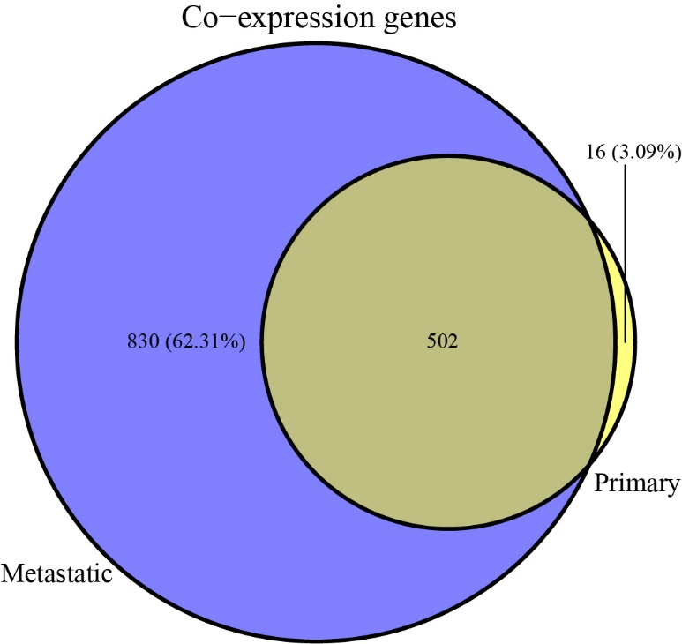

Supplementary figure 1 Comparison of primary and metastatic co-expression genes.
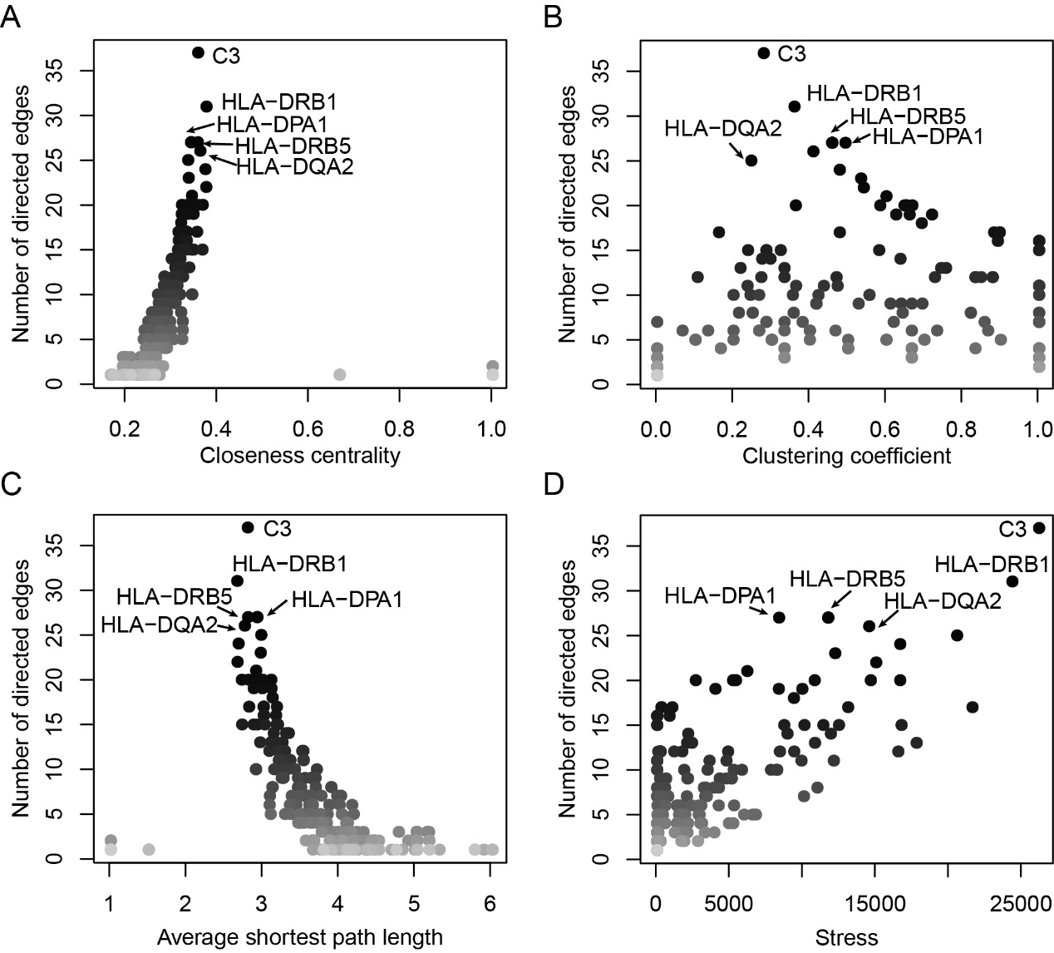
Supplementary figure 2 Four topological parameters of the PPI network, closeness centrality (A), clustering efficiency (B), average shortest path length (C) and stress (D).

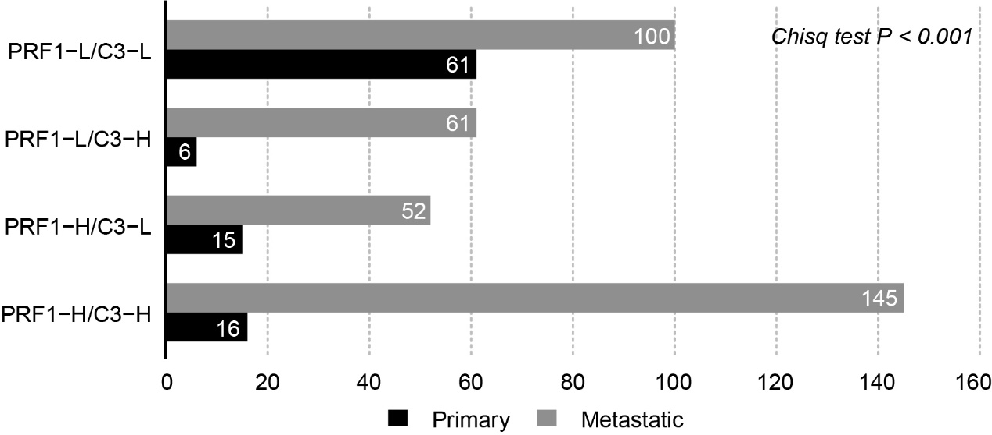
Supplementary figure 3 The primary and metastatic samples in four SKCM groups determined by the expressions of PRF1 and C3. The numbers of each group were showed in the corresponding bars.
Supplementary figure 4 T-sne algorithm showed the samples of three datasets before (A) and after merging (B) using the Z-score method.

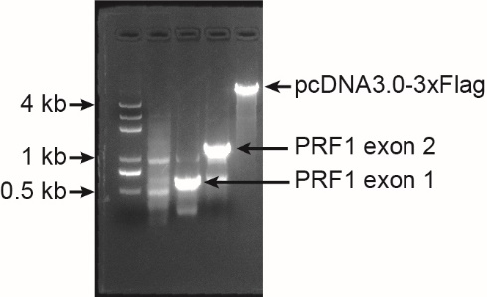
Supplementary figure 5 Agarose gel electrophoresis for the three fragments, pcDNA3.0-3xFlag, PRF1 exon1 and PRF1 exon2. The sizes of exon1, exon2 and pcDNA3.0-3xFlag were 519 and 1149, and 5484 bp, respectively. DNA ladder was shown in the left-side.

Supplementary table 1 Patient features of the TCGA SKCMs.
Patient feature | Primary (n, %) | Metastatic (n, %) | P value
Event (OS, days) |  |  | < 0.001
alive | 70 (455.5) | 166 (1931.5)
dead | 28 (440.0) | 192 (1337.0)
Gender |  |  | 0.55
Male | 58 (20.42%) | 226 (79.58%)
Female | 40 (23.26%) | 132 (76.74%)
Stage |  |  | < 0.001
I | 2 (2.44%) | 80 (97.56%)
II | 62 (45.59%) | 74 (54.41%)
III | 27 (15.88%) | 143 (84.12%)
IV | 3 (13.04%) | 20 (86.96%)
Na | 4 (8.89%) | 41 (91.11%)
Supplementary table 2 Primers used for PRF1 amplification.
Primer | Sequence (5’->3’) | Length
PRF1-1F (exon 1) | GGATGACGATGACAAGGAATTCATGGCAGCCCGTCTGC | 519 bp
PRF1-1R (exon 1) | GTGTGATGGATATCTGCAGTCACCACACGGCCCCACTC
PRF1-2F (exon 2) | GTGGAGTGCCGCTTCTACAGTTTCCATGTGGTACACACTC | 1149 bp
PRF1-1R (exon 2) | GAGTGTGTACCACATGGAAACTGTAGAAGCGGCACTCCAC

Supplementary table 3 Primers used for quantitative PCR.
Primer | Sequence (5’->3’)
GAPDH -qF | GGACTCATGACCACAGTCCA
GAPDH -qR | TCAGCTCAGGGATGACCTTG
PRF1 -qF | GTCTGGGATCAGGACTCTGG
PRF1 -qR | GGCCATGATTCAGGTTGCAT
Complement C3 -qF | AAGCCCAACCTCAGCTACAT
Complement C3 -qR | CAACCATGCTCTCGGTGAAG

Supplementary table 4 Co-expression genes identified in primary and metastatic SKCMs.
Category of co-expression genes | Gene Symbol
Primary specific | LINC00861, RP11-23J18.1, TIMD4, PRDM8, PARP15, TMEM156, CCR7, SELL, HLA-DOB, CCND2, TNFRSF8, GP1BA, IFI27, LILRA4, POU2F2, SLAMF1
Metastatic specific | LRRC25, ANKRD22, PSTPIP2, STX11, SMCO4, GBP1, ZMYND15, HLA-DMA, SECTM1, FCGR3A, TRAV24, PLA2G2D, GALM, ADAP2, TRAV12-3, NR1H3, CD300A, RP11-222K16.2, VAMP5, CTB-41I6.2, HLA-DPA1, TOMM20P2, CXCL10, RP11-848P1.3, TRBV10-3, TNFSF10, HLA-DRB1, CYBA, HLA-DQA1, LYN, TMEM176B, SRGN, FLVCR2, C3AR1, TRAV6, NOD2, PRR5L, SLC29A3, IL18, ACP2, SLC43A2, TMEM176A, PRKCH, LCP2, CIITA, TRBV13, UCP2, MS4A4A, GBP2, MPP1, CTA-384D8.35, CLEC12A, SIGLEC10, HLA-DQB1, CLEC10A, C2, LCP1, FCN1, DRAM1, SQRDL, RP11-93B14.9, C1S, TRAV8-1, MAFB, PIM1, PRDM1, NLRC4, CSF1R, CTSC, ATF5, FTL, TMEM37, C1R, CYBB, IDO1, FYB, MNDA, SLCO2B1, GNA15, IRF2, GBP1P1, C10orf54, RHOG, SERPING1, TRAV13-2, BTN3A3, CARD9, LILRB5, IKBKE, RAB20, GLIPR2, MFNG, SOD2, RP11-93B14.10, CXCL11, FOLR2, ACRBP, CEBPA, P2RY13, TRBV5-1, SAMHD1, TRBV5-4, NMI, GGTA1P, DEF6, HLA-DRB5, TRIM22, RILPL2, FPR1, LIPA, NUB1, SLC15A3, EVL, RN7SL138P, ITGAX, PLEKHO1, RIPK3, SLAMF7, PAOX, SCPEP1, CRYBB1, TRIM14, TRBV12-4, PLEKHF1, REC8, DOCK8, FERMT3, VOPP1, PPM1M, GPR68, RELB, RASSF4, GCNT1, GLUL, RGS18, MYD88, CD163, IL2RA, CD68, IGHGP, ITGAM, CD274, TRPM2, PDCD1LG2, STXBP2, RP11-289I10.2, HSD11B1, SAMD9L, DOK3, NECAP2, THEMIS2, NAAA, CCR2, NPL, NFKBIA, CD209, ZNF831, BCL3, TRBV5-6, GRB2, MZB1, HLA-A, SYNGR2, FLT3LG, ITGAE, FBP1, IGHV3-33, APOBEC3F, IGLC2, ACE, ZNF385A, PIM2, CSF2RB, CD40, CLEC2D, C10orf128, CFLAR, MSR1, MYO7A, GNAI2, DGKZ, DYSF, EOMES, FTLP2, TTC7A, DHRS9, PML, RP11-44K6.2, CORO7, KLRG1, GPR84, CSF1, EFHD2, BTN3A1, RP11-25K19.1, DENND2D, MARCH1, FCGRT, C1orf54, GBP3, RASGEF1B, VAMP8, HLA-DPB2, MOB3A, P2RY14, IGHG2, CLIC3, ELF4, DERL3, RP1-102E24.10, NUAK2, PPP1R16B, CCDC64, KCNK6, IGLV1-47, ADRBK1, NBEAL2, TMEM106A, ASPHD2, RNF166, FTLP3, ICAM1, GZMM, P2RX1, LBH, ARID5A, IL10RB, MIR155HG, CASP10, HLA-DOA, FAM78A, TRBV30, CD101, LIMD2, MAX, C17orf59, APOC1, TCIRG1, HLA-S, RP11-750H9.5, BCL11B, ABCG1, SUSD3, IGHV3-41, CTD-2376I4.2, FNBP1, ADCY7, SLC46A3, KCNJ5, SLC9A9, CYLD, GM2A, RPS6KA1, MRC1, TRAV23DV6, CDC42SE2, MMP25, NFKB2, CD97, TRAV41, FAM110A, HNRNPA1P21, GATA3, IGHG3, RASGRP4, IGLV1-40, IGHG1, CLEC4A, ADAP1, ATG7, RAB42, CXCL12, TLR7, GPSM3, GLRX, TMSB4XP4, RAB8A, SIPA1, TSPAN32, C11orf21, RGS19, ADORA3, SUSD6, PLD3, MFSD7, APOBEC3C, PSMB8-AS1, TMSB4XP1, GPX1, ADAMDEC1, PTGES3P1, RNASE2, IGLV1-41, FKBP15, TCAF2, ORMDL3, MS4A7, UNC93B1, SUCNR1, PLCB2, SLC8B1, B3GNT8, SFMBT2, OGFR, LGALS2, VMO1, Y_RNA, MVP, ST8SIA4, SLC2A5, DENND3, ZNF267, ZNFX1, RP11-264I13.2, CTSH, ASB2, ST6GALNAC4, C17orf62, TIFA, TFEB, TXNDC11, ARAP2, ATP2A3, CFD, CNN2, IGKV1-6, GCHFR, MOB3C, NLRP3, DTX2, OSTF1, IGKV1-9, ARRDC1, IGLV2-14, CD1D, TCN2, TRBV6-6, CHST12, CHST15, EHD1, ARHGAP4, MB21D1, CD33, VCAM1, ARHGEF1, IGKV1-16, BTN3A2, JSRP1, ALOX5AP, CMAHP, TOR2A, UNC13D, GPR125, SLC2A6, CD28, MARCO, SLC6A12, RBM47, RP11-1334A24.6, DYNLT1, TGFB1, LY75, XRN1, IGHD3-16, RARRES2, MAPK13, TUBA4A, TNIP1, MAN2B1, B3GALT4, PRR13, IGKV1-12, MBD2, IGHV3-48, ZDHHC18, RP11-34P13.16, IGHV4-55, NUDT18, KLRB1, GSTK1, UBE2D1, HLA-DRB9, SCARF1, PARP10, SLC25A28, EGFL6, CAPZB, SLC31A2, MGAT4A, HLA-U, RP11-34P13.15, NUBP1, IGHD1-1, FLI1, APOE, AMPD3, IGHV1-2, RP11-294C11.2, UBE2F, SH3BP2, SLC9A3R1, CYTH1, HLA-DQA2, ALOX5, IGLV1-51, HVCN1, GSDMD, ADA, IRF3, CASP4, TWF2, PREX1, MICB, IFIH1, PHF11, STAT2, RNU4-62P, RP11-1166P10.8, TMEM140, RP11-16E12.2, DAPP1, ARHGEF3, GRN, SERPINB1, IGHV4-39, IGLJ2, TNFAIP8, IRF9, IGKV1-17, COTL1, PRKD2, TPST2, TNFRSF17, CCDC28A, TNFSF13B, ICAM2, RALGDS, SLC16A13, SIDT2, TMEM51, CTSD, PNRC1, CSK, SKAP1, C3, FUCA1, TLR4, BTK, MAN1A1, CCL7, ZNF101, MAP3K14, ATHL1, CALCOCO2, IGHV7-40, STX4, ACVRL1, GGT5, FAM46C, NPC2, LYL1, SH3BP1, RAB4B, C15orf48, PARP11, RASGEF1A, RP11-876N24.5, SHKBP1, RLTPR, ZDHHC9, BATF3, OAZ1, ERAP1, FKBP11, RP11-876N24.3, NLE1, LACC1, SLC38A5, C14orf159, FAM168B, IGLV1-44, ACTB, C1RL, IGHD6-25, CCL2, IGHD3-22, RARRES1, PECAM1, IGLV2-8, FUOM, MYCL, SLC40A1, FRAT1, FCHO1, HPSE, BTG2, SMAP2, IGLC3, SPATA13, SERPINB9P1, AC246787.5, SYK, IGHV3-23, MOB1A, AQP9, EHBP1L1, PRKCB, CST3, PODN, RP11-848P1.2, EIF4E3, ID2, IGKV1-8, NFKBIE, FAS, IGHV4-59, FMO2, OAS2, HTRA3, LINC01232, SOCS7, RP13-977J11.2, HLA-J, PLEKHO2, ELL, CMIP, PSAP, GADD45B, GRAP2, RTP4, RBCK1, GRIPAP1, RRN3P2, KIAA1551, PTPN18, CASS4, LPXN, ALKBH2, RILP, WNT10A, CNOT6L, NFKBID, IGKV3D-11, IGKC, CTSZ, ARPC2, KCTD15, IGLC6, CTD-2020K17.1, RP11-661A12.5, TLR2, HLA-DQB1-AS1, PRR13P5, KIAA0513, LITAF, IGLV2-11, HS3ST2, RFX5, ACP5, RP11-452I5.2, GADD45G, TINF2, ST6GALNAC6, ABHD3, IGHD3-3, DNPEP, IFITM1, XAF1, EAF2, TBXAS1, TMSB10, CYB5R4, SCAMP2, ELMO1, IGLJ1, CNDP2, IL15, FYN, AC104699.1, AKAP1, HID1, TOR3A, TRERF1, IGHV1-18, FAM49B, CMTM4, FAM107B, POU2AF1, ALDH2, ACSL5, GPX1P1, BIRC3, BCL2L11, IGKV3-20, IGLL5, PFN1, KCTD3, PLCG2, TRAF2, GCSH, GNG12, INPP5A, RFTN1, ALPK1, SP100, ABRACL, MIR8071-2, POMT2, TMEM86A, SIDT1, DDX60, CISH, PIK3IP1, CHST10, ZNF778, IL17RA, CCM2, LHFPL1, TEP1, TRBV24-1, TSPAN33, BLNK, CC2D2A, ZNF438, TMEM119, NADK, TLR5, CASP8, TM6SF1, CYP2S1, FTH1, C5AR1, IMPDH2, PDE6B, SH3BGRL3, RHEBL1, LASP1, MKNK1, BASP1, IRS2, IGHV3-30, WDR35, B4GALT2, EVI2A, EI24, FAM117A, NCKAP1, FGD6, DDHD1, TMEM241, DNM2, PIK3CG, RSPO3, PNOC, MR1, NCEH1, CASP7, ENSG00000271375.1, IGKV1-5, AC246787.3, IGLV1-50, IL1RN, MIR4645, DNASE2, SMPDL3A, PTPRE, TOMM20, RNF19B, UCK2, MAST3, GPATCH4, SLC25A45, RNF144A, IFNAR2, IL3RA, PLA2G12A, SLFN5, ARHGAP17, RP11-134L10.1, ADAM8, ANKRD13B, SHISA5, AKR1A1, SLFN13, TBC1D2B, ZC3H12A, AP1B1, ISCU, LINC00665, GGT1, GSDMB, PLCL2, STAB1, IFITM3, SLC39A10, AC246787.1, PAICS, RHBDF2, TRIM59, WDR12, CHFR, SYNGR3, WIPF1, NPM3, PNKD, IGHA1, BHLHA15, FKBP7, VASP, CAMK1D, CAMSAP2, ARSA, SPRED2, TGM2, LINC01150, SYTL1, MMP19, POFUT1, DOCK11, TNPO2, TMSB4XP8, POLD2, PTPLAD2, C4B, IGHV3-71, PSMA3, RP3-508I15.20, PRKCQ-AS1, MAF, C14orf79, ARPC3, SAT1, AMMECR1L, TEAD1, FBXL2, CTBP2, CXorf38, IGHV3-62, LRPPRC, MIR621, CCDC109B, TCTN3, IGHJ3P, C19orf26, GFOD2, RRP15, C19orf44, ZNF112, EXTL2, TNFAIP3, TFAP4, MFSD1, FBXW8, PACRGL, GNG12-AS1, LINC00324, ATG16L2, CEP89, ZMYM6NB, AGAP1, CSNK1E, ZCCHC14, SSR4, MRPL45, URB1, MECR, BPHL, ZFYVE9, MIR4537, FBXW9, CCT6A, P2RY12, TRADD, LAMP3, PLA1A, MAT2B, IL4R, IGHV3-35, STK17B, ELP2, SOGA1, IGKV3OR2-268, ZNRF2, hsa-mir-4538, IGHV3-52, HLA-DPA3, AC093162.5, HERPUD1, MARCH2, ZSCAN20, NUGGC, IARS2, IKBKG, RP11-10L12.4, ATRN, SETMAR, SLC25A15, POGK, ALDH16A1, MORN4, FAM49A, ZNF584, CYP27A1, IGKV1-27, AC246787.4, CTD-2521M24.9, HOPX, TWISTNB, SLC25A35, ZNF710, USF1, ACACA, RIN3, WIZ, FGL2, DSE, CMPK2, SLC25A3, ZNF74, CCL18, CFAP97, EID3, IGKV3-11, RP11-353N4.6, RP11-395G23.3, GBGT1, LARS, TANC1, ATP6V0E1, TRMT5
Shared by both | LAG3, NKG7, CXCR6, CCL4, CCL5, PDCD1, CD8B, TBX21, CD8A, C1QC, C1QA, GZMH, CD7, C1QB, CXCR3, CTSW, IL2RB, SIRPG, HAVCR2, DOK2, HCST, IL12RB1, TMEM150B, MYO1F, IRF1, JAKMIP1, FASLG, SLA2, KIR2DL4, GZMA, TYROBP, GBP5, AC092580.4, TRAV19, GCH1, P2RY6, IFNG, PSMB10, TNFRSF1B, TRGV10, USP30-AS1, FAM26F, SLAMF8, GNGT2, TRGC2, ITGB2, SIGLEC1, CCL4L1, TIGIT, CCL3, CXCR2P1, AC133644.2, GZMB, ASCL2, ABI3, CD2, CCR5, FCGR1A, NFAM1, CD27, CRTAM, TRAV14DV4, SLC7A7, SPI1, FCRL6, RARRES3, IL32, APOL3, ZBED2, PILRA, IL4I1, PSTPIP1, SH2D2A, AOAH, HK3, CCRL2, TRBV9, ITGAL, HCK, SLA, LILRB2, ITGB7, AIF1, GPR171, AKAP5, SIGLEC9, TRAC, PSMB9, SIRPB1, CECR1, LILRB4, STAC3, CXCL9, FTH1P22, CD300LF, CD74, RP11-493L12.5, LILRB3, RP11-291B21.2, GZMK, LILRA6, CD38, IL10RA, TAPBPL, EBI3, BATF, UBE2L6, CTSS, LST1, TNFRSF9, PSME2, HLA-DPB1, IL2RG, TRBC2, TRAV1-2, RP11-598F7.3, TLR8, LSP1, LGALS9, UBASH3A, TRBV7-9, CD86, XCL2, PLEK, AC011899.9, TNFAIP2, SIGLEC7, CXCL16, LAIR1, C19orf38, PTAFR, NAGK, APOBEC3H, UBD, CYTH4, SELPLG, CD3D, SEMA4A, CD3E, TRAV4, ETV7, TRAV5, PSME1, NCF2, TRBV7-6, XCL1, APOL1, TAP1, CD4, SH2D1A, PCED1B, GIMAP4, NLRC5, TRAFD1, SYTL3, GIMAP6, IL15RA, AP002954.4, ARRB2, OR2I1P, TRAV17, CCL8, NCF4, CSF3R, PSME2P2, MYO1G, NCF1, WAS, TRBV11-2, SAMSN1, C1orf162, LCK, SPN, NCKAP1L, WARS, TRBV28, MS4A6A, HLA-DMB, CD14, LILRB1, SOWAHD, HLA-DRA, RP11-274E7.2, CD247, SIT1, IL21R, RP4-728D4.2, VAV1, STAT1, BATF2, VSIG4, CD3G, TAPBP, HLA-F, PTPN7, IGSF6, APBB1IP, PRKCQ, THEMIS, TRAV12-1, SNX20, TRAV8-6, APOL2, GBP4, IFI30, GNLY, TRAV12-2, TYMP, SOCS1, FGR, TRBV6-5, RP11-24F11.2, HLA-B, ARHGAP30, TRBV25-1, DNAJC5B, NCF1C, RP11-1094M14.8, FCGR1C, IKZF3, B2M, TRBV27, HLA-E, RASAL3, SLAMF6, TRAV29DV5, TRBV19, CD300C, TNFAIP8L2, LAPTM5, SCIMP, EPSTI1, PIK3R5, ICOS, PRAM1, CD244, TRBV4-1, LILRA5, TRGV7, IL18BP, CCL3L3, APOL6, C5orf56, GPR65, RAB37, RNF213, RP11-1094M14.5, GPR114, CLEC7A, PARVG, APOBR, TRAV8-3, TRAV13-1, HCLS1, AMICA1, SIGLEC14, SIRPB2, HAPLN3, TRIM21, CD6, CD72, TRAV21, LGMN, IFI35, CD84, CCR1, TRAV27, LAP3, HLA-C, APOL4, ARHGAP9, ZBP1, HTRA4, MPEG1, TRBJ2-1, PTPN6, PARP12, XCR1, FMNL1, ZNF683, OSCAR, TRAV8-2, NCF1B, TMSB4X, GFI1, TOX, GIMAP8, PTPN22, PSMB8, MAP4K1, FGD2, RNASE6, AKNA, CD53, APOBEC3D, BIN2, TNFRSF18, DOCK2, PTGER2, CLEC4E, TAP2, IRF5, SEMA4D, TFEC, RASGRP1, S1PR4, TRBV2, FBXO6, PTGER4, RP5-1091N2.9, RASSF5, CRIP1, RP11-47L3.1, IGFLR1, UBA7, SASH3, GIMAP1, GPR132, TRAV3, RAC2, GMIP, HLA-H, RP11-686D22.10, TRAV2, GAB3, CST7, TRAV16, TRAV26-1, FGD3, CORO1A, TRAV20, GIMAP2, APOBEC3G, ITK, TRBJ2-7, TRBV7-3, HLA-L, ICAM3, PARP14, TRBV15, HCG4P7, RNASET2, JAK3, ZBTB32, CEACAM21, DUSP2, CCDC88B, SPOCK2, TRAV9-2, GPR174, TRBJ2-3, MIAT, GIMAP7, TRIM69, C16orf54, TRAV8-4, PCED1B-AS1, SNAI3, SIGLEC8, OASL, TRDV1, RP4-647J21.1, ARL11, TRBJ2-2P, ARHGAP25, TRAT1, LY86, ZAP70, KCNA3, ARHGDIB, GMFG, HMHA1, NLRC3, TRBV29-1, ARHGAP27, STAT4, DBH-AS1, INPP5D, PSD4, MLKL, PIK3AP1, TRBJ2-4, MEI1, PRR33, PLA2G7, CCDC69, DENND1C, SEPT1, PATL2, TRG-AS1, PTPRC, TRANK1, CD5, TAGAP, DPEP2, TBC1D10C, TRBV18, ACAP1, VNN2, HLA-DQB2, HLA-K, FOXP3, ODF3B, RP11-405M12.4, EVI2B, TRBV4-2, CYTIP, CD96, FPR3, P2RY10, TRBV6-1, TREM2, LY9, SP140, PARP9, HLA-DRB6, IKZF1, HCP5, TRBV12-3, AC010518.2, PTK2B, RP11-638I2.9, DTX3L, CXorf21, PYHIN1, CD200R1, GVINP1, TRBV3-1, TRAF3IP3, RP11-325F22.2, LAX1, RP5-1028K7.2, TOX2, RCSD1, LYZ, SH2D3C, CCDC88C, SEPT6, HSH2D, DHX58, CD48, FCRL3, P2RY8, CARD11, PIK3R6, MMP25-AS1, CLECL1, LPAR5, TESPA1, CTA-384D8.36, NAPSB, RP11-326C3.2, CMKLR1, LAT2, CXCL13, MOV10, TMC8, BZRAP1-AS1, RHOH, BST2, IRF8, IGHV6-1, SP110, KLHDC7B, TRBJ2-2, TNFSF8, ANXA2R, XIRP1, AC245100.1, LLNLR-470E3.1, CFP, TRBV20-1, SP140L, TNF, GPR18, LTA, SDS, RP11-284N8.3, WDFY4, KIF21B, CD180, CD52, CD37, XXbac-BPG248L24.12, RP11-219E7.1, CTD-2023M8.1, IL10, AC006129.2, RP5-1171I10.5, IGJ, ERAP2, CD69, IRF7, AGAP2, BTLA, AC079767.4, OAS1, C1orf228, IGLV2-23, C19orf66, TRDC, ITGB2-AS1

Supplementary table 5. Relative expressions of PRF1 and C3 in three treatment groups (Each treatment repeats three times).
Gene | Control |  |  | Treatments
 |  |  |  | Empty vector |  |  | Recombinant vector (0.1ug) |  |  | Recombinant vector (1ug)
C3 | 1.0483 | 1.0203 | 0.9349 | 1.1608 | 0.8412 | 0.8517 | 1.0897 | 1.0158 | 1.4047 | 2.4398 | 2.3328 | 2.7100
PRF1 | 0.9386 | 0.9426 | 1.1303 | 0.9329 | 0.9375 | 1.0443 | 6.7251 | 5.9700 | 7.3472 | 26.4380 | 27.0566 | 34.0543

