Electronic Supplementary Material (ESM)

Detection and attribution of the spatiotemporal trend of climatic disaster impacts and vulnerability in Nepal
Dipesh Chapagain (dipesh@uni-bonn.de)*, Luna Bharati (L.bharati@cgiar.org), & Christian Borgemeister (cborgeme@uni-bonn.de)

Center for Development Research (ZEF), University of Bonn
Genscherallee 3
53113 Bonn, Germany

*Corresponding author
Telephone: +49 1748952454
ORCHID iD: https://orcid.org/0000-0002-2418-6343

Table S1: List of disaster types included in this study and respective disaster types as listed in the DesInventar and Nepal DRR Portal database.
Disaster Types
Grouped in this study | As listed in DesInventar | As listed in Nepal DRR Portal
- Landslides | Landslides | Landslides
- Floods and heavy rains | Floods  Rains | Floods  Heavy Rainfall  Flash Floods
- Thunderstorms | Thunderstorms | Thunderbolt
- Cold waves and frosts | Cold Waves  Frosts | Cold Waves  Frosts
- Windstorms | Strong Wind  Storms | Strong Wind  Wind Storms  Storms
- Snowstorms and avalanches | Snow Storms  Avalanches | Snow Storms  Avalanches
- Heat waves | Heat Waves | Heat Waves
- Hailstorms | Haim Storms | Hailstones  Hail Storms

Table S2: List of analytical dimensions of the Nepal Living Standard Survey (NLSS)
S. No. | NLSS Analytical Dimensions
 | Mountains
 | Urban-Kathmandu
 | Urban-Hills
 | Urban-Tarai
 | Rural-Hills-Eastern
 | Rural-Hills-Central
 | Rural-Hills-Western
 | Rural-Hills-Mid & Far Western
 | Rural-Tarai-Eastern
 | Rural-Tarai-Central
 | Rural-Tarai-Western
 | Rural-Tarai-Mid & Far Western

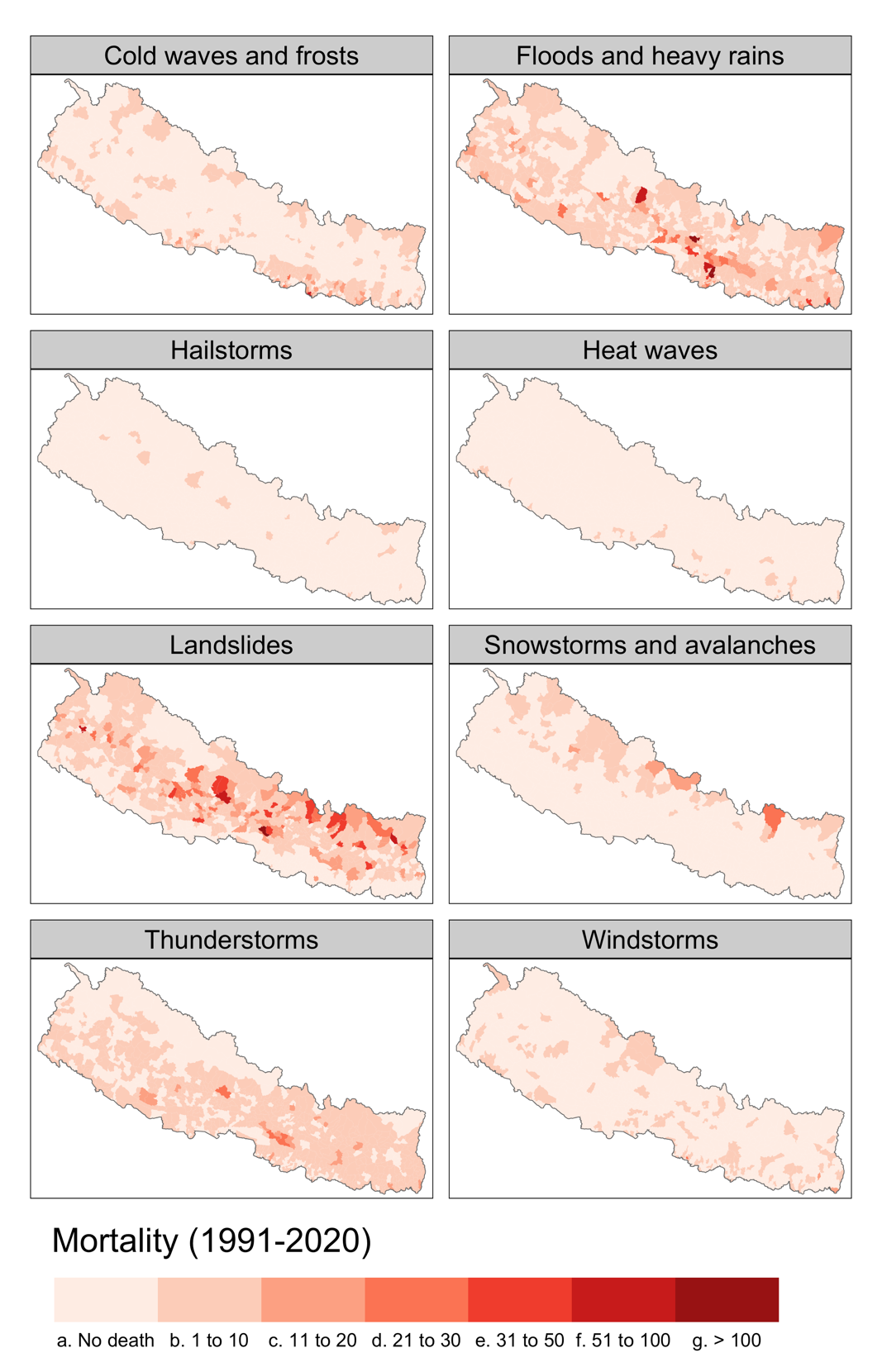
Figure S1: Spatial distribution of climatic disaster impacts (mortality) by disaster types in Nepal during 1991-2020. The color code range in the maps is manually created and the range values are as shown in the legend.

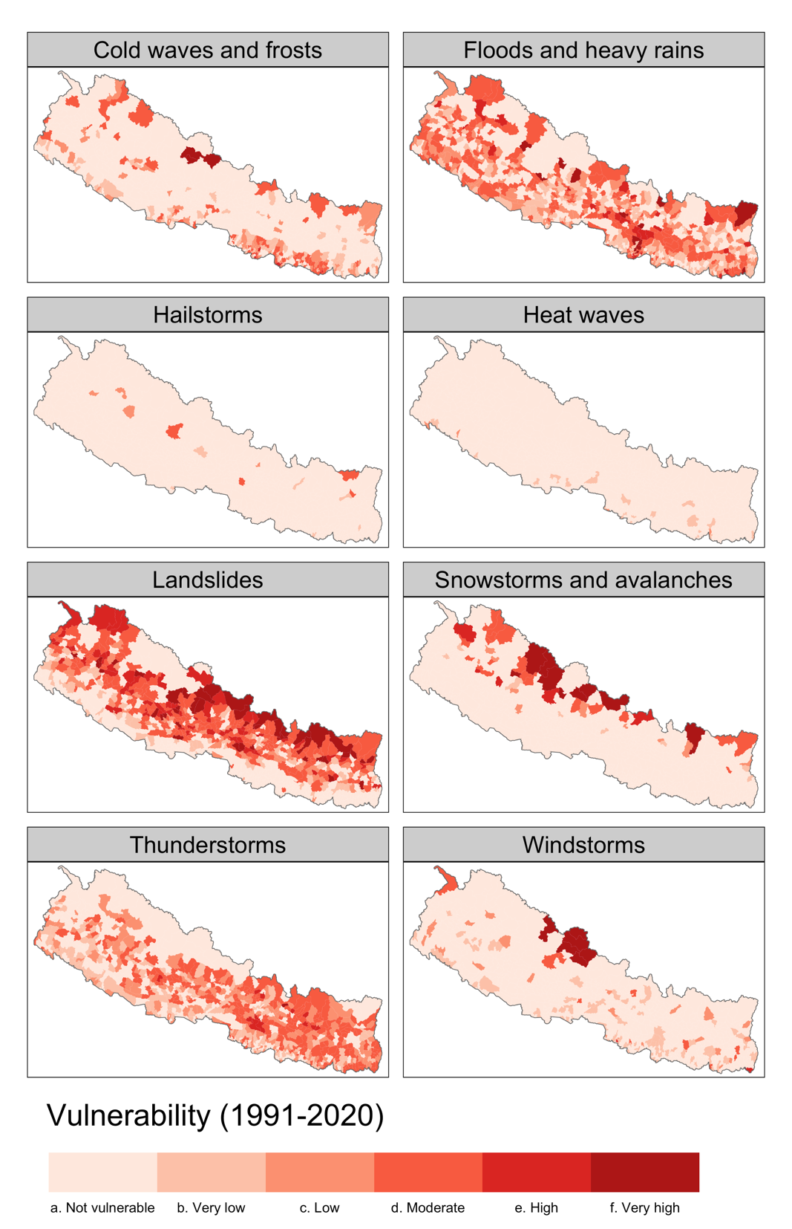

Figure S2: Spatial distribution of climatic disaster vulnerability (mortality normalized by exposed population) by disaster types in Nepal during 1991-2020. The color code range in the maps is manually created and the range values are as shown in the legend in Fig. 6.
Table S3: Results of the regression analysis
 | Dependent variable: No. of people died (log)
 | OLS model | Location fixed effect model
Constant | 3.643*** (0.221)
No. of people exposed to disaster (log) | -0.043*** (0.015) | -0.056 (0.109)
No. of disaster incidences recorded (log) | 1.160*** (0.026) | 1.157*** (0.029)
Per-capita income (log) | -0.271*** (0.022) | -0.340*** (0.034)
Observations | 3,554 | 3,554
R² | 0.371 | 0.516
Adjusted R² | 0.370 | 0.391
Residual Std. Error | 0.595 (df = 3550) | 0.585 (df = 2824)
F Statistic | 697.499*** (df = 3; 3550) | 4.127*** (df = 729; 2824)
Note: | *p<0.1; **p<0.05; ***p<0.01  Estimate std. error in parentheses

