Supplementary Materials
Low Income (LIE)
High Income (HIE)
Upper−Middle Income (UMIE)
Middle Income (MIE)
Low−Middle Income (LMIE)
0 20 40 60
Share of Studies across Income Groups in %
Figure 7: Proportion of country classification by income group
Leguminous (Crops7)
Sugar (Crops8)
Fruit/Nuts (Crops3)
Beverage/Species (Crops6)
Root/Tuber (Crops5)
Oil Seed (Crops4)
Non−Food (Crops9)
Vegetables/Melons (Crops2)
Cereals (Crops1)
0
20
40
60
Share of Studies across Crops in %
Figure 8: Proportion of crop types
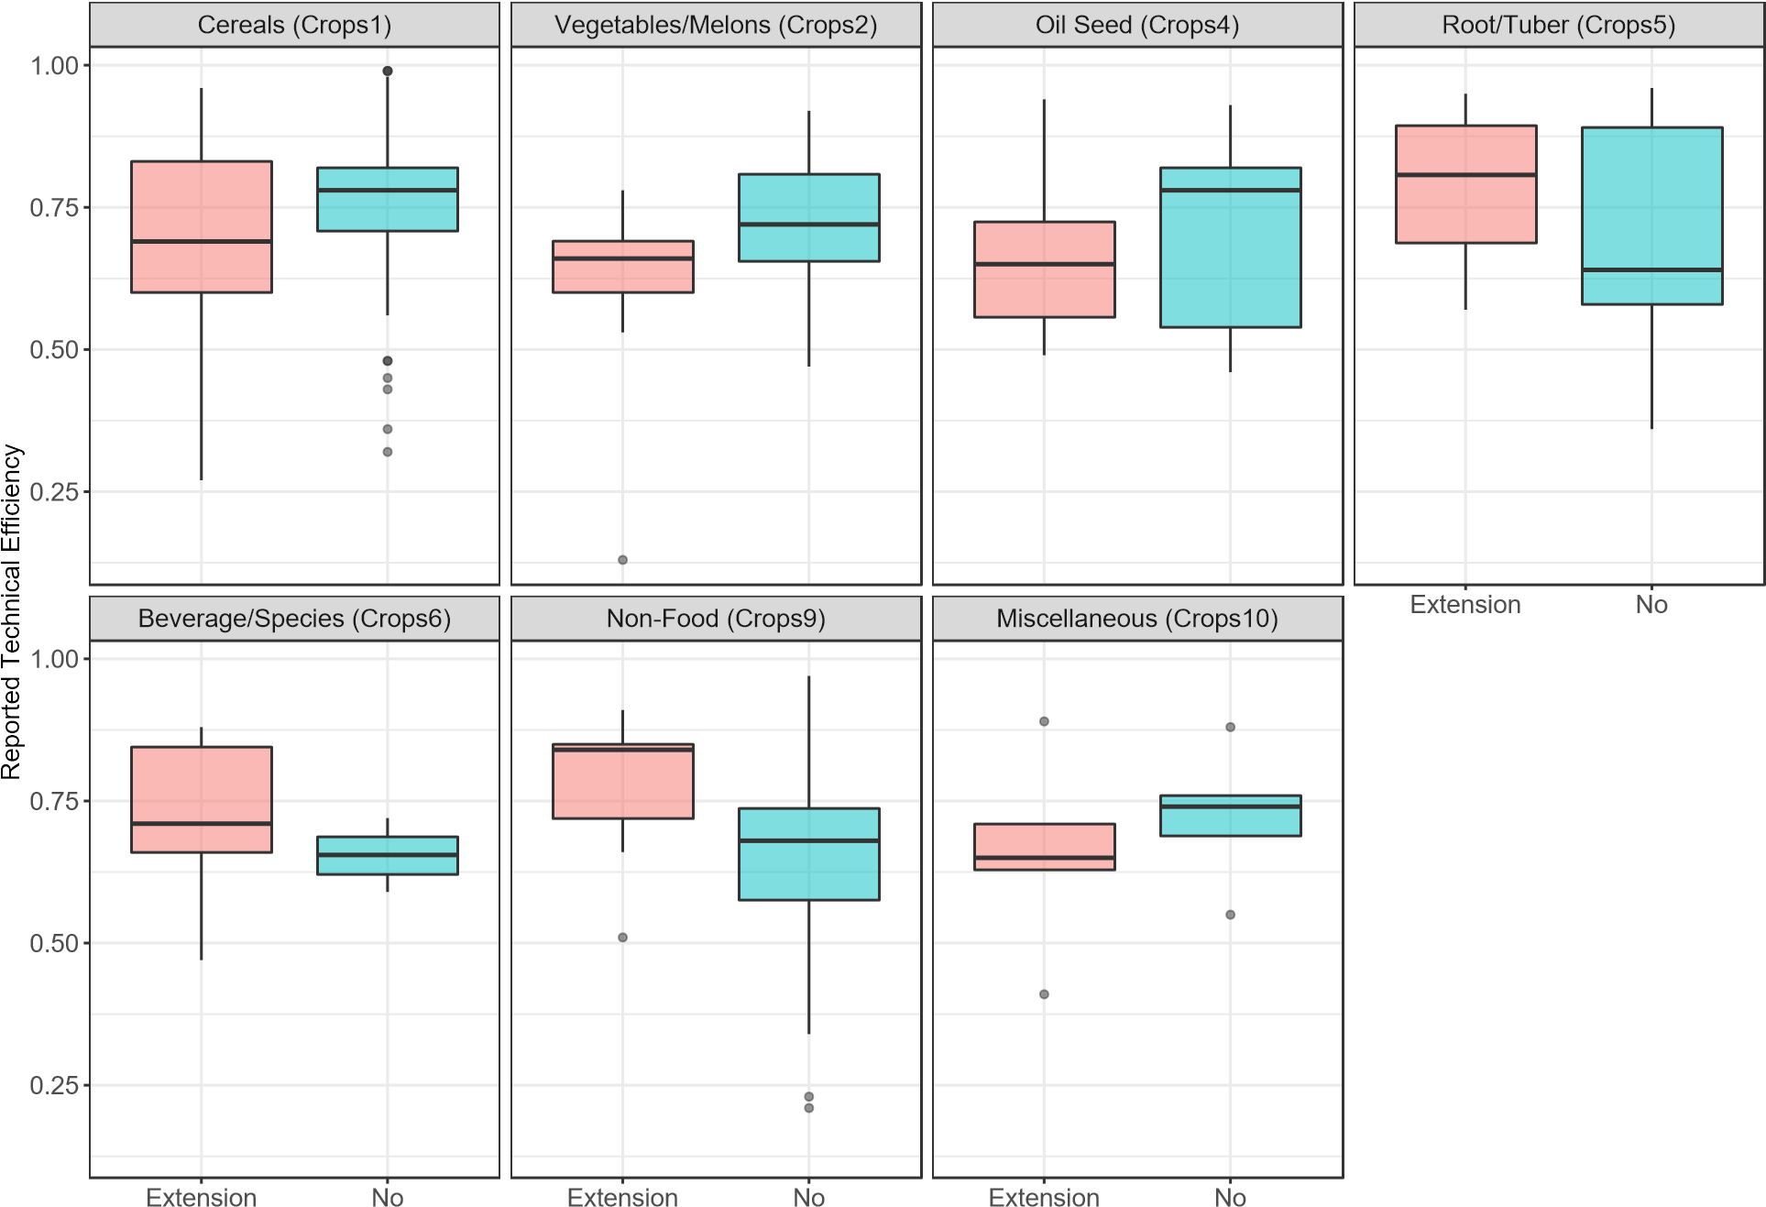
Figure 9: Agricultural extension and technical efficiency by crop type
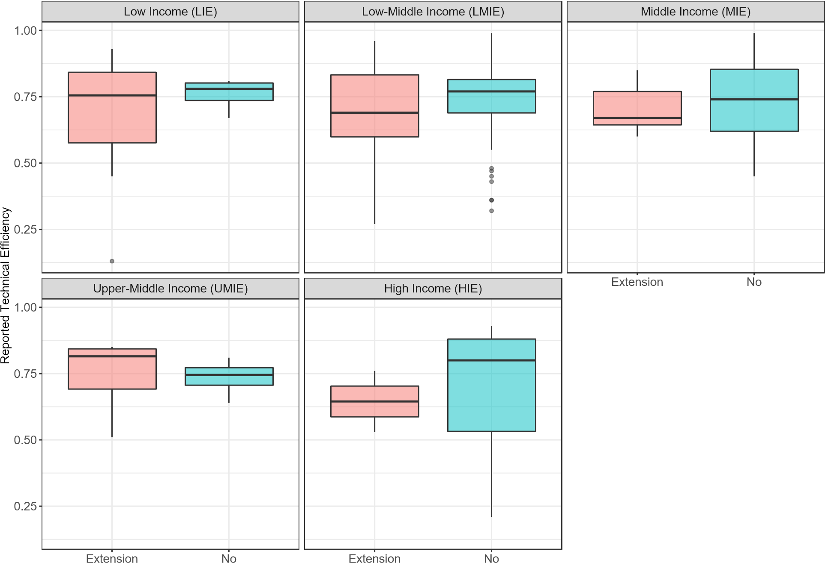
Figure 10: Agricultural extension and technical efficiency by income group
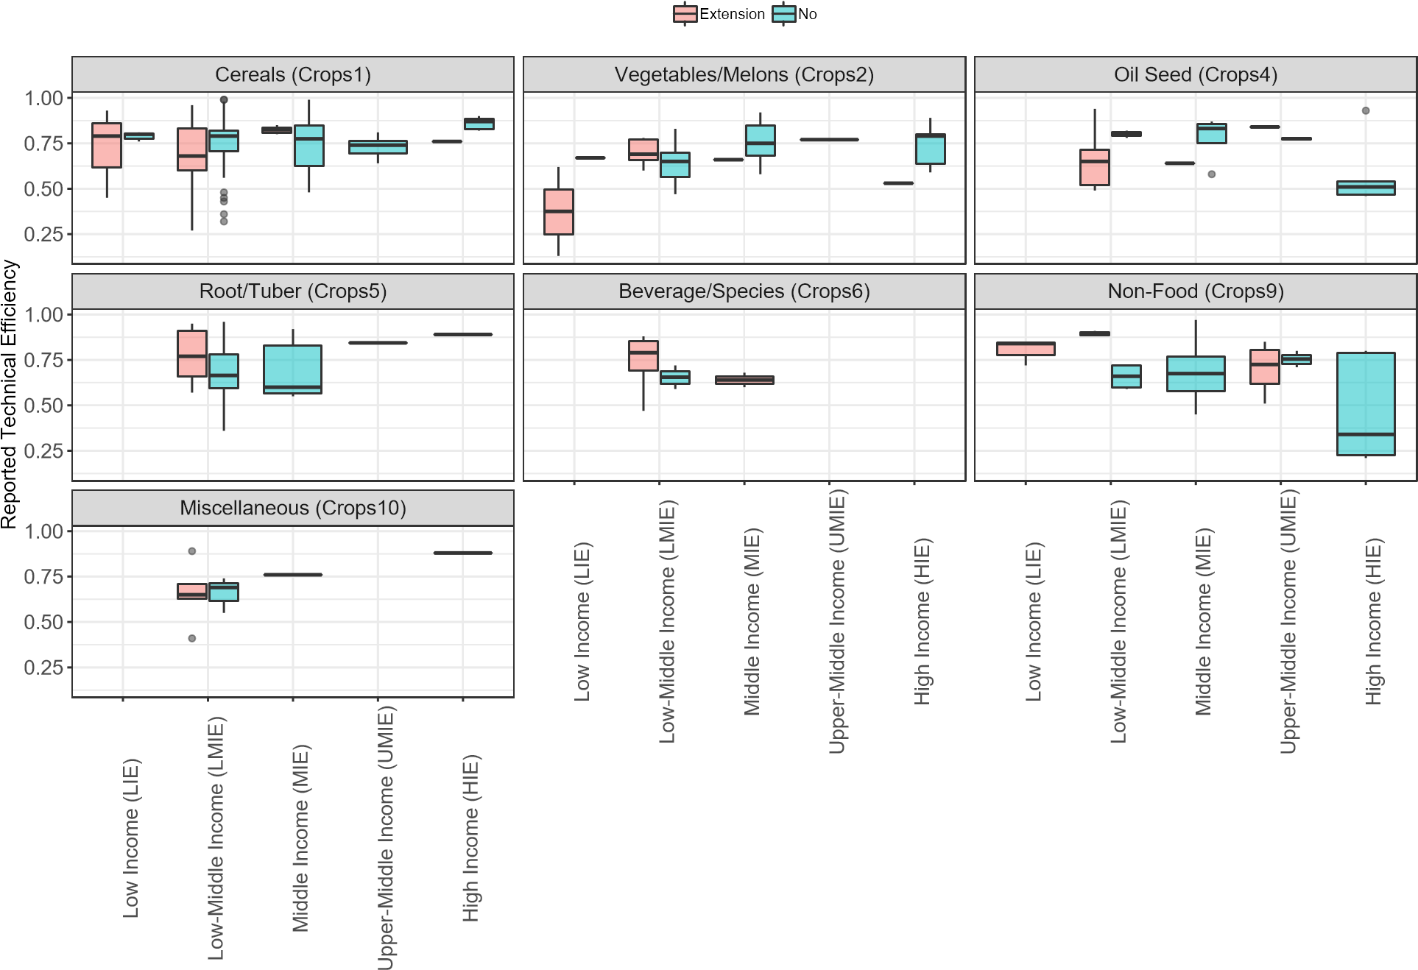
Figure 11: Agricultural extension and technical efficiency by crop types and income group
1990 2000 2010 2020
0.4
0.6
0.8
Reported Technical Efficiency
Low Income (LIE) Low-Middle Income (LMIE) Middle Income (MIE) Upper-Middle Income (UMIE) High Income (HIE)
Figure 12: Technical efficiency between income groups across time
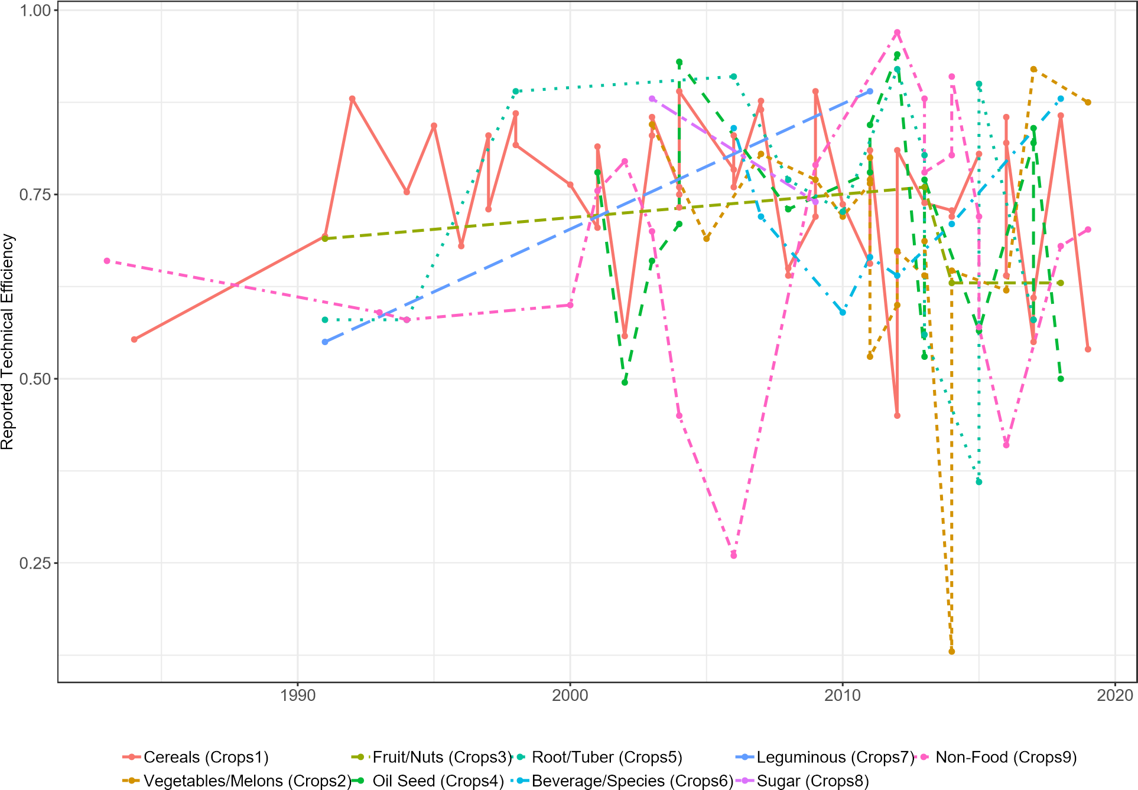
Figure 13: Technical efficiency between type of crops across time

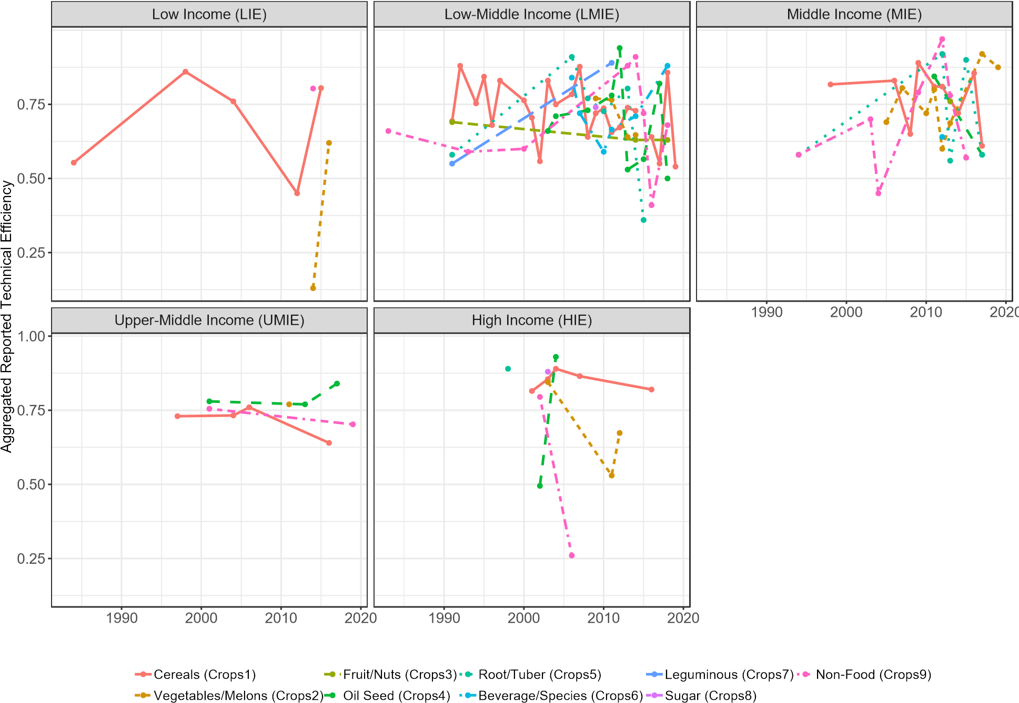
Figure 14: Technical efficiency between type of crops and income groups across time
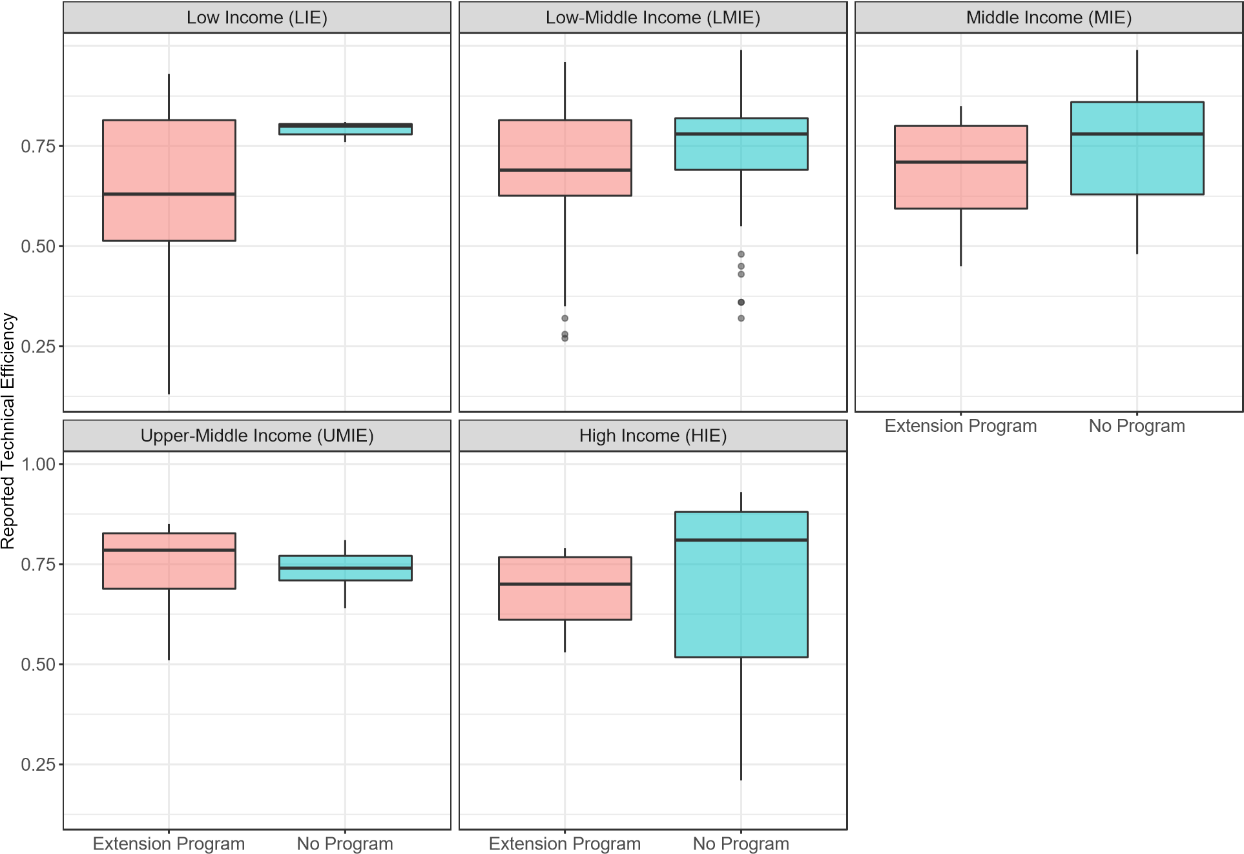
Figure 15: Technical efficiency between income groups, aggregated
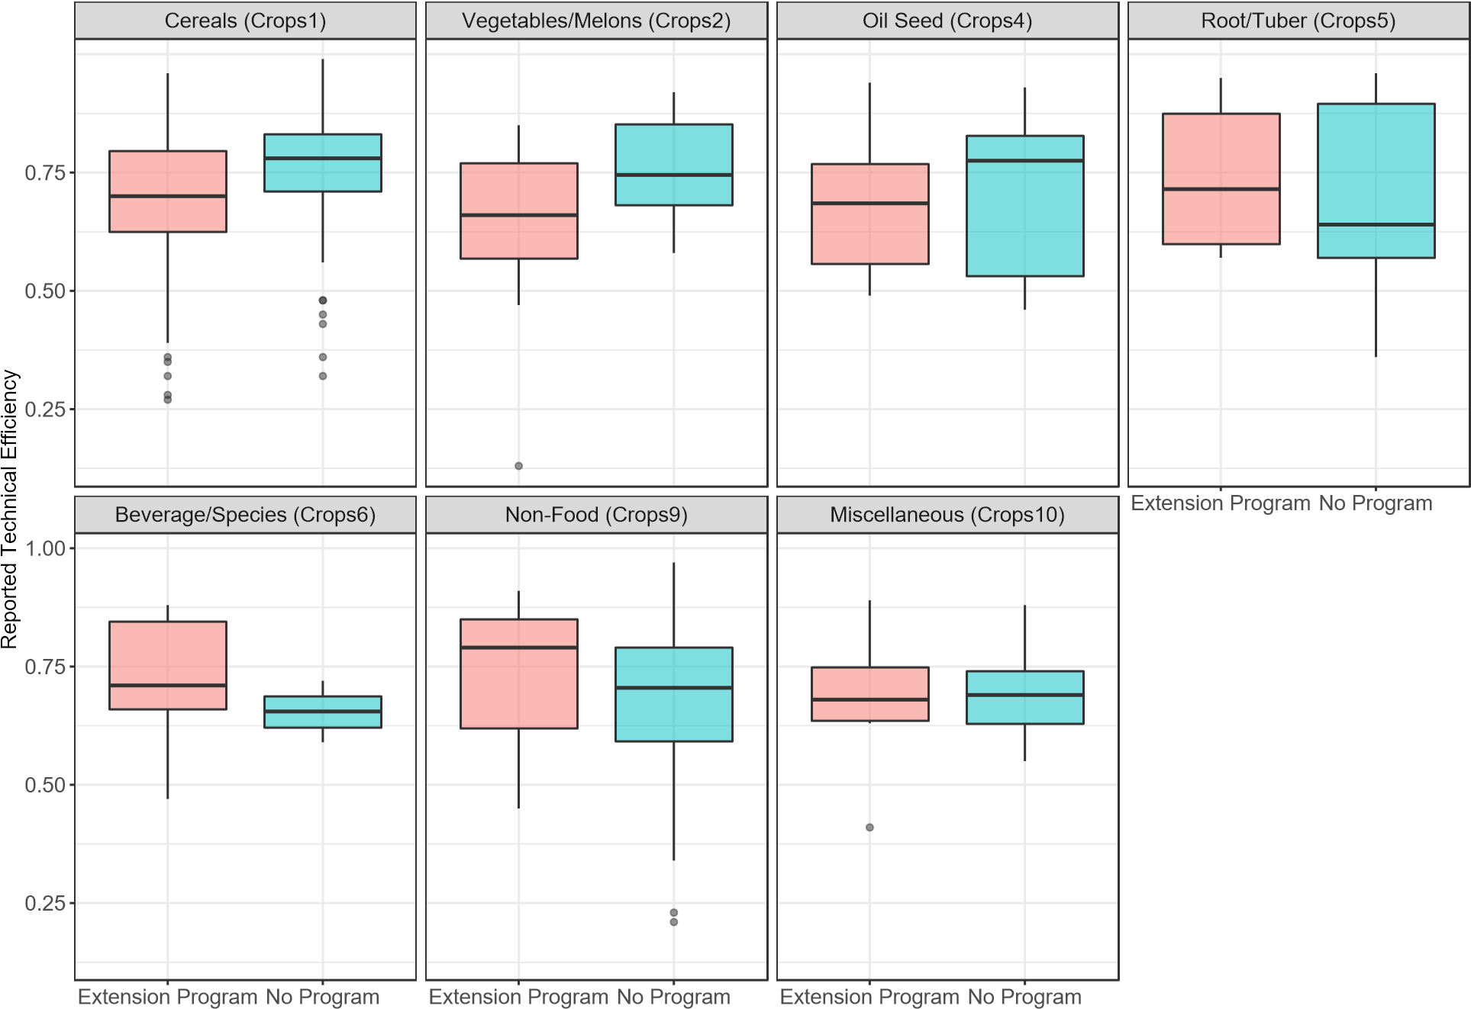
Figure 16: Technical efficiency between crop types, aggregated

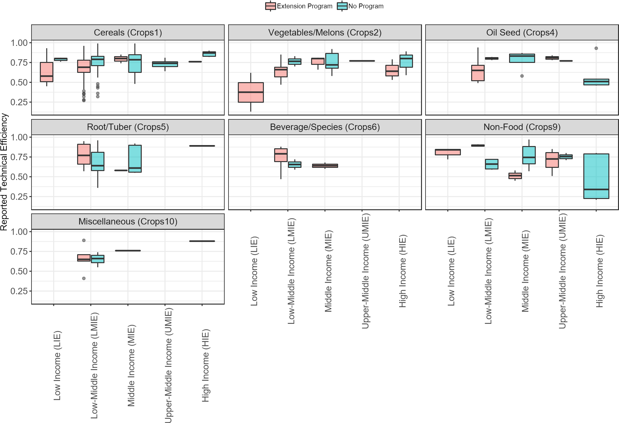
Figure 17: Technical efficiency between crop types within income groups, aggregated
Table 3: Propensity of implementing extension programs using complete case analysis
 | Extension services
 | Model (1) | Model (2) | Model (3)
Constant | 0.325***  (0.034) | 0.480***  (0.033) | -0.289*  (0.173)
Low income economy |  | 0.186  (0.130) | 0.728  (0.652)
Middle income economy |  | -0.403***  (0.063) | -2.685***  (0.528)
Upper middle income economy |  | -0.304***  (0.081) | -1.558***  (0.498)
High income economy |  | -0.403***  (0.091) | -2.765***  (0.793)
Vegetables and Melons | -0.068  (0.086) |  | 0.395  (0.511)
Oil seed | 0.104  (0.108) |  | 1.281**  (0.575)
Tuber/root | 0.009  (0.116) |  | 0.272  (0.581)
Beverage and species | 0.475***  (0.152) |  | 2.519***  (0.956)
Non-food | -0.014  (0.093) |  | 0.675  (0.529)
Miscellaneous | -0.039  (0.181) |  | -0.183  (0.908)
Observations | 314 | 314 | 314
Log Likelihood | −205.441 | −182.057 | −163.336
Akaike Inf. Crit. | 424.881 | 374.115 | 348.672
Note: ∗p<0.1; ∗∗p<0.05; ∗∗∗p<0.01

Table 4: Exclusion and inclusion criteria
Exclusion step  Reasons | The first exclusion  - not in English  - not original article  - not studying food crops | The second exclusion  - common definition on TE  - incomplete data reported  - duplication check | Final inclusion  - english  - crop study  - original article
 | 4. no empirical analysis |  | 4. common definition on TE
 | 5. not about TE |  | 5. complete data reported
Corresponding PRISMA step | Screening | Eligibility

