Supplementary Information

SI1. River flood reanalysis
A river flood reanalysis derived from Tanoue et al.¹ was used to estimate the return period corresponding to the annual maximum water storage and the validation of the modelling framework (i.e. modelled hazards, exposure and risk). The river flood reanalysis was simulated by CaMa-Flood (ver. 3.6.4)², forced by the daily input runoff simulated by MATSIRO³ using bias-corrected atmospheric reanalysis data from the S14FD⁴. The S14FD is based on a Japanese 55-year reanalysis dataset, which was corrected using observed climate variables via spatial interpolation to a horizontal resolution of 0.5° × 0.5° and with elevation corrections. The S14FD is used as the reference data of the S14 database. Iizumi et al.⁴ compared extreme temperature and precipitation indices derived from S14FD with those derived from other forcing data and found that S14FD frequently achieved a better correspondence. The river flood reanalysis was conducted for the period 1958–2013 using the output data from 1961–2013.

SI2. Socioeconomic data
A gridded GDP map (i.e. asset map) of the present and future socioeconomic conditions is an essential driver for estimating flood risk. In this study, flood risk was estimated using a gridded map of population multiplied by country- and year-based GDP per capita data, under the assumption that GDP per capita did not change within a country. We obtained GDP per capita data for the current socioeconomic conditions derived from James et al.⁵ and for the socioeconomic conditions under the five future SSPs from the International Institute for Applied Systems Analysis model⁶. These values were unified to the 2005 international USD on a purchasing power parity (PPP) basis. A gridded present population map was obtained from Tanoue et al.⁷, which was constructed by distributing the country population data from the World Bank database (http://data.worldbank.org/ about/country-and-lending-groups) using a downscaled population distribution map of the History Database of the Global Environment (ver. 3.1) at a 5′ × 5′ horizontal resolution^{8,9}. For consistency with horizontal resolution of damage, we then downscaled the population map to a 30″ × 30″ horizontal resolution using the Global Rural-Urban Mapping Project ver. 1 (GRUMPv1) in 2000¹⁰ for 1961–2013. As the future population map, we used the spatially explicit population scenarios developed by Jones and O’Neill¹¹. The map was developed by a parameterized gravity-based downscaling model, which was consistent with the national population, urbanization projections, and assumptions of the SSP narratives. The spatial population distribution for each SSP was as follows: SSP1, population concentration pattern; SSP5, sprawl pattern; SSP2, historical pattern; SSP3 and SSP4, mixed patterns of other SSPs. Because the horizontal resolution of the map was 0.125° × 0.125°, we downscaled to a 30″ × 30″ horizontal resolution using GRUMPv1.

SI3. Unit cost database
We assumed that the unit cost, defined as the construction costs of hardware measures per unit distance per flood protection level, would increase as the flood protection level increased. This was because the height and area of hardware would increase as the flood protection level increased. The total costs, including labour costs, procurement price of the materials and maintenance costs, would also increase, suggesting that the unit cost varies from country to country and over time. Previous studies have assumed a relationship between the height of the levee and the unit cost, but no study has investigated the relationship between the flood protection level and the unit cost of hardware measures. Therefore, we developed an original unit cost database of flood protection hardware measures to investigate the above relationship, based on previous reports and databases. We collected 276 sources of data regarding the total project costs of flood protection structures and the assumed protection levels worldwide. These data were collected from Japan International Cooperation Agency (JICA) reports (152) (http://open_jicareport.jica.go.jp/), Ministry of Land, Infrastructure, Transport and Tourism (MLIT) reports (91), the United States Army Corps of Engineers (USACE) digital library (27) and other data sources (5) (e.g. literature and web sites). The JICA reports of Japanese flood management projects across 19 countries covered mainly lower- and middle-income countries, while the USACE digital library and MLIT covered high-income countries (i.e. USA and Japan).
We collected the total project costs from these data sources. The reported costs included the costs of construction, O&M, labour and land acquisition. If a report listed costs by region or by flood countermeasures, those values separately included into the database. Because dam operation is not assumed in the CaMa-Flood model, if the cost of dam construction was included in the total project costs, we removed it from the total costs. These project costs were reported with a discount rate, causing an underestimation of the adaptation costs if these discounted values were used. We therefore converted to the total project costs of projects without a discount rate based on the estimations obtained from those using a discount rate and the period of construction and evaluation described in the literature. If the periods of construction or evaluation were unknown, we assumed values of 30 and 50 years, respectively. If a discount rate was not provided, we collected a discount rate from other reports in the relevant country, which was derived from the same data source. Because the project costs were described in a local currency unit, we converted to a deflated and PPP-based value (base year 2005) using the ratio of the nominal value to the nominal GDP of the countries multiplied by the deflated GDP on a PPP basis. The construction length along rivers for which protection was required was used for calculating unit costs. The construction length was collected from the literature. Because some reports from MLIT and USACE did not include the construction length, we obtained the values from the MLIT web site (http://www.mlit.go.jp/river/toukei_chousa/kasen/jiten/toukei/kasen_teibou_seibi.pdf) and National Levee Database (https://levees.sec.usace.army.mil/). Finally, we calculated the cost of construction per unit distance for each region.
Flood protection levels were collected from the literature. If there were multiple protection levels for a region, the maximum value was used. The values of the protection levels were clearly described in the JICA and USACE reports, while there were some reports in MLIT that did not clearly describe the protection level (e.g. phrases such as the largest after the war or the largest in the observation period were used). Therefore, we interpreted these descriptions as a 50-year return period of the protection level.
Based on the above investigation, a relationship between the assumed protection level and its unit costs was derived, as shown in Supplementary Figure S8. The JICA, MLIT and USACE reports covered the protection standards for the 2–100-, 20–200- and 67–500-year return periods, respectively. The variation in the unit cost increased as the protection level increased, suggesting the creditability of our assumption (i.e. the relationship between the unit cost and flood protection level). The large variation may be due to the variation in labour costs, construction periods and land acquisition costs among countries. Referring to a previous study¹², which developed a unit cost model of coastal levees, we fitted a linear regression calculated by an ordinary least squares regression for the relationship. The correlation coefficient of the linear regression was 0.44, and the slope of the linear regression was 2.404 [million USD/km/log₂(Flood Protection level)]. The unit cost was close to that used in W17 (USD 7.0 million km m⁻¹ heightening), which was reported in New Orleans, LA, USA, because the conversion of our unit cost value to a million USD km m⁻¹ heightening value using FLOPROS and CaMa-Flood boundary data produced a value of USD 3.8 million km m⁻¹ heightening for the USA.

SI4. Inundation model reproductivity
Because the annual maximum flood hazard is an essential driver for estimating damage, the river discharge simulated by CaMa-Flood was validated in large river basins at the national, continental and global scales^{2,7,13,14}. Although the river flood reanalysis has not been evaluated at the global scale, we first compared the simulated river discharge in large-scale rivers with gauging observations. Because global river discharge observations were available, modelled discharges were compared with observed daily discharges derived from the Global Runoff Data Centre (http://www.bafg.de/GRDC/EN/Home/homepage_node.html). We selected a total of 49 gauging stations, which had an upstream area larger than 150,000 km² and at least 30 years of available data (within the period 1960–2005) for this analysis. We calculated the correlation coefficients between the modelled and observed river discharge and the number of stations with a bias of <50%. The correlation coefficients of annual mean, annual maximum and extreme discharges (i.e. 100-year return period) were 0.88, 0.83 and 0.76, respectively (Supplementary Figure S9). Among the 49 stations, the number with the annual mean, annual maximum and extreme river discharges within the targeted bias were 28, 25 and 25, respectively. These comparisons of river discharge were within an acceptable range for global analysis. Potential biases in the retrospective inundation simulation were caused mainly by the climate forcing variables, the bias correction methods, uncertainties in land surface processes (especially in dry regions) and artificial river flow regulation (e.g. reservoir operation and water intake).
Next, we validated the historical river flood simulation in a similar manner to that described above. We calculated the correlation coefficient for the relationship between the modelled and observed river discharge. Although there were larger biases in the river discharges in dry regions compared with those derived from the river flood reanalysis, the correlation coefficients of the annual mean, annual maximum and extreme discharges were 0.88, 0.70 and 0.57, respectively (Supplementary Figure S10). The correlation coefficients based on the historical river flood simulation were slightly lower than those based on the river flood reanalysis. Among the 49 stations, the numbers with the annual mean, annual maximum and extreme river discharges within the targeted bias were 29, 22 and 22, respectively. This result indicates that the bias correction of the S14 database and our modelling framework worked well, and therefore the historical river flood simulation was also in an acceptable range for the global analysis.

SI5. Damage validation against reported values
Exposure is an indicator of assets and population potentially affected by flooding; therefore, a validation of modelled exposure based on the river flood reanalysis provided a useful check of our modelling framework. Previous studies have validated modelled exposure using reported flood damage statistics^{7,15} and national administrative hazard maps¹⁶. Here, we aggregated the modelled exposed population to a global scale and then compared the result with the reported flood damage statistics (flood fatalities)¹⁷. Only the modelled exposed population for which fatalities were recorded in the Emergency Events Database was used in the analysis. Supplementary Figure S6a shows that the annual variations in the modelled exposed population and the reported fatalities displayed significant increasing trends, resulting in a significant correlation between the modelled exposure and reported values (R = 0.72, p <0.01). This indicated that our modelling framework captured the relative variation in the affected population.
To validate our modelling framework and capture the spatial and temporal variations in modelled damage, the modelled damage based on the river flood analysis was validated using the reported flood damage statistics¹⁷. We obtained 958 events of “Total losses” in the “Riverine Flood” category. The reported losses were given as a nominal value, which we converted to a deflated PPP-based value (base year 2005) using the ratio of the nominal total economic losses to the nominal GDP of the countries multiplied by the deflated GDP on a PPP basis. The annual variation in modelled damage captured the reported total losses (Supplementary Figure S6b), with the modelling framework showing a significant correlation between the modelled and reported values (R = 0.69); however the modelled damage was approximately 1.3 times higher than the reported values. The modelled damage was compared with reported damages derived from the Emergency Events Database for each country and each year when the country reported flood events (Supplementary Figure S7). The correlation coefficient for the relationship between the modelled and reported damage was 0.36, and the percent bias was 91.2% (Supplementary Table S2). The damage was within a bias of <100% for 548 events (57.2% of all samples). We calculated the correlation coefficient and percent bias for each region. Our modelling framework captured the spatial and temporal variabilities of damage but overestimated the values in all regions, except for middle east and north Africa. These discrepancies were due not only to the uncertainty of simulated flood hazards (Supplementary Figure S9) but also to the uncertainties of the estimated asset map and vulnerability (e.g. modelled flood protection standards, damage-depth function).
Our modelling framework was then applied to the historical river flood simulation. Because the historical river flood simulations, derived from each GCM, are independent of the time series in the river flood reanalysis, we aggregated the modelled flood damage in each region and then compared it with the flood damage statistics (Supplementary Table 3). The modelled damage based on the historical simulation was slightly greater than that based on the reanalysis, and the model captured the regional differences in the reported damage. The modelled damage overestimated the flood damage statistics, especially in dry regions (e.g. sub-Saharan, middle east and north Africa). A similar bias in the river flood reanalysis was recognized in the historical simulation, which was due mainly to the uncertainties associated with the simulated flood hazard (Supplementary Figure S10), the estimated asset map and the used vulnerability. On the other hand, our estimated global damage was in good agreement with that calculated by other studies. Supplementary Table S1 summarizes the modelled damage derived from this study and other studies. Previous studies used Inter-Sectoral Impact Model Intercomparison Project forcing data and assumptions of the current protection level from FLOPROS, resulting in a damage estimation of 52–97 billion USD. On the other hand, this study used the same assumptions as those adopted in the current protection level, but using the S14 database as climate forcing data. The modelled damage was 62 billion USD for the river flood reanalysis and 102 billion USD for the historical simulation. The value based on the historical simulation was slightly higher than that estimated by other studies, suggesting that our estimated RFD is appropriate.

SI6. Limitations and uncertainties
The CaMa-Flood model can capture the spatial pattern of the observed flooded area fraction and inundation period for past river floods, e.g. Bangladesh in 2010 and Thailand in 2011. For example, Tanoue, et al.¹ validated a modelled flooded area fraction and inundation period using satellite observations derived from Moderate Resolution Imaging Spectroradiometer data over the Chao Playa river basin in 2011. The CaMa-Flood model captured the spatial pattern of the large flooded area fraction and inundation period for the Thailand flood in 2011, although there were some discrepancies in the lowland regions and tributaries. Because the model does not assume a human modification effect such as dam operation, the flooded area fraction and modelled inundation period were relatively overestimated in the downstream region. In addition, the current simulation did not consider the effect of channel bifurcation, because we did not have sufficient data to calibrate the additional parameters required to develop river bifurcation channels^{14,18}, which may lead to an overestimation in the main channel and an underestimation in the tributaries. Similar biases were expected in the simulation of lower deltaic regions and highly regulated rivers.
A few studies have attempted to evaluate the indirect economic losses at the global and continental scales^{16,19,20}; however, these modelling framework is insufficient to evaluate direct economic losses (e.g., losses due to business interruption) at the global scale. Recently, Tanoue, et al.¹ developed a global modelling framework to evaluate the direct economic losses and applied it to the 2011 Thailand flood. Future studies need to evaluate the direct economic losses and the reduction of these losses by adaptation. In addition, soft flood protection measures (e.g. flood warning systems) are an important factor for reducing the both direct and indirect economic losses. Flood warning systems can reduce the population exposed to river flooding, leading to a reduction in GDP losses and welfare losses. Although evaluation of the economic losses of exposed populations is difficult, a modelling framework to estimate these losses is required. We did not assume an autonomous adaptation, which could reduce flood risks with time and socioeconomic development^{7,15,27}. Future studies should disentangle the relationship between autonomous adaptation and flood protection levels.

References for supplementary information
1 Tanoue, M. et al. Estimation of direct and indirect economic losses caused by a flood with long-lasting inundation: Application to the 2011 Thailand flood. Water Resources Research, doi:DOI:10.1029/2019WR026092 (2020).
2 Yamazaki, D., Kanae, S., Kim, H. & Oki, T. A physically based description of floodplain inundation dynamics in a global river routing model. Water Resources Research 47, doi:10.1029/2010wr009726 (2011).
3 Takata, K., Emori, S. & Watanabe, T. Development of the minimal advanced treatments of surface interaction and runoff. Global and Planetary Change 38, 209-222, doi:10.1016/s0921-8181(03)00030-4 (2003).
4 Iizumi, T., Takikawa, H., Hirabayashi, Y., Hanasaki, N. & Nishimori, M. Contributions of different bias-correction methods and reference meteorological forcing data sets to uncertainty in projected temperature and precipitation extremes. Journal of Geophysical Research: Atmospheres 122, 7800-7819, doi:10.1002/2017jd026613 (2017).
5 James, S. L., Gubbins, P., Murray, C. J. & Gakidou, E. Developing a comprehensive time series of GDP per capita for 210 countries from 1950 to 2015. Popul Health Metr 10, 12, doi:10.1186/1478-7954-10-12 (2012).
6 O’Neill, B. C. et al. A new scenario framework for climate change research: the concept of shared socioeconomic pathways. Climatic Change 122, 387-400, doi:10.1007/s10584-013-0905-2 (2014).
7 Tanoue, M., Hirabayashi, Y. & Ikeuchi, H. Global-scale river flood vulnerability in the last 50 years. Sci Rep 6, 36021, doi:10.1038/srep36021 (2016).
8 Klein Goldewijk, K., Beusen, A., Van Drecht, G. & De Vos, M. The HYDE 3.1 spatially explicit database of human-induced global land-use change over the past 12,000 years. Global Ecology and Biogeography 20, 73-86, doi:10.1111/j.1466-8238.2010.00587.x (2011).
9 Klein Goldewijk, K. & Verburg, P. H. Uncertainties in global-scale reconstructions of historical land use: an illustration using the HYDE data set. Landscape Ecology 28, 861-877, doi:10.1007/s10980-013-9877-x (2013).
10 University, C. f. I. E. S. I. N.-C.-C., IFPRI, A. I. F. P. R. I.-., Bank, T. W. & CIAT, C. I. d. A. T.-. (ed NY Palisades) (NASA Socioeconomic Data and Applications Center (SEDAC), 2011).
11 Jones, B. & O’Neill, B. C. Spatially explicit global population scenarios consistent with the Shared Socioeconomic Pathways. Environmental Research Letters 11, doi:10.1088/1748-9326/11/8/084003 (2016).
12 Lenk, S., Rybski, D., Heidrich, O., Dawson, R. J. & Kropp, J. P. Costs of sea dikes – regressions and uncertainty estimates. Natural Hazards and Earth System Sciences 17, 765-779, doi:10.5194/nhess-17-765-2017 (2017).
13 Hirabayashi, Y. et al. Global flood risk under climate change. Nature Climate Change 3, 816-821, doi:10.1038/nclimate1911 (2013).
14 Ikeuchi, H. et al. Modeling complex flow dynamics of fluvial floods exacerbated by sea level rise in the Ganges–Brahmaputra–Meghna Delta. Environmental Research Letters 10, doi:10.1088/1748-9326/10/12/124011 (2015).
15 Jongman, B. et al. Declining vulnerability to river floods and the global benefits of adaptation. Proc Natl Acad Sci U S A 112, E2271-2280, doi:10.1073/pnas.1414439112 (2015).
16 Dottori, F. et al. Increased human and economic losses from river flooding with anthropogenic warming. Nature Climate Change 8, 781-786, doi:10.1038/s41558-018-0257-z (2018).
17 EM-DAT. The OFDA/CRED international disaster database, <www.emdat.be> (
18 Yamazaki, D., Sato, T., Kanae, S., Hirabayashi, Y. & Bates, P. D. Regional flood dynamics in a bifurcating mega delta simulated in a global river model. Geophysical Research Letters 41, 3127-3135, doi:10.1002/2014gl059744 (2014).
19 Koks, E. E. et al. The macroeconomic impacts of future river flooding in Europe. Environmental Research Letters 14, doi:10.1088/1748-9326/ab3306 (2019).
20 Willner, S. N., Otto, C. & Levermann, A. Global economic response to river floods. Nature Climate Change 8, 594-598, doi:10.1038/s41558-018-0173-2 (2018).
21 Winsemius, H. C. et al. Global drivers of future river flood risk. Nature Climate Change 6, 381-385, doi:10.1038/nclimate2893 (2015).
22 Ward, P. J. et al. Assessing flood risk at the global scale: model setup, results, and sensitivity. Environmental Research Letters 8, doi:10.1088/1748-9326/8/4/044019 (2013).
23 Alfieri, L. et al. Global projections of river flood risk in a warmer world. Earth's Future 5, 171-182, doi:10.1002/2016ef000485 (2017).
24 Scussolini, P. et al. FLOPROS: an evolving global database of flood protection standards. Natural Hazards and Earth System Sciences 16, 1049-1061, doi:10.5194/nhess-16-1049-2016 (2016).
25 Huizinga, J., Moel, H. D. & Szewczyk, W. in Joint Research Centre.
26 Ward, P. J. et al. A global framework for future costs and benefits of river-flood protection in urban areas. Nature Climate Change 7, 642-646, doi:10.1038/nclimate3350 (2017).
27 Kinoshita, Y., Tanoue, M., Watanabe, S. & Hirabayashi, Y. Quantifying the effect of autonomous adaptation to global river flood projections: application to future flood risk assessments. Environmental Research Letters 13, doi:10.1088/1748-9326/aa9401 (2018).

Supplementary Tables

Supplementary Table 1. A comparison of the modelled flood damage.
Source | Climate forcing | Protection | DDF | Period | EAD |  | EAD/GDP
Winsemius, et al. ²¹ | ISI-MIP | High and other income countries set to 100-year and 5-year return period, respectively. | Ward, et al. ²² | 1960-1999 | – |  | 0.25%
Alfieri, et al. ²³ | ISI-MIP+2GCMs | FLOPROS²⁴ | Huizinga, et al. ²⁵ | 1976-2005 | €58 billion  ($52 billion) |  | –
Ward, et al. ²⁶ | ISI-MIP | FLOPROS²⁴ | Ward, et al. ²² | 1960-1999 | $94 billion |  | –
Dottori, et al. ¹⁶ | ISI-MIP | FLOPROS²⁴ | Huizinga, et al. ²⁵ | – | €110 billion  （$97 billion） |  | –
This study | S14FD | FLOPROS²⁴ | Huizinga, et al. ²⁵ | 1961-2013 | $62 billion |  | 0.24%
This study | S14 database | FLOPROS²⁴ | Huizinga, et al. ²⁵ | 1961-2005 | $102 billion | 0.39%
DDF: Damage-depth function

Supplementary Table 2. Correlation coefficients and percent bias for the relationships between modelled and reported flood damage.
Region | R | PBIAS
Global | 0.36 | 91.2%
East Asia & Pacific | 0.51 | 24.0%
Europe & Central Asia | 0.22 | 109.6%
Latin America & The Caribbean | 0.11 | 101.1%
Middle East & North Africa | -0.04 | -34.0%
North America | 0.36 | 289.0%
South Asia | 0.23 | 101.6%
Sub-Saharan Africa | 0.34 | 6.7%

Supplementary Table 3. Flood damage for each region.
Region | EM-DAT  [billion US $] | Reanalysis  [billion US $] | Historical  [billion US $]
East Asia & Pacific | 10.1 | 37.4 | 35.5
Europe & Central Asia | 6.5 | 16.7 | 15.6
Latin America & The Caribbean | 0.9 | 18.2 | 11.7
Middle East & North Africa | 0.4 | 5.2 | 3.3
North America | 2.7 | 4.5 | 3.3
South Asia | 2.2 | 14.8 | 10.4
Sub-Saharan Africa | 0.1 | 5.5 | 4.3

Supplementary figures
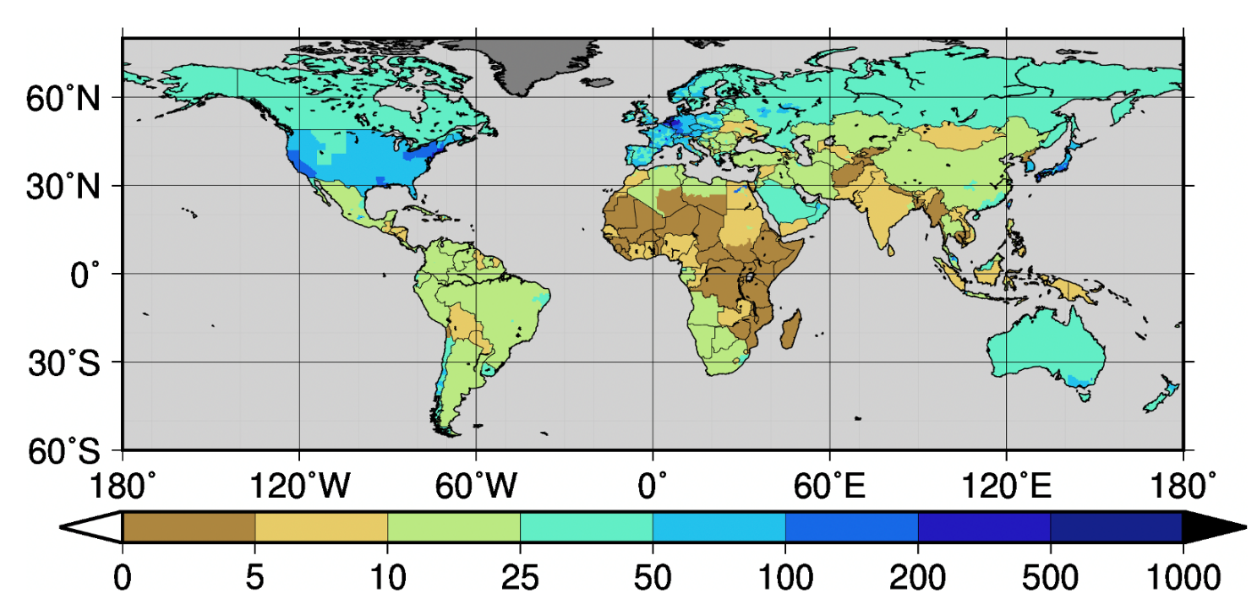
Supplementary Figure 1. Current flood protection level.
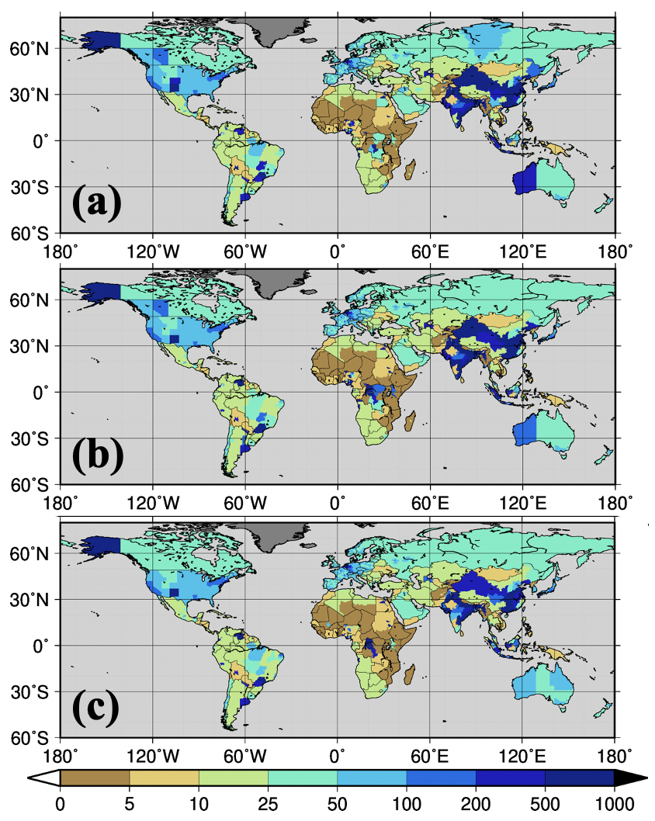
Supplementary Figure 2. Future flood protection levels. Future protection levels required for the optimized adaption objective. The results for the RCP2.6/SSP1 (a), RCP4.5/SSP2 (b) and RCP6.0/SSP3 (c) scenarios are shown.
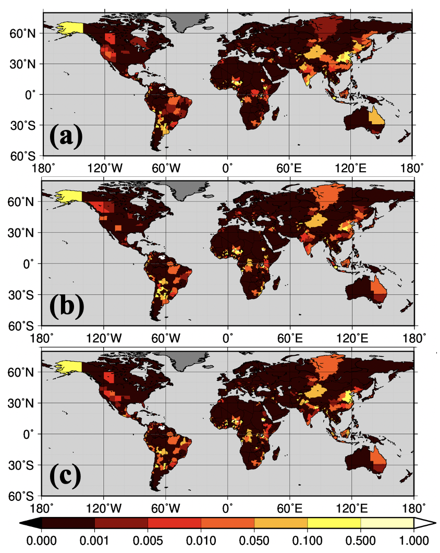
Supplementary Figure 3. Residual flood damage (RFD) as a proportion of subnational administrative GDP. RFD for the optimized adaption objective. The results for the RCP2.6/SSP1 (a), RCP4.5/SSP2 (b) and RCP6.0/SSP3 (e) scenarios are shown.
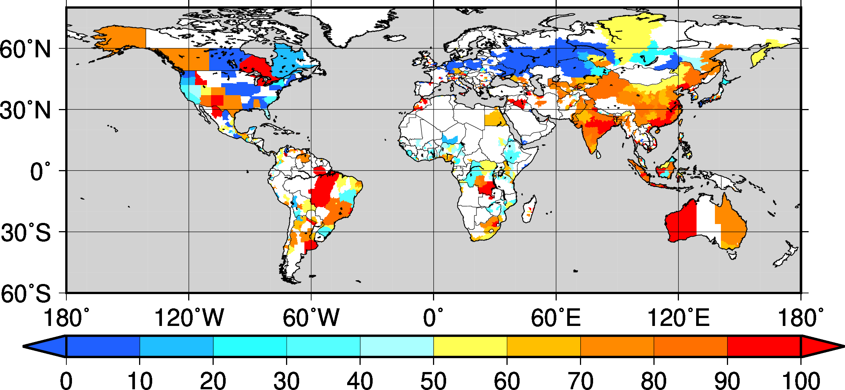
Supplementary Figure 4. Percentage of damage during the construction period relative to the total damage. The percentage for the optimized adaption objective. The results for the RCP8.5/SSP5 scenario are shown.

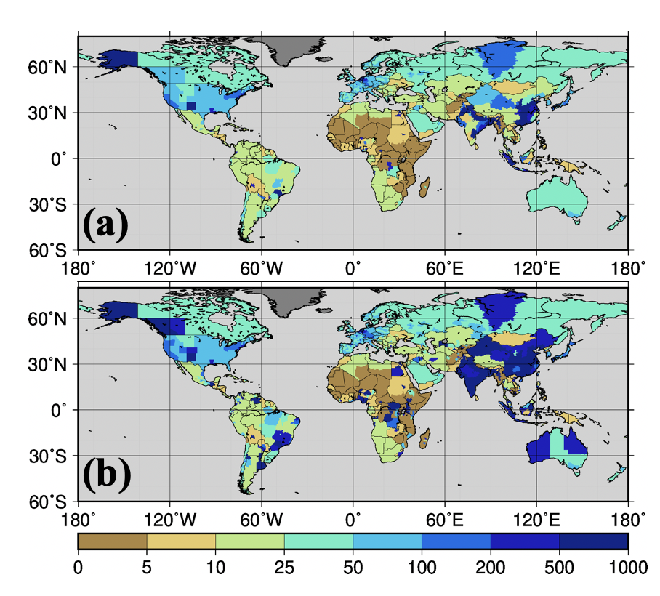
Supplementary Figure 5. The sensitivity of future flood protection levels to the unit cost of adaptation. The flood protection level assuming three-fold higher (a) and three-fold lower (b) unit costs of the optimized adaption objective. The results for the RCP8.5/SSP5 scenario are shown.

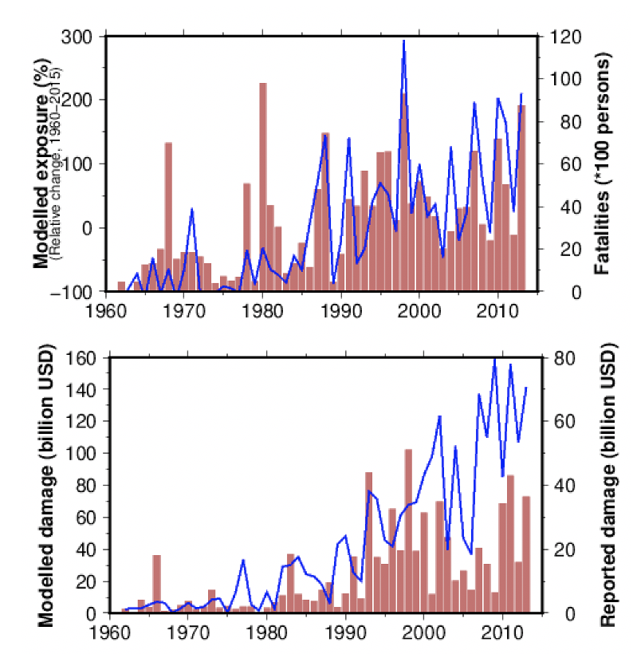
Supplementary Figure 6. (a) Reported fatalities (bar) and the modelled global exposed population (line). The modelled global exposed population displayed relative changes compared with the average for 1960–2013. (b) Reported (bar) and modelled damage (line).

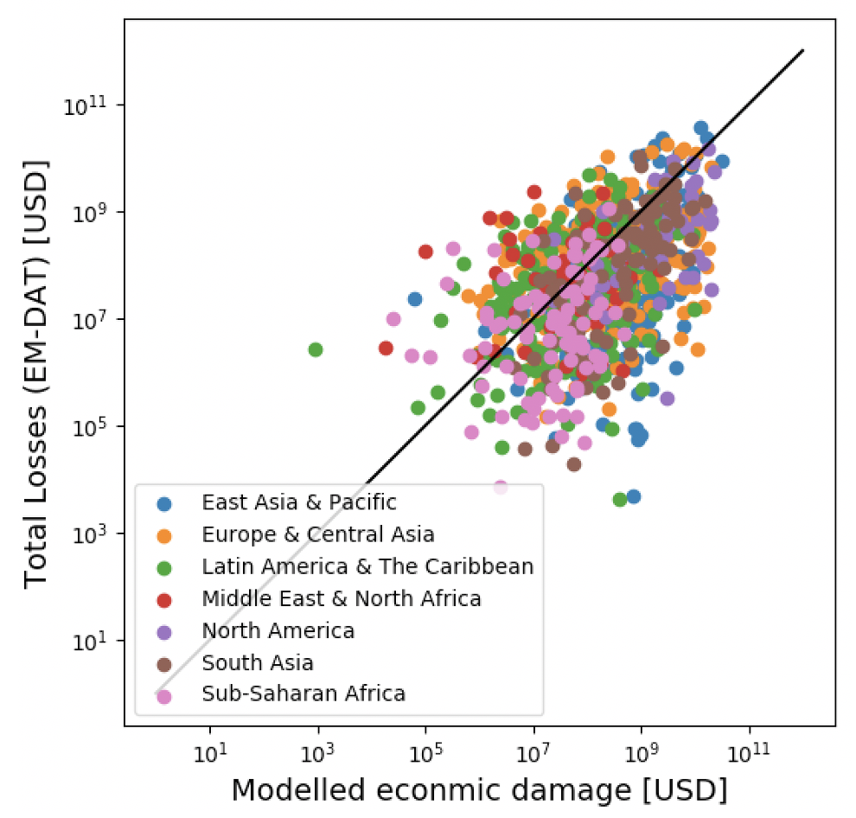
Supplementary Figure 7. Relationship between the modelled and observed damage for the period from 1960 to 2013. Solid line is the 1:1 line.

Supplementary Figure 8. Relationship between investment cost per unit length of flood prevention structure and the assumed flood protection level (FPL). Black solid lines represent regression equations of investment costs based on an ordinary least squares regression.

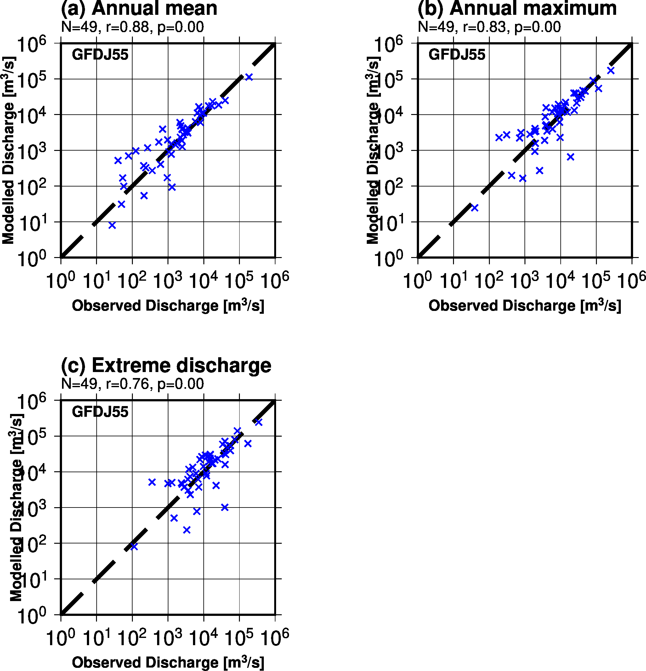
Supplementary Figure 9. Relationship between the modelled and observed discharge for the period from 1960 to 2005 at 49 selected gauging stations: (a) annual mean, (b) annual maximum and (c) extreme discharge corresponding to the 100-year return period. The retrospective inundation simulation was selected for the comparison. N, r and p indicate number of samples, correlation coefficient and probability, respectively. The dashed line is the 1:1 line.

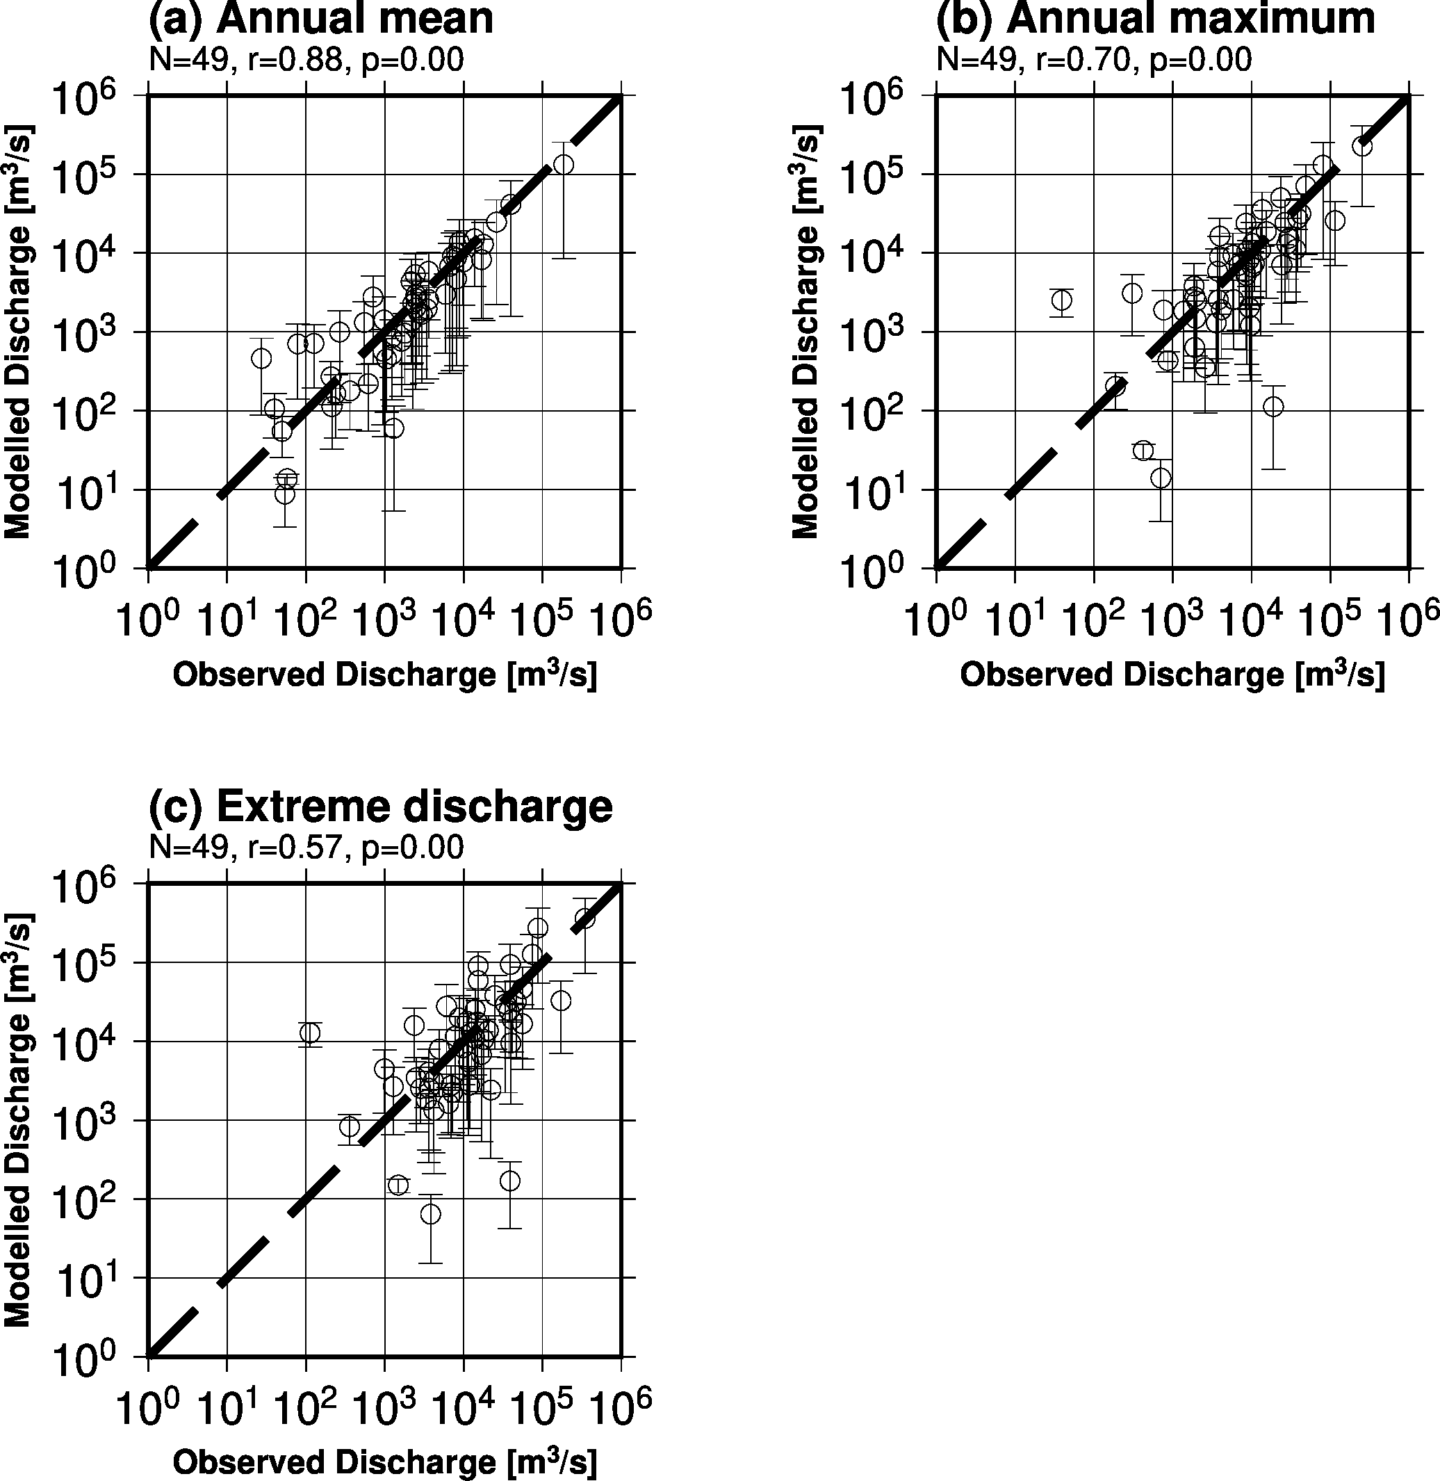
Supplementary Figure 10. The relationship between modelled and observed discharge for the period from 1960 to 2005 at 49 selected gauging stations: (a) annual mean, (b) annual maximum and (c) extreme discharge corresponding to the 100-year return period. The historical simulation was selected for the comparison. Error bars indicate the maximum and minimum values among five general circulation models (GCMs). N, r and p indicate number of samples, correlation coefficient and probability, respectively. The dashed line is the 1:1 line.

