Supplementary information
Cobs porous carbon-based materials with high energy and excellent cycle stability for supercapacitor applications
Moses Kigozi ^{a, b, *}, Richard K Koech ª, Kingsley Orisekeh ª, Ravi Kali ^{c}, Omar L M Kamoga ^{b}, Balaji Padya ^{c}, Abdulhakeem Bello ª, Gabriel N Kasozi ^{d}, Pawan Kumar Jain ^{c}, John Baptist Kirabira ^{e}, Azikiwe Peter Onwualu ª, Nelson Y Dzade ^{f, *}
ª Department of Materials Science and Engineering, African University of Science and Technology P.O. BOX 681 Garki, Abuja Nigeria.
^{b} Department of Chemistry, Faculty of Science and Education, Busitema University P.O BOX 236 Tororo – Uganda.
^{c} Centre for Carbon Materials, International Advanced Research Centre for Powder Metallurgy & New Materials (ARCI), Balapur P. O 500 005 Hyderabad India.
^{d}Department of Chemistry, College of Natural Science, Makerere University, P.O BOX 7062, Kampala, Uganda
^{e}Department of Mechanical Engineering, Makerere University, P.O BOX 7062, Kampala, Uganda
^{f} School of Chemistry, Cardiff University, Main Building, Park Place, CF10 3AT, Cardiff, United Kingdom.

*Corresponding Authors email: DzadeNY@cardiff.ac.uk / mkigozi@aust.edu.ng

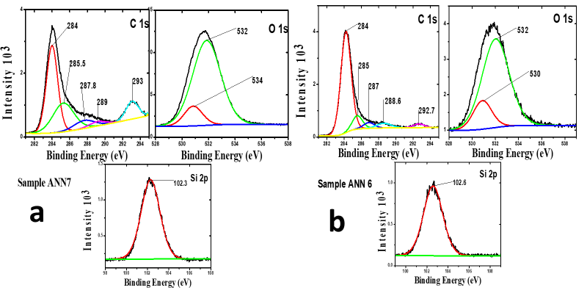
Figure S1: XPS deconvoluted spectra for (a) (ANN7) and (b) ANN6 activated samples
Figure S2: GCD for 3 electrode system for ANN6, ANN7 and ANN8 activated samples at different current density.

Figure S3: CV scanned at 5mV/s before and after stability test
Figure S4: (a) specific capacitance at different current density, (b) the Ragone plots for ANN6, ANN7 and ANN8 based supercapacitors.

Figure S5: EIS for zoomed high frequency for ANN6, ANN7, and ANN8 activated carbon scanned at 10mV
Figure S6: EIS scanned at different potential 10mV and 20mV
Figure S7: Stability by voltage holding at maximum potential for 10hours before discharge

Figure S8: Self-discharge of devices from 1.0V after stability test.

