Supporting Information

Anion-Exchange-Mediated Internal Electric Field: Boosting Photogenerated Carrier Separation and Utilization

Tong Han^{1#}, Xing Cao^{1#}, Kaian Sun^{1#}, Qing Peng^{1*}, Weng-Chon Cheong², Zheng Chen ³, Rui Lin⁴, Di Zhao⁵, Zewen Zhuang¹, Chen Chen¹, Dingsheng Wang¹, and Yadong Li^{1*}

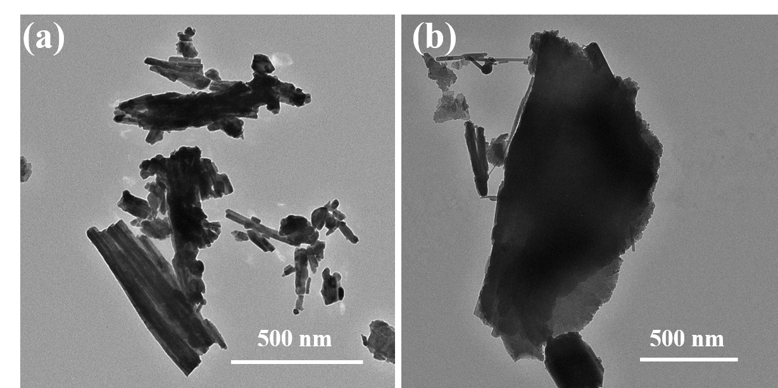
Figure S1. (a) TEM image of the hydrothermal product without mannitol; (b) TEM image of the hydrothermal product without PVP.

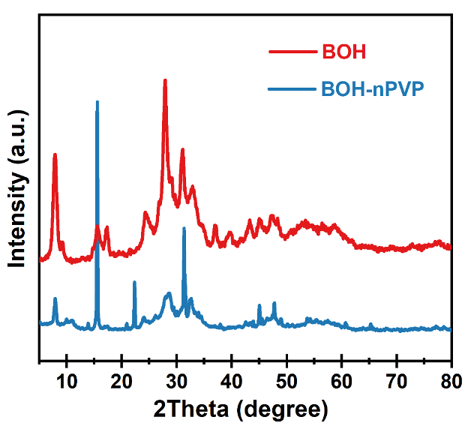
Figure S2. The XRD patterns of the BOH and BOH-nPVP.

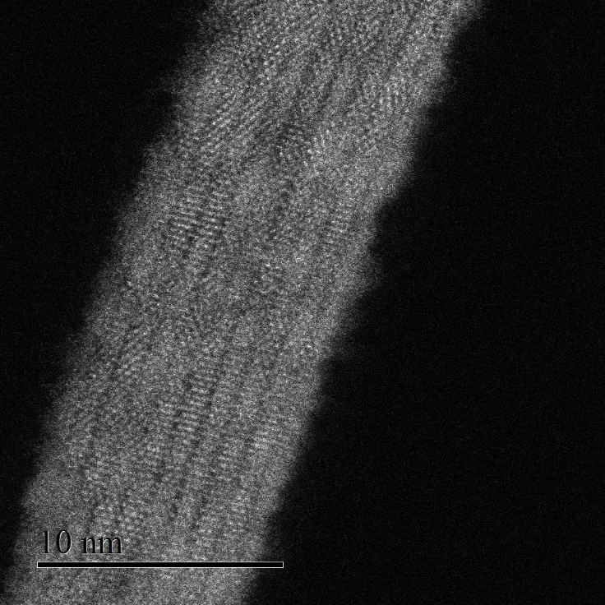
Figure S3. Atomic-resolution HAADF-STEM image of BOH.

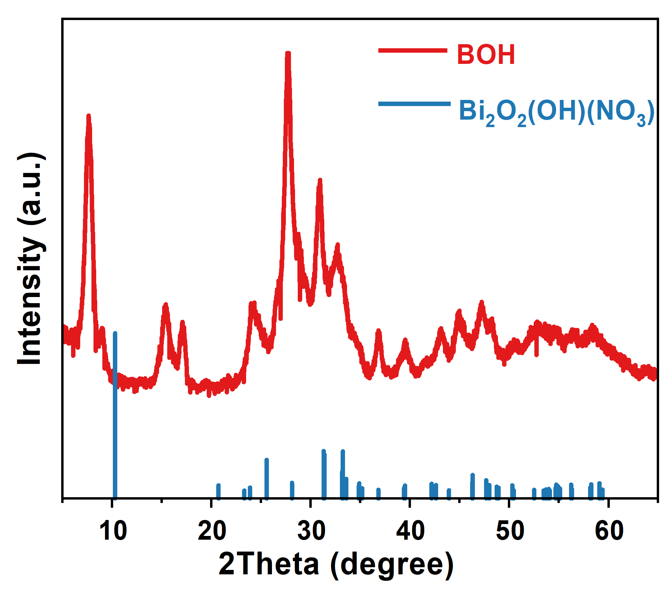
Figure S4. The XRD patterns of the BOH and Bi₂O₂(OH)(NO₃).
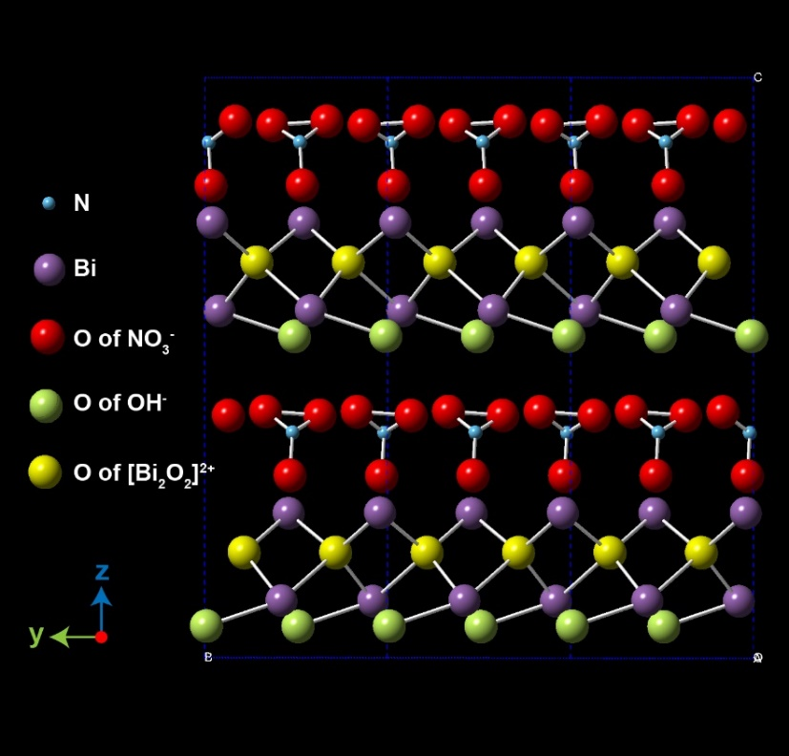
Figure S5. Two-dimensional model structure of Bi₂O₂(OH)(NO₃), viewed down the x-axis.

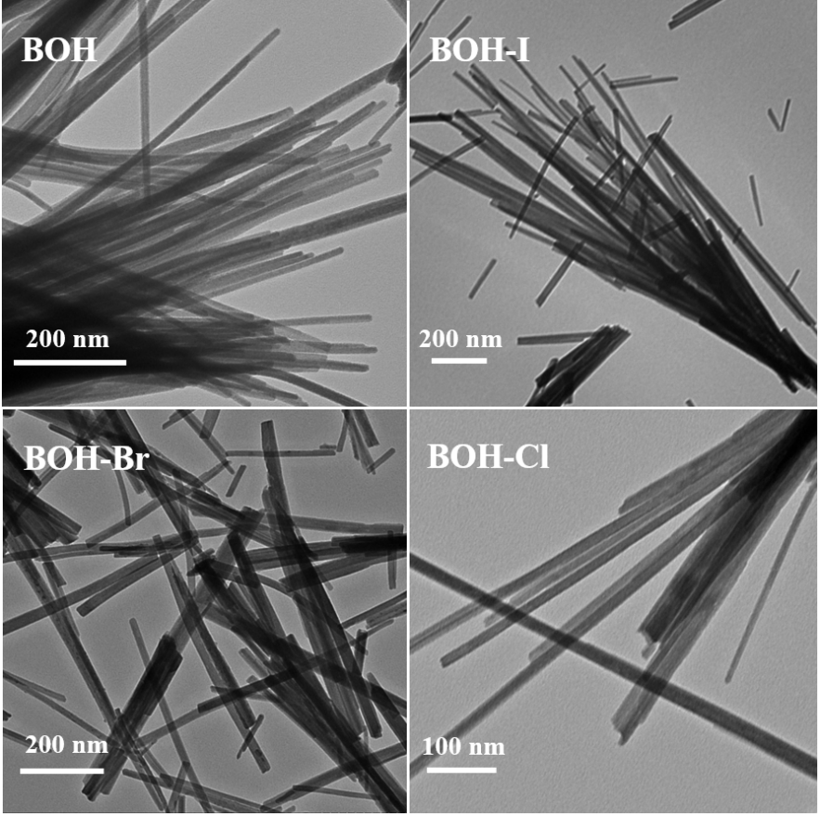
Figure S6. TEM images of BOH samples before and after halide-anion exchange.

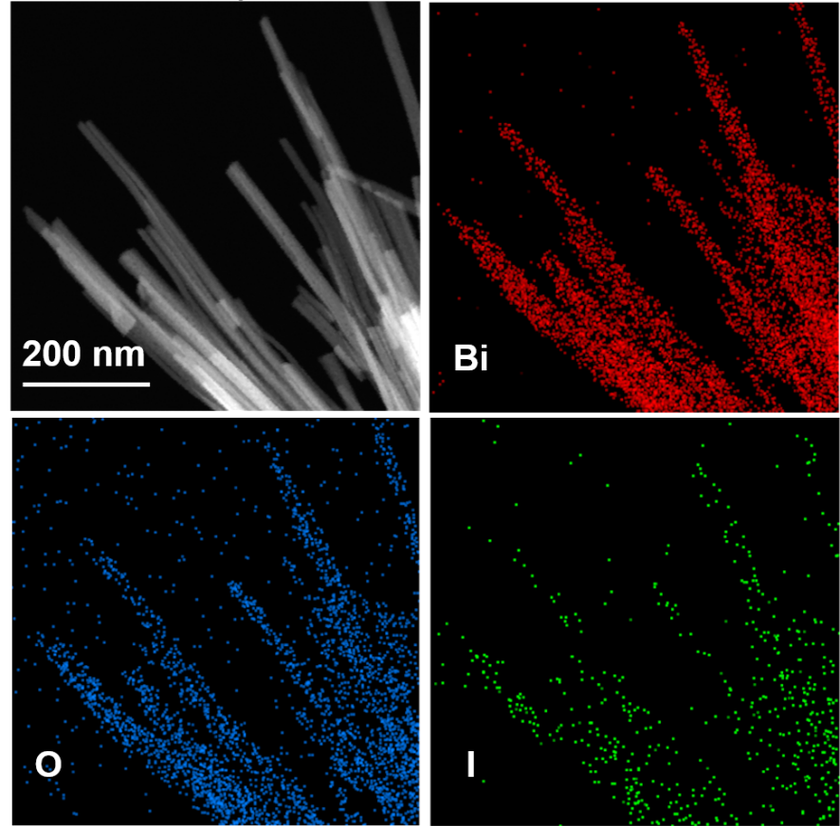
Figure S7. The EDS mapping of BOH-I.

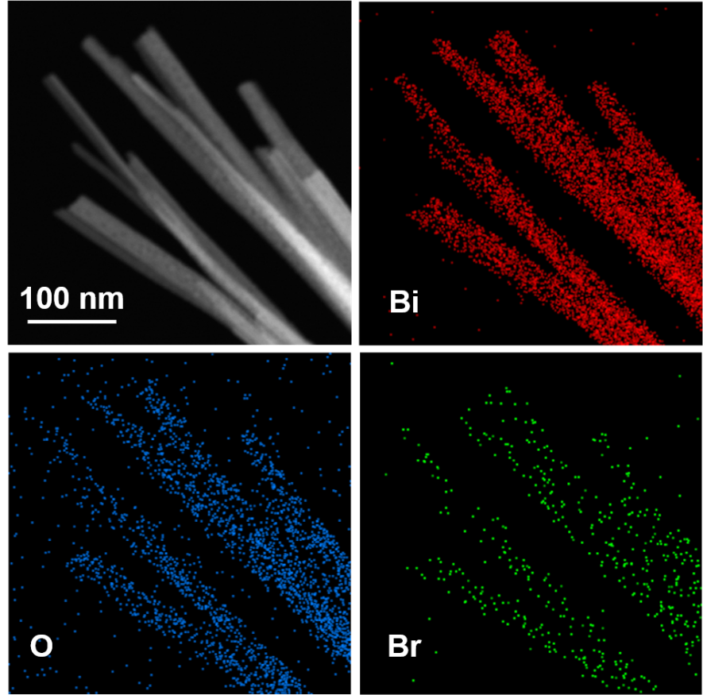
Figure S8. The EDS mapping of BOH-Br.

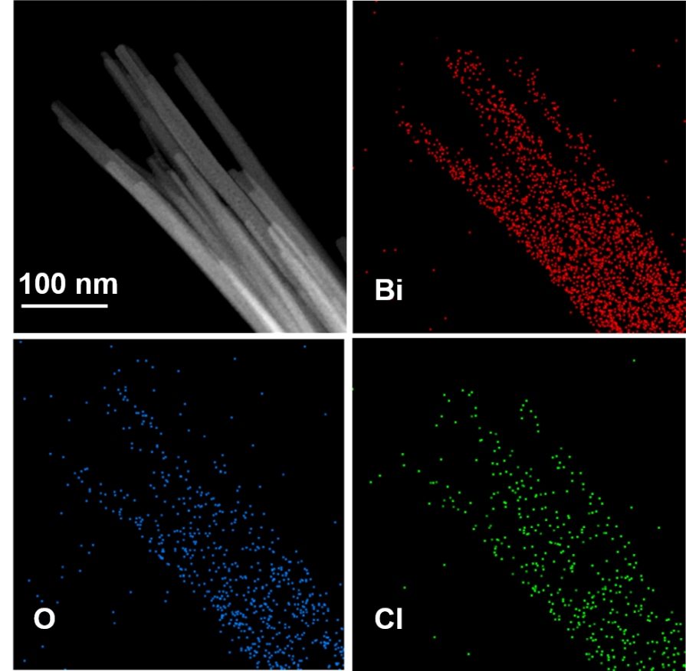
Figure S9. The EDS mapping of BOH-Cl.

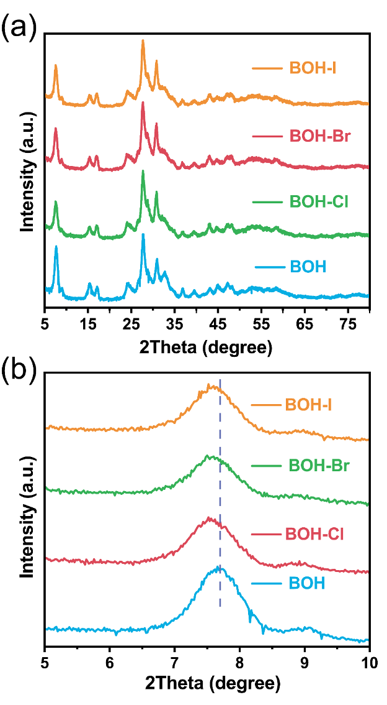
Figure S10. The XRD patterns of the BOH and BOH-X.

Figure S11. (a) XPS spectra of Bi in the samples before and after ion exchange; (b–d) XPS spectra of halogens in the BOH-I, BOH-Br and BOH-Cl, respectively.

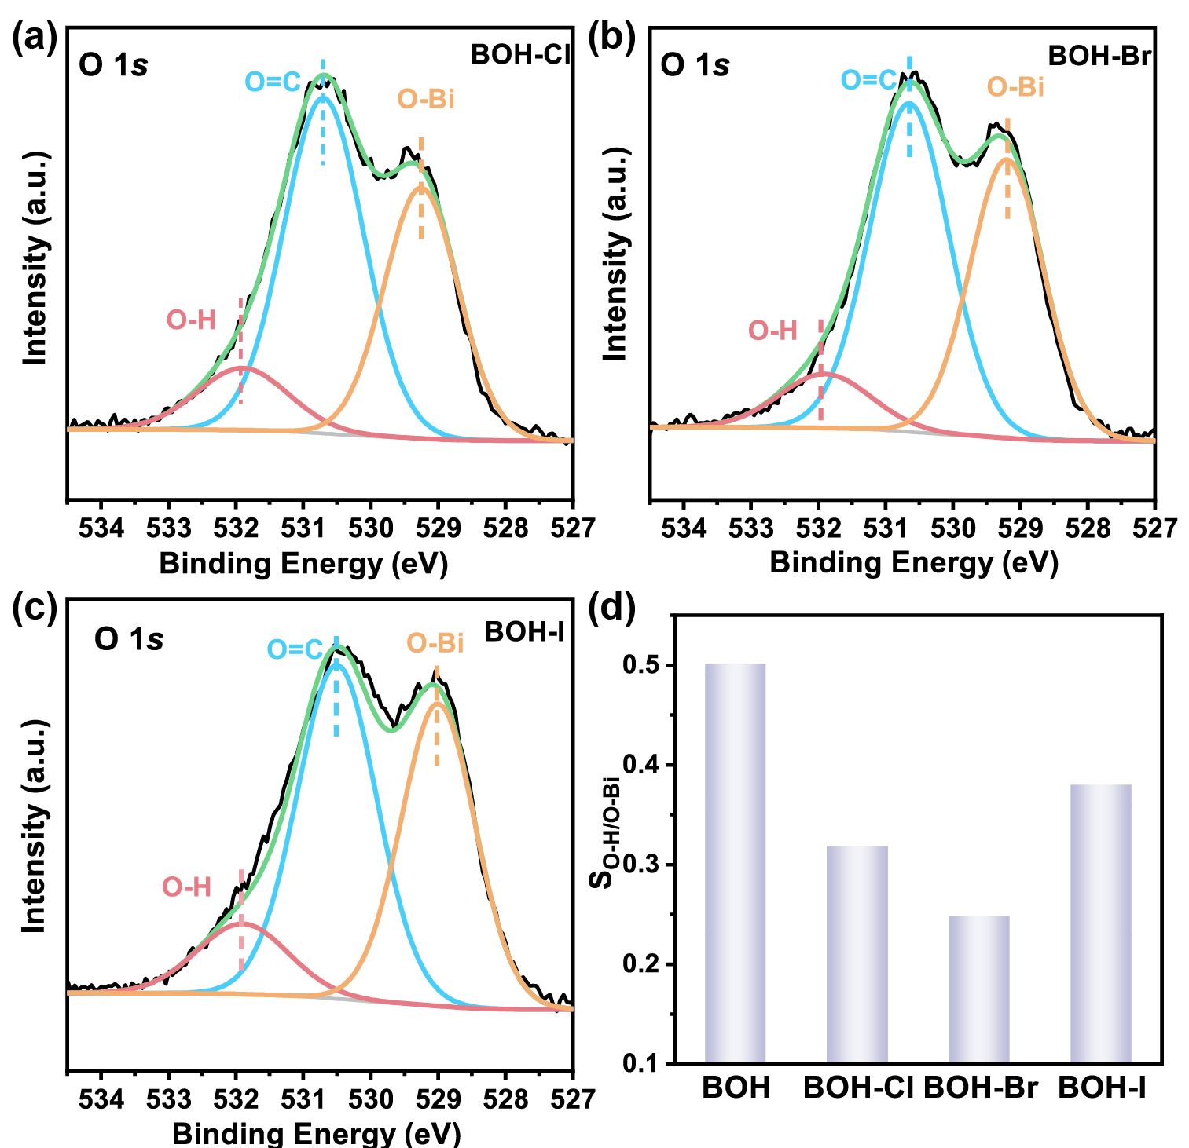
Figure S12. (a–c), XPS spectra of O in the ion-exchanged samples; (d) the ratios of O–H bond before and after ion exchange.
Figure S13. (a) High-resolution XPS spectra of I 3d (a) and N 1s (b) for BOH-I with Ar⁺ sputtering at different depths.
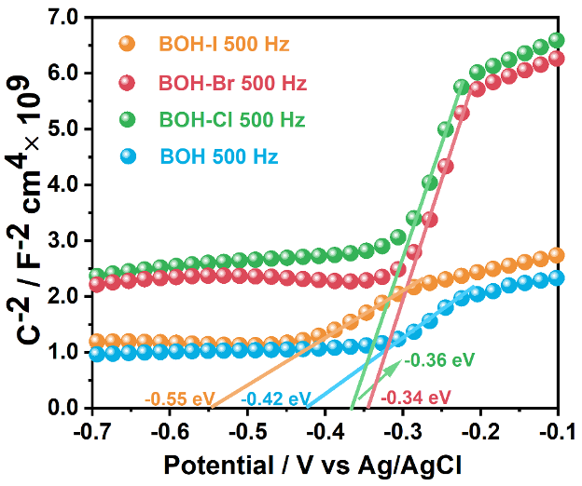
Figure S14. Mott–Schottky plots of the samples before and after ion exchange.
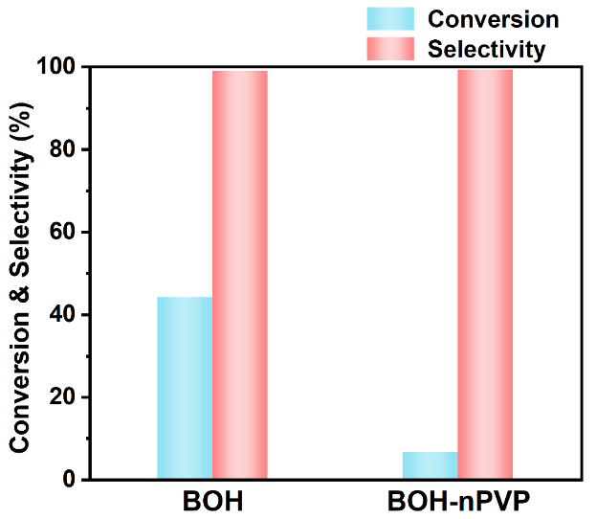
Figure S15. Catalytic performances of the normal BOH and BOH-nPVP.

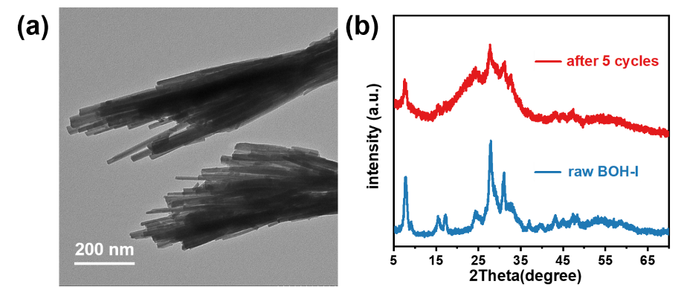
Figure S16. TEM image (a) and XRD patterns (b) of BOH-I after 5 catalytic cycles.

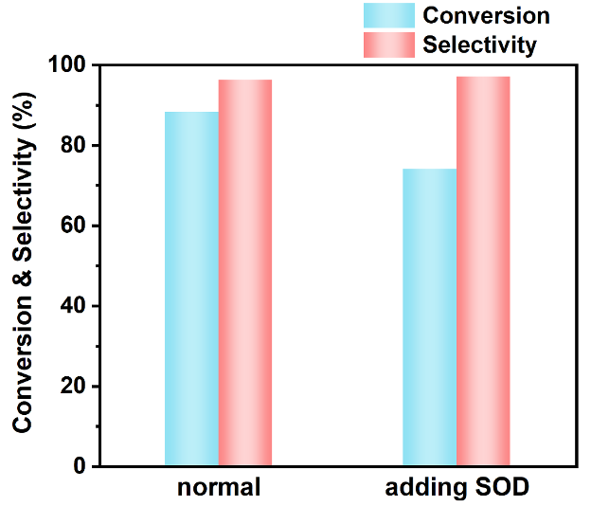
Figure S17. Catalytic performances of the normal BOH-I and after addition of superoxide dismutase (SOD).

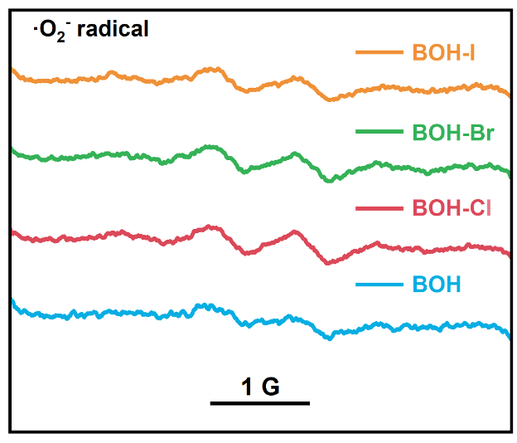
Figure S18. EPR spectra for the samples before and after ion exchange, with DMPO as scavenger.
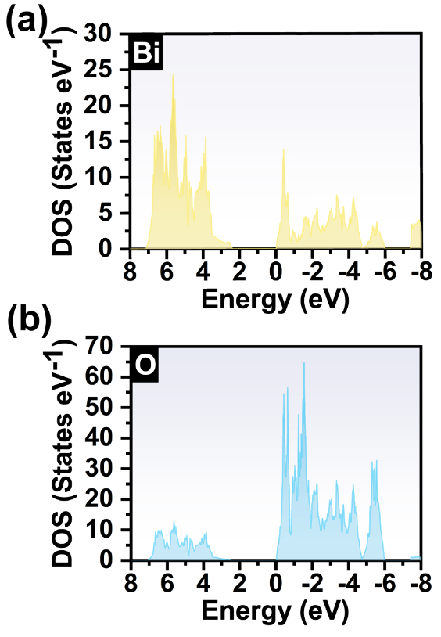

Figure S19. The calculated density of state of BOH: (a) and (b) show the contribution of bismuth and oxygen element to valence bands and conduction bands, respectively.

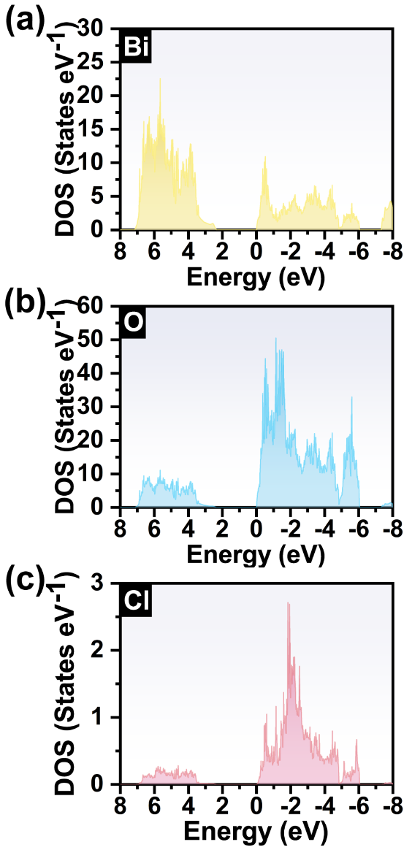
Figure S20. The calculated density of state of BOH-Cl: (a), (b) and (c) show the contribution of bismuth, oxygen and chlorine element to valence bands and conduction bands, respectively.
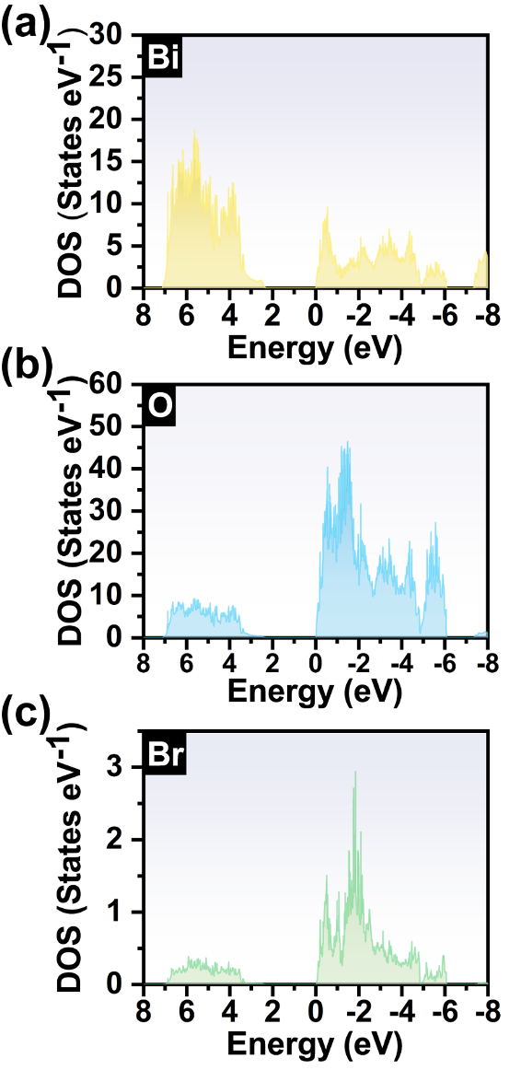
Figure S21. The calculated density of state of BOH-Br: (a), (b) and (c) show the contribution of bismuth, oxygen and bromine element to valence bands and conduction bands, respectively.
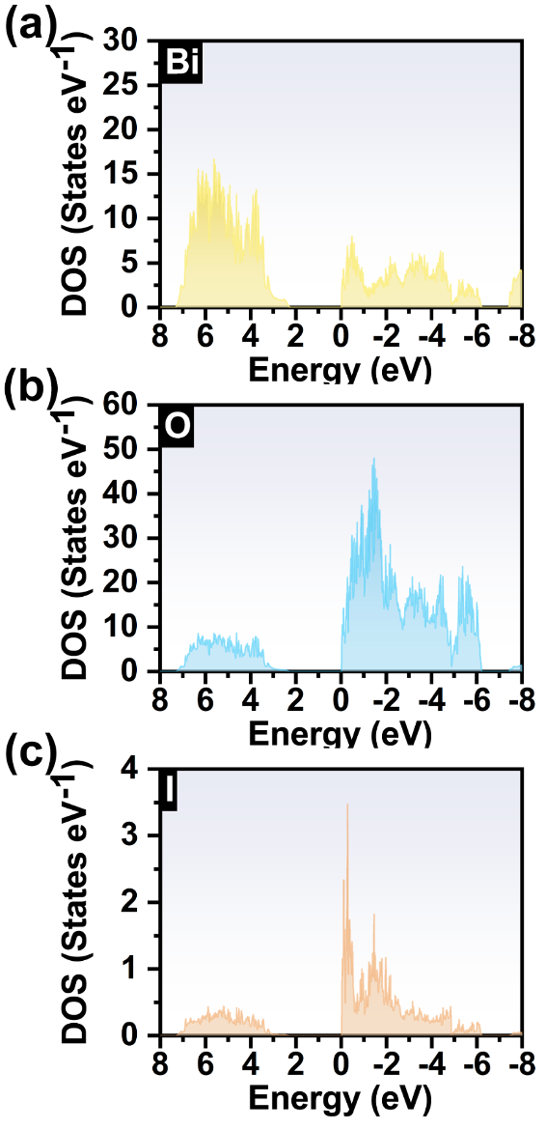
Figure S22. The calculated density of state of BOH-I: (a), (b) and (c) show the contribution of bismuth, oxygen and iodine element to valence bands and conduction bands, respectively.
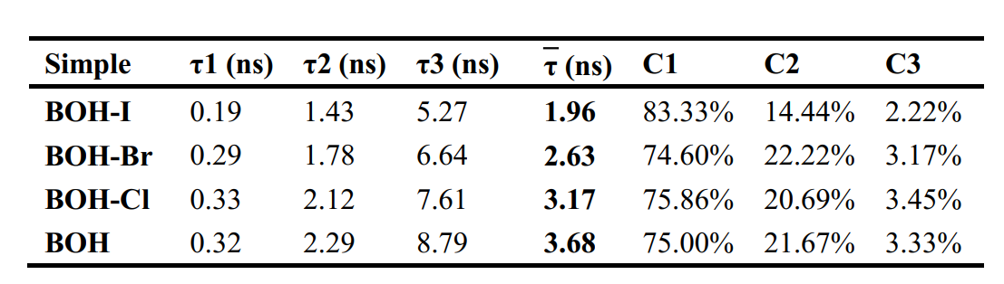
Table S1. The average PL lifetimes of BOH and BOH-X determined from the transient PL spectra.

