SUPPORTING INFORMATION FOR
Transitional Wave Climate Regions on Continental and Polar Coasts in a Warming World
I. Odériz^{1*}, N. Mori^{2.3}, T. Shimura², A. Webb², R. Silva¹, T.R. Mortlock^{4,5}
¹ Instituto de Ingeniería, Universidad Nacional Autónoma de México, México
² Disaster Prevention Research Institute, Kyoto University, Japan
³ Swansea University, UK
⁴Risk Frontiers (RF), Australia
⁵Department of Earth and Environmental Sciences, Macquarie University (MQ), Australia
*Corresponding author: Itxaso Odériz (itxaso.oderiz@gmail.com)

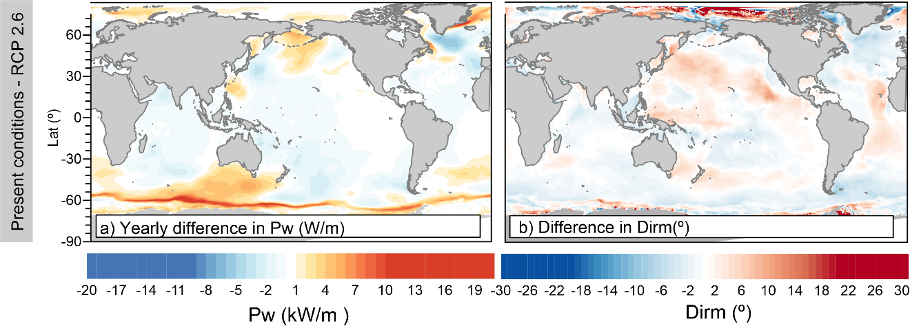
Figure SI 1 Yearly difference between RCP2.6 and Present conditions of wave power (a) and mean wave direction (b).

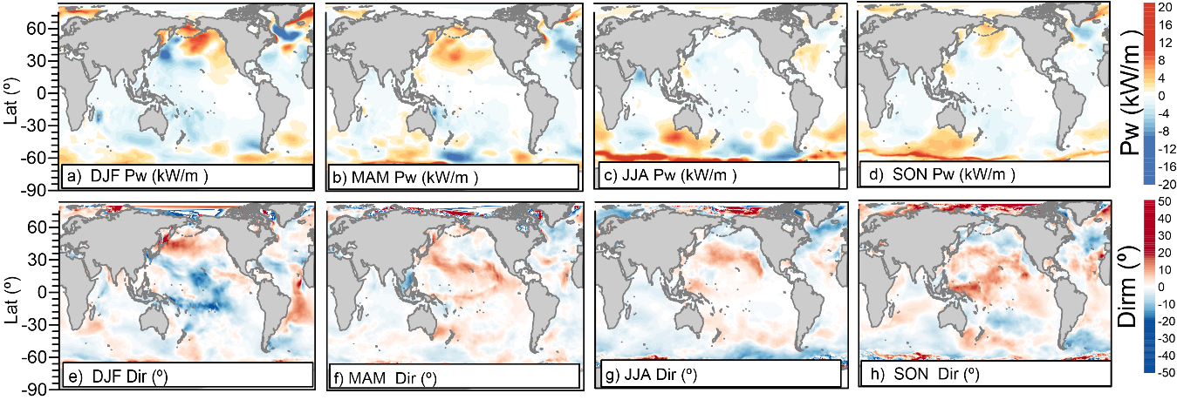
Figure SI 2 Seasonal difference between RCP2.6 and Present conditions of wave power (a,b,c,d) and mean wave direction (e,f,g,h) in DJF ( a,e), MAM( b,f), JJA(c,g), and SON(d,h).

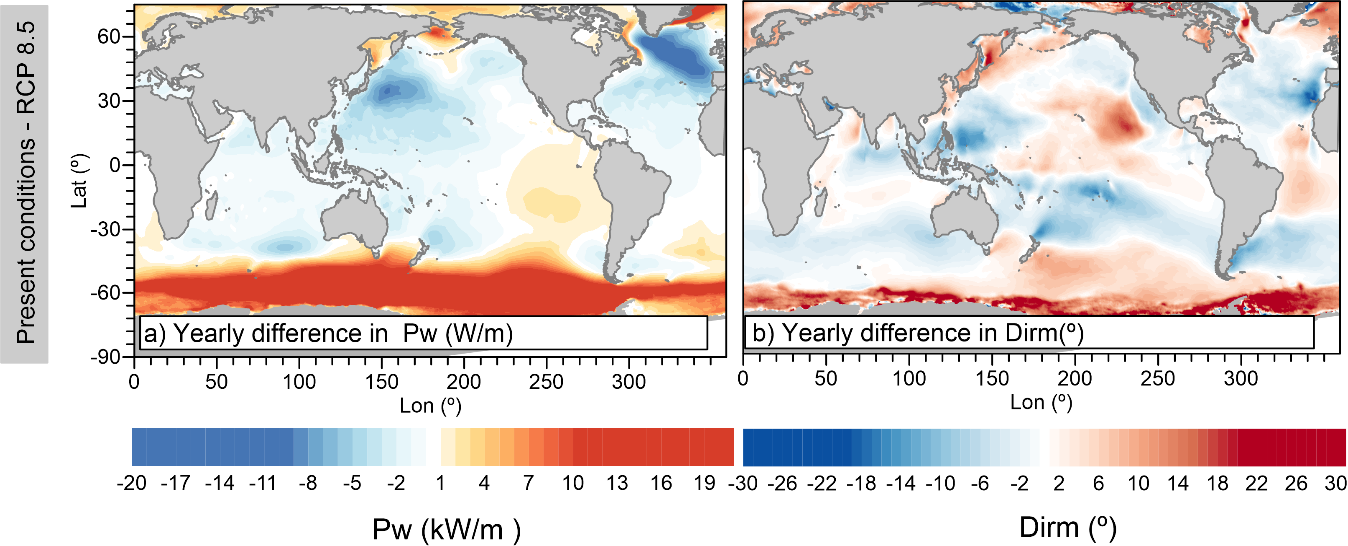
Figure SI 3 Difference between RCP8.5 conditions (2075-2099) and present conditions (1979-2003) in a) Wave power and b) mean wave direction.
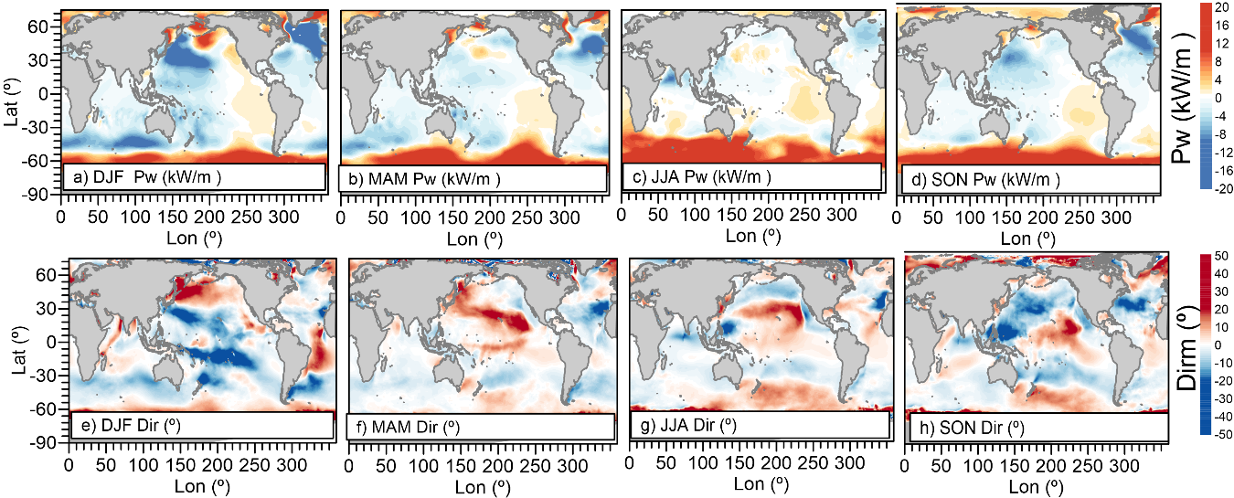
Figure SI 4 Difference between RCP8.5 conditions (2075-2099) and present conditions (1979-2003) in (a, b, c, d) wave power and (e, f, g, h) mean wave direction during, (a, e) DJF, (b, f) MAM, (c, g) JJA, and (d, h) SON season.

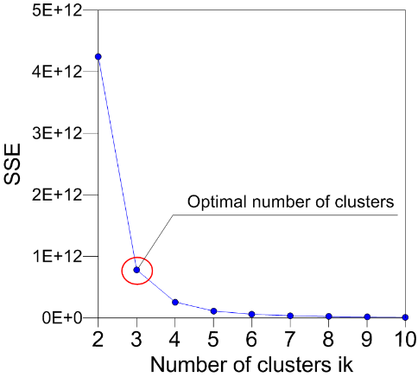
Figure SI 5 Optimal number of clusters for historical conditions (1979-2003).

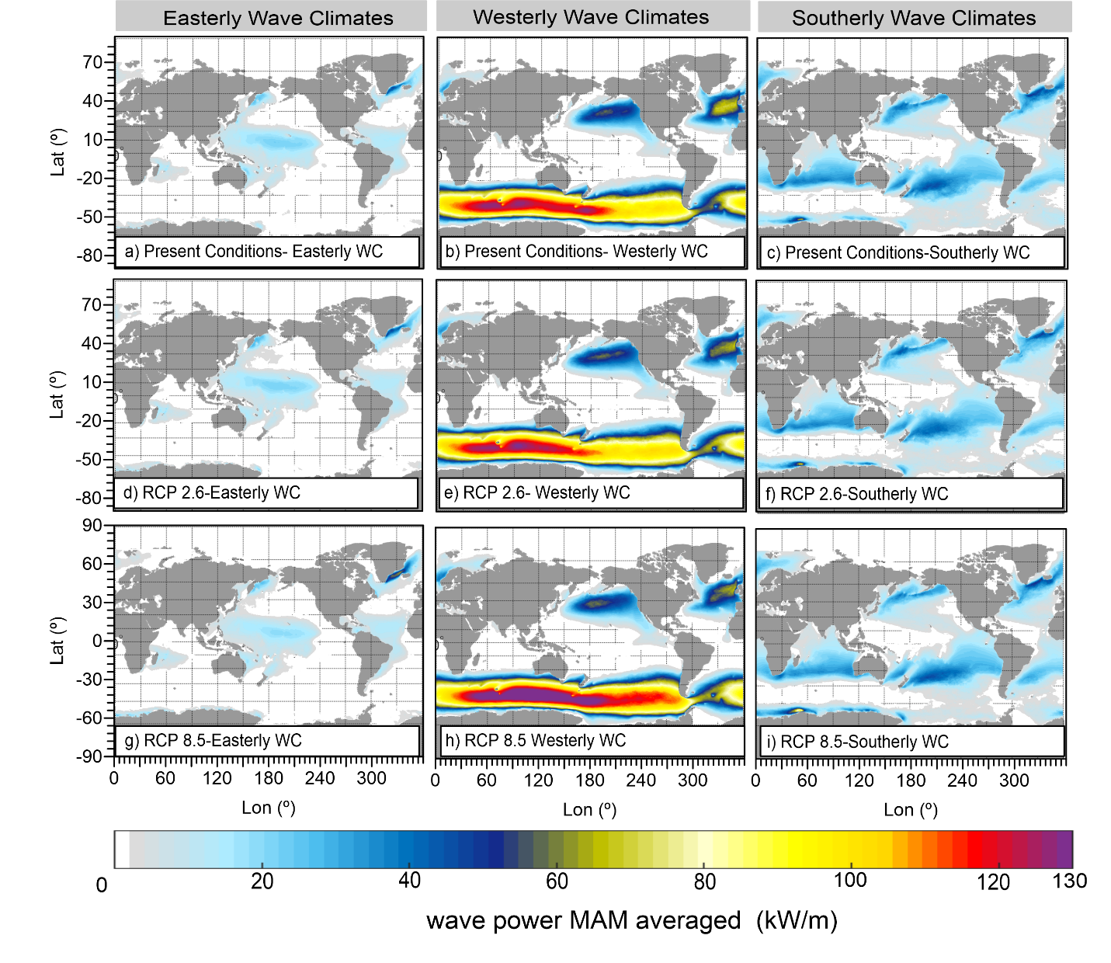
Figure SI 6 MAM averaged wave power for the (a, b, c) present scenario, (d, e, f) RCP2.6, and (h, I, j) RCP 8.5 scenarios for the (a, d, g,) easterly WC, (b, e, h) westerly, and (c, f, i) southerly wave climates.
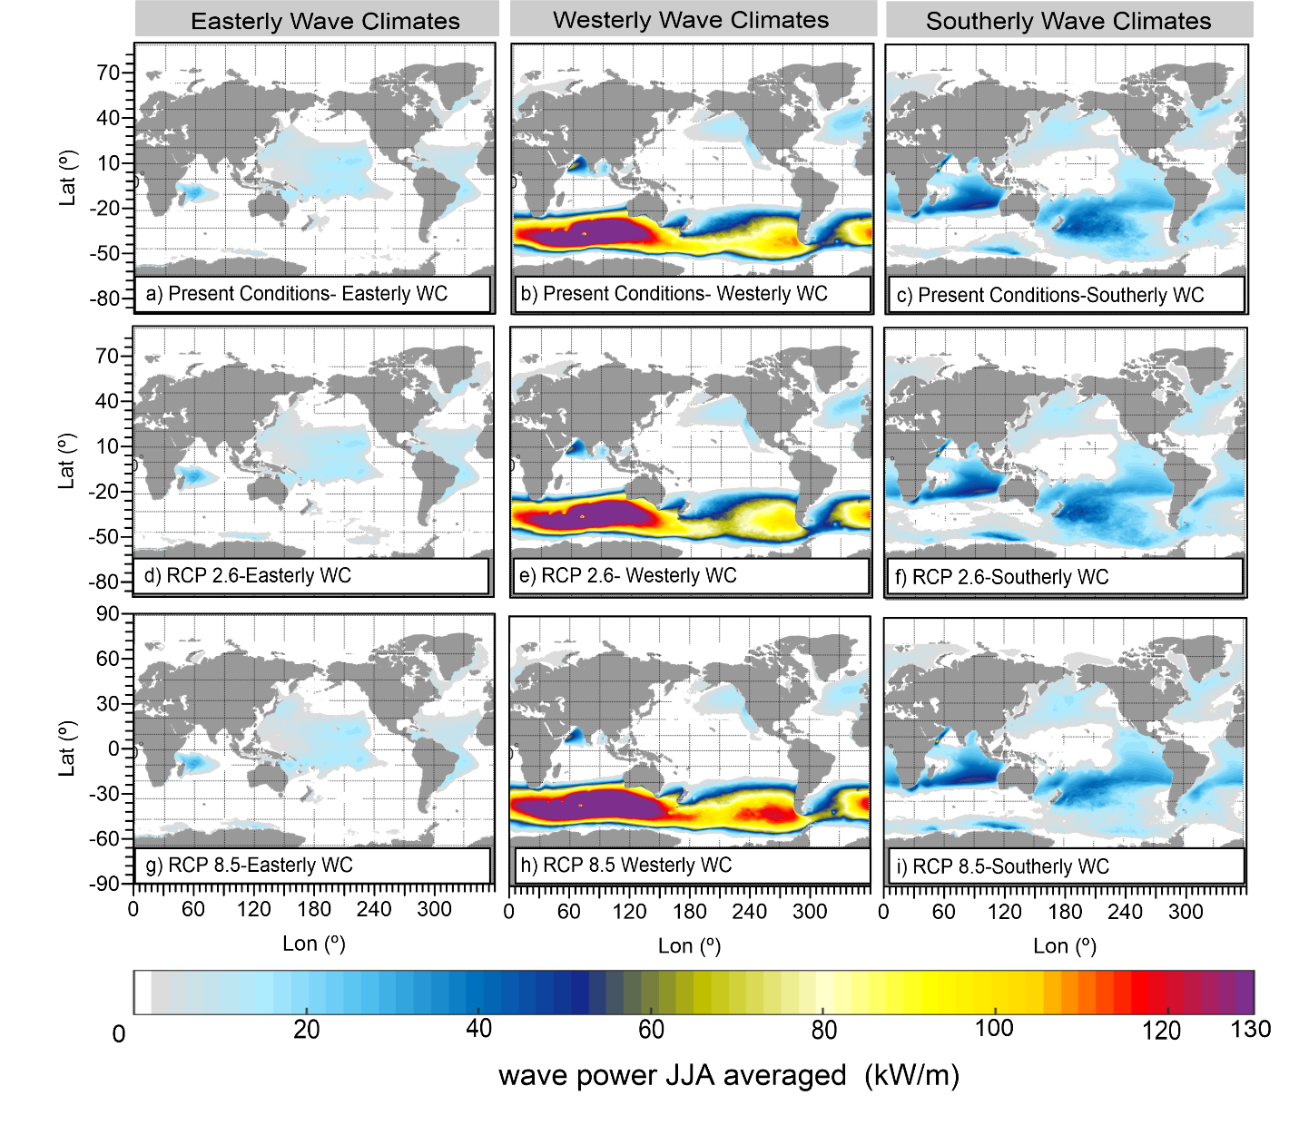
Figure SI 7 JJA averaged wave power for the (a, b, c) present scenario, (d, e, f) RCP2.6, and (h, I, j) RCP 8.5 scenarios for the (a, d, g,) easterly WC, (b, e, h) westerly, and (c, f, i) southerly wave climates.
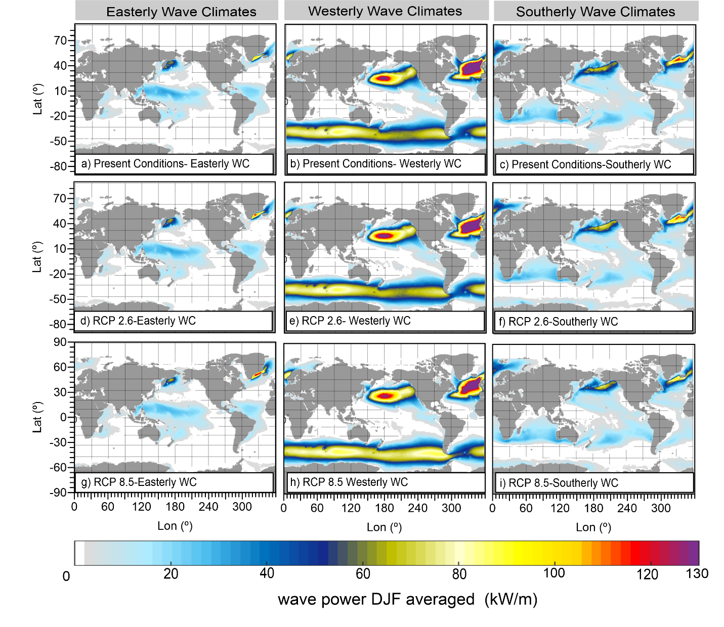
Figure SI 8 DJF averaged wave power for the (a, b, c) present scenario, (d, e, f) RCP2.6, and (h, I, j) RCP 8.5 scenarios for the (a, d, g,) easterly WC, (b, e, h) westerly, and (c, f, i) southerly wave climates.
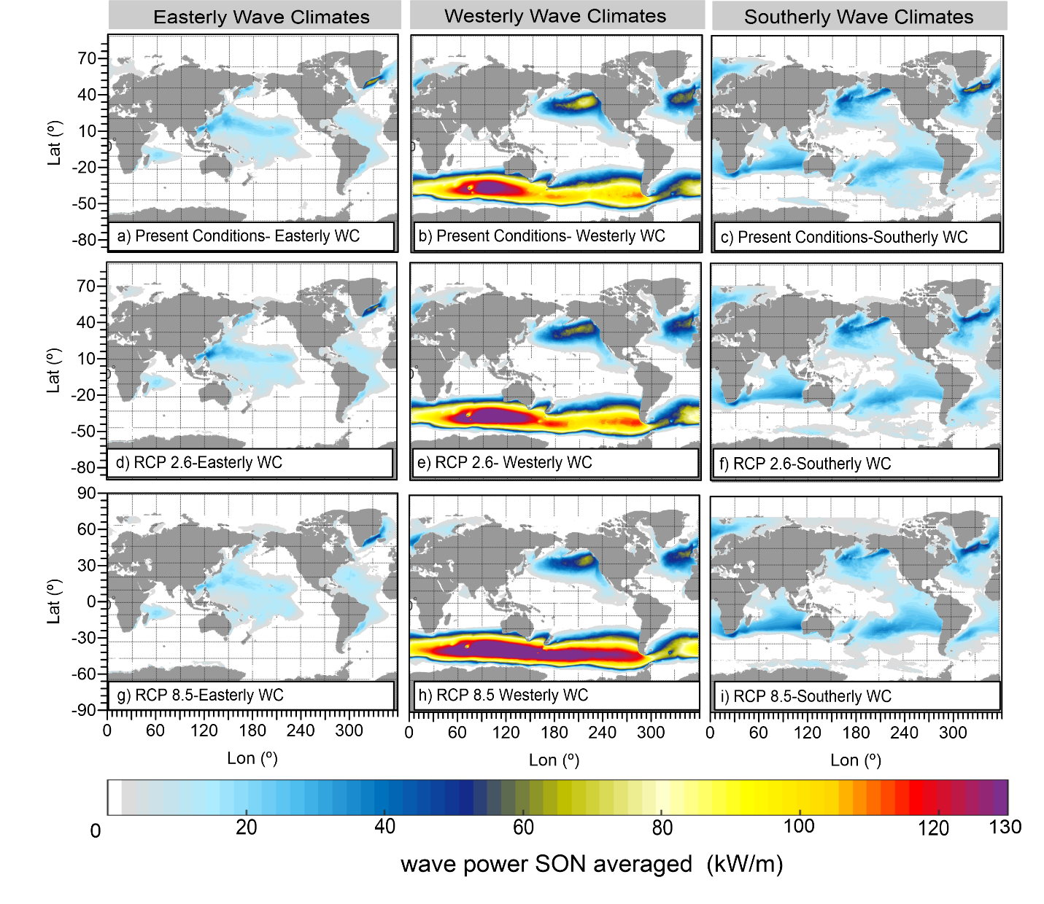
Figure SI 9 SON averaged wave power for the (a, b, c) present scenario, (d, e, f) RCP2.6, and (h, I, j) RCP 8.5 scenarios for the (a, d, g,) easterly WC, (b, e, h) westerly, and (c, f, i) southerly wave climates.

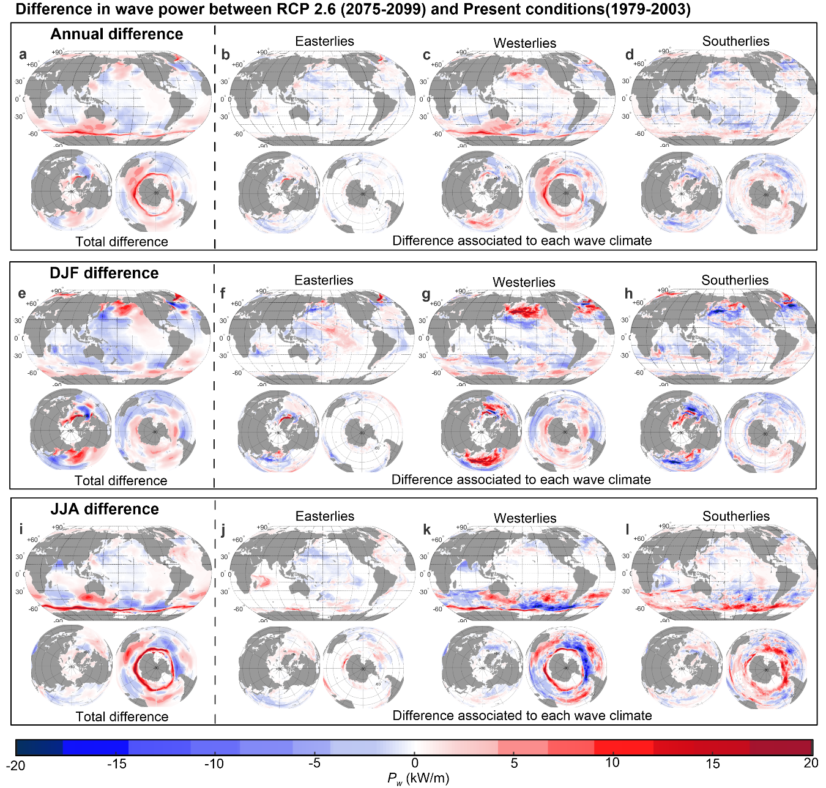
Figure SI 10 Differences between RCP2.6 and present conditions in yearly averaged wave power for the (a, b, c) easterly, (d, e, f) westerly, and (g, h, i) and southerly wave climates. The results are shown in a (a, d, g,) global, (b, e, h) the Antarctic, and (c, f, i) the Arctic views.

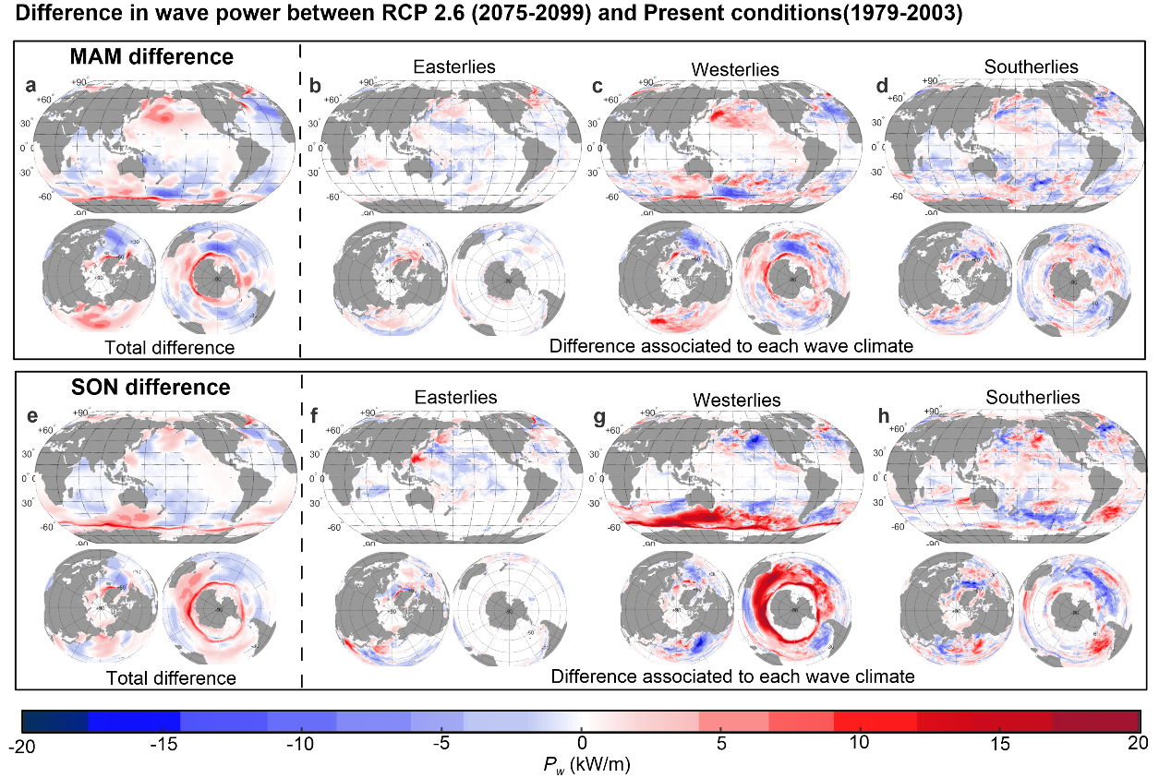
Figure SI 11 Differences between RCP2.6 and present conditions in SON averaged wave power for the (a, b, c) easterly, (d, e, f) westerly, and (g, h, i) and southerly wave climates. The results are shown in a (a, d, g,) global, (b, e, h) the Antarctic, and (c, f, i) the Arctic views.

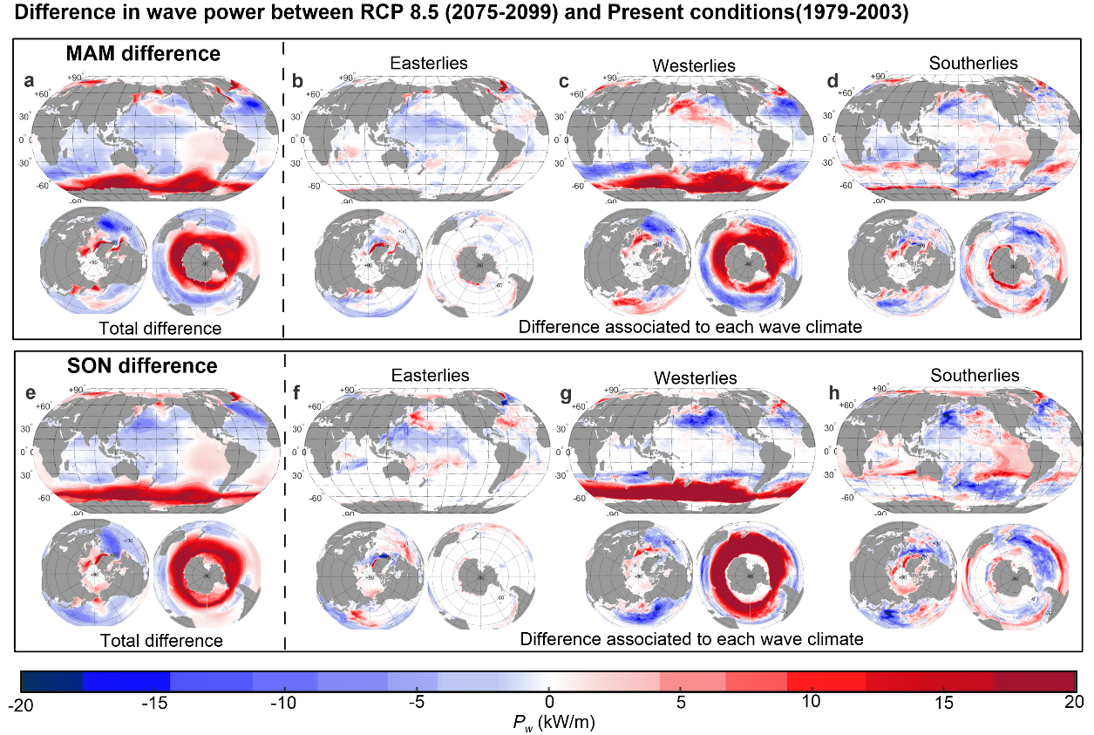
Figure SI 12 Differences between RCP2.6 and present conditions in MAM averaged wave power for the (a, b, c) easterly, (d, e, f) westerly, and (g, h, i) and southerly wave climates. The results are shown in a (a, d, g,) global, (b, e, h) the Antarctic, and (c, f, i) the Arctic views.

Seasonal Changes in area covered by each wave climate
In the Indian Ocean, the proportion of area covered by the southerlies is projected to increase year-round while the westerlies decrease, with the largest changes occurring during DJF (+7.9 % and -7.8 %, respectively); on the other hand, the easterlies exhibits both patterns with the largest changes occurring during JJA (+5.1 %) and DJF (-1.7 %). In the Pacific Ocean, the proportion by the easterlies is projected to increase overall (except in MAM) while the westerlies (again) decrease, with the largest changes occurring during SON (+8.4 % and -6.9 %, respectively); the southerly wave climate is also projected to increase year-round (except in SON) with the largest change in MAM (3.3 %). Similarly, in the Atlantic Ocean, the proportion by the easterlies is projected to increase overall (except in JJA; -2.8 %) while the westerlies generally decrease (except SON), with the largest changes occurring during MAM (+4.5 % and -5.1 %, respectively); meanwhile, the southerlies will expand during DJF and MAM (up to +6 %) but shrink during SON (-2.3 %). In the Southern Ocean, the general pattern holds except during SON, when the proportion of area covered expands for all the wave climates.
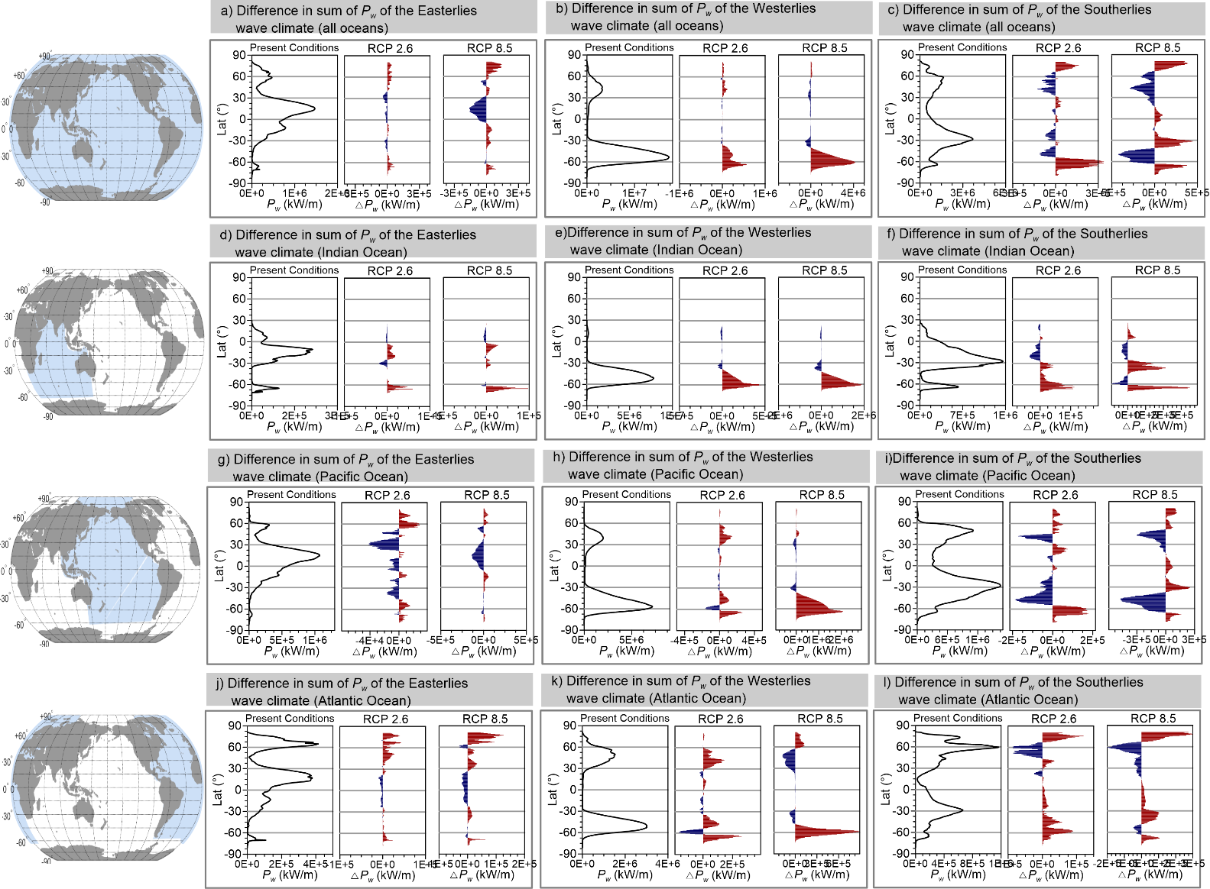
Figure SI 13 Differences between RCP8.5 and present conditions in mean wave direction for the (a, d, g, j) easterly, (b, e, h, k) westerly, and (c, f, I, l) and southerly wave climates. For (a, b, c) DJF, (d, e, f) MAM, (g, h, i) JJA, and (j, k, l) SON.

To compare the results between the projection scenarios and historical conditions, the residuals in percentage were calculated. The annual residual was calculated as well as the relative residual for the wave power.
$${P_{w}}_{P}={{P_{w}}_{Present}}_{W}+{{P_{w}}_{Present}}_{E}+{{P_{w}}_{Present}}_{S}$$ | ( 1 )
$${P_{w}}_{RCP2.6}={{P_{w}}_{RCP2.6}}_{W}+{{P_{w}}_{RCP2.6}}_{E}+{{P_{w}}_{RCP2.6}}_{S}$$ | ( 2 )
$${P_{w}}_{RCP8.5}={{P_{w}}_{RCP8.5}}_{W}+{{P_{w}}_{RCP8.5}}_{E}+{{P_{w}}_{RCP8.5}}_{S}$$ | ( 3 )

$${e_{Pw}}_{RCP}={\hat{P_{w}}}_{sRCP}-{P_{w}}_{P}$$ |  | ( 4 )
$${e_{PwRCP}}_{E,W,S}=100∙\frac{{{\hat{P_{w}}}_{RCP}}_{E,W,S}-{{P_{w}}_{P}}_{E,W,S}}{{P_{w}}_{P}}$$ |  | ( 5 )
Where:
${e_{Pw}}_{RCP}$= | residuals of the wave power for RCP (2.6,8.5) scenarios [W/m]
${P_{w}}_{P}$= | the annual mean of present conditions , ${P_{w}}_{P}=\frac{\sum_{i=1}^{i=n}{{P_{w}}_{Pi}}}{N}[W/m]$;
${\hat{P_{w}}}_{RCP}$= | the annual mean of the RCP (2.6,8.5) scenarios, ${\hat{P_{w}}}_{RCP}=\frac{\sum_{i=1}^{i=n}{{P_{w}}_{RCP}}}{N}[W/m]$;
N= | The total number of measurement (300 (25 yeas X 12months) of the time range studied, [months].
${e_{PwRCP}}_{E,W,S}$= | residuals of the wave power for each wave climate in the scenario of RCP2.6 the RCP 8.5 [W/m]
${{\hat{P_{w}}}_{RCP2.6}}_{E,W,S}$= | Annual average of wave power for each wave climate in the scenario of RCPs [W/m]
${{P_{w}}_{P}}_{E,W,S}$= | Annual average of wave power for each climate type in the present scenario [W/m]
E= | Easterly wave climates.
W= | Westerly wave climates.
S= | Southerly wave climates.
If$e=0$ there is no differences between the present and projected scenarios, where $e<0$ the wave power will decrease and where $e>0$ the wave power will increase.

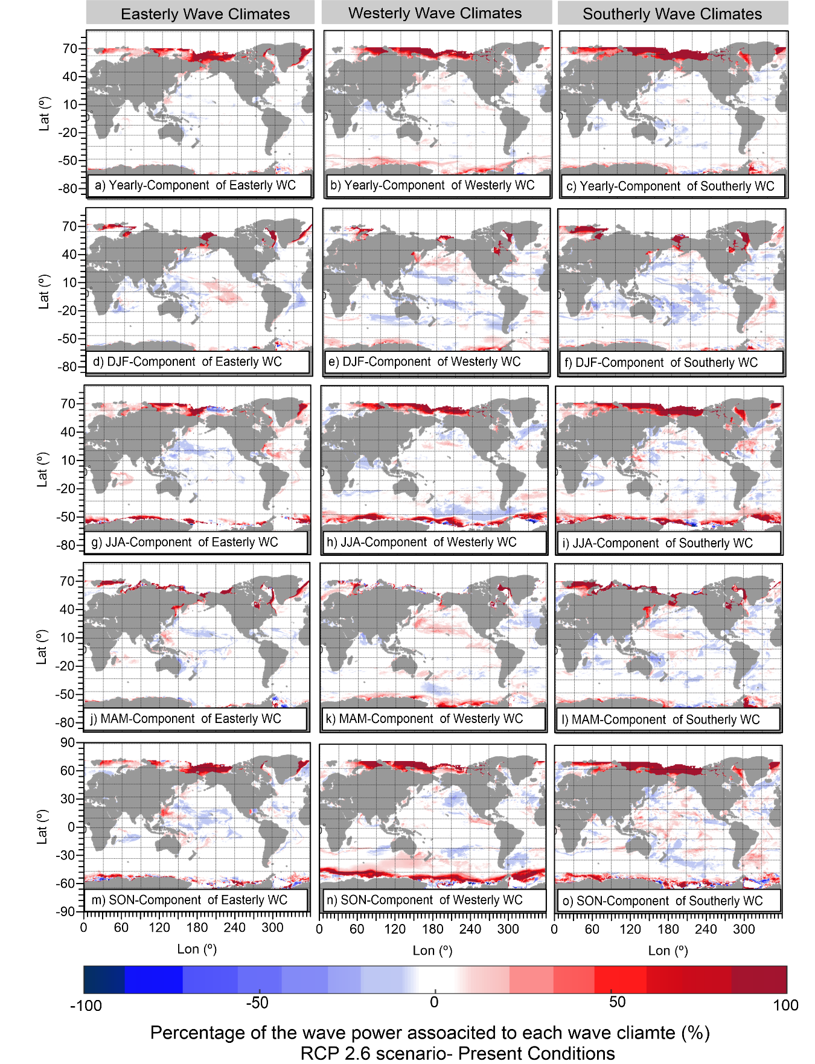
Figure SI 14 Percentage of wave power difference between RCP2.6 and present conditions associated to each wave climate: easterly (a, d, g, j, m), westerly(b, e, h, k, n), and southerly (c, i, l, o) yearly (a, b, c) DJF (d, e, f), JJA(g, h, i), MAM (j, k, l), and SON (m, n, o).
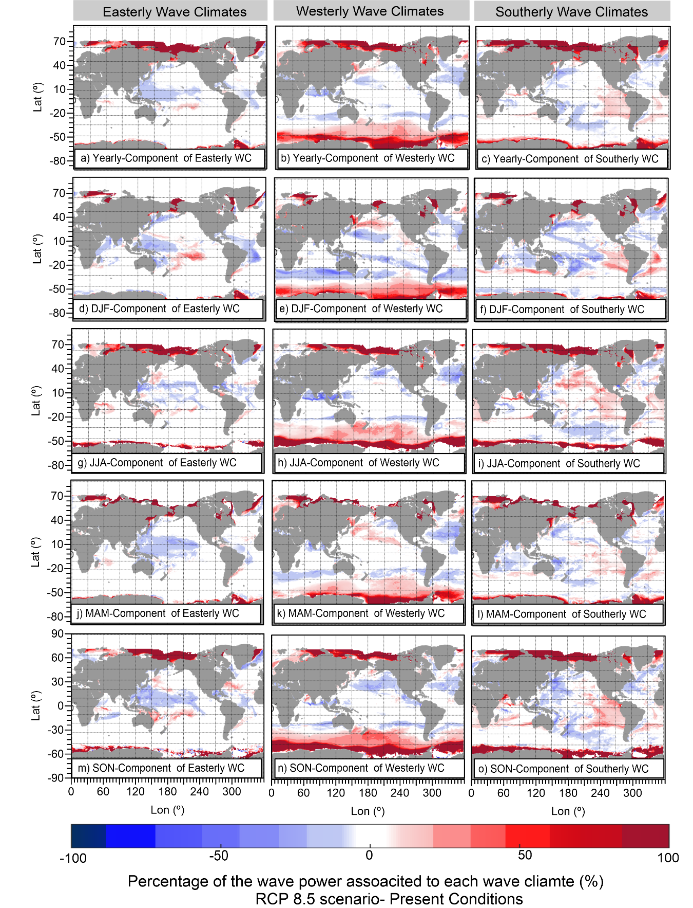
Figure SI 15 Percentage of wave power difference between RCP8.5 and present conditions associated to each wave climate: easterly (a, d, g, j, m), westerly(b, e, h, k, n), and southerly (c, i, l, o), yearly (a, b, c) DJF (d, e, f), JJA(g, h, i), MAM (j, k, l), and SON (m, n, o).

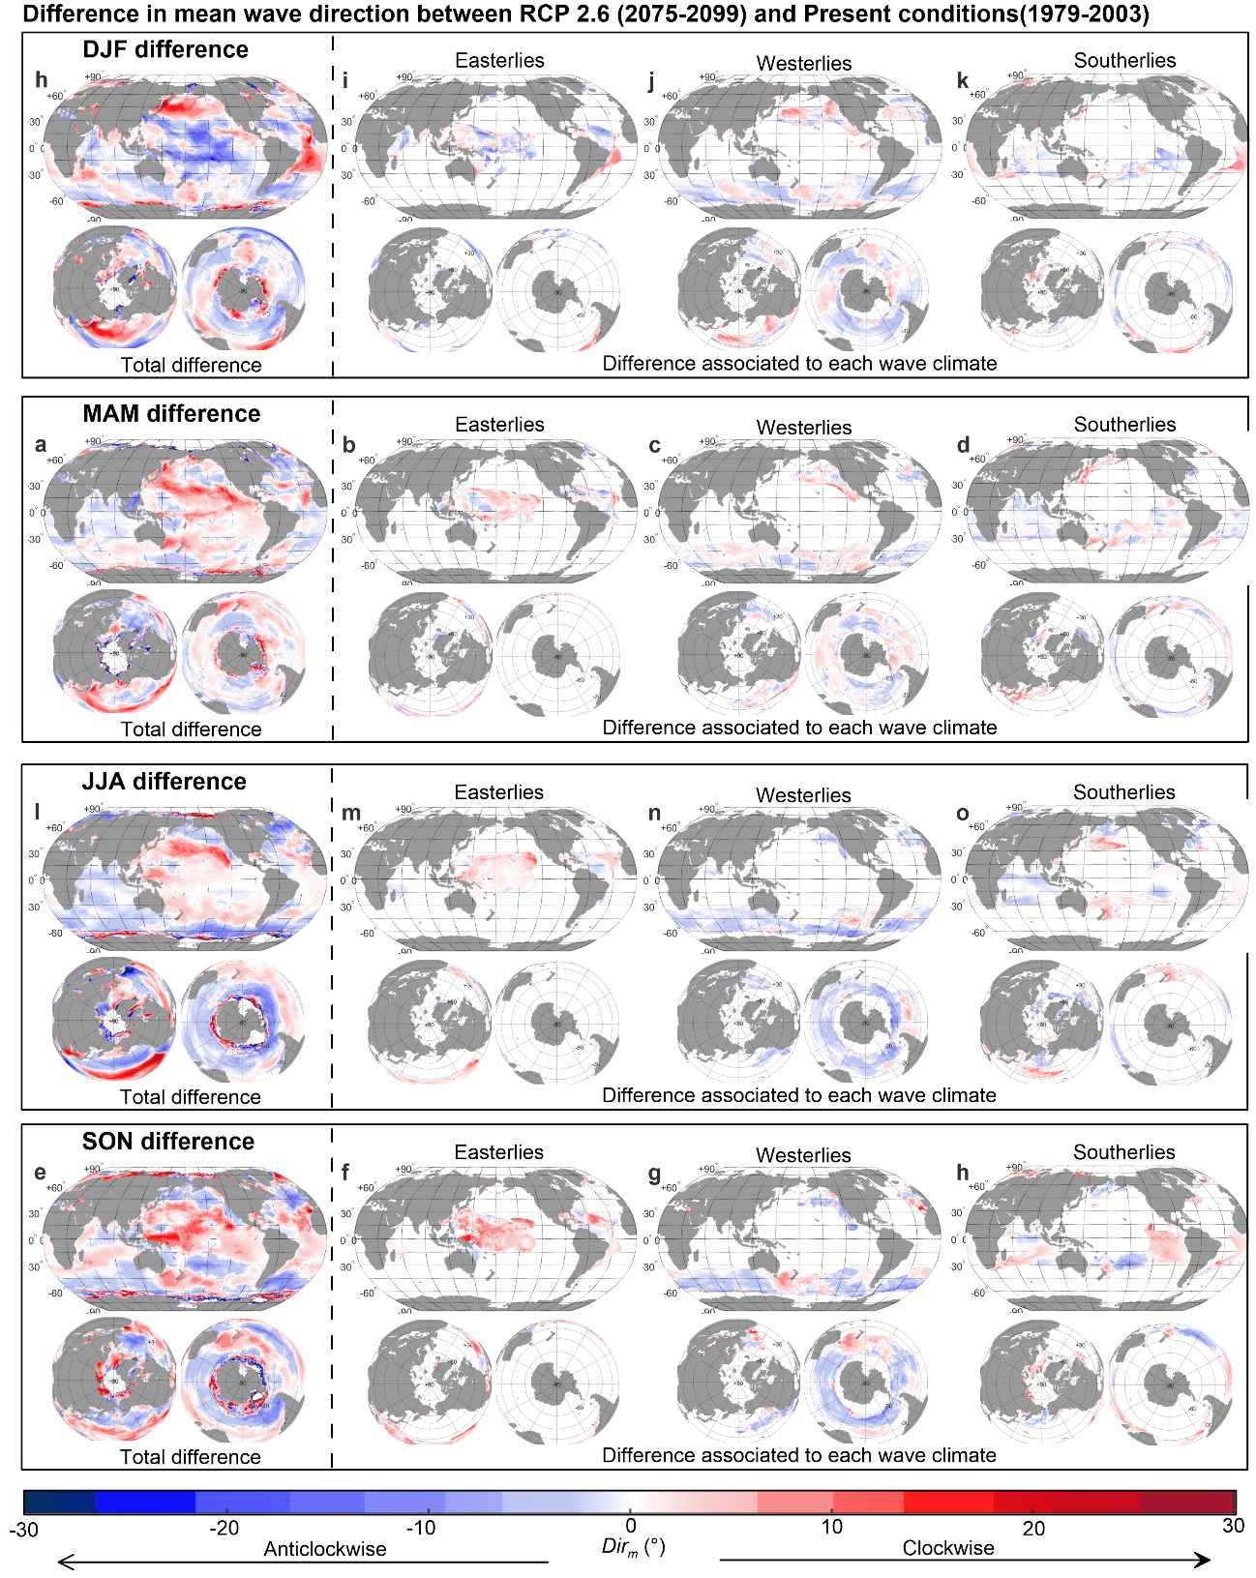
Figure SI 16 Difference between RCP2.6 and present conditions in mean wave direction for the (a, d, g, j) easterly, (b, e, h, k) westerly, and (c, f, I, l) and southerly wave climate. For (a, b, c) DJF, (d, e, f) MAM, (g, h, i) JJA, and (j, k, l) SONs.
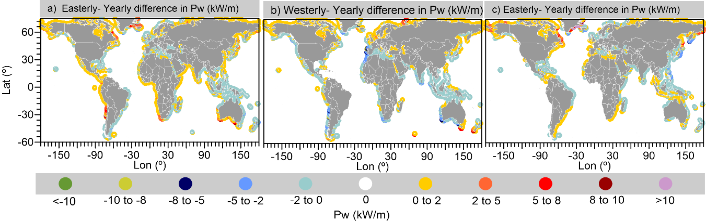
Figure SI 17 Wave power difference between RCP 8.5 scenario and historical conditions for a) Southerly, b ) Westerly, and C) Easterly wave climates.

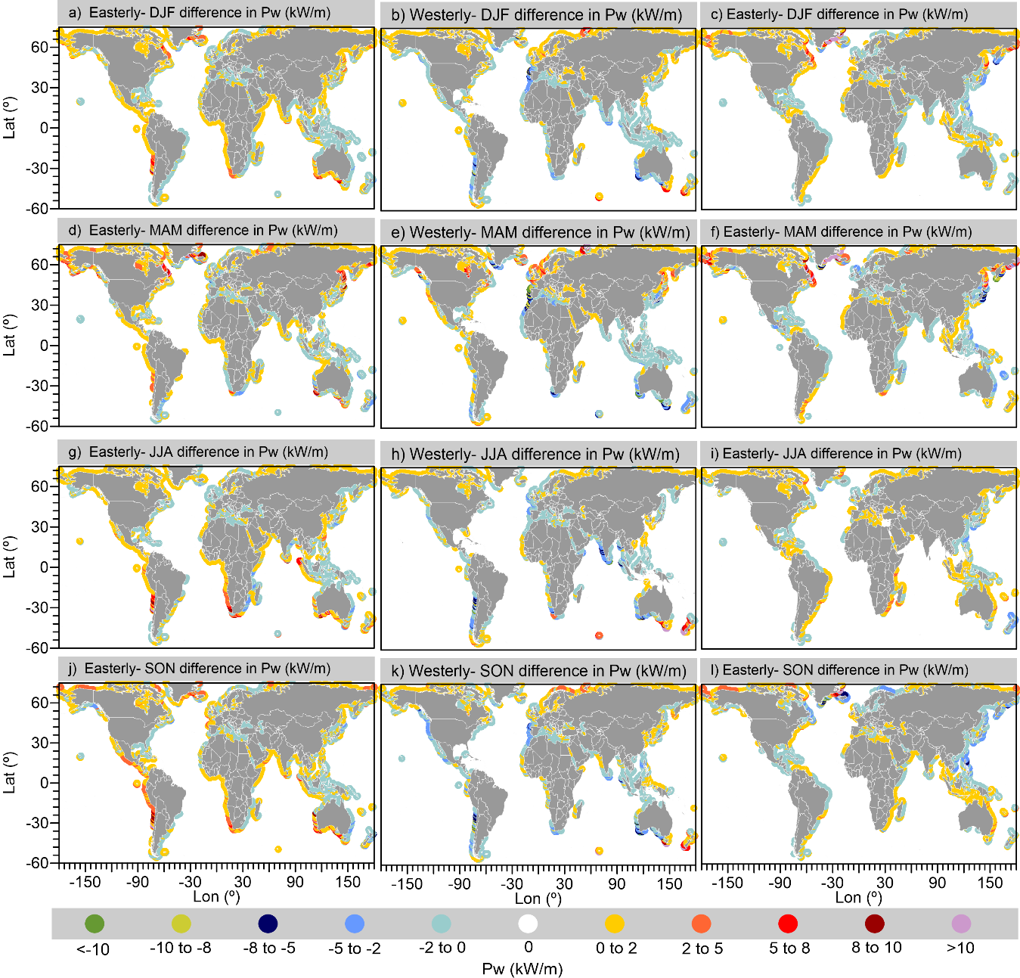
Figure SI 18 Wave power difference between RCP 8.5 scenario and historical conditions in DJF, MAM, JJA, and SON.

The percentage of ice was calculated as the total number of months, minus the number of months with wind wave $n_{W}$data, divided by the total number of months.
$$C_{ice}(\%)=100∙\frac{n_{T}-n_{W}}{n_{T}}$$ |  | ( 6 )
Where:
$C_{ice}(\%)$= | Presence of ice cover [%]
$n_{T}$= | Total number of months [months]
$n_{W}$= | Months with wave data [months]

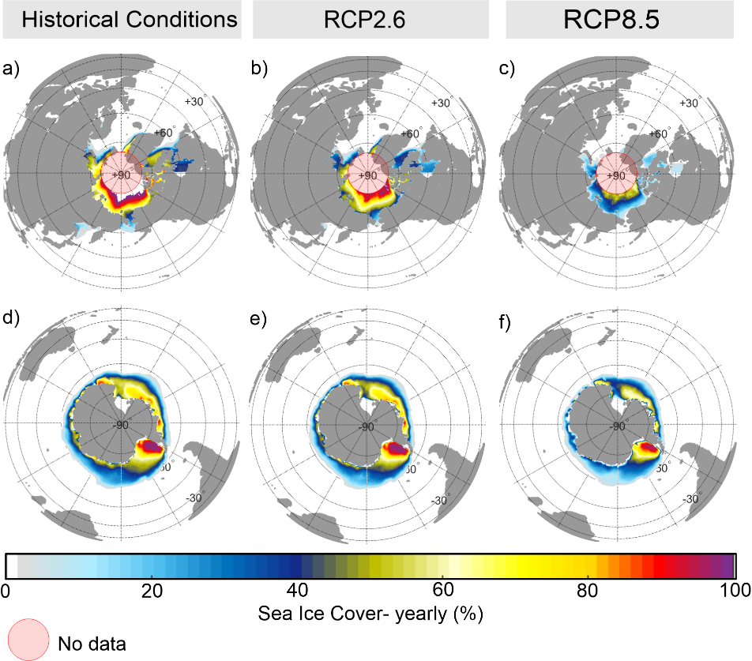
Figure SI 19 Yearly percentage of Ice Cover for (a, b) Present (1979-2003), (b, e) RCP2.6 (2075-2099), and (c, f) RCP8.5 (2075-2099) scenarios.

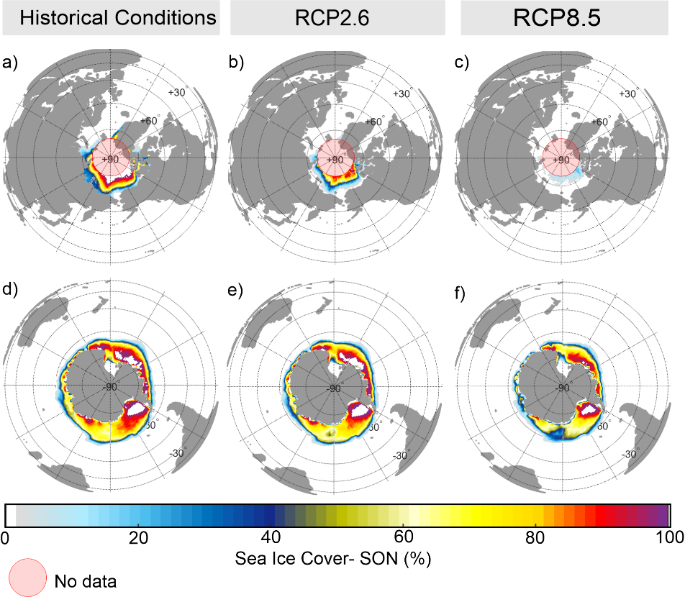
Figure SI 20 SON percentage of Ice Cover for (a, b) Present (1979-2003), (b, e) RCP2.6 (2075-2099), and (c, f) RCP8.5 (2075-2099) scenarios.
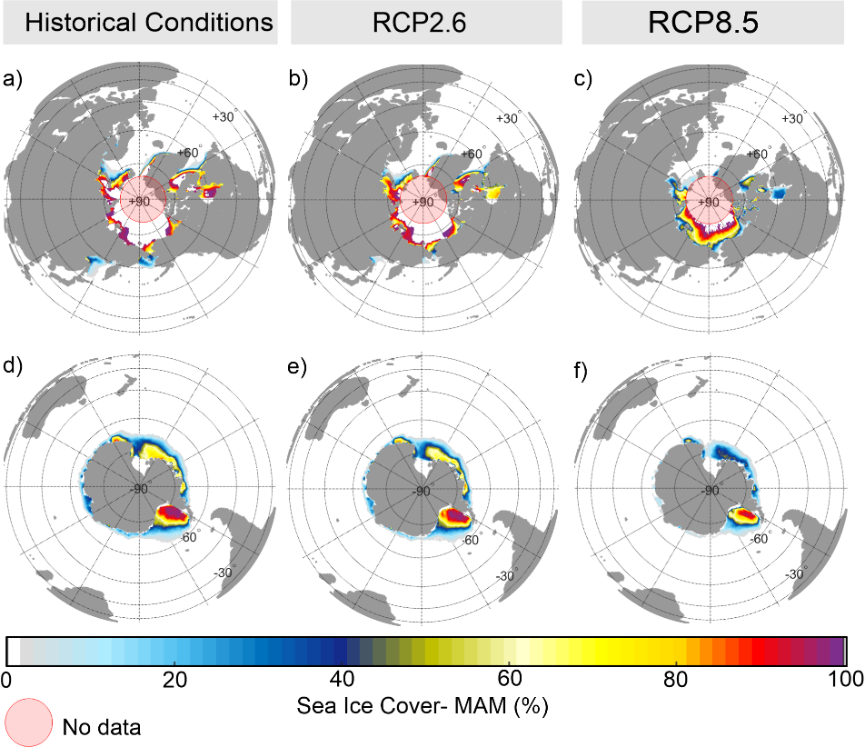
Figure SI 21 MAM percentage of Ice Cover for (a, b) Present (1979-2003), (b, e) RCP2.6 (2075-2099), and (c, f) RCP8.5 (2075-2099) scenarios.

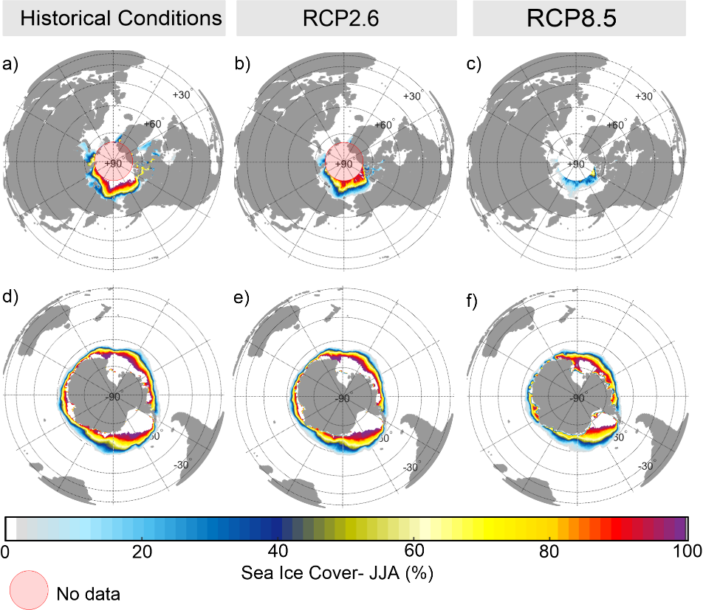
Figure SI 22 JJA percentage of Ice Cover for (a, b) Present (1979-2003), (b, e) RCP2.6 (2075-2099), and (c, f) RCP8.5 (2075-2099) scenarios.
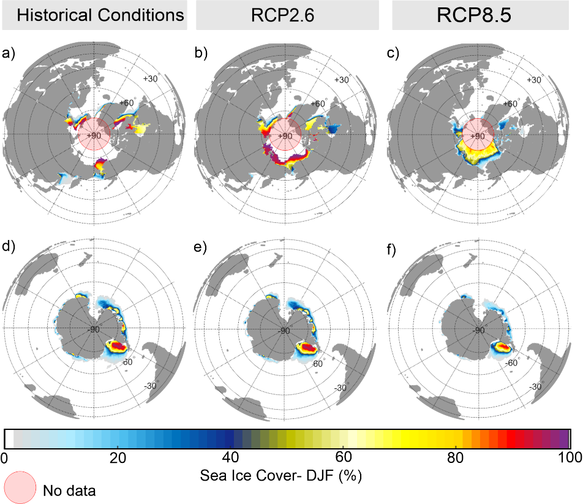
Figure SI 23 DJF percentage of Ice Cover for (a, b) Present (1979-2003), (b, e) RCP2.6 (2075-2099), and (c, f) RCP8.5 (2075-2099) scenarios.

