Supplementary Material S1: Spatial distribution of covariates and 1km-sites segmented from flight paths.
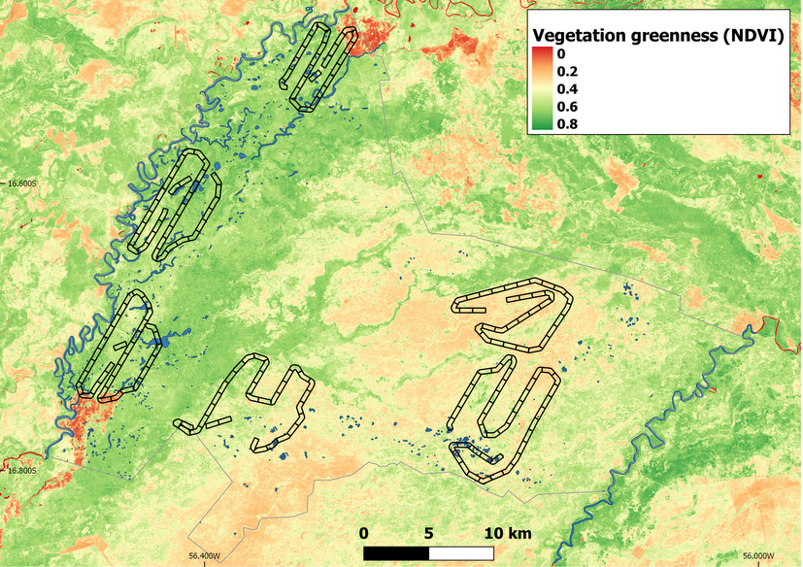
Fig. S1.1. Spatial distribution of vegetation greenness (from Normalised Difference Vegetation Index) for the dry season (2017) in Sesc Pantanal Reserve (gray contour) as a proxy for quality forage for marsh deer. The NDVI was extracted from images of the Sentinel-2 satellite (10 m pixel resolution).

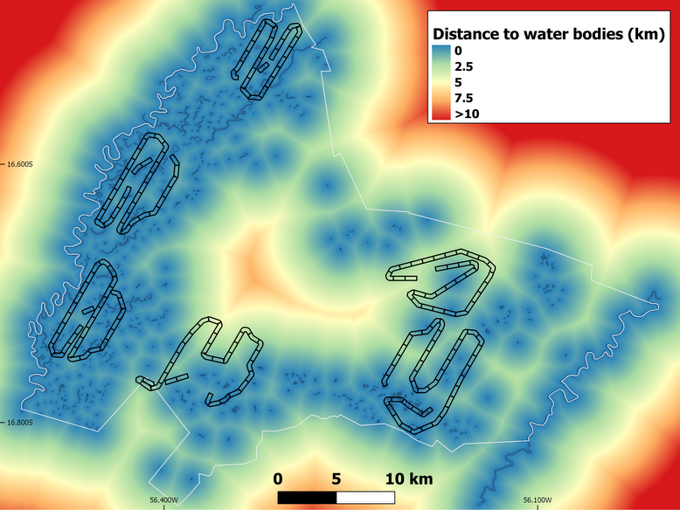
Fig. S1.2. Distance to water bodies in the dry season (2017) of the Sesc Pantanal Reserve (white contour). The water bodies were extracted from images of the Sentinel-2 satellite (10 m pixel resolution) and the distance to the nearest water body was calculated for each pixel.

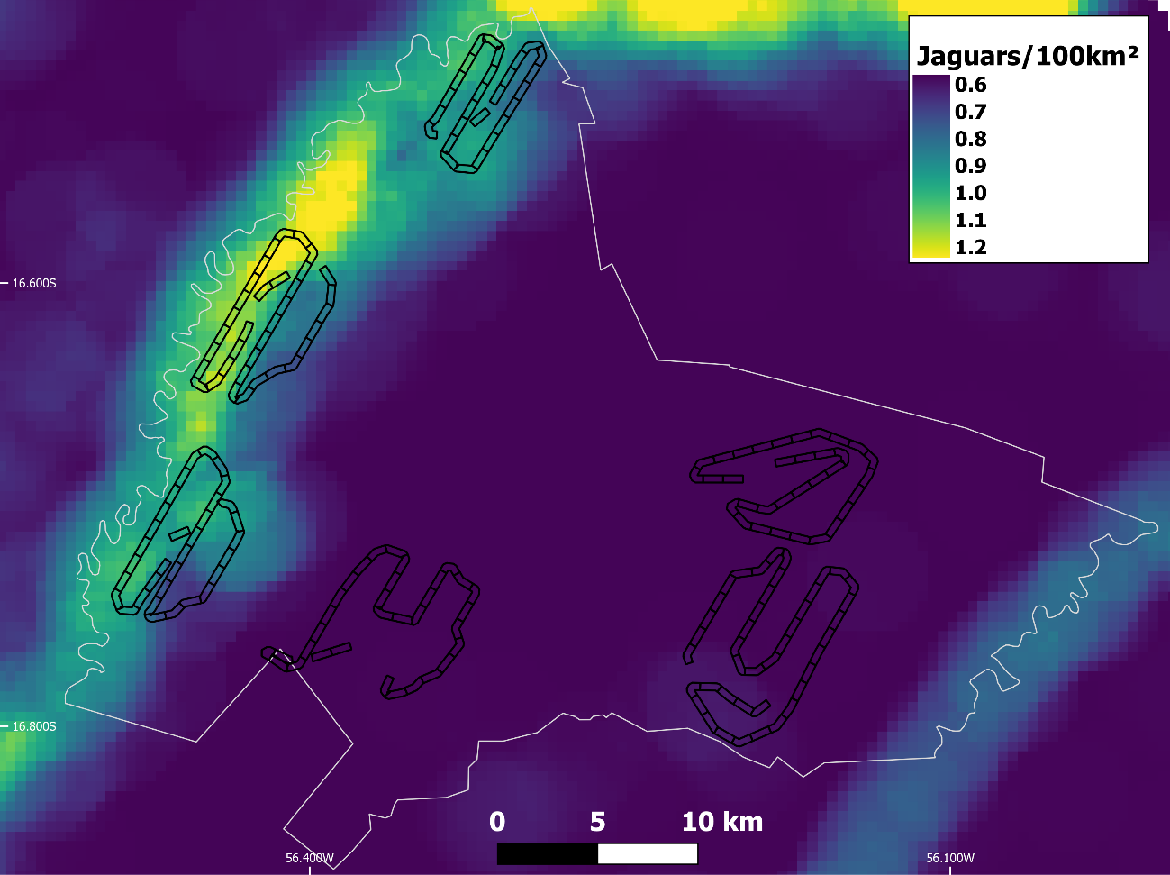
Fig. S1.3. Density map of jaguars (Panthera onca) for the dry season (2016) in the Sesc Pantanal Reserve (white contour). Jaguar density was estimated using spatial captures of individuals from 355 camera trap stations in 2010-2012 that were fitted with closed population spatially explicit capture recapture models (SECR). The AICc best-ranked model presented the intensity of activity centers positively related to water amount in a 3000m-radius buffer. Then, we predicted this density map of jaguars to 2016, using the class water from a land cover map produced under a supervised classification of Landsat scenes (30 m spatial resolution).

