Synthesis and biological evaluation of novel pyrazinoic acid derivatives as anticancer agents
Shiva akhlaghi.^{1,2} Azar Mostoufi.² Hadi kalantar.¹ Masood Fereidoonnezhad.^{1, 2} ✉
¹Toxicology Research Center, Medical Basic Sciences Research Institute, Ahvaz Jundishapur University of Medical Sciences, Ahvaz, Iran.
²Department of Medicinal Chemistry, School of Pharmacy, Ahvaz Jundishapur University of Medical Sciences, Ahvaz, Iran.
✉Corresponding author. Tel.: +98 61 33112278; Fax: +98 61 33738381; Email: Fereidoonnezhad-m@ajums.ac.ir

2-(cyclohexylamino)-1-(2-methoxyphenyl)-2-oxoethyl pyrazine-2-carboxylate (P1)
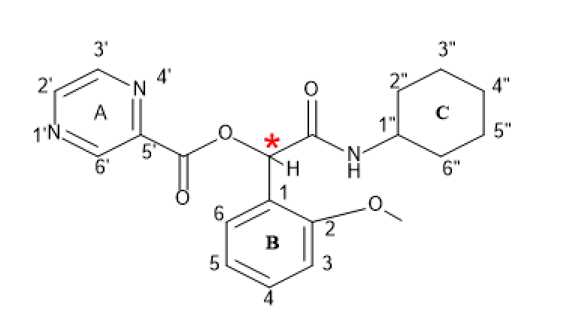

P1

Yield: 77%, mp: 134-136°C, white solid. IR (KBr disk): (3272.91 (NH amid group)), (3100.26-3029.84 (CH aromatic)), (2930.78-2854.42 (CH aliphatic)), (1727.87 (C=O ester)), (1655.64 (C=O amid)), (1612.47-1458.08 (C=C aromatic)), (1274.32 (C-O)) cm⁻¹. ¹H NMR (499 MHz, DMSO-d₆) δ (9.23 (s, 1H)H^{6’}), (8.86 (d, J = 42.6 Hz, 3H)H^{3’},H^{2’}), (8.07 (d, J = 7.6 Hz, 1H) NH), (7.39 (t, J = 7.2 Hz, 1H) H⁶, (7.17 – 6.85 (m, 3H)(H³,H^{4,},H5), (6.46 (s, 1H)CH group, (3.81 (s, 3H)H(ome)^{[O]}), (3.60 (s, 1H) H^{1”}), (1.85 – 1.41 (m, 6H)H^{2”},H^{6”},H^{4”}), (1.18 (q, J = 52.4, 18.1, 11.3, 10.6 Hz, 3H)H^{3”}H^{5”}).¹³C NMR (126 MHz, dmso) δ 165.98, 162.79, 157.16, 148.15, 145.56, 144.74, 142.56, 130.31, 128.40, 123.24, 120.26, 111.25, 70.90, 55.51, 47.70, 39.02, 31.89, 24.96, 24.34.

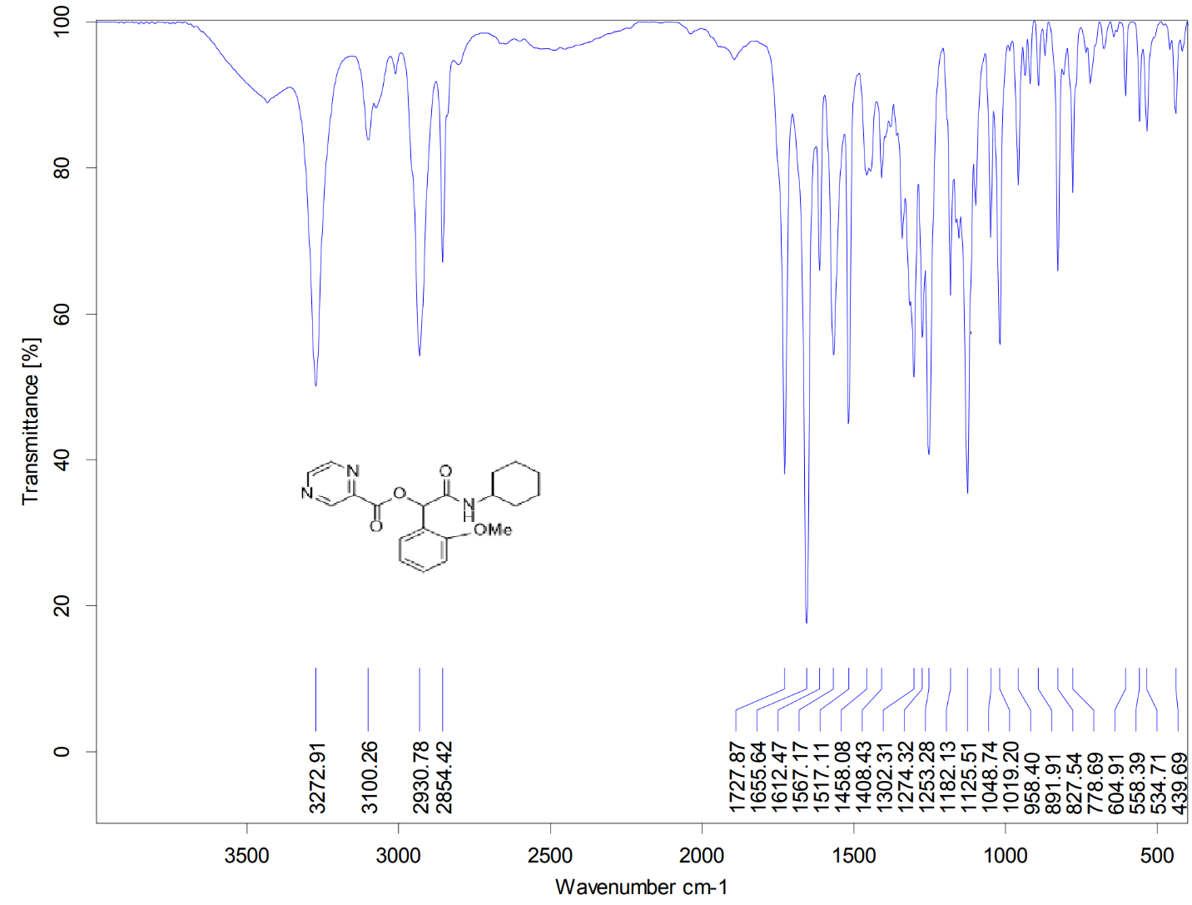
Figure S1. IR spectrum of P1
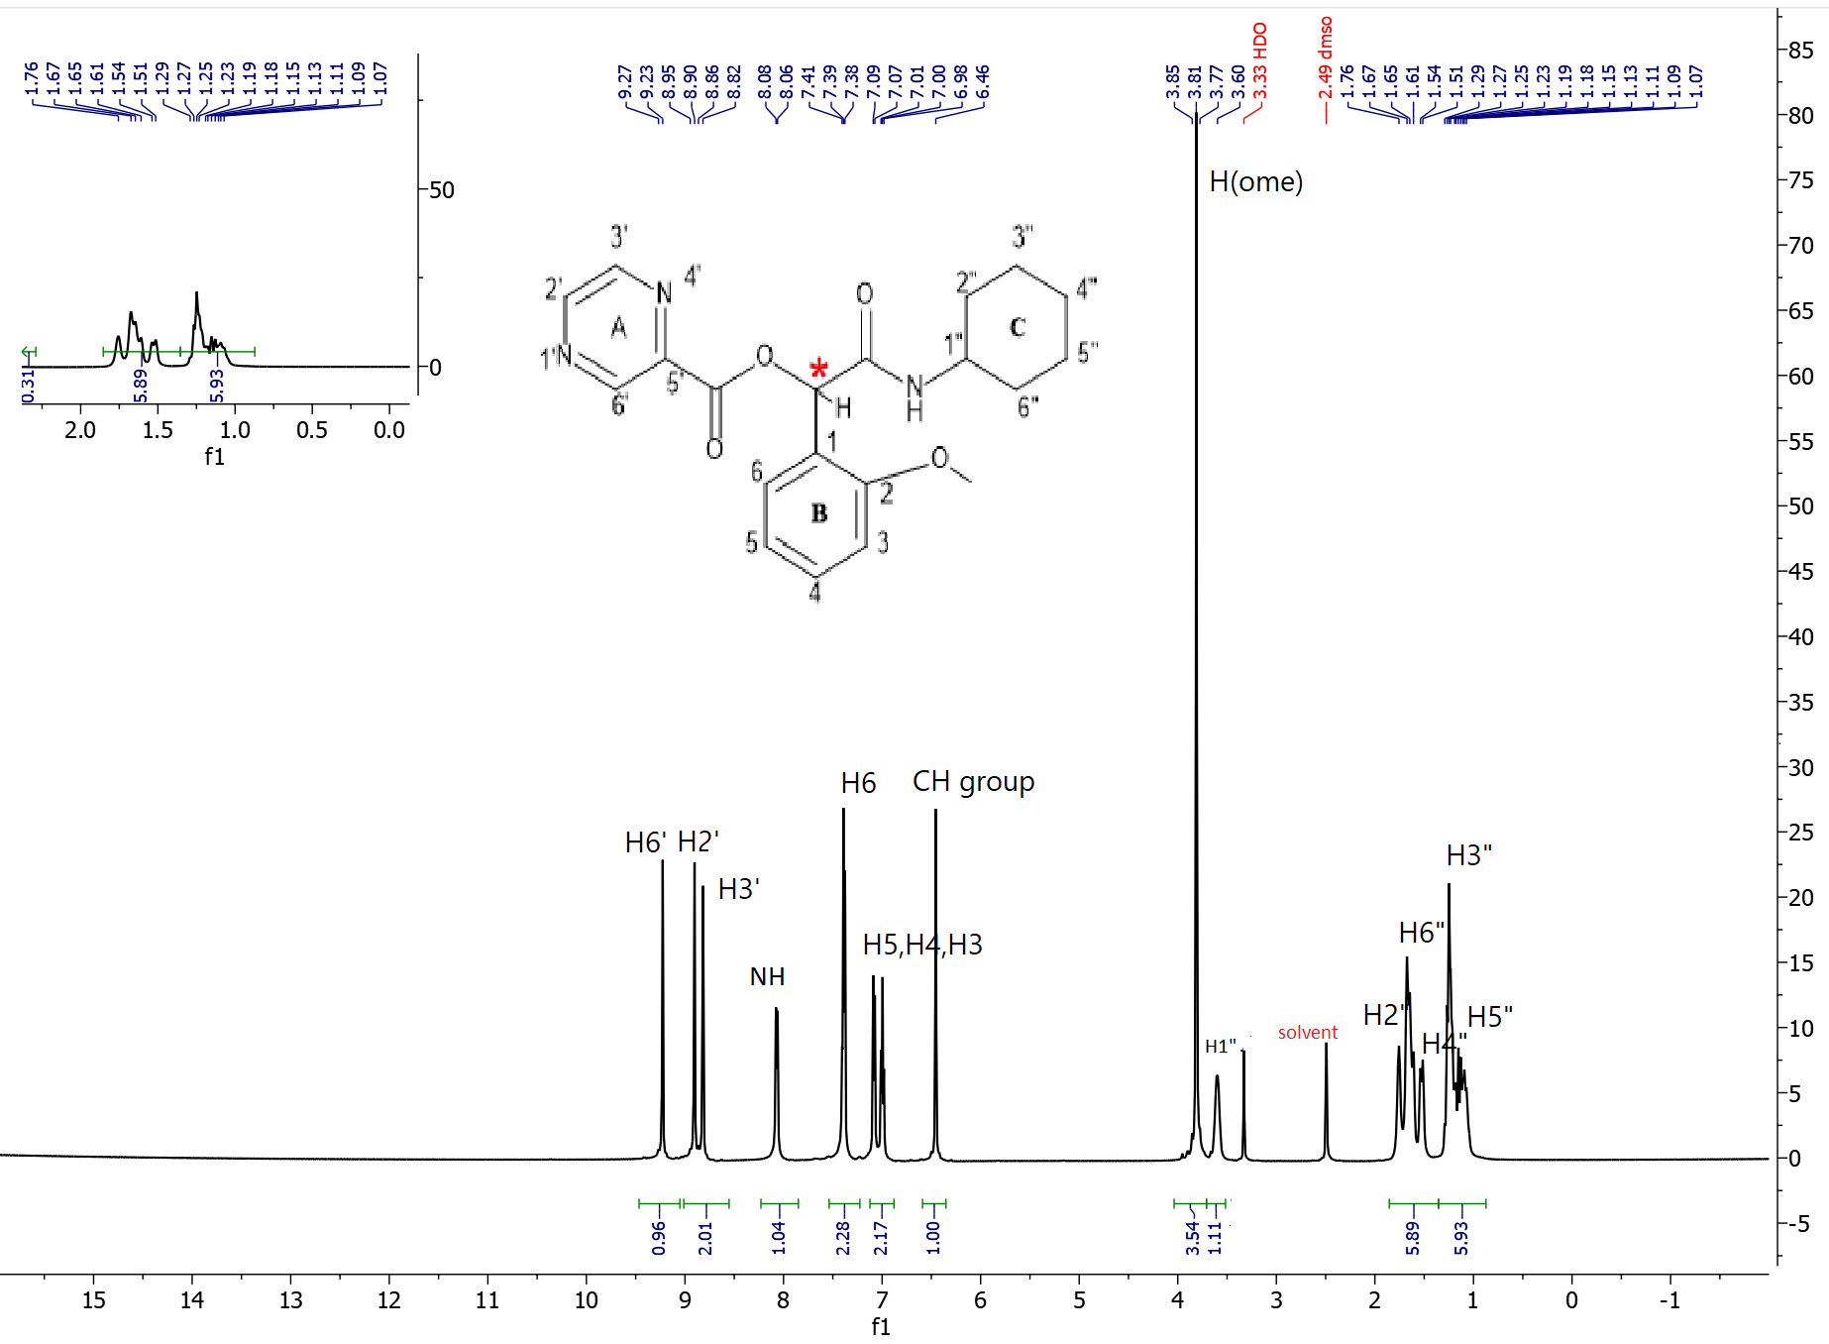
Figure S2. ¹H-NMR spectrum of P1

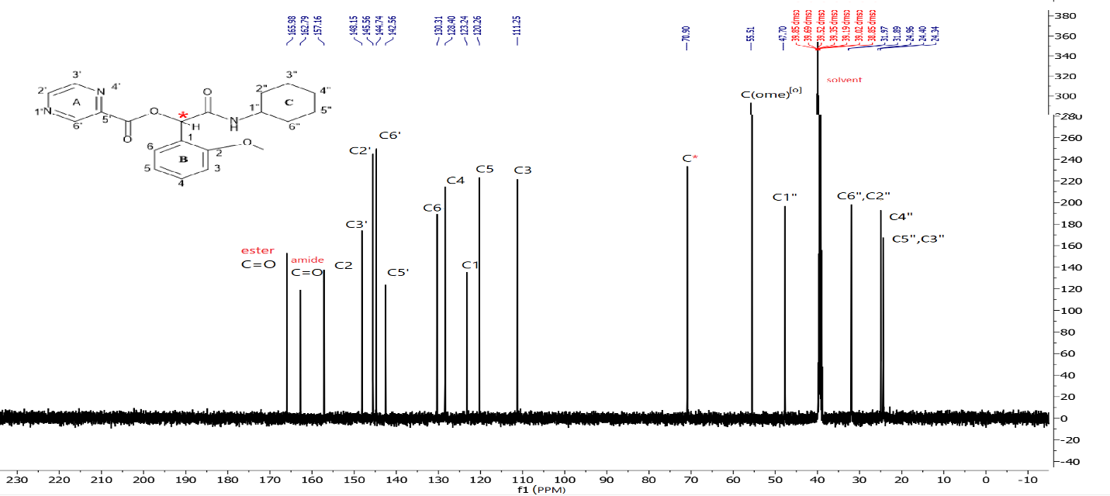
Figure S3. ¹³C-NMR spectrum of P1

2-(cyclohexylamino)-1-(3-methoxyphenyl)-2-oxoethyl pyrazine-2-carboxylate(P2)
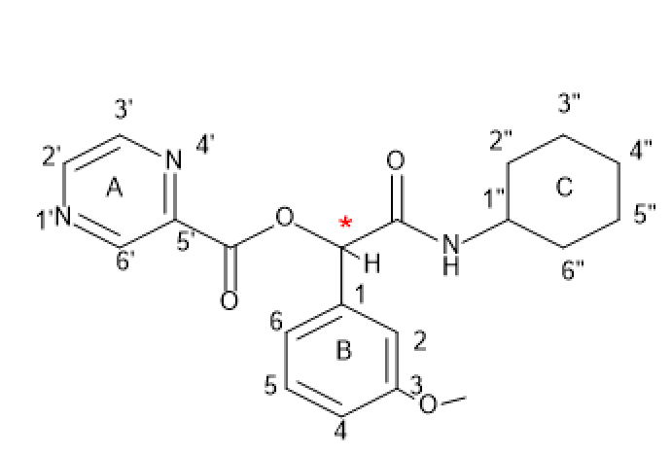
P2
Yield: 80%, mp: 173-175°C, white solid. IR (KBr disk): (3272.91 (NH amid group)), (3100.26-3029.84 (CH aromatic)), (2930.78-2854.42 (CH aliphatic)), (1727.87 (C=O ester)), (1655.64 (C=O amid)), (1612.47-1458.08 (C=C aromatic)), (1274.32 (C-O)) cm⁻¹. ¹H NMR (499 MHz, DMSO-d₆) δ (9.30 (s, 1H) H^{6’} , (8.90 (dd, J = 35.3, 1.7 Hz, 3H)H^{3’,2’}), (8.27 (d, J = 7.6 Hz, 1H) NH), (7.35 (t, J = 8.0 Hz, 2H) H⁵), (7.17 (d, J = 7.4 Hz, 2H) H²), (7.04 – 6.88 (m, 2H)H^{4,6}), (6.09 (s, 1H) CH*), (3.77 (s, 1H) H^{1”}), (3.52 (s, 1H) H^{1”}), (1.85 – 1.41 (m,5H) H^{2”,4”,6”}), (1.35 – 0.98 (m, 4H) H^{5”,3”}). ¹³C NMR (126 MHz, dmso) δ 166.74, 163.22, 159.65, 148.85, 146.29, 145.45, 143.14, 137.39, 130.09, 119.95, 114.39, 113.70, 76.65, 55.62, 48.23, 40.50, 40.34, 40.17, 40.00, 39.84, 39.67, 39.50, 32.68, 32.50, 25.59, 24.93, 24.84. Elemental analysis calcd (%) for C20H23N3O4 (369.17):C,65.03; H,6.28; N,11.37;found: C,65.16;H,6.41;N,11.50
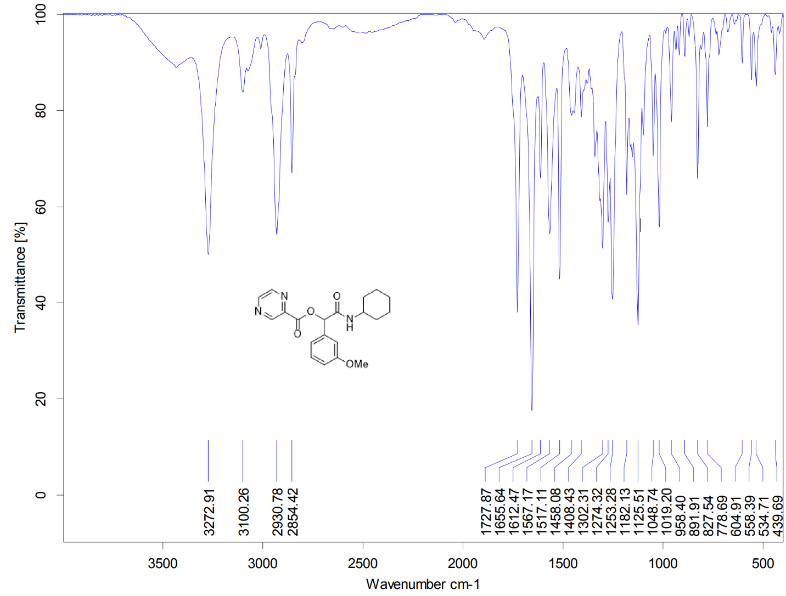
Figure S4. IR spectrum of P2

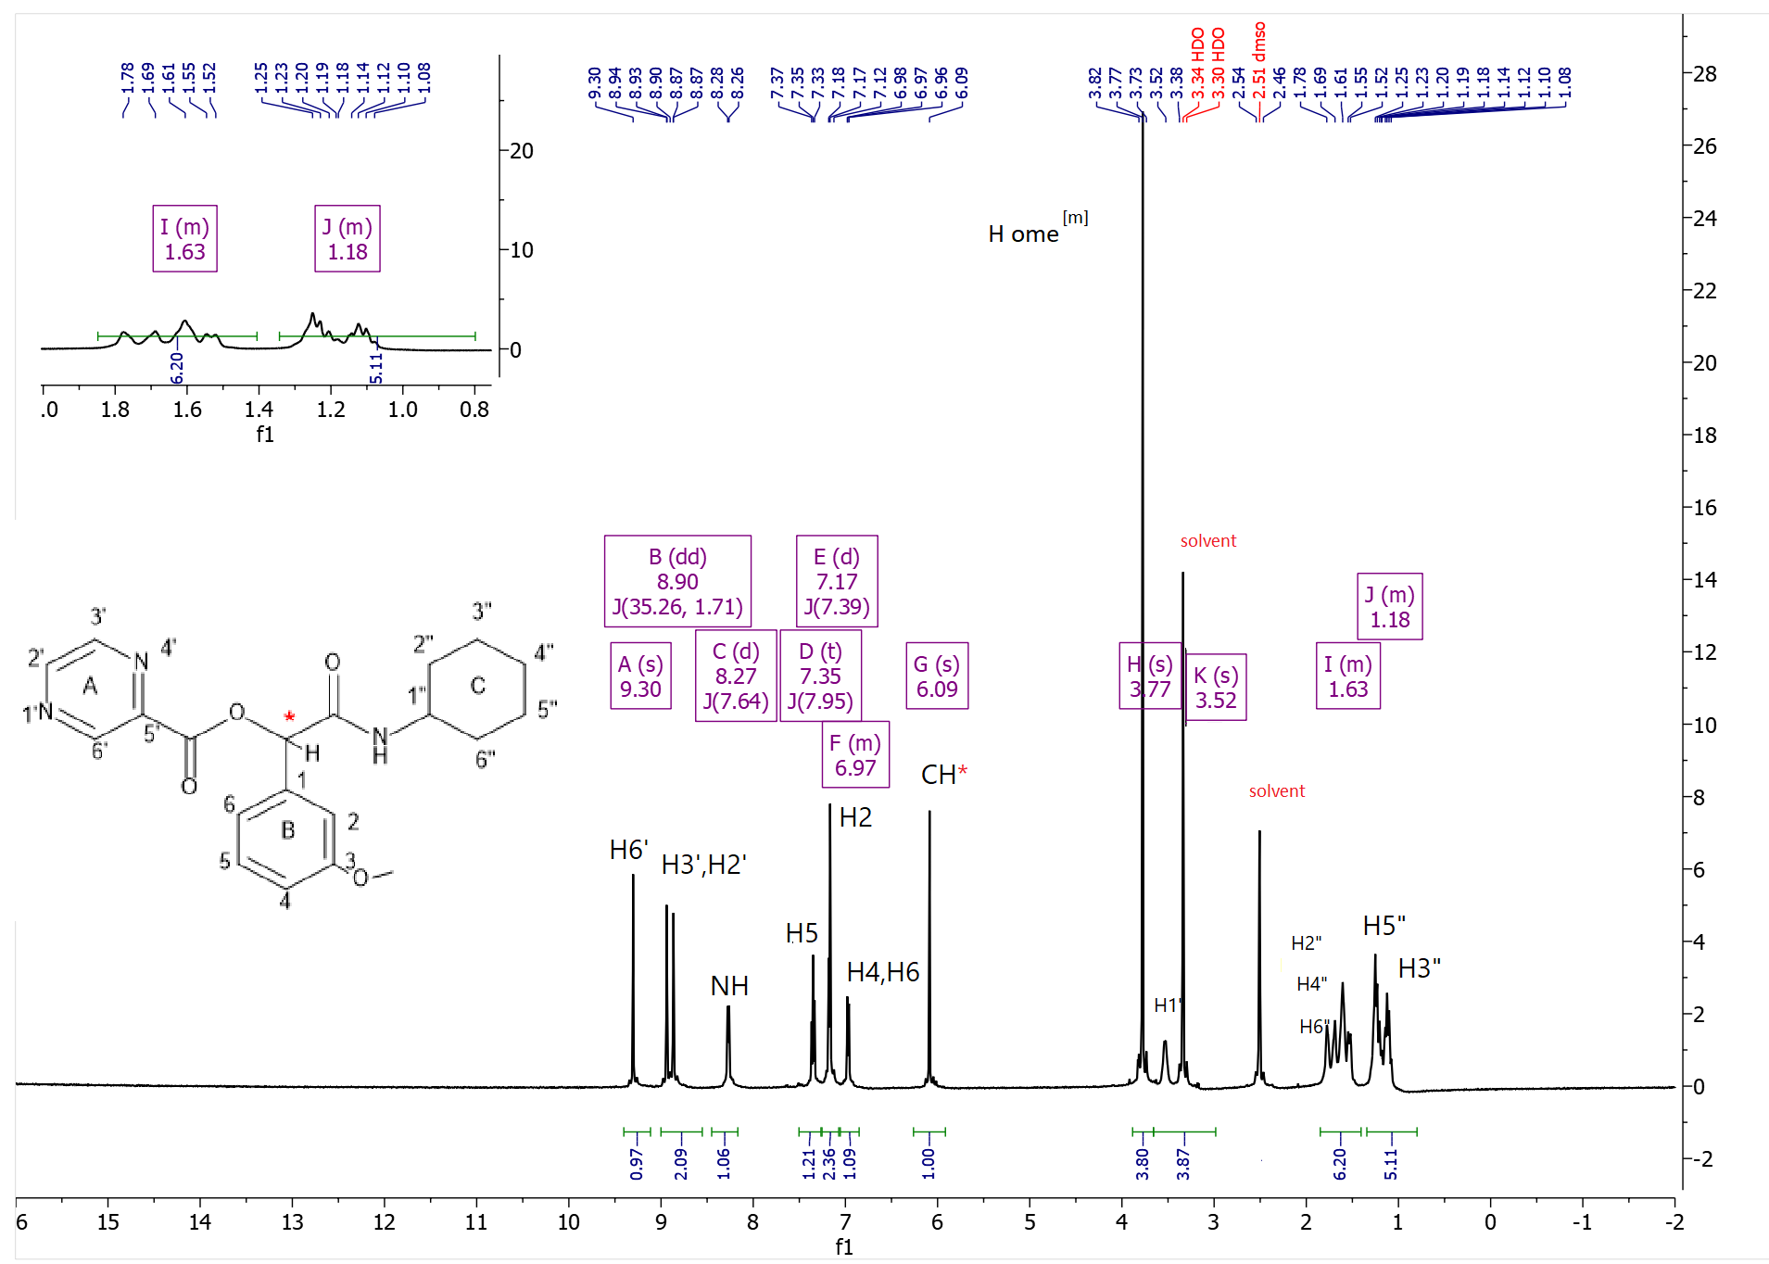
Figure S5. ¹H-NMR spectrum of P2
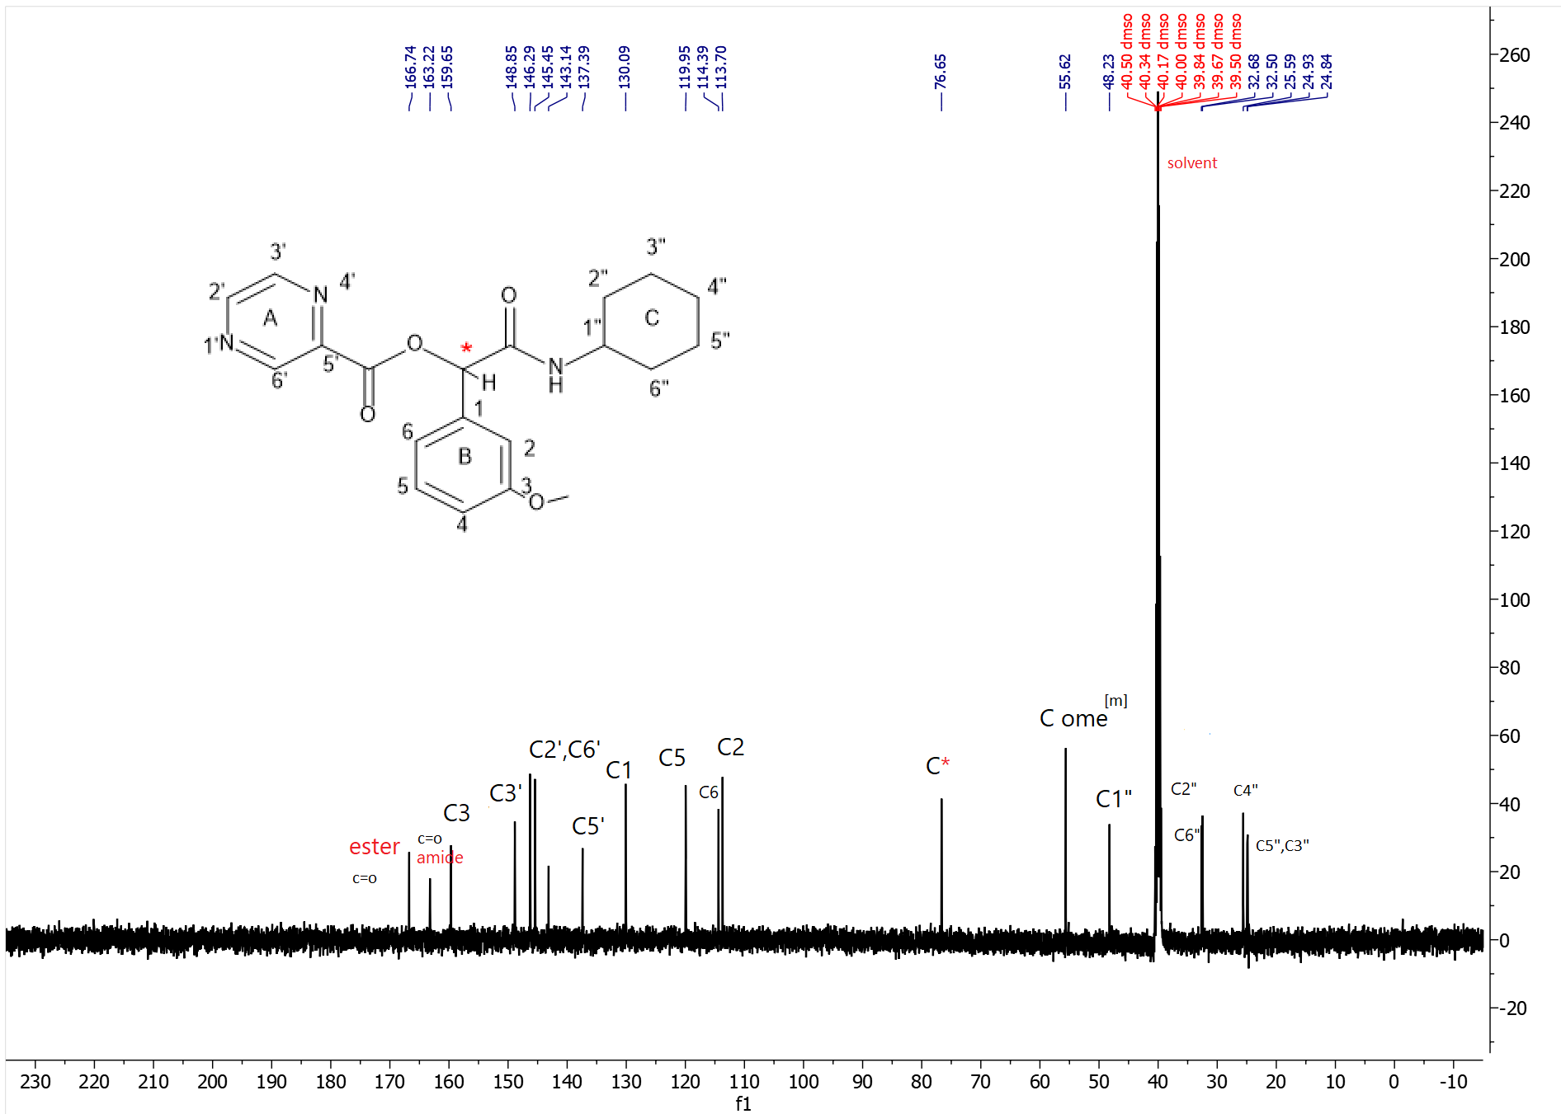
Figure S6. ¹³C-NMR spectrum of P2
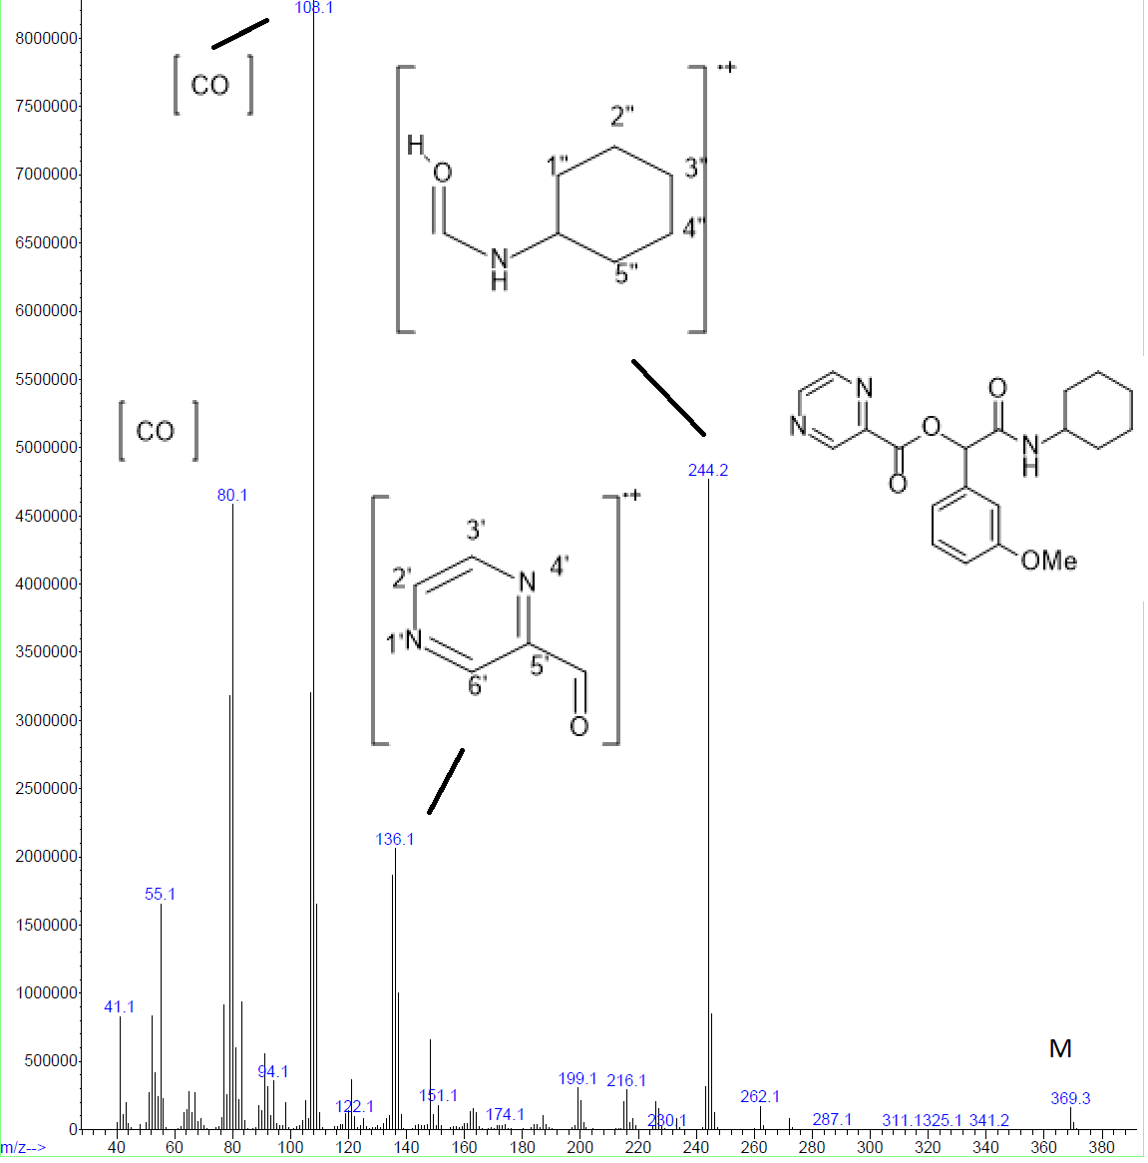
Figure S7. Mass spectrum of P2

2-(cyclohexylamino)-1-(4-methoxyphenyl)-2-oxoethyl pyrazine-2-carboxylate(P3)
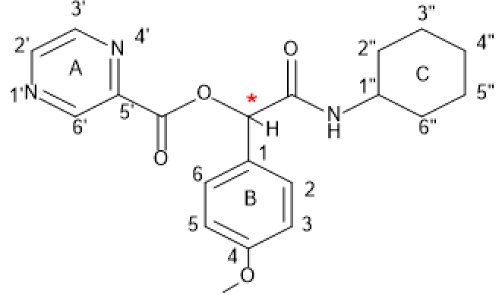
P3
Yield: 83%, mp: 182-184°C, white solid. IR (KBr disk): (3252.47 (NH amid group)), (3080.85-3029.84 (CH aromatic)), (2929.16-2851.53 (CH aliphatic)), (1744.23 (C=O ester)), (1656.08 (C=O amid)), (1603.72-1463.43 (C=C aromatic)), (1261.32 (C-O)) cm⁻¹. ¹H NMR (300 MHz, DMSO-d₆) δ (9.21 (d, J = 29.2 Hz, 1H) H^{6’}), (8.98 – 8.58 (m, 4H) H³,H^{2’}), ( 8.21 (d, J = 7.4 Hz, 1H)NH) , (7.50 (d, J = 8.3 Hz, 2H)H²,H⁶) , (6.97 (d, J = 8.3 Hz, 2H) H⁵,H³) , (6.05 (s, 1H) CH* group) , (3.50 (s, 3H) H ome^{[P]}), (1.86 – 1.38 (m, 6H) H^{1”,2”,4”,6”}) , (1.36 – 0.77 (m, 3H) H^{5”,3”}. ¹³C NMR (75 MHz, DMSO) δ 166.65, 162.83, 159.57, 148.33, 145.78, 145.53, 144.95, 144.49, 142.73, 129.03, 127.47, 113.84, 76.07, 55.19, 47.71, 40.33, 40.05, 39.77, 39.49, 39.21, 38.93, 38.65, 32.23, 25.12, 24.48.

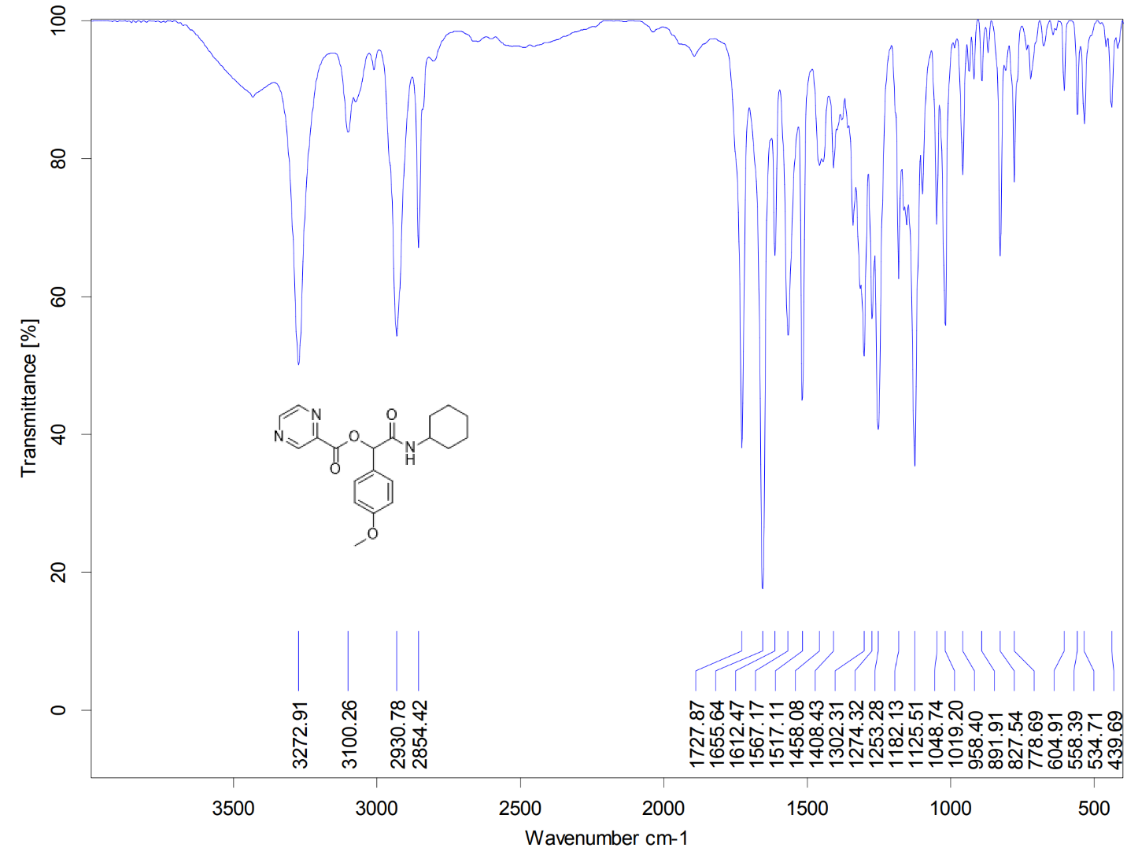
Figure S8. IR spectrum of P3
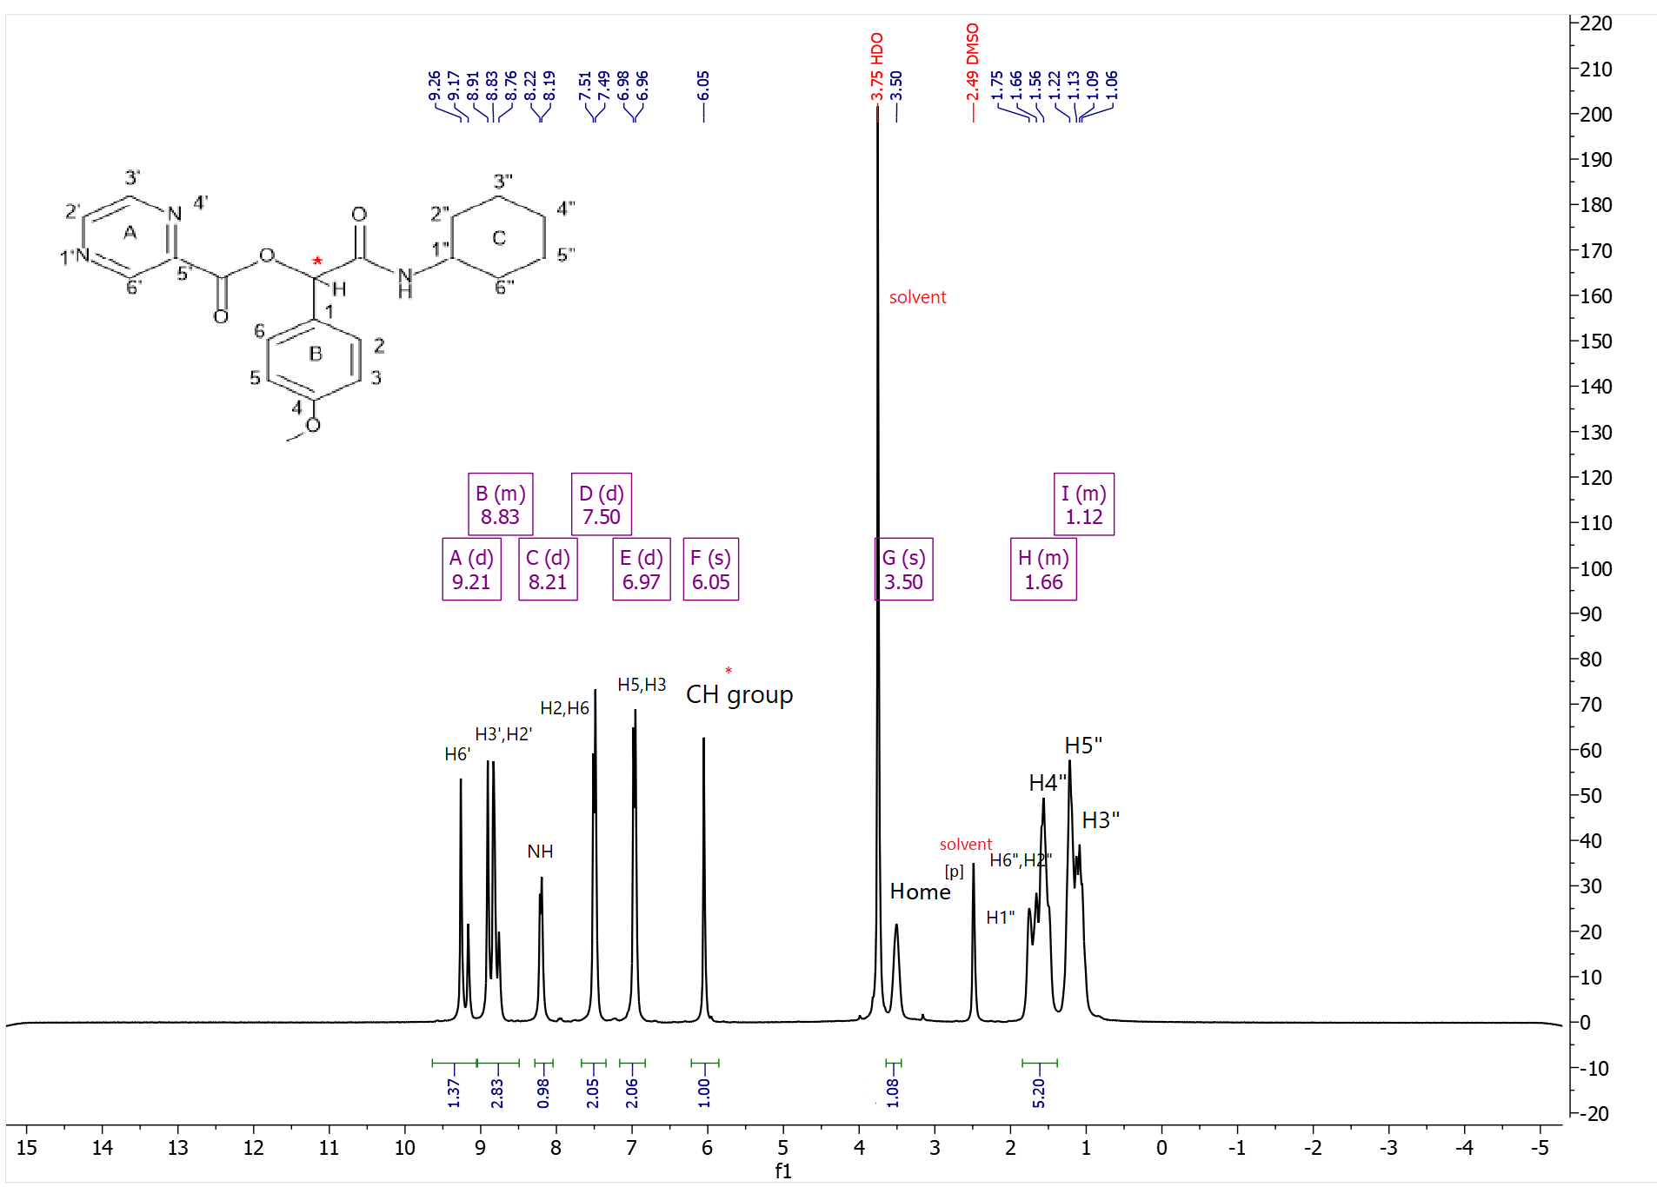
Figure S9. ¹H-NMR spectrum of P3

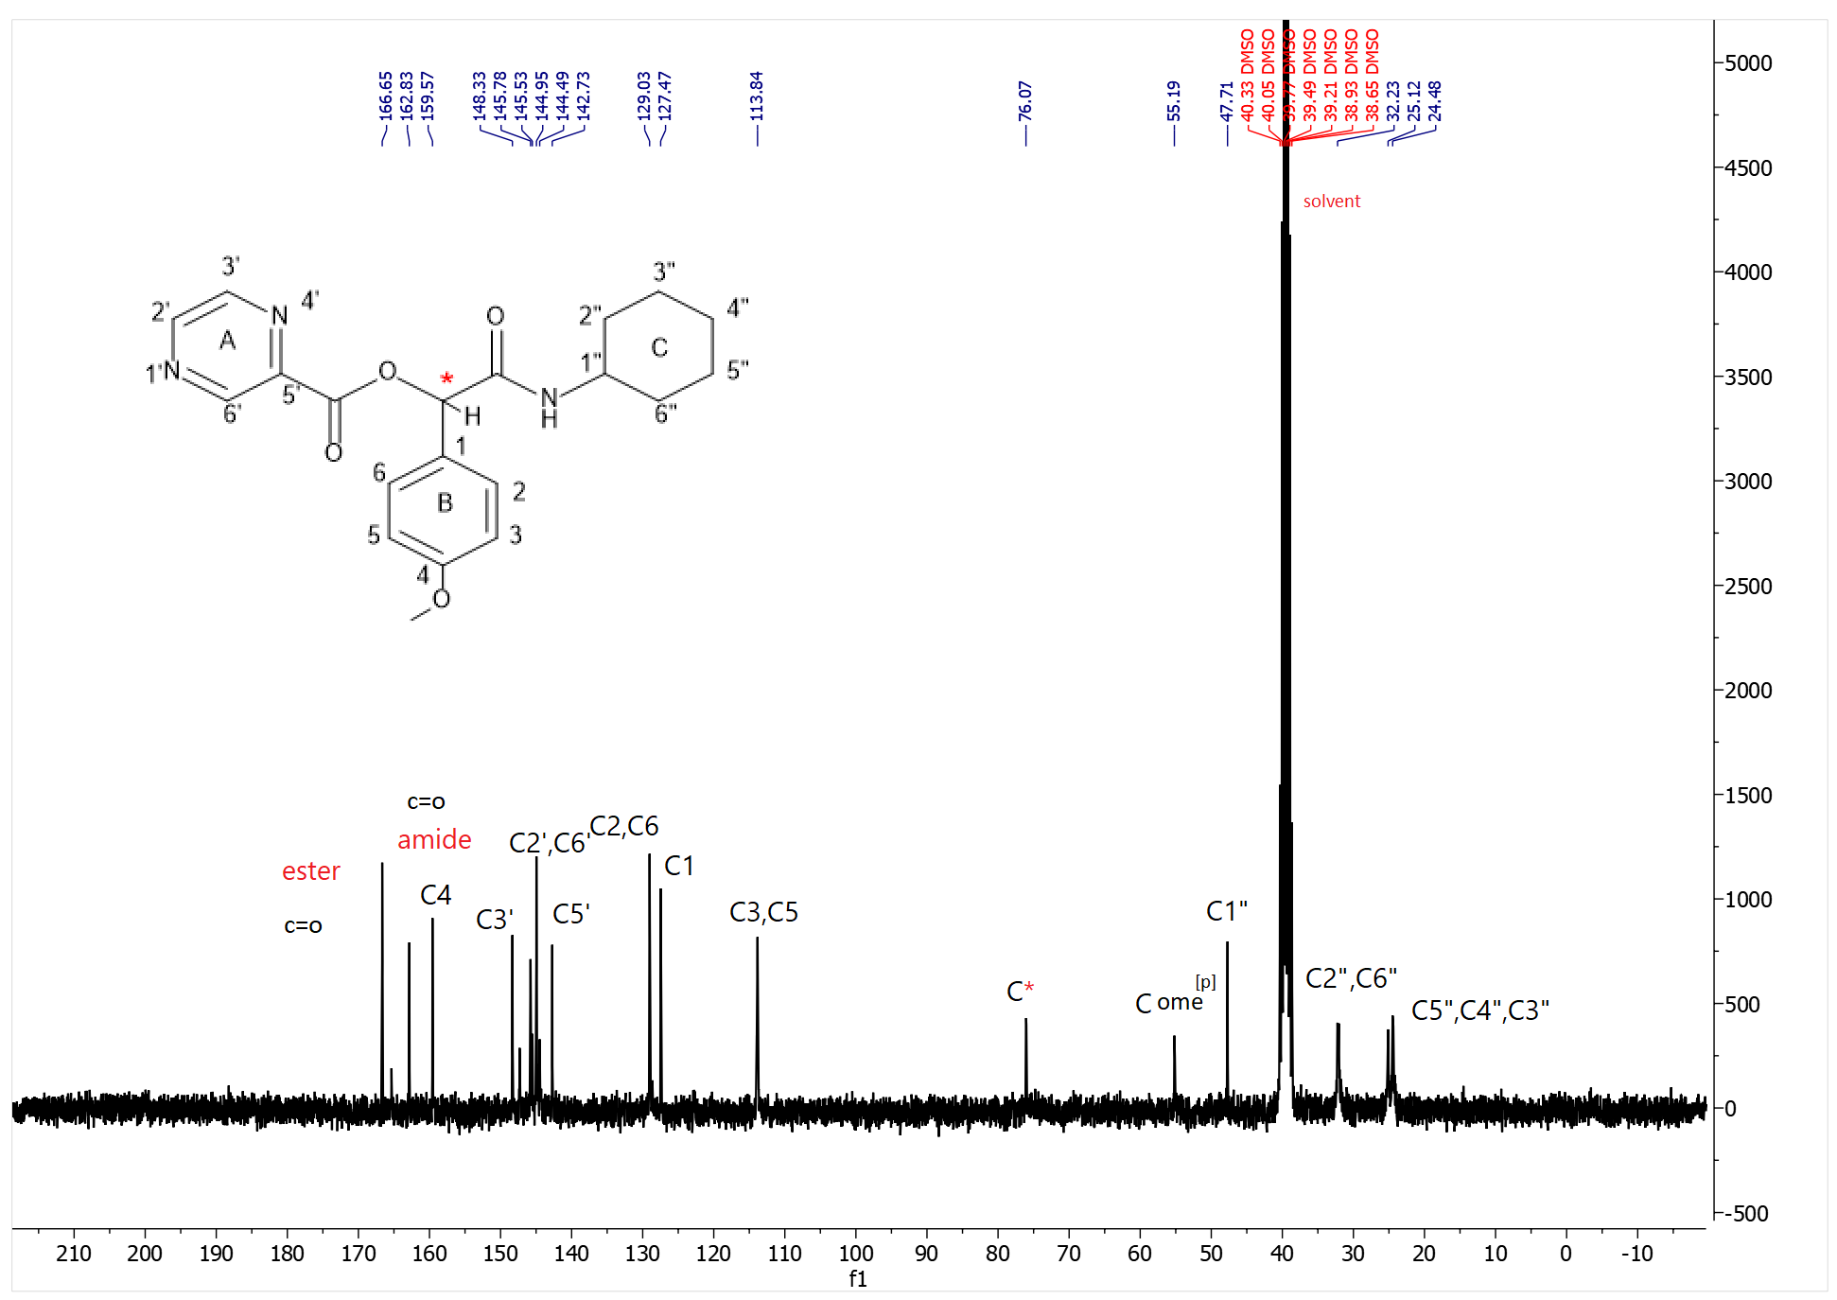
Figure S10. ¹³C-NMR spectrum of P3

2-(cyclohexylamino)-1-(3,4-dimethoxyphenyl)-2-oxoethyl pyrazine-2-carboxylate(P4)
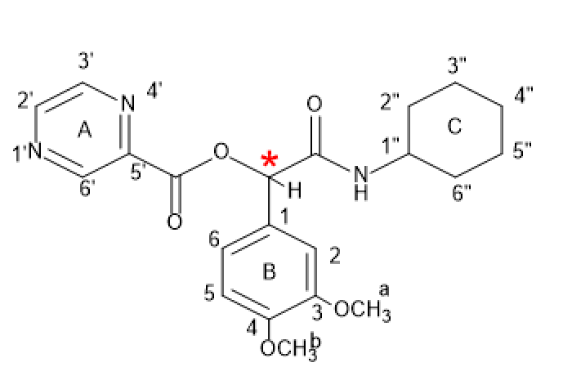
P4
Yield: 47%, mp: 192-193°C, white solid. IR (KBr disk): (3266.25 (NH amid group)), (3098.33-3029.84 (CH aromatic)), (2928.16-2852.96 (CH aliphatic)), (1746.36 (C=O ester)), (1655.67 (C=O amid)), (1593.12-1563.43 (C=C aromatic)), (1258.88 (C-O)) cm⁻¹. 1H NMR (499 MHz, DMSO-d6) δ (9.28 (s, 1H) h^{6’}, (8.88 (d, J = 36.9 Hz, 2H) H^{3’,2’}) , (8.18 (d, J = 7.7 Hz, 1H) NH), (7.26 – 7.04 (m, 3H) H^{2,5}), (6.99 (d, J = 8.2 Hz, 1H) H⁶), (6.04 (s, 1H) CH*), (3.76 (s, 6H) H ome^{[a,b]}), (3.33 (s, 1H) H^{1”}), (1.90 – 1.43 (m, 6H) H^{2”,4”,6”}, (1.33 – 0.85 (m,3H) H^{5”,3”}). ¹³C NMR (126 MHz, dmso) δ 167.01, 163.26, 149.68, 148.99, 148.77, 146.25, 145.41, 143.22, 128.14, 120.71, 112.05, 111.82, 76.75, 56.02, 55.99, 48.18, 40.49, 40.32, 40.15, 39.98, 39.82, 39.65, 39.48, 32.67, 32.52, 25.59, 24.95, 24.87. Elemental analysis calcd (%) for C₂₁H₂₅N₃O₅ (399.18):C,63.14; H,6.31; N,10.52;found: C,63.26;H,6.43;N,10.64.

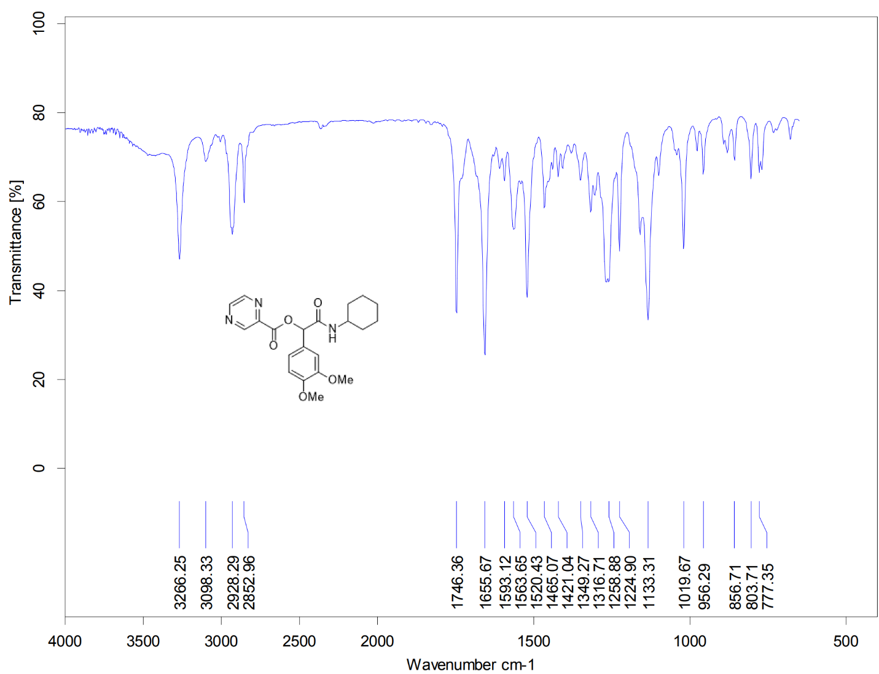
Figure S11. IR spectrum of P4

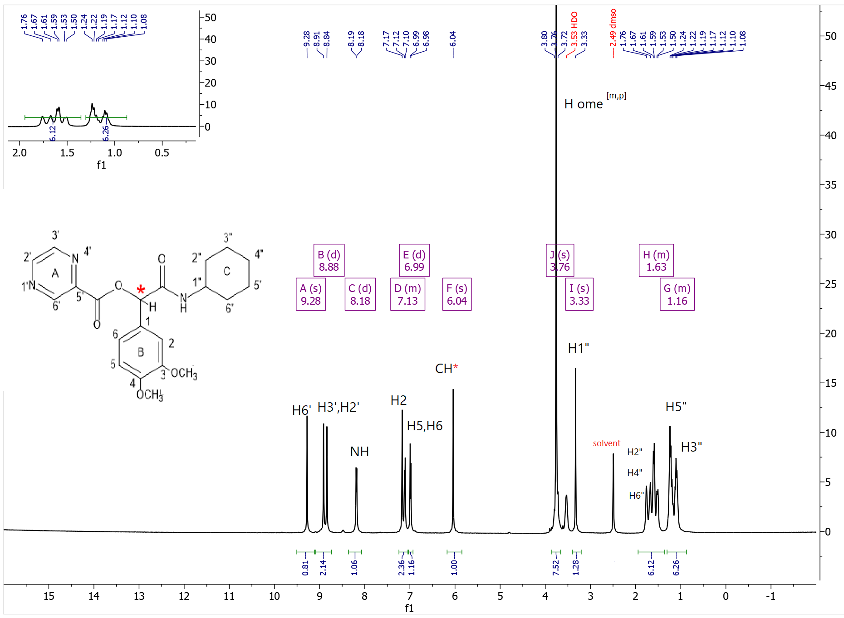
Figure S12. ¹H-NMR spectrum of P4
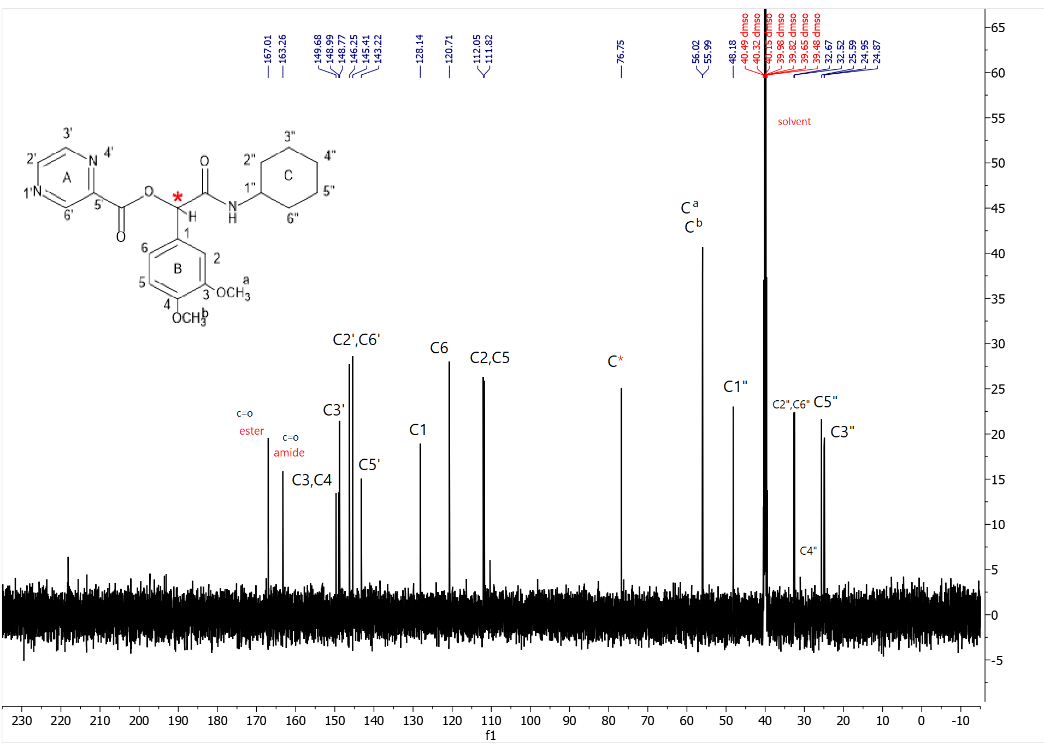
Figure S13. ¹³C-NMR spectrum of P4
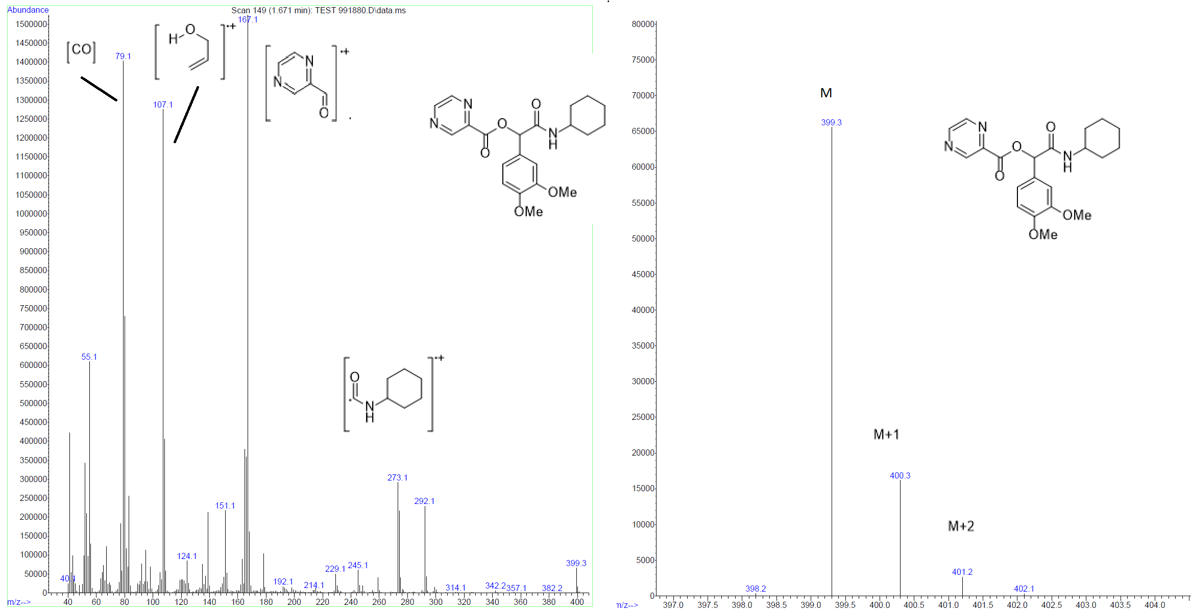
Figure S14. Mass spectrum of P4
2-(cyclohexylamino)-1-(2,5-dimethoxyphenyl)-2-oxoethyl pyrazine-2-carboxylate(P5)
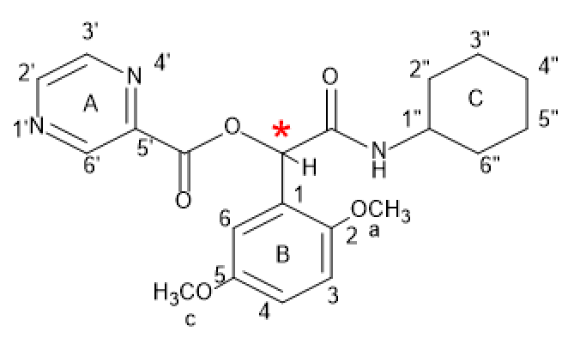
P5
Yield: 49%, mp: 114-117°C, white solid. IR (KBr disk): (3266.25 (NH amid group)), (3098.33-3029.84 (CH aromatic)), (2928.16-2852.96 (CH aliphatic)), (1746.36 (C=O ester)), (1655.67 (C=O amid)), (1593.12-1563.43 (C=C aromatic)), (1258.88 (C-O)) cm⁻¹. 1H NMR (300 MHz, DMSO-d6) δ (9.23 (d, J = 1.3 Hz, 1H) H^{6’}, (9.02 – 8.73 (m, 2H) H^{3’,2’}), (8.10 (d, J = 7.9 Hz, 1H) NH), (7.27 – 6.79 (m, 4H) H^{4,3,6}) , (6.41 (s, 1H) CH*), (3.76 (s, 6H) H^{a,c}, 3.34 (s, 1H) H^{1”}), (1.84 – 1.43 (m, 5H) H^{2”,4”,6”}), (1.18 (dq, J = 29.0, 8.6 Hz, 4H) H^{5”,3”}). 13C NMR (75 MHz, DMSO) δ 166.04, 162.92, 153.00, 151.44, 148.38, 145.79, 144.94, 142.65, 124.28, 114.73, 114.50, 112.62, 70.99, 56.25, 56.19, 55.49, 47.86, 40.33, 40.05, 39.78, 39.50, 39.22, 38.94, 38.67, 32.09, 25.11, 24.55.
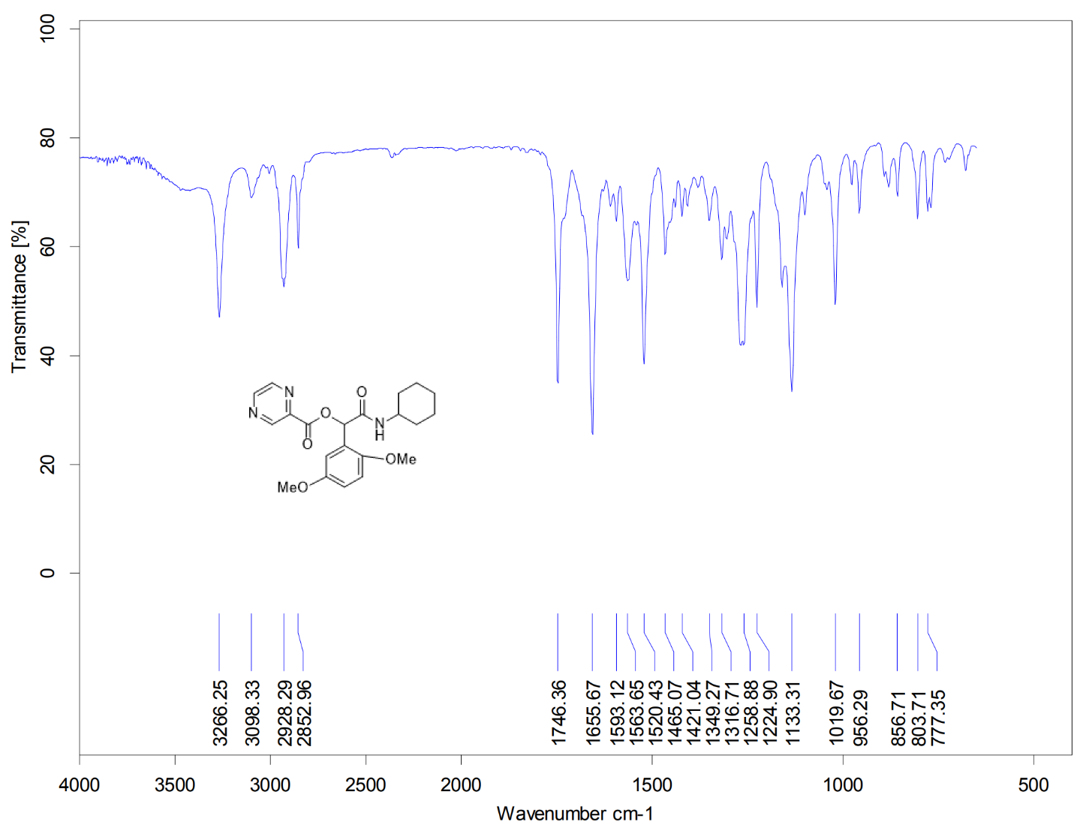
Figure S15. IR spectrum of P5
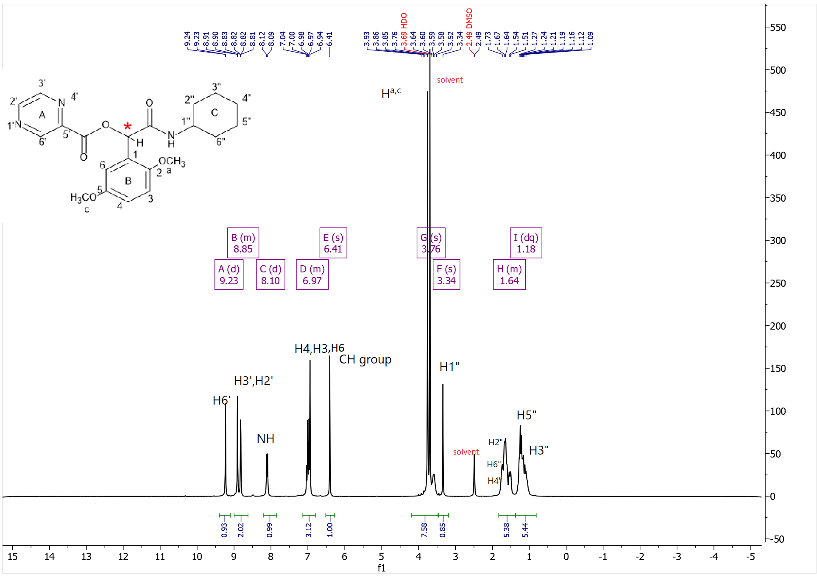
Figure S16. ¹H-NMR spectrum of P5
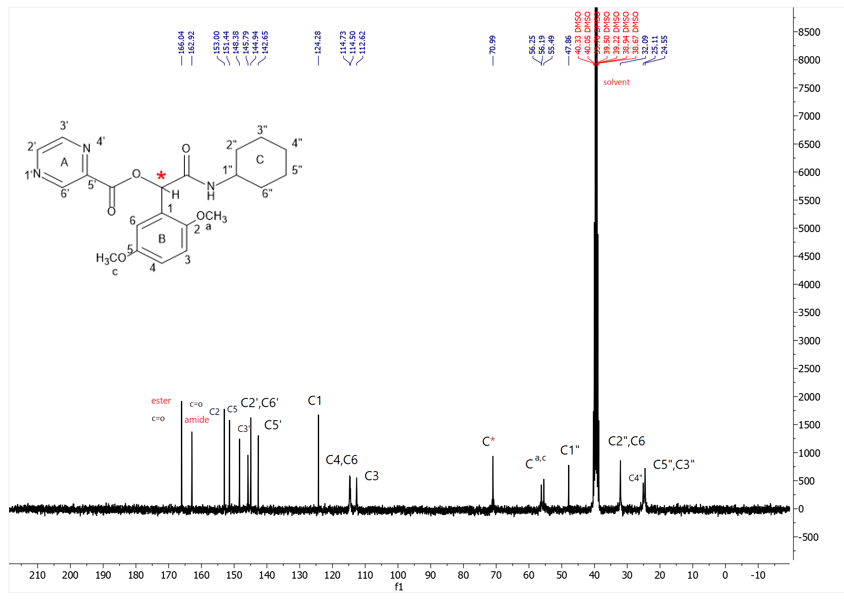
Figure S17. ¹³C-NMR spectrum of P5

2-(cyclohexylamino)-2-oxo-1-(2,4,6-trimethoxyphenyl)ethyl pyrazine-2-carboxylate(P6)
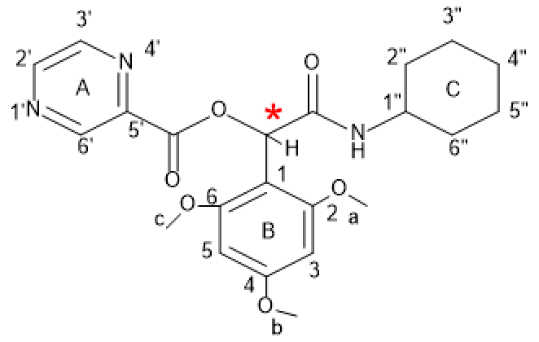
P6

Yield: 55%, mp: 99-100°C, white solid. IR (KBr disk): (3266.25 (NH amid group)), (3098.33-3029.84 (CH aromatic)), (2928.16-2852.96 (CH aliphatic)), (1746.36 (C=O ester)), (1655.67 (C=O amid)), (1593.12-1563.43 (C=C aromatic)), (1258.88 (C-O)) cm⁻¹. ¹H NMR (499 MHz, DMSO-d6) δ (10.33 (s, 1H)H^{6’}), (9.23 (s, 1H) H3’), (8.86 (d, J = 43.7 Hz, 1H) H^{2’}), (7.56 (d, J = 8.1 Hz, 1H) NH), (7.37 – 7.07 (m, 3H) H³), (6.94 – 6.71 (m, 1H) H⁵), (6.40 (s, 1H) NH), (5.84 (d, J = 5.4 Hz, 1H) CH*), (5.13 (d, J = 5.3 Hz, 2H) H⁵), (3.99 – 3.56 (m, 9H) H^{a,b,c}) overlapping multiple), (3.62 – 3.49 (m, 1H) H^{1”}, (1.60 (d, J = 68.4 Hz, 3H) H^{2”,4”,6”}), 1.19 (d, J = 62.3 Hz, 2H) H^{5”,3”}). ¹³C NMR (126 MHz, dmso) δ 189.30, 171.43, 153.52, 151.34, 131.43, 124.77, 123.58, 114.90, 114.30, 113.52, 112.83, 110.70, 68.29, 56.81, 56.58, 56.01, 55.93, 55.77, 47.63, 40.49, 40.32, 40.15, 39.98, 39.82, 39.65, 39.48, 32.80, 32.61, 25.59, 25.11, 25.07. Elemental analysis calcd (%) for C₂₂H₂₇N₃O₆ (429.19):C,61.53; H,6.34; N,9.78;found: C,61.54;H,6.44;N,10.65.
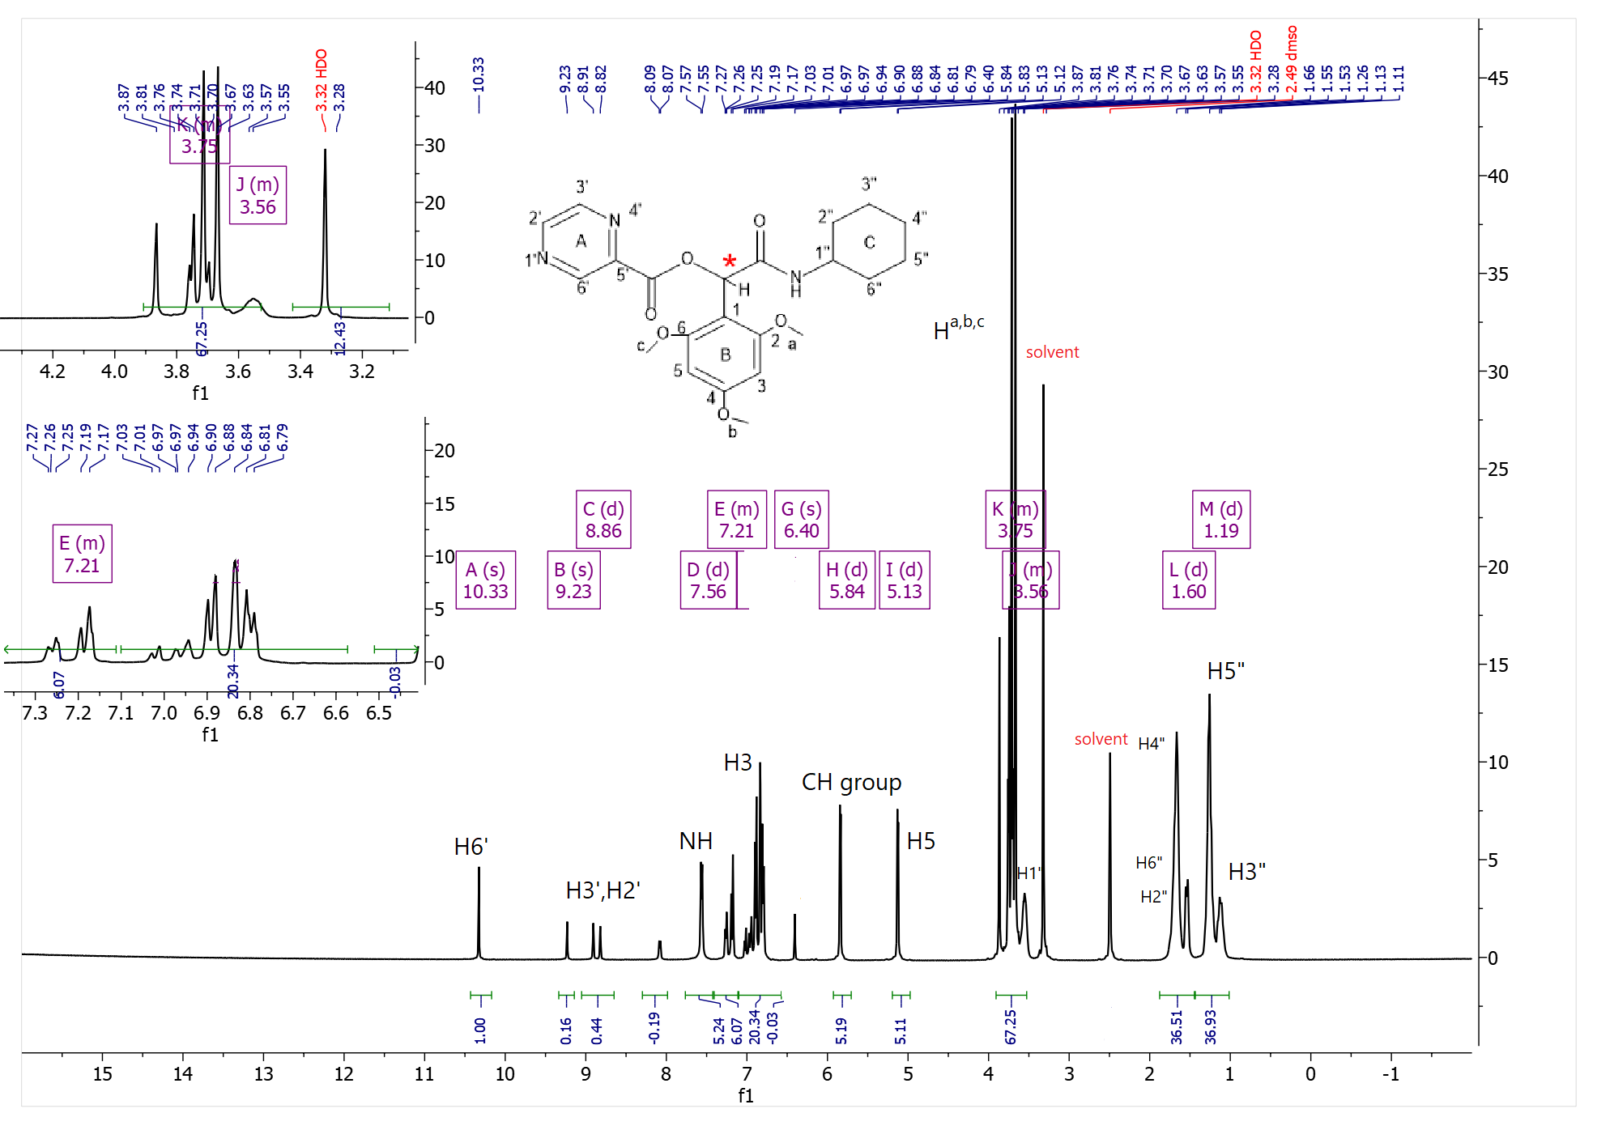
Figure S18. ¹H-NMR spectrum of P6
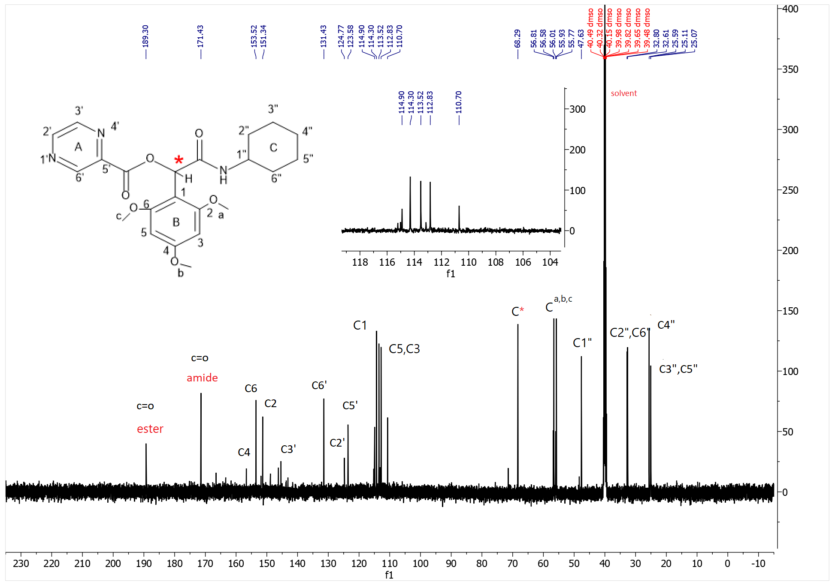
Figure S19. ¹³C-NMR spectrum of P6
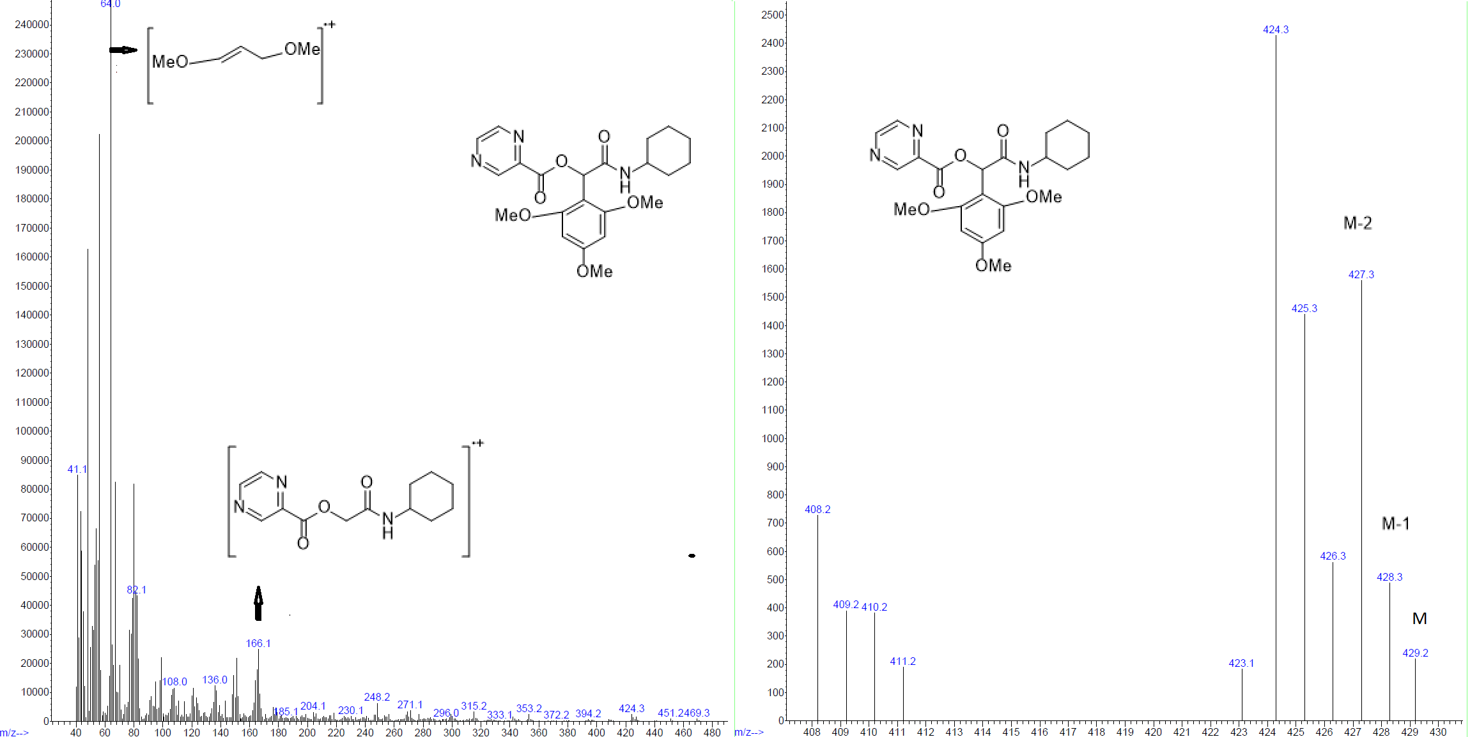
Figure S20. Mass spectrum of P6

2-(cyclohexylamino)-1-(2-nitrophenyl)-2-oxoethyl pyrazine-2-carboxylate(P7)
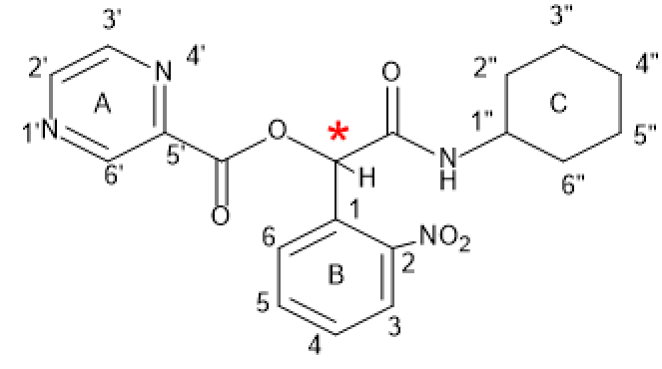
P7
Yield: 84%, mp: 160-162°C, white solid. IR (KBr disk): (3285.07 (NH amid group)), (3093.62-3029.84 (CH aromatic)), (2931.26-2855.74 (CH aliphatic)), (1730.45 (C=O ester)), (1656.67 (C=O amid)), (1527.37-1559.44 (C=C aromatic)), (1279.34 (C-O)) cm⁻¹. ¹H NMR (499 MHz, DMSO-d6) δ (9.27 (s, 1H)H^{6’}, (8.90 (d, J = 40.8 Hz, 2H)H^{3’,2’}), (8.33 (d, J = 7.4 Hz, 1H) NH), (8.11 (d, J = 7.9 Hz, 1H) H³), (7.93 – 7.54 (m, 3H) H^{4,5,6}), (6.79 (s, 1H)CH*, (3.59 (s, 1H) H^{1”}), (1.90 – 1.41 (m, 6H) H^{6”,4”,2”}) , (1.17 (ddd, J = 44.4, 20.7, 10.0 Hz, 4H) H^{3”,5”}). ¹³C NMR (126 MHz, dmso) δ 165.40, 163.06, 149.00, 146.36, 145.49, 142.83, 134.48, 130.70, 130.36, 129.77, 125.43, 72.18, 48.61, 40.32, 40.15, 39.98, 39.82, 39.65, 32.51, 32.47, 25.56, 24.88, 24.83.
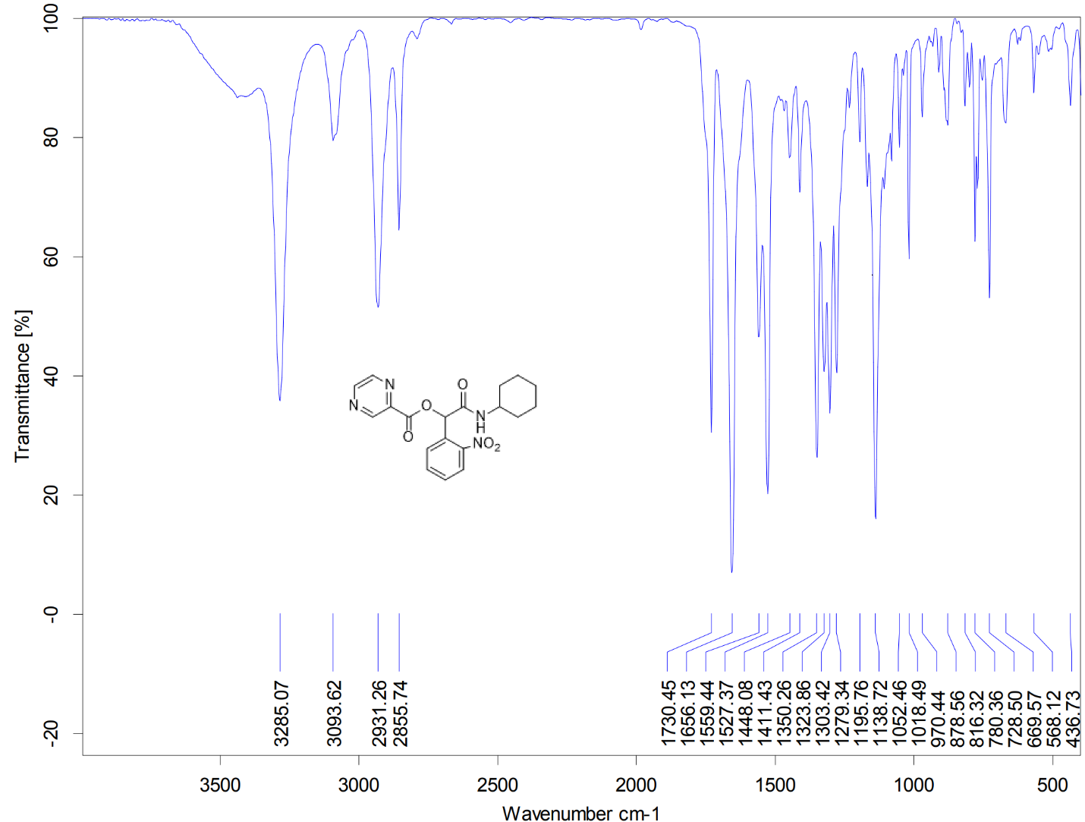
Figure S21. IR spectrum of P7
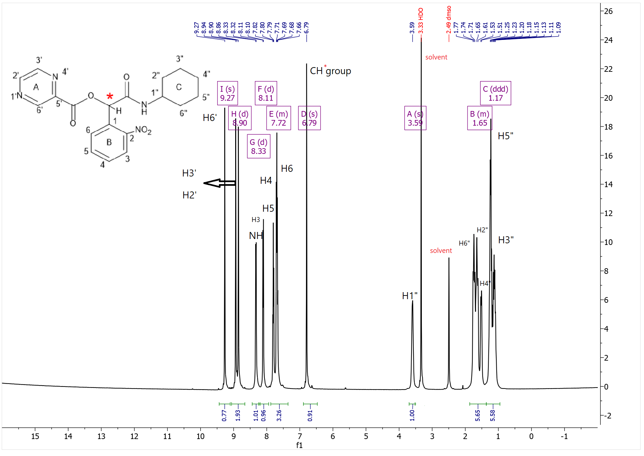
Figure S22. ¹H-NMR spectrum of P7
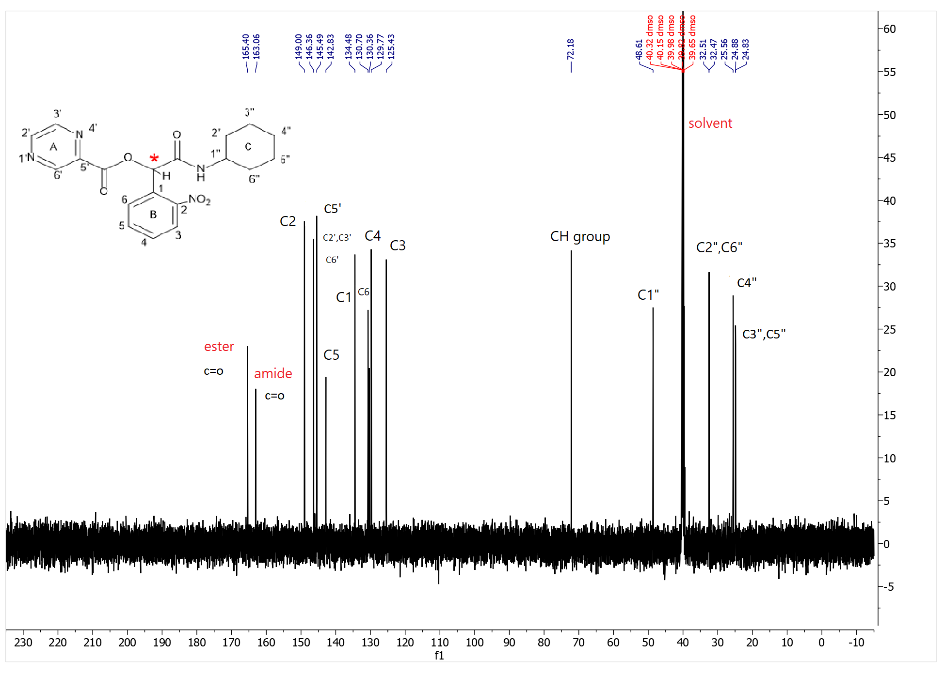
Figure S23. ¹³C-NMR spectrum of P7

2-(cyclohexylamino)-1-(3-nitrophenyl)-2-oxoethyl pyrazine-2-carboxylate(P8)
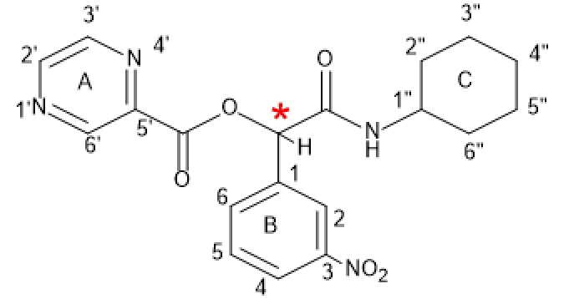
P8
Yield: 90%, mp: 163-165°C, white solid. IR (KBr disk): (3285.07 (NH amid group)), (3093.62-3029.84 (CH aromatic)), (2931.26-2855.74 (CH aliphatic)), (1730.45 (C=O ester)), (1656.67 (C=O amid)), (1527.37-1559.44 (C=C aromatic)), (1279.34 (C-O)) cm⁻¹. ¹H NMR (499 MHz, DMSO-d6) δ (9.39 – 9.13 (m, 1H) H^{6’}), (8.92 (dt, J = 34.5, 1.5 Hz, 3H)H^{3’,2’}, (8.47 (d, J = 12.4 Hz, 1H) H²), (8.27 (d, J = 8.2 Hz, 1H)H⁴) , (8.08 (d, J = 7.5 Hz, 1H) NH), (7.87 – 7.62 (m, 2H) H^{6,5}), (6.30 (s, 1H) CH* group, (3.53 (s, 1H)H^{1”}), (1.94 – 1.39 (m, 6H) H^{6”,4”,2”}), (1.41 – 0.86 (m, 3H) H^{5”,3”}). ¹³C NMR (126 MHz, dmso) δ 166.18, 163.06, 148.98, 148.23, 146.40, 145.49, 142.93, 138.05, 134.27, 130.75, 124.14, 122.45, 75.57, 48.34, 40.51, 40.34, 40.26, 40.17, 40.01, 39.84, 39.67, 39.51, 32.62, 32.41, 25.56, 24.85, 24.75. Elemental analysis calcd (%) for C₁₉H₂₀N₄O₅ (384.39):C, 59.37; H, 5.24; N,14.58;found: C,58.43;H,4.30;N 13.64.
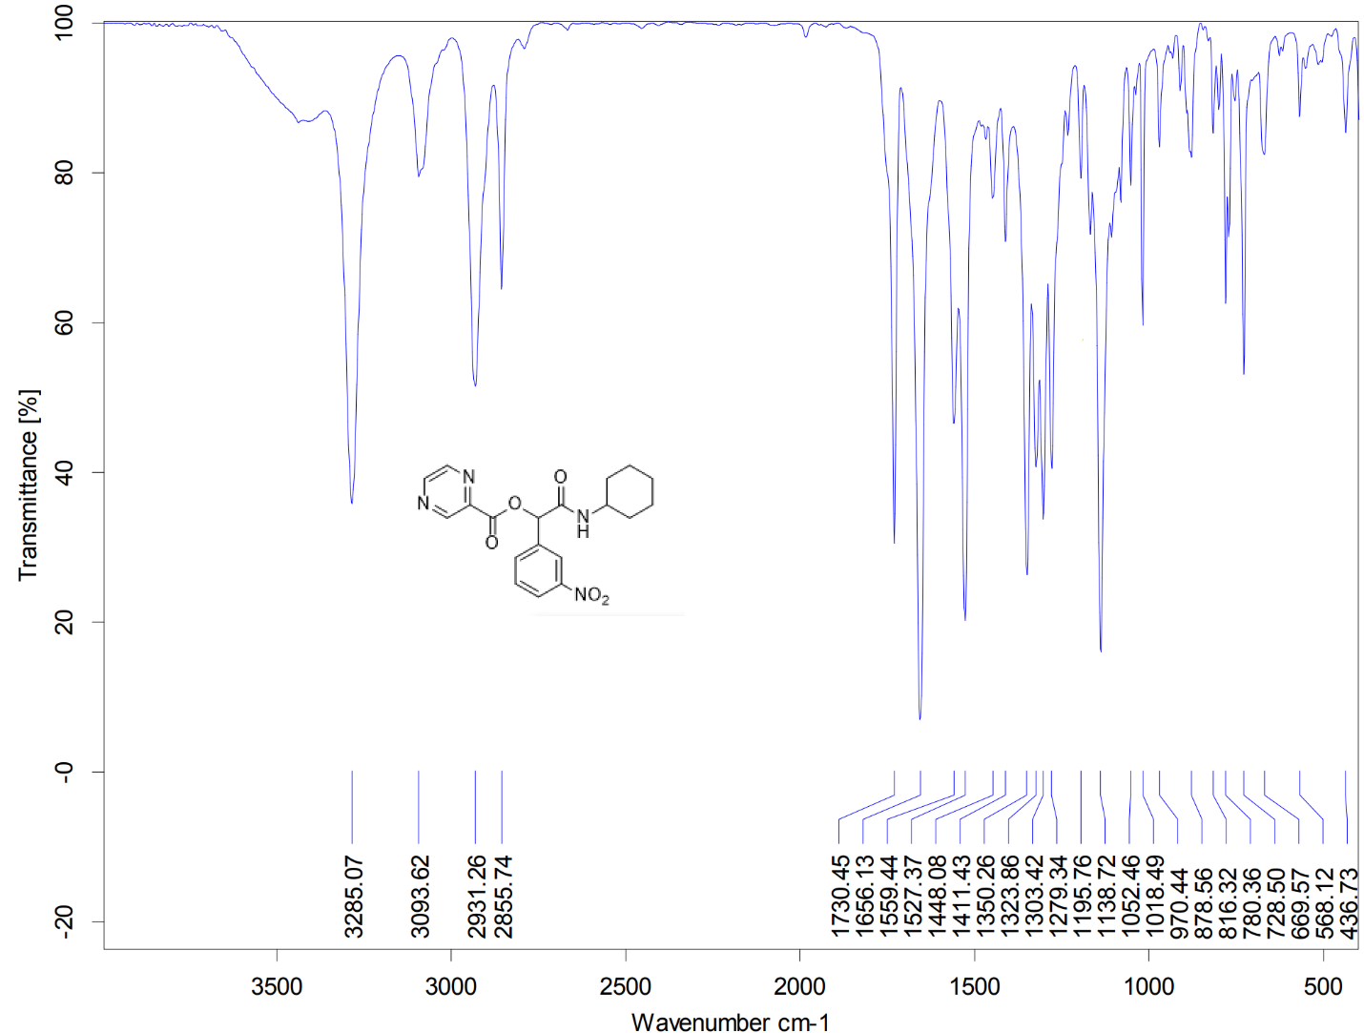
Figure S24. IR spectrum of P8
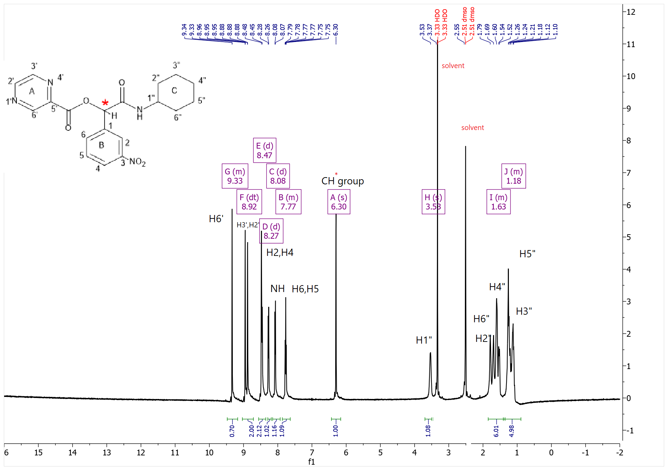
Figure S25. ¹H-NMR spectrum of P8
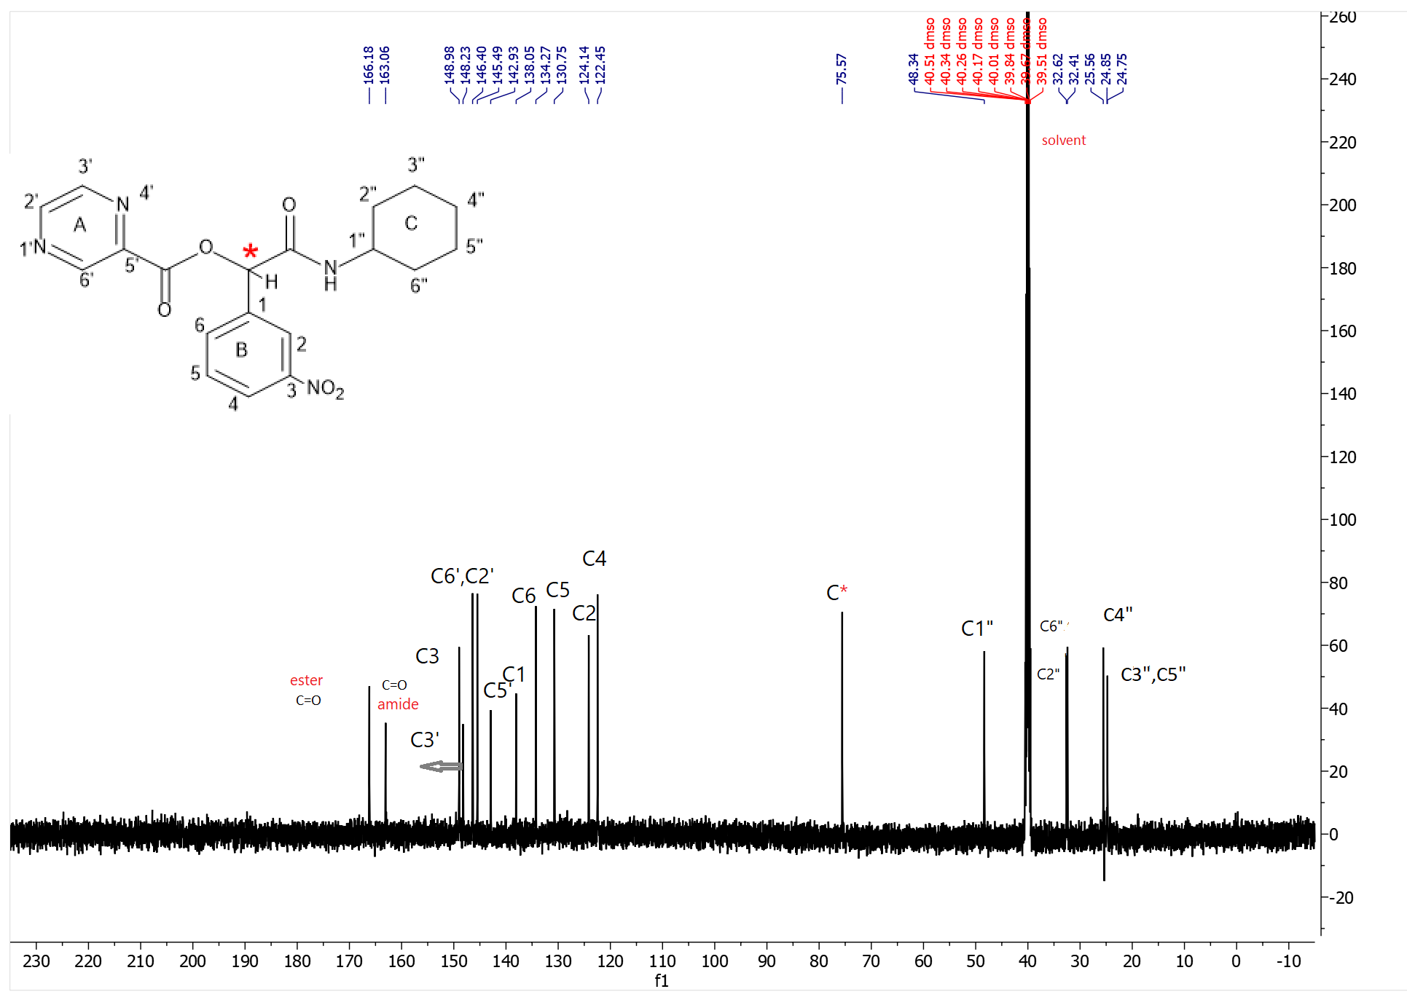
Figure S26. ¹³C-NMR spectrum of P8
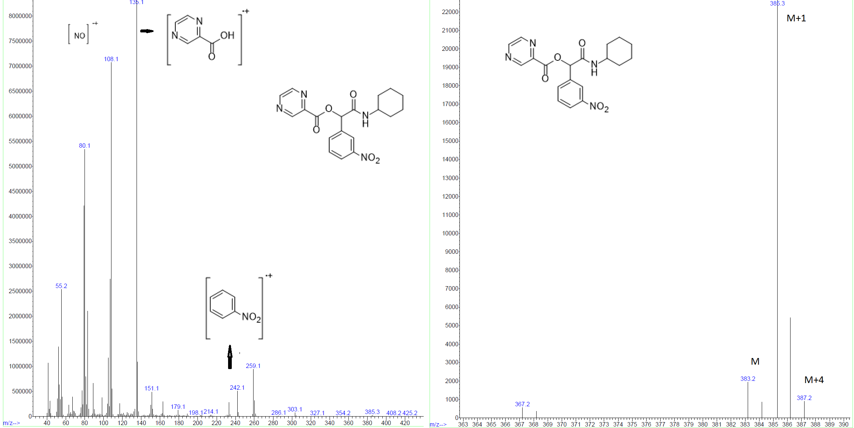
Figure S27. Mass spectrum of P8

2-(cyclohexylamino)-1-(4-nitrophenyl)-2-oxoethyl pyrazine-2-carboxylate(P9)
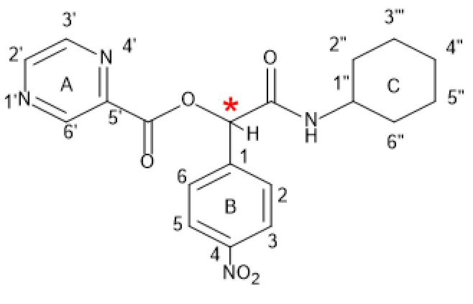
P9
Yield: 85%, mp: 200-202°C, white solid. IR (KBr disk): (3285.07 (NH amid group)), (3093.62-3029.84 (CH aromatic)), (2931.26-2855.74 (CH aliphatic)), (1730.45 (C=O ester)), (1656.67 (C=O amid)), (1527.37-1559.44 (C=C aromatic)), (1279.34 (C-O)) cm⁻¹. ¹H NMR (499 MHz, DMSO-d6) δ (9.34 (s, 1H) H^{6’}, (8.90 (d, J = 35.1 Hz, 2H) H^{3’,2’}), (8.37 (dd, J = 77.1, 7.9 Hz, 3H) H^{5,3},NH), (7.89 (d, J = 8.2 Hz, 2H) H^{6,2}), (6.28 (s, 1H) CH*), (3.51 (s, 2H)H^{1’}, (1.81 – 1.33 (m, 6H) H^{4”,6”,2”}), (1.33 – 0.85 (m, 3H)H^{5”,3”}). ¹³C NMR (126 MHz, dmso) δ 165.96, 162.99, 148.97, 148.07, 146.40, 145.48, 143.09, 142.89, 128.80, 124.14, 75.76, 48.37, 40.48, 40.31, 40.15, 39.98, 39.81, 39.65, 39.48, 32.62, 32.39, 25.54, 24.84, 24.75.
Figure S28. IR spectrum of P9
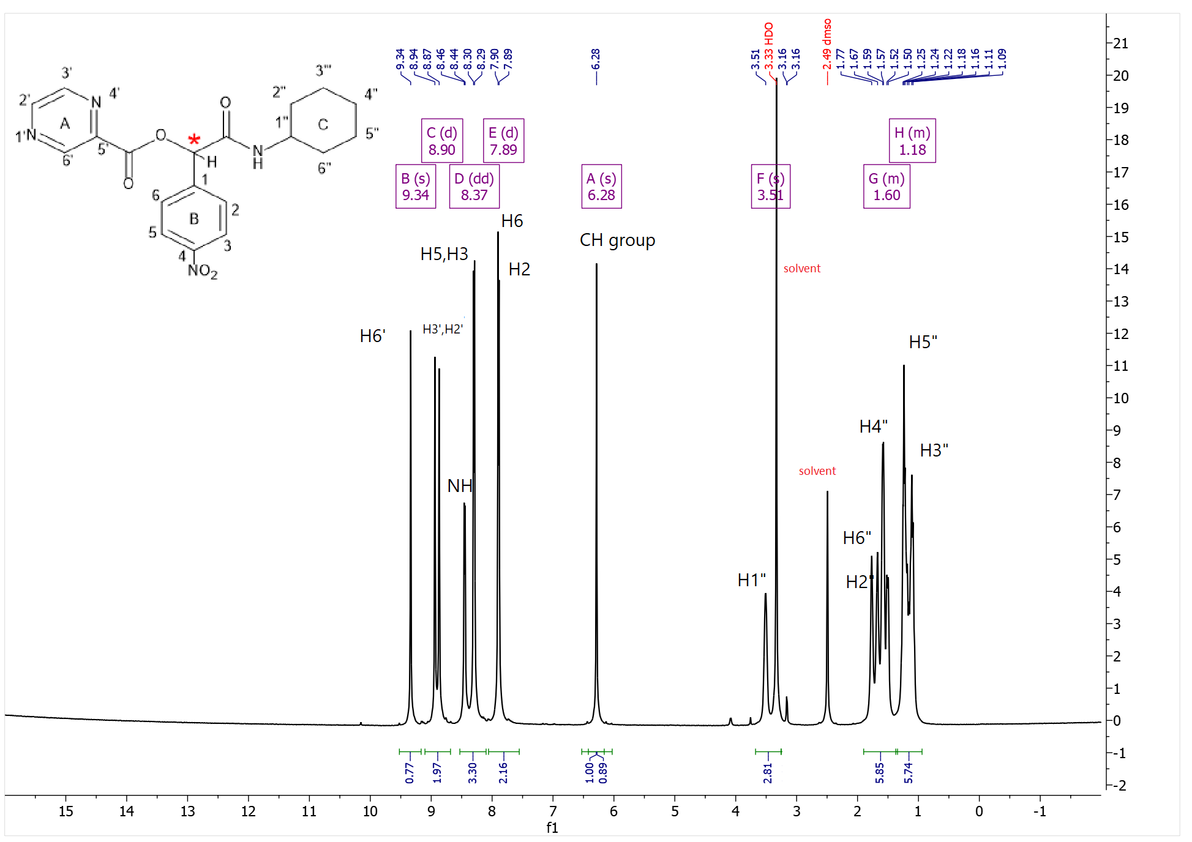
Figure S29. ¹H-NMR spectrum of P9
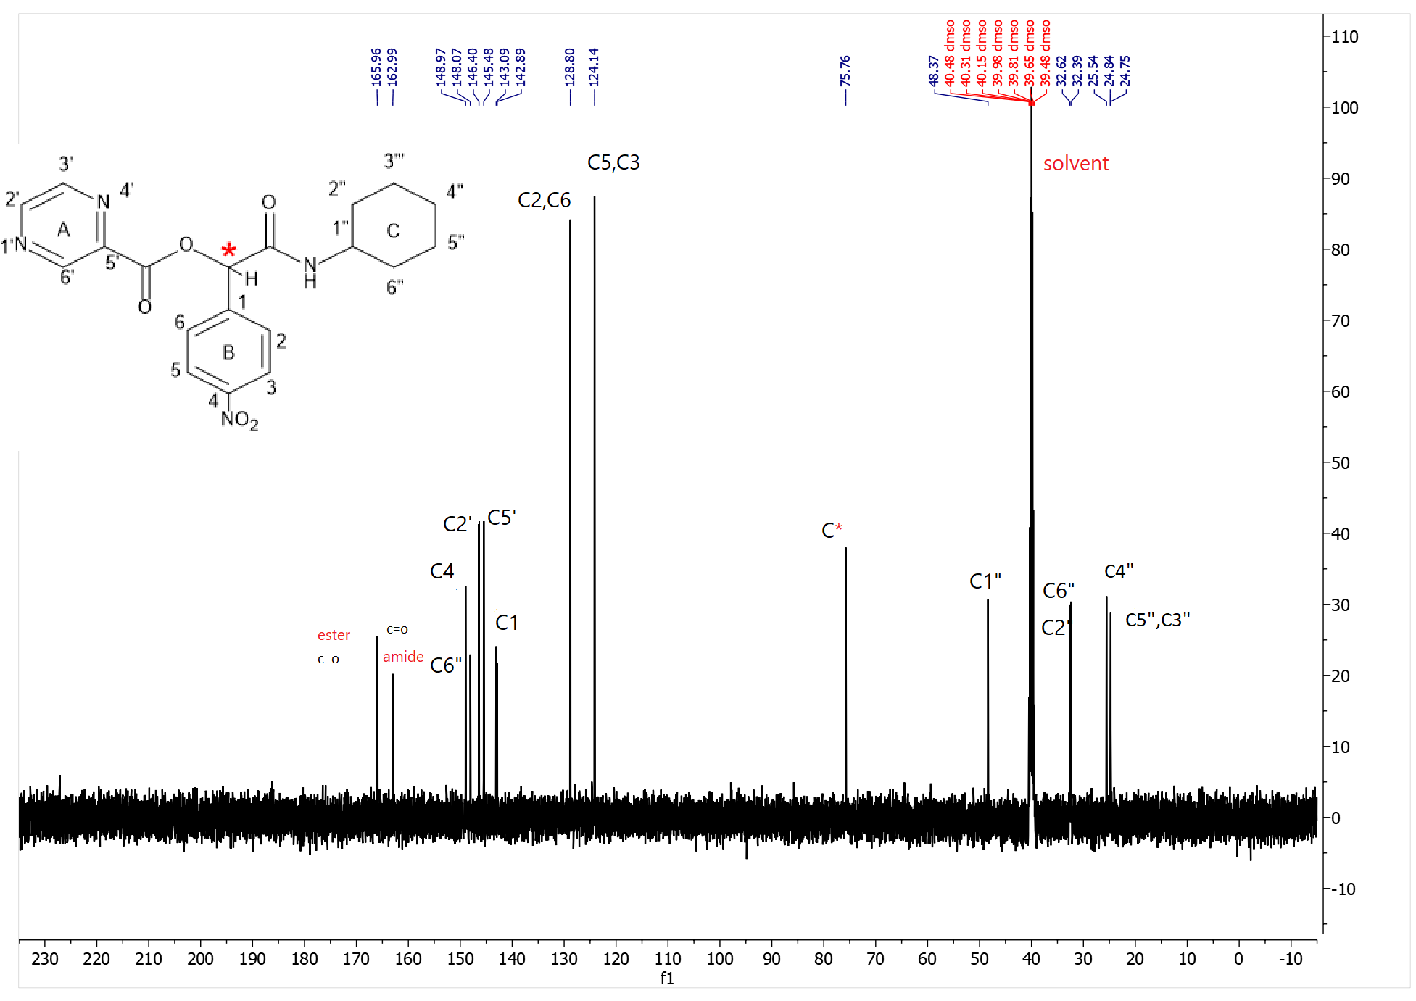
Figure S30. ¹³C-NMR spectrum of P9

2-(cyclohexylamino)-1-(2,4-dinitrophenyl)-2-oxoethyl pyrazine-2-carboxylate(P10)
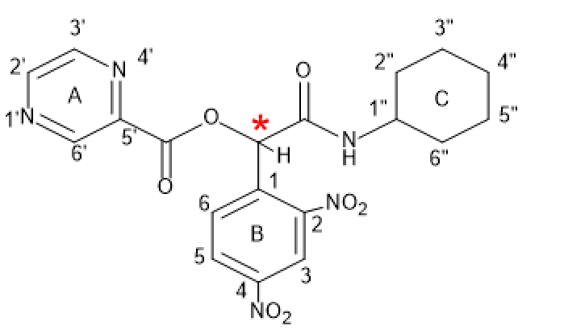
P10
Yield: 88%, mp: 197-199°C, white solid. IR (KBr disk): (3334.18 (NH amid group)), (3106.15 (CH aromatic)), (2937.88-2856.13 (CH aliphatic)), (1744.38 (C=O ester)), (1681. (C=O amid)), (1538.43 (NO₂ symmetric stretch)), (1538.43-1450.11 (C=C aromatic)), (1348.34 (NO₂ asymmetric stretch)), (1224.20 (C-O ester)) cm⁻¹. ¹H NMR (499 MHz, DMSO-d₆) δ (9.31 (s, 1H) H^{6’}, (9.09 – 8.69 (m, 3H) H^{2’,3’,3}), (8.57 (d, J = 8.5 Hz, 1H)H⁵), (8.43 (d, J = 7.5 Hz, 1H) NH), (8.01 (d, J = 8.6 Hz, 1H) H⁶), (6.92 (s, 1H) CH*), (3.58 (s, 1H) H^{1”}), (1.98 – 1.41 (m, 7H) H^{2”,4”,6”}), 1.18 (ddd, J = 44.5, 20.2, 9.3 Hz, 3H) H^{5”,3”}). ¹³C NMR (126 MHz, dmso) δ 164.56, 162.91, 149.08, 148.79, 148.07, 146.54, 145.52, 142.70, 136.69, 131.23, 128.50, 120.75, 71.88, 48.82, 40.31, 40.14, 39.97, 39.81, 39.64, 32.47, 32.44, 25.54, 24.86. Elemental analysis calcd (%) for C₁₉H₁₉N₅O₇ (429.19):C,53.15; H,4.46; N,16.31;found: C,53.22;H,4.53;N,16.38.
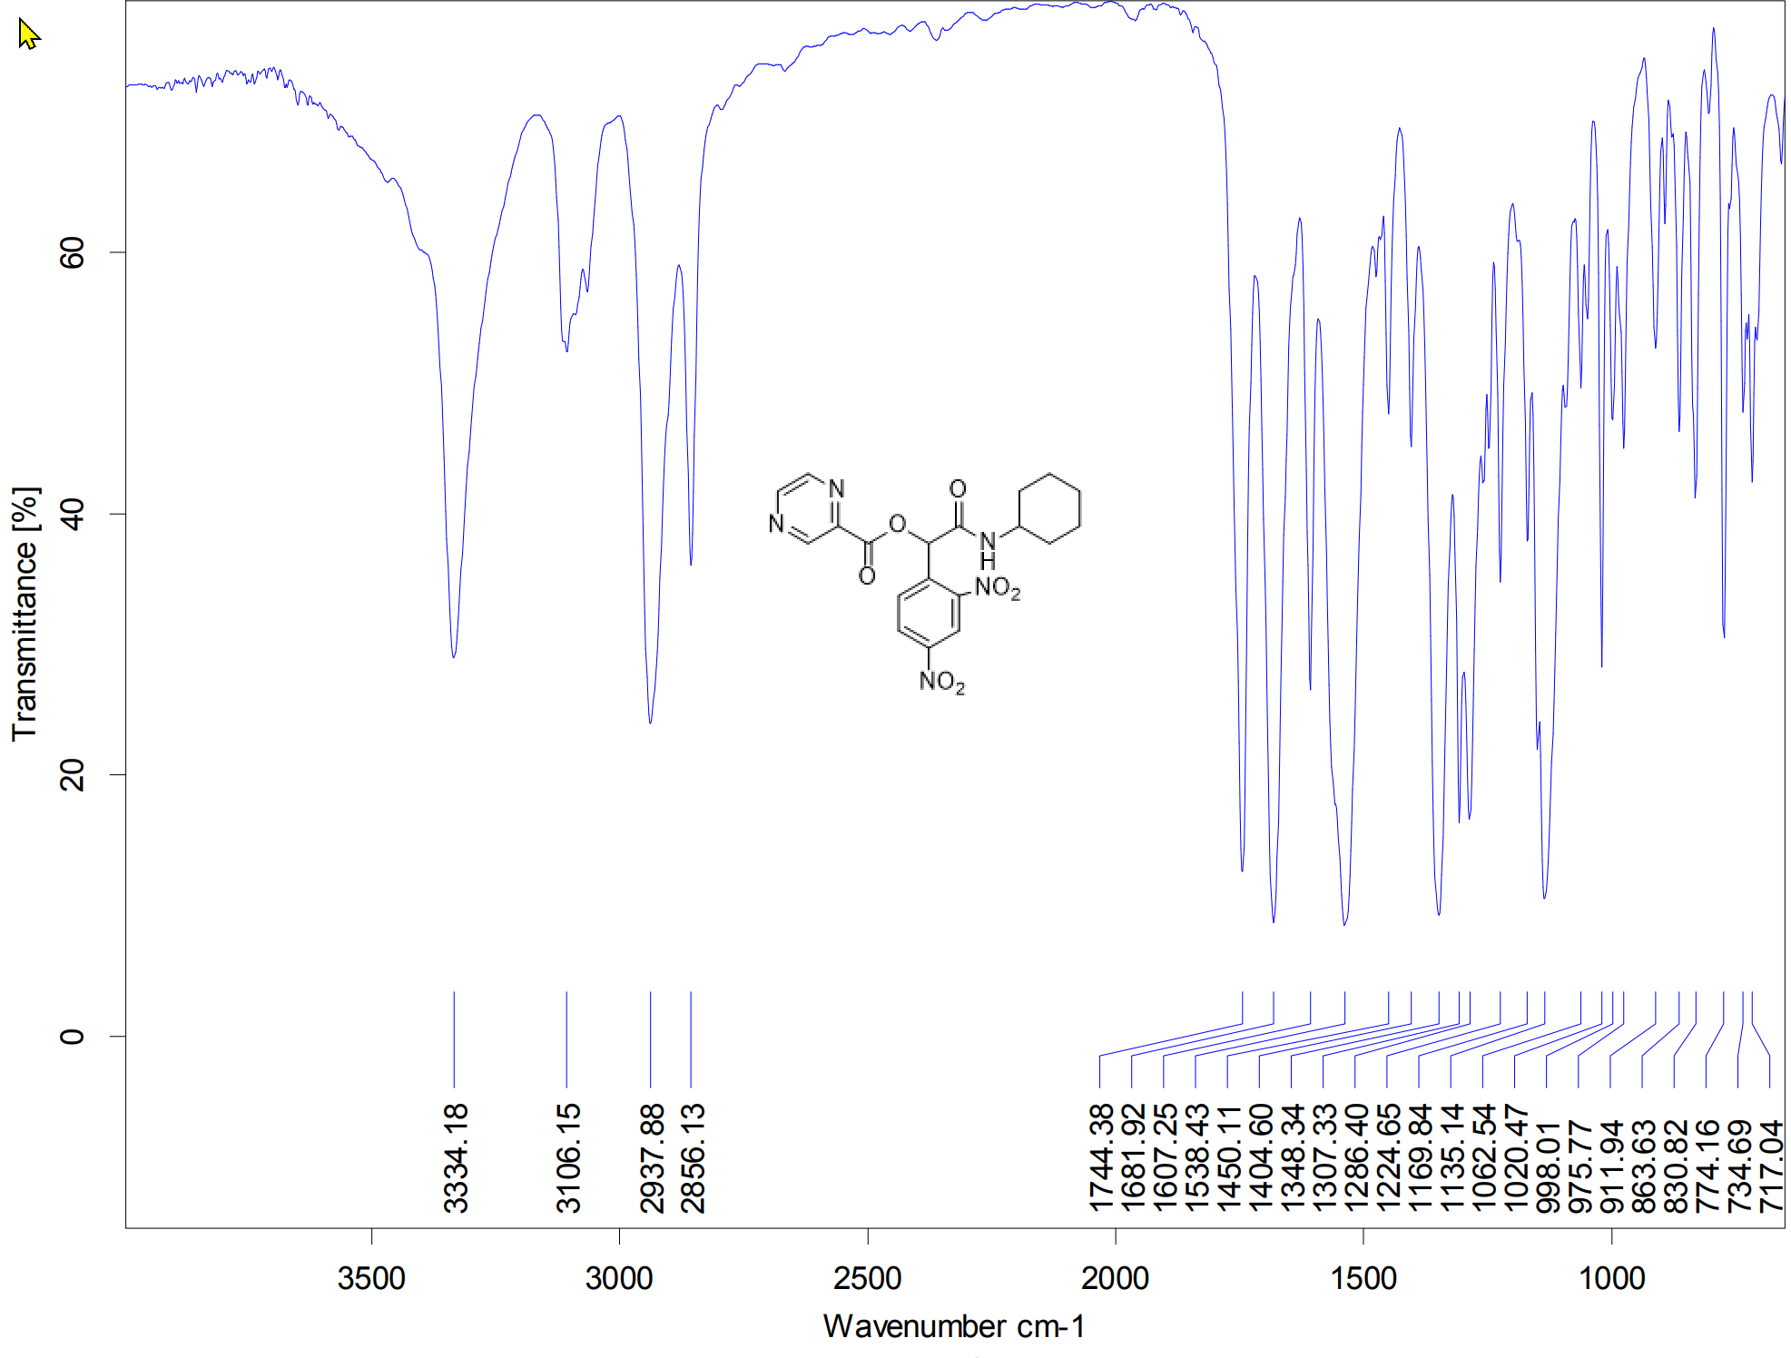
Figure S31. IR spectrum of P10
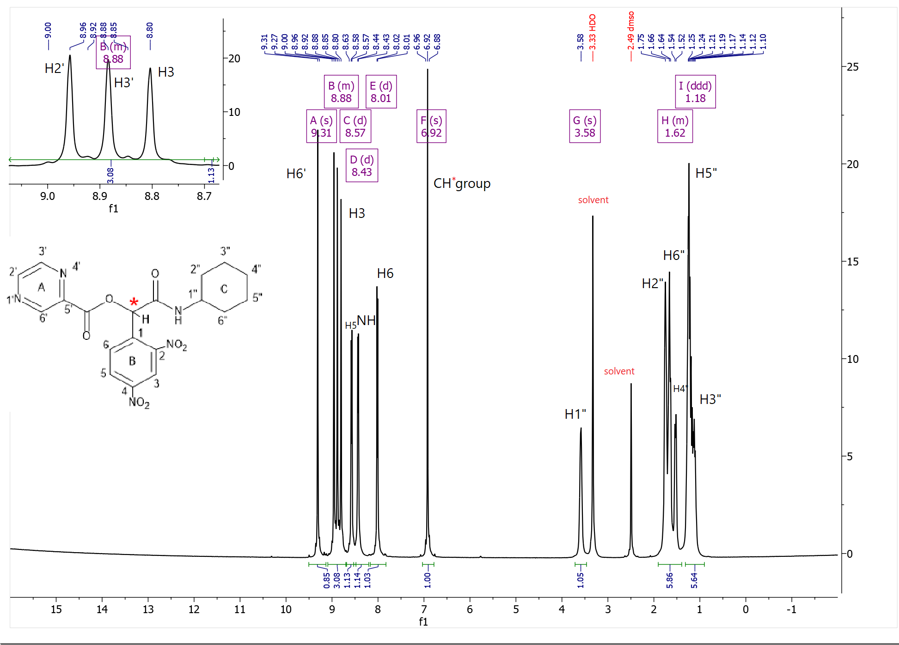
Figure S32. ¹H-NMR spectrum of P10
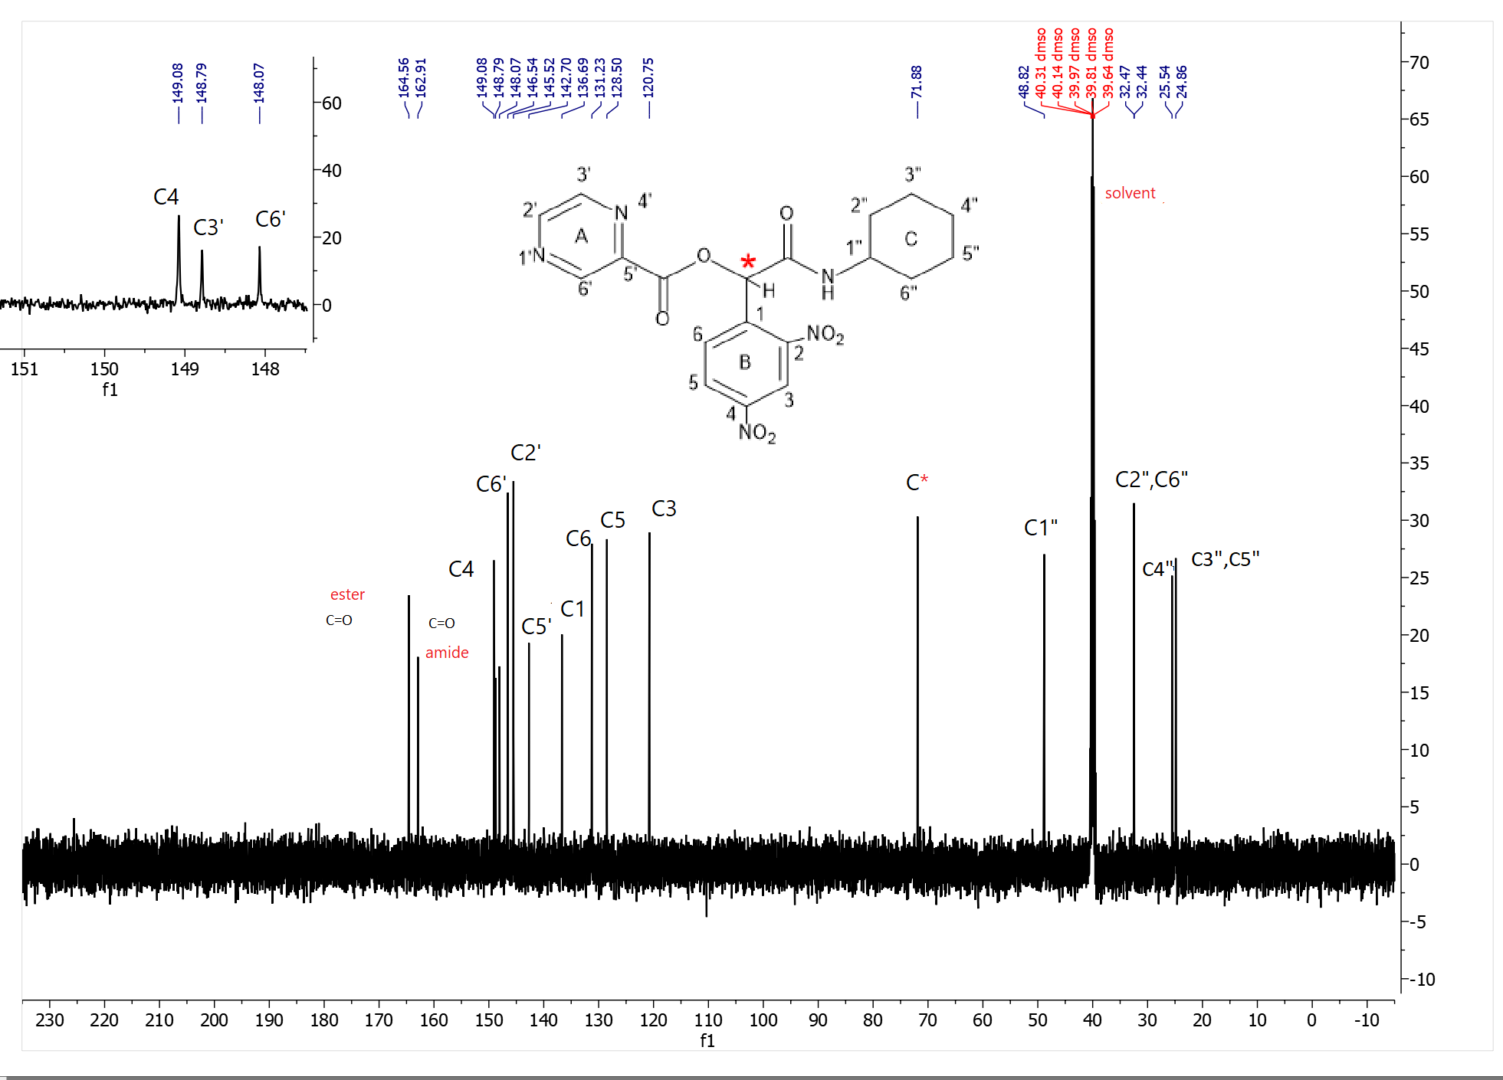
Figure S33. ¹³C-NMR spectrum of P10
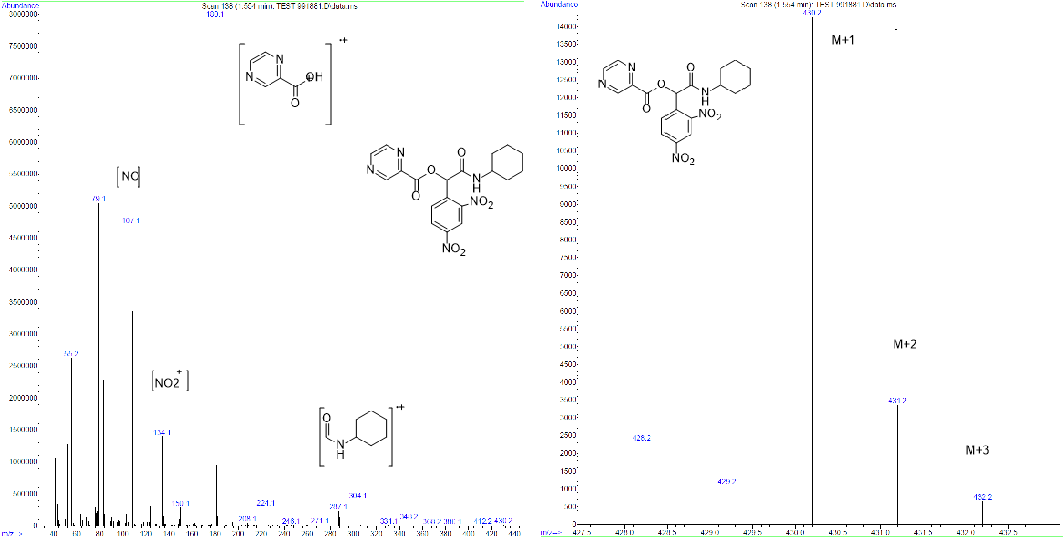
Figure S34. Mass spectrum of P10

2-(cyclohexylamino)-1-(2-fluorophenyl)-2-oxoethyl pyrazine-2-carboxylate(P11)
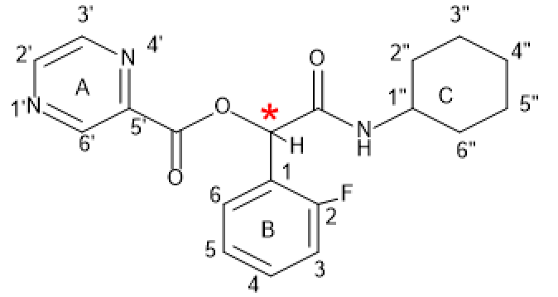
P11
Yield: 55%, mp: 143-145°C, white solid. IR (KBr disk): (3265.97 (NH amid group)), (3100.43 (CH aromatic)), (2930.03-2854.01 (CH aliphatic)), (1718.87 (C=O ester)), (1656.95 (C=O amid)), (1569.89-1510.03 (C=C aromatic)), (1187.89 (C-O)), (C-F (967.65)) cm⁻¹. ¹H NMR (499 MHz, DMSO-d6) δ (9.26 (s, 1H) H^{6’}, 8.87 (d, J = 43.6 Hz, 2H) H^{3’.2’}), (8.28 (d, J = 7.6 Hz, 1H) NH), (7.68 – 7.40 (m, 1H) H⁵), (7.36 – 7.06 (m, 1H) H⁶), (6.40 (s, 1H) CH*), (3.70 – 3.44 (m, 1H) H^{1”}), (1.85 – 1.41 (m, 7H) H^{2”,4”,6”}), (1.19 (ddd, J = 44.5, 22.4, 11.2 Hz, 5H) H^{5”,3”}). ¹³C NMR (126 MHz, dmso) δ 165.74, 163.18, 161.73, 159.76, 148.90, 146.32, 145.40, 142.94, 131.78, 131.72, 130.12, 125.16, 123.30, 123.19, 116.20, 116.03, 70.68, 48.46, 40.49, 40.32, 40.15, 39.98, 39.82, 39.65, 39.48, 32.54, 32.49, 25.57, 24.98, 24.93. Elemental analysis calcd (%) for C₁₉H₂₀FN₃O₃ (357.15):C,63.85; H,5.64; N,11.76;found: C,63.90;H,5.69;N,11.81.
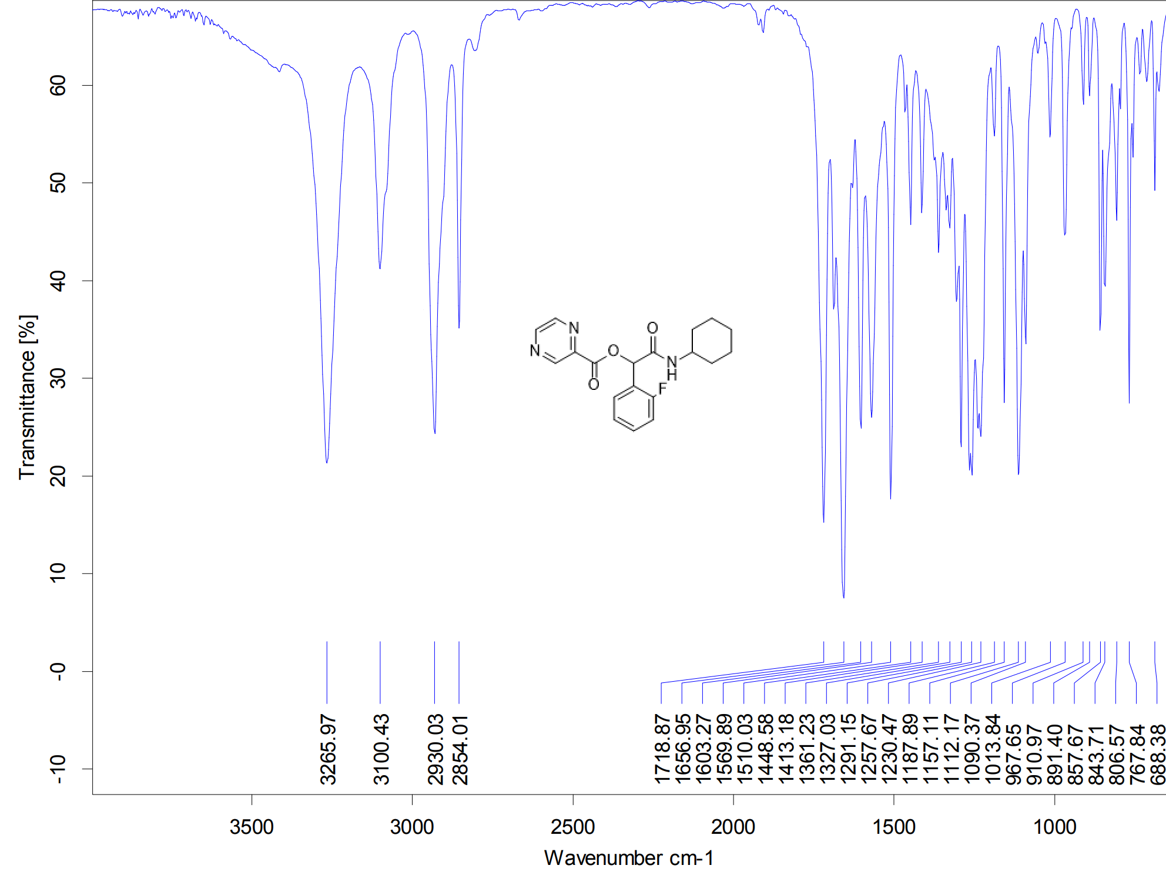
Figure S35. IR spectrum of P11
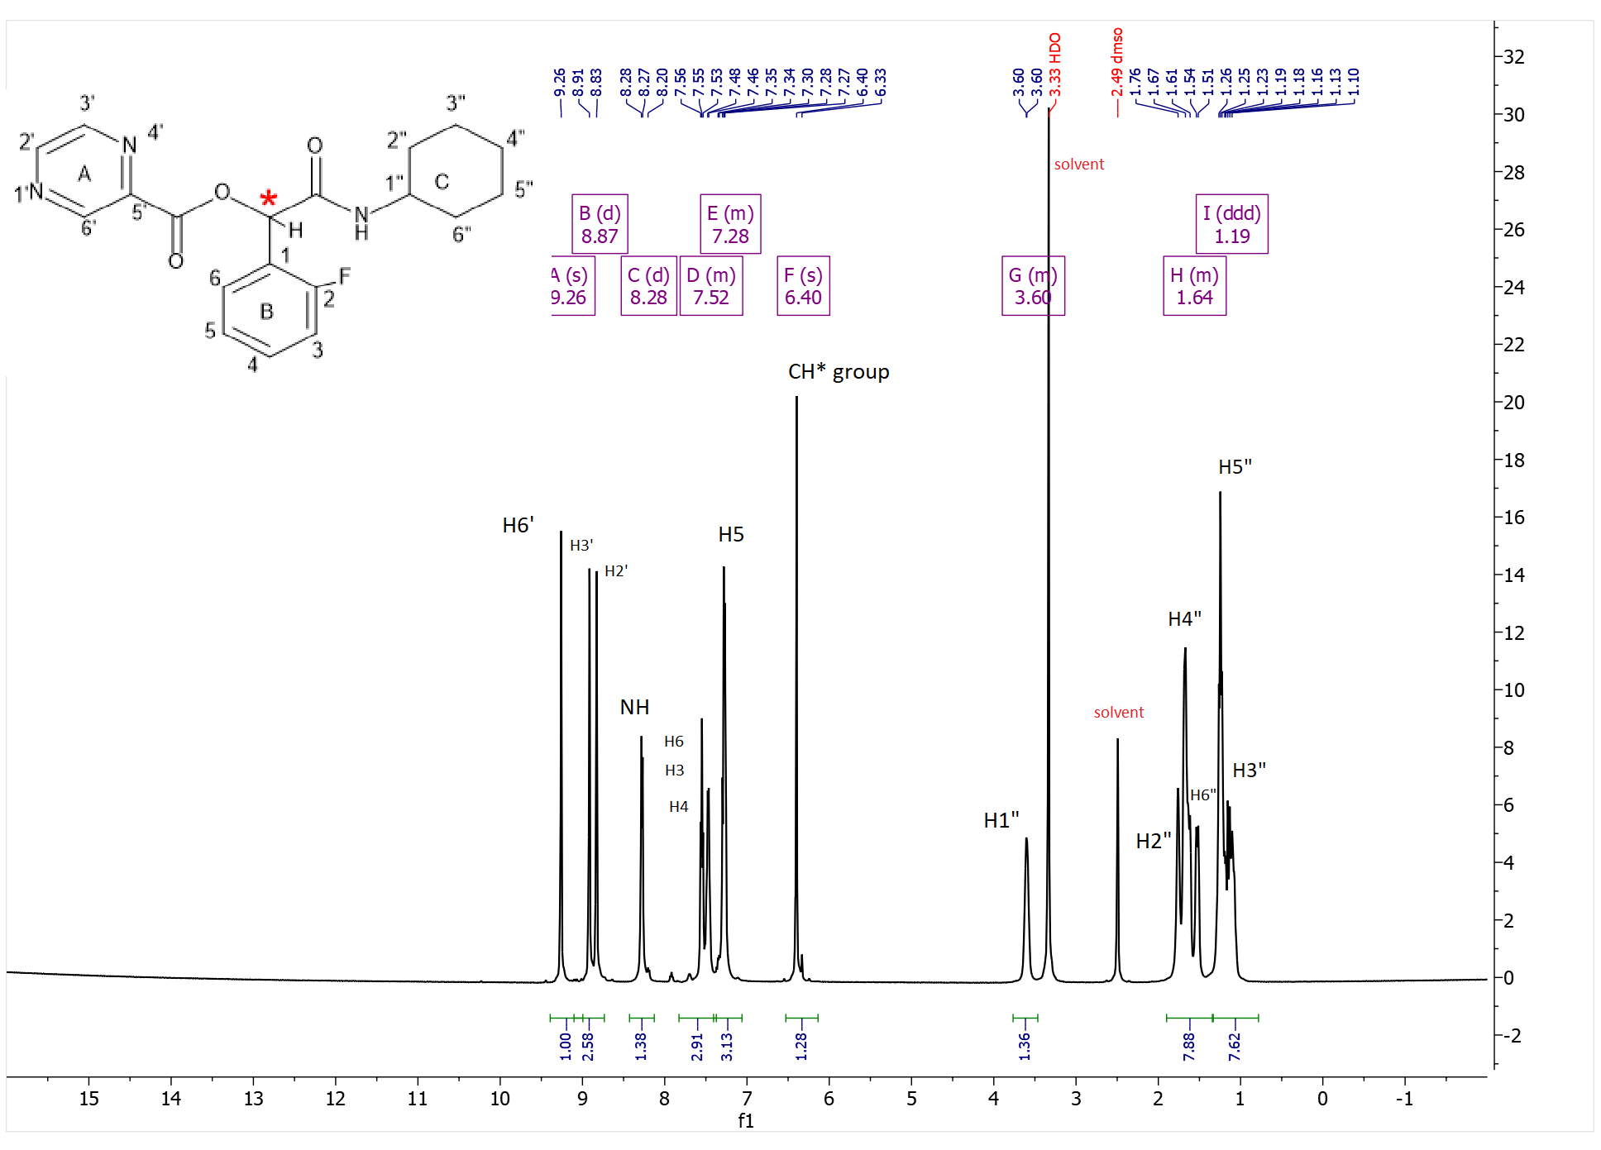
Figure S36. ¹H-NMR spectrum of P11
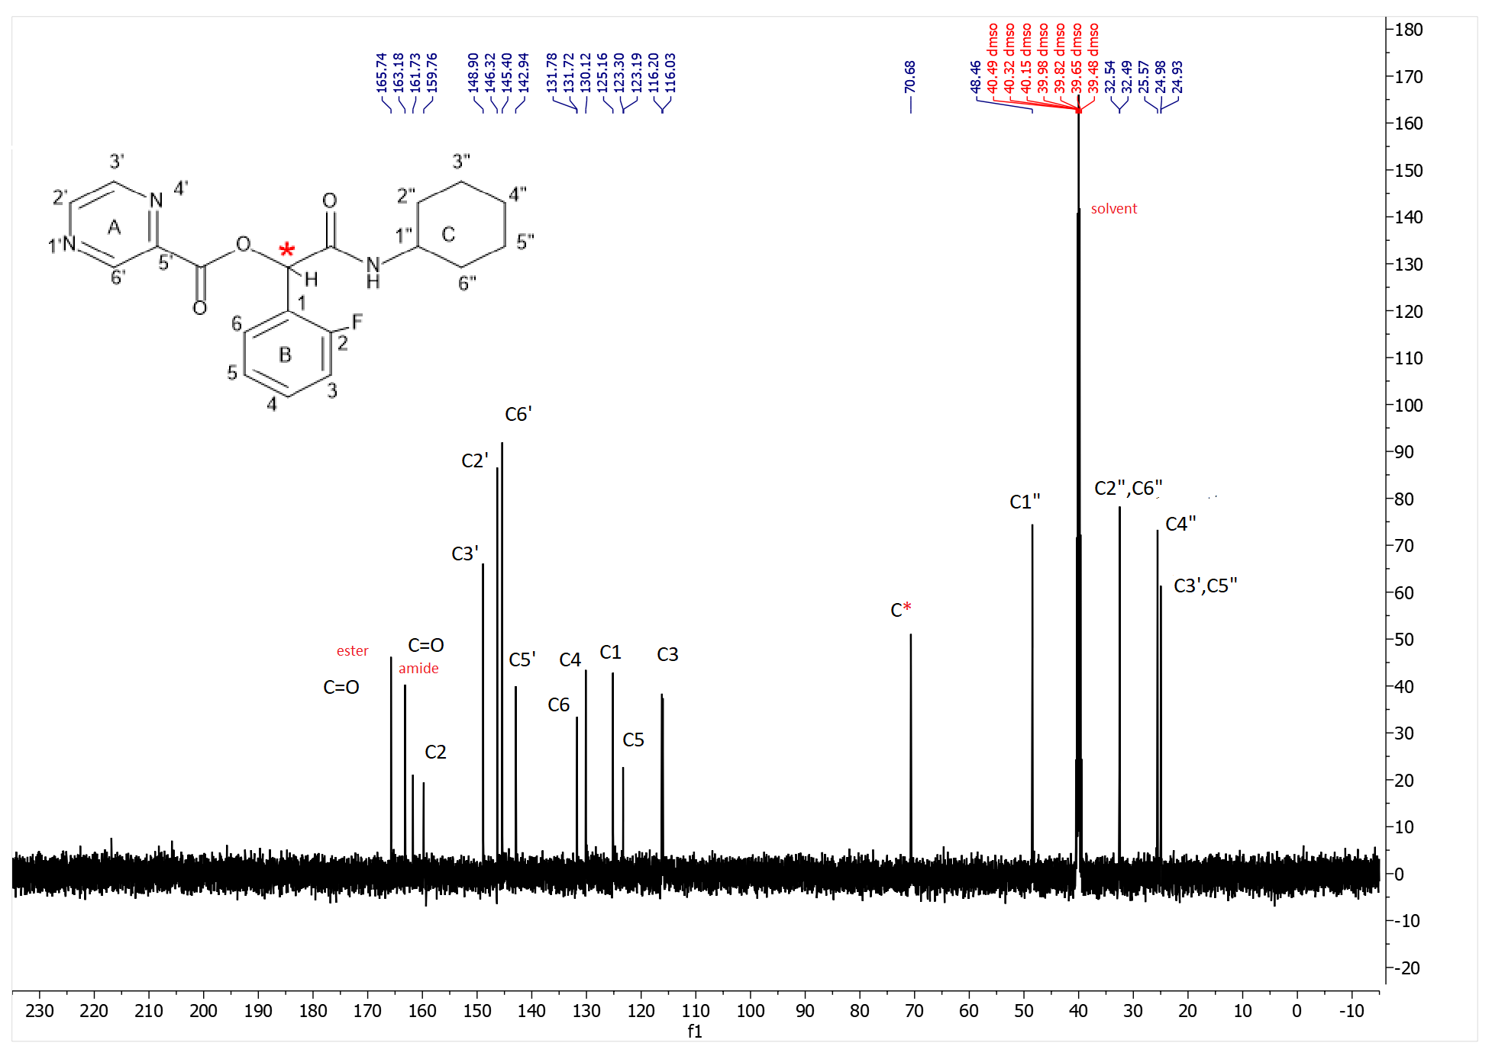
Figure S37. ¹³C-NMR spectrum of P11
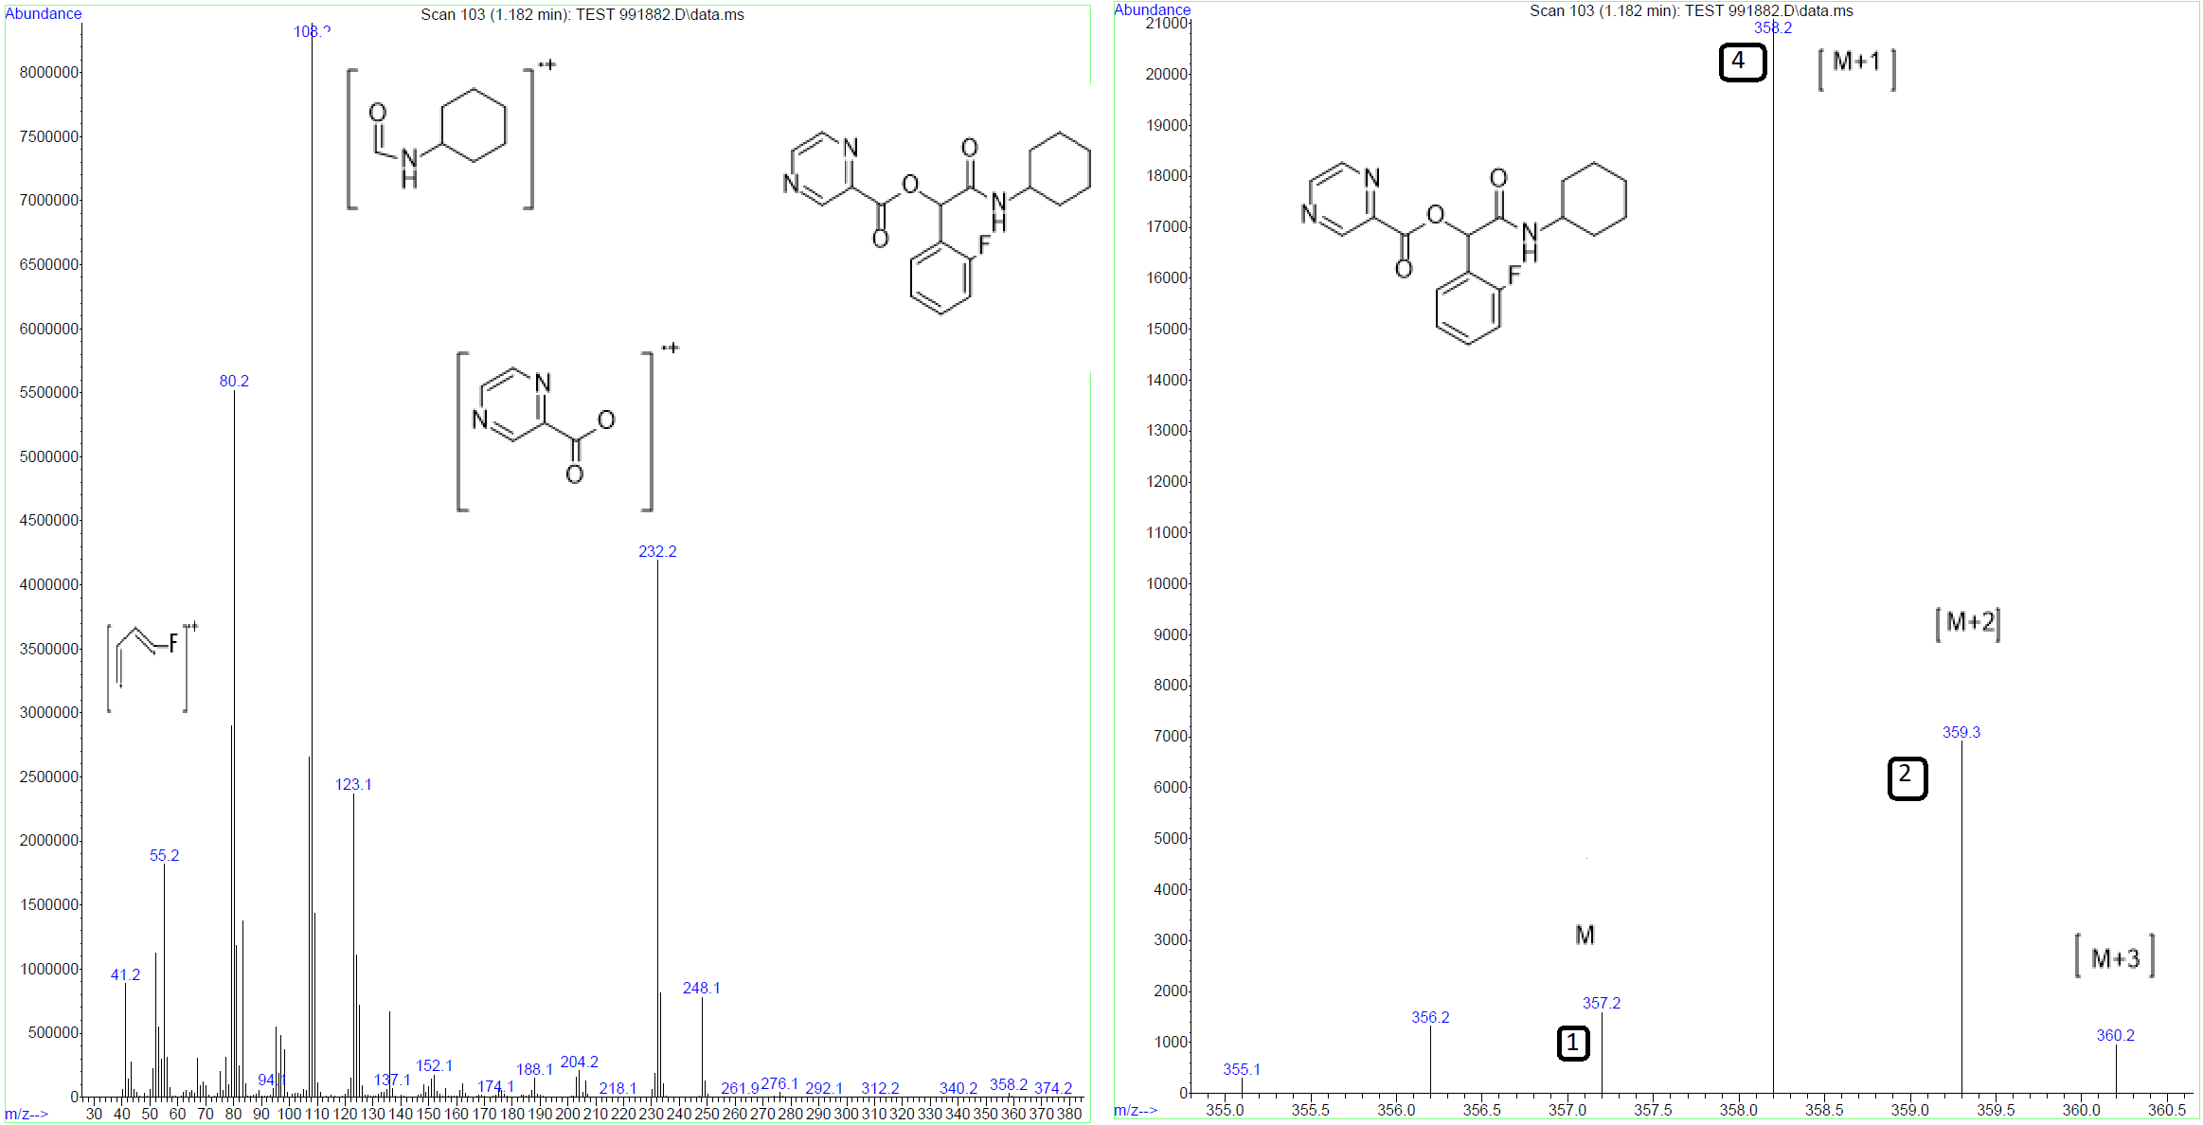
Figure S38. Mass spectrum of P11
2-(cyclohexylamino)-1-(3-fluorophenyl)-2-oxoethyl pyrazine-2-carboxylate(P12)
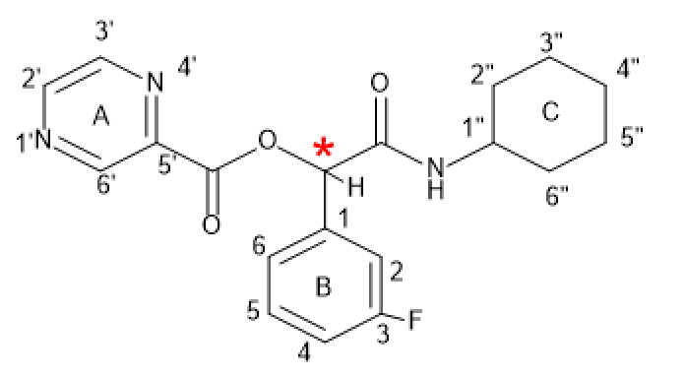
P12
Yield: 54%, mp: 143-145°C, white solid. IR (KBr disk): (3265.97 (NH amid group)), (3100.43 (CH aromatic)), (2930.03-2854.01 (CH aliphatic)), (1718.87 (C=O ester)), (1656.95 (C=O amid)), (1569.89-1510.03 (C=C aromatic)), (1187.89 (C-O)), (C-F (967.65)) cm⁻¹. ¹H NMR (499 MHz, DMSO-d6) δ (9.32 (s, 1H)H^{6’}), (9.18 (s, 3H) ) H^{Ring (A,B)} overlapping multiple), (9.04 – 8.70 (m, 3H) H^{2’,3’,5}), (8.30 (dd, J = 19.1, 7.9 Hz, 1H) NH), (7.46 (dq, J = 21.6, 11.4, 9.4 Hz, 2H) H^{6,4}), 7.23 (t, J = 7.6 Hz, 1H) H²), (6.14 (s, 1H) CH*), (1.87 – 1.41 (m, 5H) H^{1”,2”,6”}), (1.42 – 0.90 (m, 3H) H^{5”,3”}). ¹³C NMR (126 MHz, dmso) δ 166.43, 163.10, 161.44, 148.89, 148.13, 146.35, 146.02, 145.45, 145.07, 143.00, 138.62, 138.56, 131.08, 131.01, 123.75, 116.08, 115.92, 114.61, 114.43, 75.94, 48.27, 40.48, 40.31, 40.15, 39.98, 39.81, 39.65, 39.48, 32.62, 32.43, 25.55, 24.87, 24.78.
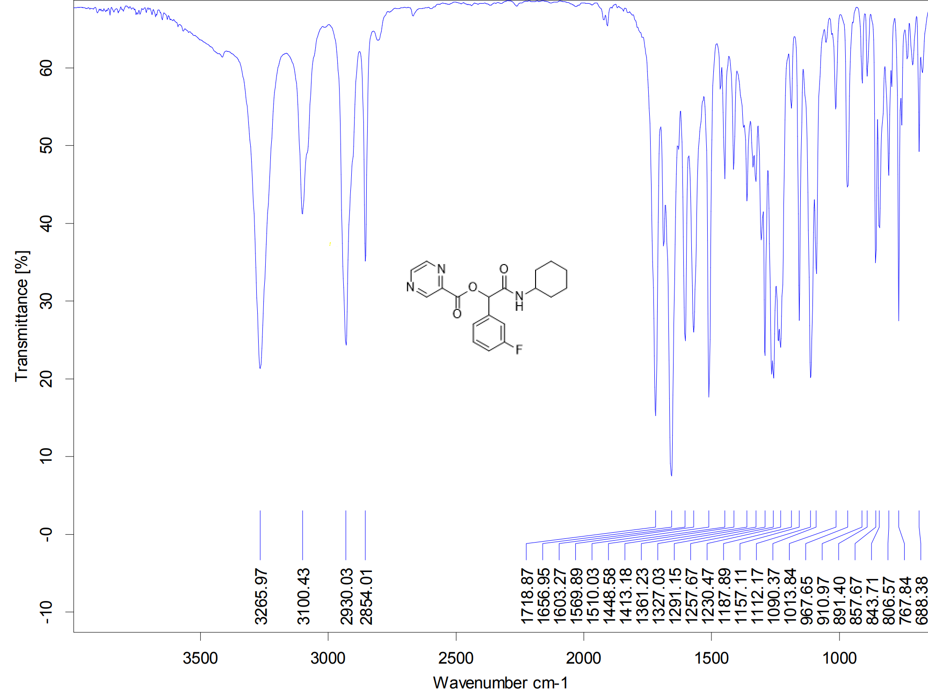
Figure S39. IR spectrum of P12
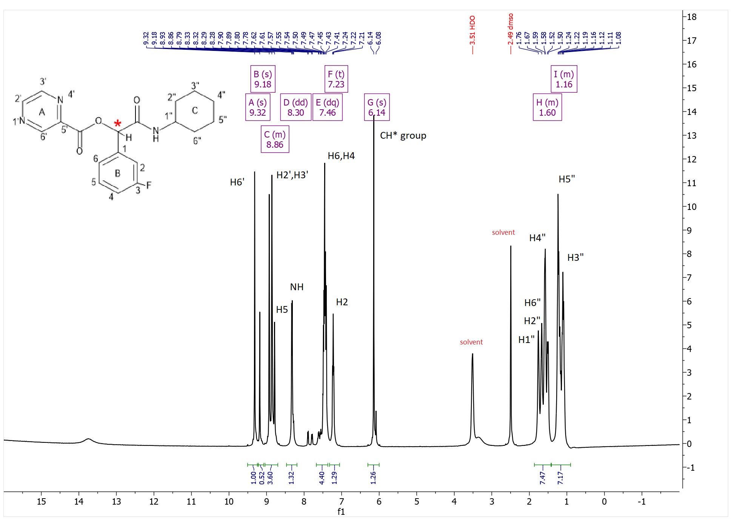
Figurer S40. ¹H-NMR spectrum of P12
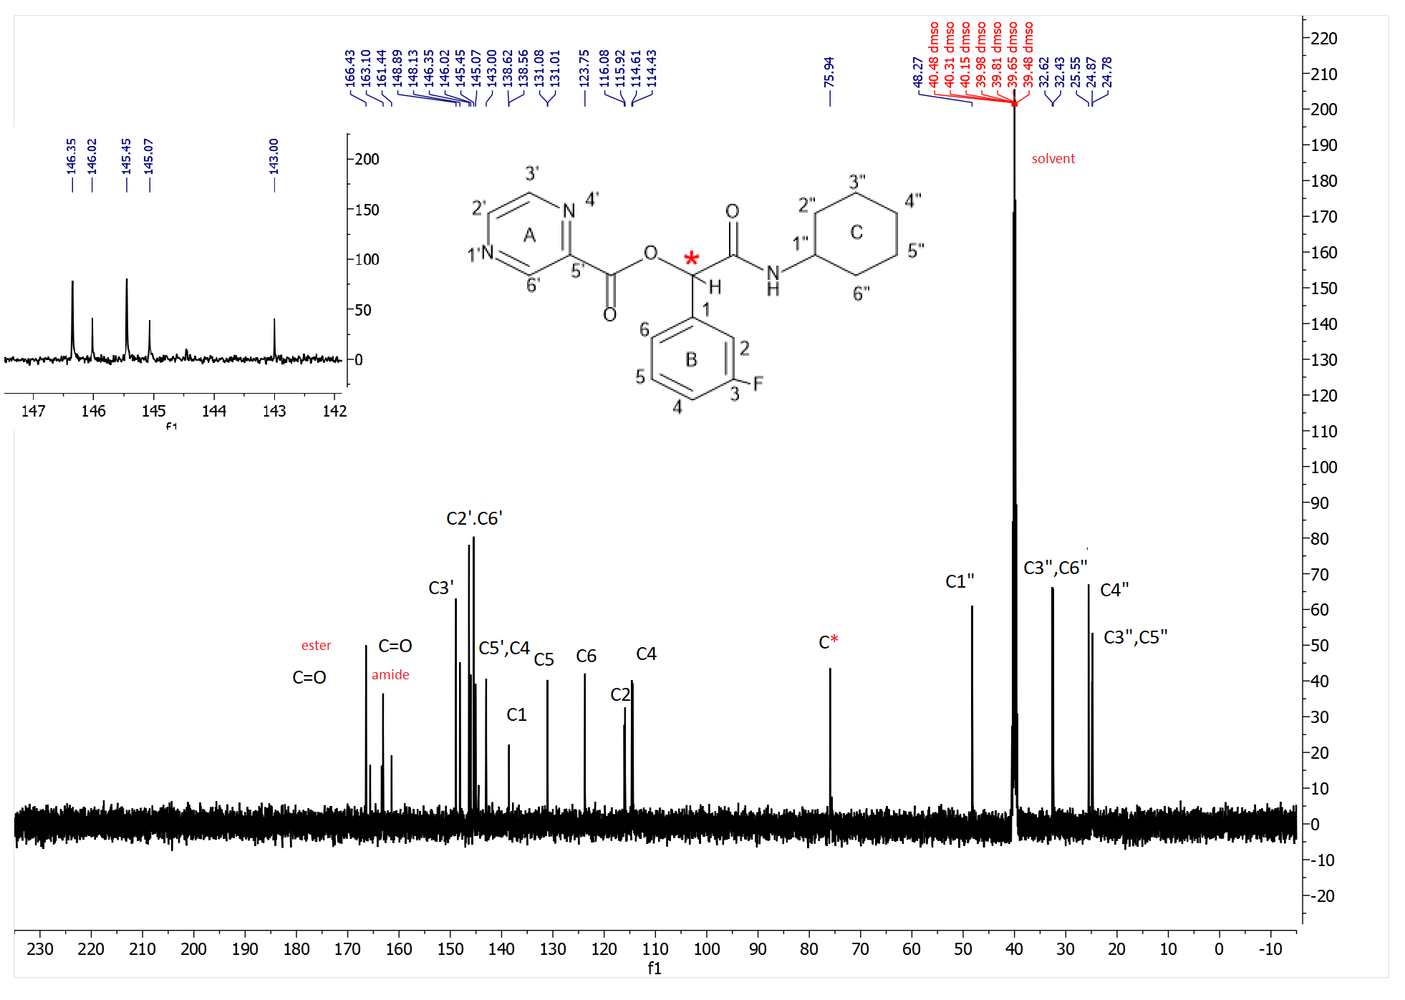
Figure S41. ¹³C-NMR spectrum of P12

2-(cyclohexylamino)-1-(4-fluorophenyl)-2-oxoethyl pyrazine-2-carboxylate(P13)
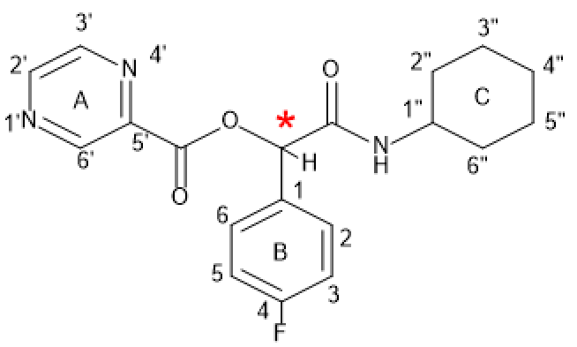
P13
Yield: 56%, mp: 180-182°C, white solid. IR (KBr disk): (3265.97 (NH amid group)), (3100.43 (CH aromatic)), (2930.03-2854.01 (CH aliphatic)), (1718.87 (C=O ester)), (1656.95 (C=O amid)), (1569.89-1510.03 (C=C aromatic)), (1187.89 (C-O)), (C-F (967.65)) cm⁻¹. ¹H NMR (300 MHz, DMSO-d6) δ (9.29 (s, 1H) H^{6’}, (9.03 – 8.71 (m, 2H) H^{2’,3’}), (8.39 – 8.21 (m, 2H) H²), (8.09 (dd, J = 8.4, 5.7 Hz, 1H) NH), (7.64 (dd, J = 7.6, 4.7 Hz, 2H)H⁶), (7.47 – 7.12 (m, 3H) H^{3,5}) overlapping multiple), (6.09 (d, J = 22.8 Hz, 1H) CH*), 3.50 (s, 1H) H^{1”}) , (2.15 – 1.38 (m, 4H) H^{2”,4”,6”}), (1.12 (dd, J = 30.1, 19.4 Hz, 3H) H^{3”,5”}). ¹³C NMR (75 MHz, DMSO) δ 166.67, 166.34, 163.99, 163.88, 162.73, 160.63, 148.41, 145.85, 144.97, 142.61, 132.26, 131.85, 131.81, 129.59, 125.79, 116.10, 115.80, 115.53, 115.24, 75.57, 74.95, 47.75, 40.33, 40.06, 39.78, 39.50, 39.22, 38.94, 38.67, 32.20, 32.00, 25.10, 24.43.
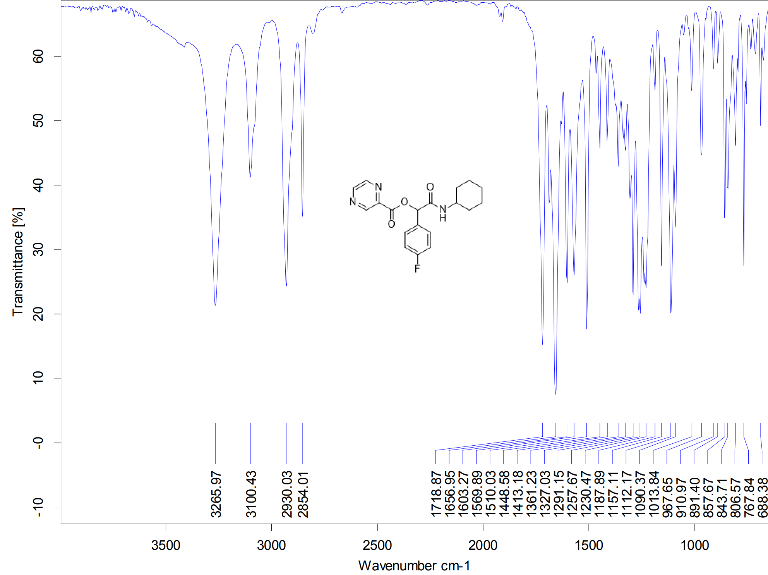
Figure S42. IR spectrum of P13
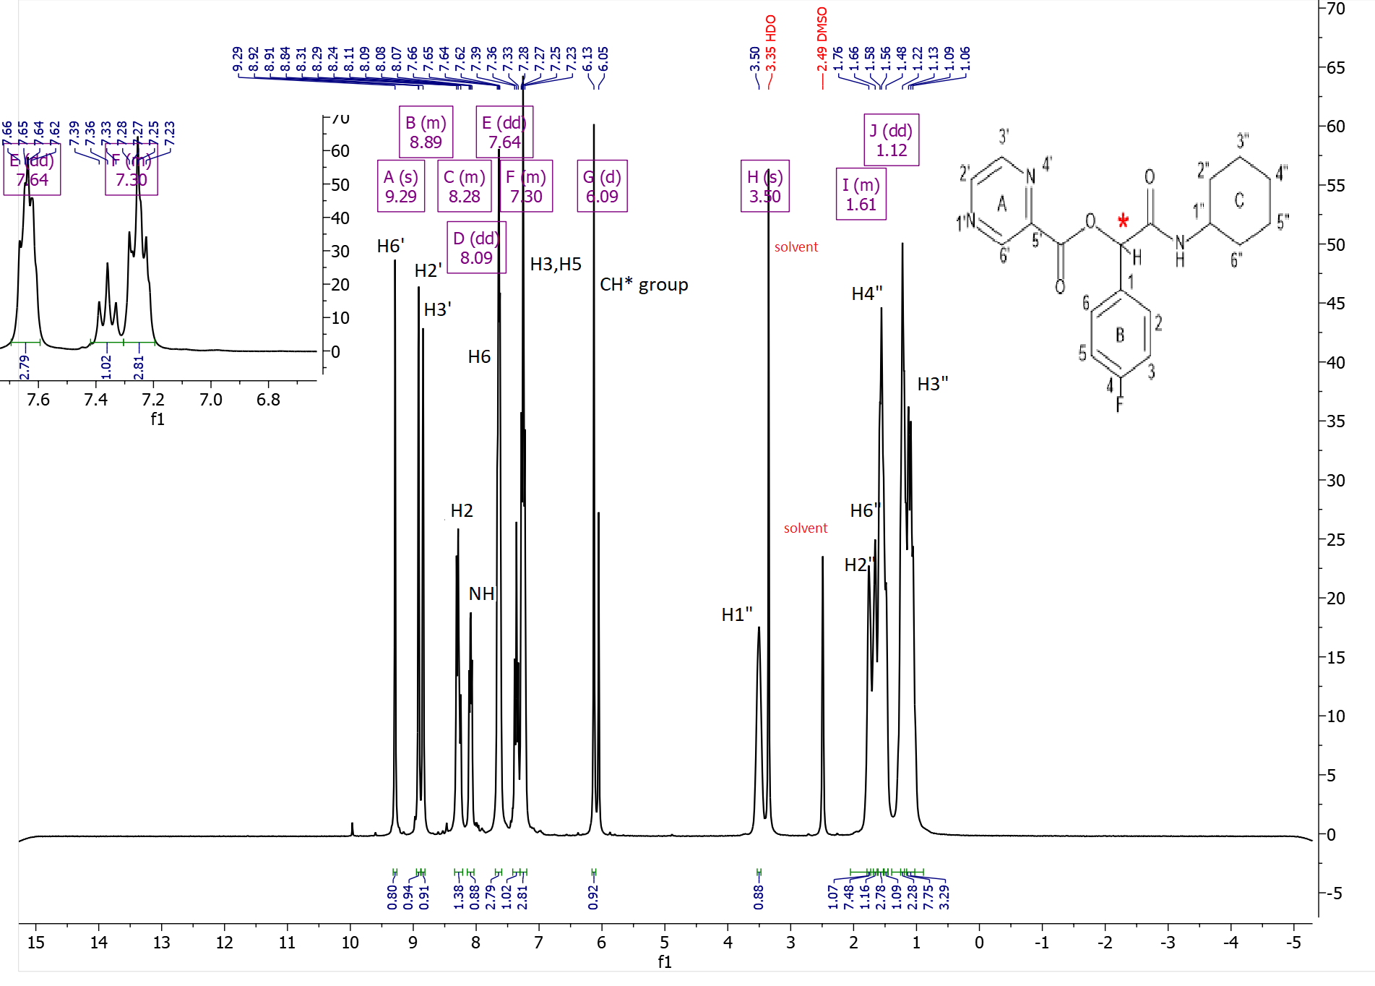
Figure S43. ¹H-NMR spectrum of P13
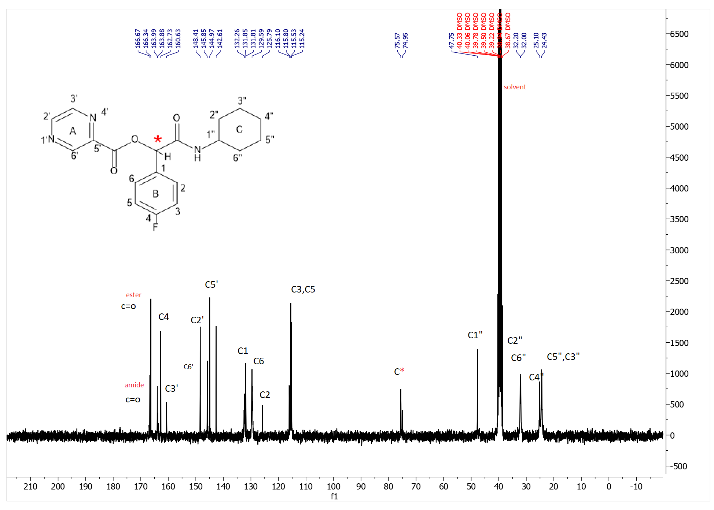
Figure S44. ¹³C-NMR spectrum of P13

1-(2-chlorophenyl)-2-(cyclohexylamino)-2-oxoethyl pyrazine-2-carboxylate(P14)
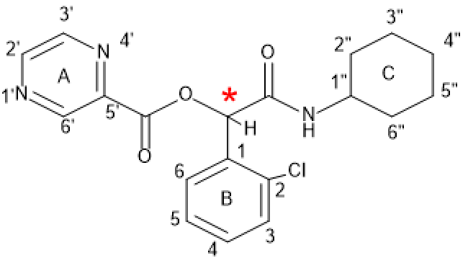
P14
Yield: 48%, mp: 138-139°C, white solid. IR (KBr disk): (3308.64 (NH amid group)), (3061.78-3029.67 (CH aromatic)), (2938.15-2850.61(CH aliphatic)), (1738.85(C=O ester)), (1649.84(C=O amid)), (1536.92-1449.65 (C=C aromatic)), (1133.88 (C-O)), (755.87 (C-Cl)) cm⁻¹. ¹H NMR (499 MHz, DMSO-d6) δ (8.33 (d, J = 7.7 Hz, 1H) H^{6’}), (7.86 (d, J = 8.0 Hz, 2H)H^{3’,2’}), (7.71 – 7.23 (m, 6H) H^{3,4,5,6},NH overlapping multiple), (6.40 (s, 1H) CH*), (5.24 (s, 1H)H^{1”}), (1.66 (ddd, J = 74.7, 41.4, 13.2 Hz, 6H)H^{2”,4”,6”}), (1.20 (dq, J = 54.4, 14.5, 12.0 Hz, 3H).H^{5”,3”}). ¹³C NMR (126 MHz, dmso) δ 165.77, 164.27, 134.21, 134.13, 133.69, 131.93, 131.43, 131.22, 130.14, 130.03, 129.45, 128.01, 127.93, 73.40, 48.47, 40.49, 40.32, 40.15, 39.99, 39.82, 39.65, 39.49, 32.51, 25.58, 24.91.
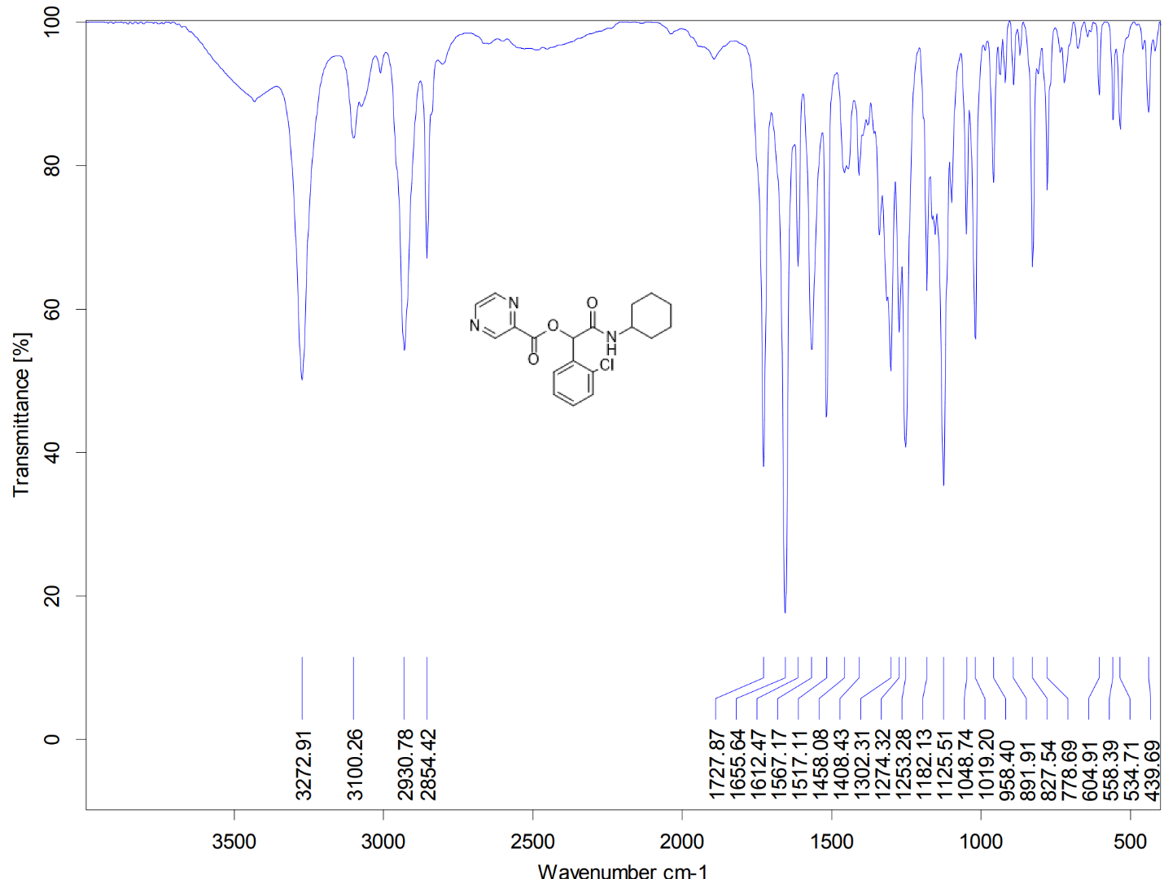
Figure S45. IR spectrum of P14

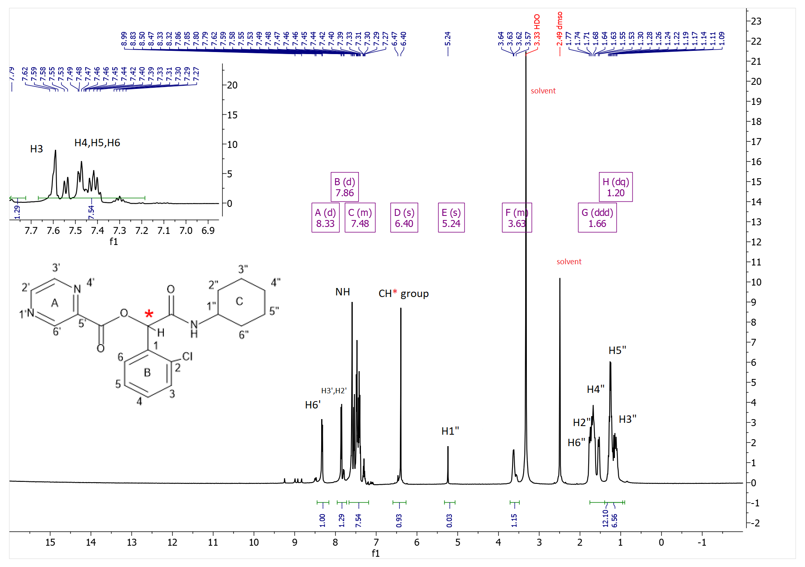
Figure S46. ¹H-NMR spectrum of P14
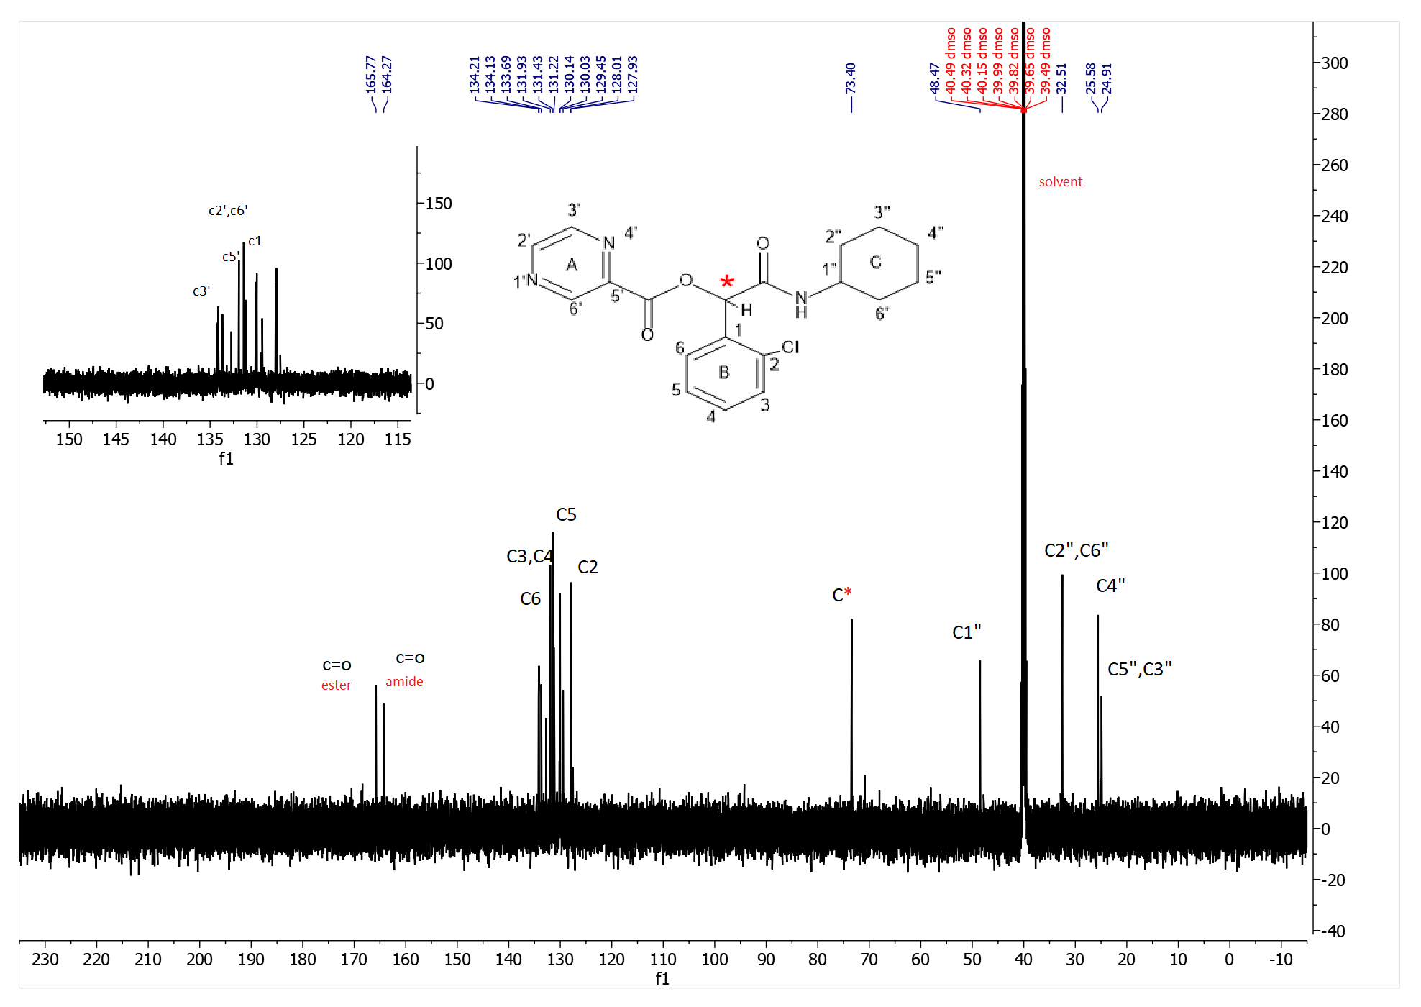
Figure S47. ¹³C-NMR spectrum of P14

1-(3-chlorophenyl)-2-(cyclohexylamino)-2-oxoethyl pyrazine-2-carboxylate(P15)
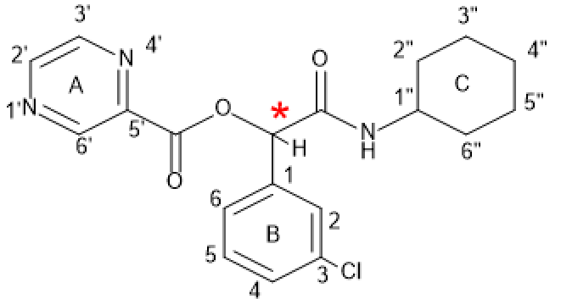
P15
Yield: 49%, mp: 139-141°C, white solid. IR (KBr disk): (3308.64 (NH amid group)), (3061.78-3029.67 (CH aromatic)), (2938.15-2850.61(CH aliphatic)), (1738.85(C=O ester)), (1649.84(C=O amid)), (1536.92-1449.65 (C=C aromatic)), (1133.88 (C-O)), (755.87 (C-Cl)) cm⁻¹. ¹H NMR (300 MHz, DMSO-d₆) δ (9.31 (d, J = 1.3 Hz, 1H) H^{6’}), (9.04 – 8.77 (m, 2H) H^{3’.2’}), (8.36 (d, J = 7.8 Hz, 1H)NH), (7.78 – 7.32 (m, 4H) H^{2,4,5,6} overlapping multiple), (6.13 (s, 1H) CH*, (3.66 – 3.44 (m, 1H) H^{1”}), (1.84 – 1.35 (m, 6H) H^{2”,4”,6”}), (1.15 (ddd, J = 43.8, 19.5, 9.6 Hz, 4H) H^{5”,3”}). ¹³C NMR (75 MHz, DMSO) δ 165.96, 162.66, 148.47, 145.89, 144.99, 142.51, 137.83, 133.05, 130.49, 128.69, 127.15, 127.04, 125.92, 75.46, 47.81, 40.33, 40.06, 39.78, 39.50, 39.22, 38.94, 38.67, 32.16, 25.10, 24.41.
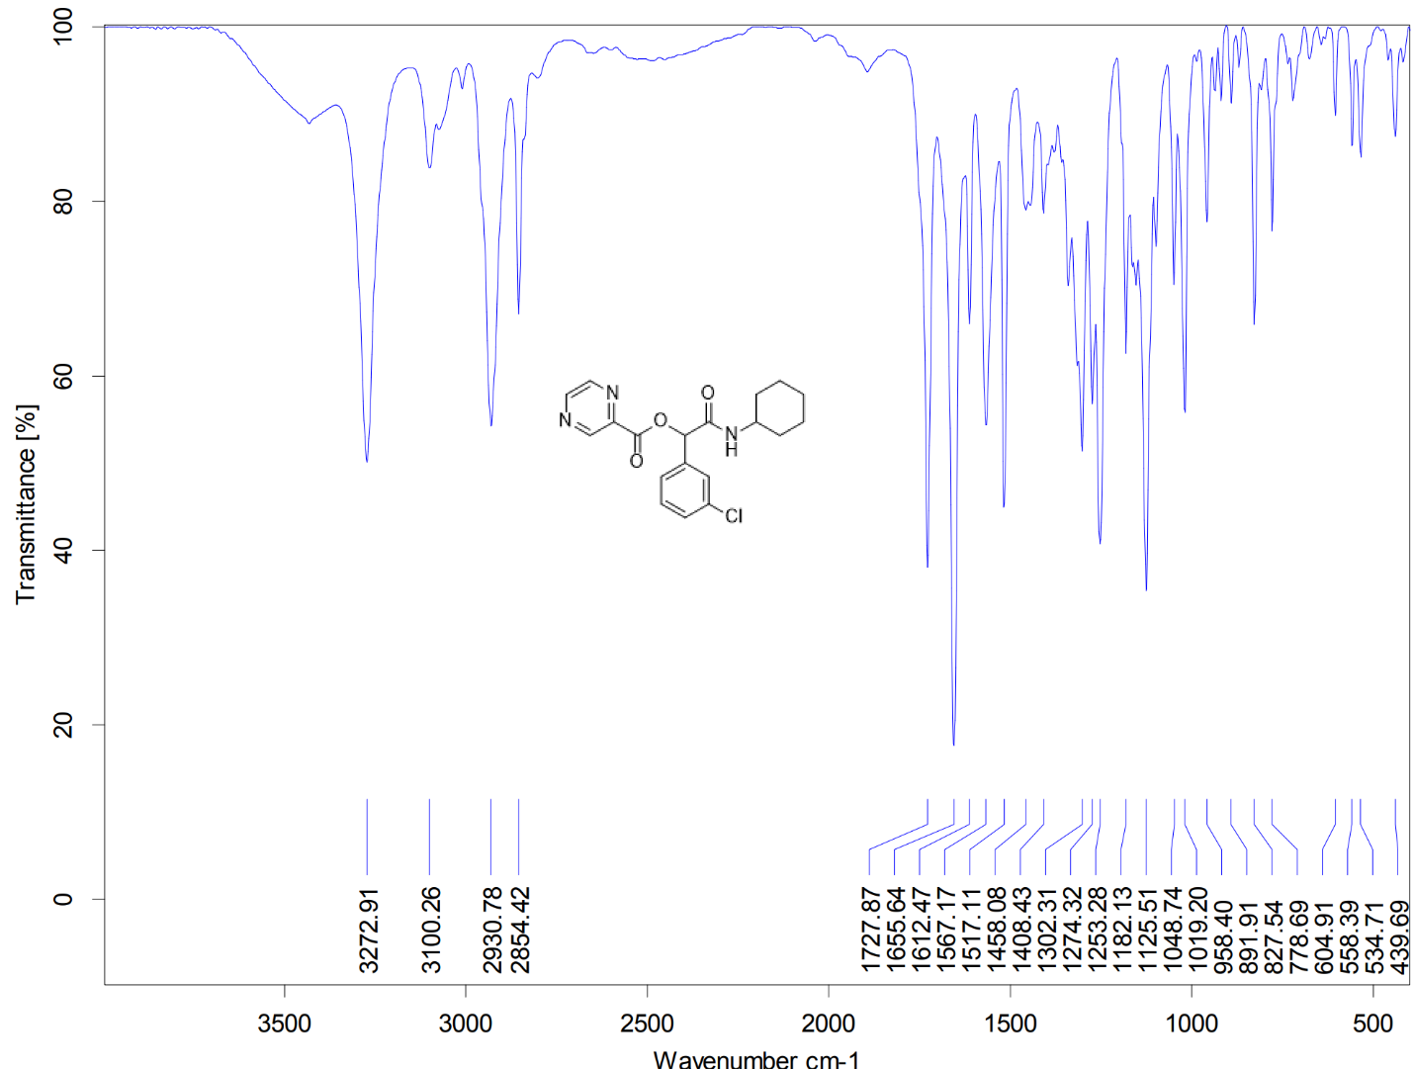
Figure S48. IR spectrum of P15
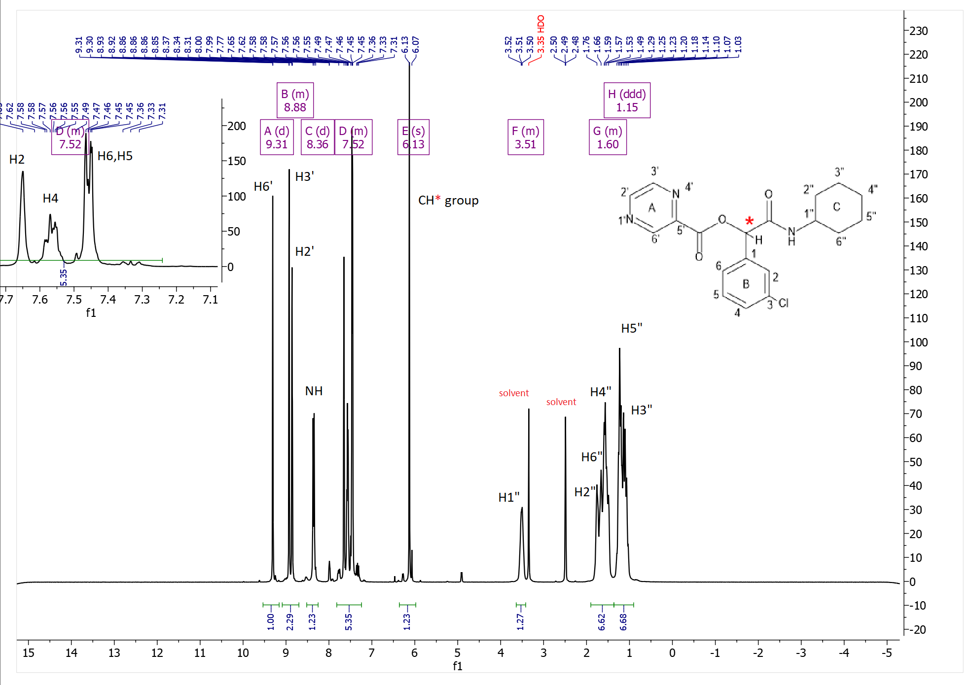
Figure S49. ¹H-NMR spectrum of P15

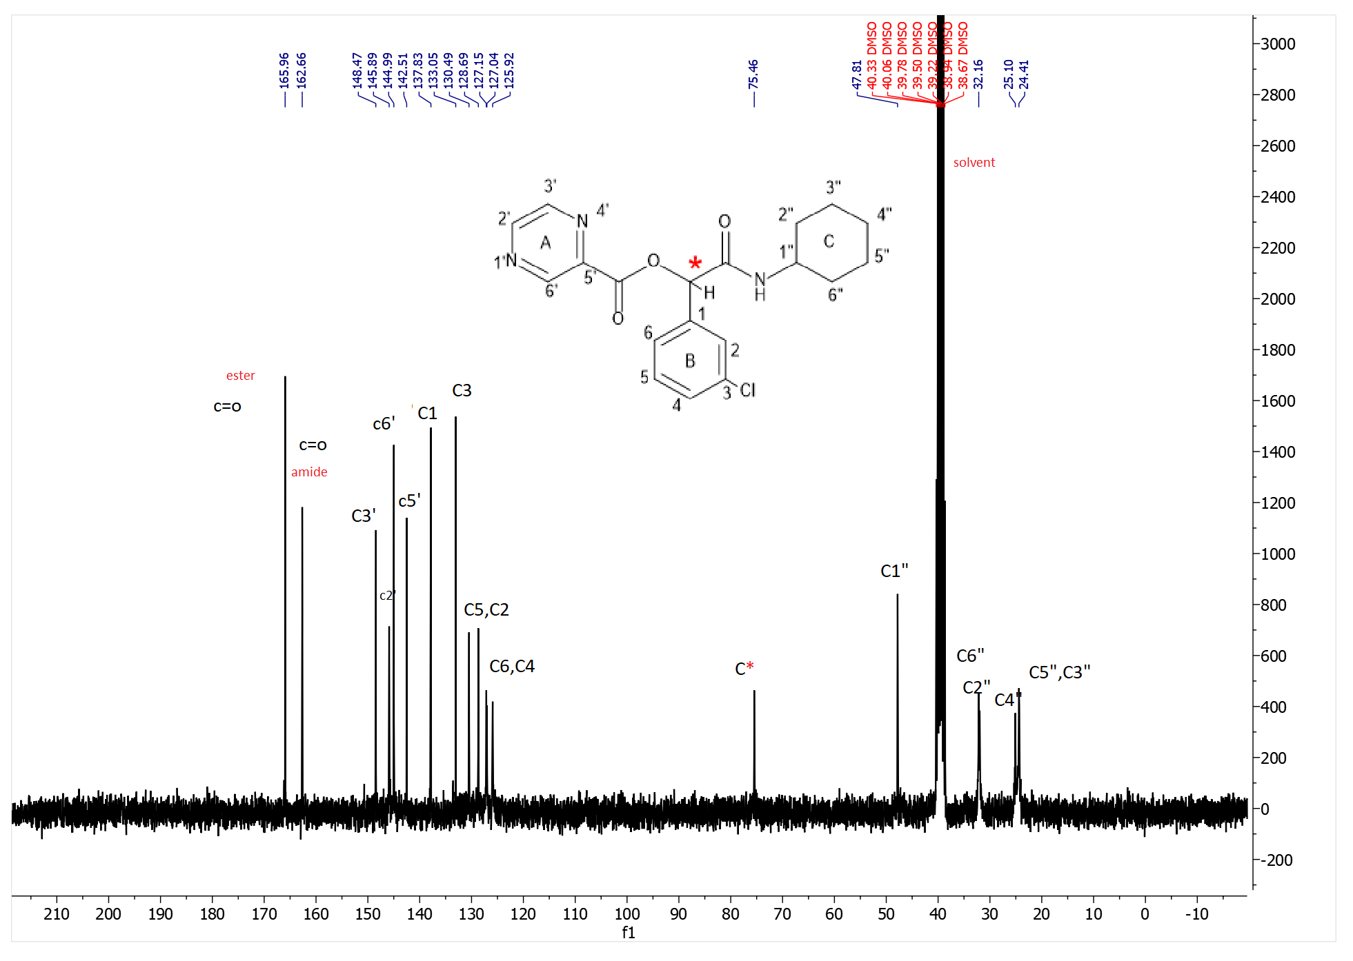
Figure S50. ¹³C-NMR spectrum of P15

1-(4-chlorophenyl)-2-(cyclohexylamino)-2-oxoethyl pyrazine-2-carboxylate(P16)
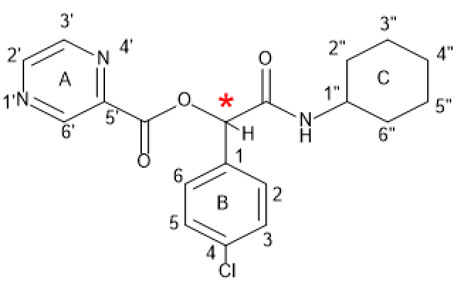
P16
Yield: 49%, mp: 139-141°C, white solid. IR (KBr disk): (3308.64 (NH amid group)), (3061.78-3029.67 (CH aromatic)), (2938.15-2850.61(CH aliphatic)), (1738.85(C=O ester)), (1649.84(C=O amid)), (1536.92-1449.65 (C=C aromatic)), (1133.88 (C-O)), (755.87 (C-Cl)) cm⁻¹. ¹H NMR (300 MHz, DMSO-d6) δ (9.30 (s, 1H) H^{6’}), (8.88 (d, J = 20.6 Hz, 2H) H^{3’,2’}), (8.33 (d, J = 7.6 Hz, 1H) NH), (7.80 – 7.30 (m, 4H) H^{2,3,5.6} overlapping multiple), (6.13 (s, 1H) CH*), (3.50 (s, 1H) H^{1”}), (1.93 – 1.44 (m, 7H) H^{2”,4”,6”}), (1.43 – 0.87 (m, 3H) H^{5”,3”}). ¹³C NMR (75 MHz, DMSO) δ 166.10, 162.66, 148.41, 145.85, 144.97, 142.54, 134.50, 133.40, 129.18, 128.53, 75.49, 47.76, 40.32, 40.04, 39.76, 39.48, 39.20, 38.93, 38.65, 32.17, 31.97, 25.09, 24.39. Elemental analysis calcd (%) for C₁₉H₂₀ClN₃O₃ (373.12):C,61.04; H,5.39; N,11.24;found: C,61.12;H,5.47;N,11.32.

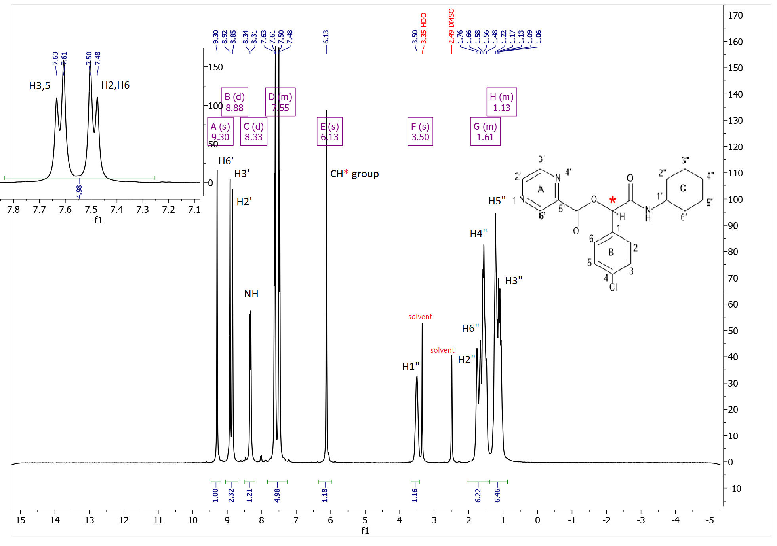
Figure S51. ¹H-NMR spectrum of P16
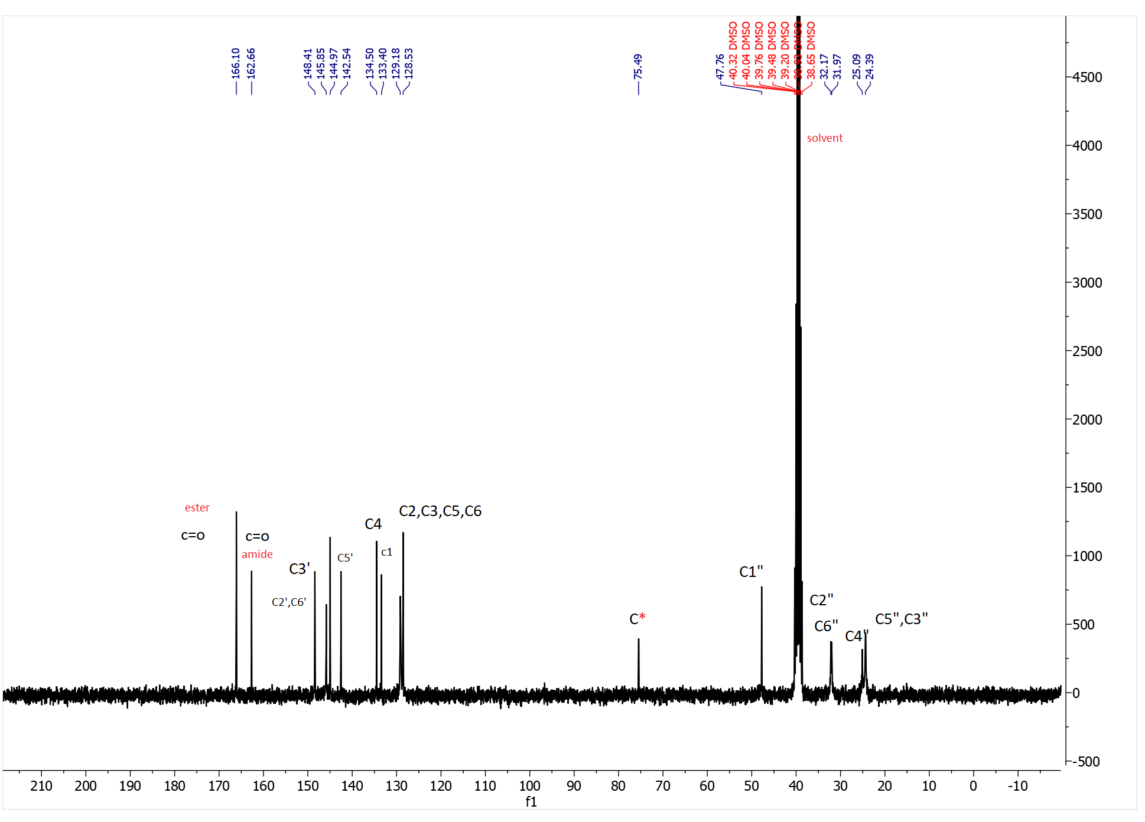
Figure S52. ¹³C-NMR spectrum of P16
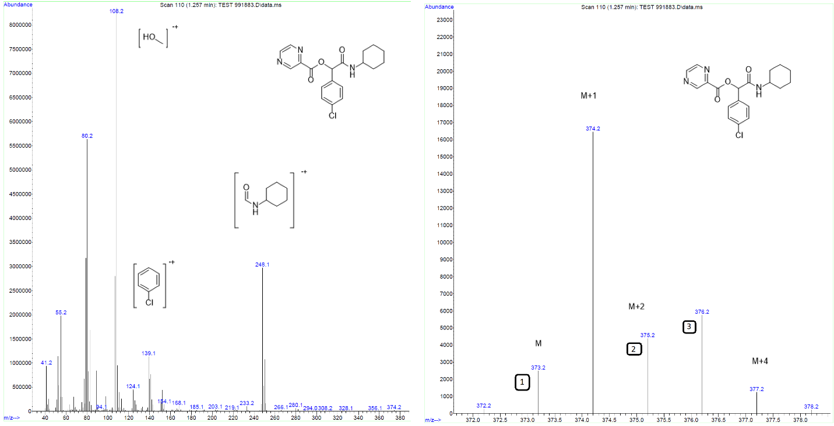
Figure S53. Mass spectrum of P16
2-(cyclohexylamino)-1-(2,4-dichlorophenyl)-2-oxoethyl pyrazine-2-carboxylate(P17)
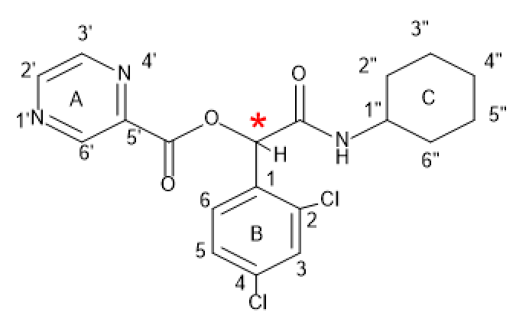
P17
Yield: 77%, mp: 164-166°C, white solid. IR (KBr disk): (3325.35 (NH amid group)), (3061.78-3029.67 (CH aromatic)), (2938.15-2850.61(CH aliphatic)), (1738.85(C=O ester)), (1649.84(C=O amid)), (1536.92-1449.65 (C=C aromatic)), (1133.88 (C-O)), (755.87 (C-Cl)) cm⁻¹. ¹H NMR (499 MHz, DMSO-d₆) δ (9.26 (s, 1H) H^{6’}), (9.03 – 8.78 (m, 2H) H^{3’,2’}), (8.36 (d, J = 7.7 Hz, 1H) NH), (7.72 (s, 1H) H³), (7.53 (q, J = 8.7 Hz, 2H) H^{6,5}), (6.44 (s, 1H) CH*), 3.61 (s, 1H) H^{1”}), (1.94 – 1.41 (m, 6H) H^{2”,4”,6”}), (1.37 – 0.92 (m, 4H) H^{5”,3”}). ¹³C NMR (126 MHz, dmso) δ 165.31, 163.10, 149.00, 146.35, 145.47, 142.77, 135.12, 135.05, 132.86, 131.48, 129.66, 128.29, 73.08, 48.56, 40.49, 40.32, 40.16, 39.99, 39.82, 39.65, 39.49, 32.50, 32.48, 25.57, 24.95, 24.91. . Elemental analysis calcd (%) for C₁₉H₁₉Cl₂N₃O₃ (407.08):C,55.89; H,4.69; N,10.29;found: C,57.01;H,5.76;N,11.41.
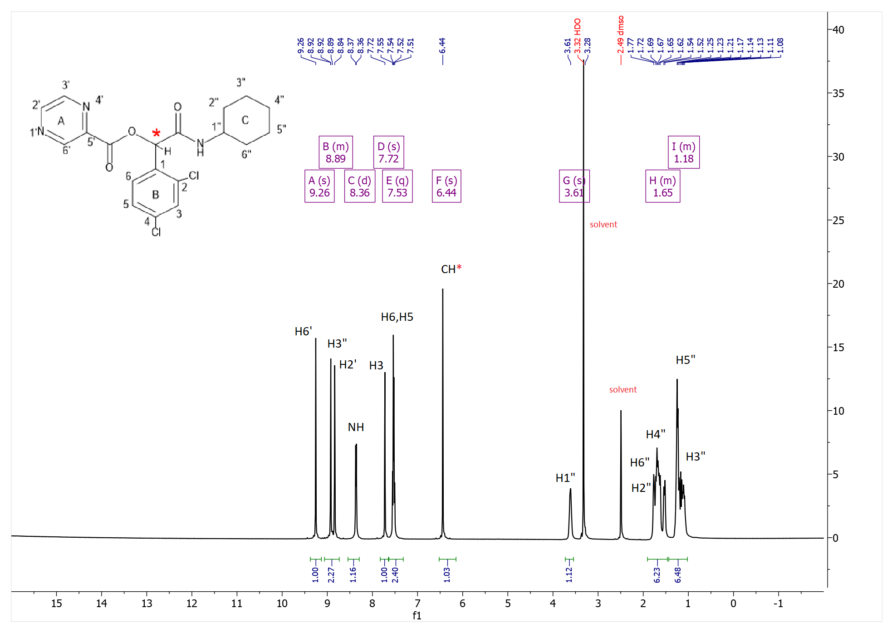
Figure S54. ¹H-NMR spectrum of P17
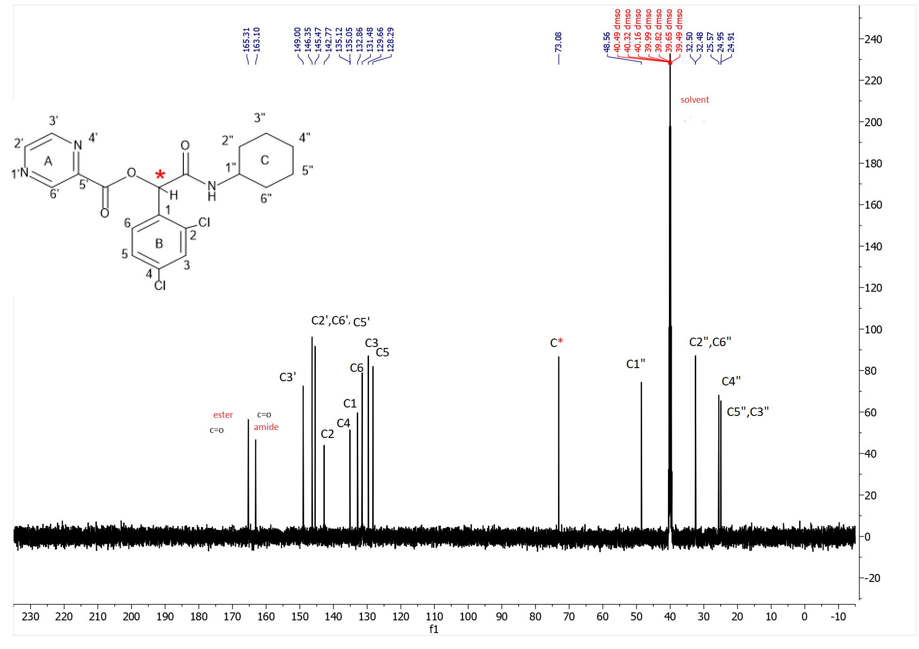
FigureS55. ¹³C-NMR spectrum of P17
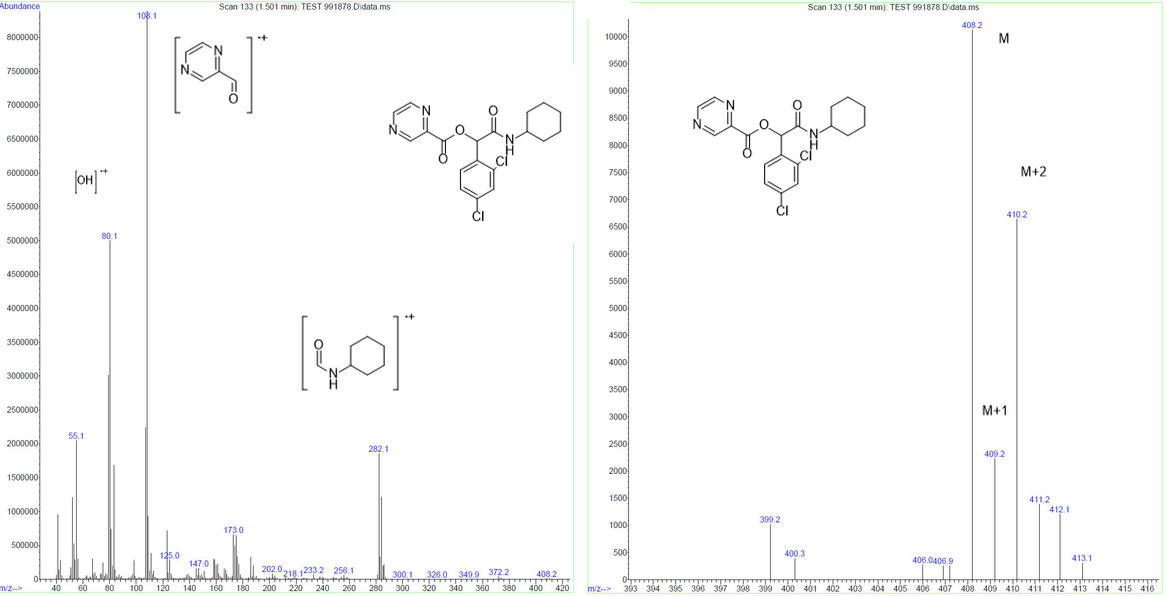
Figure S56. Mass spectrum of P17
2-(cyclohexylamino)-2-oxo-1-(p-tolyl)ethyl pyrazine-2-carboxylate(p18)
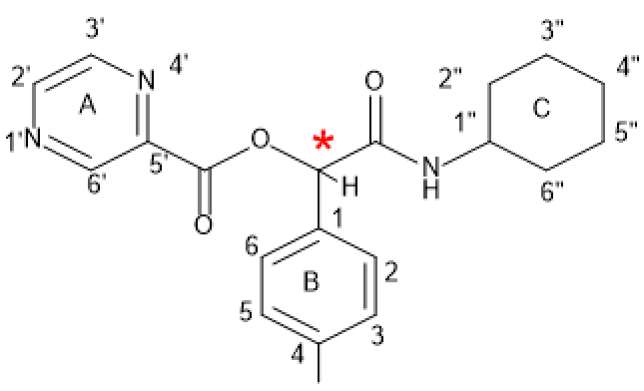
P18
Yield: 48%, mp: 180-182°C, white solid. IR (KBr disk): (3275.50 (NH amid group)), (3068.59-3037.58 (CH aromatic)), (2939.29-2855.41 (CH aliphatic)), (1731.89 (C=O ester)), (1656.44 (C=O amid)), (1545.71-1494.55 (C=C aromatic)), (1127.78 (C-O)) cm⁻¹. ¹H NMR (499 MHz, DMSO-d₆) δ (9.28 (s, 1H) H^{6’}), (8.88 (d, J = 35.5 Hz, 2H) H^{2’.3’}), (8.22 (d, J = 7.6 Hz, 1H) NH), (7.34 (dd, J = 125.5, 7.3 Hz, 4H) H^{6,5,2,3}), (6.08 (s, 1H) CH*), (3.51 (s, 1H) H^{1”}, 2.49 (s, 3H) Me group), (1.85 – 1.33 (m, 6H) H^{2”,4”,6”}), (1.33 – 0.83 (m, 4H) H^{5”,3”}). ¹³C NMR (126 MHz, dmso) δ 166.96, 163.25, 148.79, 146.24, 145.42, 143.18, 138.55, 133.05, 129.46, 127.85, 76.68, 48.20, 40.33, 40.16, 39.99, 39.83, 39.66, 39.49, 32.69, 32.50, 25.59, 24.93, 24.85, 21.24. Elemental analysis calcd (%) for C₂₀H₂₃N₃O₃ (353.17):C,67.97; H,6.56; N,11.89;found: C,68;H,6.59;N,11.92.

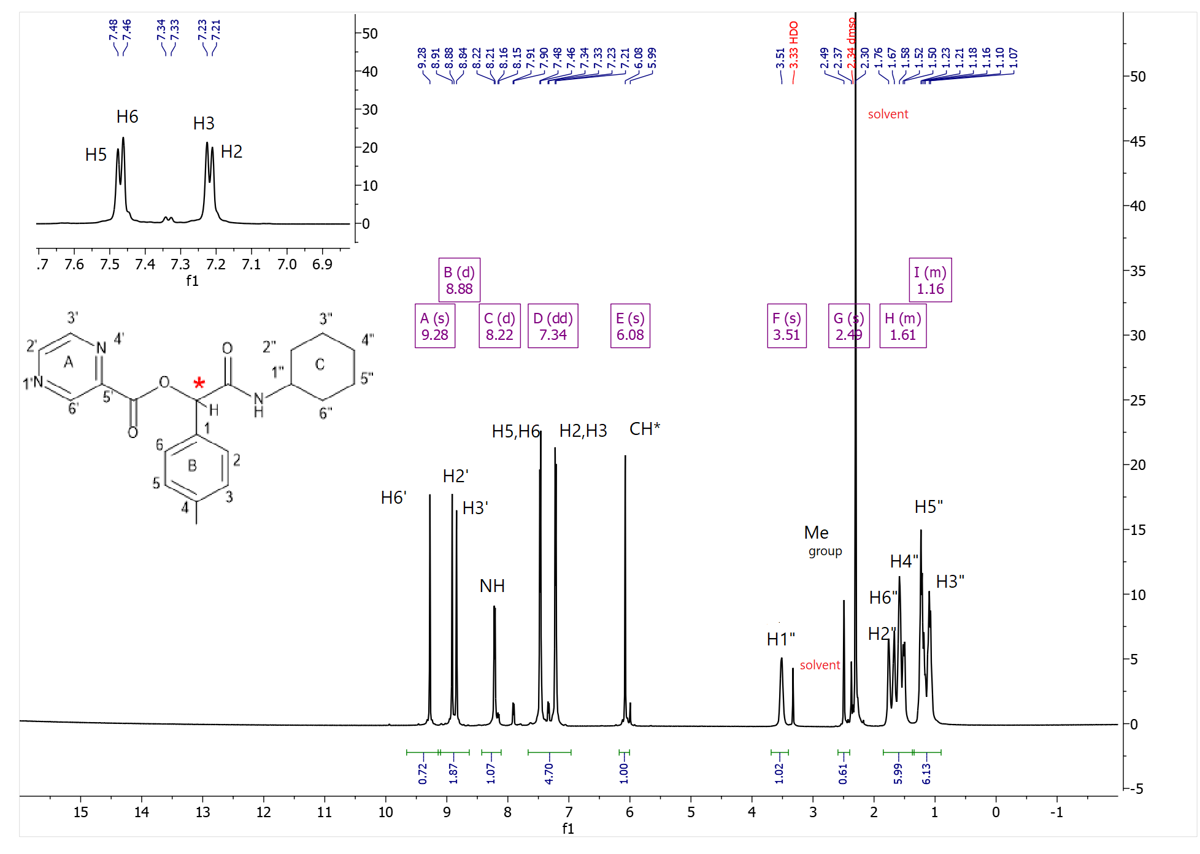
Figure S57. ¹H-NMR spectrum of P18
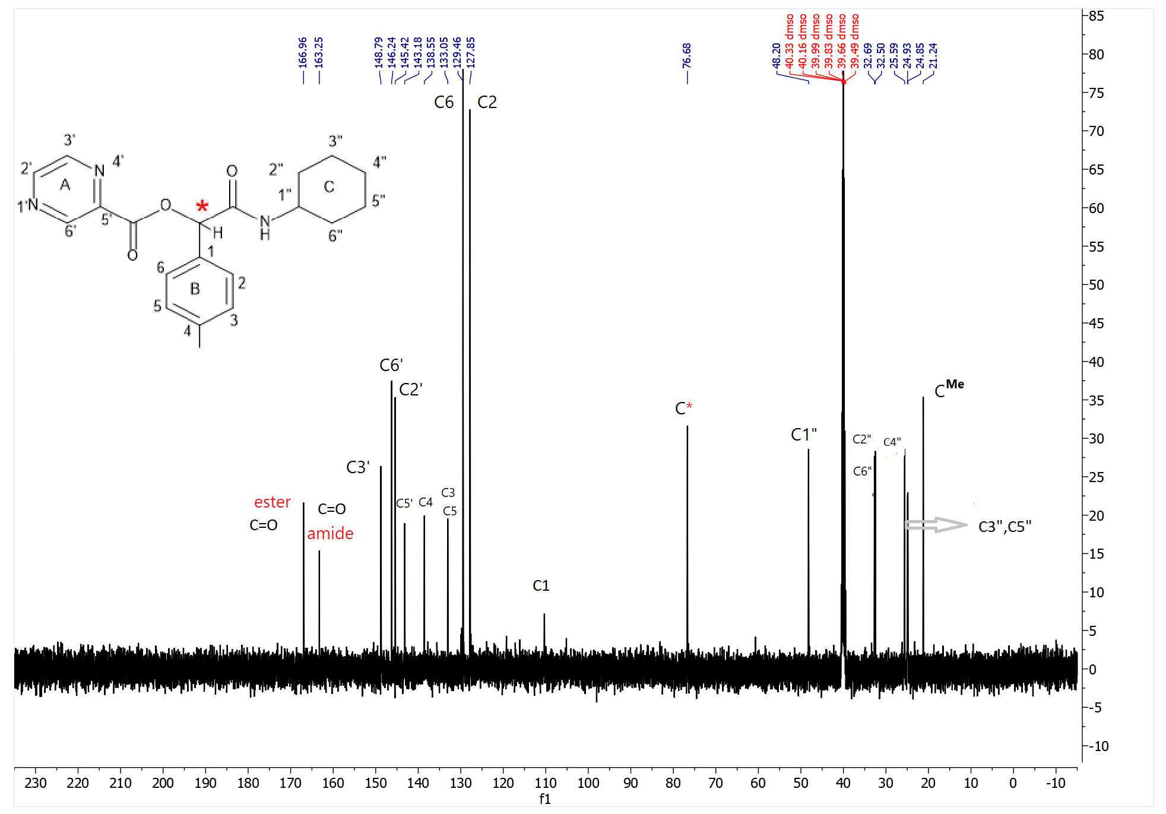
Figure S58. ¹³C-NMR spectrum of P18
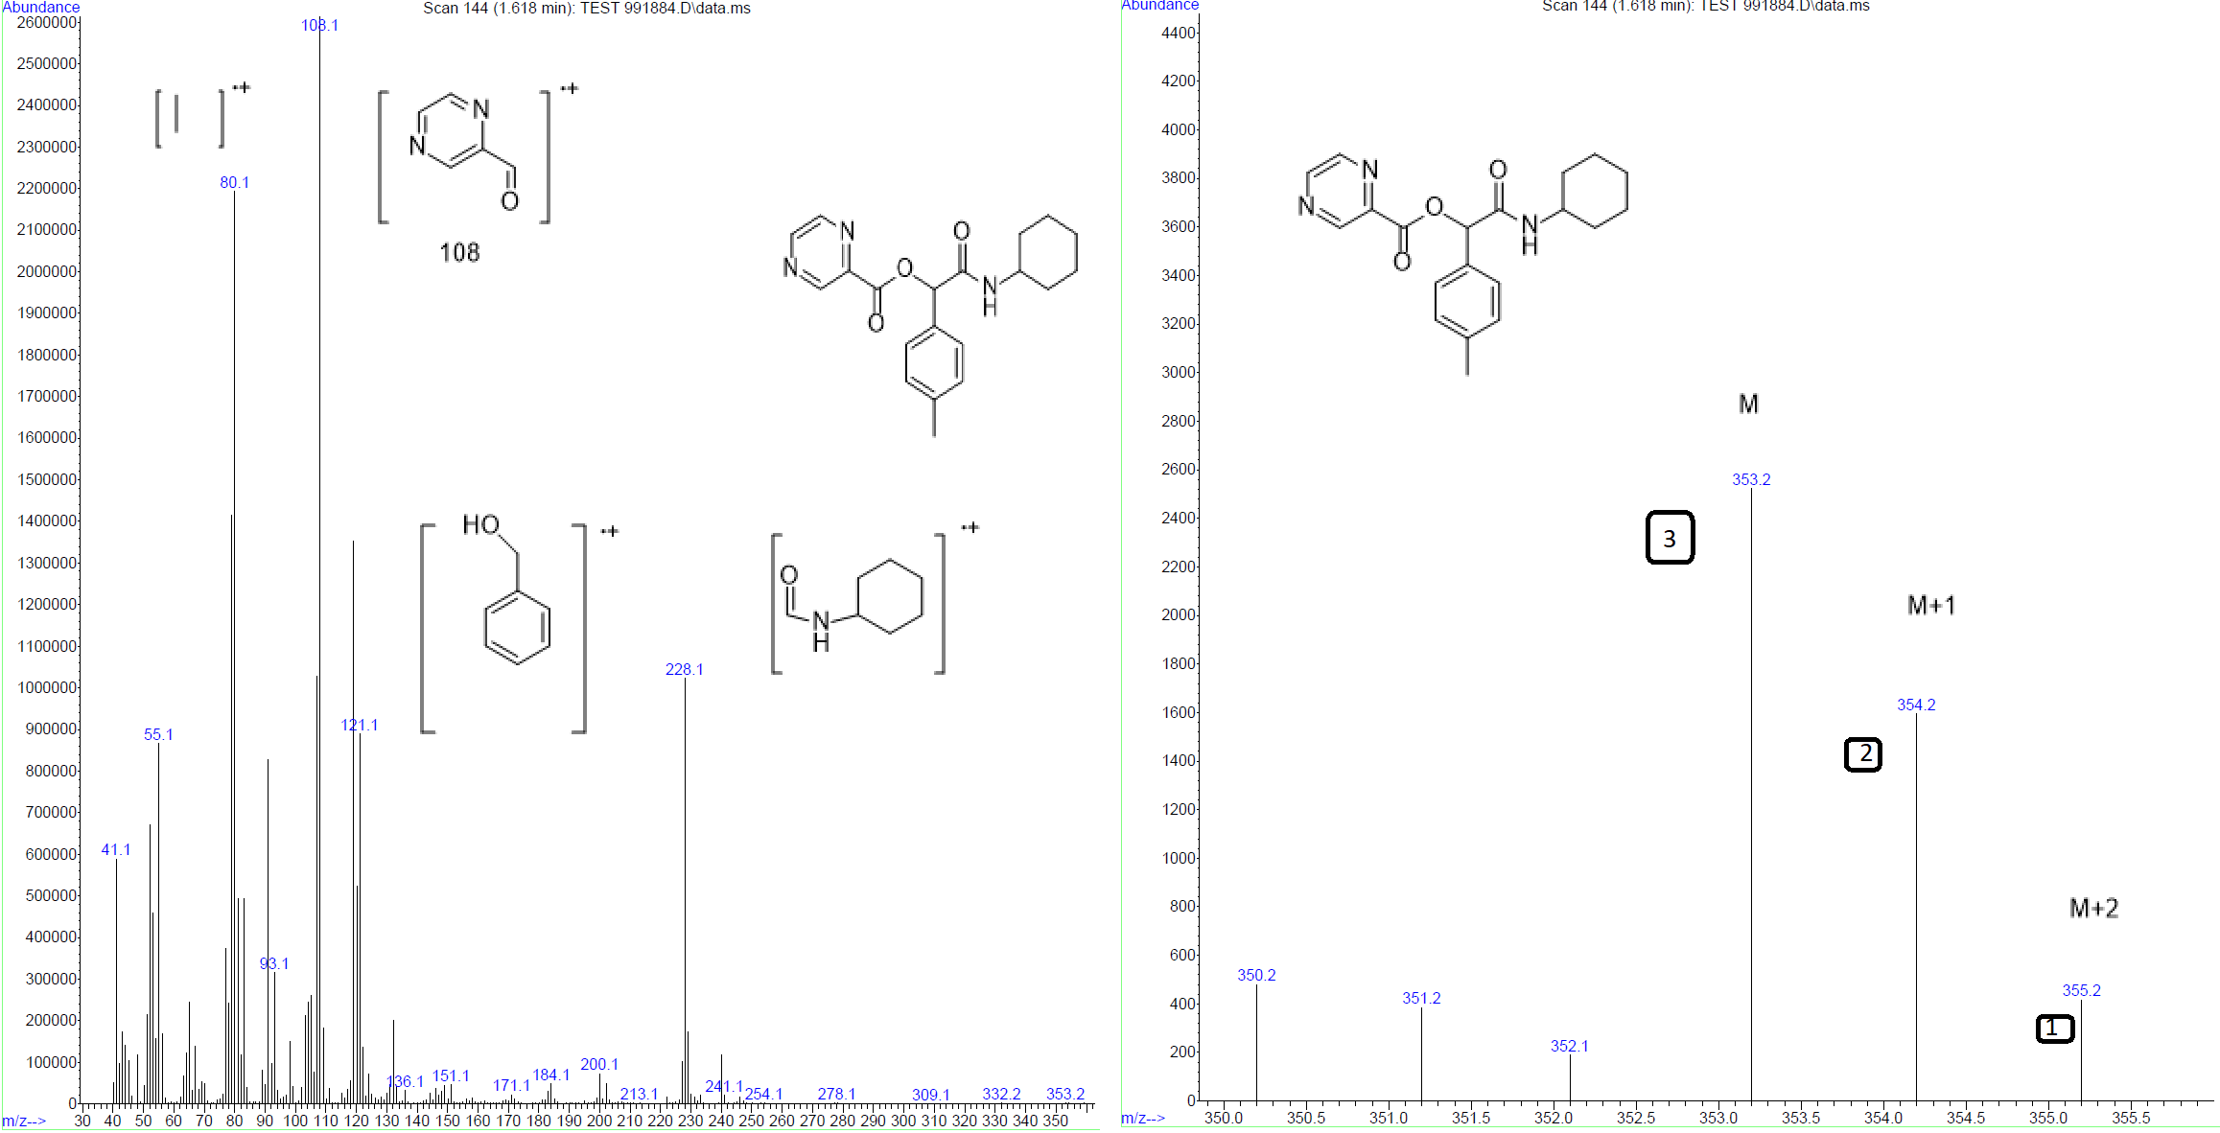
Figure S59. Mass spectrum of P18

2-(cyclohexylamino)-2-oxo-1-phenylethyl pyrazine-2-carboxylate(P19)
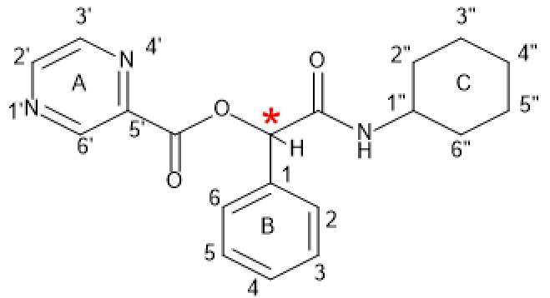
P19
Yield: 62%, mp: 172-174°C, white solid. IR (KBr disk): (3315.29 (NH amid group)), (3071.59-3030.32 (CH aromatic)), (2933.82-2857.39 (CH aliphatic)), (1725.84 (C=O ester)), (1665.11(C=O amid)), (1549.11-1498.04 (C=C aromatic)), (1131.69 (C-O)) cm⁻¹.¹H NMR (300 MHz, DMSO-d₆) δ (9.29 (s, 1H) H^{6’}), (9.05 – 8.70 (m, 2H) H^{3’,2’}), (8.29 (d, J = 7.8 Hz, 1H)NH), (7.80 – 7.24 (m, 5H) H^{2,3,4,5,6}), (6.09 (d, J = 18.1 Hz, 1H) CH*), (3.50 (s, 1H) H^{1”}, (1.88 – 1.35 (m,6H) H^{2”,4”,6”}), (1.41 – 0.84 (m,4 H) H^{3”,5”}). ¹³C NMR (75 MHz, DMSO) δ 166.78, 166.38, 162.77, 148.37, 145.82, 144.96, 142.64, 135.51, 128.67, 128.46, 127.37, 76.24, 47.73, 40.32, 40.04, 39.76, 39.48, 39.20, 38.93, 38.65, 32.21, 32.01, 25.09, 24.43. Elemental analysis calcd (%) for C₁₉H₂₁N₃O₃ (339.16):C,67.24; H,6.24; N,12.38;found: C,67.28;H,6.28;N,12.42.

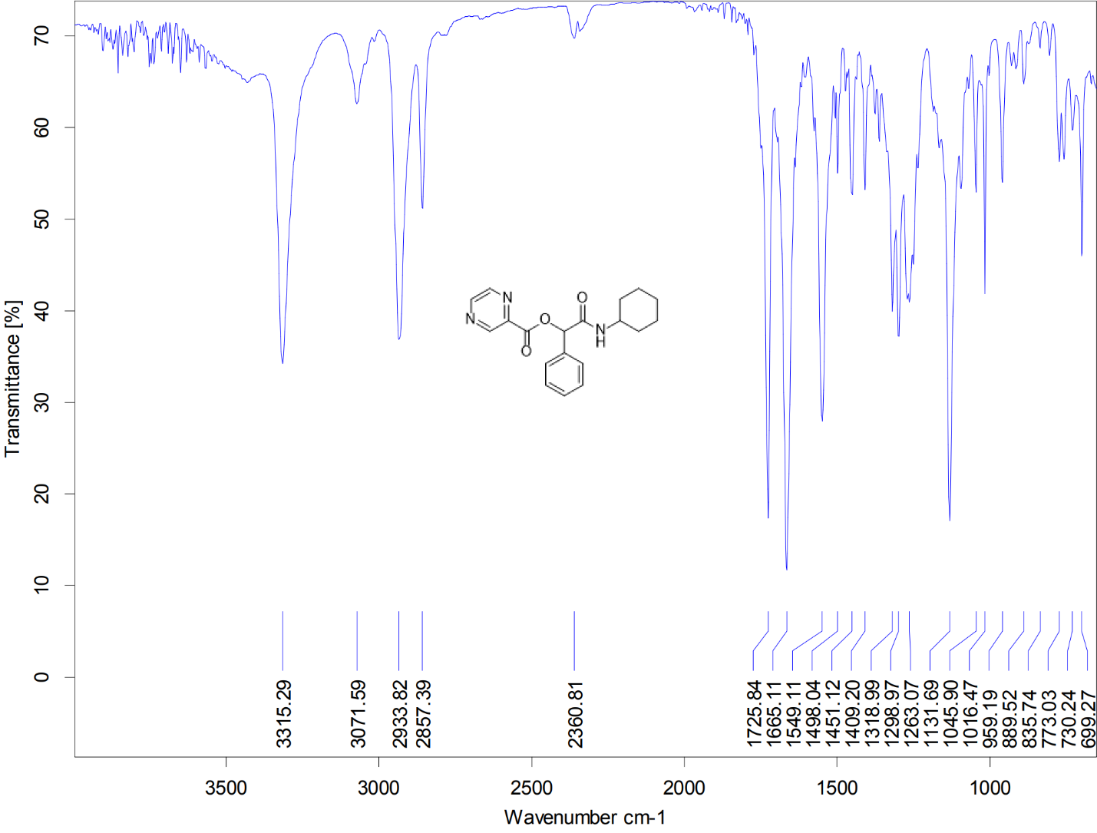
Figure S60. IR spectrum of P19

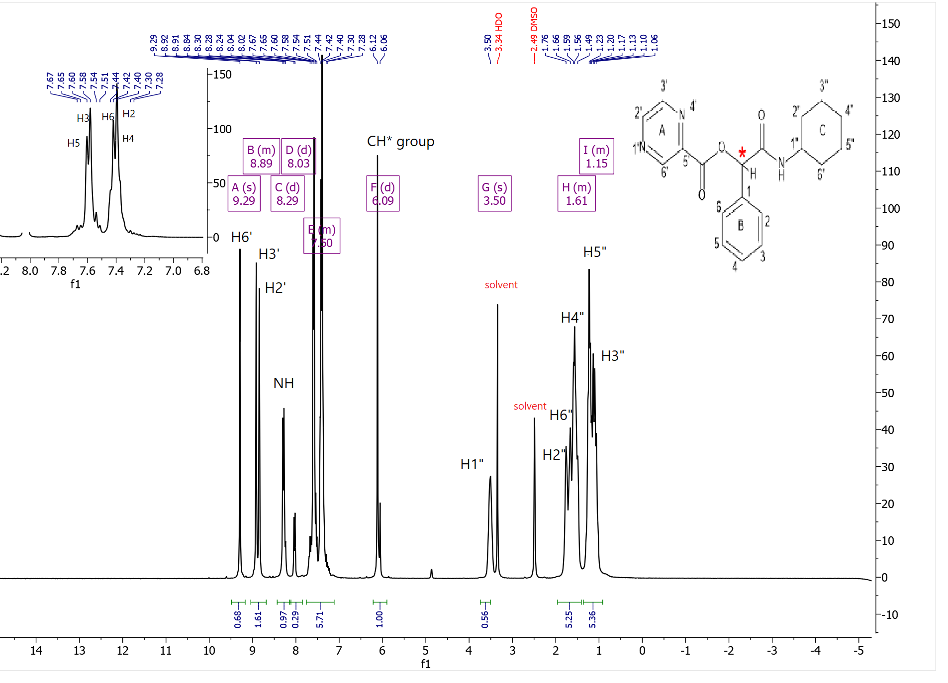
Figure S61. ¹H-NMR spectrum of P19
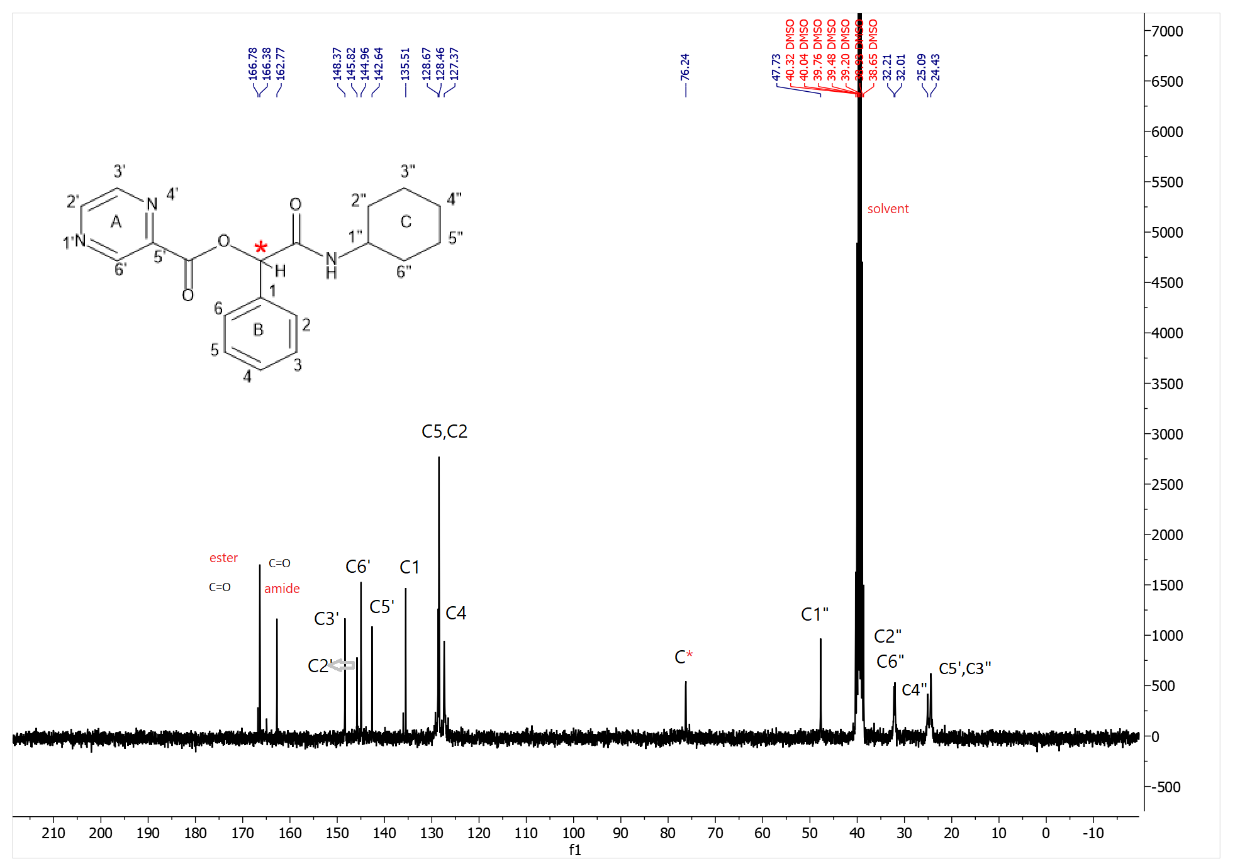
Figure S62. ¹³C-NMR spectrum of P19
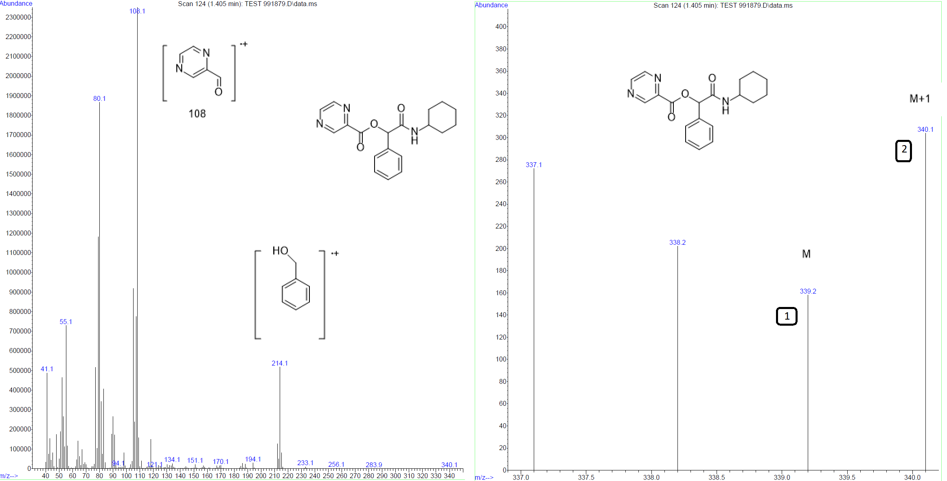
Figure S63. Mass spectrum of P19

1-(3-bromophenyl)-2-(cyclohexylamino)-2-oxoethyl pyrazine-2-carboxylate(P20)
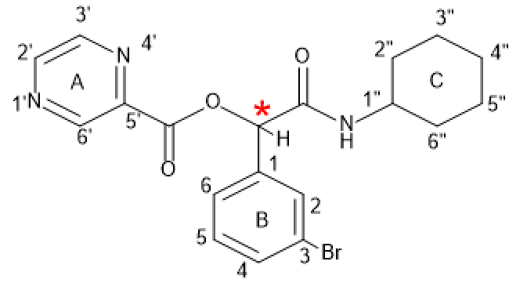
P20
Yield: 68%, mp: 142-145°C, white solid. IR (KBr disk): (3224.06 (NH amid group)), (3080.35-3025.97 (CH aromatic)), (2933.07-2854.21(CH aliphatic)), (1739.68(C=O ester)), (1650.87(C=O amid)), (1571.77-1413.39 (C=C aromatic)), (1164.44 (C-O)), (754.90 (C-Br)) cm⁻¹. ¹H NMR (300 MHz, DMSO-d6) δ (9.30 (s, 1H) H^{6’}), (8.89 (d, J = 20.3 Hz, 2H) H^{2’,3’}), (8.36 (d, J = 7.4 Hz, 1H) NH), (8.01 – 7.17 (m, 4H) H^{2,4,5,6}), (6.09 (d, J = 18.5 Hz, 1H) CH*), (3.50 (s, 1H) H^{1”}), (1.91 – 1.41 (m, 6H) H^{2”,4”,6”}), (1.39 – 0.80 (m, 4H) H^{5”,3”}). ¹³C NMR (75 MHz, DMSO) δ 165.94, 162.64, 148.44, 145.87, 144.97, 142.49, 138.03, 131.58, 130.75, 130.03, 129.90, 126.34, 121.56, 75.39, 47.79, 40.32, 40.04, 39.76, 39.48, 39.21, 38.93, 38.65, 31.97, 25.07, 24.39. Elemental analysis calcd (%) for C₁₉H₂₁BrN₃O₃ (417.07):C,54.56; H,4.82; N,10.05; found: C,54.49; H,4.75; N,9.98.

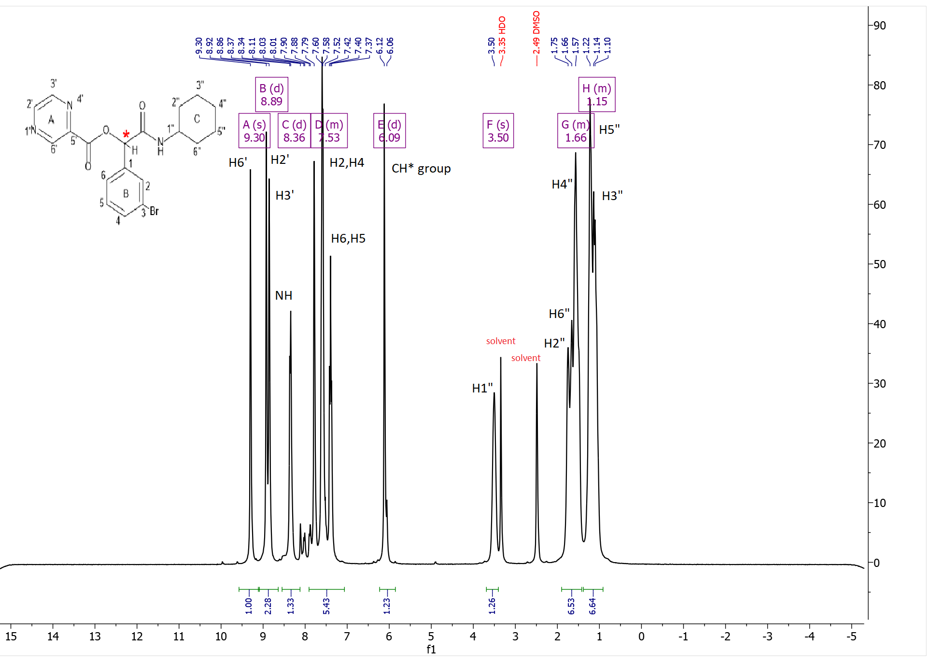
Figure S64. ¹H-NMR spectrum of P20
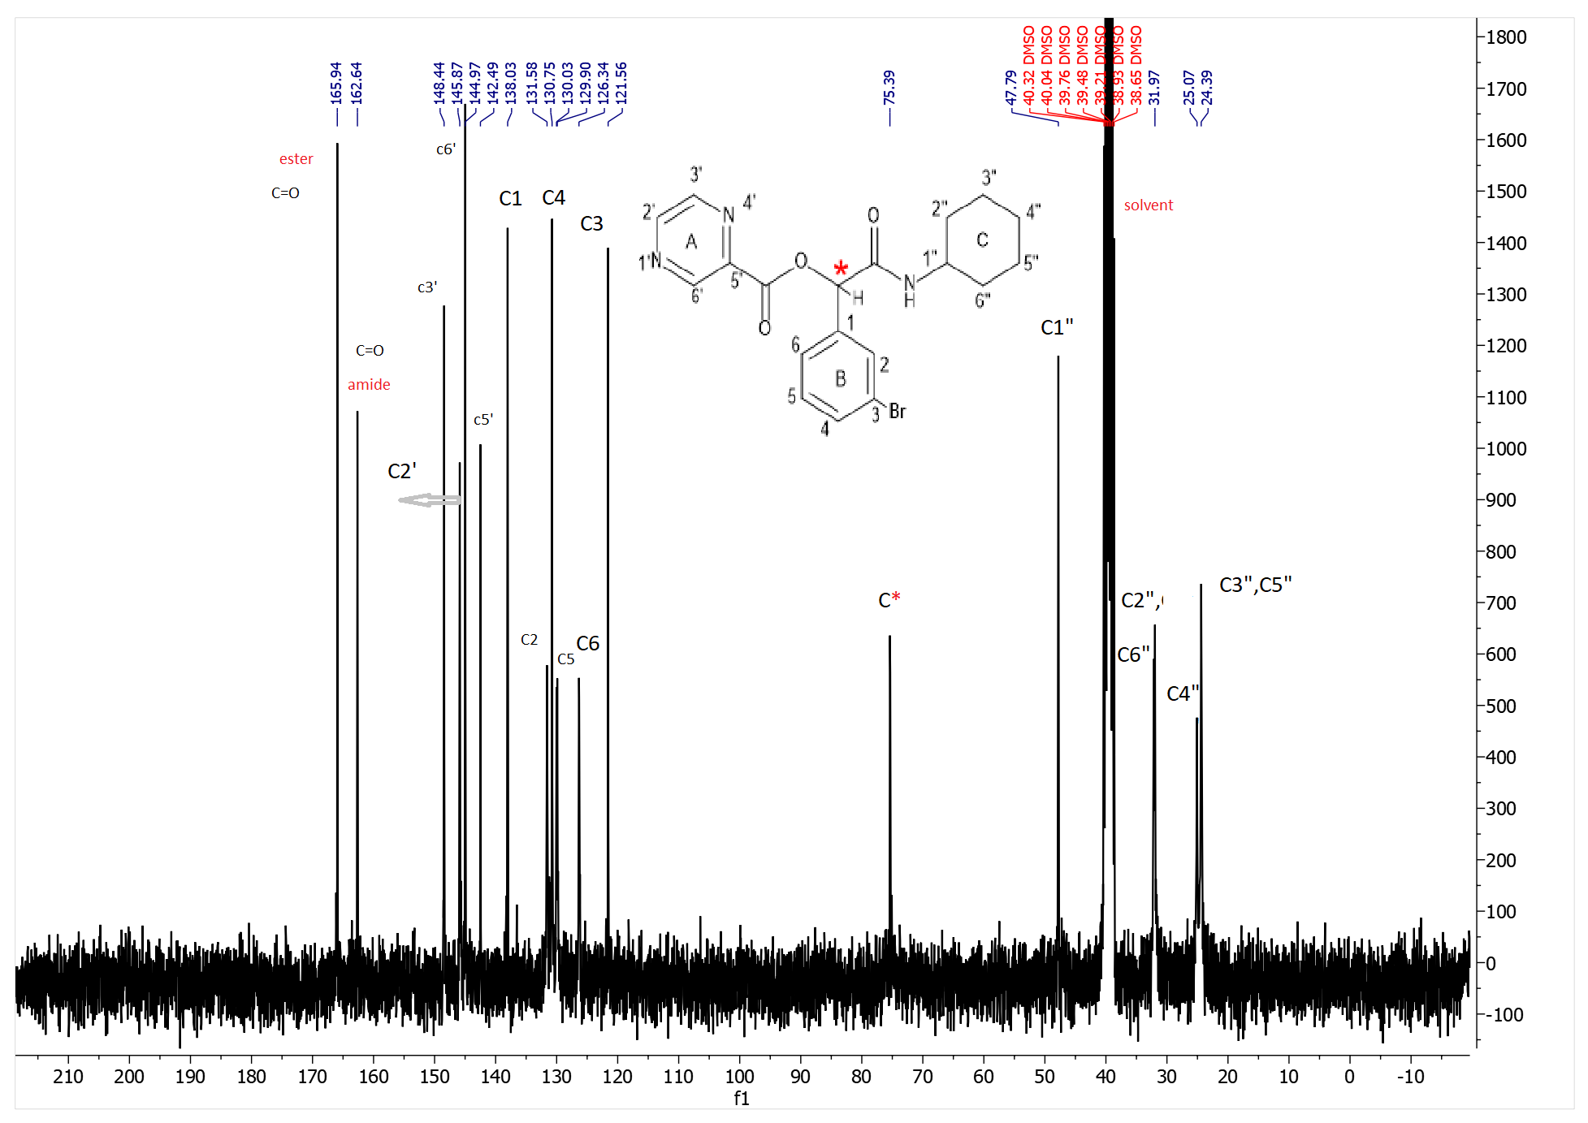
Figure S65. ¹³C-NMR spectrum of P20
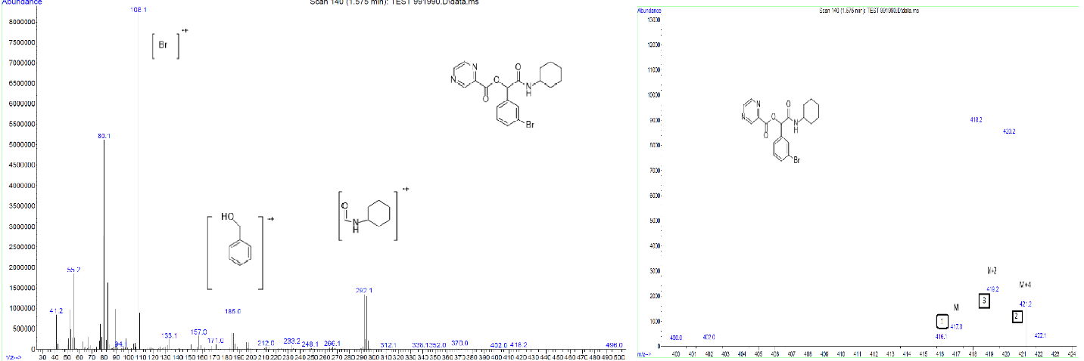
Figure S66. Mass spectrum of P20

