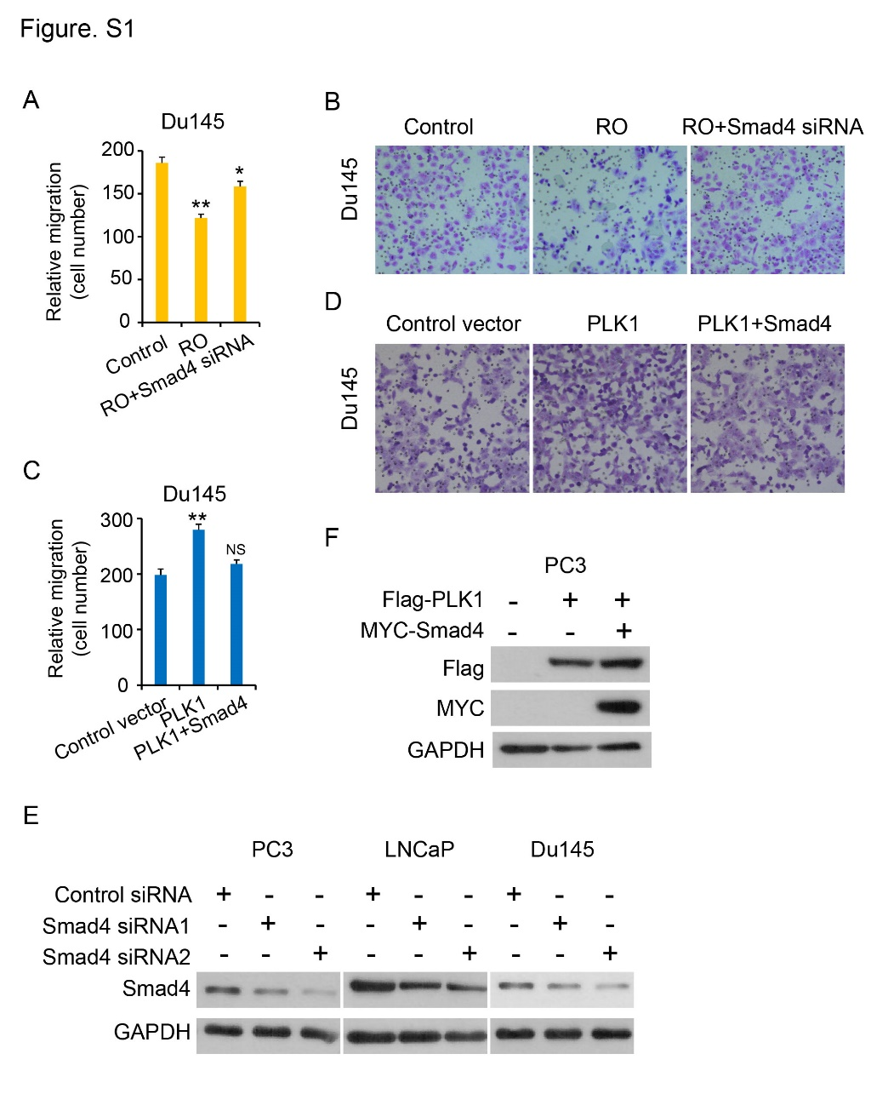
Fig. S1 Smad4 reversed the biological function of PLK1 in prostate cancer
A-B, Quantification analysis of migration assays (A) and representative Transwell data of migration assays (B) in Du145 cells treated with RO3280 for 12 h, followed by transfected with Smad4 siRNA. C-D, Quantification analysis of migration assays (C) and representative Transwell data of migration assays (D) in Du145 cells stably expressing control or PLK1 plasmid, followed by transfected with Smad4 plasmid. E, Western blotting analysis of Smad4 expression in control and PELO depleted PC3 cells, LNCaP cells and Du145 cells. GAPDH was used as a loading control. F, PC3 cells were transfected with Flag-PLK1 and Myc-Smad4 expression plasmids as indicated, and Cell lysates were subjected to immunoblot with Flag or MYC antibody. GAPDH was used as a loading control.
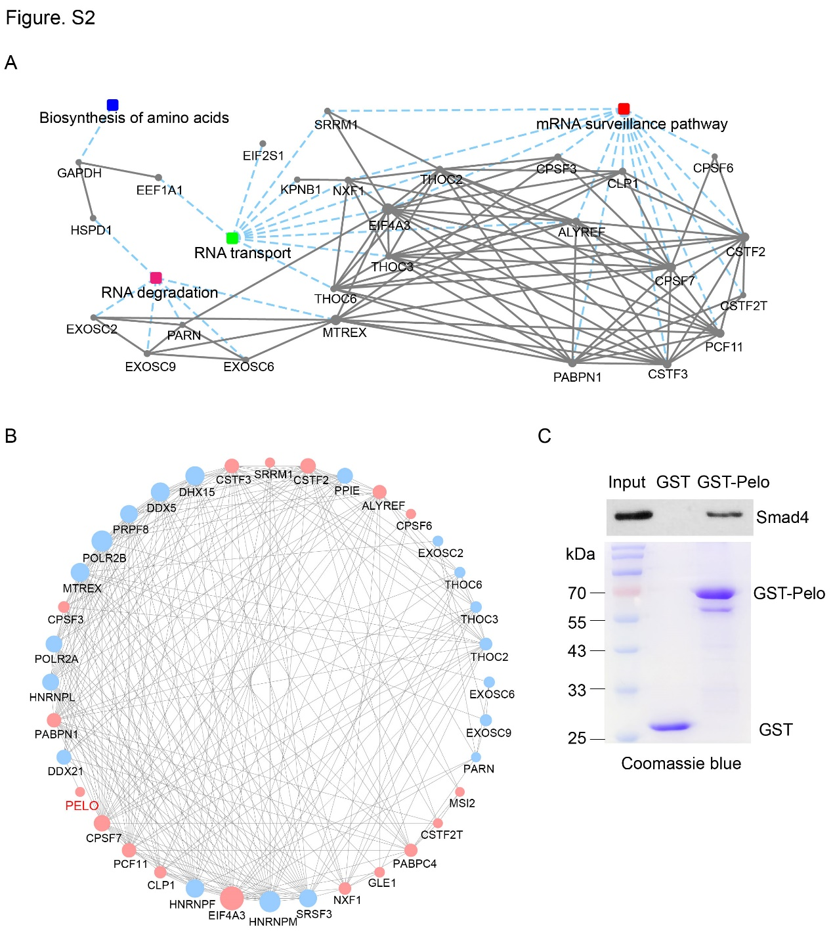
Fig. S2 Protein-protein interaction network constructed with enriched proteins in PC3 cells
A-B, Protein-protein interaction network constructed with enriched proteins in PC3 cells identified through IP-MS/MS. C, GST pull-down assay with the indicated GST-fused proteins and PC3 cells extracts.

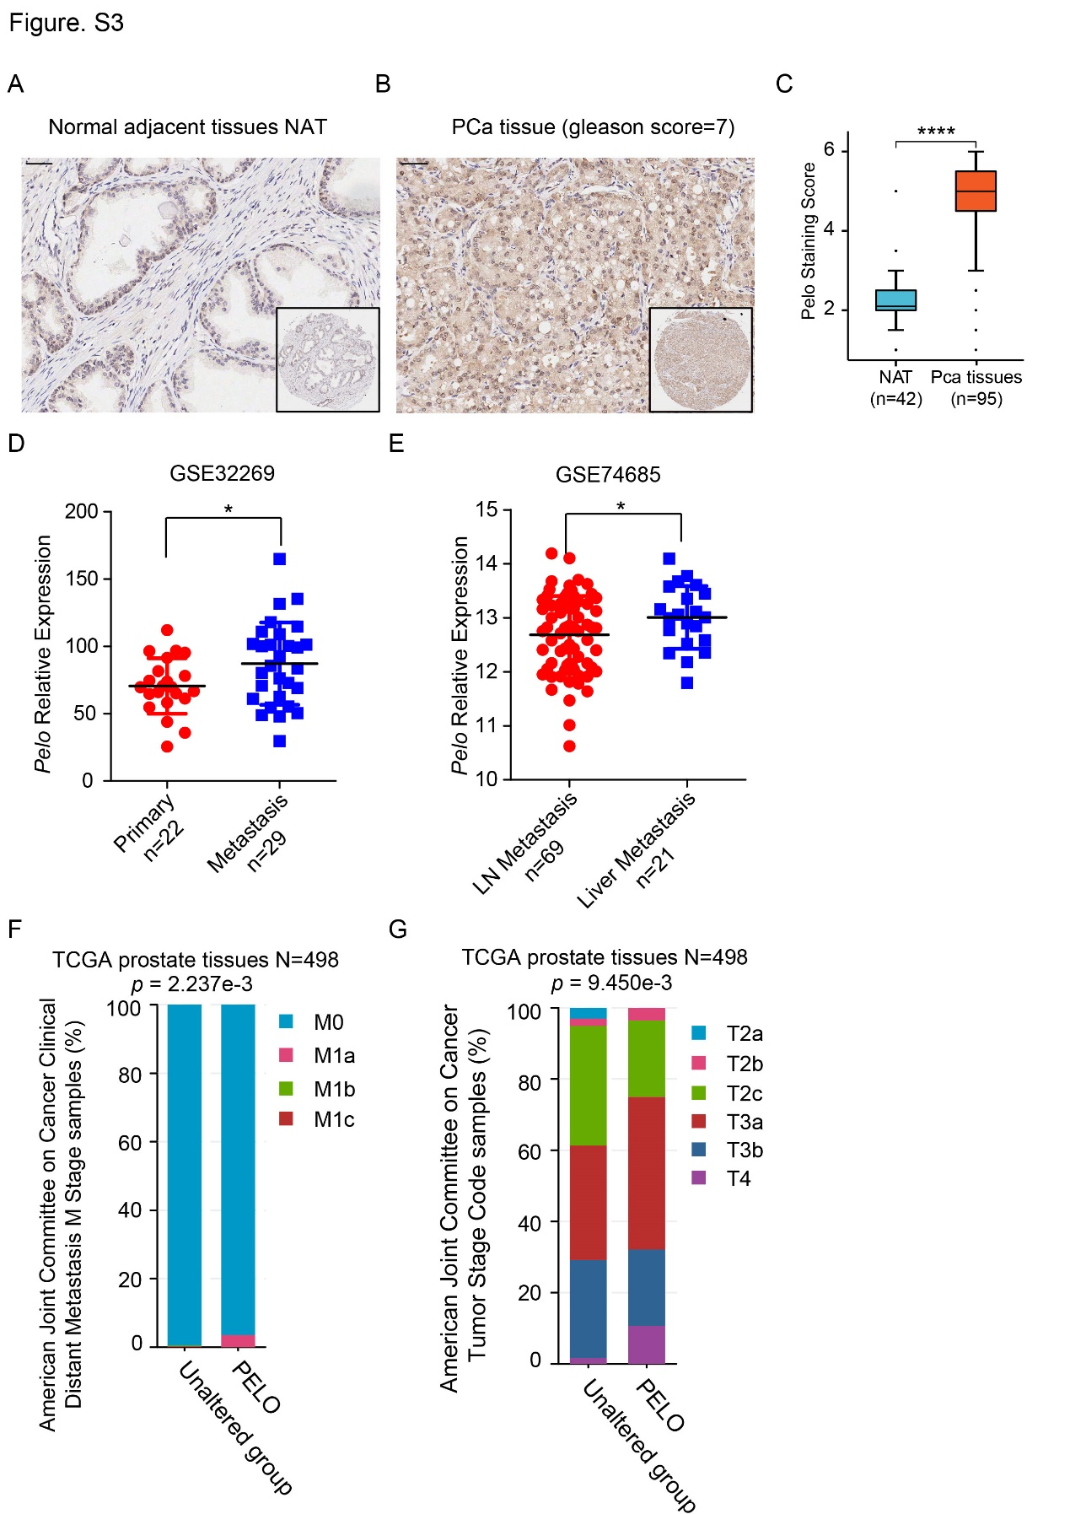

Fig. S3 PELO was highly expressed in high stage and metastatic PCa samples compared with in primary samples
A-C, Representative picture of PELO protein expression in prostate cancer tissue chip detected by IHC (A, B) and quantification of PELO protein in prostate cancer (C). Scale bar = 100 μm. D, PELO mRNA expression in primary and metastatic tissues of prostate cancer from GEO databases GSE32269. E, PELO mRNA expression was higher in liver metastatic tumors than in lymph node metastatic tumors from GEO databases GSE74685. F-G, PELO was highly expressed in metastatic prostate tissues (F) and high tumor stage (G) samples from TCGA databases (n=498).

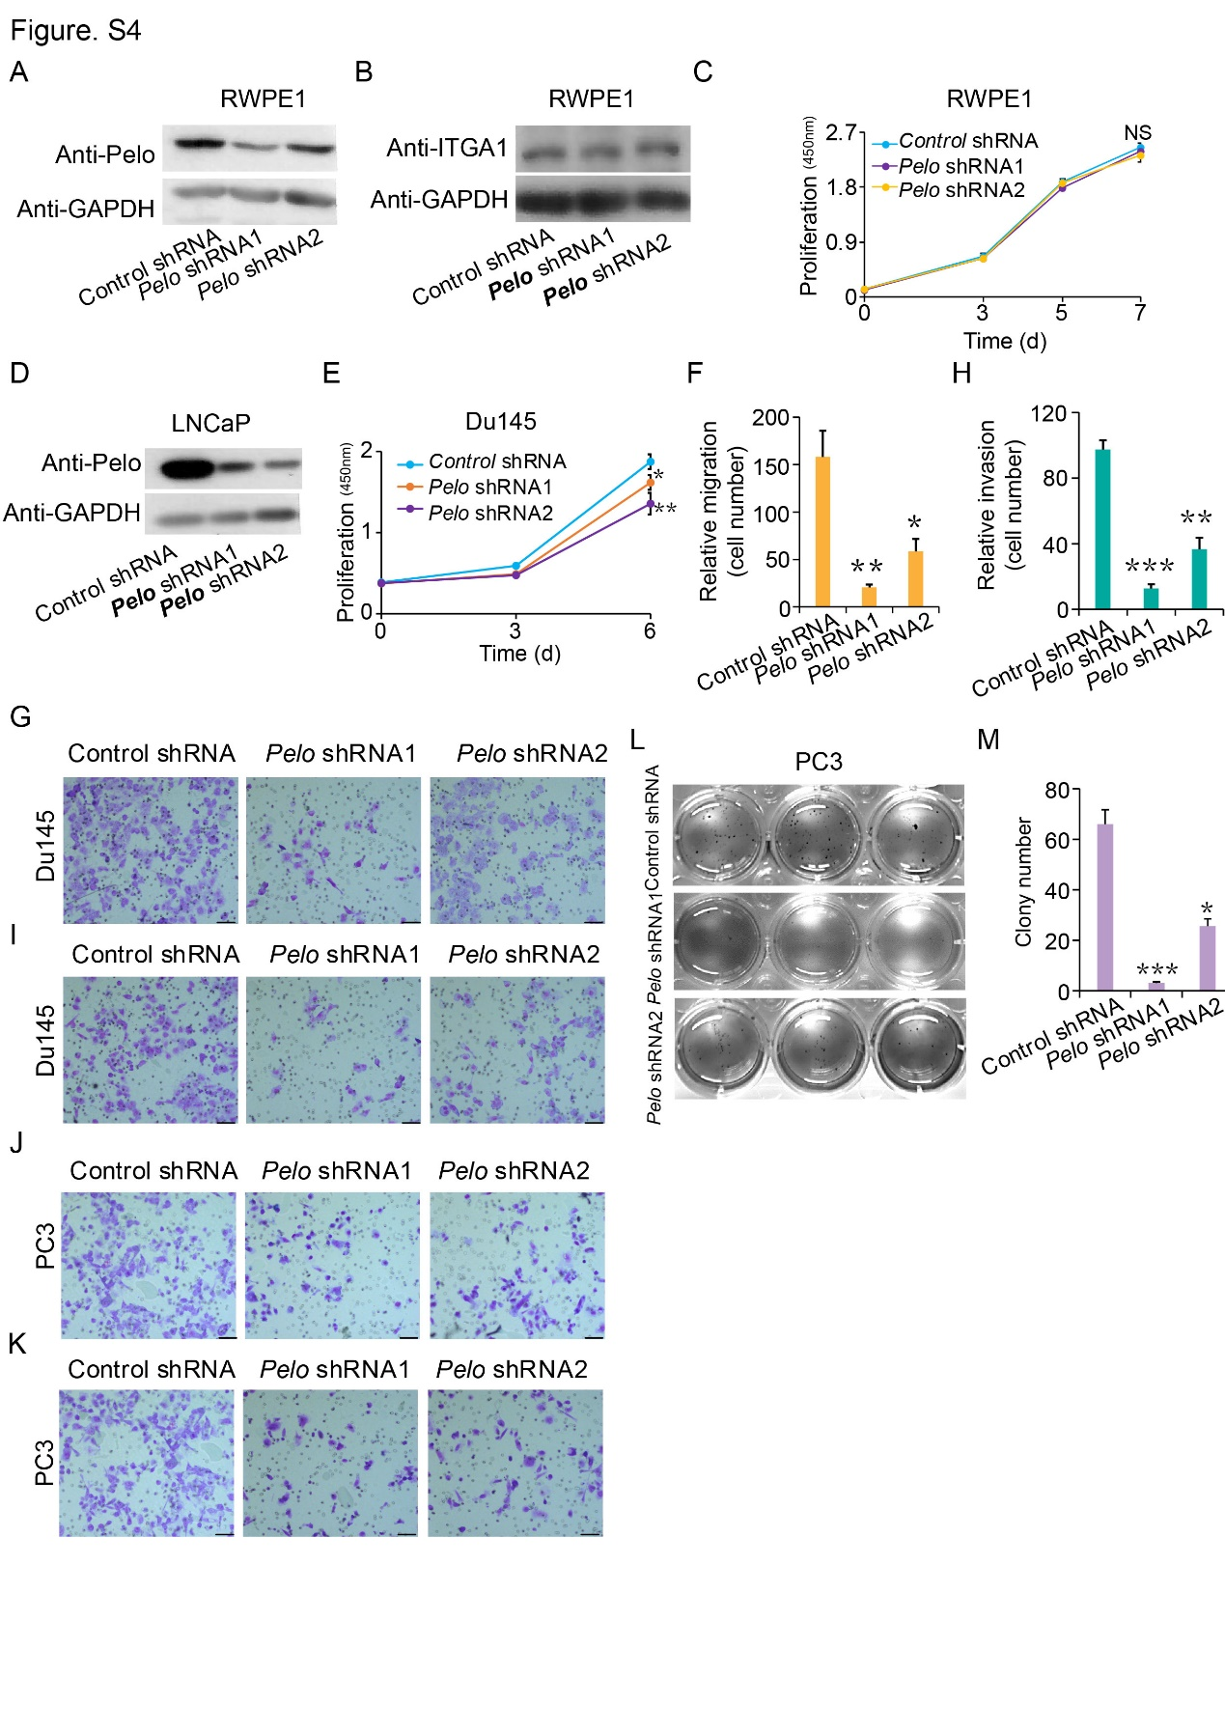
Fig. S4 Knockdown of PELO markedly decreased cell proliferation, migration, invasion and colony formation ability in PCa
A-B, Western blotting analysis of PELO (A) and ITGA1 (B) expression in control and PELO depleted RWPE1 cells. C, Effects of PELO knockdown on cell proliferation measured by XTT colorimetric assays (mean ± SD of triplicate experiments) in RWPE1 cells. D, Western blotting analysis of PELO expression in control and PELO depleted LNCaP cells. E, Effects of PELO knockdown on cell proliferation measured by XTT colorimetric assays (mean ± SD of triplicate experiments) in Du145 cells. F-G, Quantification analysis (F) and representative pictures (G) of migration assays in Du145 cells transfected with PELO shRNA (PELO shRNA1, PELO shRNA2) or control shRNA (mean ± SD of triplicate experiments). Scale bar = 100 μm. H-I, Quantification analysis (H) and representative pictures (I) of invasion assays in Du145 cells transfected with PELO shRNA (PELO shRNA1, PELO shRNA2) or control shRNA (mean ± SD of triplicate experiments). Scale bar = 100 μm. J-K, Representative pictures of migration (J) and invasion (K) assays in PC3 cells transfected with PELO shRNA (PELO shRNA1, PELO shRNA2) or control shRNA (mean ± SD of triplicate experiments). Scale bar = 100 μm. L, Effects of PELO on the growth of PC3 cells, as detected using a colony formation assay. Data are presented as means ± s.d. (n=3), and all data represent the results of three independent experiments. M, Quantification analysis of colony numbers in PC3 cells transfected with PELO shRNA (PELO shRNA1, PELO shRNA2) or control shRNA. *p < 0.05; **p < 0.01; ***p < 0.001.

