Additional file 3

Materials needed for the PERF-FIT
1 agility ladder with nine (35x35 cm) squares and 3 cm wide rungs (see schedule)
4 sheets of paper with a red cross
1.5 liter pet bottle filled with water
8 pieces of foam (40 x 20 cm wide and 5 cm high)
4 soda cans (weight 13 oz or 0.368 kg)
2 kg sandbag (20x20 cm)
Tennis ball
Colored string or lace or sticker to indicate left and right for young children

Tape measure
Stopwatch

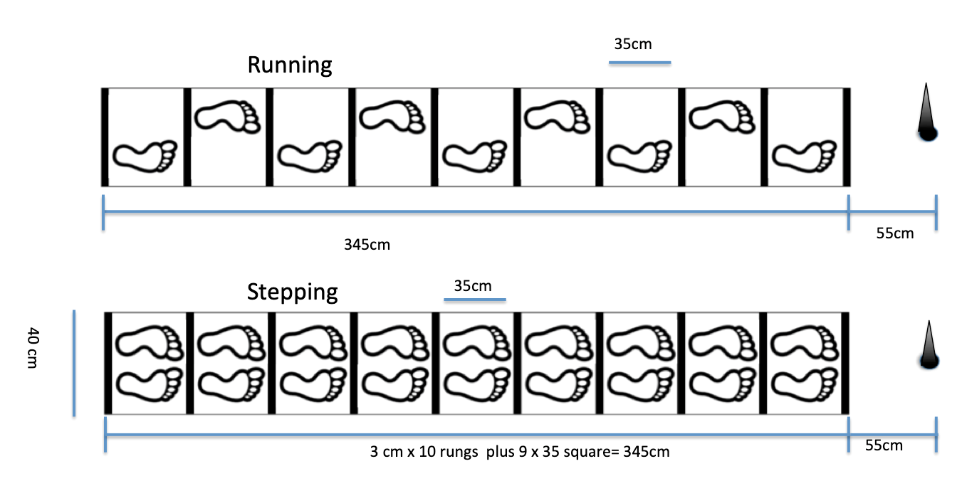

The PERF-FIT manual and the instruction videos to learn the test can be accessed free of charge after registration via the first author for use in low resource communities. bouwiensmits@hotmail.com

