Supplementary Material
Ti/TiO₂/SiO₂ multilayer thin films with enhanced spectral selectivity for optical applications

Dongju Kim^{1, +}, Junho Lee¹, Deahyeon Ko¹, Kyoung Ryeol Park², Dongwon Kim¹, Jennifer S Forrester³, Jong Cheol Kim^{4, *}, Sungwook Mhin^{1, *}
¹ Department of Advanced Materials Engineering, Kyonggi University, Suwon 16227, Republic of Korea
² Department of Materials Science and Engineering, Hanyang University, 222 Wangsimni-ro, Seoul, 04763, Republic of Korea
³ Analytical Instrument Facility, North Carolina State University, Raleigh, North Carolina 27695, USA
⁴ Daegu Mechatronics & Materials Institute, 11 Seongseogongdan-ro, Daegu, 42714, Republic of Korea

⁺These author’s contributed equality to this work.
*Correspondence and requests for materials should be addressed to S. M (email: swmhin@kgu.ac.kr) or J. C. K (email: jckim@dmi.re.kr)

Figure captions.

Figure. S1. XRD patterns of (a) TiO₂ thin film, and (b) SiO₂ thin film.

Figure. S2. Process and mechanism for the formation of dense thin films by Pulsed-DC reactive sputtering: (a) Ti thin film, (b) TiO₂ thin film, (c) SiO₂ thin film.

Figure. S3. Refractive Index (n) and Extinction Coefficient (k) as a function of sputtering parameters: (a) Ti thin film, (b) TiO₂ thin film, (c) SiO₂ thin film.

Figure. S4. Morphology and transmittance spectra of multi-layered structures of Ti/TiO₂/SiO₂ films with 7-8 layers: (a) Cross-sectional SEM micrograph of multilayer film with Ti 4 nm (b) Cross-sectional SEM micrograph of multilayer film with Ti 8 nm, and (c) Cross-sectional SEM micrograph of multilayer film with Ti 11 nm.

Figure. S5. Morphology and layer thickness multi-layered structure of TiO₂/SiO₂ films with 23 layers.

Figure. S6. Transmittance spectra of multilayer films of (a) TiO₂/SiO₂ films with 23-layers, (b) Ti/TiO₂/SiO₂ films with 24-layers. (c) 25-layers, and (d) 26-layers.

Figure. S1.

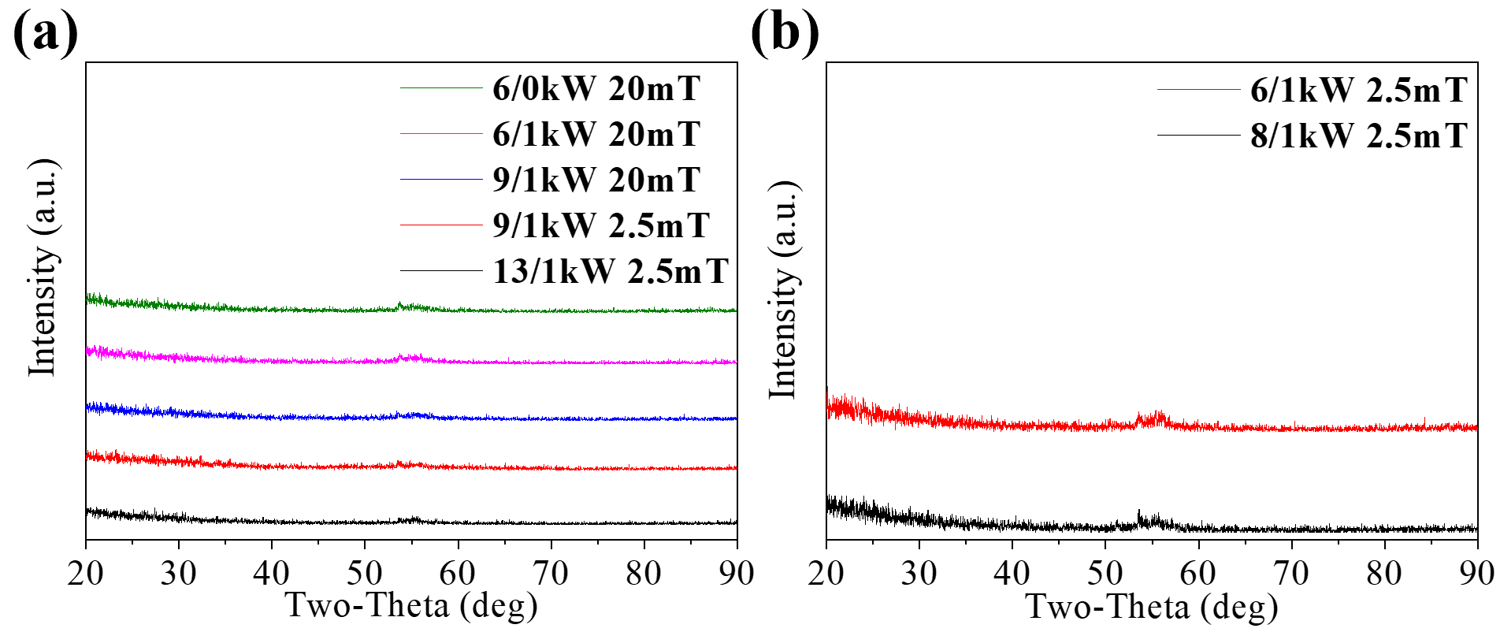

Figure. S2.

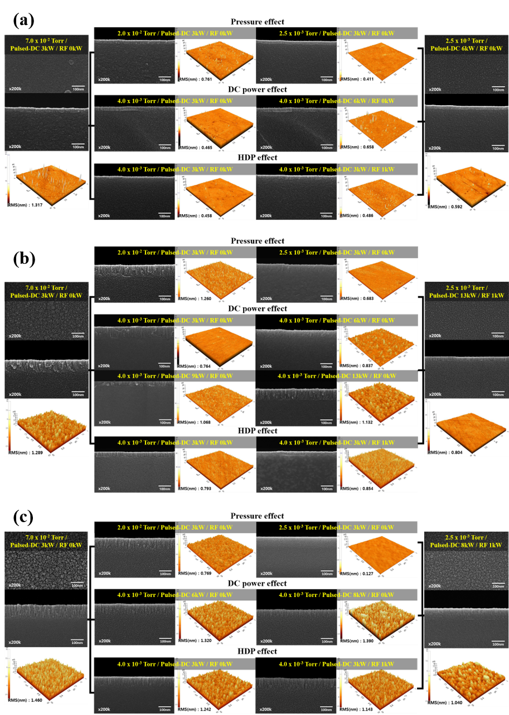

Figure. S3.

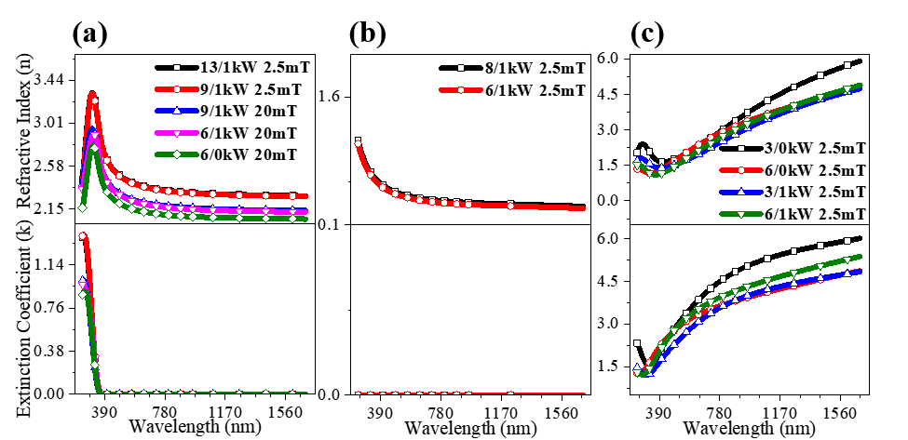

Figure. S4.

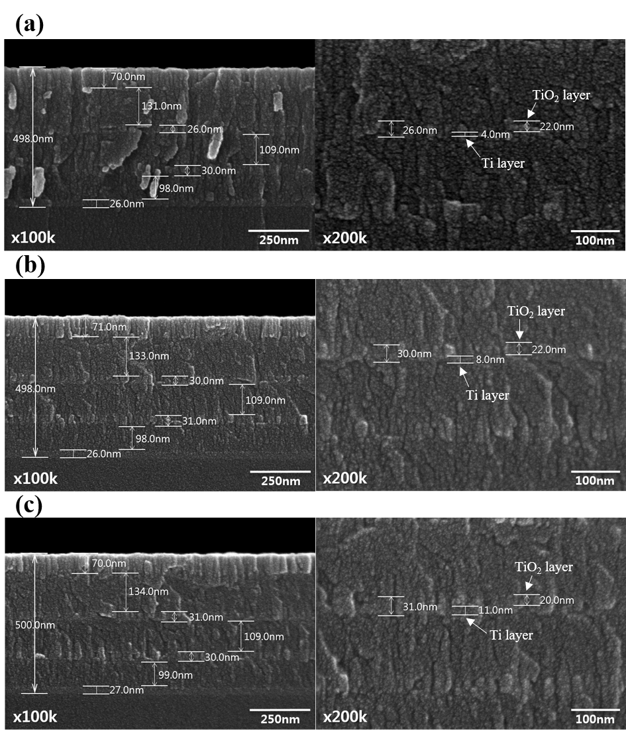

Figure. S5.

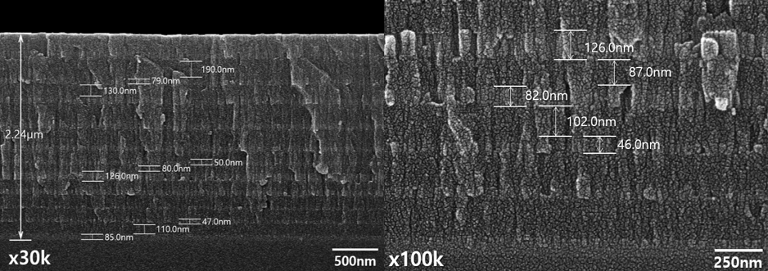

Figure. S6.

