Supplementary Information (S)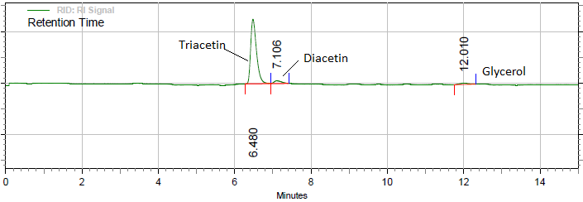
Fig. S1. HPLC chromatogram of triacetin produced during glycerol esterification in presence of Fe₃O₄@SiO₂@PO₄³⁻.
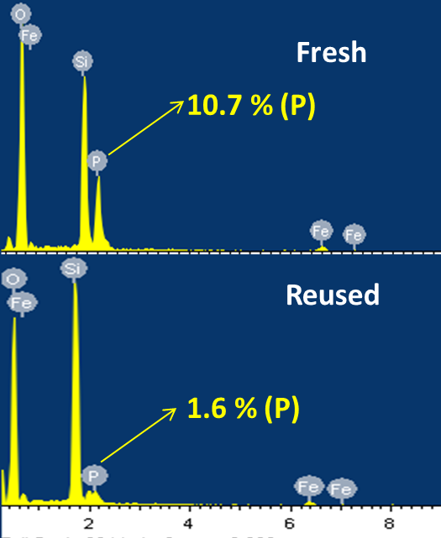
Fig. S2. Comparison of EDX spectra of fresh and reused catalyst.

