Noninvasive technology of photostimulation of lymphatic clearance of red blood cells from the mouse brain after intraventricular hemorrhage
Dong-Yu Li, Shao-Jun Liu, Ting-Ting Yu, Zhang Liu, Si-Lin Sun, Denis Bragin, Alexander Shirokov, Nikita Navolokin, Jürgen Kurths, Ivan Fedosov, Oxana Semyachkina-Glushkovskaya*, Dan Zhu*
Figure S1 - Schematic illustration of PS stimulation of RBCs clearance from mouse brain: (1) – the autologous arterial blood was injected into the right ventricle to induce IVH; (2) - 3 days after a surgical procedure, transcranial PS (1267 nm, 63 J/cm²) of the parietal cortex was performed every day for one week under inhalation anesthesia (1% isoflurane at 1 L⁄ min N₂O⁄O₂ − 70:30) using the sequence of 17 min – irradiation, 5 min – pause, 61 min in total; (3) - PS stimulates the RBCs clearance from the brain via MLVs into dcLNs, respectively.

Table S1 - Temperature (⁰C) at the external surface of skull and the brain cortex
before and after PS
Number of mouse/ Thermocouple positioning | 1 | 2 | 3 | 4 | 5 | 6 | 7 | 8 | 9 | 10 | Mean±SEM
no PS
The skull external surface | 35.49 | 35.57 | 35.68 | 35.74 | 36.46 | 35.31 | 36.26 | 36.15 | 35.84 | 35.71 | 35.82±0.12
Under the skull on the cortex surface | 37.25 | 37.31 | 37.18 | 37.28 | 37.29 | 37.11 | 36.27 | 37.23 | 37.32 | 37.26 | 37.15±0.11
3 J/cm² PS
The skull external surface | 35.93 | 36.06 | 35.97 | 36.02 | 36.04 | 35.89 | 36.09 | 36.05 | 36.13 | 35.15 | 35.93±0.10
Under the skull on the cortex surface | 36.98 | 37.13 | 37.51 | 36.91 | 37.09 | 37.08 | 37.02 | 37.12 | 37.11 | 36.95 | 37.09±0.06
6 J/cm² PS
The skull external surface | 35.89 | 36.39 | 36.29 | 35.57 | 35.52 | 35.88 | 36.11 | 35.98 | 35.92 | 36.08 | 35.96±0.08
Under the skull on the cortex surface | 37.51 | 36.42 | 37.21 | 36.53 | 37.41 | 36.25 | 37.94 | 37.37 | 37.55 | 37.91 | 37.11±0.17
9 J/cm² PS
The skull external surface | 36.28 | 36.15 | 36.21 | 36.21 | 36.05 | 35.63 | 36.07 | 36.52 | 35.71 | 35.33 | 36.01±0.11
Under the skull on the cortex surface | 37.00 | 37.71 | 37.12 | 37.49 | 36.71 | 36.55 | 36.81 | 37.22 | 37.58 | 37.37 | 37.15±0.12
18 J/cm² PS
The skull external surface | 36.48 | 36.44 | 36.38 | 36.52 | 36.49 | 36.55 | 36.62 | 36.67 | 36.71 | 36.38 | 36.52±0.03 ***
Under the skull on the cortex surface | 37.34 | 37.01 | 37.24 | 37.11 | 37.03 | 36.98 | 36.84 | 36.92 | 37.19 | 37.85 | 37.14±0.11
27 J/cm² PS
The skull external surface | 37.69 | 37.84 | 37.19 | 37.68 | 37.48 | 38.17 | 37.88 | 38.10 | 37.15 | 37.33 | 37.65±0.09 ***
Under the skull on the cortex surface | 37.43 | 37.39 | 36.55 | 37.17 | 37.02 | 37.08 | 37.55 | 37.72 | 37.19 | 36.64 | 37.18±0.13
*** - P<0.001 vs. the control group (no PS)

Figure S2 - OCT monitoring of the GNRs accumulation rate in dcLNs before and after PS: *** - p<0.001 vs. the control group (no PS), n=10 in each group.

Table S2 – GNRs accumulation rate (a.u.) in dcLN in healthy mice before and after PS
Number of mouse/Time of observation of PS effects | 1 | 2 | 3 | 4 | 5 | 6 | 7 | 8 | 9 | 10 | Mean±SEM
no PS
20 min | 95.6 | 99.4 | 96.8 | 115.3 | 115.7 | 97.8 | 111.2 | 96.0 | 95.5 | 95.2 | 101.0±2.2
40 min | 142.3 | 101.8 | 102.6 | 89.6 | 102.7 | 97.5 | 99.4 | 102.5 | 100.3 | 85.4 | 102.4±6.1
60 min | 143.7 | 101.6 | 97.6 | 102.2 | 101.8 | 94.3 | 100.7 | 102.5 | 103.4 | 94.2 | 104.2±5.3
3 J/cm² PS
20 min | 125.9 | 102.3 | 99.2 | 98.5 | 100.9 | 103.6 | 100.4 | 100.2 | 99.7 | 91.3 | 102.0±3.7
40 min | 126.4 | 106.4 | 107.9 | 103.5 | 106.6 | 110.3 | 103.8 | 106.5 | 108.9 | 70.8 | 105.1±6.0
60 min | 143,8 | 106.6 | 110.3 | 107.7 | 111.6 | 106.6 | 106.6 | 107.5 | 108.4 | 63.2 | 107.3±8.7
6 J/cm² PS
20 | 113.3 | 114.3 | 82.1 | 116.4 | 89.6 | 117.6 | 112.2 | 89.7 | 86.8 | 86.6 | 100.8±4.7
40 | 112.8 | 89.8 | 107.6 | 115.5 | 92.5 | 104.3 | 109.4 | 111.9 | 91.9 | 87.9 | 102.3±3.3
60 | 117.3 | 73.1 | 125.5 | 120.6 | 89.2 | 113.1 | 121.4 | 122.2 | 89.5 | 80.4 | 105.2±6.2
9 J/cm² PS
20 min | 124.3 | 125.3 | 95.1 | 127.4 | 100.6 | 126.6 | 123.2 | 100.7 | 97.8 | 97.6 | 111.8±4.5
40 min | 140.6 | 96.4 | 148.8 | 143.9 | 103.5 | 142.4 | 147.7 | 148.5 | 105.8 | 98.7 | 127.6±7.3
60 min | 157.6 | 115.4 | 159.8 | 160.9 | 122.5 | 160.4 | 161.7 | 165.5 | 122.8 | 115.7 | 144.2±6.9***
18 J/cm² PS
20 min | 132.5 | 148.1 | 109.6 | 95.8 | 113.8 | 87.0 | 116.2 | 122.5 | 114.3 | 122.2 | 116.2±6.6
40 min | 152.8 | 96.3 | 102.6 | 118.3 | 114.2 | 125.6 | 185.2 | 133.6 | 137.6 | 148.8 | 131.5±9.6
60 min | 130.9 | 167.4 | 125.6 | 129.6 | 153.2 | 220.1 | 127.1 | 138.5 | 157.3 | 152.3 | 150.2±10.2***
27 J/cm² PS
20 min | 136.5 | 121.9 | 114.9 | 115.9 | 118.6 | 49.5 | 125.6 | 119.8 | 100.6 | 78.8 | 110.5±9.9
40 min | 143.7 | 46.1 | 132.4 | 121.2 | 129.9 | 135.9 | 139.6 | 145.2 | 140.6 | 120.3 | 125.9±10.7
60 min | 142.2 | 193.1 | 85.2 | 148.2 | 127.1 | 125.9 | 147.6 | 164.5 | 201.9 | 155.9 | 148.2±12.6***
*** - P<0.001 vs. the control group (no PS)

Table S3 –GNRs level (μg/g tissue) in dcLN in healthy mice before and after PS
Number of mouse/Time of observation of PS effects | 1 | 2 | 3 | 4 | 5 | 6 | 7 | 8 | 9 | 10 | Mean±SEM
no PS
20 min | 5.7 | 1.5 | 1.2 | 1.3 | 0.9 | 0.8 | 0.7 | 1.6 | 1.4 | 0.1 | 1.5±0.6
40 min | 8.5 | 2.6 | 2.8 | 3.1 | 2.2 | 2.5 | 2.7 | 2.6 | 1.9 | 0.1 | 2.9±0.9
60 min | 8.5 | 3.8 | 3.4 | 3.9 | 3.6 | 3.1 | 4.8 | 5.3 | 3.5 | 0.1 | 4.0±0.9
3 J/cm² PS
20 min | 4.8 | 2.5 | 3.1 | 2.2 | 1.4 | 3.6 | 1.5 | 2.7 | 1.1 | 0.1 | 2.3±0.5
40 min | 7.6 | 3.3 | 3.1 | 2.5 | 3.1 | 3.2 | 2.8 | 2.7 | 3.6 | 0.1 | 3.2±0.8
60 min | 6.6 | 4.3 | 3.5 | 4.5 | 4.9 | 4.7 | 5.2 | 4.4 | 4.8 | 0.1 | 4.3±0.7
6 J/cm² PS
20 | 1.3 | 2.2 | 2.8 | 1.4 | 1.2 | 2.2 | 0.8 | 1.1 | 2.3 | 2.1 | 1.7±0.2
40 | 0.1 | 4.5 | 3.1 | 2.2 | 3.9 | 2.6 | 0.2 | 0.4 | 2.6 | 3.5 | 2.3±0.5
60 | 7.1 | 0.7 | 6.8 | 5.7 | 0.9 | 5.9 | 0.1 | 0.4 | 6.9 | 2.9 | 3.7±0.9
9 J/cm² PS
20 min | 3.6 | 4.8 | 2.4 | 5.2 | 4.2 | 2.7 | 4.6 | 14.1 | 4.3 | 0.1 | 4.6±1.5
40 min | 9.6 | 9.8 | 9.5 | 9.3 | 10.4 | 9.4 | 9.7 | 10.1 | 10.3 | 9.9 | 9.8±1.1
60 min | 12.5 | 9.6 | 12.4 | 11.8 | 12.4 | 12.1 | 10.8 | 24.1 | 13.1 | 8.2 | 12.7±1.7***
18 J/cm² PS
20 min | 5,1 | 2,8 | 1,2 | 2,4 | 4,9 | 3,2 | 4,1 | 3,9 | 14,1 | 6,3 | 4.8±1.4
40 min | 2,7 | 18,8 | 9,7 | 5,4 | 3,2 | 2,1 | 4,1 | 5,1 | 7,4 | 3,5 | 6.2±1.8
60 min | 7,3 | 5,1 | 4,2 | 6,2 | 15,3 | 18,2 | 19,5 | 16,7 | 19,9 | 5,6 | 11.8±1.7***
27 J/cm² PS
20 min | 3.5 | 5.9 | 2.9 | 0.8 | 3.9 | 2.1 | 26.7 | 3.8 | 1.2 | 7.2 | 5.8±2.8
40 min | 5,4 | 13,4 | 10,2 | 5,2 | 6,8 | 7,8 | 8,9 | 3,8 | 2,3 | 8,2 | 7.2±1.7
60 min | 13.1 | 8.1 | 15.7 | 19.9 | 16.2 | 11.8 | 2.3 | 17.1 | 10.2 | 16.6 | 13.1±1.9***
*** - P<0.001 vs. the control group (no PS)

Table S4 –EBD fluorescent intensity (a.u.) in dcLN in healthy mice before and after PS
Number of mouse/Time of observation of PS effects | 1 | 2 | 3 | 4 | 5 | 6 | 7 | 8 | 9 | 10 | Mean±SEM
no PS
20 min | 8,5 | 1.1 | 0,3 | 0,6 | 0.9 | 0.8 | 0,2 | 0.5 | 0,4 | 0,1 | 1.3±0.9
40 min | 10.5 | 4.2 | 5.1 | 4.8 | 4.6 | 2.3 | 3.2 | 3.8 | 4.3 | 0.2 | 4.3±1.1
60 min | 16.2 | 7.5 | 7.4 | 5.2 | 7.3 | 6.6 | 6.2 | 6.1 | 6.4 | 3.1 | 7.2±1.4
3 J/cm² PS
20 min | 3.1 | 1.4 | 1.8 | 1.2 | 1.7 | 2.2 | 2.4 | 2.1 | 1.9 | 1.2 | 1.9±0.2
40 min | 11.7 | 2.4 | 2.1 | 2.5 | 2.4 | 3.4 | 2.3 | 3.5 | 3.2 | 0.5 | 3.4±1.2
60 min | 20.8 | 4.6 | 6.2 | 6.6 | 4.9 | 6.4 | 5.5 | 6.7 | 5.9 | 0.4 | 6.8±2.2
6 J/cm² PS
20 | 1.8 | 1.9 | 2.2 | 2.1 | 0.7 | 2.3 | 2.5 | 1.7 | 2.4 | 1.5 | 1.9±0.2
40 | 4.1 | 8.8 | 1.3 | 4.6 | 4.4 | 5.1 | 5.3 | 4.2 | 4.5 | 4.7 | 4.7±0.8
60 | 6.9 | 19.1 | 6.7 | 5.5 | 7.3 | 0.5 | 6.5 | 5.2 | 7.4 | 4.9 | 7.0±2.0
9 J/cm² PS
20 min | 7.8 | 6.9 | 8.8 | 8.5 | 8.3 | 7.3 | 8.5 | 19.3 | 8.2 | 4.4 | 8.8±1.6
40 min | 12.8 | 12.7 | 13.4 | 14.2 | 13.2 | 12.3 | 13.8 | 24.5 | 14.4 | 8.7 | 14.0±1.7
60 min | 18.1 | 21.4 | 17.4 | 15.2 | 17.5 | 24.2 | 14.1 | 23.5 | 14.3 | 17.7 | 18.3±1.1***
18 J/cm² PS
20 min | 7,1 | 10,1 | 4,8 | 3,2 | 19,7 | 3,7 | 11,2 | 5,4 | 21,7 | 6,1 | 9.3±1.8
40 min | 17,5 | 24,3 | 8,2 | 8,7 | 6,3 | 7,1 | 15,9 | 16,3 | 5,8 | 18,9 | 12.9±2.0
60 min | 27,5 | 18,1 | 6,5 | 17,6 | 34,1 | 9,8 | 18,3 | 5,4 | 29,5 | 25,2 | 19.2±3.1***
27 J/cm² PS
20 min | 10,1 | 17,2 | 3,4 | 6,8 | 7,5 | 4,1 | 6,2 | 2,4 | 5,7 | 15,6 | 7.9±1.6
40 min | 14,2 | 26,5 | 8,1 | 9,6 | 7,4 | 12,3 | 10,6 | 6,1 | 12,4 | 9,8 | 11.7±2.2
60 min | 12,1 | 16,2 | 7,4 | 28,4 | 58,2 | 5,7 | 13,4 | 8,2 | 32,1 | 7,3 | 18.9±5.5***
*** - P<0.001 vs. the control group (no PS)

Figure S3 – Detection of effective time for fluorescent imaging of EBD (5%, 5µl) accumulation in dcLNs after dye injection into the right ventricle. The green arrow represents the right dcLN, and the yellow arrow represents the left dcLN of the mouse.

Measurement of laser power through the mouse scalp and skull
The optical setup was developed with the 1267 nm laser (Innolume Gmbh, Germany) and collimator (Thorlabs Ltd., USA) given 5 mm diameter beam on the illuminated surface of the mouse skull. The scattering coefficient and diffuse transmittance were measured on the fresh mouse scalp and the skull from 10 mice (Fig. S5).
Figure S4 - Scheme of the optic setup for measuring the mouse scalp and skull transmittance level for 1267 nm QD semiconductor laser.

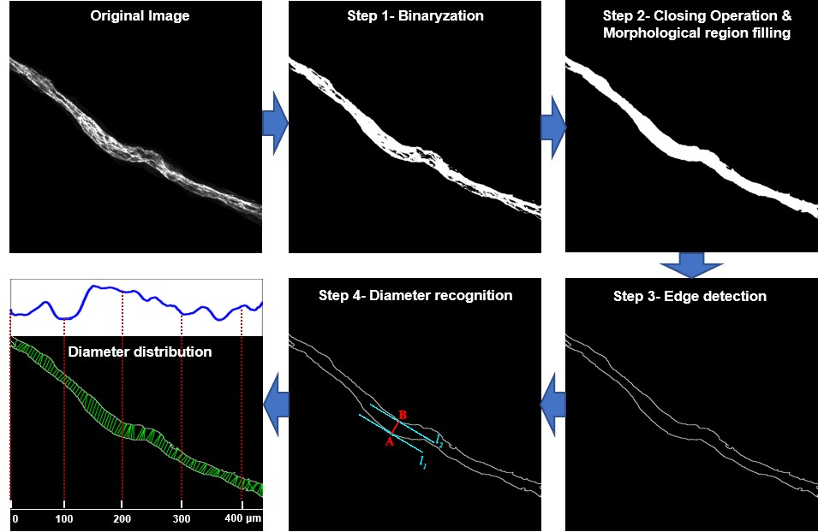
Figure S5 Schematic illustration of MLV diameter distribution calculation.

