Article title: Uncertainties in the effectiveness of biological control of stem borers under different climate change scenarios in Eastern Africa
Journal name: Climatic Change
Author names: Ines Jendritzki, Henri E. Z. Tonnang, Paul-André Calatayud, Christian Borgemeister, Tino Johansson, Lisa Biber-Freudenberger
Affiliation and e-mail address of the corresponding author: Center for Development Research, Department of Ecology and Natural Resources Management, University of Bonn, ijendrit@uni-bonn.de

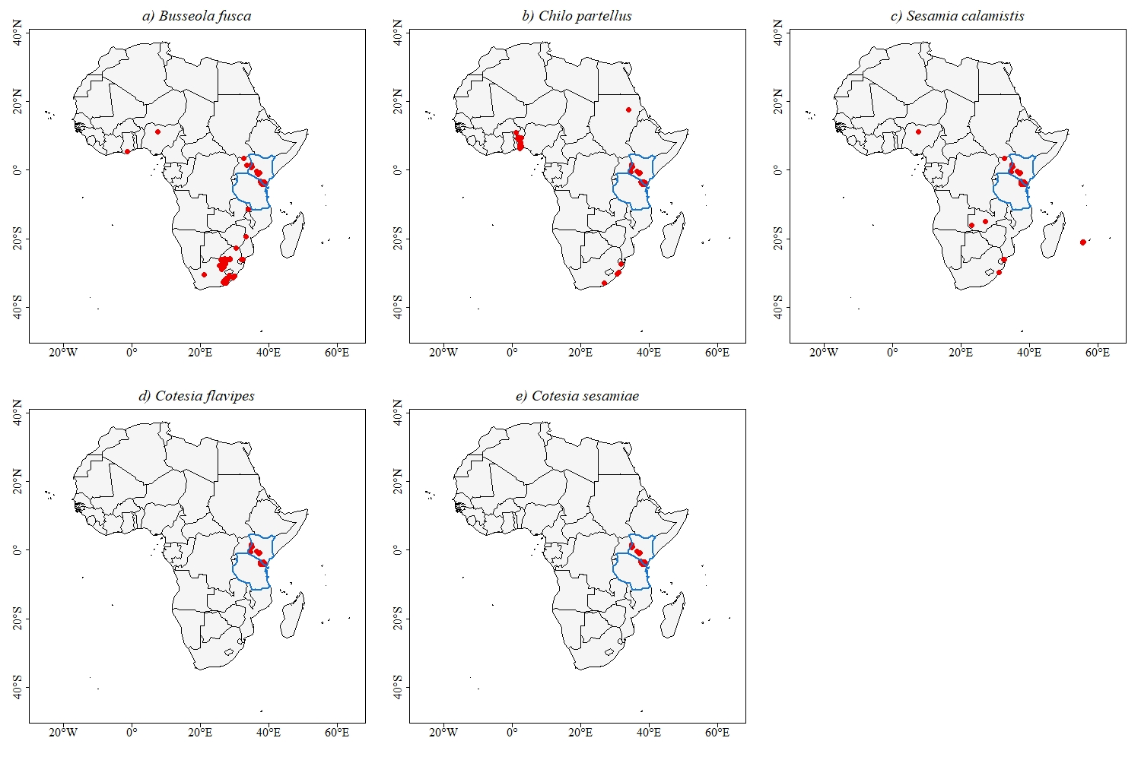
Fig: Distribution of species’ presence points used for species distribution modelling

