**Computational investigation of adenosine 5′- (α, β-methylene)-**

**diphosphate（AMPCP） derivatives as** **ecto-5′-nucleotidase （CD73） inhibitors by using 3D-QSAR, molecular docking, and molecular dynamics simulations**

Jiatong Wen,† Heng Zhang,† Churen Meng,† Di Zhou,† Gang Chen, † Jian Wang, ‡ Yang Liu, ‡, Lei Yuan, *, ‡ Ning Li*,†

† School of Traditional Chinese Materia Medica, Key Laboratory for TCM Material Basis Study and Innovative Drug Development of Shenyang City, Shenyang Pharmaceutical University, Shenyang 110016, People’s Republic of China

‡ School of Pharmaceutical Engineering, Shenyang Pharmaceutical University, Shenyang 110016, People’s Republic of China

* To whom correspondence should be addressed. School of Traditional Chinese MateriaMedica, Shenyang Pharmaceutical University, Wenhua Road 103, Shenyang 110016, China. Tel: +86-24-43520739. E-mail address: yuanlei3094@163.com (L. Yuan), [liningsypharm@163.com](mailto:liningsypharm@163.com) (N. Li).

Table S1. Docking results of the 60 compounds in the dataset with glide XP.

|  |  |
| --- | --- |
| No | Docking score |
| 1 | -8.202 |
| 2 | -8.84 |
| 3 | -8.587 |
| 4 | -8.438 |
| 5 | -7.84 |
| 6 | -7.394 |
| 7 | -8.304 |
| 8 | -8.83 |
| 9 | -8.143 |
| 10 | -8.534 |
| 11 | -7.88 |
| 12 | -9.377 |
| 13 | -8.286 |
| 14 | -9.601 |
| 15 | -8.769 |
| 16 | -9.653 |
| 17 | -8.939 |
| 18 | -10.172 |
| 19 | -8.77 |
| 20 | -9.811 |
| 21 | -9.44 |
| 22 | -10.37 |
| 23 | -9.136 |
| 24 | -8.736 |
| 25 | -9.524 |
| 26 | -9.204 |
| 27 | -9.094 |
| 28 | -10.491 |
| 29 | -9.187 |
| 30 | -9.575 |
| 31 | -8.812 |
| 32 | -9.333 |
| 33 | -10.536 |
| 34 | -8.874 |
| 35 | -10.401 |
| 36 | -9.872 |
| 37 | -11.649 |
| 38 | -10.81 |
| 39 | -10.385 |
| 40 | -10.173 |
| 41 | -10.036 |
| 42 | -10.471 |
| 43 | -10.236 |
| 44 | -10.029 |
| 45 | -8.352 |
| 46 | -8.958 |
| 47 | -8.947 |
| 48 | -9.604 |
| 49 | -8.517 |
| 50 | -7.944 |
| 51 | -8.492 |
| 52 | -8.794 |
| 53 | -9.231 |
| 54 | -9.2 |
| 55 | -9.278 |
| 56 | -8.461 |
| 57 | -9.23 |
| 58 | -8.745 |
| 59 | -9.183 |
| 60 | -8.956 |

Figure S1. The CoMSIA steric contour maps for compound **5** (A) and compound **55** (B). Green color and yellow color represent favorable and unfavorable region for steric field.

**B**

**A**

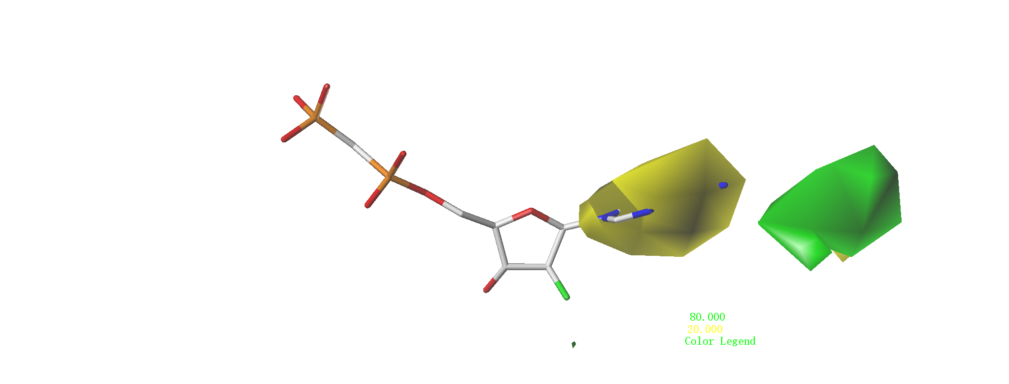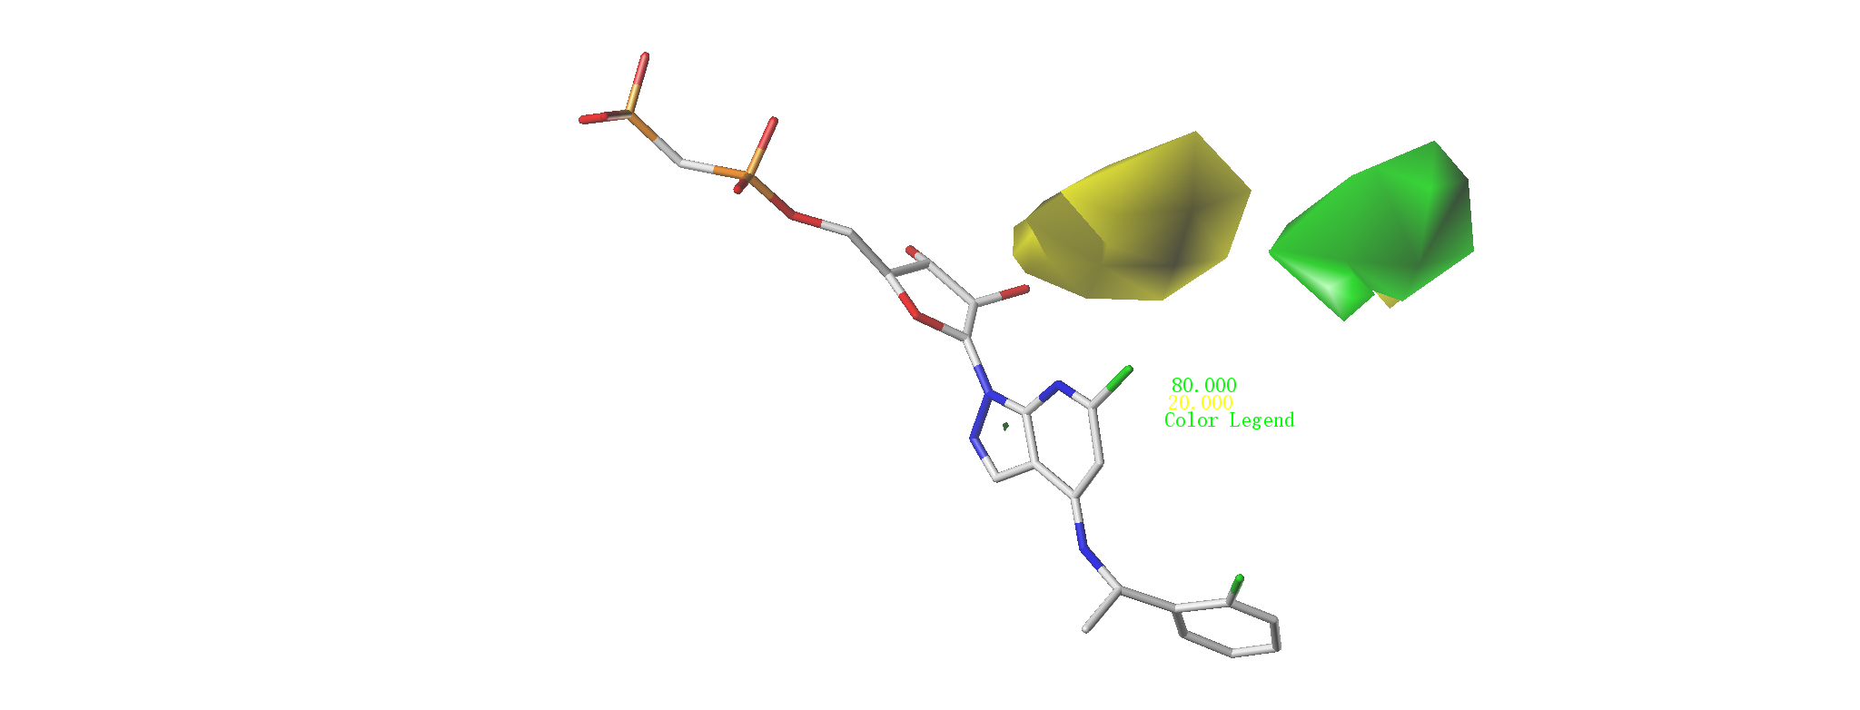

Figure S2. The CoMSIA electrostatic field contour maps for compound **5** (A) and compound **55**(B). The red color shows the favored negative electrostatic region and the blue color shows the favored positive electrostatic region.

**B**

**A**

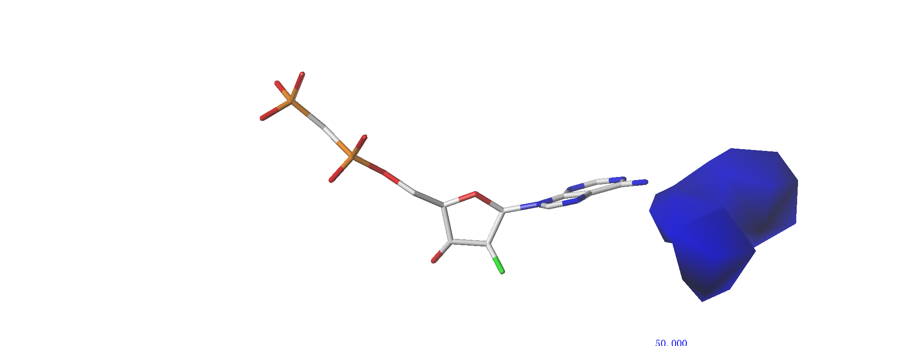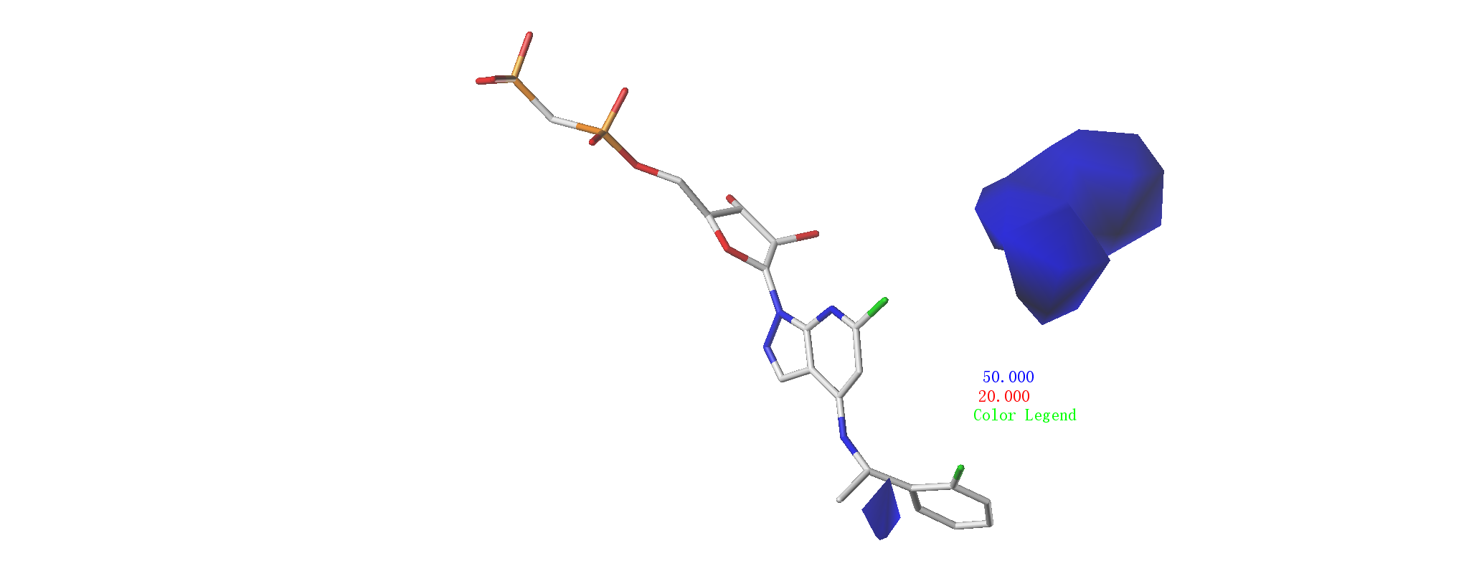

Figure S3. The plot of protein secondary structure elements (SSE) distribution by residue index throughout the protein structure.

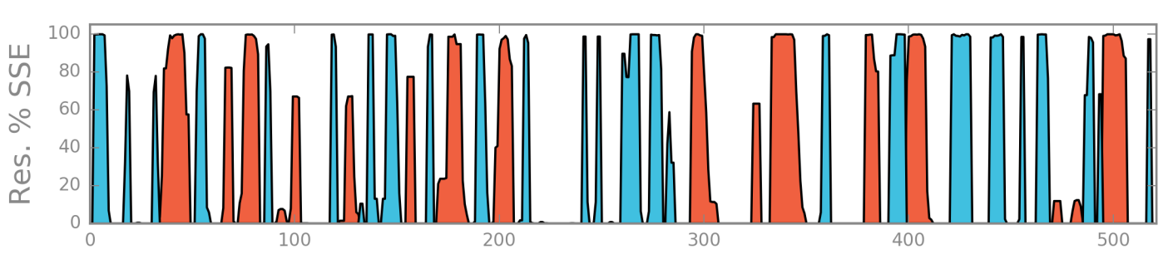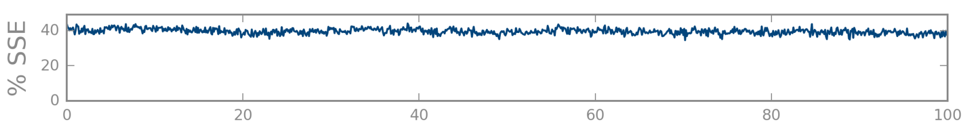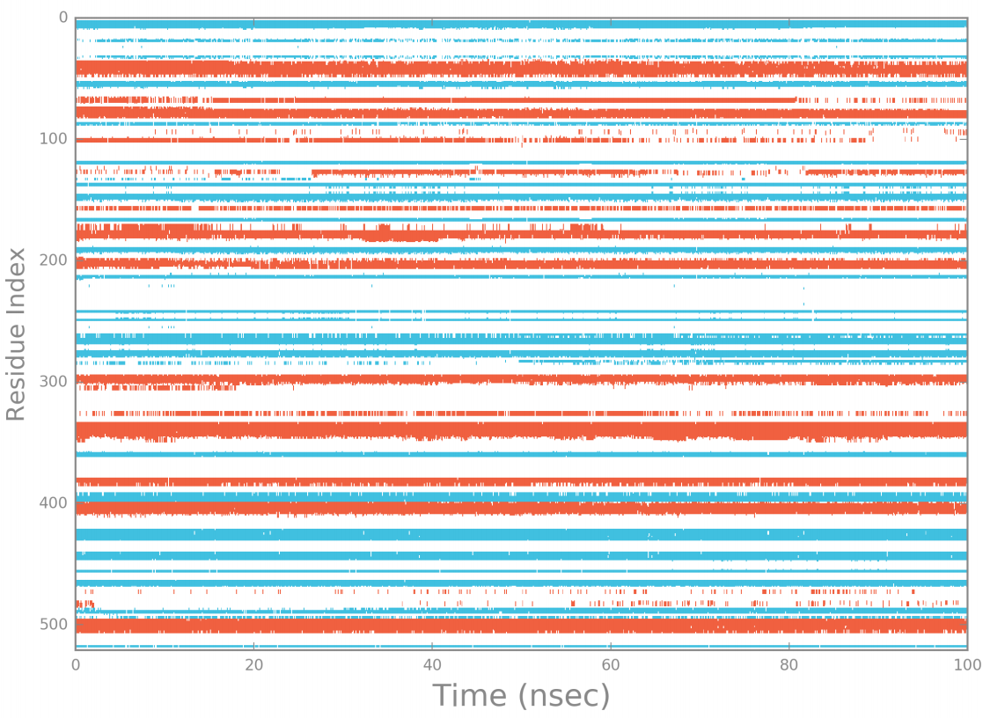

Figure S4. RMSD plot of two compound **5** and **55** calculated with the reference of themselves.



Figure S5. Conformational evolution of every rotatable bond in compounds **5** throughout 100 ns MD simulation. Radial plots describe the conformation of the torsion throughout the course of the simulation. The beginning of the simulation is the center of the radial plot, and the time evolution is plotted outward. Each rotatable bond torsion is accompanied by a dial plot and bar plots of the same color.

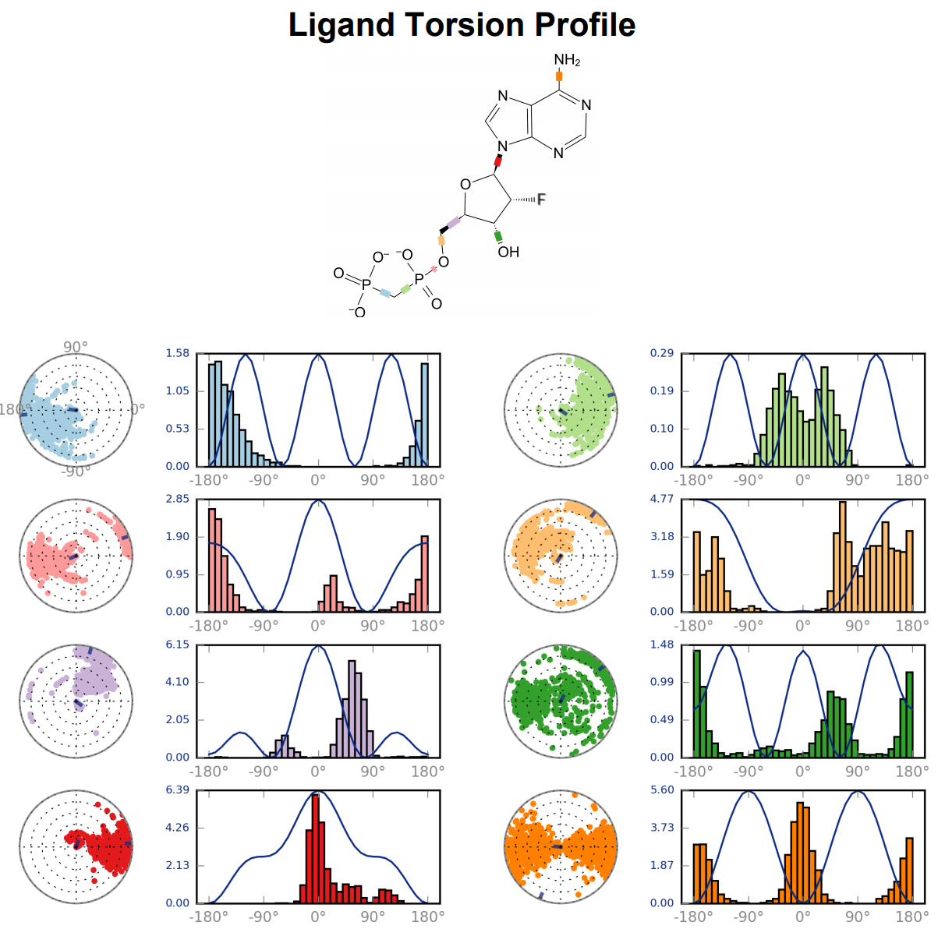

Figure S6. Conformational evolution of every rotatable bond in compounds **55** throughout 100 ns MD simulation. Radial plots describe the conformation of the torsion throughout the course of the simulation. The beginning of the simulation is the center of the radial plot, and the time evolution is plotted outward. Each rotatable bond torsion is accompanied by a dial plot and bar plots of the same color.

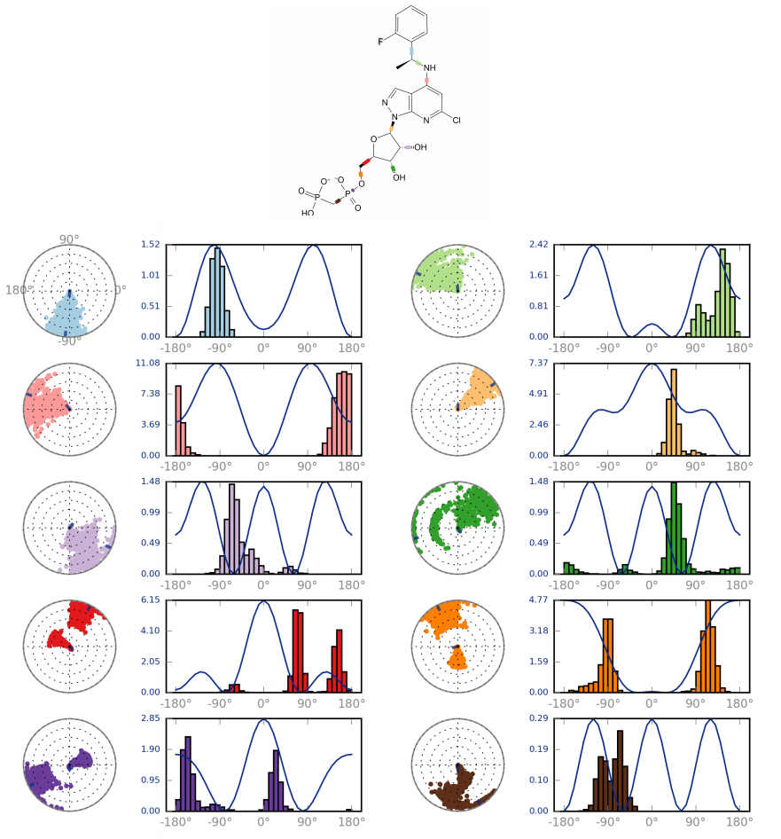

Figure S7. Histogram of binding free energy calculated with compound **5** and compound **55** with the energy decomposed into several types of interaction.