Online Supplementary Materials

Supplementary Figure I. Cumulative Density Function for Readmissions within 30 Days in Takotsubo syndrome
Supplementary Table I. Independent Predictors of Inhospital Mortality After Index Hospitalization With Takotsubo Syndrome
Supplementary Table II. Independent Predictors of 30-Day Total Mortality After Index Hospitalization With Takotsubo Syndrome
Supplementary Table III. Causes of Readmission in all Takotsubo Syndrome Patients
Supplementary Table IV. Causes of Readmission in Takotsubo Syndrome Patients With Malignancy
Supplementary Table V. Causes of Readmission in Takotsubo Syndrome Patients Without Malignancy
Supplementary Table VI. Costs and Charges over 30 Days After Index Hospitalization for Takotsubo syndrome With or Without Malignancy

Supplementary Figure I. Cumulative Density Function for Readmissions within 30 Days in Takotsubo syndrome
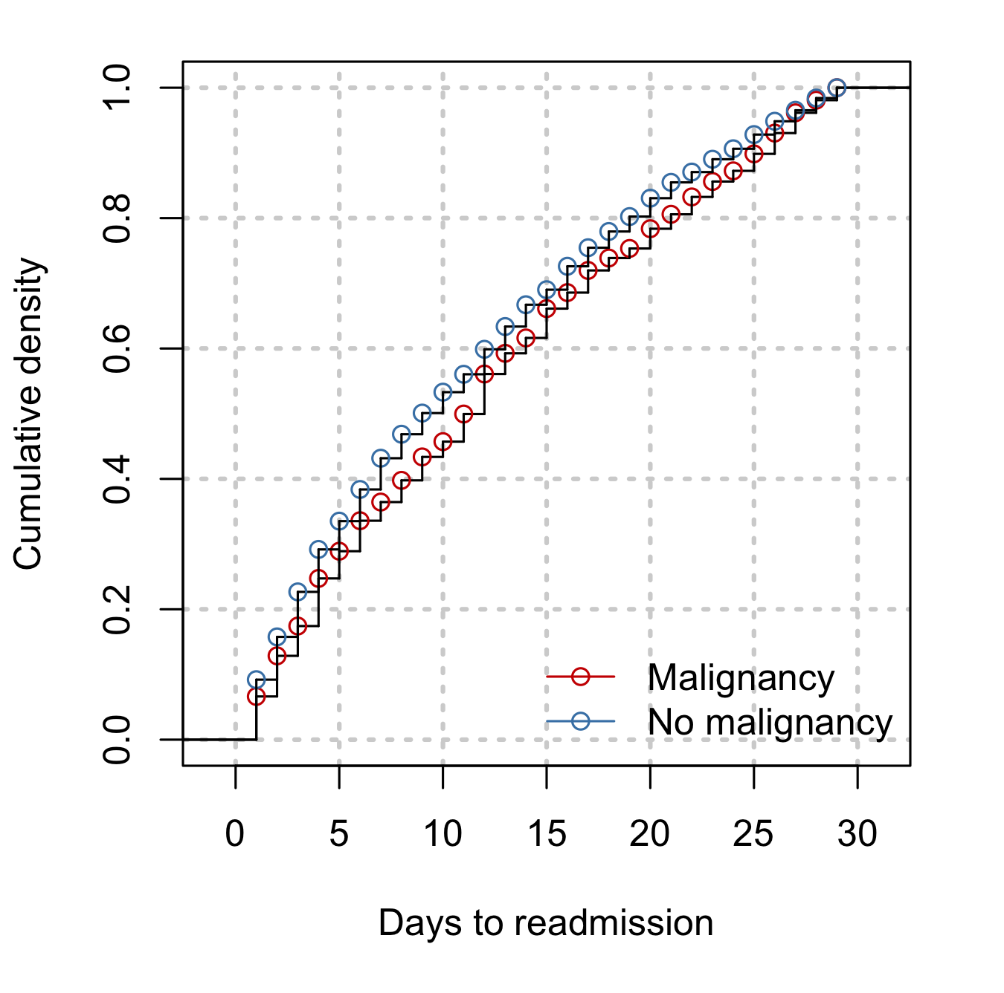

Supplementary Table I. Independent Predictors of Inhospital Mortality After Index Hospitalization With Takotsubo Syndrome
Variables | Unadjusted OR | Lower CI | Higher CI | P value | Adjusted OR | Lower CI | Higher CI | P value
Malignancy | 1.96 | 1.56 | 2.46 | <0.001 | 1.68 | 1.29 | 2.17 | <0.001
Age≥70 yrs | 1.81 | 1.49 | 2.19 | <0.001 | 1.85 | 1.49 | 2.30 | <0.001
Smoking | 0.71 | 0.58 | 0.88 | <0.001 | 0.72 | 0.57 | 0.91 | 0.006
Fluid and electrolyte | 3.80 | 3.17 | 4.56 | <0.001 | 2.06 | 1.67 | 2.55 | <0.01
Pulmonary Circ Disease | 3.81 | 2.65 | 5.48 | <0.001 | 1.86 | 1.18 | 2.93 | 0.008
Chronic Pulmonary disease | 1.41 | 1.15 | 1.74 | <0.001 | 1.31 | 1.04 | 1.65 | 0.022
Cardiogenic shock | 11.26 | 9.18 | 13.82 | <0.001 | 5.80 | 4.53 | 7.43 | <0.001
Cardiac arrest | 16.88 | 13.10 | 21.74 | <0.001 | 8.63 | 6.34 | 11.76 | <0.001
Arrhythmia | 2.66 | 2.19 | 3.24 | <0.001 | 1.62 | 1.31 | 2.01 | <0.001
Abbreviations: OR, odds ratio; CI, confidence interval.

Supplementary Table II. Independent Predictors of 30-Day Total Mortality After Index Hospitalization With Takotsubo Syndrome*
Variables | Unadjusted OR | Lower CI | Higher CI | P value | Adjusted OR | Lower CI | Higher CI | P value
Malignancy | 1.93 | 1.55 | 2.42 | <0.001 | 1.62 | 1.25 | 2.10 | <0.001
Age≥70 yrs | 1.87 | 1.55 | 2.26 | <0.001 | 1.88 | 1.51 | 2.34 | <0.001
Smoking | 0.75 | 0.63 | 0.93 | <0.001 | 0.77 | 0.62 | 0.96 | 0.019
Fluid and electrolyte | 3.74 | 3.14 | 4.45 | <0.001 | 2.15 | 1.76 | 2.63 | <0.001
Pulmonary Circ Disease | 3.85 | 2.68 | 5.55 | <0.001 | 1.90 | 1.22 | 2.96 | <0.001
Chronic pulmonary disease | 1.58 | 1.31 | 1.90 | <0.001 | 1.45 | 1.18 | 1.79 | <0.001
Cardiogenic shock | 9.39 | 7.66 | 11.51 | <0.001 | 4.82 | 3.78 | 6.16 | <0.001
Cardiac arrest | 14.18 | 11.08 | 18.16 | <0.001 | 7.60 | 5.64 | 10.26 | <0.001
Arrhythmia | 2.47 | 2.05 | 2.97 | <0.001 | 1.52 | 1.24 | 1.85 | <0.001
Family Hx of CAD | 0.36 | 0.21 | 0.63 | <0.001 | 0.58 | 0.34 | 0.98 | 0.042
Abbreviations: OR, odds ratio; CI, confidence interval; CAD, coronary artery disease.
*Thirty-day total mortality included inhospital mortality and 30-day readmission mortality together.

Supplementary Table III. Causes of Readmission in all takotsubo syndrome patients
Causes of Readmission | CCS codes | Frequency (%)
Cardiac causes |  | 21.6
Heart failure | 108 | 10.62
Arrhythmia | 106 | 4.70
Angina and Chronic Ischemic Heart Disease | 101 | 2.60
Acute myocardial infarction | 100 | 2.23
Non-specific chest pain | 102 | 1.93
Cardiac arrest | 107 | 1.10
Other cardiac causes |  | 9.0
Other circulatory (heart) disease/Complication of hypertension | 98, 99, 104, 117 | 2.83
Syncope | 245 | 0.73
Myocarditis/pericarditis | 97 | 0.70
Valvular heart disease | 96 | 0.45
Conduction disorder | 105 | 0.40
Non-cardiac causes |  | 69.4
Infectious | 2, 4, 122, 135, 148, 159, 197, 201 | 19.76
Respiratory | 103, 127, 128, 129*, 130, 131, 133, 134 | 12.44
Others | 81, 85, 199, 205, 211, 212, 231, 248, 251, 252, 259, N/S | 6.9
Gastrointestinal | 120, 138, 140, 141, 145, 146, 149, 151, 152, 153, 154, 155, 230, 246, 250 | 6.39
Endocrine/Metabolic | 50, 51, 55, 58 | 4.4
Neuropsychiatric/Substance | 83, 95, 242, 653, 657, 659, 660, 661 | 3.42
Genitourinary | 157, 158, 163, 164 | 3.08
Hematologic/oncologic | 19, 42, 45, 59, 60, 62 | 1.99
Stroke/Transient ischemic attack | 109, 110, 112, 113 | 1.56
Peripheral vascular disease | 114, 115, 116, 118 | 1.48
Trauma | 226, 233, 234, 244 | 1
Complication of medical procedure or implant/graft | 237, 238 | 8.8
Rehabilitation | 254 | 1.14
*Aspiration pneumonitis (CCS 129) was included in the respiratory problem.
Supplementary Table IV. Causes of Readmission in takotsubo syndrome patients with malignancy
Causes of Readmission | CCS codes | Frequency (%)
Cardiac causes |  | 18.3
Heart failure | 108 | 8.1
Arrhythmia | 106 | 4.9
Angina and Chronic Ischemic Heart Disease | 101 | 1.8
Acute myocardial infarction | 100 | 0.8
Non-specific chest pain | 102 | 2.6
Cardiac arrest | 107 | 0.1
Other cardiac causes |  | 6.2
Other circulatory (heart) disease/Complication of hypertension | 98, 99, 104, 117 | 4.3
Syncope | 245 | 0.2
Myocarditis/pericarditis | 97 | 1.6
Valvular heart disease | 96 | 0.1
Conduction disorder | 105 | 0
Non-cardiac causes |  | 75.5
Infectious | 2, 4, 122, 135, 148, 159, 197, 201 | 20.1
Respiratory | 103, 127, 128, 129*, 130, 131, 133, 134 | 8.4
Others | 81, 85, 199, 205, 211, 212, 231, 248, 251, 252, 259, N/S | 10.9
Gastrointestinal | 120, 138, 140, 141, 145, 146, 149, 151, 152, 153, 154, 155, 230, 246, 250 | 7.8
Endocrine/Metabolic | 50, 51, 55, 58 | 3.1
Neuropsychiatric/Substance | 83, 95, 242, 653, 657, 659, 660, 661 | 3.8
Genitourinary | 157, 158, 163, 164 | 4.6
Hematologic/oncologic | 19, 42, 45, 59, 60, 62 | 6.7
Stroke/Transient ischemic attack | 109, 110, 112, 113 | 2.5
Peripheral vascular disease | 114, 115, 116, 118 | 1.2
Trauma | 226, 233, 234, 244 | 0.9
Complication of medical procedure or implant/graft | 237, 238 | 5.5
Rehabilitation | 254 | 0
*Aspiration pneumonitis (CCS 129) was included in the respiratory problem.
Supplementary Table V. Causes of Readmission in takotsubo syndrome patients without malignancy
Causes of Readmission | CCS codes | Frequency (%)
Cardiac causes |  | 22.3
Heart failure | 108 | 11.14
Arrhythmia | 106 | 3.29
Angina and Chronic Ischemic Heart Disease | 101 | 2.42
Acute myocardial infarction | 100 | 1.67
Non-specific chest pain | 102 | 3.5
Cardiac arrest | 107 | 0.28
Other cardiac causes |  | 9.5
Other circulatory (heart) disease/Complication of hypertension | 98, 99, 104, 117 | 6.46
Syncope | 245 | 0.87
Myocarditis/pericarditis | 97 | 1.55
Valvular heart disease | 96 | 0.35
Conduction disorder | 105 | 0.27
Non-cardiac causes |  | 68.1
Infectious | 2, 4, 122, 135, 148, 159, 197, 201 | 12.04
Respiratory | 103, 127, 128, 129*, 130, 131, 133, 134 | 12.41
Others | 81, 85, 199, 205, 211, 212, 231, 248, 251, 252, 259, N/S | 8.8
Gastrointestinal | 120, 138, 140, 141, 145, 146, 149, 151, 152, 153, 154, 155, 230, 246, 250 | 9.45
Endocrine/Metabolic | 50, 51, 55, 58 | 3.7
Neuropsychiatric/Substance | 83, 95, 242, 653, 657, 659, 660, 661 | 4.75
Genitourinary | 157, 158, 163, 164 | 3.62
Hematologic/oncologic | 19, 42, 45, 59, 60, 62 | 0.99
Stroke/Transient ischemic attack | 109, 110, 112, 113 | 3.96
Peripheral vascular disease | 114, 115, 116, 118 | 2.33
Trauma | 226, 233, 234, 244 | 1.2
Complication of medical procedure or implant/graft | 237, 238 | 4.85
Rehabilitation | 254 | 0.11
*Aspiration pneumonitis (CCS 129) was included in the respiratory problem.

Supplementary Table VI. Costs and Charges over 30-days after Index Hospitalization for Takotsubo syndrome with or without Malignancy
Outcomes | Overall | TTS with malignancy | TTS without malignancy | P Value†
Number of patients, n (%) | 61583 (100) | 7542 (12.2) | 54041 (87.8)
Charge (index hospitalization), $ | 39498 (25935-68521)* | 46876 (28416-87536 | 38593 (25481-66425) | <0.001
Cumulative charges (index hospitalization + 30-day readmission), $ | 41830 (26501-75167) | 50936 (29819-97989) | 40735 (26160-72619) | <0.001
Cost (index hospitalization), $ | 11427 (7999-17933) | 13344 (8909-24171) | 11194 (7900-17933) | <0.001
Cumulative costs (index hospitalization + 30-day readmission), $ | 11998 (8181-20564) | 14686 (9294-27337) | 11704 (8065-19630) | <0.001
Abbreviations: TTS, Takotsubo syndrome.
*All values are shown as a median (interquartile range).
†Mann-Whitney-Wilcoxon test was used in all comparisons.

