Supplemental Materials: Real-space imaging of phase transitions in
bridged artificial kagome spin ice
Kevin Hofhuis,^{1,2*} Sandra Helen Skjærvø,^{1,2} Sergii Parchenko,^{1,2,3} Hanu Arava,^{1,2} Zhaochu Luo,^{1,2} Armin Kleibert,³ Peter Michael Derlet,^{1,4} and Laura Jane Heyderman^{1,2*}
¹Laboratory for Mesoscopic Systems, Department of Materials, ETH Zurich, 8093 Zurich, Switzerland
²Laboratory for Multiscale Materials Experiments, Paul Scherrer Institute, 5232 Villigen PSI, Switzerland
³Swiss Light Source (SLS), Paul Scherrer Institute, 5232 Villigen PSI, Switzerland
⁴Condensed Matter Theory Group, Paul Scherrer Institute, 5232 Villigen PSI, Switzerland
e-mail: kevin.hofhuis@psi.ch, laura.heyderman@psi.ch
Supplemental figures:
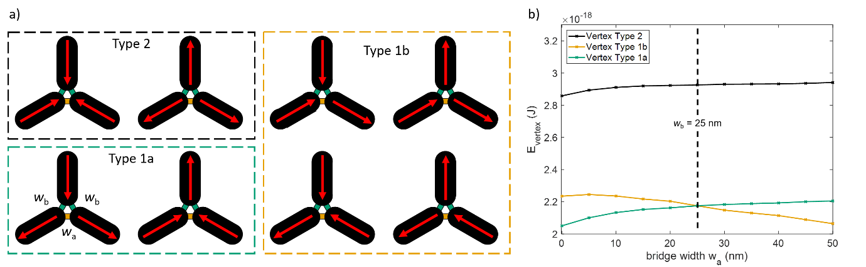

SM Fig. 1 | Bridged artificial kagome spin ice and vertex energies simulations.
(a) Bridged artificial kagome spin ice vertices showing the two-fold degenerate Type 1a vertices, the four-fold degenerate Type 1b vertices, and the high-energy excited Type 2 vertices. For w_{a} < w_{b}, we can see in (b), that the Type 1a vertex is the lowest energy configuration due to the asymmetric bridge placement. As soon as w_{a} = w_{b}, the degenerate kagome system is recovered with six-fold degeneracy (Type 1a and Type 2b vertices have the same energy), and beyond (w_{a} > w_{b}) a four-fold degenerate vertex system is created.

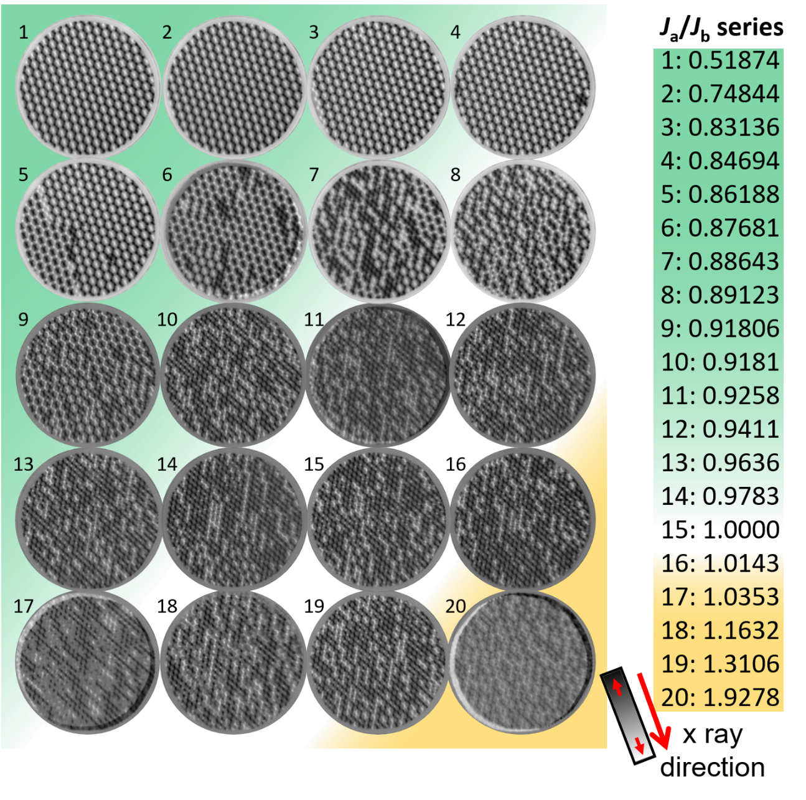
SM Fig. 2 | Bridged artificial kagome spin ice J_{a}/J_{b} series.
XMCD-PEEM images of bridged artificial kagome spin ice with twenty different bridge combinations giving J_{a}/J_{b} from 0.51874 to 1.9278. The images are obtained at room temperature after thermal annealing to 400 K and subsequent cooling to T_{B} = 310 K so that the magnetic moments are frozen. For statistics, at each J_{a}/J_{b} this procedure is repeated three times. The colour shading indicates the vertex degeneracy with green being two, orange is four, and white is six fold degenerate.
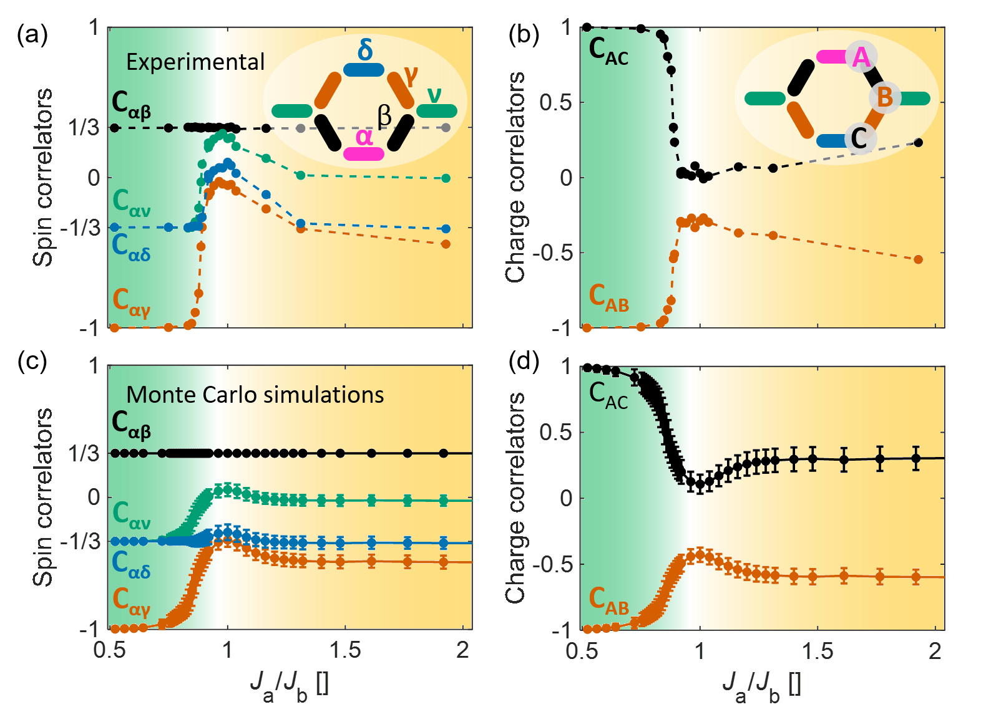

SM Fig. 3 | Spin and charge correlators obtained from experimental configurations and Monte Carlo simulations. Experimentally observed (a), spin and (b), charge correlators for various degeneracy strengths J_{a}/J_{b} obtained by varying the bridge width w_{a}, where the lithographically defined widths are used to determine the degeneracy strength J_{a}/J_{b} from Fig 1b. The definition of the correlators is given in the insets. Monte Carlo simulations are performed using the degeneracy strength J_{a}/J_{b} determined from micromagnetic simulations and the obtained temperature dependence of the spin and correlators is fitted to the experimental correlators. The obtained best-fit temperature is 310 K, and the corresponding (c), spin and (d), charge correlators are plotted.

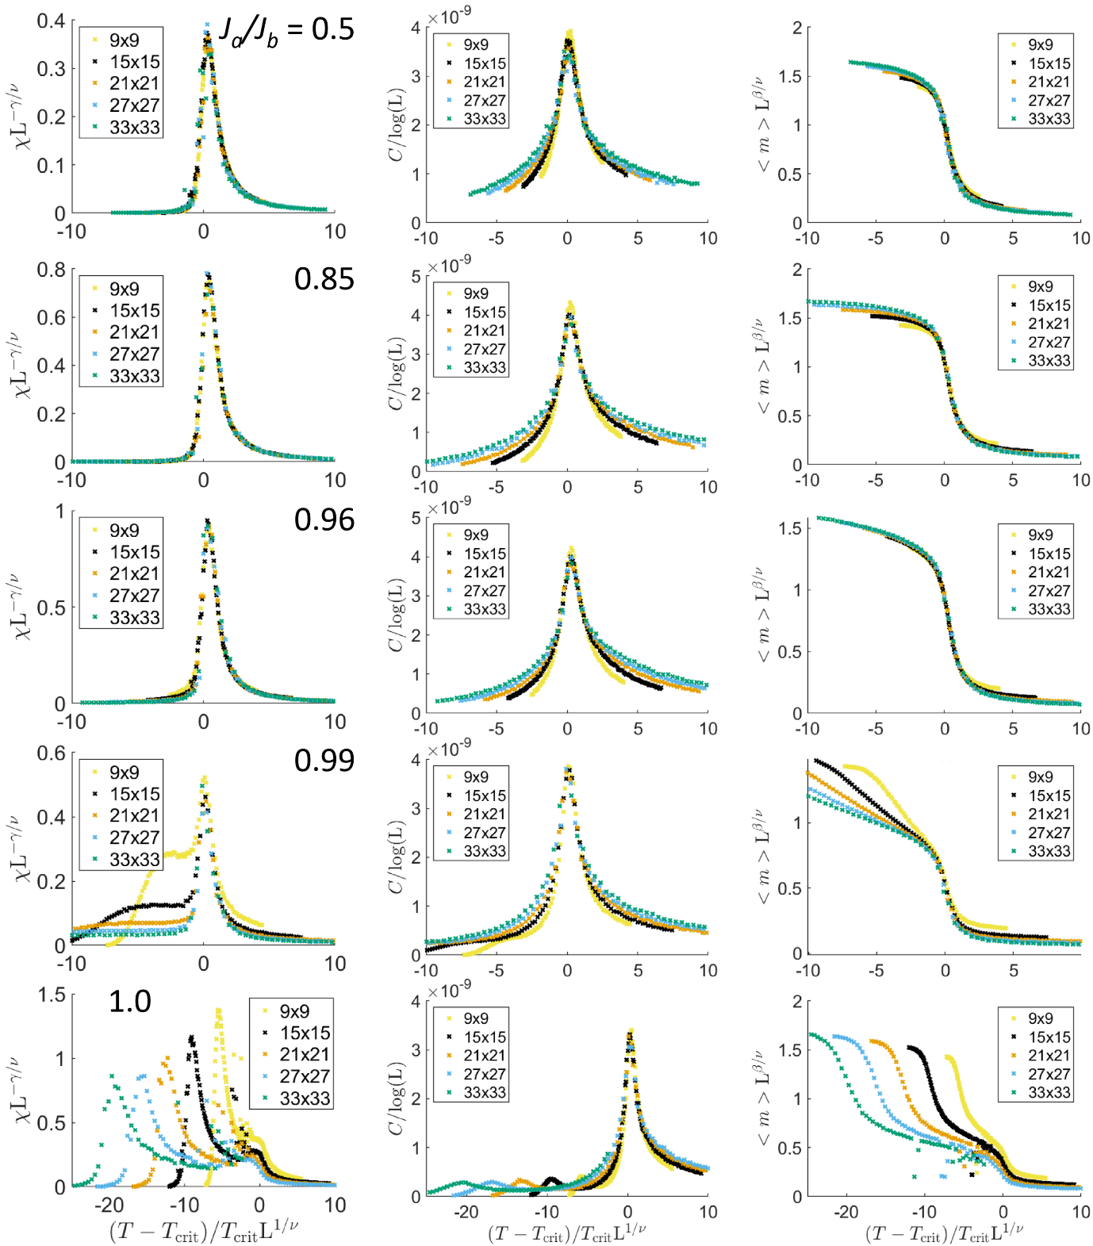

SM Fig. 4 | Monte Carlo simulations and scaling of the bridged artificial kagome spin ice. Magnetic susceptibility (left column), heat capacity (middle column), and staggered magnetisation (right column) plotted against reduced temperature using T_{crit} obtained from the Binder 4th order cumulant analysis. The scaling collapse occurs when assuming critical exponents of two dimensional Ising system (ν = 1, γ= 7/4, α= 0, β = 1/8) for various degeneracy strengths J_{a}/J_{b} = [0.5, 0.85, 0.96, 0.99, 1.0] and corresponding T_{crit} = [656.5, 309, 194, 160.4, 149] K, for the system sizes L = 9, 15, 21, 27, and 33. At J_{a}/J_{b} = 1, only the T_{crit} = 149 K is of 2D Ising universality class and thus scaled accordingly, while the second phase transition is a 3-state Potts transition at T_{crit} = 56 K. Interestingly, close to this degenerate case at J_{a}/J_{b} = 0.99, the low temperature shoulders are due to the strong moment fluctuations associated with the second phase transition.
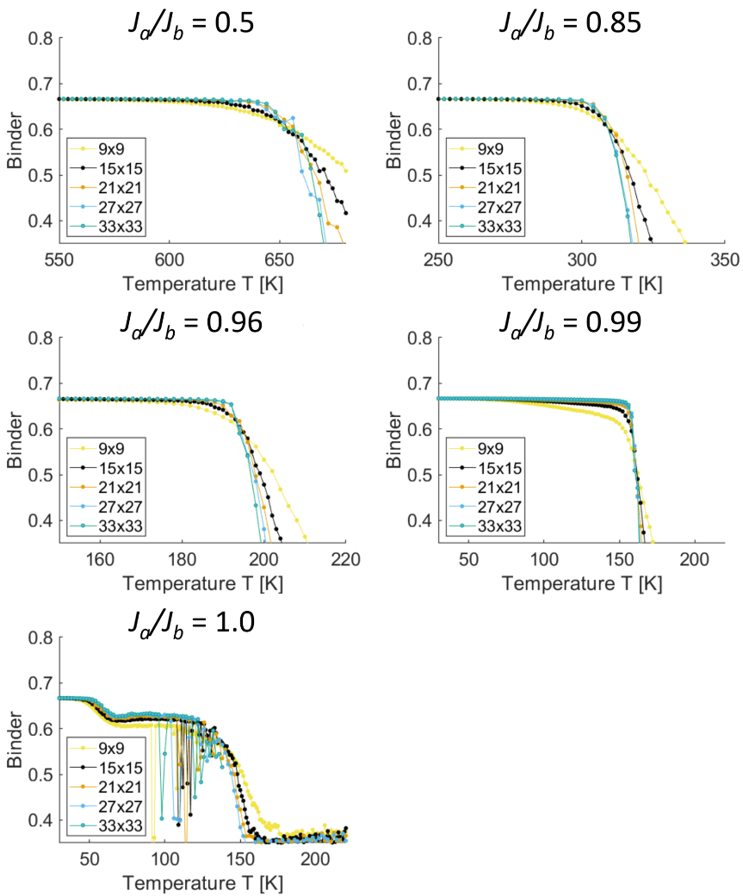
SM Fig. 5 Binder cumulant analysis for bridged artificial kagome spin ice. Monte Carlo simulations for the bridged artificial kagome spin ice that show the Binder cumulant as a function of temperature for a range of system sizes. Various degeneracy strengths are simulated J_{a}/J_{b} = [0.5, 0.85, 0.96, 0.99, 1.0], and the degenerate artificial kagome spin ice (J_{a}/J_{b} = 1.0) displays a two stage ordering in the order parameter. The scattering of data points is a result of there being insufficient unique spin configuration states.

Supplementary Movie captions

Supplementary Movie 1: XMCD image sequence of thermally-activated nanomagnets relaxing to a thermal equilibrium of the bridged artificial kagome spin ice with J_{a}/J_{b} = 0.5187. The top left box displays the XMCD contrast images, obtained as a function of time at constant temperature T = 320 K (T_{B} = 310 K), starting from an initial frozen as-grown out-of-equilibrium ice-rule obeying phase, which relaxes towards the equilibrium long-range ordered phase. The extracted spin configurations are given in the top right box, from which the vertex charge ordering is extracted and indicated with yellow dots in the bottom left, while blue dots indicate disordered charges. In the bottom right corner, we display the corresponding formation of moment loops, indicated with magenta and green for the left and right-handed chirality of the loops. The images are from a field-of-view of 20 μm in the XPEEM.

Supplementary Movies 2 to 4: XMCD image sequence of thermally-activated nanomagnets fluctuating at 310, 337 and 339 K (T_{B} = 310 K) of the bridged artificial kagome spin ice with J_{a}/J_{b} = 0.847 (T_{crit} = 340 K). The top left box displays the series of XMCD contrast images obtained as a function of time at constant temperature after equilibrating for 20 minutes. The extracted spin configurations are given in the top right box, from which the vertex charge ordering is extracted and indicated with yellow dots in the bottom left, while blue dots indicate disordered charges. In the bottom right corner, we display the corresponding formation of moment loops, indicated with magenta and green for the left and right-handed chirality of the loops. The images are from a field-of-view of 20 μm in the XPEEM.

