Emission impacts of supply chain disruptions for COVID and China’s solid waste import ban

Supplementary Information

Supplementary Methods: Regional Data and Evolution
Table S1. Data sources and corresponding values collected.
International Copper Study Group (ICSG)^{1,2} | Global average mine capacity utilization, total mining production, concentrate production, solvent extraction-electrowinning (SX-EW) production, primary and secondary smelting and refining production, refined copper consumption, direct melt copper consumption, regional distributions of global mining, refining, and semi-fabricator production
International Copper Association (ICA)³ | Global sector to final product accounting matrix
Minsur | Global copper consumption by end-use sector
Glöser et al.⁴ | Global sectoral lifetime distributions, consumption by final product to waste type accounting matrix, technical recycling efficiencies and collection rates by waste type, fabrication efficiencies by final product, sector to shape accounting matrix
International Wrought Copper Council (IWCC ⁵) | Sector to shape accounting matrix
Copper Development Association (CDA)⁶⁻⁸ | Semi-fabricator shape and alloy data, general understanding of semi-fabricator system, scrap stream and scrap flows, energy consumption
CRU Group⁹ | Annual TCRC
S&P Global Market Intelligence¹⁰ | Individual (global and regional) minesite data, including head grades, total cash margin, annual production, etc.
Wood Mackenzie¹¹ | Individual (global and regional) refinery capacity utilization and primary and secondary refinery production; China concentrate, SX-EW, total mining, and primary and secondary refining production; China refined copper consumption and refined copper, scrap, and concentrate imports and exports
Shanghai Metals Market^{12,13} | Base metal prices, China sectoral lifetimes, collection rates, and demand; China domestic and imported scrap supply, scrap demand
Fastmarkets AMM,¹⁴ Fastmarkets MB¹⁵ | Scrap and refined metal prices
UN Comtrade¹⁶ | China refined copper consumption and refined copper, scrap, and concentrate imports

Regionalization of primary and secondary refinery production mandated a reassessment of the dynamic panel regression models performed on the individual primary and secondary refinery production and capacity utilization data provided by Wood Mackenzie through 2016.¹⁷ Refineries were separated into four groups – China and rest-of-world (RoW) primary and secondary refineries, where primary refineries process only primary material and secondary refineries process a mixture of primary and secondary material – and aggregated to be treated as four representative refineries. For each individual refinery, the evolution of capacity utilization can be described by equation S1 while for each set of secondary refineries, the fraction of refinery production stemming from secondary material, the secondary ratio (SR), evolves according to equation S2.

$log\left({CU}_{i,t}\right)=α+ρlog\left({CU}_{i,t-1}\right)+βlog\left({TCRC}_{t}\right)+{μ }_{i}+ε_{i,t}$ (S1)

$log\left({SR}_{i,t}\right)=α+ρlog\left({SR}_{i,t-1}\right)+β_{1}log\left({TCRC}_{t}\right)+{β_{2}\log\left({Spread}_{No.2, t}\right)+μ }_{i}+ε_{i,t}$ (S2)

Where $CU_{i,t}$ is the primary or secondary capacity utilization for each refinery $i$ at time $t$, $TCRC_{t}$ is the global TCRC at time $t$ as refinery-specific refining charges were unavailable, $μ_{i}$ is the individual-invariant error term, and $ε_{i,t}$ is an idiosyncratic error. Given these equations are in log-linear form, each $β$ represents the short-run TCRC or No.2 spread elasticity to CU or SR, while $β÷\left(1-ρ\right)$ represents the long-run elasticity, which accounts for the impact of past TCRC or No.2 spread values on CU or SR.^{18,19} However, the coefficients for each of these parameters were not statistically significant at the regional level, and consequently the global values were used for each region. The resulting primary and secondary CU and SR evolution equations for the four representative refineries are shown in equations S3-S5.

${CU}_{primary, t}={CU}_{primary, t-1}∙{\left(\frac{{TCRC}_{t}}{{TCRC}_{t-1}}\right)}^{0.0574}$ (S3)
${CU}_{secondary,t}={CU}_{secondary,t-1}∙{\left(\frac{{TCRC}_{t}}{{TCRC}_{t-1}}\right)}^{0.153}$ (S4)
${SR}_{t}={SR}_{t-1}∙{\left(\frac{{TCRC}_{t}}{{TCRC}_{t-1}}\right)}^{-0.197}∙{\left(\frac{{Spread}_{No.2,t}}{{Spread}_{No.2,t-1}}\right)}^{0.316}$ (S5)

Regional initial CU values were calculated using the averages from individual China and RoW data, with initial capacity values calculated based on 2018 primary and secondary total production. Initial regional SRs were estimated by extrapolating average regional SRs from the average 2016 Wood Mackenzie value to 2018 using equation S5, and each of these parameters is shown in Table S2.

Table S2. Regional refinery hyperparameters for the simulation start time of 2018, where capacities are reported in kilotonnes (kt, thousand metric tonnes), CU and SR are fractions of 1.
 | China | Rest of World
Primary capacity | 6,650 kt | 818 kt
Primary CU | 0.875 | 0.854
Primary CU long-run elasticity to TCRC | 0.0574 | 0.0574
Secondary Capacity | 4,240 kt | 11,200 kt
Secondary CU | 0.886 | 0.836
Secondary CU long-run elasticity to TCRC | 0.153 | 0.153
SR | 0.420 | 0.293
SR long-run elasticity to TCRC | -0.197 | -0.197
SR long-run elasticity to No.2 scrap spread from cathode price | 0.316 | 0.316

Supplementary Methods: Semi-Fabricator Alloy Distribution Framework
The regional, sectoral distribution of total copper demand was obtained using exogenous economic growth indicators and copper use intensity evolution, as described in the Methods section of this work and by Dr. Xinkai Fu.¹⁸ Sectors are construction, electrical, transport, industrial, and other, while regions are China, the European Union, Japan, North America, and other. Following regrouping to match the China-RoW division used in this model, a sector-shape conversion matrix was used to convert sectoral consumption into two unalloyed shapes – wire and other – and five unalloyed shapes – wire, tube, RBS (rods, bars, and solids), PSS (plates, sheets, and strips), and castings. This static matrix was derived by grouping sector and shape data reported by Glöser et al and the International World Copper Council, using the average distribution of the last four years’ reported data, and is shown in Table S3.^{4,5} Due to a lack of data availability, it was assumed that this distribution holds constant between regions as well.

Table S3. The sector-shape conversion matrix
 |  | Construction | Electrical | Industrial | Transport | Other
Unalloyed | Wire | 0.451 | 0.944 | 0.361 | 0.569 | 0.480
 | Other | 0.407 | 0.002 | 0.136 | 0.139 | 0.252
Alloyed | Tube | 0.003 | 0.035 | 0.055 | 0.013 | 0.007
 | RBS | 0.100 | 0.019 | 0.260 | 0.034 | 0.036
 | PSS | 0.001 | 0.000 | 0.024 | 0.110 | 0.150
 | Wire | 0.001 | 0.000 | 0.016 | 0.006 | 0.039
 | Cast | 0.037 | 0.000 | 0.148 | 0.129 | 0.036
Total: |  | 1.000 | 1.000 | 1.000 | 1.000 | 1.000

The resulting regional copper demand by shape was further broken down into alloy designations to permit a compositional distribution of copper demand for the linear programming optimization model. Unalloyed shapes were assumed to have the same high-copper composition of the CW003A CEN alloy or similar, while alloyed shapes required a more thorough treatment.

For each alloy, some specific scrap grades are preferred, particularly those with similar chemical compositions to the alloy. Therefore, the breakdown of direct melt scrap consumption depends on the grades and quantities of alloys produced. Mathematically, consumption by alloy grade can be calculated as shown in equation S6.
$C_{a_{i},t}=\sum_{s_{j}ϵs}{C_{s_{j},t}A_{s_{j},a_{i}}}$ (S6)
$C_{a_{i},t}$ represents consumption of alloy grade $a_{i}$ at year t, and $A_{s_{j},a_{i}}$ is an accounting matrix to calculate the fraction of alloy $a$ consumed for each shape $s_{j}$. The sum is over $s$, a set containing the five alloyed semis shapes (tube, RBS, PSS, wire, and castings). Because no reported data is readily available for the accounting matrix $A_{s_{j},a_{i}}$, the fraction of each shape comprised by each of the 190 alloyed semis was determined based on the CDA’s copper alloy supplier database.⁶ This database provided alloy supplier counts for each semis shape, and while it was limited to suppliers in the United States, it was assumed that average sectoral alloy compositions within each shape would be sufficiently similar between regions. Based on industry interviews, it was further assumed that the 80-20 rule would apply, which states that 80% of a market is dominated by 20% of its constituents.

Here, the rule was adjusted slightly to account for the large number of alloys with either no suppliers listed by the CDA or with a small number of suppliers to represent the large number of specialty alloys that introduce trace amounts of less common elements to the eventual scrap stream. This large quantity of alloys with few or no suppliers produced a highly-skewed distribution in the number of suppliers. As such, alloys were broken into groups representing high-demand, moderate-demand, and specialty alloys comprising 70%, 20%, and 10% of a given shape’s production, respectively. High-demand alloys had a number of suppliers greater than two standard deviations above the mean number of suppliers, moderate-demand alloys had a number of suppliers greater than half one standard deviation above the mean number of suppliers, and specialty alloys were all others. Each alloy’s production fraction is then equal to the group fraction multiplied by the alloy’s supplier fraction within its group. The accounting matrix $A_{s_{j},a_{i}}$ can then be represented by equation S7 below.
$A_{s_{j},a_{i}}=\frac{0.7n_{{s_{j},a}_{i}}δ\left(n_{s_{j},a_{i}}>mean\left(n_{s_{j}}\right)+2stdev\left(n_{s_{j}}\right)\right)}{\sum_{a_{i}∈a}{n_{{s_{j},a}_{i}}δ\left(n_{s_{j},a_{i}}>mean\left(n_{s_{j}}\right)+2stdev\left(n_{s_{j}}\right)\right)} }+\frac{0.2n_{{s_{j},a}_{i}}δ\left(n_{s_{j},a_{i}}>mean\left(n_{s_{j}}\right)+0.5stdev\left(n_{s_{j}}\right) ∪ n_{s_{j},a_{i}}<mean\left(n_{s_{j}}\right)+2stdev\left(n_{s_{j}}\right)\right)}{\sum_{a_{i}∈a}{n_{{s_{j},a}_{i}}δ\left(n_{s_{j},a_{i}}>mean\left(n_{s_{j}}\right)+0.5stdev\left(n_{s_{j}}\right) ∪ n_{s_{j},a_{i}}<mean\left(n_{s_{j}}\right)+2stdev\left(n_{s_{j}}\right)\right)} }+\frac{0.1n_{{s_{j},a}_{i}}δ\left(n_{s_{j},a_{i}}<mean\left(n_{s_{j}}\right)+0.5stdev\left(n_{s_{j}}\right)\right)}{\sum_{a_{i}∈a}{n_{{s_{j},a}_{i}}δ\left(n_{s_{j},a_{i}}<mean\left(n_{s_{j}}\right)+0.5stdev\left(n_{s_{j}}\right)\right)} }$ (S7)
Where $A_{s_{j},a_{i}}$ is the accounting matrix from above for shape $s_{j}$ and alloy $a_{i}$, $n_{s_{j},a_{i}}$ is the number of suppliers for each alloy within each shape, $δ$ is the Dirac delta function, and the mean and standard deviation are calculated using all alloys within a given shape. Alloys with no suppliers listed were given $A_{s_{j},a_{i}}$ of 0.005, and the accounting matrix was then normalized such that the sum over alloys for each shape was equal to one. The accounting matrix was then perturbed and renormalized iteratively until the average copper content of each alloyed semis shape matched that from ICA data. The accounting matrix is then assumed to remain static with time.

Supplementary Methods: Scrap Price, Availability, and their Interplay
Scrap markets were assumed to be sufficiently illiquid that purchasing followed an order book formulation, where increasing consumption of any scrap grade increases the average price of that grade for the market and the resulting average scrap price is a function of availability. For example, if a fabricator needs 100 kt of scrap and the cheapest available scrap is 50 kt at US$5000 per tonne, with an additional 100 kt is available at US$6000 per tonne, the average price of scrap for that fabricator will then be US$5500 per tonne, as shown in equation S8. Using China copper scrap import transaction data from Big Trade Data, we found empirical evidence for order book behavior (Figure S1a), producing an average cost curve (Figure S1b) and developed a formulation for expressing this curve in piecewise linear form (Figure S1b, equation S9) as a function of scrap price, availability, and quantity demanded.
$Average Cost=\sum_{u∈unit costs}{u*q_{u}}$ (S8)
Where $u$ represents an individual unit cost within the set of unit costs corresponding with the set of quantities $q$, with $q_{u}$ being the quantity purchased at a given unit cost.
$Market Average Cost\left(x\right)=\left\{\begin{aligned}0, x=0 \\ 0.777p+0.782\frac{p}{a}x, 0<x<0.187a \\ 0.872p+0.276\frac{p}{a}x, &0.187a≤x<0.812a \\ 0.672p+0.522\frac{p}{a}x, 0.812a≤x<1 \end{aligned}\right.$ (S9)
Where we calculate the average cost of a given scrap grade for the entire market based on the quantity demanded by the market $x$, the quantity of that scrap grade available $a$, and the reported or calculated market average price for that scrap grade $p$.

Figure S1: Order book formulation for No.2 scrap
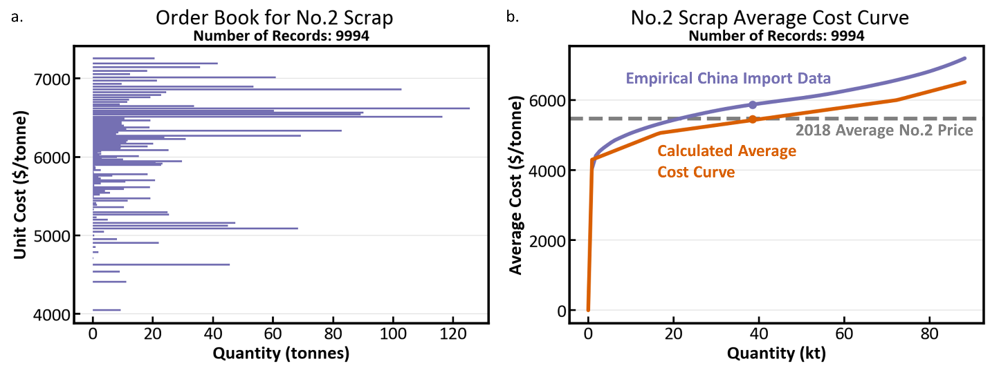
a, Reported China copper scrap import transaction quantities and unit costs for the 9994 records identified as corresponding to the No.2 scrap grade in 2018. b, The resulting average cost curves from the empirical China import transaction data calculated using equation S8 (blue) and the calculated piecewise linear average cost curve using equation S9, the quantity of available scrap, and the 2018 reported No.2 price. Dots indicate the average unit price of the corresponding dataset.

Within the linear programming optimization model described in Supplementary Methods: Linear Programming Optimization Model, the total cost of the market’s consumption of a given scrap grade is calculated by integrating equation S9, while for refined materials it is simply the product of the quantity demanded and the unit cost. These values were used to create piecewise linear penalty functions for each refined metal and scrap grade such that the total price was minimized. Post-industrial recycled material prices were calculated as a constant fraction of refined copper price, reflecting the expectation that nearly 100% of new scrap generated each year is consumed due to its capacity for direct melt consumption.

Historical scrap prices were reported by Fastmarkets MB and the American Metal Market, and average scrap price and refined metal price evolution are calculated as follows. A given year’s scrap and cathode prices are calculated using the supply-demand balance, or change in inventory, produced by historical data or model evolution in the year prior using equations S10 and S11, and the elasticity values shown in Table S4. Prices for non-copper refined metals were assumed to evolve proportionally to refined copper, as shown in equation S12.
$P_{cathode,t}=P_{cathode,t-1}+β_{cathode SD}*{Bal}_{cathode}$ (S10)

$${Spread}_{scrap,t}={Spread}_{scrap,t-1}+β_{scrap SD}*{Bal}_{scrap}+β_{scrap cathode}*(P_{cathode,t}-P_{cathode, t-1})$$
(S11)
$P_{metal,t}=P_{metal, t-1}*\frac{P_{cathode,t}}{P_{cathode,t-1}}$ (S12)
Where $P$ represents the price of copper cathode or that of the other refined metals considered in this study (Al, Fe, Mn, Ni, Pb, Sn, Zn) based on subscript, spread is the term used for the difference between cathode price and scrap price within a given time period, and the $β$ terms are explained and given values in Table S4. Equations S11 and S12 are evaluated for each scrap grade and refined metal, respectively, where each of the alloyed scrap grades considered here (aluminum bronze, cartridge, grape, low brass, manganese bronze, nickel silver, ocean, red brass, leaded red brass, tin bronze, leaded tin bronze, yellow brass, and leaded yellow brass) is evaluated using its own price but the same alloyed elasticities.

Table S4. List of symbols for use in equations S10-S12, where SD refers to supply and demand.
Symbol | Name | Value
$β_{cathode SD}$ | Cathode SD elasticity | -0.645598
$β_{scrap SD}$ | No.2 spread SD elasticity | 0.0845
 | No.1 spread SD elasticity | 0.02955
 | Alloyed scrap spread SD elasticity | 0.193818
$β_{scrap cathode}$ | No.2 spread cathode elasticity | 0.18399
 | No.1 spread cathode elasticity | 0.064346
 | Alloyed scrap spread cathode elasticity | 0.422019

We now present the data used for calculating scrap generation at the level of detail required for use in the semi-fabricator alloy distribution framework described in Supplementary Methods: Semi-Fabricator Alloy Distribution Framework, where a lognormal distribution of material lifetimes was used to calculate scrap generation, recycling collection and recovery rates were used to calculate old scrap entering useable inventories, and fabrication efficiencies, recovery rates, and external scrap ratios were used to calculate new scrap entering useable inventories. Lifetimes, fabrication efficiencies, and new scrap generation rates are shown in Table S5; regional scrap collection and recovery rates are shown in Table S6. The new scrap generation rate is equal to $\frac{1}{fabrication efficiency}-1$.

Table S5. Sectoral lifetimes, fabrication efficiencies, and new scrap generation rates for China and RoW.
Sector | RoW Lifetime | RoW Fabrication efficiency | RoW New scrap generation rate | CN Lifetime | CN Fabrication efficiency | CN New scrap generation rate
Plumbing | 40 | 0.95 | 0.05 | 28 | 0.95 | 0.05
Building Plant | 40 | 0.9 | 0.11 | 28 | 0.95 | 0.05
Architecture | 50 | 0.85 | 0.18 | 28 | 0.95 | 0.05
Communications | 30 | 0.9 | 0.11 | 28 | 0.95 | 0.05
Electrical Power | 40 | 0.9 | 0.11 | 25 | 0.93 | 0.08
Telecommunications | 30 | 0.9 | 0.11 | 28 | 0.95 | 0.05
Power Utility | 30 | 0.85 | 0.18 | 25 | 0.93 | 0.08
Electrical Industrial | 15 | 0.8 | 0.25 | 15 | 0.95 | 0.05
Non-Elec. Industrial | 20 | 0.9 | 0.11 | 15 | 0.95 | 0.05
Electrical Automotive | 12 | 0.75 | 0.33 | 12 | 0.75 | 0.33
Non-Elec. Automotive | 15 | 0.9 | 0.11 | 13 | 0.97 | 0.04
Other Transport | 25 | 0.8 | 0.25 | 13 | 0.97 | 0.04
Consumer | 8 | 0.75 | 0.33 | 11 | 0.96 | 0.04
Cooling | 10 | 0.8 | 0.25 | 11 | 0.96 | 0.04
Electronic | 5 | 0.75 | 0.33 | 4.9 | 0.95 | 0.05
Diverse | 10 | 0.75 | 0.33 | 10 | 0.75 | 0.33

Table S6. Regional end-of-life (EOL) scrap collection and recovery rates for the five waste categories considered in this study: construction and demolition (C&D), municipal solid waste (MSW), waste electrical and electronic equipment (WEEE), end-of-life vehicles (ELV), industrial electrical waste (IEW), and industrial non-electrical waste (INEW).
Waste Category | RoW EOL collection rate | RoW Recovery rate | CN EOL collection rate | CN Recovery rate
C&D | 0.72 | 0.9 | 0.75 | 0.9
MSW | 0.05 | 0.55 | 0.1 | 0.6
WEEE | 0.63 | 0.55 | 0.3 | 0.6
ELV | 0.91 | 0.7 | 0.52 | 0.8
IEW | 0.66 | 0.75 | 0.5 | 0.98
INEW | 0.68 | 0.2 | 0.7 | 0.88

Based on interviews with industry experts, we assumed the external scrap ratio to be 0.1, with home scrap and exchange scrap accounting for the remainder of new scrap generation. External scrap is that which manufacturers sell to scrap dealers or processors. Home scrap, also called in-house scrap or runaround scrap, is both generated and directly remelted for consumption at the manufacturer. Because it never leaves the fabrication facility, home scrap is not included in consumption statistics and its generation is highly uncertain. Exchange scrap, also called toll scrap, is incapable of direct remelt at the manufacturer and is instead sent to upstream scrap processors, processed, and returned to the manufacturer. Historical new scrap consumption is calculated based on total scrap consumption and the calculated old scrap generation. Based on fabrication efficiencies, the total quantity of pre-consumer scrap is known; by incorporating the calculated new scrap consumption, we then calculated the fraction of home and exchange pre-consumer scrap, which has evolved over time as shown in Figure S2. Throughout this study, we refer to the sum of external and exchange scrap as new scrap or post-industrial scrap. For data beyond 2018, we assumed increases in the home scrap ratio based on improving technology.

Figure S2: Home, exchange, and external scrap ratios for manufacturers
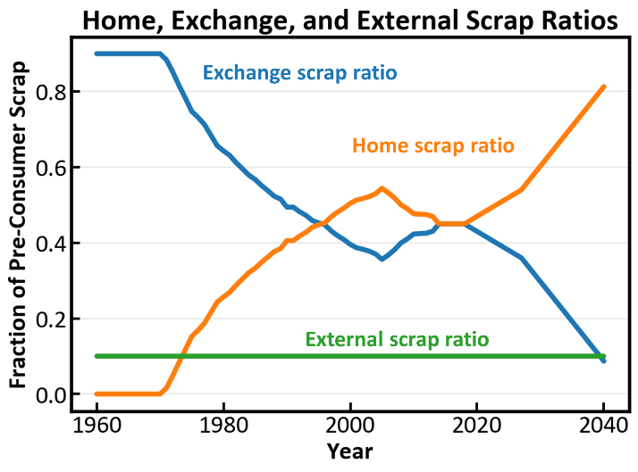
Home, exchange, and external scrap ratios for scrap generated by manufacturers.

Supplementary Methods: Linear Programming Optimization Model
Consumption for each of the 190 alloys can be calculated based on equation S6. Refined metal and direct melt scrap consumption are then determined by the linear programming optimization model within the blending module. The major model assumptions are:
- Alloyed semis (brass mills and foundries) have the capability to directly melt and blend different raw materials including refined metals and grades of alloyed copper scraps into alloys. It is assumed that there is no loss of materials during the blending process, and the chemical composition of the final blended product is the weighted average of all raw materials.
- The only quality constraint on the blended alloy product is the compositional specifications of elements in the alloy. In reality, there could be other quality constraints in the fabrication processes, such as requirements for mechanical properties and durability that might prohibit specific scrap grades into entering the melt. These other constraints are essentially neglected in this model.
- It is assumed that raw material costs only come from scraps and refined metals purchased. Other costs such as energy, labor, fixed costs, etc. are considered as constant. As long as compositional requirements are met, fabricators seek to minimize raw material costs by purchasing the cheapest mix of raw materials possible.
- Fabricators allow for the possibility that some products could be outside compositional requirements. Rather, they control for the success rate, or the fraction of products that meet compositional requirements.
- All refined raw materials are assumed to be infinitely available.
- The quantity of refined copper consumed globally each year is determined outside the blending module, under the assumption that its liquidity enables immediate redistribution between China and RoW.
- Secondary refinery scrap consumption is primarily composed of No.2 scrap, though secondary refineries may also use up to 5% of alloyed scrap available.

Based on these assumptions, a blending optimization model is formulated mathematically as follows:
Objective:
$\min\left(RMC\right)=\sum_{i}{M_{i}}P_{i}$ (S13)
Subject to:
- Compositional constraints:
$∀j, Pr\left\{\sum_{i}{M_{i}}X_{ij}≤c_{j}^{U}Q\right\}>λ$ (S14)
$∀j, Pr\left\{\sum_{i}{M_{i}}X_{ij}≥c_{j}^{L}Q\right\}>λ$ (S15)

- Mass balance:
$\sum_{i}{M_{i}}=Q$ (S16)
The description of each variable/symbol can be found in Table S7. This model uses 214 grades of raw materials, including 8 refined metals, 1 grade of unalloyed scrap (No.1, ISRI trade name barley), 13 grades of alloyed scrap, and 191 categories of post-industrial recycled material. The complete list of these grades and their compositional ranges are shown in Table S19. Due to limited data availability for both scrap compositions and scrap prices, the 14 scrap grades used here represent groups of scrap grades rather than specific ISRI grades. For example, the nickel-silver scrap grade in this model corresponds to six ISRI grades (Maize, Major, Malar, Malic, Naggy, Niece). A chance constrained formulation is used here, where the compositional constraints are probabilistic instead of deterministic. This formulation corresponds to assumption 4 mentioned above. In order to find the optimal solution, the compositional constraints are represented through the fuzzy number approach, following what is used in a previous study.²⁰ The total cost of the market’s consumption of a given scrap grade is calculated by integrating equation S9 described in Supplementary Methods: Scrap Price, Availability, and their Interplay; while for refined materials this value is simply the product of the quantity demanded and the unit cost. These values were used to create piecewise linear penalty functions for each refined metal and scrap grade within each region, which enabled market-wide price minimization.

Table S7. Description of variables used in the blending optimization model
Symbol | Description
$$RMC$$ | Total raw material cost
$$M_{i}$$ | Mass of raw material grade i consumed
$$P_{i}$$ | Price of raw material grade i
$$X_{ij}$$ | Mass fraction of element j in material i
$$c_{j}^{U/L}$$ | Upper/lower limit for element j in alloy based on its specification
$$Q$$ | Mass of alloy produced
$$λ$$ | Confidence level of product meeting specification

The direct melt scrap breakdown model described above takes regional fabricator consumption, raw material prices, and global refined copper demand as input, and calculates the amount of direct melt scrap consumption for each scrap grade, refined metal, and distribution of these quantities between China and RoW. Given that global refined copper demand is calculated endogenously as a function of cathode price outside the blending model, this model was not permitted the additional degree of freedom allotted by determining global refined copper demand, and therefore refined copper demand acted as an additional constraint.

Supplementary Data: Import Data
Table S8. Year over year change in copper scrap exports to China and change in imports for the nations addressed in this study, in kt copper content. Blank cells indicate a lack of data availability.
 | kt change in exports to China |  |  | kt change in imports
 | 2017-2018 | 2018-2019 | 2017-2019 | 2017-2018 | 2018-2019 | 2017-2019
China | 0.0 | 0.0 | 0.0 | -49.0 | -19.1 | -68.0
Rep. of Korea | 3.8 | 12.6 | 16.4 | 31.8 | -1.2 | 30.6
India | 0.2 | 4.3 | 4.4 | 9.0 | 13.5 | 22.4
Germany | -16.2 | -6.8 | -23.0 | 39.2 | -2.1 | 37.1
Taiwan | 17.6 | 38.3 | 55.9 | 11.0 | 38.3 | 55.9
Belgium | 6.9 | -11.2 | -4.3 | 10.4 | 18.0 | 28.4
Malaysia | 13.0 | 201.1 | 214.0 | 50.6 | 20.0 | 70.6
Canada | 7.5 | 7.2 | 14.7 | 10.2 | 16.9 | 27.1
Viet Nam | 1.8 | 1.4 | 3.2 | -0.5 | 2.5 | 2.1
Indonesia | 5.4 | 15.6 | 20.9 | 12.3 | 7.7 | 20.0
USA | -41.7 | -103.1 | -144.8 | -43.8 | 7.0 | -36.8
Japan | 38.0 | -22.1 | 15.8 | 23.5 | -40.3 | -16.8
Pakistan | 1.1 | -2.7 | -1.6 | 8.2 | 6.9 | 15.0
Singapore | 5.6 | 14.9 | 20.5 | 0.4 | -2.8 | -2.5
Thailand | -41.2 | 25.8 | -15.4 | -9.2 | 15.0 | 5.8
United Arab Emirates | 1.8 | 25.7 | 27.5 | -11.3 | 0.0 | -11.3
United Kingdom | 13.3 | 12.9 | 26.3
EU | -7.9 | -24.6 | -32.5

Table S9. The percentage of each country’s copper scrap exports that go to China in each year and the year over year change in the copper content (%) for copper scrap imports for each country, where the percentage given is relative to the initial year in the range displayed. Blank cells indicate a gap in data availability.
 | % of country’s exports going to China |  |  | Year over year % change in %Cu of copper scrap imports
 | 2017 | 2018 | 2019 | 2017-2018 | 2018-2019 | 2017-2019
China |  |  |  | 42.5 | 40.1 | 99.6
Rep. of Korea | 89.5 | 67.9 | 38.3 | 8 | -4.1 | 3.6
India | 5.7 | 4.9 | 29.8 | -4 | -11 | -14.5
Germany | 36.7 | 24.3 | 14.7 | 3.3 | 0.7 | 4.0
Taiwan | 51.4 | 49.2 |  | 2.7
Belgium | 39.7 | 20.9 | 15.3 | 2.2 | 2.8 | 5.1
Malaysia | 8.7 | 44.3 | 81.4 | -44.3 | 9.1 | -39.3
Canada | 38.1 | 23.3 | 19.1 | 5 | -2.9 | 2.0
Viet Nam | 5.2 | 6.4 | 5.5 | 3.1 | -0.4 | 2.7
Indonesia | 43.7 | 34.7 | 25.8 | 3.3 | -13.4 | -10.5
USA | 68.4 | 29.6 | 10.1
Japan | 93.5 | 80.4 | 39.7 | 4 | -4.3 | -0.5
Pakistan | 29.6 | 17.4 | 1.1 | -78 | -84.6 | -96.6
Singapore | 0.0 | 33.0 | 33.4 |  | -8.5
Thailand | 26.3 | 32.4 | 31.1 | 17.4 | 5.1 | 23.5
United Kingdom | 49.5 | 41.8 | 25.3
United Arab Emirates | 42.0 | 38.5 |  | 61.1

Supplementary Methods: China’s Concentrate Imports
China’s concentrate imports were calculated using values calculated using primary refining production in China (divided by 0.99, the concentrate to cathode efficiency assumed in this model) and subtracting the estimated concentrate production from mining within China, where China’s share of global concentrate production was assumed to hold constant at the 2017 value of 9% reported by ICSG.¹

Figure S3: China’s historical and simulated concentrate imports
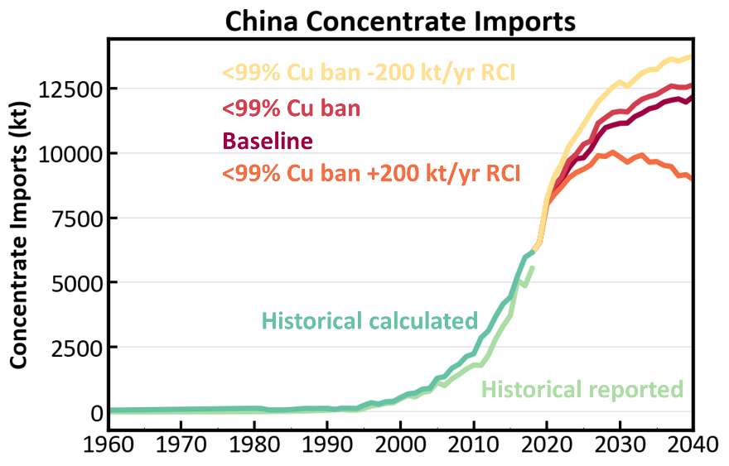
China’s historical and simulated concentrate imports under baseline and No.2 ban scenarios, with or without ±200 kt/yr changes in refined copper imports.

Supplementary Data: Sensitivity to Scrap SD Elasticities
One of the key factors in determining the distributions of scrap and refined copper consumption between China and RoW was the evolution of scrap spreads, calculated as shown in Supplementary Methods: Scrap Price, Availability, and their Interplay. As such, we conducted a sensitivity analysis for the impact of scrap spread elasticity to scrap supply-demand balance. In this set of scenarios, we halved or doubled the elasticity, demonstrating that increasing its value produces a small increase in the CO₂e emissions response due to China’s more rapid shift away from using scrap material as its price rises in conjunction with the solid waste import ban, even as the RoW’s response enables a small decrease primary refining and increase in secondary refining. Decreasing the scrap spread SD elasticity produces the opposite effect.
Figure S4: Global and regional system response distributions for varying scrap SD elasticity
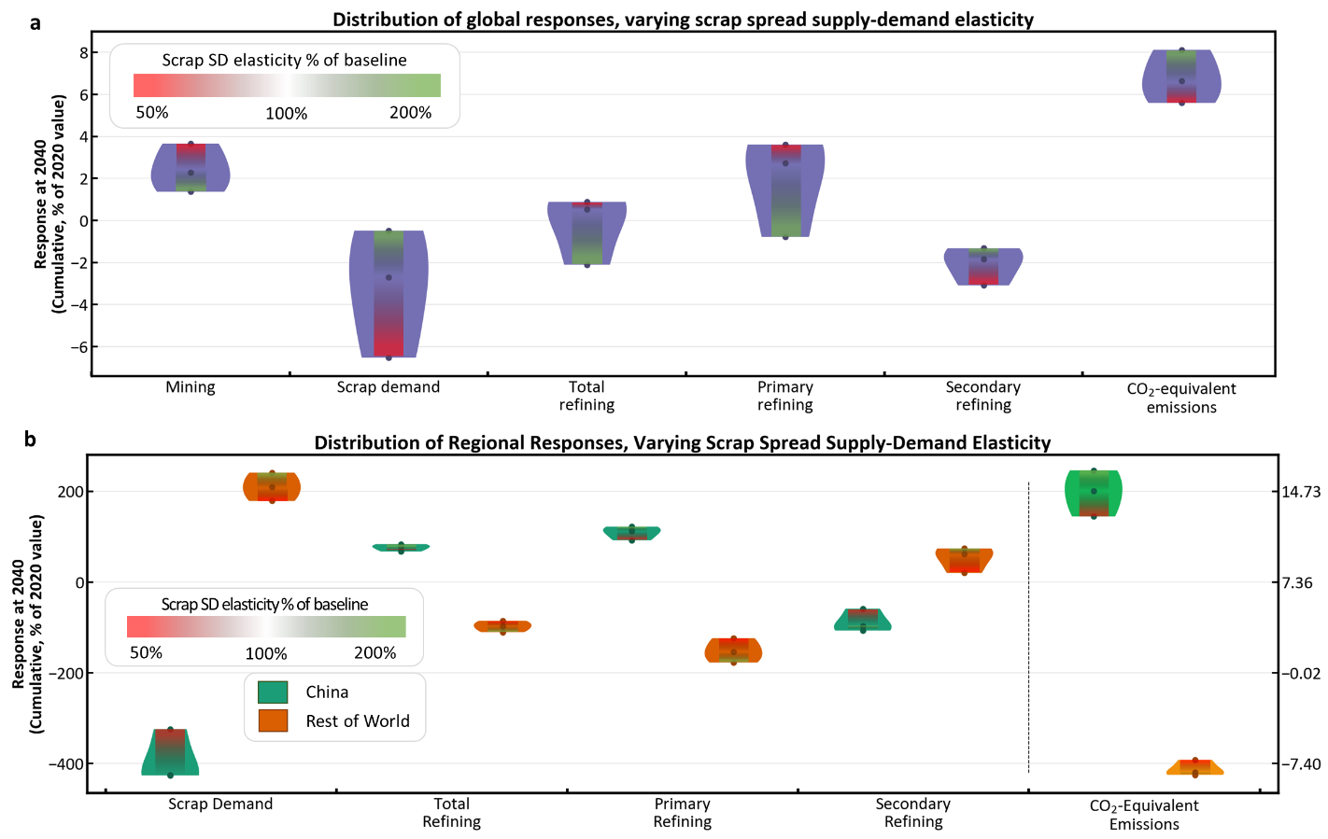
a, Violin plot showing the distributions of global responses for varying scrap spread elasticity to the supply-demand balance. b, Violin plot showing the distributions of regional responses for each supply chain actor, with CO2e emissions highlighted as a system-level response and plotted on a secondary axis. China is shown in green, the rest of world in orange.

Supplementary Data: Figure Reproduction in Absolute Units
Figure S5: Results of China’s solid waste import ban
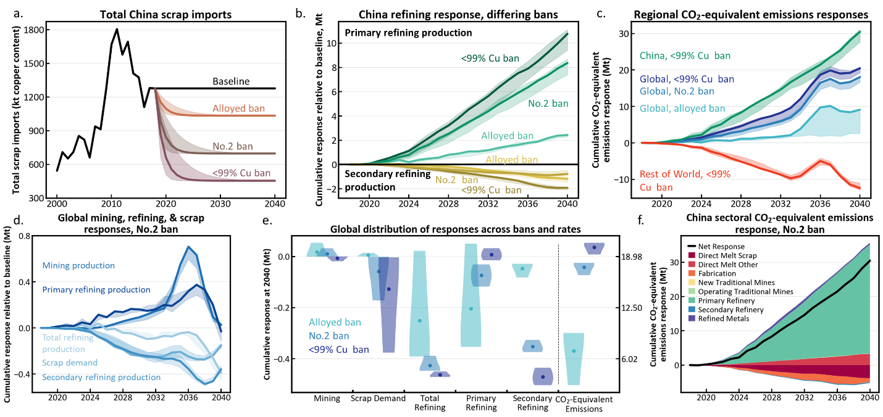
Reproduction of Figure 2 using cumulative departure from baseline in million metric tonnes as y-axis units for each plot. a, Scrap imports for each scenario in copper content. b, Primary and secondary refining responses in China relative to baseline for each scenario. c, Regional CO₂e emissions responses for each scenario at the global level and regional results for the No.2 scrap ban over the simulation period. d, Cumulative global mining, refining, and scrap demand responses for the No.2 scrap ban over the simulation period. e, The distributions of global mining, scrap demand, total refining, primary refining, secondary refining, and CO₂e emissions responses for each ban, evaluated cumulatively at 2040 relative to baseline. Points represent the mean of the three ban rates, while the shaded regions represent the distributions of ban rate results. CO₂e emissions are plotted on a secondary axis. f, Cumulative sectoral CO₂e emissions response for China, where all increasing impacts were plotted above the x-axis, all decreasing impacts were plotted below the x-axis, and the black line represents the net response within China as a result of these sectoral changes.

Figure S6: Results for changing China’s refined copper imports coincident with No.2 ban
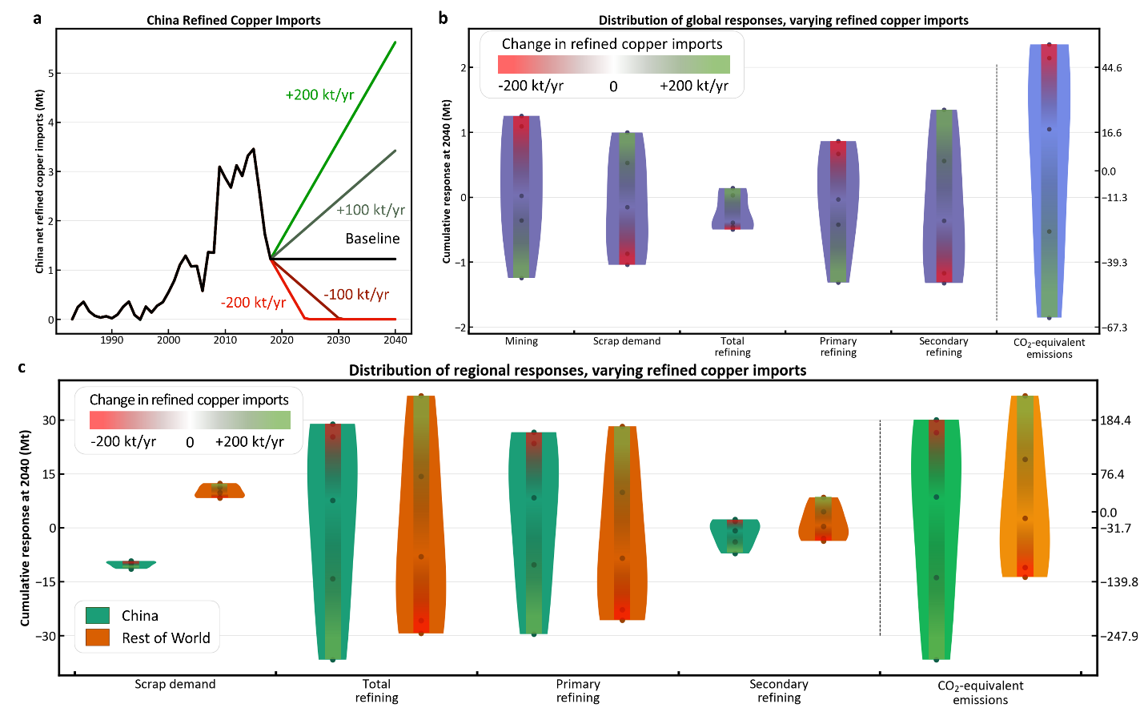
Reproduction of Figure 3 using cumulative departure from baseline in million metric tonnes as y-axis units for each plot. a, Historical Chinese net refined copper imports and scenario definition, where in this case the baseline corresponds with the No.2 scrap ban and refined copper imports are increased or decreased at rates of 100 or 200 kt/year, with minimum zero. b, Violin plot showing the distributions of global responses for varying refined copper imports, where CO2e emissions are highlighted as an aggregate response and are plotted on a secondary axis. c, Violin plot showing the distributions of regional responses for each supply chain actor, with CO2e emissions highlighted as a system-level response and plotted on a secondary axis. China is shown in green, the rest of world in orange.

Figure S7: System response to COVID-19 scenarios and supply chain disruption sensitivities
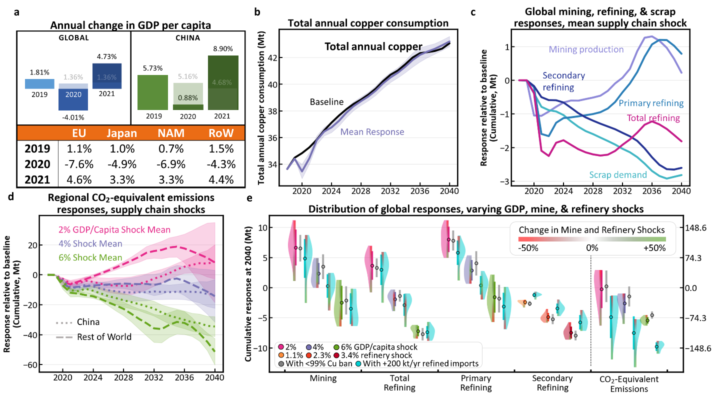
a, The annual changes in GDP per capita for 2019, 2020, and 2021 used in the COVID-19 response scenario, using values adapted from annual change in GDP from the International Monetary Fund. Baseline values for China and global are shown in gray. b, Global annual copper consumption including alloyed and unalloyed refined and scrap copper consumption for baseline and the mean COVID-19 scenario response. Shaded areas represent one standard deviation. c, Cumulative global secondary refining, scrap demand, mining production, total refining, and primary refining responses relative to baseline as a percent of the 2020 value, labelled from top to bottom using 2040 as reference. Standard deviations not shown for clarity. d, Cumulative CO₂e emissions responses relative to baseline for China and RoW as a percent of the 2020 global value. e, Violin plot showing the distribution of global responses for COVID-19 response scenarios using 2, 4, and 6% declines in global GDP per capita from 2019-2020, with mean values shown as same-colored points. Gray points and bars represent the mean system response and standard deviation when the No.2 scrap China solid waste import ban is simulated simultaneous with the COVID-19 shocks. Green and red bars indicate the magnitude of the mine and refinery system shocks. For secondary refining, GDP changes produced near-equal violin plots and here the data are grouped by the three levels of refinery shock instead.

Supplementary Data: Remaining Environmental Impact Indicators
Figure S8: Environmental impact responses broken down by supply chain actor, relative to baseline
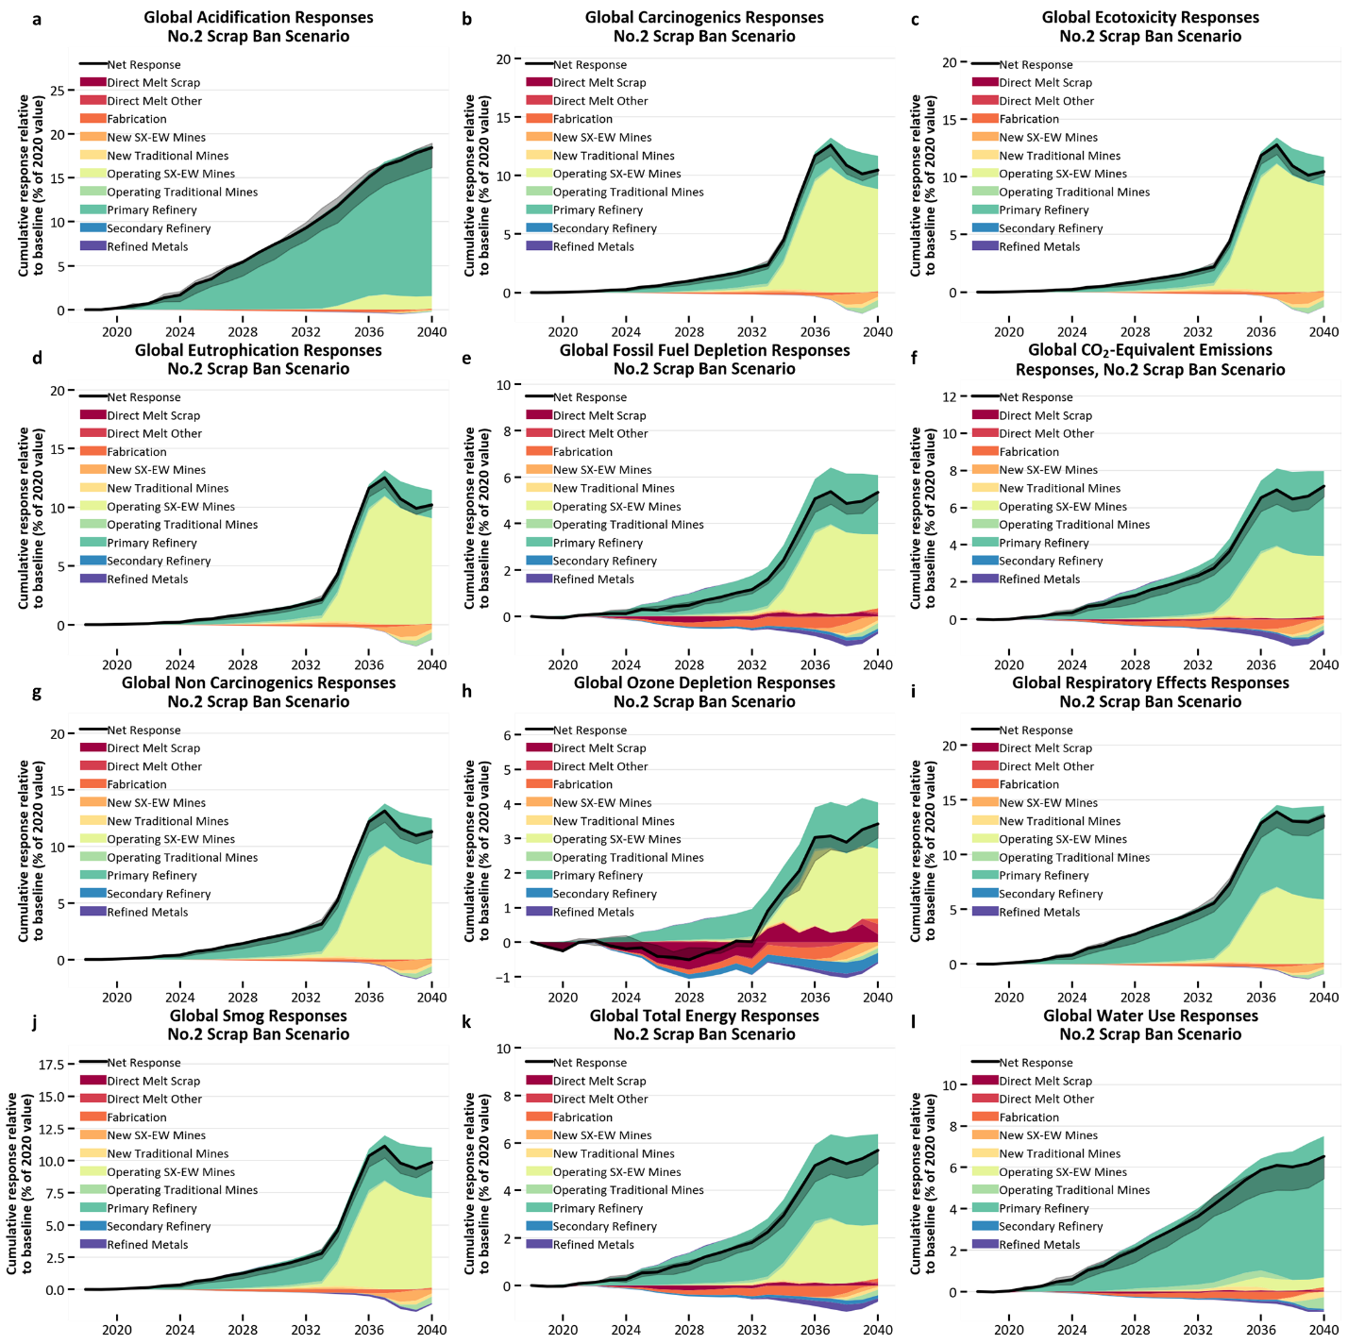
All responses are reported relative to baseline in their original calculated units, and gray shading around the net response represents ban rate variation. a, Global CO₂e emissions response. b, Global SO₂e emissions response. c, Global carcinogenics human health (disease cases) impact response. d, Global ecotoxicity (fraction of potentially-affected species integrated over time and volume of freshwater compartment) response. e, Global N emissions contributing toward eutrophication. f, Global fossil fuel depletion response. g, Global non-carcinogenics human health (disease cases) impact response. h, Global ozone depletion impact response. i, Global respiratory effects (particulate matter less than 2.5 micrometers in diameter) impact response. j, Global smog (O₃ emissions) impact response. k, Global total energy consumption response. l, Global water use response.

Figure S9: Environmental impact responses broken down by supply chain actor, as % of 2020 value
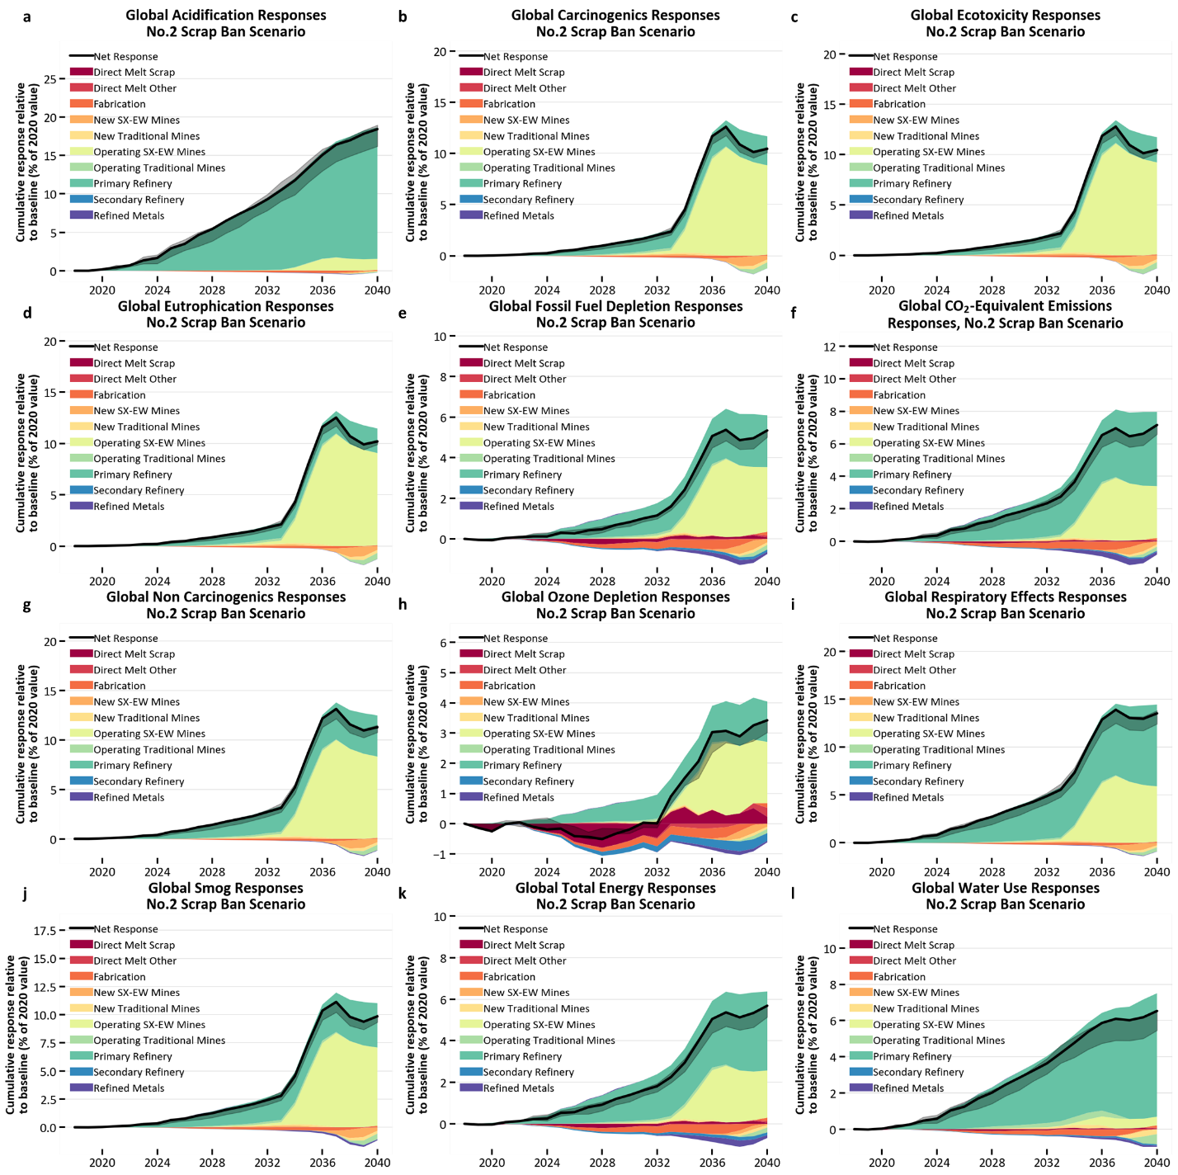
All responses are reported relative to baseline as a percent of the 2020 value, and gray shading around the net response represents ban rate variation. a, Global SO₂e emissions response. b, Global carcinogenics human health (disease cases) impact response. c, Global ecotoxicity (fraction of potentially-affected species integrated over time and volume of freshwater compartment) response. d, Global N emissions contributing toward eutrophication. e, Global fossil fuel depletion response. f, Global CO₂e emissions response. g, Global non-carcinogenics human health (disease cases) impact response. h, Global ozone depletion impact response. i, Global respiratory effects (particulate matter less than 2.5 micrometers in diameter) impact response. j, Global smog (O₃ emissions) impact response. k, Global total energy consumption response. l, Global water use response.

Figure S10: Environmental impact responses for changing China refined copper imports: China
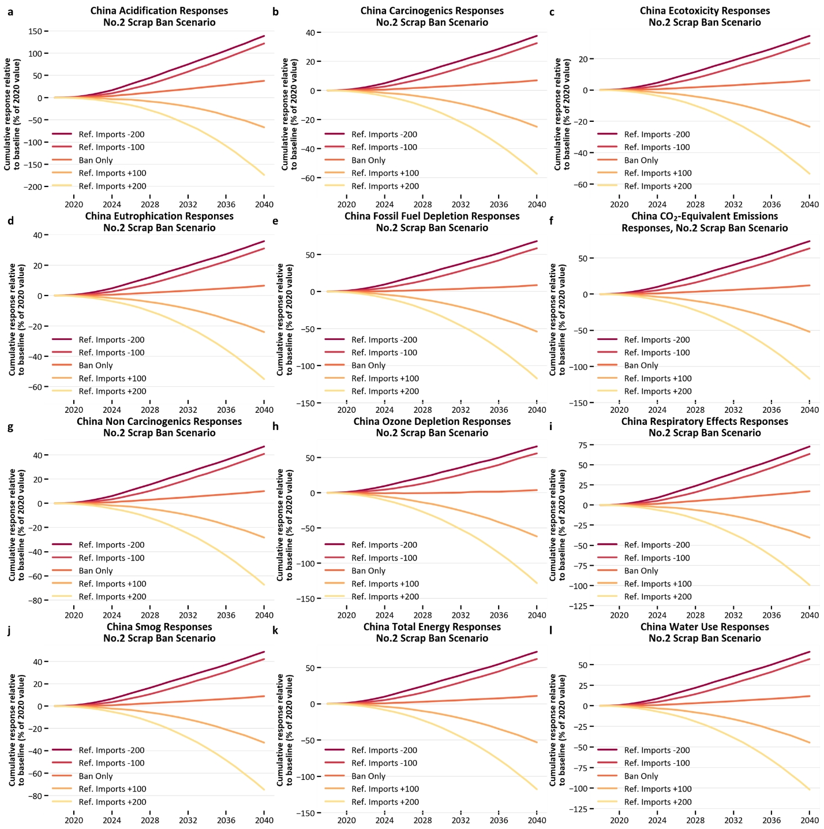
All responses are reported relative to baseline as a percent of the 2020 value. a, China SO₂e emissions response. b, China carcinogenics human health (disease cases) impact response. c, China ecotoxicity (fraction of potentially-affected species integrated over time and volume of freshwater compartment) response. d, China N emissions contributing toward eutrophication. e, China fossil fuel depletion response. f, China CO₂e emissions response. g, China non-carcinogenics human health (disease cases) impact response. h, China ozone depletion impact response. i, China respiratory effects (particulate matter less than 2.5 micrometers in diameter) impact response. j, China smog (O₃ emissions) impact response. k, China total energy consumption response. l, China water use response.

Figure S11: Environmental impact responses for changing China refined copper imports: Global
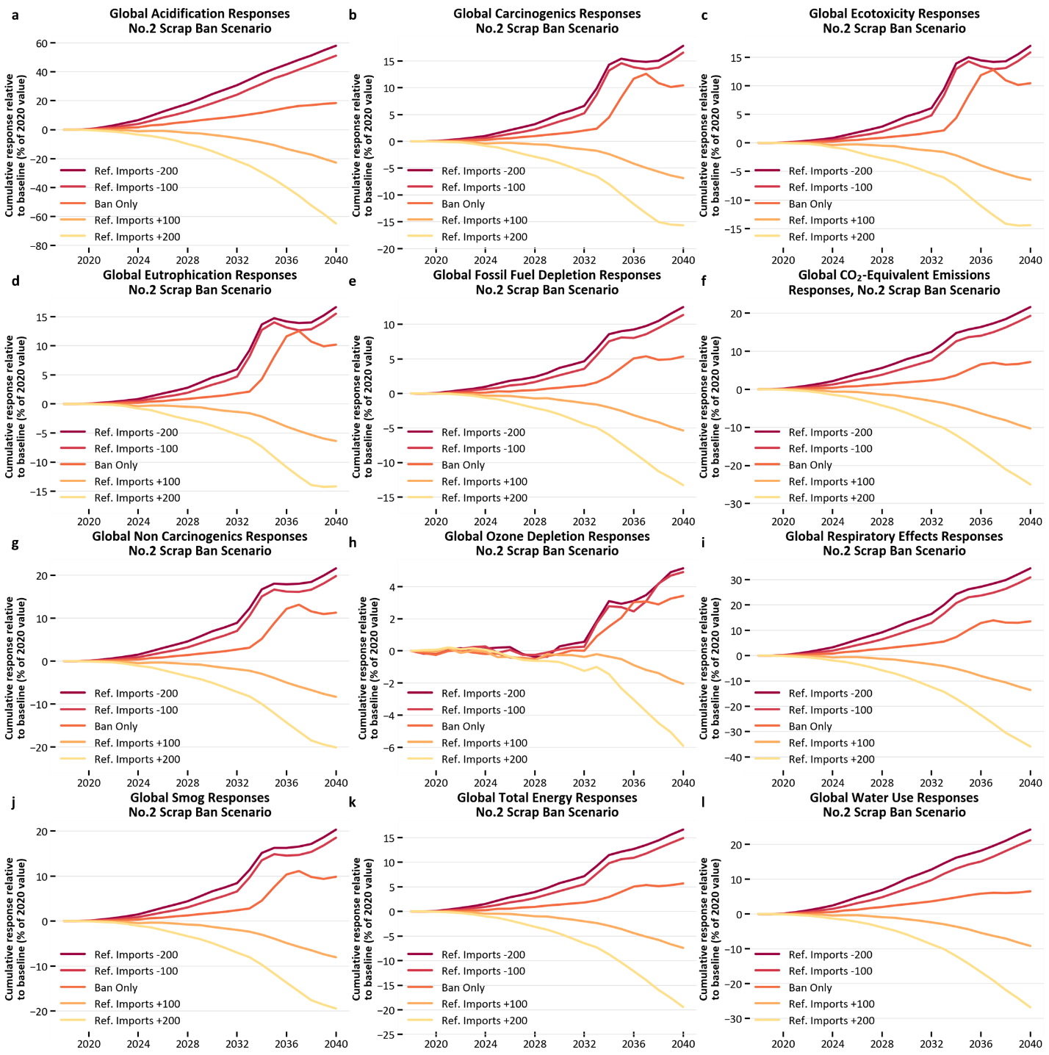
All responses are reported relative to baseline as a percent of the 2020 value. a, Global SO₂e emissions response. b, Global carcinogenics human health (disease cases) impact response. c, Global ecotoxicity (fraction of potentially-affected species integrated over time and volume of freshwater compartment) response. d, Global N emissions contributing toward eutrophication. e, Global fossil fuel depletion response. f, Global CO₂e emissions response. g, Global non-carcinogenics human health (disease cases) impact response. h, Global ozone depletion impact response. i, Global respiratory effects (particulate matter less than 2.5 micrometers in diameter) impact response. j, Global smog (O₃ emissions) impact response. k, Global total energy consumption response. l, Global water use response.

Figure S12: Mean environmental impact responses for supply chain shock relative to baseline
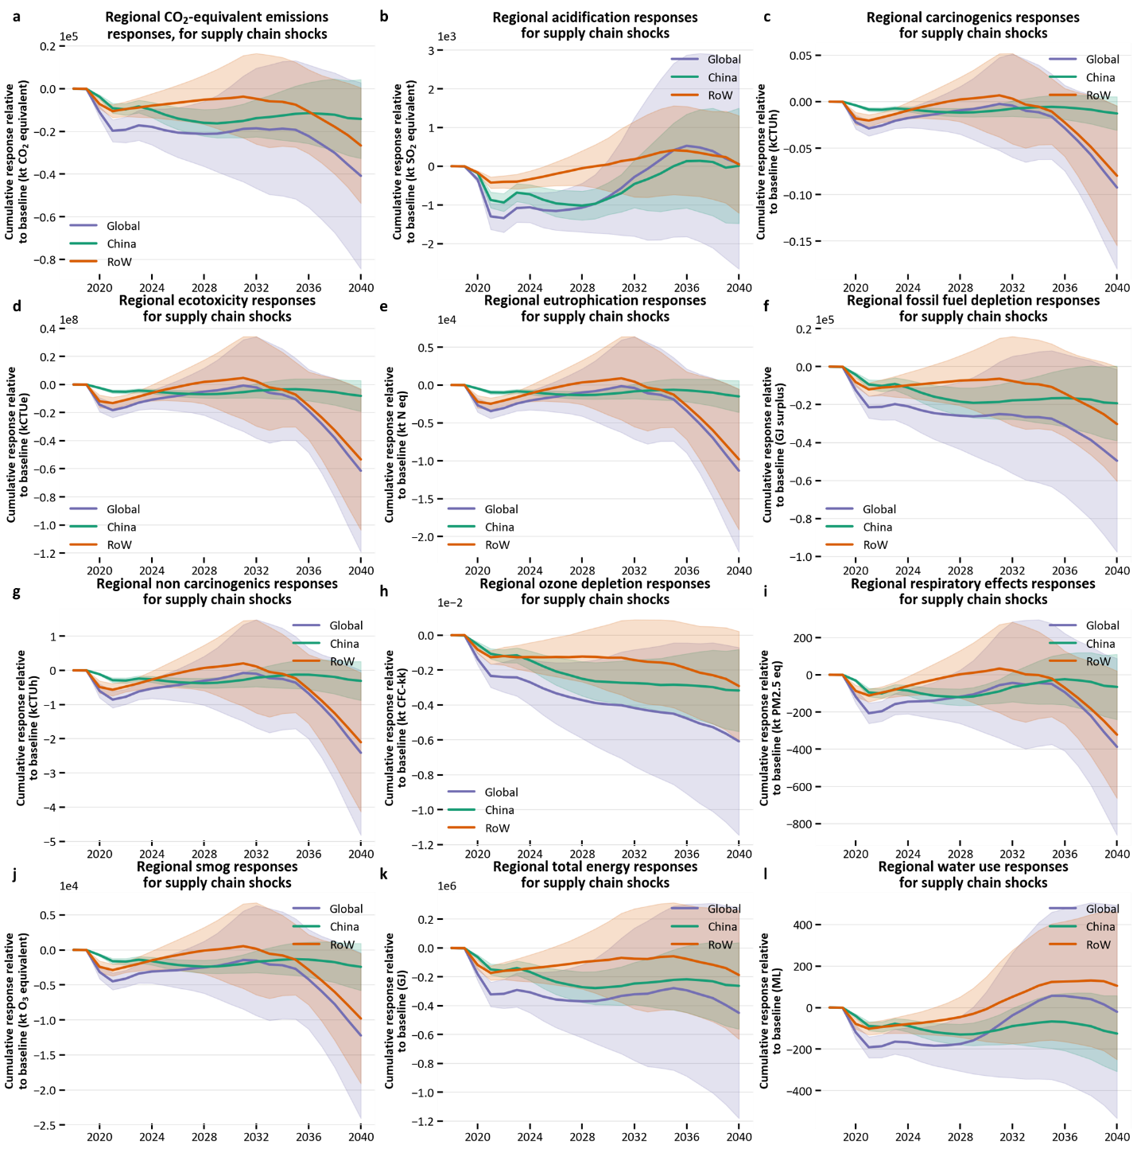
All responses are reported relative to baseline in their original calculated units, and shading represents one standard deviation difference from mean. a, Regional CO₂e emissions response. b, Regional SO₂e emissions response. c, Regional carcinogenics human health (disease cases) impact response. d, Regional ecotoxicity (fraction of potentially-affected species integrated over time and volume of freshwater compartment) response. e, Regional N emissions contributing toward eutrophication. f, Regional fossil fuel depletion response. g, Regional non-carcinogenics human health (disease cases) impact response. h, Regional ozone depletion impact response. i, Regional respiratory effects (particulate matter less than 2.5 micrometers in diameter) impact response. j, Regional smog (O₃ emissions) impact response. k, Regional total energy consumption response. l, Regional water use response.

Figure S13: Mean environmental impact responses for supply chain shock, as % of 2020 value
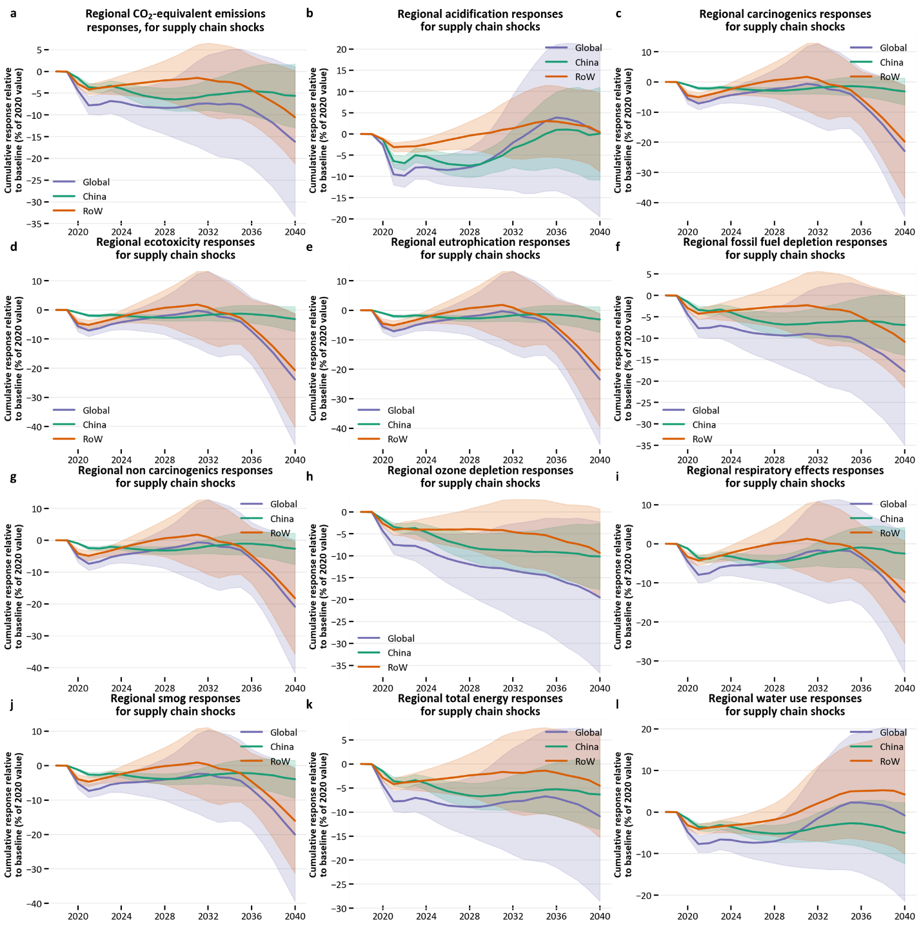
All responses are reported relative to baseline as a percent of 2020 value, and shading represents one standard deviation difference from mean. a, Regional CO₂e emissions response. b, Regional SO₂e emissions response. c, Regional carcinogenics human health (disease cases) impact response. d, Regional ecotoxicity (fraction of potentially-affected species integrated over time and volume of freshwater compartment) response. e, Regional N emissions contributing toward eutrophication. f, Regional fossil fuel depletion response. g, Regional non-carcinogenics human health (disease cases) impact response. h, Regional ozone depletion impact response. i, Regional respiratory effects (particulate matter less than 2.5 micrometers in diameter) impact response. j, Regional smog (O₃ emissions) impact response. k, Regional total energy consumption response. l, Regional water use response.

Supplementary Data: Impacts of Each Supply Chain Shock
Figure S14: Parameter changes for each supply chain shock, with SR included in refinery shocks
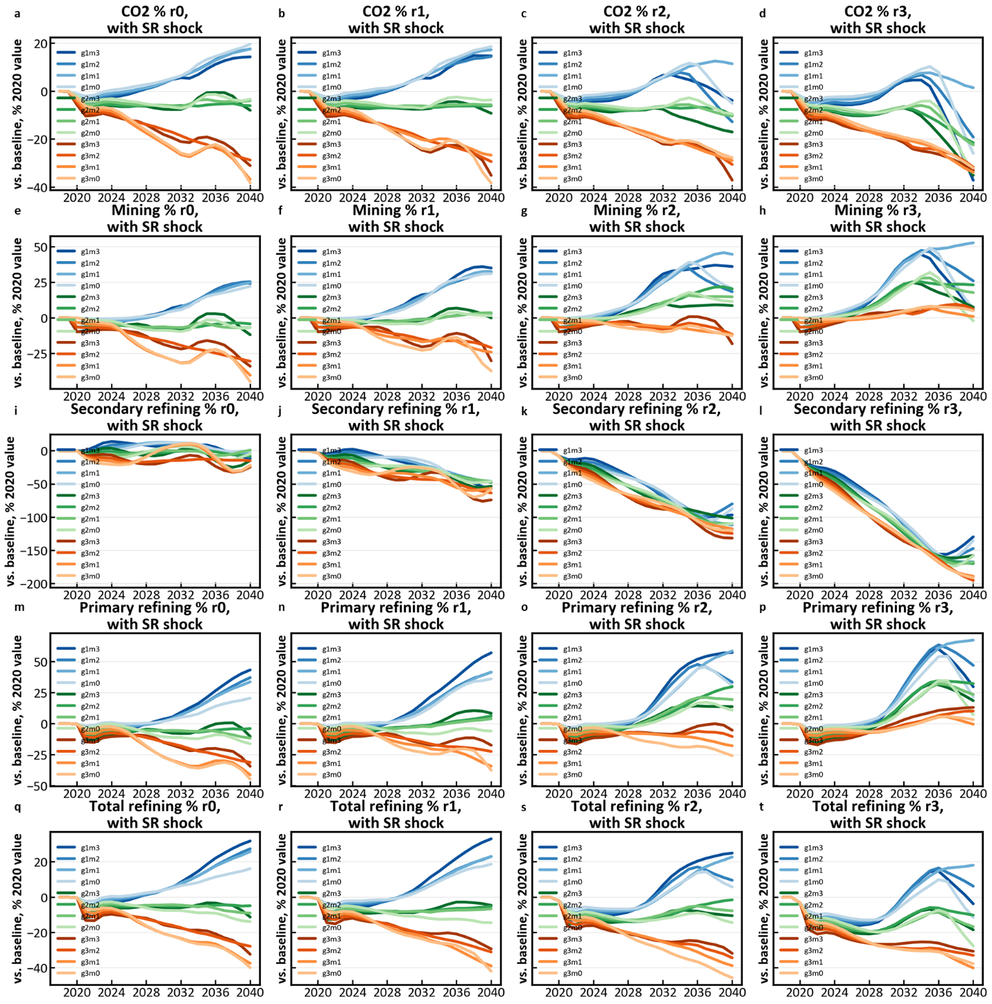
All changes are cumulative, global, and relative to 2020 value. Refinery capacity utilization shocks are zero (r0), 1.14 (r1), 2.29 (r2), and 3.93% (r3) decreases from 2019-2020. SR ratio decreases are zero (r0), 3.46 (r1), 6.93 (r2), and 10.4% (r3) from 2019-2020. GDP per capita decreases are 2 (g1), 4 (g2), and 6% (g3) from 2019-2020 with proportional rebound. Mining capacity utilization decreases are 0 (m0), 1.31 (m1), 2.62 (m2), and 3.93% (m3) from 2019-2020. Combinations of GDP and mining shocks are shown on each plot, where refinery shocks increase from left to right. a-d, CO₂e emissions; e-h, mining production; i-l, secondary refining production; m-p, primary refining production; q-t, total refining production.

Figure S15: Parameter changes for each supply chain shock, with SR excluded from refinery shocks
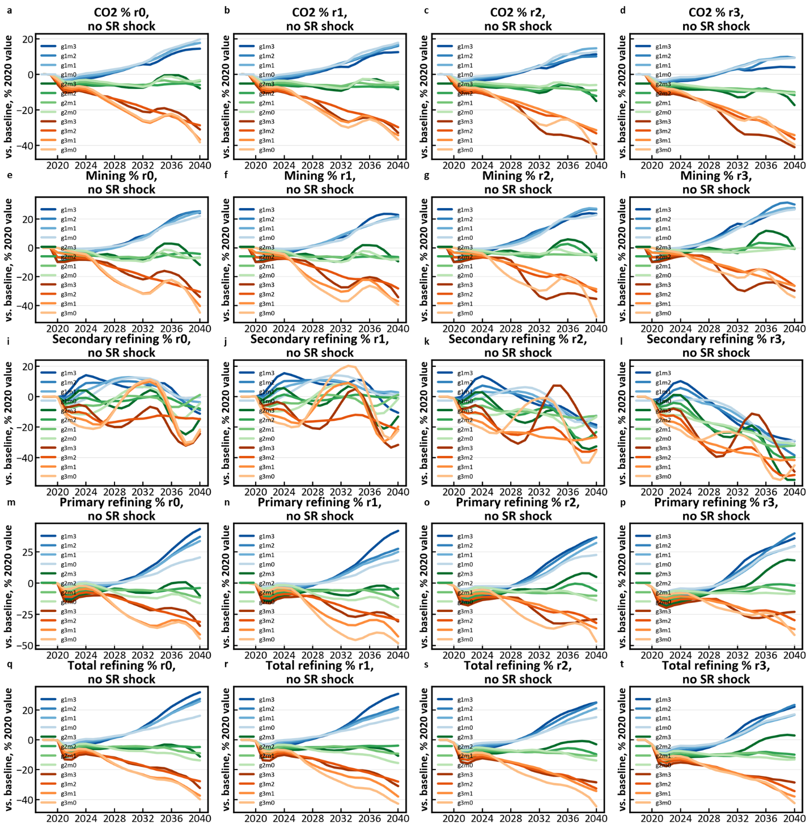
All changes are cumulative, global, and relative to 2020 value. Refinery capacity utilization shocks are zero (r0), 1.14 (r1), 2.29 (r2), and 3.93% (r3) decreases from 2019-2020. SR ratio remains unchanged from baseline. GDP per capita decreases are 2 (g1), 4 (g2), and 6% (g3) from 2019-2020 with proportional rebound. Combinations of GDP and mining shocks are shown on each plot, where refinery shocks increase from left to right. Mining capacity utilization decreases are 0 (m0), 1.31 (m1), 2.62 (m2), and 3.93% (m3) from 2019-2020. a-d, CO₂e emissions; e-h, mining production; i-l, secondary refining production; m-p, primary refining production; q-t, total refining production.

Supplementary Data: Life Cycle Analysis Data
Table S10. Regional impact scaling factors for concentrate and SX-EW mines.
 |  |  |  |  | TRACI Scale |  | Energy Scale |  | Water Scale
SX-EW Mines | Oceania |  |  | 1.23 |  | 1.75 |  | 0.36
 | Africa |  |  | 5.67 |  | 4.28 |  | 0.47
 | Europe |  |  | 10.56 |  | 2.80 |  | 0.29
 | North America |  |  | 0.80 |  | 2.55 |  | 0.28
 | China |  |  | 23.03 |  | 9.71 |  | 1.31
 | Other Asia |  |  | 23.03 |  | 9.71 |  | 1.31
 | Latin America |  |  | 0.82 |  | 1.64 |  | 0.15
Concentrate Mines | Oceania |  |  | 0.75 |  | 1.22 |  | 0.84
 | Africa |  |  | 1.55 |  | 2.37 |  | 0.87
 | Europe |  |  | 0.71 |  | 1.24 |  | 0.34
 | North America |  |  | 1.11 |  | 1.93 |  | 0.86
 | China |  |  | 2.34 |  | 3.69 |  | 1.86
 | Other Asia |  |  | 2.60 |  | 4.07 |  | 1.89
 | Latin America |  |  | 0.83 |  | 1.33 |  | 0.40

Table S11. Regional environmental impact indicators for concentrate and SX-EW mines, for one kg of Cu.
 |  | Ozone depletion (kg CFC-kk) | Global warming (kg CO2 eq) | Smog (kg O3 eq) | Acidific-ation (kg SO2 eq) | Eutroph-ication (kg N eq) | Carcino-genics (CTUh) | Non carcinog-enics (CTUh) | Respiratory effects (kg PM2.5 eq) | Ecotoxicity (CTUe) | Fossil fuel depletion (MJ surplus) | Total Energy (MJ) | Water use (m3)
SX-EW Mines | Oceania | 3.5E-07 | 4.5E+00 | 1.9E+00 | 8.3E-02 | 8.6E-01 | 7.3E-06 | 1.9E-04 | 1.1E-02 | 4.6E+03 | 4.7E+00 | 7.5E+01 | 1.8E-02
 | Africa | 6.9E-07 | 9.6E+00 | 2.8E+00 | 1.3E-01 | 2.0E+00 | 1.6E-05 | 4.2E-04 | 1.8E-02 | 1.1E+04 | 9.3E+00 | 1.5E+02 | 1.8E-02
 | Europe | 2.9E-07 | 3.1E+00 | 1.3E+00 | 5.9E-02 | 4.0E-01 | 3.5E-06 | 8.6E-05 | 8.4E-03 | 2.1E+03 | 3.2E+00 | 5.8E+01 | 6.8E-03
 | North America | 7.8E-07 | 8.8E+00 | 4.2E+00 | 1.8E-01 | 3.0E+00 | 2.5E-05 | 6.5E-04 | 2.6E-02 | 1.6E+04 | 9.3E+00 | 1.5E+02 | 1.9E-02
 | China | 1.1E-06 | 1.5E+01 | 6.2E+00 | 2.7E-01 | 3.3E+00 | 2.8E-05 | 7.3E-04 | 3.8E-02 | 1.8E+04 | 1.3E+01 | 2.6E+02 | 3.9E-02
 | Other Asia | 1.1E-06 | 1.5E+01 | 6.2E+00 | 2.7E-01 | 3.3E+00 | 2.8E-05 | 7.3E-04 | 3.8E-02 | 1.8E+04 | 1.3E+01 | 2.6E+02 | 3.9E-02
 | Latin America | 3.7E-07 | 4.7E+00 | 2.1E+00 | 9.3E-02 | 1.7E+00 | 1.4E-05 | 3.7E-04 | 1.3E-02 | 9.1E+03 | 4.8E+00 | 8.1E+01 | 8.3E-03
Concentrate Mines | Oceania | 1.1E-07 | 1.6E+00 | 7.3E-01 | 3.4E-02 | 4.9E-01 | 4.0E-06 | 1.1E-04 | 2.6E-02 | 2.6E+03 | 1.7E+00 | 2.5E+01 | 6.5E-02
 | Africa | 2.2E-07 | 3.4E+00 | 1.1E+00 | 5.3E-02 | 1.1E+00 | 8.9E-06 | 2.4E-04 | 4.1E-02 | 5.9E+03 | 3.5E+00 | 5.0E+01 | 6.7E-02
 | Europe | 8.9E-08 | 1.1E+00 | 5.3E-01 | 2.4E-02 | 2.3E-01 | 2.0E-06 | 4.9E-05 | 1.9E-02 | 1.2E+03 | 1.2E+00 | 1.9E+01 | 2.5E-02
 | North America | 2.4E-07 | 3.1E+00 | 1.6E+00 | 7.5E-02 | 1.7E+00 | 1.4E-05 | 3.7E-04 | 5.8E-02 | 9.2E+03 | 3.4E+00 | 5.1E+01 | 6.9E-02
 | China | 3.6E-07 | 5.4E+00 | 2.4E+00 | 1.1E-01 | 1.9E+00 | 1.5E-05 | 4.1E-04 | 8.7E-02 | 1.0E+04 | 4.8E+00 | 8.3E+01 | 1.4E-01
 | Other Asia | 3.6E-07 | 5.4E+00 | 2.4E+00 | 1.1E-01 | 1.9E+00 | 1.5E-05 | 4.1E-04 | 8.7E-02 | 1.0E+04 | 4.8E+00 | 8.3E+01 | 1.4E-01
 | Latin America | 1.2E-07 | 1.7E+00 | 8.3E-01 | 3.8E-02 | 9.5E-01 | 7.7E-06 | 2.1E-04 | 3.0E-02 | 5.2E+03 | 1.8E+00 | 2.6E+01 | 3.1E-02

Table S12. Constants used to calculate CO₂e emissions, energy consumption, and water use as function of ore grade as described by equation (2) in the main body.
 | A | B
Concentrate TRACI | 1.58 | -0.626
SX-EW TRACI | 2.06 | -1.208
Concentrate Energy | 15.7 | -0.573
SX-EW Energy | 36.5 | -0.351
Concentrate Water | 0.0734 | -0.094
SX-EW Water | 0.0412 | -0.340

Table S13. Calculated average ore grade for each region considered in this study, used to develop regional impact scaling factors
 | Concentrate Ore Grade | SX-EW Ore Grade
Oceania | 0.62 | 0.62
Africa | 0.59 | 1.18
Europe | 1.01 | 4.97
North America | 0.40 | 0.25
China | 0.54 | 2.55
Asia | 0.64 | 2.55
Latin America | 0.67 | 0.43
Average | 0.65 | 0.67

Table S14. Direct melt scrap and secondary refining impact indicators.
 |  | Ozone depletion (kg CFC-kk) | Global warming (kg CO2 eq) | Smog (kg O3 eq) | Acidifi-cation (kg SO2 eq) | Eutrop-hication (kg N eq) | Carcin-ogenics (CTUh) | Non carcin-ogenics (CTUh) | Respi-ratory effects (kg PM2.5 eq) | Ecotoxicity (CTUe) | Fossil fuel depletion (MJ surplus) | Total Energy (MJ) | Water use (m3)
Regional Secondary Refining | Oceania | 8.63E-08 | 1.74E-01 | 9.73E-03 | 3.84E-03 | 5.92E-04 | 1.63E-08 | 1.32E-07 | 2.48E-04 | 4.09E+00 | 3.50E-01 | 6.08E+00 | 1.55E-03
 | Africa | 1.45E-07 | 2.55E-01 | 1.31E-02 | 1.52E-03 | 1.14E-03 | 2.98E-08 | 2.19E-07 | 1.72E-04 | 7.85E+00 | 6.01E-01 | 8.68E+00 | 1.58E-03
 | Europe | 1.03E-07 | 1.21E-01 | 5.35E-03 | 2.09E-04 | 3.88E-04 | 5.49E-09 | 3.35E-08 | 5.24E-05 | 1.32E+00 | 3.43E-01 | 4.73E+00 | 7.14E-04
 | North America | 2.57E-07 | 2.45E-01 | 1.94E-02 | 1.33E-03 | 1.75E-03 | 4.39E-08 | 2.81E-07 | 1.92E-04 | 1.20E+01 | 6.86E-01 | 1.01E+01 | 1.51E-03
 | China | 1.76E-07 | 3.16E-01 | 2.23E-02 | 2.17E-03 | 1.61E-03 | 4.19E-08 | 2.98E-07 | 2.96E-04 | 1.11E+01 | 6.40E-01 | 1.09E+01 | 2.99E-03
 | Other Asia | 1.76E-07 | 3.16E-01 | 2.23E-02 | 2.17E-03 | 1.61E-03 | 4.19E-08 | 2.98E-07 | 2.96E-04 | 1.11E+01 | 6.40E-01 | 1.09E+01 | 2.99E-03
 | Latin America | 1.02E-07 | 1.91E-01 | 1.25E-02 | 1.23E-03 | 1.13E-03 | 2.94E-08 | 2.15E-07 | 1.39E-04 | 7.81E+00 | 3.79E-01 | 6.74E+00 | 8.48E-04
Direct Melt | Low Grade | 1.12E-06 | 1.40E+00 | 7.97E-02 | 8.08E-03 | 3.79E-03 | 1.50E-07 | 6.53E-07 | 1.01E-03 | 2.35E+01 | 3.35E+00 | 3.86E+01 | 1.19E-02
 | Brass | 3.11E-07 | 3.90E-01 | 2.22E-02 | 2.25E-03 | 1.05E-03 | 4.17E-08 | 1.82E-07 | 2.82E-04 | 6.54E+00 | 9.33E-01 | 1.07E+01 | 3.31E-03
 | No2 | 4.09E-07 | 5.12E-01 | 2.91E-02 | 2.95E-03 | 1.38E-03 | 5.48E-08 | 2.39E-07 | 3.70E-04 | 8.58E+00 | 1.23E+00 | 1.41E+01 | 4.34E-03
 | No1 | 2.77E-07 | 3.46E-01 | 1.97E-02 | 2.00E-03 | 9.37E-04 | 3.71E-08 | 1.62E-07 | 2.51E-04 | 5.81E+00 | 8.29E-01 | 9.54E+00 | 2.94E-03

Table S15. Primary refining impact indicators.
 | Ozone depletion (kg CFC-kk) | Global warming (kg CO2 eq) | Smog (kg O3 eq) | Acidif-ication (kg SO2 eq) | Eutrop-hication (kg N eq) | Carcino-genics (CTUh) | Non carcino-genics (CTUh) | Respi-ratory effects (kg PM2.5 eq) | Ecotoxicity (CTUe) | Fossil fuel depletion (MJ surplus) | Total Energy (MJ) | Water use (m3)
Oceania | 1.08E-07 | 2.09E+00 | 2.88E-01 | 1.09E+00 | 1.42E-01 | 1.34E-06 | 6.25E-05 | 4.50E-02 | 7.18E+02 | 1.74E+00 | 3.20E+01 | 1.88E-02
Africa | 1.82E-07 | 3.06E+00 | 3.89E-01 | 4.32E-01 | 2.74E-01 | 2.44E-06 | 1.04E-04 | 3.14E-02 | 1.38E+03 | 2.99E+00 | 4.56E+01 | 1.92E-02
Europe | 1.30E-07 | 1.45E+00 | 1.58E-01 | 5.92E-02 | 9.32E-02 | 4.49E-07 | 1.59E-05 | 9.54E-03 | 2.32E+02 | 1.71E+00 | 2.49E+01 | 8.65E-03
North America | 3.22E-07 | 2.94E+00 | 5.74E-01 | 3.78E-01 | 4.19E-01 | 3.59E-06 | 1.33E-04 | 3.50E-02 | 2.11E+03 | 3.41E+00 | 5.29E+01 | 1.82E-02
China | 2.21E-07 | 3.79E+00 | 6.59E-01 | 6.16E-01 | 3.85E-01 | 3.43E-06 | 1.41E-04 | 5.39E-02 | 1.94E+03 | 3.18E+00 | 5.75E+01 | 3.62E-02
Other Asia | 2.21E-07 | 3.79E+00 | 6.59E-01 | 6.16E-01 | 3.85E-01 | 3.43E-06 | 1.41E-04 | 5.39E-02 | 1.94E+03 | 3.18E+00 | 5.75E+01 | 3.62E-02
Latin America | 1.27E-07 | 2.29E+00 | 3.70E-01 | 3.50E-01 | 2.72E-01 | 2.41E-06 | 1.02E-04 | 2.53E-02 | 1.37E+03 | 1.88E+00 | 3.54E+01 | 1.03E-02

Table S16. Fabrication impact indicators.
 | Ozone depletion (kg CFC-kk) | Global warming (kg CO2 eq) | Smog (kg O3 eq) | Acidif-ication (kg SO2 eq) | Eutroph-ication (kg N eq) | Carcin-ogenics (CTUh) | Non carcinogenics (CTUh) | Respiratory effects (kg PM2.5 eq) | Ecotoxicity (CTUe) | Fossil fuel depletion (MJ surplus) | Total (MJ) | Water use (m3)
RoW | 9.87E-07 | 3.58E+00 | 3.64E-01 | 8.46E-02 | 1.47E-01 | 1.37E-06 | 3.59E-05 | 1.15E-02 | 7.83E+02 | 4.95E+00 | 6.65E+01 | 2.22E-02
EU and NAM | 1.01E-06 | 3.12E+00 | 3.35E-01 | 8.30E-02 | 1.48E-01 | 1.36E-06 | 3.59E-05 | 1.03E-02 | 7.82E+02 | 4.62E+00 | 6.57E+01 | 2.29E-02

Table S17. Impact indicators for producing each alloying element considered in this study.
 | Ozone depletion (kg CFC-kk) | Global warming (kg CO2 eq) | Smog (kg O3 eq) | Acidifi-cation (kg SO2 eq) | Eutroph-ication (kg N eq) | Carcino-genics (CTUh) | Non carcino-genics (CTUh) | Respir-atory effects (kg PM2.5 eq) | Ecotoxicity (CTUe) | Fossil fuel depletion (MJ surplus) | Total Energy (MJ) | Water use (m3)
Zn | 2.37E-07 | 5.80E+00 | 6.88E-01 | 5.36E-02 | 6.98E-02 | 7.21E-07 | 5.21E-05 | 1.11E-02 | 3.23E+02 | 4.10E+00 | 7.60E+01 | 1.89E-02
Pb | -1.17E-07 | 5.08E-02 | -2.67E-01 | 1.90E-02 | 4.98E-02 | 7.19E-07 | 2.53E-05 | 3.03E-03 | 2.77E+02 | -1.35E+00 | -5.06E+00 | -5.31E-03
Sn | 1.64E-06 | 1.93E+01 | 3.40E+00 | 4.38E-01 | 9.54E-02 | 2.55E-06 | 6.87E-06 | 1.12E-01 | 2.00E+02 | 1.98E+01 | 3.08E+02 | 1.36E-01
Ni | 1.25E-06 | 1.18E+01 | 2.02E+00 | 1.46E+00 | -3.09E-02 | -4.95E-08 | -2.55E-05 | 1.08E-01 | -3.79E+02 | 1.32E+01 | 1.83E+02 | -1.11E-01
Al | 7.51E-07 | 1.96E+01 | 1.22E+00 | 1.10E-01 | 6.00E-02 | 5.53E-06 | 5.63E-06 | 2.25E-02 | 2.45E+02 | 1.01E+01 | 2.22E+02 | 1.38E-02
Mn | 2.16E-07 | 2.80E+00 | 3.80E-01 | 1.85E-02 | 1.97E-02 | 5.26E-05 | 1.28E-06 | 1.71E-02 | 7.47E+02 | 2.79E+00 | 5.53E+01 | 1.04E-02
Fe | 1.39E-08 | 1.09E-01 | 1.79E-02 | 9.79E-04 | 4.34E-04 | 6.52E-09 | 3.09E-08 | 9.52E-04 | 8.09E-01 | 1.36E-01 | 1.69E+00 | 6.32E-04

Table S18. Regional distribution of each supply chain activity within RoW, where China’s fraction is listed for 2017 and permitted to evolve within the model.
 | Fabricators | Refineries | SX-EW Mines | Concentrate Mines
Oceania | 0 | 3 | 0 | 5
Africa | 2 | 11 | 24 | 11
Europe | 41 | 32 | 1 | 14
North America | 20 | 12 | 23 | 14
Other Asia | 32 | 15 | 2 | 9
Latin America | 5 | 27 | 50 | 46

Supplementary Data: Compositional information for scrap, products, refined materials

Table S19. Upper and lower compositional bounds for each of the raw materials and products used in this study. Alloys are listed in the UNS system, and may be recognized by their form of “C” followed by a 5-digit number and shape of manufacture. Shapes include tube, wire, PSS (plate, sheet, strip), RBS (rod, bar, solid), and cast. These alloys are used as new scrap categories as well. Old scrap is listed using categorical or ISRI grade, and the 8 refined metals considered as alloying elements are grouped. Each of these categories is grouped and materials are listed alphabetically within the given group. This table may be found in the attached tabular data file.

References
1 World Copper Factbook 2018. (International Copper Study Group, 2018).
2 ICSG 2018 Statistical Yearbook. (International Copper Study Group, 2018).
3 Stocks and Flows, <https://copperalliance.org/about-copper/stocks-and-flows/> (2020).
4 Glöser, S., Soulier, M. & Tercero Espinoza, L. A. Dynamic analysis of global copper flows. Global stocks, postconsumer material flows, recycling indicators, and uncertainty evaluation. Environmental Science and Technology 47, 6564-6572 (2013).
5 International World Copper Council. Global Semis Production and Demand, <http://www.coppercouncil.org/iwcc-statistics-and-data> (2020).
6 Copper Development Association. Copper Alloy Supplier Database, <https://www.copper.org/resources/suppliers/CDAFabricatorSearch.php> (2020).
7 Copper Development Association. Copper and Copper Alloys: Compositions, Applications & Properties, 2004).
8 Janice, L. J. 2013 Technical Report - The U.S. Copper-base Scrap Industry and its By-products. (2013).
9 Copper, <https://www.crugroup.com/analysis/copper/> (2020).
10 S&P Global Market Intelligence. SNL Metals & Mining Data (2019).
11 Metals and Mining Research, <https://www.woodmac.com/research/products/metals-and-mining/> (2020).
12 Publication Center, <https://www.metal.com/> (2020).
13 China Copper Market Study. Shanghai Metals Market (2019).
14 Prices & data, <https://www.amm.com/> (2020).
15 Price Book, <https://www.metalbulletin.com/> (2020).
16 UN Comtrade Database. UN Comtrade Online (2019).
17 Croissant, Y. & Millo, G. Panel data econometrics in R: The plm package. Journal of statistical software 27, 1-43 (2008).
18 Fu, X. Assessing Byproduct Mining and Metal Recycling as Indicators of Material Criticality Doctoral thesis, Massachusetts Institute of Technology, (2019).
19 Cooper, J. C. Price elasticity of demand for crude oil: estimates for 23 countries. OPEC review 27, 1-8 (2003).
20 Noshadravan, A., Gaustad, G., Kirchain, R. & Olivetti, E. Operational Strategies for Increasing Secondary Materials in Metals Production Under Uncertainty. Journal of Sustainable Metallurgy 3, 350-361, doi:10.1007/s40831-016-0100-6 (2017).

