Supplementary figure S1. Flow chart of Machine Learning
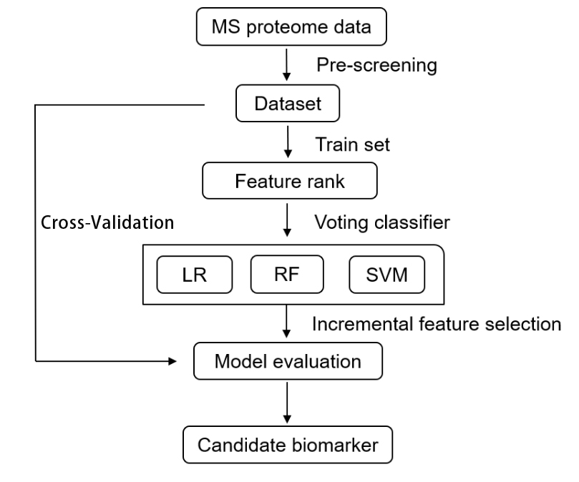

Supplementary figure S2. Quality control of the proteomics
- Length distribution of all identified peptides
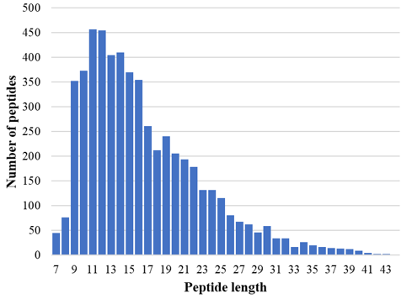
- Distribution diagram of the number of peptides
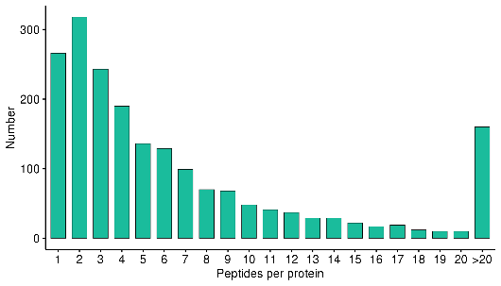
- Distribution diagram of protein mass
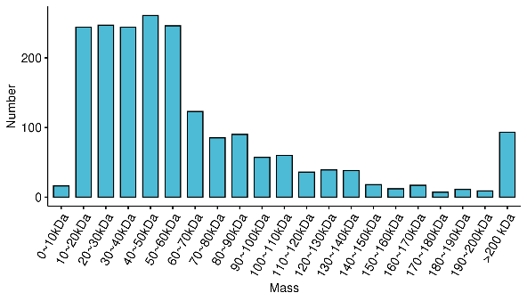

Supplementary figure S3. Heatmap of unsupervised clustering analysis
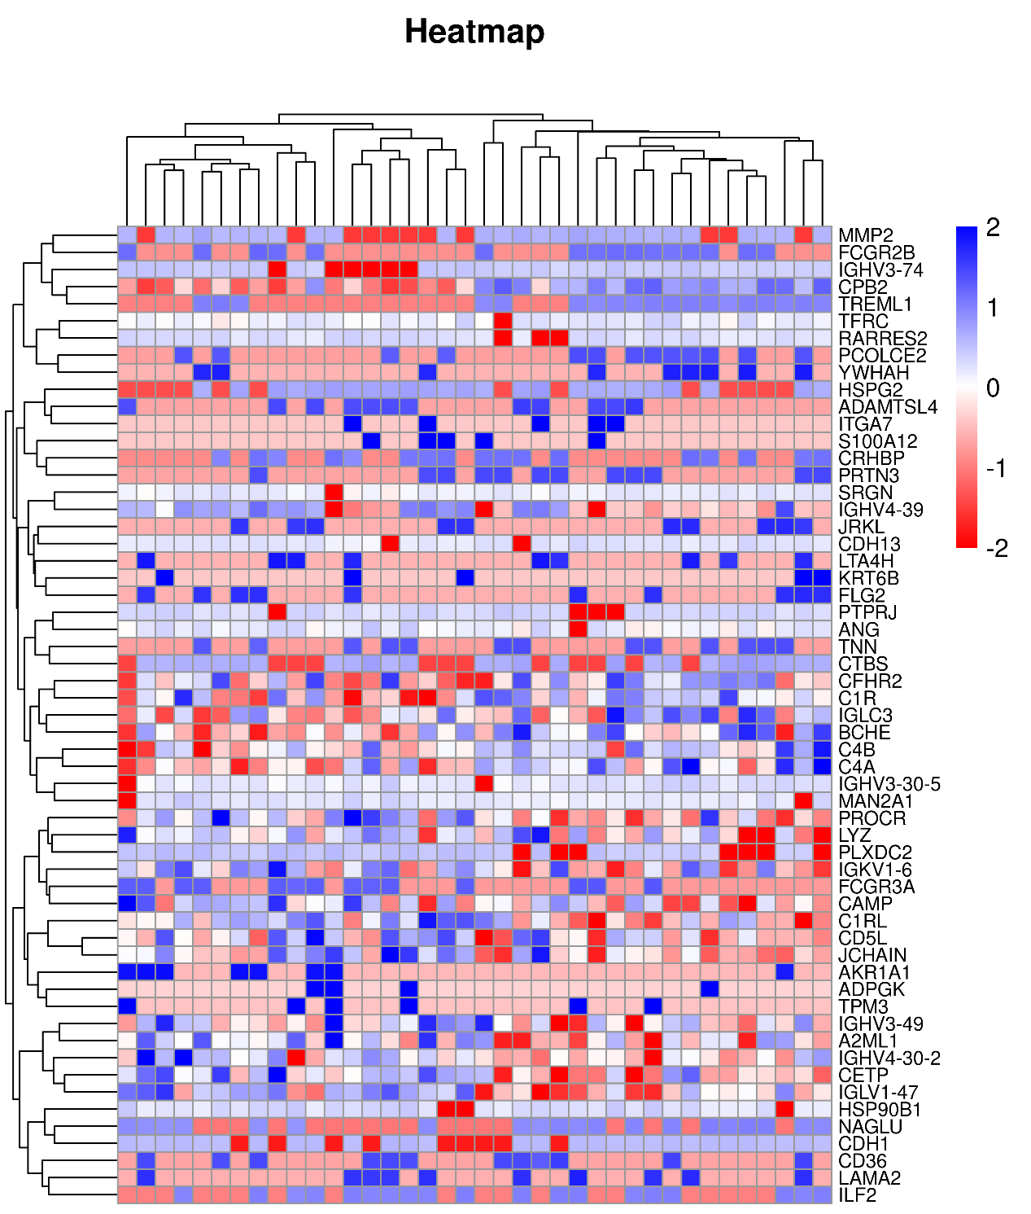

Supplementary figure S4. Principal-component analysis of differentially expressed proteins
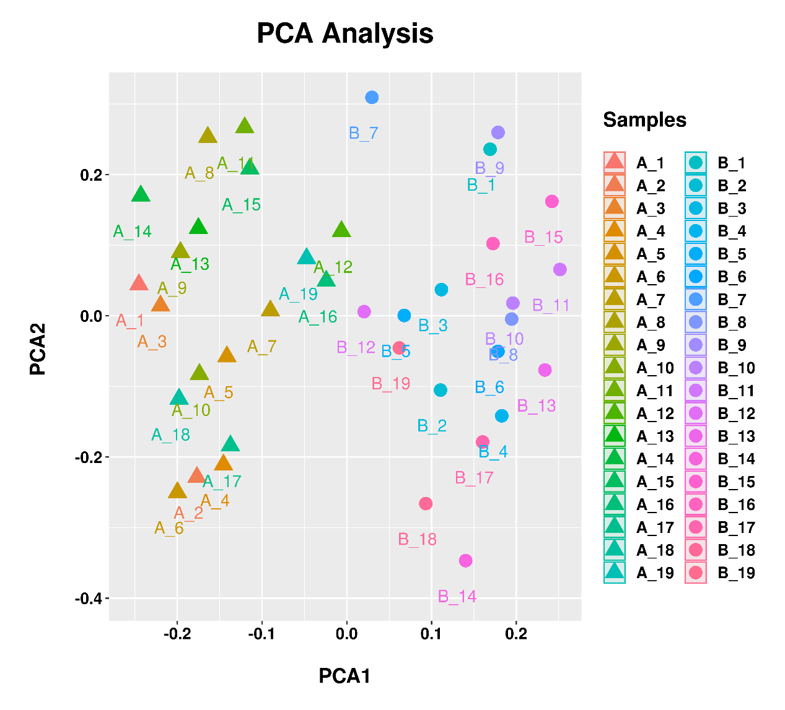

Supplementary figure S5. Gene Set Enrichment Analysis
A. HALLMARK_COAGULATION
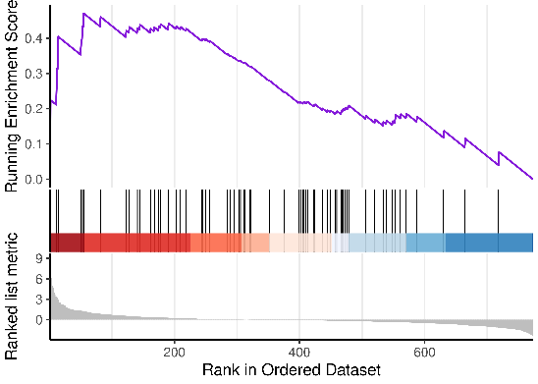

B. GO_LIPID METABOLIC PROCESS
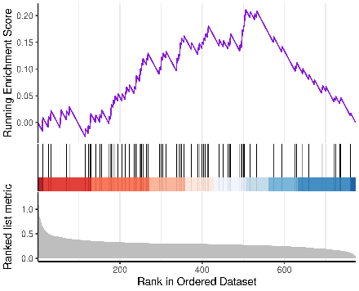

Supplementary figure S6. Feature analysis
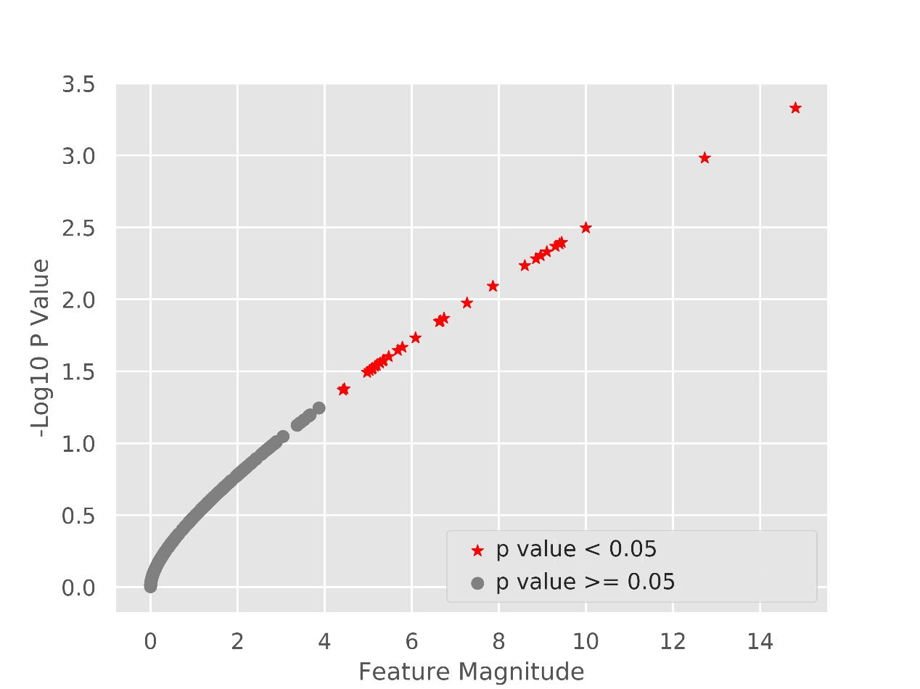
Note: In this figure, X-axis was the score of each expression feature, and Y-axis was the p-value of corresponding expression feature converted to -log10. Among them, the expression characteristics with a p value < 0.05 were indicated in red, and the expression characteristics with a p value > 0.05 were indicated in gray.

Supplementary figure S7. Ranking histogram
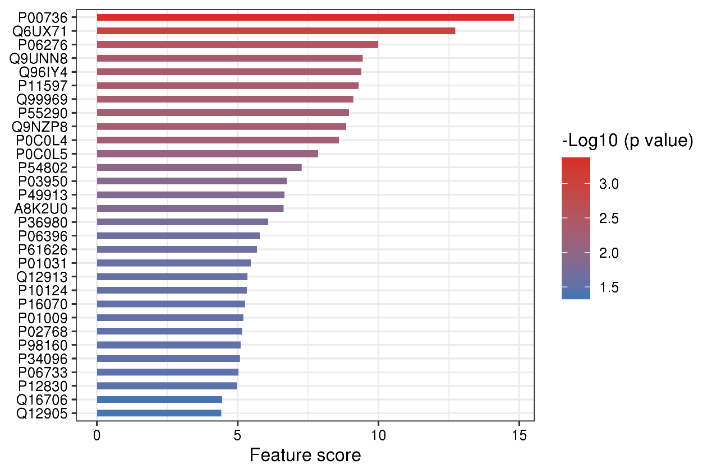
Note: In the figure, the expression feature was sorted according to the score, and the color of the histogram was filled with the feature's -log10 p value.

Supplementary figure S8. Incremental feature selection curve
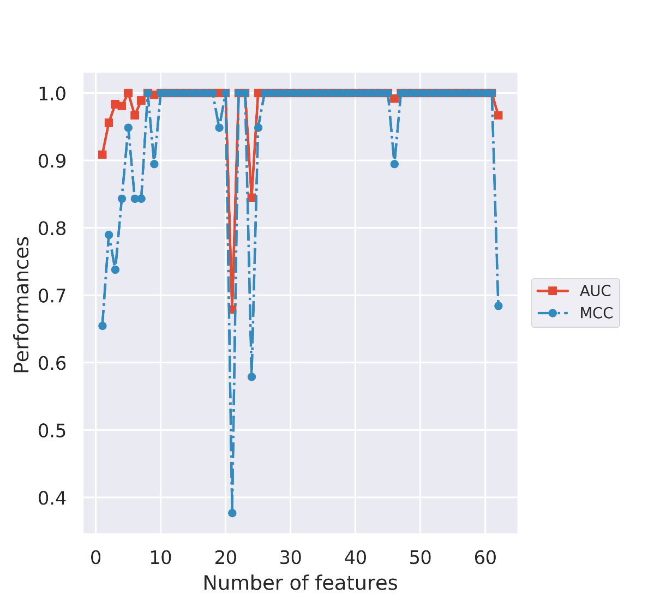

Supplementary figure S9. Box plot of the levels of six candidate proteins in two groups
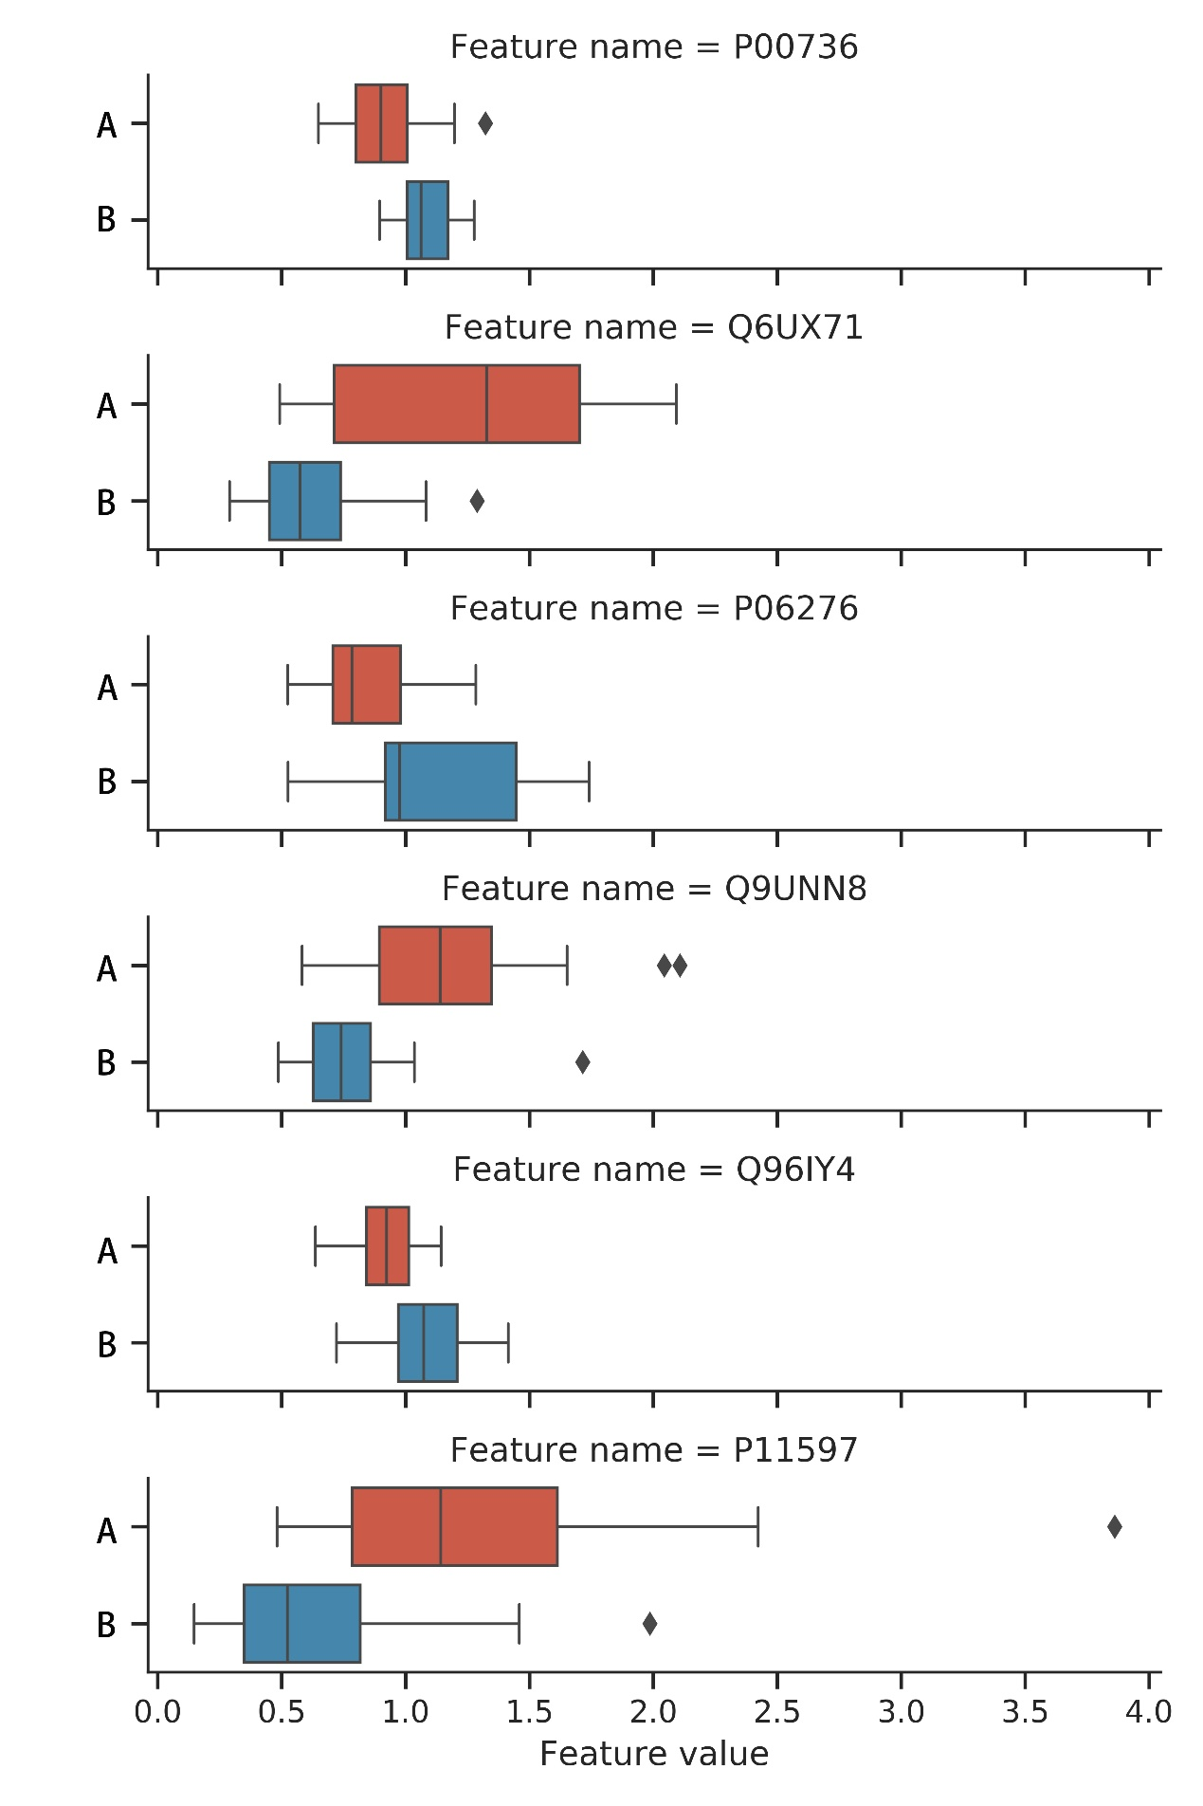

Supplementary figure S10. Correlation scatter plot of target proteins and biochemical parameters
A. CETP and HDL-C
B. CETP and TG
C. EPCR and fibrinogen

