Comparative actualistic study hints at origins of intriguing Miocene “coprolites” of Poland

Tomasz Brachaniec1, Dorota Środek1, Dawid Surmik1, Robert Niedźwiedzki2, Georgios L. Georgalis3, Bartosz J. Płachno4, Piotr Duda5, Alexander Lukeneder6, Przemysław Gorzelak7, Mariusz A. Salamon1*

Supplementary Information

Supplementary Table1. List of taxa of observed fish excrements. Fossil representatives taken from1.

modern fish | fossil representative
Aspius sp. | Aspius sp., Aspius laubei, Barbus sp., Barbus bohemicus
Leuciscus sp. | Palaeoleuciscus sp., Palaeoleuciscus chartacerus
Tinca sp. | Palaeotinca sp., Palaeotinca egeriana, Palaeotinca obtruncata

Supplementary Table 2. List of taxa of observed amphibian excrements. Fossil representatives taken from1.

modern amphibians | fossil representative
Andrias sp. | Andrias bohemicus, Andrias cf. scheuchzeri, Chelotriton cf. paradoxus

Supplementary Table 3. List of taxa of observed bird excrements. Fossil representatives taken from1.

modern birds | fossil representative
Phalacrocorax sp. | Nectornis sp., Phalacrocorax littoraris
Strigiformes indet. | Prosybris antiqua, Mioglaux debellatrix,  Intulula tinnipara
Aquila sp. | Polemaetus sp.
Accipiter sp. | Accipitridae indet.

Supplementary Table 4. List of taxa of observed mammals excrements. Fossil representatives taken from1.

modern mammals | fossil representative
Ursus sp. | Ursavus elmensis, Ursavus isorei, Tomocyon sp., Hemicyon cf. stehlini, Amphicyon bohemicus, Amphicyon major, Megamphicyon giganteus, Cynelos schlosseri
Rhinocerotidae indet. | Mesaceratherium aff. paulhiacense, Prosantorhinus laubei, Protaceratherium minutum
Cervus sp. | Procervulus cf. praelucidus
Equidae indet. | Anchitherium aurelianense

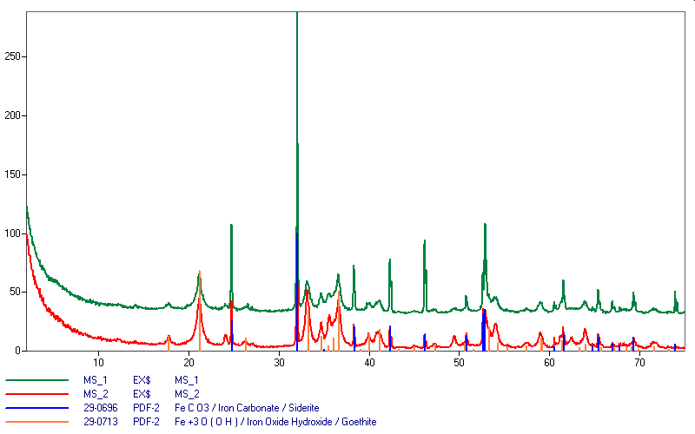

Supplementary Figure 1. XRD diffractograms for two coprolite morphotypes. Green line – morphotype 1, red line – morphotype 2.
Supplementary Movie 1. Tomographic animation of Miocene coprolite from Turów.

References
- Dvořák, Z., Mach K., Prokop, J. & Knor, S. Třetihorní fauna severočeské hnědouhelné pávne, 1-175 (Granit Publishing House, 2010).

