Background on Topic Modelling
Topic modelling is a probabilistic approach to identifying clusters of related words within a corpus of documents. Documents can be any textual data (for e.g., U.S. Congressional Record speeches¹; tweets²; and electronic medical records³) making topic modelling a flexible tool in reducing dimensionality. While there are multiple approaches to topic modelling (see for Barde & Bainwad, 2017, for overview)⁴, the approach taken in this paper employs term-frequency inverse-document-frequency indices to discover sets of terms that efficiently identify latent structure (i.e. topics) within a corpus of documents. Topic modelling uses a generative procedure called Latent Dirichlet Allocation (LDA) that iteratively tunes probabilities that candidate topics are associated with terms within the observed data.^{5,6} Due to this underlying generative procedure topic modelling is particularly well-suited to highly sparse discrete data; a common data format within the epidemiology of psychiatric disorders in which co-morbidity is rife, symptoms are not always indicative, and where it can be difficult to collect data in sufficient quantities due to low population incidence.
1 Quinn KM, Monroe BL, Colaresi M, Crespin MH, Radev DR. How to Analyze Political Attention with Minimal Assumptions and Costs. American Journal of Political Science 2010; 54: 209–228.
2 Lau J, Collier N, Baldwin T. On-line trend analysis with topic models: #twitter trends detection topic model online. Proceedings of COLING 2012, C12-1093 2012; : 1519–1534.
3 McCoy TH, Castro VM, Snapper L, Hart K, Januzzi JL, Huffman JC et al. Polygenic loading for major depression is associated with specific medical comorbidity. Transl Psychiatry 2017; 7: e1238–e1238.
4 Barde BV, Bainwad AM. An overview of topic modeling methods and tools. In: 2017 International Conference on Intelligent Computing and Control Systems (ICICCS). IEEE: Madurai, 2017, pp 745–750.
5 Griffiths TL, Steyvers M. Finding scientific topics. Proceedings of the National Academy of Sciences 2004; 101: 5228–5235.
6 Blei D, Ng A, Jordan M. Latent Dirichlet allocation. The Journal of Machine Learning Research 2001; 3: 601–608.

Supplementary Figure 1. Pseudo-EMRs constructed in preparation for topic modelling by latent Dirichlet allocation
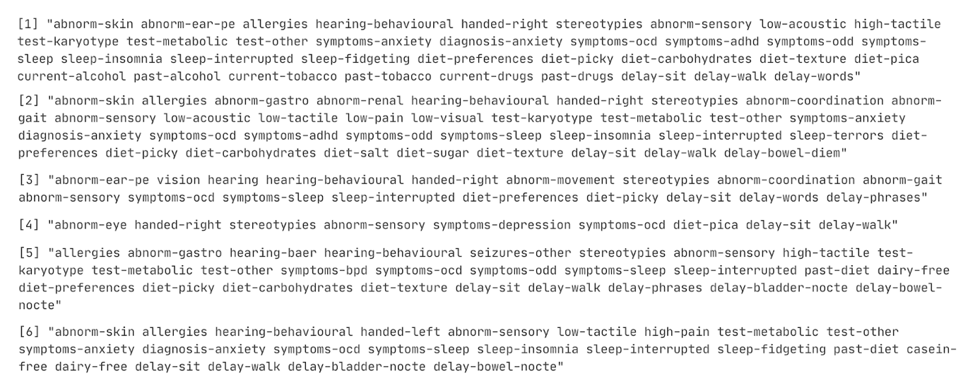
Numbers 1-6 indicate unique subjects with ID masked. Observed psychiatric and sociodemographic features have been transformed into a pseudo-EMR for each subject.

Supplementary Figure 2. Evaluation of various model diagnostics in relation to selecting the optimal number of topics to model given the observed data
Top left: Held-out likelihood indicates perplexity (higher is better). Top right: Lower bound indicates model convergence (higher is better). Bottom left: Residuals indicate model saturation (lower is better). Bottom right: Semantic coherence indicates co-occurrence of probable terms per topic (higher is better).

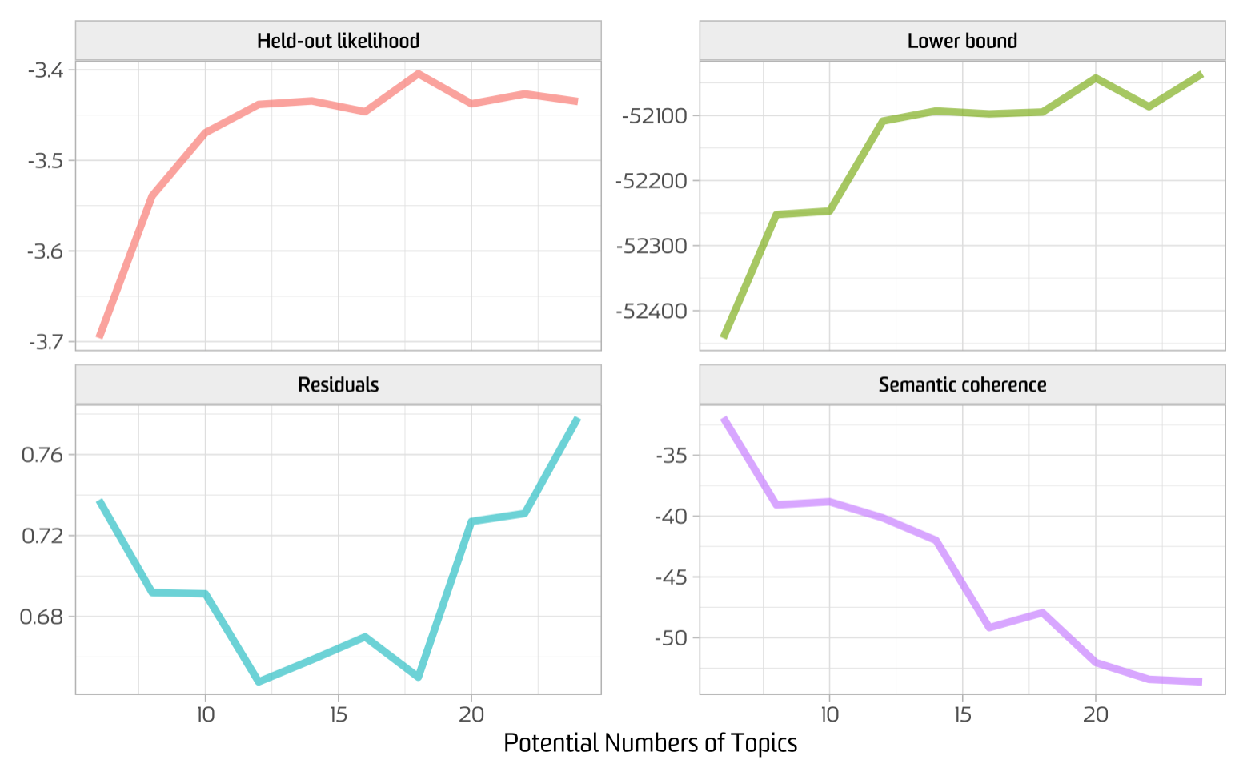

Supplementary Table 1. Descriptive Table of Counts and Percentages for Clinical Features included in Topic Modeling
Clinical label | n | %
high-tactile | 450 | 63.6
low-acoustic | 446 | 63.1
handed-right | 427 | 60.4
abnorm-sensory | 401 | 56.7
stereotypies | 390 | 55.2
low-pain | 350 | 49.5
low-visual | 350 | 49.5
hearing-behavioural | 330 | 46.7
diet-preferences | 325 | 46.0
symptoms-ocd | 299 | 42.3
symptoms-odd | 275 | 38.9
symptoms-sleep | 273 | 38.6
current-alcohol | 269 | 38.0
past-tobacco | 269 | 38.0
past-alcohol | 268 | 37.9
current-drugs | 268 | 37.9
past-drugs | 268 | 37.9
current-tobacco | 267 | 37.8
symptoms-adhd | 264 | 37.3
delay-bladder-nocte | 263 | 37.2
delay-sit | 242 | 34.2
diet-picky | 225 | 31.8
abnorm-gastro | 213 | 30.1
allergies | 200 | 28.3
abnorm-coordination | 198 | 28.0
symptoms-anxiety | 189 | 26.7
sleep-insomnia | 187 | 26.4
hearing-assessment | 185 | 26.2
diet-carbohydrates | 172 | 24.3
diet-texture | 168 | 23.8
sleep-interrupted | 164 | 23.2
abnorm-skin | 161 | 22.8
delay-phrases | 152 | 21.5
delay-bowel-diem | 145 | 20.5
delay-bladder-diem | 141 | 19.9
test-karyotype | 134 | 19.0
delay-bowel-nocte | 134 | 19.0
test-other | 131 | 18.5
abnorm-gait | 127 | 18.0
past-diet | 121 | 17.1
diagnosis-adhd | 115 | 16.3
test-metabolic | 103 | 14.6
delay-walk | 102 | 14.4
diet-pica | 100 | 14.1
delay-words | 90 | 12.7
hearing-baer | 89 | 12.6
gluten-free | 85 | 12.0
symptoms-depression | 84 | 11.9
asthma | 81 | 11.5
diet-salt | 81 | 11.5
diet-sugar | 79 | 11.2
abnorm-ear-pe | 75 | 10.6
vision | 73 | 10.3
abnorm-movement | 69 | 9.8
casein-free | 69 | 9.8
abnorm-teeth | 68 | 9.6
symptoms-bpd | 65 | 9.2
abnorm-respiratory | 63 | 8.9
abnorm-growth | 59 | 8.3
seizures-other | 58 | 8.2
past-hospital | 55 | 7.8
delay-roll | 54 | 7.6
dairy-free | 48 | 6.8
abnorm-ear | 45 | 6.4
diagnosis-odd | 44 | 6.2
infant-irritable | 42 | 5.9
sleep-terrors | 42 | 5.9
abnorm-genital | 41 | 5.8
infant-floppy | 40 | 5.7
abnorm-eye | 40 | 5.7
abnorm-joint | 39 | 5.5
hearing | 32 | 4.5
abnorm-bone | 31 | 4.4
sleep-fidgeting | 30 | 4.2
diagnosis-anxiety | 29 | 4.1
diagnosis-ocd | 28 | 4.0
abnorm-craniofacial | 26 | 3.7
abnorm-heart | 25 | 3.5
seizures-febrile | 24 | 3.4
diagnosis-sleep | 21 | 3.0
diagnosis-depression | 20 | 2.8
abnorm-renal | 19 | 2.7
infant-stiff | 16 | 2.3
abnorm-cerebral | 15 | 2.1
infant-lethargic | 10 | 1.4
seizures-intractable | 10 | 1.4
endocrine-growth | 9 | 1.3
endocrine-sex | 9 | 1.3
diagnosis-bmd | 9 | 1.3
endocrine-thyroid | 8 | 1.1
test-imaging | 5 | 0.7
endocrine-diabetes | 3 | 0.4
egg-free | 2 | 0.3
Note. Each count represents the presence of the token psychiatric feature for a single subject.

Supplementary Table 2. Association between all topics and polygenic risk score (PRS) tranches of autism spectrum disorder (ASD). Seven tranches of SNPs (1×10⁻², 1×10⁻³, 1×10⁻⁴, 1×10⁻⁵, 1×10⁻⁶, 1×10⁻⁷, 5×10⁻⁸) are labelled as S2–S8.
Trait | ASD PRS Trenches
 | S2 |  |  | S3 |  |  | S4 |  |  | S5
 | Beta | SE | P | Beta | SE | P | Beta | SE | P | Beta | SE | P
Topic 1 | 172.233 | 485.528 | 0.723 | -121.616 | 1217.723 | 0.920 | 260.379 | 2427.650 | 0.915 | 5354.636 | 4734.450 | 0.259
Topic 2 | 516.265 | 481.227 | 0.284 | 1895.451 | 1205.217 | 0.116 | 176.934 | 2408.610 | 0.941 | 2002.122 | 4702.410 | 0.670
Topic 3 | -107.757 | 488.015 | 0.825 | 879.714 | 1223.251 | 0.472 | 1230.124 | 2439.311 | 0.614 | -3009.802 | 4762.496 | 0.528
Topic 4 | 153.631 | 485.456 | 0.752 | -415.478 | 1217.383 | 0.733 | 2721.559 | 2424.222 | 0.262 | 1359.814 | 4739.257 | 0.774
Topic 5 | -108.248 | 485.983 | 0.824 | 167.355 | 1218.762 | 0.891 | -195.763 | 2429.755 | 0.936 | -2420.770 | 4743.325 | 0.610
Topic 6 | -926.047 | 485.405 | 0.057 | -2571.968 | 1216.277 | 0.035 | -5953.031 | 2421.017 | 0.014 | -14839.312 | 4709.537 | 0.002
Topic 7 | -827.747 | 487.130 | 0.090 | -806.447 | 1224.575 | 0.510 | -1012.808 | 2441.949 | 0.678 | -3383.638 | 4766.761 | 0.478
Topic 8 | -92.369 | 486.588 | 0.850 | 510.458 | 1220.074 | 0.676 | -1420.269 | 2431.939 | 0.559 | -3337.325 | 4748.066 | 0.482
Topic 9 | -608.856 | 483.374 | 0.208 | 274.520 | 1214.030 | 0.821 | -61.888 | 2420.412 | 0.980 | 3187.722 | 4724.145 | 0.500
Topic 10 | 451.947 | 484.661 | 0.352 | 977.912 | 1215.678 | 0.422 | 1209.988 | 2424.534 | 0.618 | -1775.132 | 4734.838 | 0.708
Topic 11 | -2.234 | 486.422 | 0.996 | -1768.340 | 1217.275 | 0.147 | -1271.892 | 2431.184 | 0.601 | -3994.960 | 4745.261 | 0.400
Topic 12 | 619.120 | 479.903 | 0.198 | 1045.106 | 1204.566 | 0.386 | -629.205 | 2403.057 | 0.794 | -809.413 | 4692.571 | 0.863
Topic 13 | 380.204 | 487.377 | 0.436 | 494.217 | 1222.760 | 0.686 | 2168.882 | 2436.173 | 0.374 | 4604.506 | 4756.373 | 0.333
Topic 14 | -261.684 | 482.938 | 0.588 | 894.445 | 1210.784 | 0.460 | 257.320 | 2415.102 | 0.915 | 8586.476 | 4700.397 | 0.068
Topic 15 | -76.892 | 487.349 | 0.875 | -864.137 | 1221.572 | 0.480 | -3091.688 | 2432.635 | 0.204 | -3470.810 | 4755.250 | 0.466
Topic 16 | 541.183 | 485.491 | 0.266 | 198.051 | 1218.961 | 0.871 | 3239.184 | 2425.890 | 0.182 | 3869.329 | 4742.226 | 0.415
Topic 17 | -61.643 | 487.211 | 0.899 | -2462.132 | 1216.881 | 0.044 | -5080.260 | 2425.271 | 0.037 | -6614.400 | 4747.226 | 0.164
Topic 18 | 250.365 | 485.859 | 0.607 | 259.092 | 1218.681 | 0.832 | 1084.662 | 2429.191 | 0.655 | -2164.388 | 4743.379 | 0.648

Trait | ASD PRS Trenches
 | S6 |  |  | S7 |  |  | S8
 | Beta | SE | P | Beta | SE | P | Beta | SE | P
Topic 1 | 616.098 | 8588.841 | 0.943 | -8908.612 | 14966.803 | 0.552 | -8908.612 | 14966.803 | 0.552
Topic 2 | 7072.687 | 8515.631 | 0.407 | 8866.437 | 14849.292 | 0.551 | 8866.437 | 14849.292 | 0.551
Topic 3 | -1797.712 | 8631.851 | 0.835 | 10043.452 | 15040.954 | 0.505 | 10043.452 | 15040.954 | 0.505
Topic 4 | -824.277 | 8587.318 | 0.924 | 11642.097 | 14960.475 | 0.437 | 11642.097 | 14960.475 | 0.437
Topic 5 | -29.585 | 8596.289 | 0.997 | -3259.756 | 14984.274 | 0.828 | -3259.756 | 14984.274 | 0.828
Topic 6 | -23831.077 | 8550.878 | 0.006 | -26259.611 | 14974.760 | 0.080 | -26259.611 | 14974.760 | 0.080
Topic 7 | -404.406 | 8640.832 | 0.963 | 21910.061 | 15030.946 | 0.146 | 21910.061 | 15030.946 | 0.146
Topic 8 | -7775.528 | 8599.891 | 0.366 | -23380.881 | 14967.173 | 0.119 | -23380.881 | 14967.173 | 0.119
Topic 9 | 12285.892 | 8545.646 | 0.151 | 18464.483 | 14904.552 | 0.216 | 18464.483 | 14904.552 | 0.216
Topic 10 | -1103.284 | 8579.744 | 0.898 | -6761.168 | 14953.346 | 0.651 | -6761.168 | 14953.346 | 0.651
Topic 11 | -4473.570 | 8601.315 | 0.603 | -22476.810 | 14964.250 | 0.134 | -22476.810 | 14964.250 | 0.134
Topic 12 | -6112.541 | 8497.988 | 0.472 | -9016.880 | 14815.785 | 0.543 | -9016.880 | 14815.785 | 0.543
Topic 13 | 2744.836 | 8624.861 | 0.750 | -9580.928 | 15030.229 | 0.524 | -9580.928 | 15030.229 | 0.524
Topic 14 | 17820.554 | 8507.463 | 0.037 | 22493.041 | 14860.877 | 0.131 | 22493.041 | 14860.877 | 0.131
Topic 15 | -6263.427 | 8615.705 | 0.468 | 4930.336 | 15025.106 | 0.743 | 4930.336 | 15025.106 | 0.743
Topic 16 | 2369.588 | 8597.107 | 0.783 | 206.053 | 14987.535 | 0.989 | 206.053 | 14987.535 | 0.989
Topic 17 | -3244.903 | 8616.499 | 0.707 | 5410.359 | 15020.389 | 0.719 | 5410.359 | 15020.389 | 0.719
Topic 18 | -2217.438 | 8595.371 | 0.797 | 8351.233 | 14979.743 | 0.577 | 8351.233 | 14979.743 | 0.577
Table 2. (Cont.)

