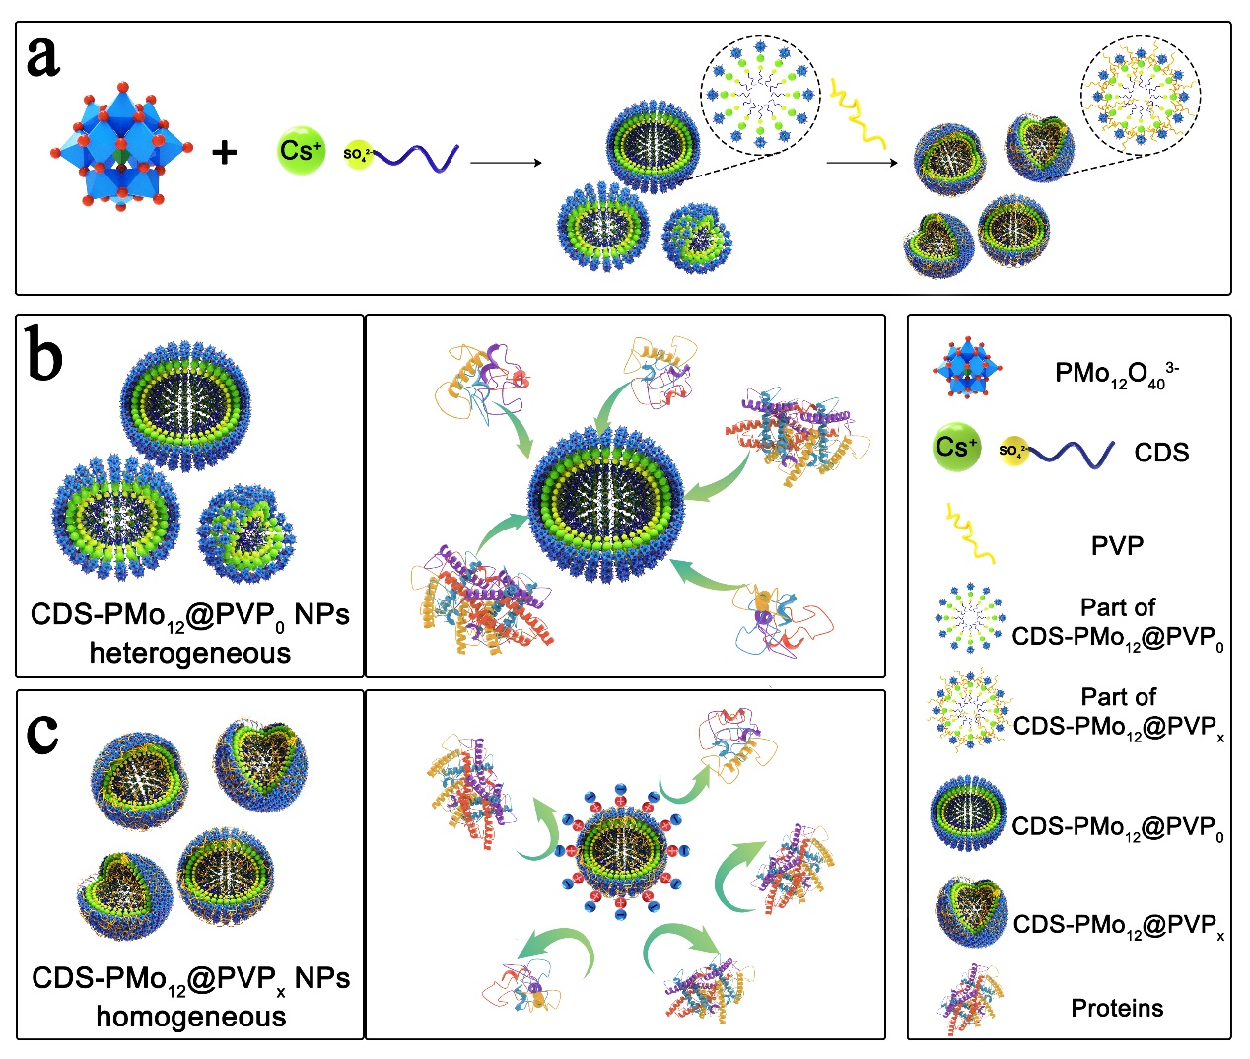
The introduction of PVP to the CDS-PMo₁₂O₄₀³⁻ reaction system further synthesizes homogenous CDS-PMo₁₂@PVP_{x}(x=0.05~1) NPs, Heterogeneous CDS-PMo₁₂@PVP₀ NPs without PVP coating protection could largely adsorb proteins. In contrast, PVP modified homogeneous CDS-PMo₁₂@PVP_{x}(x=0.05~1) NPs could protect the NPs from protein adsorption.

