Supplementary material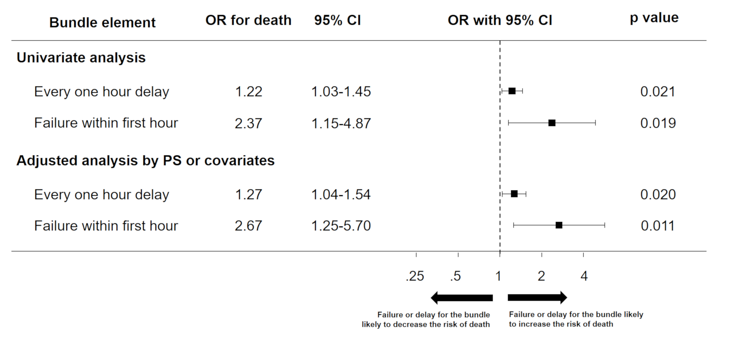
Figure. S1 Association between the increase in mortality and failure or delay in achieving three relatively low-compliance bundle components: blood culture, antibiotics, and vasopressors. Univariate and multivariate-adjusted ORs with 95% CIs for mortality risk are represented as forest plots. Covariate adjustment or propensity score adjustment was used in the regression analyses as appropriate. OR odds ratio, CI confidence interval, PS propensity score.

Table S1 Time to completion of each component of the hour-1 bundle
Components of hour-1 bundle | Not applicable | < 1 hour | 1-2 hours | 2-3 hours | 3-4 hours | 4-5 hours | 5-6 hours | > 6 hours
Measure lactate level | - | 176 (98.9%) | 2 (1.1%) | 0 (0%) | 0 (0%) | 0 (0%) | 0 (0%) | 0 (0%)
Obtain blood cultures | - | 150 (86.2%) | 17 (9.8%) | 3 (1.7%) | 1 (0.6%) | 3 (1.7%) | 0 (0%) | 0 (0%)
Broad-spectrum antibiotics | - | 91 (51.1%) | 40 (22.5%) | 20 (11.2%) | 5 (2.8%) | 6 (3.4%) | 4 (2.3%) | 12 (6.7%)
Administration of crystalloid | 59 | 112 (94.9%) | 3 (2.5%) | 2 (1.7%) | 0 (0%) | 0 (0%) | 0 (0%) | 1 (0.9%)
Apply vasopressors | 79 | 67 (69.1%) | 15 (15.5%) | 5 (5.2%) | 3 (3.1%) | 3 (3.1%) | 1 (1%) | 3 (3.1%)
Completion of all components | - | 89 (50.3%) | 35 (19.8%) | 21 (11.9%) | 7 (4%) | 7 (4%) | 5 (2.8%) | 13 (7.3%)
Missing data: Obtain blood cultures = 4; Administration of crystalloid = 1; Apply vasopressors = 2; completion of all elements = 1

