Electronic Supplementary Material
Definitive chemoradiotherapy has comparable survival outcomes to esophagectomy in patients with clinical T1N0M0 esophageal squamous cell carcinoma: real world data
Journal Name: Esophagus
Kentaro Sawada,^{1,2} Hisashi Fujiwara,³ Hiroki Yukami,² Saori Mishima,² Tomohiro Kadota,⁴ Keiichiro Nakajo,⁴ Yusuke Yoda,⁴ Masaki Nakamura,⁵ Hidehiro Hojo,⁵ Tomonori Yano,⁴ Takeo Fujita,³ Takashi Kojima,² Daisuke Kotani²
¹ Department of Medical Oncology, Kushiro Rosai Hospital
² Department of Gastroenterology and Gastrointestinal Oncology, National Cancer Center Hospital East
³ Department of Esophageal Surgery, National Cancer Center Hospital East
⁴ Department of Gastroenterology and Endoscopy, National Cancer Center Hospital East
⁵ Department of Radiation Oncology and Particle Therapy, National Cancer Center Hospital East
Corresponding author:
Daisuke Kotani
Department of Gastroenterology and Gastrointestinal Oncology, National Cancer Center Hospital East
6-5-1 Kashiwanoha, Kashiwa, Chiba 277-8577, Japan
Tel: +81-4-7133-1111
Fax: +81-4-7134-6865
E-mail: dkotani@east.ncc.go.jp

Supplementary Table 1. Pathologic findings in patients who underwent esophagectomy

 | All patients  (n=120) | Elderly patients  (n=21)
 | n (%) | n (%)
Pathologic T stage  T1a  T1b  T2  T3 | 14 (11.7)  100 (83.3)  5 (4.2)  1 (0.8) | 1 (4.8)  19 (90.5)  1 (4.8)  0
Pathologic N stage  N0  N1  N2  N3 | 88 (73.3.3)  24 (20.0)  7 (5.8)  1 (1.0) | 15 (71.4)  3 (14.3)  3 (14.3)  0
Pathological T1N0M0  Yes  No | 86 (71.7)  34 (28.3) | 15 (71.4)  6 (28.6)

 | 50.4Gy  (n=16) |  | 60Gy  (n=20) |  | P values*
 | Any grade  n (%) | ≥ Grade 3  n (%) | Any grade  n (%) | ≥ Grade 3  n (%)
Hematologic adverse events  Leucopenia  Neutropenia  Anemia  Thrombopenia  Non-hematologic adverse events  (Early toxicity)  Esophagitis  Anorexia  Creatinine increase  Stomatitis  (Late toxicity)  Pleural effusion  Irradiation pneumonitis  Pericardial fluid | 16 (100.0)  15 (93.8)  10 (62.5)  8 (50.0)  13 (81.3)  6 (37.5)  2 (12.5)  0  3 (18.8)  3 (18.8)  2 (12.5) | 6 (37.5)  5 (31.3)  0  1 (6.3)  2 (12.5)  0  0  0  0  1 (6.3)  0 | 18 (90.0)  16 (80.0)  10 (50.0)  4 (20.0)  18 (90.0)  15 (75.0)  2 (10.0)  5 (25.0)  3 (15.0)  0  2 (10.0) | 3 (15.0)  4 (20.0)  0  0  2 (10.0)  1 (5.0)  0  1 (5.0)  0  0  0 | 0.492  0.355  0.515  0.081  0.637  0.041  1.000  0.053  1.000  0.078  1.000
Supplementary Table 2. Adverse events in the CRT group according to the irradiation dose
* Fisher's exact test, Any grade

Supplementary Table 3. Details of clinical coarse in cases with recurrence
Patients ID | Treatment group | Age | Pathological Stage | Recurrent site | PFS  (months) | Treatment for recurrence
192 | esophagectomy | 69 | T1N1M0 | Lung | 18.63 | Salvage surgery
499 | esophagectomy | 59 | T1N0M0 | Lung | 37.29 | Salvage surgery
1012 | esophagectomy | 75 | T1N0M0 | Regional LN | 26.22 | Salvage surgery
226 | esophagectomy | 63 | T1N1M0 | Regional LN | 14.75 | Salvage CRT
280 | esophagectomy | 61 | T1N0M0 | Regional LN | 11.04 | Salvage CRT
485 | esophagectomy | 67 | T2N1M0 | Regional LN | 4.01 | Salvage CRT
511 | esophagectomy | 67 | T1N1M0 | Regional LN | 45.27 | Salvage CRT
1013 | esophagectomy | 75 | T1N1M0 | Regional LN | 29.96 | Salvage CRT
243 | esophagectomy | 61 | T1N0M0 | Lung | 3.75 | Chemotherapy
285 | esophagectomy | 71 | T1N2M0 | Distant LN | 23.92 | Chemotherapy
292 | esophagectomy | 67 | T1N1M0 | Liver, Distant LN | 12.91 | Chemotherapy
491 | esophagectomy | 69 | T1N0M0 | Lung | 36.40 | Chemotherapy
206 | esophagectomy | 70 | T1N0M0 | Distant LN | 9.86 | BSC
212 | esophagectomy | 73 | T3N2M0 | Bone, Peritoneal | 47.74 | BSC
219 | esophagectomy | 62 | T1N0M0 | Bone | 48.30 | BSC
221 | esophagectomy | 79 | T1N1M0 | Liver | 14.85 | BSC
223 | esophagectomy | 53 | T2N1M0 | Bone, Lung, Distant LN | 7.26 | BSC
230 | esophagectomy | 87 | T1N2M0 | Regional LN | 77.96 | BSC
268 | esophagectomy | 71 | T1N0M0 | Bone, Distant LN | 35.55 | BSC
487 | esophagectomy | 80 | T2N2M0 | Lung | 4.21 | BSC
512 | esophagectomy | 59 | T1N1M0 | Bone | 44.88 | BSC
586 | CRT | 58 | - | Local rec | 50.60 | Salvage surgery
525 | CRT | 54 | - | Regional LN | 7.20 | Salvage surgery
585 | CRT | 67 | - | Regional LN | 3.78 | Salvage surgery
517 | CRT | 77 | - | Regional LN | 14.09 | Salvage surgery
578 | CRT | 63 | - | Lung | 7.00 | Salvage surgery
518 | CRT | 61 | - | Distant LN | 60.65 | Chemotherapy
595 | CRT | 61 | - | Lung | 20.30 | Chemotherapy
609 | CRT | 70 | - | Lung | 7.23 | Chemotherapy
537 | CRT | 66 | - | Lung | 10.05 | Chemotherapy
Supplementary Table 4. Univariate and multivariate analysis for PFS
Factor | Univariate analysis |  |  | Multivariate analysis
 | OR | 95% CI | P value | OR | 95% CI | P value
CRT | 1.284 | 0.644-2.563 | 0.478 | 1.299 | 0.627-2.689 | 0.482
Male | 1.522 | 0.598-3.873 | 0.378 | 1.329 | 0.516-3.427 | 0.556
Age ≥75 | 1.531 | 0.768-3.053 | 0.227 | 1.460 | 0.721-2.955 | 0.293
PS ≥1 | 1.264 | 0.495-3.226 | 0.625 | 1.163 | 0.454-2.976 | 0.753
Clinical tumor depth (SM2/3) | 1.515 | 0.672-3.415 | 0.317 | 2.109 | 0.867-5.129 | 0.100
Circumstance (>3/4) | 1.531 | 0.835-2.807 | 0.169 | 1.356 | 0.569-3.234 | 0.492
Tumor size (>4 cm) | 1.430 | 0.775-2.637 | 0.252 | 1.370 | 0.559-3.358 | 0.491

Supplementary Table 5. Univariate and multivariate analysis for OS
Factor | Univariate analysis |  |  | Multivariate analysis
F | OR | 95% CI | P value | OR | 95% CI | P value
CRT | 1.060 | 0.479-2.342 | 0.886 | 1.007 | 0.438-2.315 | 0.986
Male | 1.585 | 0.559-4.492 | 0.386 | 1.409 | 0.490-4.052 | 0.525
Age ≥75 | 1.572 | 0.735-3.364 | 0.244 | 1.491 | 0.685-3.247 | 0.314
PS ≥1 | 1.265 | 0.444-3.605 | 0.660 | 1.136 | 0.397-3.249 | 0.812
Clinical tumor depth (SM2/3) | 1.461 | 0.605-3.524 | 0.399 | 1.801 | 0.691-4.693 | 0.229
Circumstance (>3/4) | 1.634 | 0.839-3.181 | 0.149 | 1.769 | 0.724-4.322 | 0.210
Tumor size (>4 cm) | 1.286 | 0.653-2.532 | 0.468 | 1.000 | 0.396-2.526 | 0.999

Supplementary Figure 1. Consort diagram
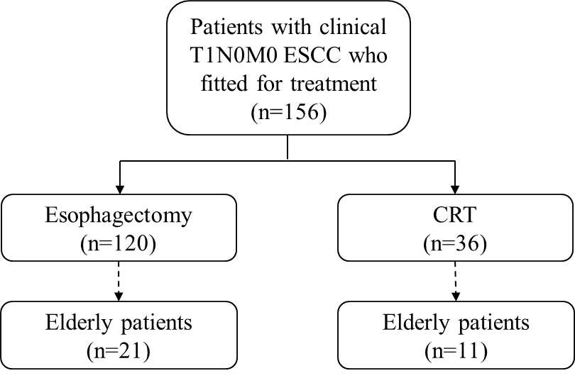

Supplementary Figure 2. PFS (A) and OS (B) according to clinical tumor invasion depth
