SUPPLEMENTARY INFORMATION

A Synthetic Acetyl-CoA Bi-cycle Synergizes the Wood-Ljungdahl Pathway for Efficient Carbon Conversion in Syngas Fermentation
Chao Wuª†, Jonathan Loª†, Chris Urbanª, Xiang Gaoª, Jonathan Humphreysª, Shrameeta Shinde^{b}, Xin Wang^{b}, Katherine J. Chouª, PinChing Manessª, Nicolas Tsesmetzis^{c}, David Parker^{c}, Wei Xiongª*

ª Biosciences Center, National Renewable Energy Laboratory, Golden, CO 80401, USA
^{b} Department of Microbiology, Miami University, Oxford, OH 45056, USA
^{c} Shell International Exploration and Production Inc, Houston, TX 77082, USA
* Correspondence to: Wei.Xiong@nrel.gov
† Denotes equal contribution

TABLE OF CONTENTS
SUPPLEMENTARY TABLES ........................................................ 3
SUPPLEMENTARY FIGURES....................................................... 7
REFERENCE…………………...................................................... 15

Table S1. Enzymes involved in the designed bicyclic acetyl-CoA pathway for syngas-fermenting in Clostridium ljungdahlii. Of the 16 enzymes, 15 are native in as being found in the genome of C. ljungdahlii DSM 13528 except phosphoketolase.

 | Enzymes | Gene Number in Clostridium ljungdahlii DSM 13528 genome
1 | Phosphotransacetylase | CLJU_c12770
2ª | Pyruvate:ferredoxin oxidoreductase | CLJU_c29340
2^{b} | Pyruvate formate lyase | CLJU_c25980
3 | Pyruvate carboxylase | CLJU_c37390
4 | Phosphoenolpyruvate carboxykinase | CLJU_c06210
5 | Endolase | CLJU_c39110
6 | Phosphoglycerate mutase | CLJU_c26320
7 | Phosphoglycerate kinase | CLJU_c39140
8 | Glyceraldehyde-3-phosphate dehydrogenase | CLJU_c13400
9 | Triose phosphate isomerase | CLJU_c39103
10 | Fructose 1,6-bisphosphate aldolase | CLJU_c02810
11 | Fructose 1,6-bisphosphatase | CLJU_c29050
12 | Transaldolase | CLJU_c25960 CLJU_c39640
13 | Transketolase | CLJU_c03050 CLJU_c03051 CLJU_c25830 CLJU_c25820
14 | Ribose-5-phosphate isomerase | CLJU_c02310 CLJU_c02190
15 | Ribulose-5-phosphate epimerase | CLJU_c01210
16 | Phosphoketolase | -

ª: Variant of the designed pathway using CO as substrate.
^{b}: Variant of the designed pathway using formate as substrate.

Table S2. Parameters for thermodynamics and kinetics analysis of the designed reductive acetyl CoA Bi-cycle pathway (CO₂ fixation) in C. ljungdahlii. Standard Gibbs free energies (ΔG'^{m}) were searched in eQuilibrator database, Michaelis constants (K_{m}), catalytic rate constants (k_{cat}) and enzyme molecular weight (MW) were chosen from Brenda. Data from Clostridia was preferential used, then that from Escherichia coli. If no data are available, default values of 200 s⁻¹, 0.2 mM and 40 kDa were assigned for k_{cat}, K_{m} and MW, respectively.

Enzyme ID | Reversibility | ΔG'^{m} (kJ mol⁻¹) | Substrates | Products | Substrate K_{m} (mM) | Product K_{m} (mM) | k_{cat} (s⁻¹) | Enzyme MW (kDa)
ªtkt1 | 1 | 9.4 | F6P;GAP | E4P;X5P | 1.1;2.1 | 0.09;0.16 | 200 | 32.423
pkt | 0 | -58.2 | X5P;Pi | GAP;AcP | 0.2;0.2 | 0.2;0.2 | 200 | 40
pta | 1 | -11.3 | CoA;AcP | AcCoA;Pi | 0.56;0.66 | 0.02;2.1 | 135.2 | 38
pfor | 1 | 13.2 | CO2;AcCoA;2rFdx | Pyr;CoA;2oFdx | 0.2;0.2;0.2 | 0.2;0.2;0.2 | 200 | 129.94
pc | 0 | -4.2 | Pyr;ATP;CO2 | OAA;ADP;Pi | 0.2;0.2;0.2 | 0.2;0.2;0.2 | 200 | 128.5
pepck | 0 | -7.5 | OAA;Pi | PEP;CO2 | 0.2;0.2 | 0.34;0.19 | 540 | 58.769
end | 1 | 4.1 | PEP | G2P | 0.2 | 0.2 | 200 | 46.94
pgm | 1 | -4.7 | G2P | G3P | 0.2 | 4.7 | 200 | 56.3
pgk | 1 | 17.7 | G3P;ATP | Go3P;ADP | 0.2;0.2 | 0.2;0.2 | 200 | 42.956
gapdh | 1 | -31.3 | Go3P;NADPH | GAP;NADP;Pi | 0.2;0.2 | 0.89;0.2;0.53 | 200 | 38.575
tpi | 1 | -5.1 | GAP | DHAP | 0.2 | 0.2 | 9000 | 27.172
fba | 1 | -2.9 | GAP;DHAP | FBP | 0.2;0.2 | 0.17 | 10.8 | 33.579
fbp | 0 | -29.6 | FBP | F6P;Pi | 0.009 | 0.2;0.2 | 12.1 | 77.46
tal | 1 | 0.4 | E4P;F6P | GAP;S7P | 0.16;1.15 | 0.27;0.285 | 13 | 24.446
ªtkt2 | 1 | 4.1 | GAP;S7P | R5P;X5P | 2.1;4 | 1.4;0.16 | 200 | 32.423
rpi | 1 | 1.5 | R5P | Ru5P | 2.2 | 0.2 | 2100 | 16.385
rpe | 1 | -3.4 | Ru5P | X5P | 0.2 | 0.2 | 200 | 23.776
ak | 1 | -12.6 | ADP;AcP | ATP;Ac | 3.355;0.58 | 1.435;116.5 | 200 | 88

ª: tkt involved in reactions with different reactants was assigned different IDs.

Table S3. Parameters for thermodynamics and kinetics analysis of the designed reductive acetyl CoA Bi-cycle pathway (formate fixation) in C. ljungdahlii. Standard Gibbs free energies (ΔG'^{m}) were searched in eQuilibrator database, Michaelis constants (K_{m}), catalytic rate constants (k_{cat}) and enzyme molecular weight (MW) were chosen from Brenda. Data from Clostridia was preferential used, then that from Escherichia coli. If no data are available, default values of 200 s⁻¹, 0.2 mM and 40 kDa were assigned for k_{cat}, K_{m} and MW, respectively.

Enzyme ID | Reversibility | ΔG'^{m} (kJ mol⁻¹) | Substrates | Products | Substrate K_{m} (mM) | Product K_{m} (mM) | k_{cat} (s⁻¹) | Enzyme MW (kDa)
ªtkt1 | 1 | 9.4 | F6P;GAP | E4P;X5P | 1.1;2.1 | 0.09;0.16 | 200 | 32.423
pkt | 0 | -58.2 | X5P;Pi | GAP;AcP | 0.2;0.2 | 0.2;0.2 | 200 | 40
pta | 1 | -11.3 | CoA;AcP | AcCoA;Pi | 0.56;0.66 | 0.02;2.1 | 135.2 | 38
pfl | 1 | 13.2 | Fm;AcCoA | Pyr;CoA | 14;0.26 | 1;0.012 | 200 | 17
pc | 0 | -4.2 | Pyr;ATP;CO2 | OAA;ADP;Pi | 0.2;0.2;0.2 | 0.2;0.2;0.2 | 200 | 128.5
pepck | 0 | -7.5 | OAA;Pi | PEP;CO2 | 0.2;0.2 | 0.34;0.19 | 540 | 58.769
end | 1 | 4.1 | PEP | G2P | 0.2 | 0.2 | 200 | 46.94
pgm | 1 | -4.7 | G2P | G3P | 0.2 | 4.7 | 200 | 56.3
pgk | 1 | 17.7 | G3P;ATP | Go3P;ADP | 0.2;0.2 | 0.2;0.2 | 200 | 42.956
gapdh | 1 | -31.3 | Go3P;NADPH | GAP;NADP;Pi | 0.2;0.2 | 0.89;0.2;0.53 | 200 | 38.575
tpi | 1 | -5.1 | GAP | DHAP | 0.2 | 0.2 | 9000 | 27.172
fba | 1 | -2.9 | GAP;DHAP | FBP | 0.2;0.2 | 0.17 | 10.8 | 33.579
fbp | 0 | -29.6 | FBP | F6P;Pi | 0.009 | 0.2;0.2 | 12.1 | 77.46
tal | 1 | 0.4 | E4P;F6P | GAP;S7P | 0.16;1.15 | 0.27;0.285 | 13 | 24.446
ªtkt2 | 1 | 4.1 | GAP;S7P | R5P;X5P | 2.1;4 | 1.4;0.16 | 200 | 32.423
rpi | 1 | 1.5 | R5P | Ru5P | 2.2 | 0.2 | 2100 | 16.385
rpe | 1 | -3.4 | Ru5P | X5P | 0.2 | 0.2 | 200 | 23.776
ak | 1 | -12.6 | ADP;AcP | ATP;Ac | 3.355;0.58 | 1.435;116.5 | 200 | 88

ª: tkt involved in reactions with different reactants was assigned different IDs.

Table S4. Parameters for thermodynamics and kinetics analysis of the Wood-Ljungdahl pathway in C. ljungdahlii. Standard Gibbs free energies (ΔG'^{m}) were searched in eQuilibrator database, Michaelis constants (K_{m}), catalytic rate constants (k_{cat}) and enzyme molecular weight (MW) were chosen from Brenda. Data from Clostridia was preferential used, then that from Escherichia coli. If no data are available, default values of 200 s⁻¹, 0.2 mM and 40 kDa were assigned for k_{cat}, K_{m} and MW, respectively.

Enzyme ID | Reversibility | ΔG'^{m} (kJ mol⁻¹) | Substrates | Products | Substrate K_{m} (mM) | Product K_{m} (mM) | k_{cat} (s⁻¹) | Enzyme MW (kDa)
fdh | 1 | 14.8 | CO2;NADH | Fm;NAD | 0.2;0.05 | 0.2;0.2 | 6.2 | 80.7
fhs | 1 | -7.2 | THF;Fm;ATP | FormylTHF;ADP;Pi | 0.22;8.2;0.1555 | 10;0.06;5 | 1.4 | 240
fol1 | 1 | 3 | FormylTHF | MethenylTHF | 0.2 | 0.19 | 200 | 41
fol2 | 1 | -11.7 | MethenylTHF;NADPH | MethyleneTHF;NADP | 0.057;0.029 | 0.127;0.0595 | 1600 | 70
mthfr | 1 | -43.2 | MethyleneTHF;NADH | MethylTHF;NAD | 0.001;0.026 | 0.12;0.2 | 324 | 124
acsA | 1 | 28.4 | CO2;rFdx;0.5NADH | CO;oFdx;0.5NAD | 0.2;0.2;0.2 | 0.2;0.2;0.2 | 200 | 67.955
acsB | 1 | -37.9 | MethylTHF;CoA;CO | THF;AcCoA | 0.2;0.2;0.2 | 0.2;0.2 | 200 | 83.554
pta | 1 | 11.3 | AcCoA;Pi | CoA;AcP | 0.02;2.1 | 0.56;0.66 | 135.2 | 38
ak | 1 | -12.6 | ADP;AcP | ATP;Ac | 3.355;0.58 | 1.435;116.5 | 200 | 88

(a)
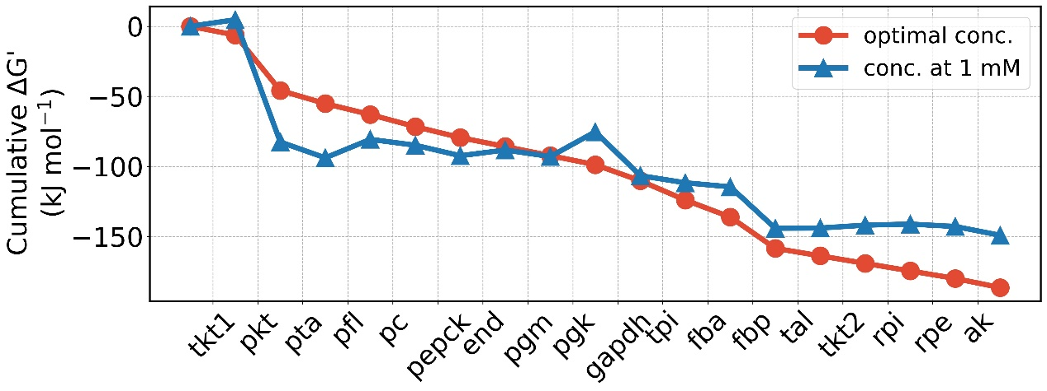

(b)
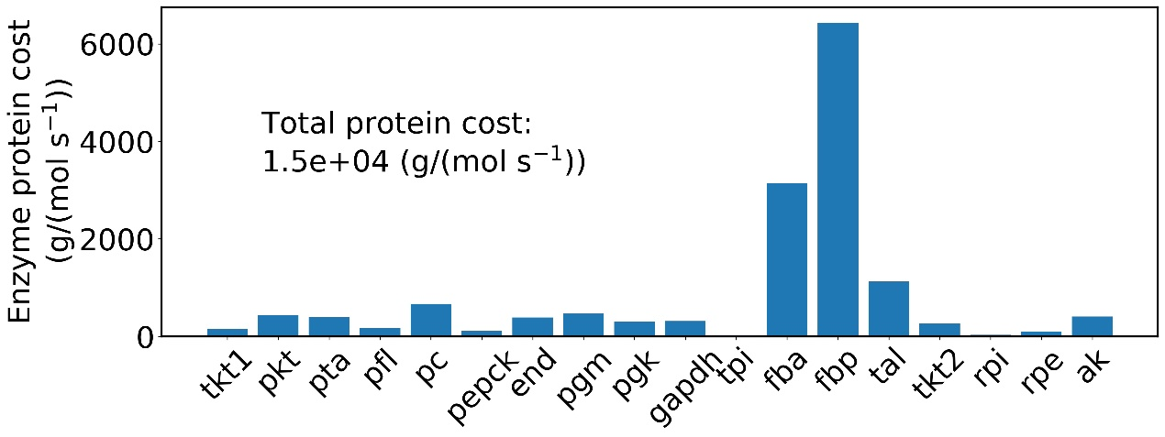

Figure S1. Thermodynamics (a) and enzyme protein cost (b) analysis of the reductive acetyl CoA Bi-cycle for formate fixation. Thermodynamic driving force of pathway is presented as the cumulative sum of reaction Gibbs energies, ΔG’. Blue line denotes standard Gibbs energies with all metabolite concentrations fixed at 1 mM, and red line denotes Gibbs energies when the minimal ΔG′ is optimized with metabolite concentrations constrained to range from 1 μM to 10 mM. Enzyme protein costs are estimated by optimizing the total enzyme mass to support unit pathway flux with metabolite concentrations constrained to range from 1 μM to 10 mM. Enzyme abbreviations: ak, Acetate kinase; end, Endolase; fba, Fructose-1,6-bisphosphate aldolase; fbp, Fructose-1,6-bisphosphatase; gapdh, Glyceraldehyde-3-phosphate dehydrogenase; pc, Pyruvate carboxylase ; pepck, Phosphoenolpyruvate carboxykinase; pfl, pyruvate formate lyase; pgk, Phosphoglycerate kinase; pgm, Phosphoglycerate mutase; pkt, Phosphoketolase; pta, Phosphotransacetylase; rpe, Ribulose-5-phosphate epimerase; rpi, Ribose-5-phosphate isomerase; tal, Transaldolase; tkt, Transketolase; tpi, Triose phosphate isomerase. Tkt involved in reactions with different reactants was marked with numbers.

- (b)
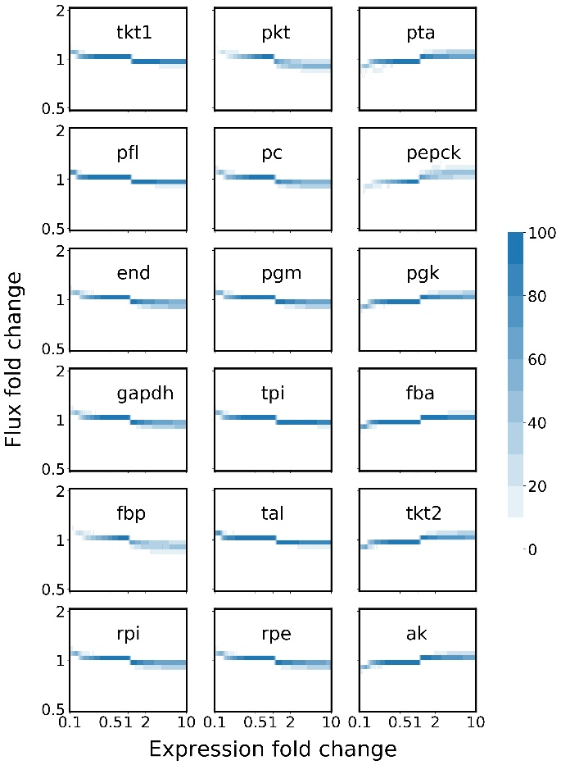
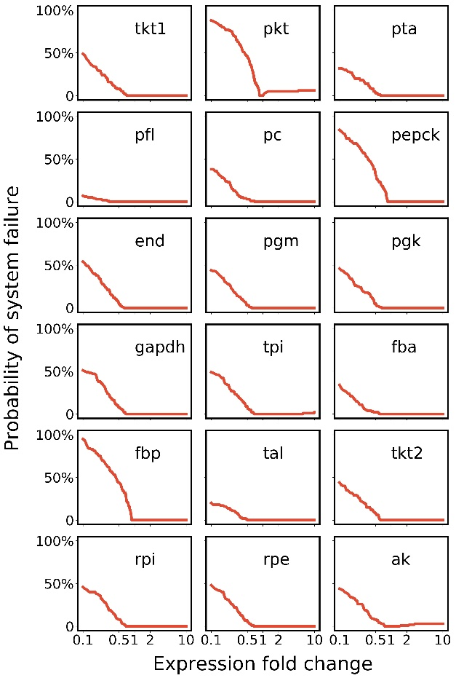

Figure S2. Pathway stability (a) and flux change (b) in response to enzyme level perturbations in the reductive acetyl- CoA Bi-cycle for formate fixation. Pathway stability is represented by the probability of system failure at varied fold change of enzyme expression levels over reference state. A pathway is considered as entering system failure when any intermediate is depleted or over accumulated over time, and the probability of system failure is calculated as counts in an ensemble of 100 models. The color in flux change heatmap indicates the number of models of corresponding flux fold change at some enzyme expression level.

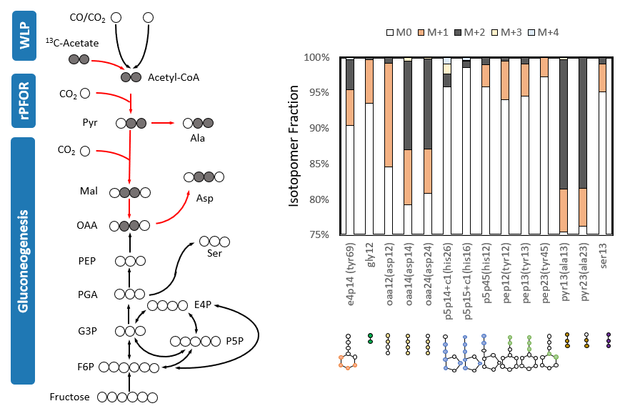

Figure S3. Functionality of only carbon fixation module proved by labeling experiment using [U-¹³C₂] acetate in heterotrophic mode. Red arrows on the left denote active reactions verified by the formation of labeled downstream metabolites. Isotopomer fraction of measurable metabolite fragments are illustrated on the right. M0 denotes fraction of fragments with all ¹²C carbon atoms, and M+i denotes fraction of fragments with i ¹³C labeled carbon atoms. In right panel, labeled metabolites are presented as “precursor fragment (amino acid fragment)”, and contributing carbon atoms from the precursor are colored.

(a) (b) (c)
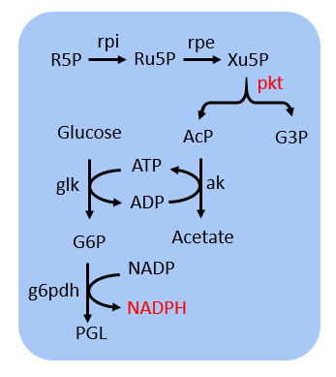
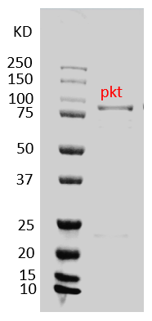
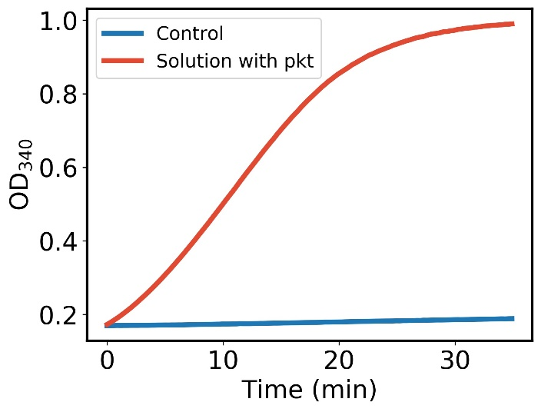

Figure S4. Purification and activity measurement of heterologous phosphoketolase. (a) SDS-PAGE gel of purified phosphoketolase; (b) Principle of in vitro enzyme assay of phosphoketolase. The formation of NADPH was recorded as the indicator of enzyme activity; (c) Solution with phosphoketolase showed a significant higher absorbance at 340 nm than the control. Abbreviations: G6P, glucose 6-phosphate; g6pdh, glucose-6-phosphate 1-dehydrogenase; glk, glucose kinase; PGL, 6-phospho-D-glucono-1,5-lactone; Xu5P, xylulose 5-phosphate.

(a) (b) (c) (d)
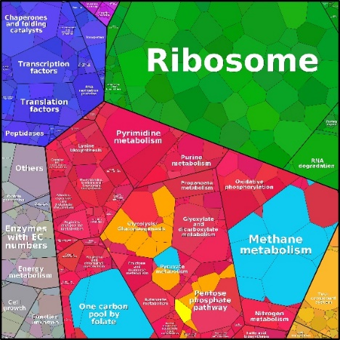
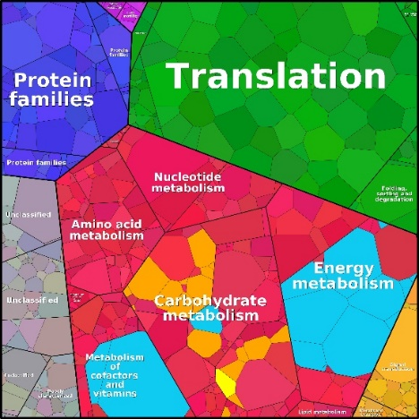
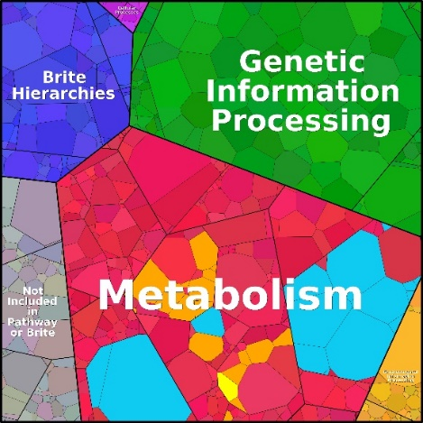
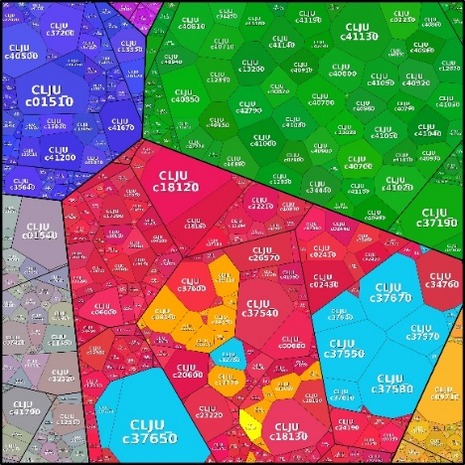

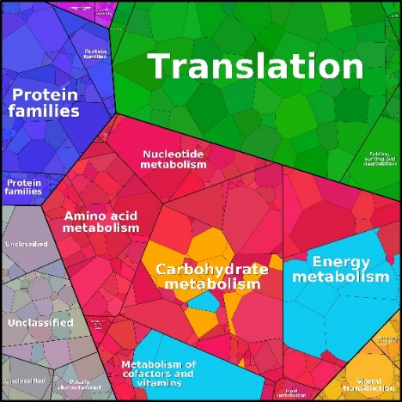
(e) (f) (g) (h)
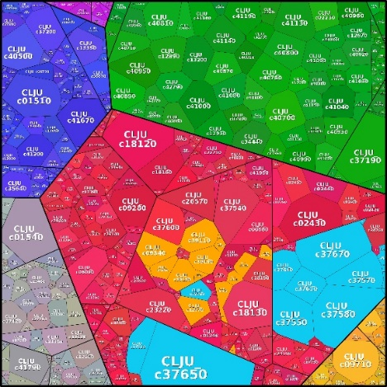
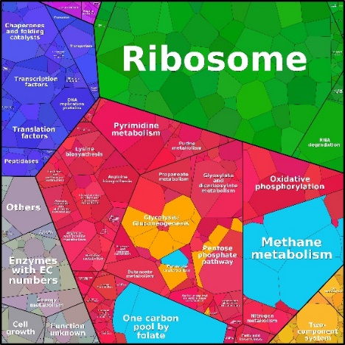
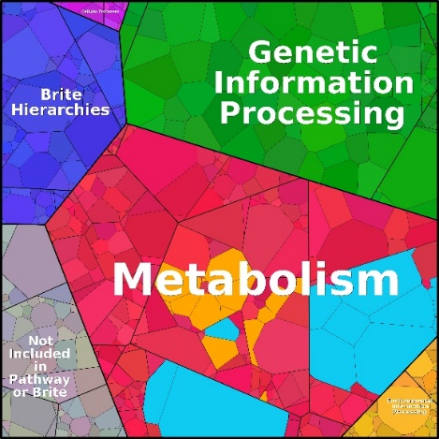

Figure S5. Pathway enzyme allocation in the proteome of C. ljungdahlii acb strain (a - d) and wild type (wt) strain (e - h) grown on CO and CO₂. Proteins are illustrated in gradually detailed categorization. Pathway enzymes for carbon fixation are under the Metabolism category. Every tile (small polygon) represents one type of protein. Tile sizes represent the mass fractions of proteins. The enzymes in the Wood-Ljungdahl pathway are shown in cyan and enzymes in the reductive acetyl-CoA bi-cycle are shown in ocher. Engineered phosphoketolase are shown in bright yellow.

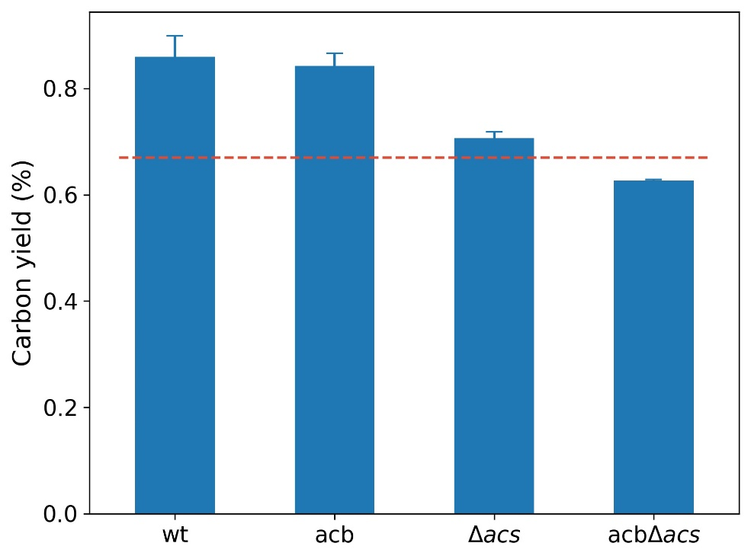

Figure S6. Carbon yield of wildtype strain (wt), heterologous phosphoketolase expression strain (acb), CO-methylating acetyl CoA synthase knockout strain (Δacs) and heterologous phosphoketolase expressed Δacs strain (acbΔacs) in heterotrophic mode. Carbon yield was defined as C-mol yield for converting fructose to acetate and ethanol, and the theoretical maximum of 67% for canonical glycolytic pathway was indicated with red line.

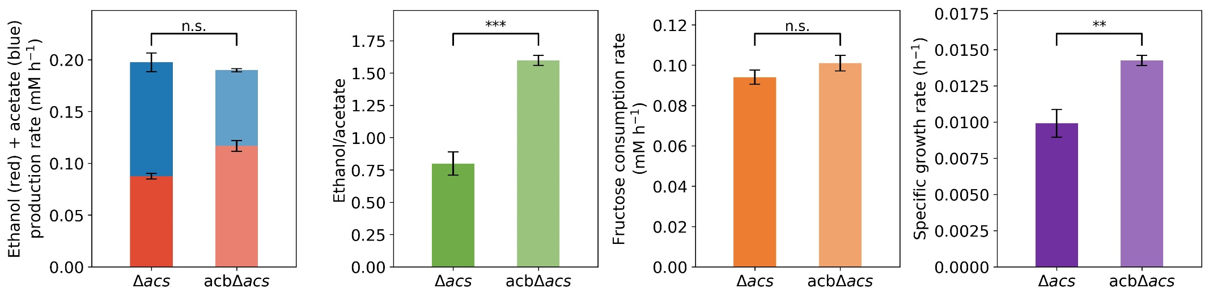

Figure S7. Growth productivities of CO-methylating acetyl CoA synthase knockout strain (Δacs) and heterologous phosphoketolase expressed Δacs strain (acbΔacs) in heterotrophic mode. Student's t-test was performed to compare the difference of each specie in three replicates. ‘**’ denotes pvalue < 0.005, ‘***’ denotes pvalue < 0.0005 and ‘n.s.’ denotes no significance.

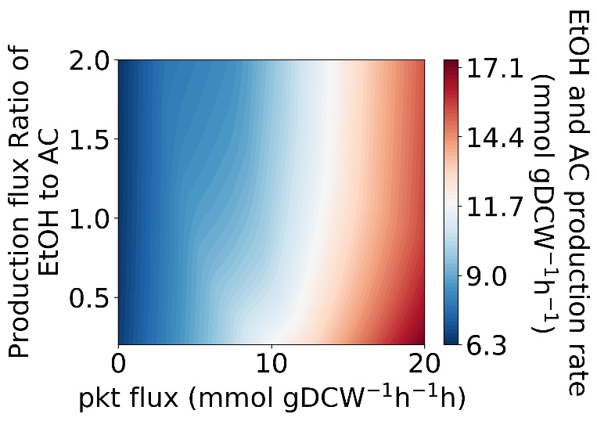

Figure S8. Contour profiling of C2 metabolites productivity as a function of production rate of ethanol to acetate and the reductive acetyl CoA bi-cycle activity in heterotrophic mode. X axis denotes the activity of acetyl CoA bi-cycle is represented by phosphoketolase (pkt) flux. Y axis denotes the production flux ratio of ethanol to acetate. The contour was profiled by using a flux balance mode of C. ljungdahlii¹ with specific growth rate as the objective function.

Reference

1. Nagarajan H, et al. Characterizing acetogenic metabolism using a genome-scale metabolic reconstruction of Clostridium ljungdahlii. Microb Cell Fact 12, 118 (2013).

